COMMON COURSE ASSIGNMENT
CSA08 – GENERATIVE AI & PROMPT ENGINEERING | Covering Large Language Models & Prompt-Driven Engineering Assistance

A. Assignment Information
Department | Computer Science and Engineering
Programme | B.E. / B.Tech – CSE
Course Code & Course Name | CSA08 – Generative AI and Prompt Engineering
Academic Year / Batch | 2026 – 2027
Faculty Name | Dr.Chandravathi C
Assignment Title | Design and Implementation of PromptCraft – A Prompt-Driven Engineering Assistant using Large Language Models and Prompt Engineering
Date of Issue | 21-08-2026
Date of Submission | 03-09-2026
Maximum Marks | 100
Course Outcome(s) – CO | CO1 & CO2
Bloom's Taxonomy Level | L3 – Apply, L4 – Analyze, L5 – Evaluate
SDG Mapping (SDG 1–17) | SDG 4 – Quality Education; SDG 9 – Industry, Innovation and Infrastructure
Industry / Societal Relevance | Prompt-driven AI assistants are increasingly used across the software industry to accelerate coding, debugging, documentation, and requirement analysis, making skills in large language models and prompt engineering directly relevant to modern engineering practice.

B. Assignment Problem / Challenge
This assignment requires students to design, implement, and evaluate an AI-powered engineering assistant that applies core Generative AI concepts — prompt design and engineering techniques (zero-shot, few-shot, and chain-of-thought prompting), large language model (LLM) API integration, and structured evaluation of model outputs — to a unified engineering-support platform called Prompt Craft. Students must integrate multiple prompting strategies, build task-specific engineering modules, deploy the system as a lightweight web application, validate output quality and reliability with sample test cases, and address basic responsible-AI considerations such as transparency of prompts, hallucination handling, and reproducibility of results.

C. Problem Statement
Scenario: “PromptCraft” – A Prompt-Driven Engineering Assistant
Many students and practicing engineers find it difficult to consistently get high-quality, reliable outputs from large language models without structured prompting. Your task is to design and implement an interactive engineering-support web application called PromptCraft that helps engineers construct effective prompts, apply prompt engineering techniques, and use an LLM to accelerate common software-engineering tasks through a unified interface.
The system shall integrate three major functional modules:

1. Prompt Engineering Workbench
Implement zero-shot, few-shot, and chain-of-thought prompting templates for common engineering tasks.
- Users should be able to enter a task description, select a prompting strategy, and optionally supply few-shot examples or context.
- The system must display the fully constructed prompt sent to the LLM together with the generated response, enabling students to see exactly how prompt structure affects output quality.

2. LLM-Powered Engineering Task Modules
Implement at least three engineering-assistant task modules, e.g., code generation & explanation, automated debugging assistance, and requirement-to-documentation generation.
- Users will enter their engineering artifact (a code snippet, an error/bug description, or a requirement statement) as input to the selected module.
- The system should show the underlying prompt template used for each module, the LLM output, and any post-processing applied, so that students can trace how the assistant arrived at its result.

3. Prompt Strategy Evaluation & Comparison
Implement comparison of at least three prompting strategies (e.g., zero-shot, few-shot, chain-of-thought) for the same task.
- Users will enter a representative engineering task and a set of reference/expected outputs for evaluation.
- The system should display response quality, response time / latency, and token usage for each strategy, allowing clear comparative analysis.
Design the application workflow so that user inputs (task descriptions, code snippets, bug reports, requirement statements) are processed through the corresponding prompt templates and LLM calls, and the results are presented as clear prompts, responses, and comparative metrics. Develop a clean, simple web interface using Streamlit. Provide 2–3 sample test cases for each module to demonstrate effectiveness. Students must use a real or simulated LLM API (e.g., OpenAI, Anthropic, or an open-source model) to generate responses.
Evaluate the application under suitable test cases and analyze the quality of LLM outputs, usability of the interface, and clarity of the prompt/response traces. The completed system should also briefly address responsible-AI considerations including transparency of prompts, hallucination and error handling, data privacy, and reproducibility of results.

D. Requirements and Constraints
- Functional: Provide interactive modules for a Prompt Engineering Workbench (with visible prompt construction and response display), LLM-Powered Engineering Task Modules (code generation, debugging assistance, and documentation generation), and Prompt Strategy Evaluation (quality, latency, and token-usage comparison). Accept user inputs as well as sample data. Produce comparative tables and prompt/response traces.
- Interface: Clean, simple, and user-friendly Streamlit web application with separate pages or clearly separated sections for each module.
- Performance: LLM calls must return results with acceptable latency for interactive classroom use and support clear comparative analysis across prompting strategies.
- Technical constraint: Use Python + Streamlit. No database or complex architecture required. Use any accessible LLM API or open-source model for prompt execution.
- Reliability: Prompt templates and task modules must behave consistently and reproducibly; intermediate prompts must be transparent; the system must handle malformed inputs and LLM API errors without crashing.
- Resource constraint: Project must be completable within the semester timeline using standard student computing resources.
- Responsible Computing: Ensure transparency of prompts and model limitations, reproducibility of results, mitigation of hallucinated or misleading outputs, and adherence to responsible-AI and data-privacy practices.
- Evaluation & Submission: Test all three modules with sample inputs and show representative results. Submit working Streamlit code, a short report containing sample prompts/outputs / screenshots, comparative analysis, and a GitHub repository link.

Submitted by:

T Deekshith (192472253)

1. Problem Understanding and Formulation

1.1 Problem Statement
CampusConnect is considered a university digital platform through which students and faculty access shared academic resources such as notes, assignments, reports, images, database records and large lecture videos. Because many users may access the platform at the same time, the operating system must coordinate processes, memory and storage resources safely and efficiently.
The objective of this assignment is to develop an integrated operating-system resource-management design that provides deadlock-free concurrent access, efficient memory utilization, reliable file storage and fair, low-overhead disk access.

1.2 Synchronization Challenges
Multiple CampusConnect users may access the same academic file simultaneously. Multiple readers can safely read a file at the same time, whereas a writer must obtain exclusive access. Without synchronization, simultaneous reads and writes can create race conditions, inconsistent data, partial updates and file corruption.
- Shared-file access must be mutually coordinated.
- Readers should be allowed to operate concurrently.
- A writer must have exclusive access.
- The synchronization mechanism should avoid race conditions and starvation as far as practical.

1.3 Deadlock Challenges
CampusConnect processes may require multiple resources, including a database handle, print spooler, network socket and file lock. Deadlock is possible when processes hold some resources while waiting indefinitely for resources held by other processes.
P1 holds Database Handle → waits for File Lock
P2 holds File Lock → waits for Database Handle
Result: P1 and P2 wait indefinitely unless the system prevents or avoids the unsafe allocation.

1.4 Memory-Management Challenges
With approximately 300 active sessions, memory pressure can become significant. If processes receive too few frames, pages may be repeatedly loaded from and evicted to disk. Excessive page faults can cause thrashing and reduce CPU utilization.

1.5 File-System Challenges
CampusConnect has a mixed workload ranging from small text documents and PDFs to large recorded lectures. The allocation strategy must support file growth, sequential and random access, and efficient use of storage without excessive fragmentation.

1.6 Disk-Scheduling Challenges
Hundreds of user operations can generate simultaneous I/O requests. Inefficient scheduling can increase head movement and seek time. FCFS, SCAN and C-SCAN are therefore compared using a representative request queue.

1.7 Expected Outcomes
- Deadlock-free and race-condition-free shared access.
- Efficient physical-memory utilization with reduced page faults.
- Thrashing prevention during high concurrent load.
- Efficient storage for small files and multi-GB videos.
- Reduced disk-head movement and fair access to I/O requests.
- Reliable and responsive access to shared academic resources.

1.8 Assumptions and Justification
Parameter | Assumed Value | Justification
Physical memory | 8 GB | Given in the problem statement.
Page size | 4 KB | Given in the problem statement and common OS page size.
Representative process | 64 MB | Given in the problem statement.
Concurrent sessions | 300 | Given in the problem statement.
Page-replacement frames | 3 | Small fixed frame count for clear algorithm comparison.
Disk cylinders | 0–199 | Given as 200 cylinders.
Initial disk head | 53 | Representative mid-disk starting position.
Banker processes | P1–P4 | Given in the problem statement.
Resource types | 4 | Database handle, print spooler, network socket, file lock.
PTE size | 8 bytes | Reasonable assumption for page-table-size calculation.

2. Application of Course Knowledge

Part I – Process Synchronization & Deadlock (CO2, Unit II)

4. Readers–Writers Model for Shared Files
The shared academic-file problem is modeled as the classical Readers–Writers problem. Readers can access the file concurrently, but a writer requires exclusive access. A mutex protects the read-count variable and a write semaphore protects the file from simultaneous writing.

4.1 Semaphore Pseudocode
Pseudocode 1 – Semaphore-based Readers–Writers synchronization
READER:
wait(mutex)
read_count = read_count + 1
if read_count == 1:
wait(write)
signal(mutex)
READ FILE
wait(mutex)
read_count = read_count - 1
if read_count == 0:
signal(write)
signal(mutex)
WRITER:
wait(write)
WRITE FILE
signal(write)

Logic: the first reader locks the writer semaphore, allowing other readers to enter while preventing writers. The last reader releases the writer semaphore. A writer holds the write semaphore throughout its critical section, so readers and other writers cannot access the file simultaneously.

4.2 Python Synchronization Simulation
Python implementation – Readers–Writers synchronization
import threading
import time
import random
read_count = 0
mutex = threading.Semaphore(1)
write_lock = threading.Semaphore(1)
shared_file = "Initial CampusConnect academic content"
def reader(reader_id):
global read_count
mutex.acquire()
read_count += 1
if read_count == 1:
write_lock.acquire()
mutex.release()
print(f"Reader {reader_id} started reading")
print("Content:", shared_file)
time.sleep(random.uniform(0.5, 1.5))
print(f"Reader {reader_id} finished reading")
mutex.acquire()
read_count -= 1
if read_count == 0:
write_lock.release()
mutex.release()
def writer(writer_id):
global shared_file
write_lock.acquire()
print(f"Writer {writer_id} started writing")
shared_file = f"Updated CampusConnect content by Writer {writer_id}"
time.sleep(1)
print(f"Writer {writer_id} finished writing")
write_lock.release()
threads = []
for i in range(3):
threads.append(threading.Thread(target=reader, args=(i + 1,)))
for i in range(2):
threads.append(threading.Thread(target=writer, args=(i + 1,)))
for t in threads:
t.start()
for t in threads:
t.join()
print("\nFinal Shared File:")
print(shared_file)

5. Banker's Algorithm Safety Check
Four resource types are assumed: A = database handle, B = print spooler, C = network socket, and D = file lock. The following allocation and maximum matrices are constructed as a reasonable example for four processes.

5.1 Allocation Matrix
Process | A | B | C | D
P1 | 1 | 0 | 1 | 0
P2 | 1 | 1 | 0 | 1
P3 | 1 | 0 | 1 | 1
P4 | 0 | 1 | 1 | 0

5.2 Maximum Matrix
Process | A | B | C | D
P1 | 2 | 1 | 1 | 1
P2 | 2 | 1 | 1 | 1
P3 | 2 | 1 | 2 | 1
P4 | 1 | 1 | 1 | 1

Total resources are [5, 3, 4, 3]. Total allocation is [3, 2, 3, 2], giving Available = Total − Allocation = [2, 1, 1, 1].

5.3 Need Matrix
Need = Maximum − Allocation.
Process | A | B | C | D
P1 | 1 | 1 | 0 | 1
P2 | 1 | 0 | 1 | 0
P3 | 1 | 1 | 1 | 0
P4 | 1 | 0 | 0 | 1

5.4 Safety Algorithm Trace
Step | Process Selected | Need ≤ Work? | Work After Completion
Initial | — | — | [2,1,1,1]
1 | P1 | Yes | [3,1,2,1]
2 | P2 | Yes | [4,2,2,2]
3 | P3 | Yes | [5,2,3,3]
4 | P4 | Yes | [5,3,4,3]

Safe sequence: P1 → P2 → P3 → P4. Since every process can complete and release its allocated resources, the system is in a SAFE state.
Python implementation – Banker's Algorithm
import numpy as np
allocation = np.array([
[1, 0, 1, 0],
[1, 1, 0, 1],
[1, 0, 1, 1],
[0, 1, 1, 0]
])
maximum = np.array([
[2, 1, 1, 1],
[2, 1, 1, 1],
[2, 1, 2, 1],
[1, 1, 1, 1]
])
available = np.array([2, 1, 1, 1])
need = maximum - allocation
finish = [False] * len(allocation)
safe_sequence = []
work = available.copy()
print("Need Matrix:\n", need)
print("\nInitial Available:", work)
while len(safe_sequence) < len(allocation):
found = False
for i in range(len(allocation)):
if not finish[i] and np.all(need[i] <= work):
print(f"\nP{i+1} can execute.")
print("Need:", need[i])
print("Available before:", work)
work += allocation[i]
print("Available after:", work)
finish[i] = True
safe_sequence.append(i + 1)
found = True
if not found:
break
if len(safe_sequence) == len(allocation):
print("\nSYSTEM IS SAFE")
print("Safe Sequence:",
" -> ".join(f"P{x}" for x in safe_sequence))
else:
print("\nSYSTEM IS NOT SAFE")

6. Deadlock-Handling Strategy
A combination of deadlock avoidance and resource-ordering rules is recommended for CampusConnect. Banker's Algorithm is appropriate for bounded resource pools where maximum demands can be estimated. For dynamic resources such as network connections, timeouts and detection mechanisms can complement avoidance.
Strategy | Advantage | Limitation | CampusConnect Assessment
Prevention | Can eliminate a necessary deadlock condition. | May reduce concurrency or resource utilization. | Useful for strict lock-order rules.
Avoidance | Prevents unsafe allocations before they occur. | Requires maximum-demand information. | Recommended for bounded critical resources.
Detection & Recovery | Flexible resource allocation. | Deadlock may occur before recovery. | Useful as a secondary safety mechanism.
Ignore | Very low overhead. | Unsafe for critical academic services. | Not recommended.

Part II – Memory Management (CO3, Unit III)

7. Paging Calculation
Physical memory = 8 GB and page size = 4 KB.
8 GB = 2^33 bytes
4 KB = 2^12 bytes
Number of frames = 2^33 / 2^12 = 2^21 = 2,097,152 frames

Therefore, the 8 GB physical memory contains 2,097,152 frames of 4 KB each.
For a 64 MB logical address space: 64 MB = 2^26 bytes. Number of pages = 2^26 / 2^12 = 2^14 = 16,384 pages.
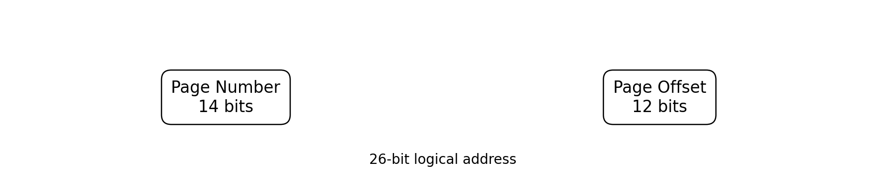
Figure 1. Logical address structure for the 64 MB process.
A 4 KB page requires a 12-bit offset. The remaining 14 bits identify one of 16,384 pages, giving a 26-bit logical address.
Assuming an 8-byte page-table entry, page-table size = 16,384 × 8 = 131,072 bytes = 128 KB.

7.1 Page Table Entry Contents
- Frame number
- Valid/present bit
- Protection bits (read/write/execute)
- Dirty/modified bit
- Reference/access bit
- Other OS-specific control information

7.2 Two-Level Page Table Design
The 14-bit page number can be split into two 7-bit indices. The logical address can therefore be viewed as Level-1 index (7 bits) + Level-2 index (7 bits) + offset (12 bits). This allows second-level tables to be allocated only for portions of the address space that are actually used.

8. Page Replacement: FIFO, LRU and Optimal
Reference string used for the representative user session: 7, 0, 1, 2, 0, 3, 0, 4, 2, 3, 0, 3, 2. The comparison uses 3 frames.

8.1 Results
Algorithm | Page Faults | Main Principle | Practicality
FIFO | 10 | Replace the page that entered first. | Simple; may show Belady's anomaly.
LRU | 9 | Replace the least recently used page. | Practical approximation possible.
Optimal | 7 | Replace the page used farthest in the future. | Theoretical benchmark; future references unavailable.

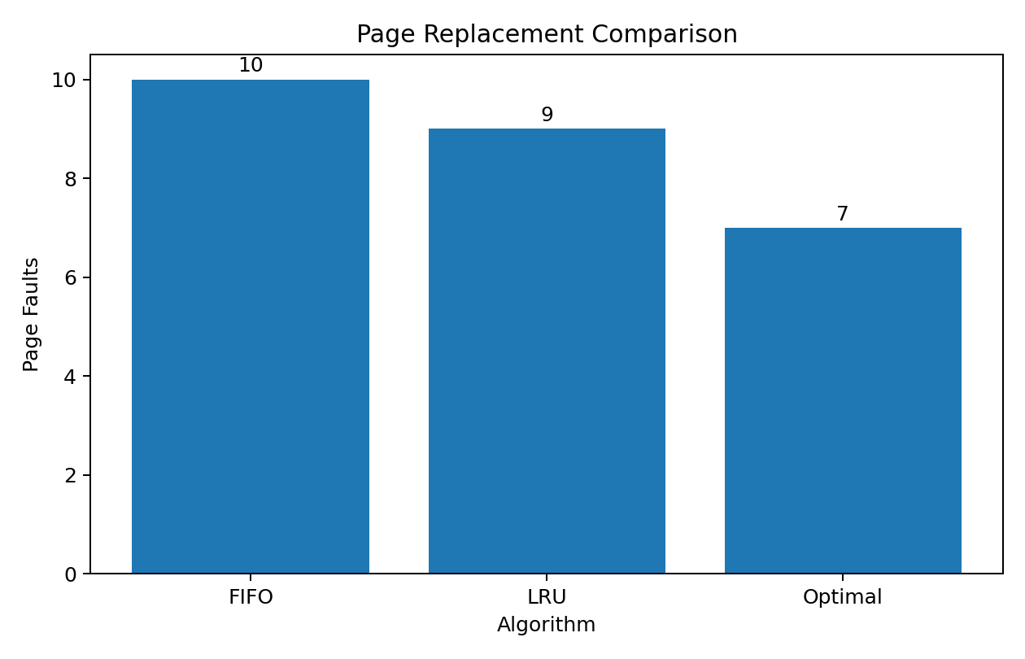
Figure 2. Page-fault comparison for the selected reference string.
Python implementation – Page replacement algorithms
reference = [7, 0, 1, 2, 0, 3, 0, 4, 2, 3, 0, 3, 2]
frames_count = 3
def fifo(reference, frame_count):
frames, queue, faults = [], [], 0
for page in reference:
if page not in frames:
faults += 1
if len(frames) < frame_count:
frames.append(page)
queue.append(page)
else:
oldest = queue.pop(0)
frames[frames.index(oldest)] = page
queue.append(page)
return faults
def lru(reference, frame_count):
frames, recent, faults = [], {}, 0
for position, page in enumerate(reference):
if page not in frames:
faults += 1
if len(frames) < frame_count:
frames.append(page)
else:
victim = min(frames, key=lambda x: recent[x])
frames[frames.index(victim)] = page
recent[page] = position
return faults
def optimal(reference, frame_count):
frames, faults = [], 0
for i, page in enumerate(reference):
if page not in frames:
faults += 1
if len(frames) < frame_count:
frames.append(page)
else:
future = reference[i+1:]
def next_use(p):
return future.index(p) if p in future else float("inf")
victim = max(frames, key=next_use)
frames[frames.index(victim)] = page
return faults
print("FIFO:", fifo(reference, frames_count))
print("LRU:", lru(reference, frames_count))
print("Optimal:", optimal(reference, frames_count))

9. Demand Paging and Working-Set Strategy
Demand paging loads a page only when it is referenced. This avoids loading unused portions of every process into RAM and therefore improves memory utilization.
Process starts
↓
Only required pages loaded
↓
Page fault occurs when an absent page is referenced
↓
OS loads the page from storage
↓
Execution continues

For 300 concurrent sessions, the working-set model should be used to estimate each process's active pages over a recent reference window. If a process has a high page-fault rate, additional frames can be allocated when available. If its working set shrinks, frames can be reclaimed.
A practical policy is to reserve approximately 1 GB for the OS kernel, file/page cache and background services, leaving approximately 7 GB for user sessions. Equal division would provide roughly 1,835,008 user frames, or about 6,117 frames per session (approximately 23.9 MB). This should be treated as a capacity reference rather than a fixed allocation.
Policy Level | Approx. Frames | Approx. Memory | Use
Minimum | 2,048 | 8 MB | Baseline allocation for an active session.
Normal target | 4,096–6,000 | 16–23.4 MB | Typical interactive session range.
Adaptive | Above normal when needed | Based on available RAM | Increase for high page-fault/working-set demand.

If the combined working-set demand exceeds available memory, low-priority or inactive sessions should be throttled or suspended rather than allowing all processes to thrash.

Part III – File Systems & Disk Scheduling (CO4, Unit IV)

10. File Allocation Methods
CampusConnect has a mixed file-size workload. Contiguous, linked and indexed allocation are compared below.
Property | Contiguous | Linked | Indexed
Sequential access | Excellent | Good | Excellent
Random access | Excellent | Poor | Excellent
External fragmentation | Yes | No | No
File growth | Difficult | Easy | Easy
Pointer overhead | Low | High | Moderate
Mixed file-size workload | Poor–Moderate | Moderate | Excellent

10.1 Recommended Method
Indexed allocation is recommended because it supports dynamic file growth and efficient random access without requiring contiguous free space. It is suitable for PDFs, assignments and large video files. In modern implementations, extent-based indexing can further reduce metadata overhead for large sequential files.

11. Disk Scheduling
Disk cylinders are 0–199. The request queue is 98, 183, 37, 122, 14, 124, 65, 67 and the initial head position is 53. For SCAN and C-SCAN, the initial direction is toward higher-numbered cylinders.

11.1 FCFS Calculation
53 → 98 → 183 → 37 → 122 → 14 → 124 → 65 → 67
Movement = 45 + 85 + 146 + 85 + 108 + 110 + 59 + 2
Total = 640 cylinders

11.2 SCAN Calculation
53 → 65 → 67 → 98 → 122 → 124 → 183 → 199 → 37 → 14
Total head movement = 331 cylinders

11.3 C-SCAN Calculation
53 → 65 → 67 → 98 → 122 → 124 → 183 → 199 → 0 → 14 → 37
Total head movement = 382 cylinders

Algorithm | Total Head Movement | Observation
FCFS | 640 cylinders | Highest movement; simple arrival-order fairness.
SCAN | 331 cylinders | Lowest for this workload; good fairness/performance balance.
C-SCAN | 382 cylinders | More uniform service direction; extra wrap-around movement.

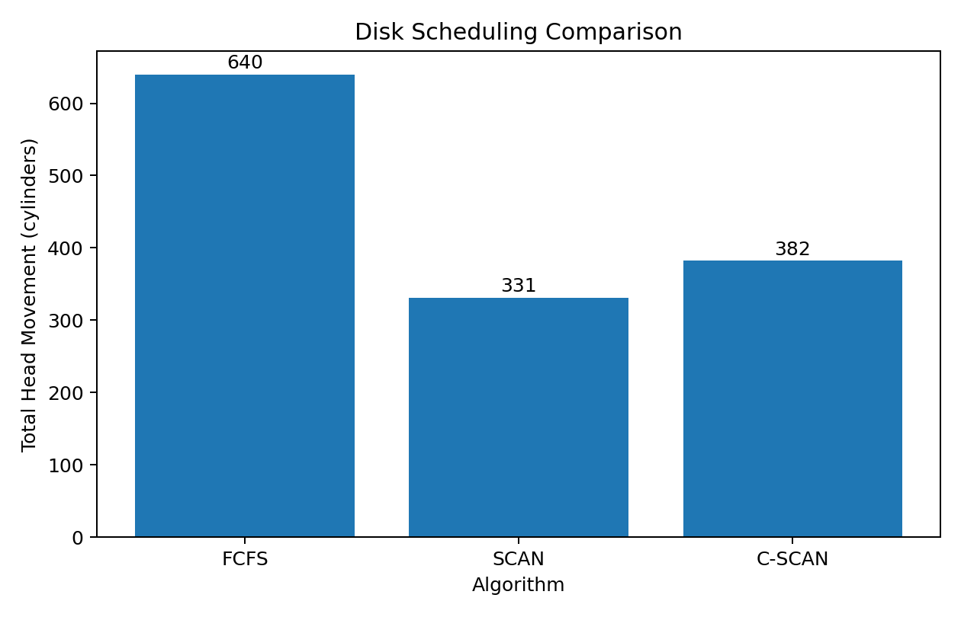
Figure 3. Disk-scheduling comparison for the selected request queue.
Python implementation – Disk scheduling algorithms
requests = [98, 183, 37, 122, 14, 124, 65, 67]
head = 53
MAX_CYLINDER = 199
def fcfs(requests, head):
total, current, path = 0, head, [head]
for request in requests:
total += abs(current - request)
current = request
path.append(request)
return total, path
def scan(requests, head):
lower = sorted([x for x in requests if x < head])
higher = sorted([x for x in requests if x >= head])
sequence = higher + [MAX_CYLINDER] + list(reversed(lower))
total, current, path = 0, head, [head]
for request in sequence:
total += abs(current - request)
current = request
path.append(request)
return total, path
def cscan(requests, head):
lower = sorted([x for x in requests if x < head])
higher = sorted([x for x in requests if x >= head])
sequence = higher + [MAX_CYLINDER, 0] + lower
total, current, path = 0, head, [head]
for request in sequence:
total += abs(current - request)
current = request
path.append(request)
return total, path
for name, fn in [("FCFS", fcfs), ("SCAN", scan), ("C-SCAN", cscan)]:
total, path = fn(requests, head)
print(name)
print("Path:", path)
print("Total Movement:", total, "cylinders\n")

12. UNIX File-System Concepts
The recommended indexed-allocation approach can be related to UNIX-like inode structures. An inode stores file metadata and references to data blocks. Traditional inode designs use direct and indirect block pointers, which are conceptually related to indexed allocation.
CampusConnect File
↓
Directory Entry
↓
Inode / Metadata
↓
Direct + Indirect / Indexed References
↓
Data Blocks

A buffer or page cache keeps frequently accessed blocks in RAM. If a student requests a frequently used PDF, the system can serve cached blocks without immediately accessing storage, reducing I/O latency.

3. Solution / Design / Methodology

3.1 Consolidated Design
The final CampusConnect design combines synchronization, memory management and storage management into one resource-management pipeline.
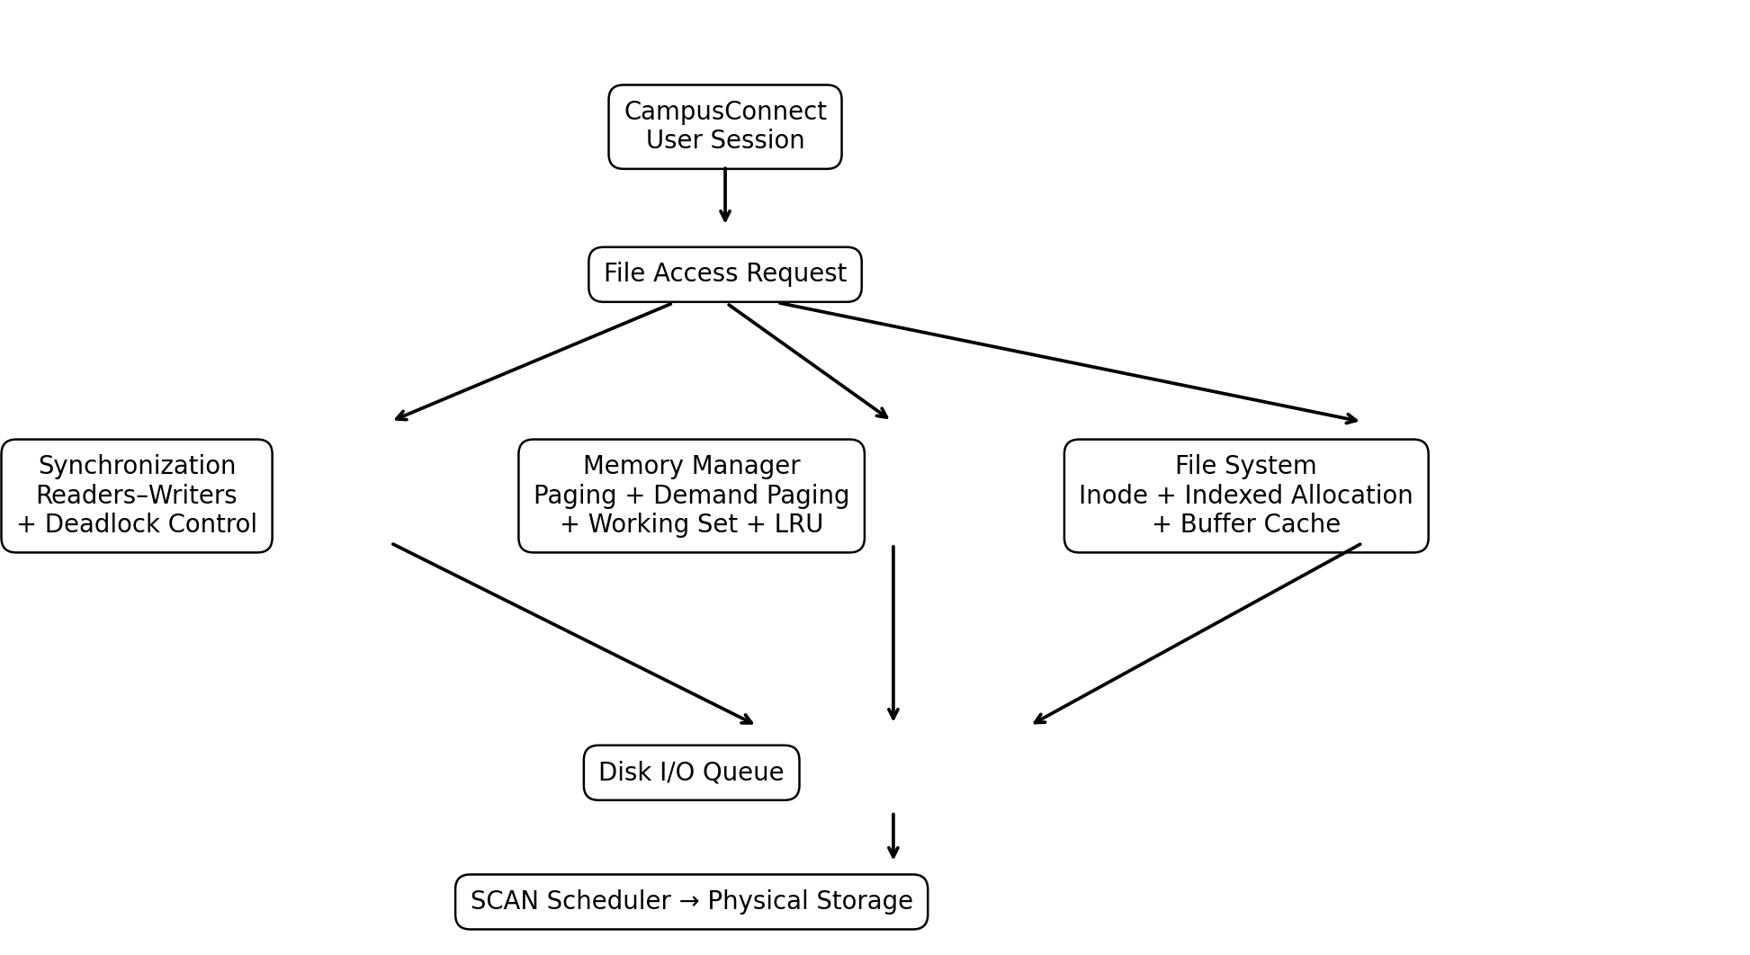
Figure 4. Integrated CampusConnect operating-system resource-management architecture.

3.2 Synchronization Design
- Use Readers–Writers synchronization for shared academic files.
- Protect read_count with a mutex.
- Use a writer semaphore for exclusive modification.
- Apply consistent lock ordering to reduce circular-wait risk.
- Use bounded waits/timeouts for external or dynamically allocated resources.

3.3 Memory-Management Design
- Use 4 KB paging.
- Use demand paging to load only referenced pages.
- Use LRU or a practical LRU approximation such as Clock/Second-Chance.
- Track working-set size and page-fault frequency.
- Keep a free-frame reserve and avoid allocating more total working-set demand than physical memory.

3.4 File-System and Disk Design
- Use indexed or extent-based allocation for mixed file sizes.
- Use inode-style metadata and block references.
- Use buffer/page cache for frequently accessed academic files.
- Use SCAN for the representative mechanical-disk workload because it produced the lowest measured movement.

3.5 User Session File-Access Flow
User requests file
↓
Authentication / permission check
↓
Acquire reader/writer synchronization lock
↓
Check page/buffer cache
↙ ↘
Cache hit Cache miss
↓ ↓
Serve data Locate file blocks via inode
↓
Disk I/O queue
↓
SCAN scheduling
↓
Read storage blocks
↓
Load into memory
↓
Serve user
↓
Release lock

4. Use of Modern Tools and Implementation
Google Colab is suitable for the Python simulations because it provides a browser-based Python environment and allows the source code and outputs to be captured directly for the report.
Tool | Purpose
Google Colab | Run and demonstrate Python implementations.
Python | Implement OS algorithms and simulations.
NumPy | Matrix operations in Banker's Algorithm.
Matplotlib | Generate comparison graphs.
threading + Semaphore | Demonstrate Readers–Writers synchronization.
Linux / WSL (optional) | Cross-check semaphore behavior with POSIX threads.

4.1 Google Colab Execution Order
- Run the Readers–Writers synchronization cell and capture the console output.
- Run the Banker's Algorithm cell and capture the Need Matrix, safety trace and safe sequence.
- Run the page-replacement cell and capture FIFO, LRU and Optimal page-fault counts.
- Run the page-fault graph cell and capture the comparison figure.
- Run the disk-scheduling cell and capture paths and head-movement totals.
- Run the disk graph cell and capture the comparison figure.

4.2 Page-Fault Graph Code
import matplotlib.pyplot as plt
algorithms = ['FIFO', 'LRU', 'Optimal']
faults = [10, 9, 7]
plt.figure(figsize=(7, 5))
plt.bar(algorithms, faults)
plt.xlabel('Page Replacement Algorithm')
plt.ylabel('Number of Page Faults')
plt.title('Page Replacement Comparison')
plt.show()

4.3 Disk-Scheduling Graph Code
import matplotlib.pyplot as plt
algorithms = ['FCFS', 'SCAN', 'C-SCAN']
movement = [640, 331, 382]
plt.figure(figsize=(7, 5))
plt.bar(algorithms, movement)
plt.xlabel('Disk Scheduling Algorithm')
plt.ylabel('Total Head Movement')
plt.title('Disk Scheduling Comparison')
plt.show()

5. Results and Validation

5.1 Banker's Algorithm Validation
The safety check produced the safe sequence P1 → P2 → P3 → P4. All four processes can complete under the assumed maximum-demand matrix, so the state is SAFE.

5.2 Page-Replacement Results
Algorithm | Faults | Rank for This Workload
Optimal | 7 | 1 – Best theoretical result
LRU | 9 | 2 – Recommended practical policy
FIFO | 10 | 3 – Simple baseline


Figure 5. Page-fault results.

5.3 Disk-Scheduling Results
Algorithm | Movement | Reduction vs FCFS
FCFS | 640 | 0%
SCAN | 331 | 48.28%
C-SCAN | 382 | 40.31%


Figure 6. Disk head-movement results.

5.4 Synchronization Validation
The synchronization simulation uses a mutex around read_count and a write semaphore around the file's write critical section. Multiple readers can execute concurrently, while a writer waits until no readers are active and then obtains exclusive access.
- No simultaneous writer/writer access.
- No reader/writer overlap while the writer semaphore is held.
- read_count updates are protected by mutex.
- The demonstration should be stress-tested with more threads for stronger validation.

6. Analysis and Engineering Decision

6.1 Page-Replacement Decision
Optimal produced 7 faults and is therefore the theoretical lower bound for the chosen reference string. However, it requires knowledge of future references and cannot be implemented exactly in a real OS. LRU produced 9 faults and better reflects locality of reference, making an LRU approximation a practical choice.

6.2 Disk-Scheduling Decision
FCFS is simple and preserves arrival order but produced 640 cylinders of movement. SCAN reduced movement to 331 cylinders, a reduction of approximately 48.28%. C-SCAN produced 382 cylinders and provides more uniform service in one direction. For the selected workload, SCAN offers the best measured balance between fairness and seek efficiency.

6.3 Deadlock Strategy Decision
Avoidance is preferred for bounded resources because it checks whether a resource request leaves the system in a safe state. Prevention through a global lock order should also be applied where possible because it is simple and reduces circular-wait risk. Detection and recovery can be retained as a secondary mechanism for unexpected dynamic resource conditions.

6.4 Overall Engineering Decision
Subsystem | Selected Design | Reason
Synchronization | Readers–Writers + semaphores | Safe concurrent reads and exclusive writes.
Deadlock | Avoidance + lock ordering + timeout support | Balances reliability and concurrency.
Memory | Paging + demand paging + LRU approximation + working set | Reduces faults and prevents thrashing.
File system | Indexed / extent-based allocation + inode concepts | Handles mixed file sizes and random access.
Disk | SCAN | Lowest movement in the selected workload with good fairness.

7. Broader Considerations

7.1 Reliability and Safety
- Use file locks and atomic update operations to protect academic data.
- Use authentication and role-based authorization for student and faculty resources.
- Maintain backups and recovery procedures.
- Use integrity checks and audit logs for important files.
- Protect metadata and cached data from unauthorized modification.

7.2 Sustainability and Economics
Efficient page allocation reduces unnecessary paging and storage I/O. Buffer caching reduces repeated disk reads. Lower disk-head movement reduces mechanical seek work for HDD-based storage. Together these measures can reduce resource usage, improve throughput and potentially reduce hardware and energy costs.

7.3 Accessibility and Society
Fair synchronization and disk scheduling help prevent a small group of users from monopolizing shared resources. Working-set-aware memory management helps maintain responsiveness during peak periods, while admission control can prevent system-wide thrashing.

7.4 Ethics and Professional Responsibility
CampusConnect may process student records, grades, assignments and personal information. The design should follow least privilege, secure authentication, confidentiality, appropriate retention, auditing and responsible handling of academic data. AI-assisted development should be disclosed according to institutional rules, and generated code should be tested rather than accepted without verification.

8. Conclusion
This report presented an integrated operating-system resource-management design for CampusConnect. Readers–Writers synchronization protects shared academic files, while deadlock avoidance and lock-ordering rules reduce the possibility of unsafe resource allocation.
The memory analysis showed that 8 GB physical memory with 4 KB pages provides 2,097,152 frames, while a 64 MB logical address space contains 16,384 pages. The representative page-replacement experiment produced 10 FIFO faults, 9 LRU faults and 7 Optimal faults. LRU or a practical LRU approximation is therefore recommended because it captures locality without requiring future knowledge.
For storage, indexed or extent-based allocation is appropriate for the mixed workload. The disk experiment produced 640 cylinders for FCFS, 331 for SCAN and 382 for C-SCAN. SCAN was selected for the representative mechanical-disk workload because it provided the lowest head movement while retaining reasonable fairness.
The final design therefore satisfies the major stated requirements: safe concurrency, efficient memory utilization, thrashing control, scalable file storage, fair disk access, and improved reliability. A production implementation would require real workload traces, security testing, failure testing and evaluation on modern SSD/NVMe storage.

9. Student Reflection

9.1 What I Learned
This assignment helped me understand that synchronization, memory management and file systems are interconnected rather than isolated OS topics. A single user request can involve a process lock, page allocation, cache lookup, file metadata and disk scheduling. The practical simulations also demonstrated why a theoretically optimal algorithm is not always the best real-world choice.

9.2 Future Improvements
- Use real CampusConnect workload traces instead of manually constructed sequences.
- Test hundreds or thousands of concurrent processes.
- Compare LRU with Clock/Second-Chance and adaptive page-fault-frequency policies.
- Implement POSIX semaphores and pthreads in a Linux/WSL environment.
- Evaluate SSD/NVMe behavior, where traditional mechanical head scheduling is less relevant.
- Use replication, distributed storage and automatic failover for large-scale deployment.
- Perform security, fault-injection and stress testing.

10. References
[1] A. Silberschatz, P. B. Galvin, and G. Gagne, Operating System Concepts, 10th ed., Wiley, 2018.
[2] A. S. Tanenbaum and H. Bos, Modern Operating Systems, 4th ed., Pearson, 2015.
[3] W. Stallings, Operating Systems: Internals and Design Principles, 9th ed., Pearson, 2018.
[4] IEEE, IEEE Standard 1003.1, POSIX Threads and synchronization interfaces.
[5] Python Software Foundation, Python Documentation: threading and synchronization primitives.
[6] NumPy Developers, NumPy Documentation.
[7] Matplotlib Development Team, Matplotlib Documentation.
[8] Google, Google Colaboratory Documentation.
[9] OpenAI, ChatGPT, used as an AI-assisted tool for explanation, drafting and code guidance; all calculations and outputs were independently checked through implementation.

Appendix A – Complete Google Colab Code
The following code blocks can be copied into separate Google Colab cells. The same source code is also provided in the relevant sections above for easier documentation and screenshot capture.

A.1 Banker's Algorithm
import numpy as np
allocation = np.array([
[1, 0, 1, 0],
[1, 1, 0, 1],
[1, 0, 1, 1],
[0, 1, 1, 0]
])
maximum = np.array([
[2, 1, 1, 1],
[2, 1, 1, 1],
[2, 1, 2, 1],
[1, 1, 1, 1]
])
available = np.array([2, 1, 1, 1])
need = maximum - allocation
finish = [False] * len(allocation)
safe_sequence = []
work = available.copy()
print("Need Matrix:\n", need)
print("\nInitial Available:", work)
while len(safe_sequence) < len(allocation):
found = False
for i in range(len(allocation)):
if not finish[i] and np.all(need[i] <= work):
print(f"\nP{i+1} can execute.")
print("Need:", need[i])
print("Available before:", work)
work += allocation[i]
print("Available after:", work)
finish[i] = True
safe_sequence.append(i + 1)
found = True
if not found:
break
if len(safe_sequence) == len(allocation):
print("\nSYSTEM IS SAFE")
print("Safe Sequence:",
" -> ".join(f"P{x}" for x in safe_sequence))
else:
print("\nSYSTEM IS NOT SAFE")

A.2 Page Replacement
reference = [7, 0, 1, 2, 0, 3, 0, 4, 2, 3, 0, 3, 2]
frames_count = 3
def fifo(reference, frame_count):
frames, queue, faults = [], [], 0
for page in reference:
if page not in frames:
faults += 1
if len(frames) < frame_count:
frames.append(page)
queue.append(page)
else:
oldest = queue.pop(0)
frames[frames.index(oldest)] = page
queue.append(page)
return faults
def lru(reference, frame_count):
frames, recent, faults = [], {}, 0
for position, page in enumerate(reference):
if page not in frames:
faults += 1
if len(frames) < frame_count:
frames.append(page)
else:
victim = min(frames, key=lambda x: recent[x])
frames[frames.index(victim)] = page
recent[page] = position
return faults
def optimal(reference, frame_count):
frames, faults = [], 0
for i, page in enumerate(reference):
if page not in frames:
faults += 1
if len(frames) < frame_count:
frames.append(page)
else:
future = reference[i+1:]
def next_use(p):
return future.index(p) if p in future else float("inf")
victim = max(frames, key=next_use)
frames[frames.index(victim)] = page
return faults
print("FIFO:", fifo(reference, frames_count))
print("LRU:", lru(reference, frames_count))
print("Optimal:", optimal(reference, frames_count))

A.3 Disk Scheduling
requests = [98, 183, 37, 122, 14, 124, 65, 67]
head = 53
MAX_CYLINDER = 199
def fcfs(requests, head):
total, current, path = 0, head, [head]
for request in requests:
total += abs(current - request)
current = request
path.append(request)
return total, path
def scan(requests, head):
lower = sorted([x for x in requests if x < head])
higher = sorted([x for x in requests if x >= head])
sequence = higher + [MAX_CYLINDER] + list(reversed(lower))
total, current, path = 0, head, [head]
for request in sequence:
total += abs(current - request)
current = request
path.append(request)
return total, path
def cscan(requests, head):
lower = sorted([x for x in requests if x < head])
higher = sorted([x for x in requests if x >= head])
sequence = higher + [MAX_CYLINDER, 0] + lower
total, current, path = 0, head, [head]
for request in sequence:
total += abs(current - request)
current = request
path.append(request)
return total, path
for name, fn in [("FCFS", fcfs), ("SCAN", scan), ("C-SCAN", cscan)]:
total, path = fn(requests, head)
print(name)
print("Path:", path)
print("Total Movement:", total, "cylinders\n")

A.4 Readers–Writers
import threading
import time
import random
read_count = 0
mutex = threading.Semaphore(1)
write_lock = threading.Semaphore(1)
shared_file = "Initial CampusConnect academic content"
def reader(reader_id):
global read_count
mutex.acquire()
read_count += 1
if read_count == 1:
write_lock.acquire()
mutex.release()
print(f"Reader {reader_id} started reading")
print("Content:", shared_file)
time.sleep(random.uniform(0.5, 1.5))
print(f"Reader {reader_id} finished reading")
mutex.acquire()
read_count -= 1
if read_count == 0:
write_lock.release()
mutex.release()
def writer(writer_id):
global shared_file
write_lock.acquire()
print(f"Writer {writer_id} started writing")
shared_file = f"Updated CampusConnect content by Writer {writer_id}"
time.sleep(1)
print(f"Writer {writer_id} finished writing")
write_lock.release()
threads = []
for i in range(3):
threads.append(threading.Thread(target=reader, args=(i + 1,)))
for i in range(2):
threads.append(threading.Thread(target=writer, args=(i + 1,)))
for t in threads:
t.start()
for t in threads:
t.join()
print("\nFinal Shared File:")
print(shared_file)

- Common Assessment Rubric

Assessment Criterion | Marks
Problem understanding & formulation | 10
Application of course / domain knowledge (Prompt Engineering, LLM Integration, Evaluation) | 20
Solution methodology / design / implementation | 20
Use of appropriate modern tools / techniques (Python, LLM APIs, Prompt Engineering Frameworks) | 10
Results, testing & validation | 15
Analysis, trade-offs & justification | 15
Broader considerations / professional responsibility | 5
Technical documentation & reflection | 5
TOTAL | 100

- CO–PO–Assessment Mapping

Assessment Component | CO | PO(s) | Bloom's Level | Marks
Problem formulation | CO1/CO2 | PO1, PO2 | L3 | 10
Application – Prompt Engineering Techniques | CO1/CO2 | PO1, PO2, PO3 | L3/L4 | 8
Application – LLM Task Module Integration | CO1 | PO1, PO2, PO3 | L3/L4 | 6
Application – Evaluation & Comparison of Prompts | CO2 | PO1, PO2, PO3 | L3/L4 | 6
Solution / Design – Integrated PromptCraft | CO1–CO2 | PO2, PO3, PO5 | L4/L5/L6 | 20
Modern tool usage (Python, LLM APIs, Prompt Engineering) | CO1–CO2 | PO5 | L3 | 10
Validation of results | CO1–CO2 | PO4 | L4/L5 | 15
Analysis & justification / trade-offs | CO1–CO2 | PO2, PO4 | L4/L5 | 15
Broader considerations & documentation / reflection | CO1–CO2 | PO6, PO12 | L3/L4 | 10

Note: PO numbers indicated are illustrative; faculty shall verify against the current CSA08 CO–PO matrix and map only the POs genuinely assessed.

C. Faculty Evaluation & Continuous Improvement CO Attainment
Performance Level | Criterion
Level 3 | ≥ 70%
Level 2 | 60 – 69%
Level 1 | 50 – 59%
Level 0 | < 50%

Target CO Attainment: Actual CO Attainment:

Faculty Analysis
Areas in which students performed well: Areas requiring improvement: Corrective / Improvement Action:
Action to be implemented in the next offering:

Github Repository: https://github.com/leviii-tech/CSA6501-Gen--AI.git

