# Step0.1 fastdfs-client-py安装

## Python.h: No such file or directory

Python.h: No such file or directory

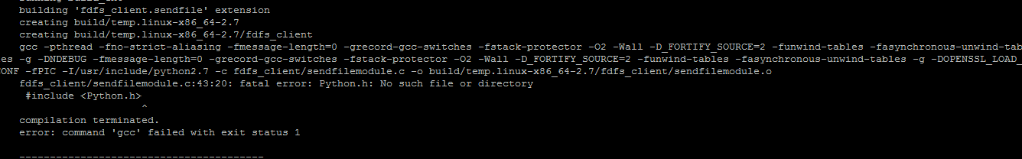

一种是真的没有Python.h这个文件，一种是Python的版本不对，

可以进入/usr/include/文件夹下的Python2.x文件夹里查找是否有Python.h这个文件。

如果是第一种情况，那么需要安装Python-dev这个包

## 配置软件源

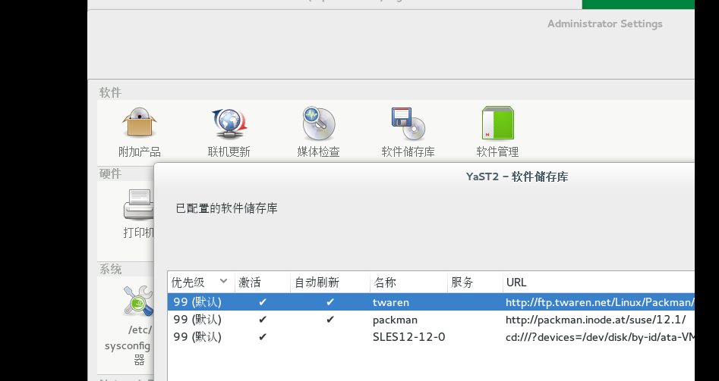

163最新的源地址

http://mirrors.163.com/openSUSE/distribution/openSUSE-stable/repo/oss/

## python-devel

zypper in python-devel

## python-tk

zypper in python-tk

# Step0.2 版本和相关网站

* 版本信息

FastDFS_v5.08.tar

fastdfs-nginx-module_v1.16.tar

libfastcommon-master 2016/11/14

pcre-8.39.tar

zlib-1.2.8.tar

nginx-1.6.3.tar

openssl-1.0.1u.tar

* Fastdfs&libfastcommon

<https://github.com/happyfish100/fastdfs>

<http://bbs.chinaunix.net/forum-240-1.html>

* python client

https://github.com/hay86

* Nginx

<http://nginx.org/en/download.html>

<https://www.openssl.org/source/>

参考

http://blog.csdn.net/hiyun9/article/details/51602428

# Step1 libfastcommon

以前的4.x版本依赖libevent,现在不需要了,只需要libfastcommon

./make.sh

./make.sh install

确认make没有错误后，执行安装，64位系统默认会复制到/usr/lib64下。

这时候需要设置环境变量或者创建软链接

export LD_LIBRARY_PATH=/usr/lib64/

ln -s /usr/lib64/libfastcommon.so /usr/local/lib/libfastcommon.so

# Step2 FastDFS Server

## 安装

tar vxzf  FastDFS_v5.08.tar.gz

cd FastDFS/

./make.sh

./make.sh install

## 确认

确认make没有错误后，执行安装，默认会安装到/usr/bin中，并在/etc/fdfs中添加三个配置文件。

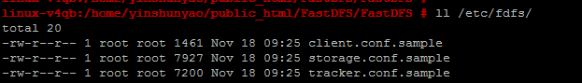

## 缺失libfastcommon

会报错如下：

./make.sh

cc -Wall -D_FILE_OFFSET_BITS=64 -D_GNU_SOURCE -g -O -DDEBUG_FLAG -c -o ../common/fdfs_global.o ../common/fdfs_global.c -I../common -I/usr/include/fastcommon

../common/fdfs_global.c:20:20: fatal error: logger.h: No such file or directory

#include "logger.h"

^

compilation terminated.

Makefile:25: recipe for target '../common/fdfs_global.o' failed

make: *** [../common/fdfs_global.o] Error 1

# Step3 Nginx

## 准备

### 建立用户组

groupadd www

#groupadd: group 'www' already exists 如果www已经存在，则会创建

useradd -g www www

### PCRE & Zlib & openssl

Openssl建议不安装，安装Nginx时with，避免与原来版本冲突

./configure

make

make intall

### suse 修改fastdfs module的config中include路径

修改/root/fastdfs-nginx-module/src/config文件，把其中的/local去掉。

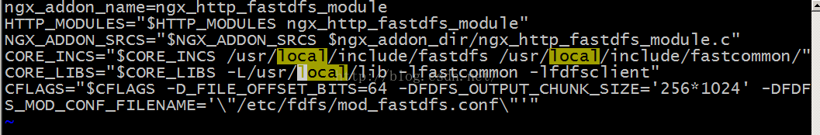

## 安装

红色部分路径需要根据实际情况修改

./configure --user=www --group=www --add-module=**/home/yinshunyao/download/FastDFS**/fastdfs-nginx-module/src --prefix=/usr/local/nginx  --with-http_stub_status_module --with-http_ssl_module --with-openssl=/home/yinshunyao/download/FastDFS/openssl-1.0.1u

./configure --user=www --group=www --add-module=/home/fast/public_html/fastdfs-nginx-module/src --prefix=/usr/local/nginx  --with-http_stub_status_module --with-http_ssl_module --with-openssl=/home/fast/public_html/openssl-1.0.1u

./configure --user=www --group=www --add-module=/home/yinshunyao/public_html/FastDFS/fastdfs-nginx-module/src --prefix=/usr/local/nginx  --with-http_stub_status_module --with-http_ssl_module --with-openssl=/home/yinshunyao/public_html/FastDFS/openssl-1.0.1u

make

make install

## 问题

### PCRE缺失

./configure: error: the HTTP rewrite module requires the PCRE library.

You can either disable the module by using --without-http_rewrite_module

option, or install the PCRE library into the system, or build the PCRE library

statically from the source with nginx by using --with-pcre=<path> option.

安装PCRE

### Openssl版本不匹配

cc1: all warnings being treated as errors

objs/Makefile:765: recipe for target 'objs/src/event/ngx_event_openssl.o' failed

make[1]: *** [objs/src/event/ngx_event_openssl.o] Error 1

make[1]: Leaving directory '/home/yinshunyao/download/FastDFS/nginx-1.8.1'

Makefile:8: recipe for target 'build' failed

make: *** [build] Error 2

* 尝试1（未解决）

Openssl源码链接

./configure --user=www --group=www --add-module=/home/yinshunyao/download/FastDFS/fastdfs-nginx-module/src --prefix=/usr/local/nginx  --with-http_stub_status_module --with-http_ssl_module --with-openssl=/home/yinshunyao/download/FastDFS/openssl-1.1.0c

* 更换较老版本（解决）

./configure --user=www --group=www --add-module=/home/yinshunyao/download/FastDFS/fastdfs-nginx-module/src --prefix=/usr/local/nginx  --with-http_stub_status_module --with-http_ssl_module --with-openssl=/home/yinshunyao/download/FastDFS/openssl-1.0.1u

### ngx_http_fastdfs_module.o ERROR

/home/yinshunyao/download/FastDFS/fastdfs-nginx-module/src/common.c:21:25: fatal error: fdfs_define.h: No such file or directory

#include "fdfs_define.h"

compilation terminated.

objs/Makefile:1139: recipe for target 'objs/addon/src/ngx_http_fastdfs_module.o' failed

make[1]: *** [objs/addon/src/ngx_http_fastdfs_module.o] Error 1

make[1]: Leaving directory '/home/yinshunyao/download/FastDFS/nginx-1.8.1'

Makefile:8: recipe for target 'build' failed

make: *** [build] Error 2

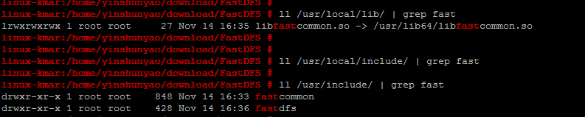

* 修改module的config中include路径（解决）

修改/root/fastdfs-nginx-module/src/config文件，把其中的local去掉。



# Step4 配置启动

**存储路径不要配置到用户目录下，可能没有权限**

## 准备配置文件

* 修改配置文件名称

首先将三个文件的名字去掉sample.

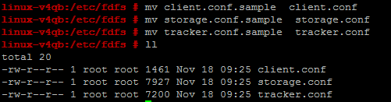

* 复制fastDFS 额外配置文件

cp /home/yinshunyao/public_html/FastDFS/fastdfs-nginx-module/src/mod_fastdfs.conf ./

cp /home/yinshunyao/public_html/FastDFS/FastDFS/conf/http.conf ./

cp /home/yinshunyao/public_html/FastDFS/FastDFS/conf/mime.types ./

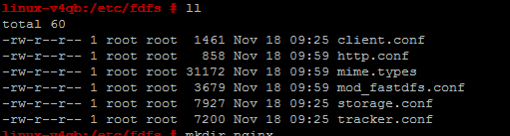

* 复制nginx配置文件

mkdir nginx

cp /home/yinshunyao/public_html/FastDFS/nginx-1.6.3/conf/nginx.conf ./nginx/

cp /home/yinshunyao/public_html/FastDFS/nginx-1.6.3/conf/mime.types ./nginx/

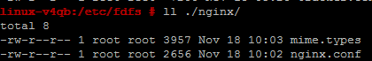

## 配置tracker和storage

暂时只修改以下几点，先让fastdfs跑起来，其余参数调优的时候再考虑。

* tracker.conf 中修改

base_path=/home/fastdfs

* storage.conf 中修改

base_path=/home/ fastdfs

tracker_server=192.168.29.132:22122 #指定tracker服务器地址。

* client.conf 中同样要修改

base_path=/ home /fastdfs #用于存放日志。

tracker_server=192.168.29.132:22122 #指定tracker服务器地址。

* 注意

配置tracker_server，如果给storage配置多个server，保证多个server都联通

不能配置127.0.0.1

TrackerServer IP配置为127.0.0.1启动时会报错

linux-kmar:/home/yinshunyao/fastdfs-storaged/logs # ll

total 4

-rw-r--r-- 1 root root 669 Nov 14 17:01 storaged.log

[2016-11-14 16:56:29] ERROR - file: storage_func.c, line: 1183, conf file "/etc/fdfs/storage.conf", tracker: "127.0.0.1:22122" is invalid, tracker server ip can't be 127.0.0.1

[2016-11-14 16:56:29] CRIT - exit abnormally!

[2016-11-14 16:57:43] ERROR - file: storage_func.c, line: 1183, conf file "/etc/fdfs/storage.conf", tracker: "127.0.0.1:22122" is invalid, tracker server ip can't be 127.0.0.1

[2016-11-14 16:57:43] CRIT - exit abnormally!

[2016-11-14 17:01:14] ERROR - file: storage_func.c, line: 1183, conf file "/etc/fdfs/storage.conf", tracker: "127.0.0.1:22122" is invalid, tracker server ip can't be 127.0.0.1

[2016-11-14 17:01:14] CRIT - exit abnormally!

## 配置nginx-module

cp /home/yinshunyao/download/FastDFS/fastdfs-nginx-module/src/mod_fastdfs.conf /etc/fdfs/

修改该配置文件

tracker_server=192.168.254.128:22122

group_name=group1

url_have_group_name = true #url中是否包含group1分组名称

base_path=/home/storage  
store_path0=/home/storage

## 创建数据存储文件夹

前面配置的日志和数据存储路径需要手工创建

linux-kmar:/home # mkdir fastdfs

## 启动tracker和storage

/usr/bin/fdfs_trackerd /etc/fdfs/tracker.conf

/usr/bin/fdfs_storaged /etc/fdfs/storage.conf

## Nginx配置

8888端口号与storage.conf中配置保持一致

 ln -s /home/yinshunyao/fastdfs-data/data  /home/yinshunyao/fastdfs-data/data/M00

server {

listen 8888;

server_name localhost 192.168.254.128 127.0.0.1;

#charset koi8-r;

#access_log logs/host.access.log main;

location /group1/M00{

root /home/yinshunyao/fastdfs-data/data;

ngx_fastdfs_module;

}

error_page 404 /404.html;

# redirect server error pages to the static page /50x.html

#

error_page 500 502 503 504 /50x.html;

location = /50x.html {

## Nginx启动

/usr/local/nginx/sbin/nginx -c /etc/fdfs/nginx/nginx.conf

/usr/local/nginx/sbin/nginx -c /etc/nginx/nginx.conf

## 防火墙配置

或者界面上配置

vim /etc/sysconfig/SuSEfirewall2

FW_SERVICES_EXT_TCP="8080 8888"

rcSuEfirewall2 restart

# Step5上传测试

## 自带客户端上传

fdfs_test /etc/fdfs/client.conf upload test.txt

http://192.168.254.132:8080/group1/M00/00/00/wKj-hFguZReAXdKGAAAAFvTCyuE971.txt

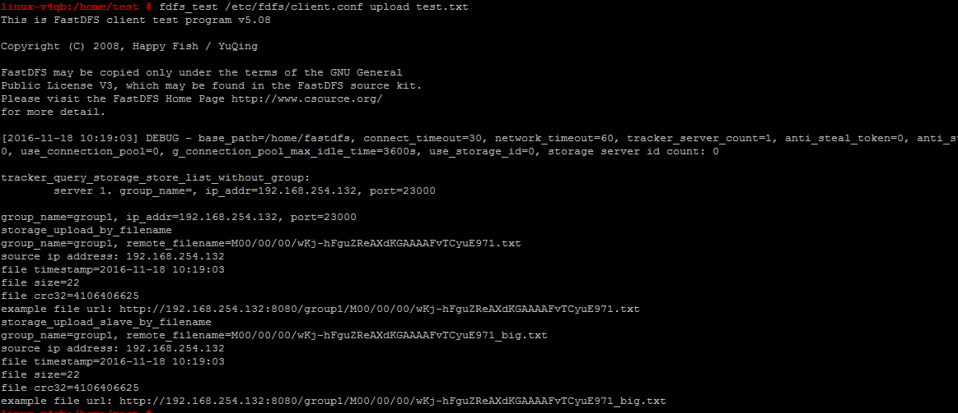

## 网页浏览

注意上面生成的链接8080是Client.conf中配置的，不是真实有效的，8888端口是nginx中配置的端口号，实际访问需要采用这个端口号；这个端口与storage中的端口号保持一致

<http://192.168.254.132:8888/group1/M00/00/00/wKj-hFguZReAXdKGAAAAFvTCyuE971.txt>

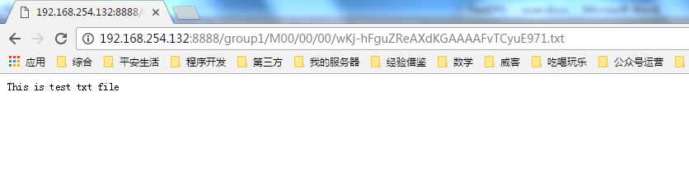

## Python上传

* Python代码

*# -*- coding: utf8 -*-  
"""  
File: fdfs_upload_test.py  
Brief: fastDFS文件系统上传测试  
  
Author: yinshunyao  
Date: 2016/11/17  
"""***from** fdfs_client.client **import** *  
client = Fdfs_client(**'/etc/fdfs/client.conf'**)  
ret = client.upload_by_filename(**'test.txt'**)  
**print** ret

* 上传执行

python fdfs_upload_test.py

{'Status': 'Upload successed.', 'Storage IP': '192.168.254.132', 'Remote file_id': 'group1/M00/00/00/wKj-hFguZwqAFogmAAAALQsVaWA629.txt', 'Group name': 'group1', 'Local file name': 'test.txt', 'Uploaded size': '45B'}

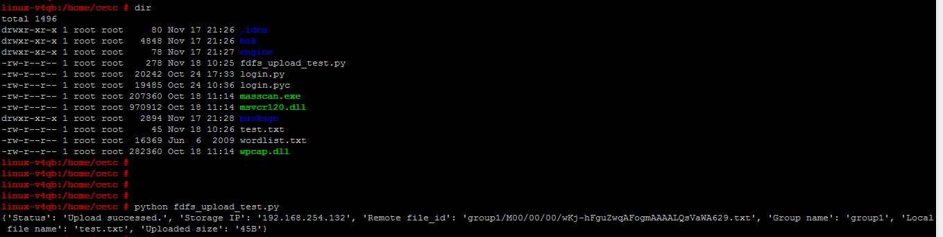

* 访问链接

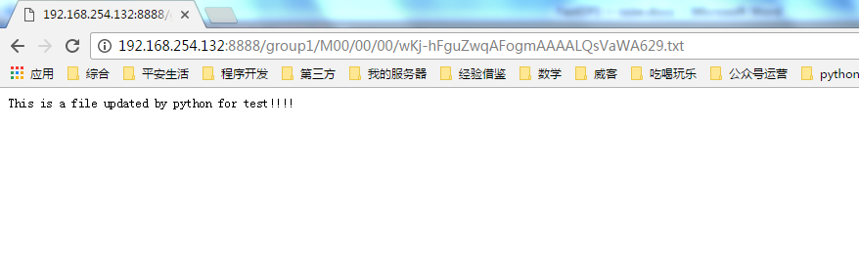

## http访问异常

[2016-11-15 17:12:26] ERROR - file: ../common/fdfs_global.c, line: 52, the format of filename "group1/M00/00/00/wKj-gFgq0VOAdKcdAAAAEqOM6iI6443848" is invalid



vi /etc/fdfs/mod_fastdfs.conf

url_have_group_name = true

# StepX 重启

/usr/bin/restart.sh /usr/bin/fdfs_trackerd /etc/fdfs/tracker.conf

/usr/bin/restart.sh /usr/bin/fdfs_storaged /etc/fdfs/storage.conf

/usr/bin/restart.sh /usr/local/nginx/sbin/nginx -c /etc/fdfs/nginx/nginx.conf