Set 6 – 264033, XDucer 106

Pre-deployment – DockCalMay2018.xml (Dock512__24May18-Phase0-D20180525-T111828-0.raw)

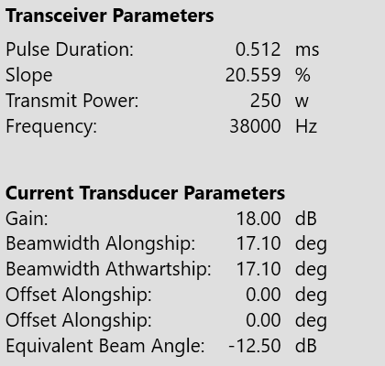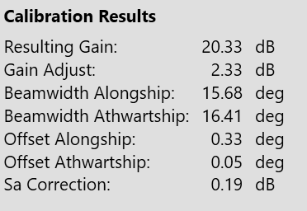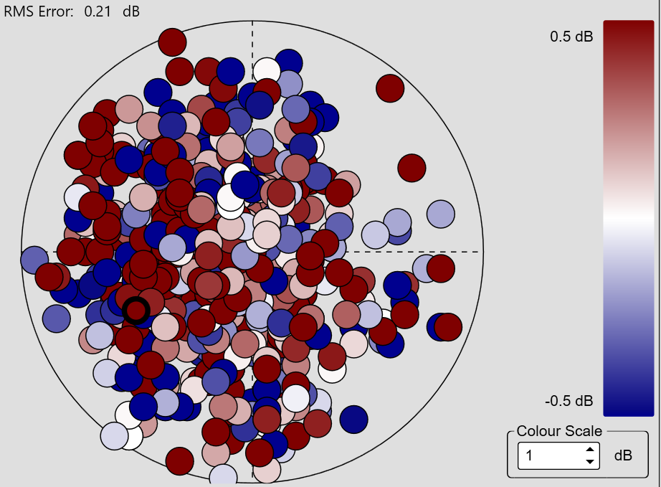

Pre-deployment2 – DockCalMay2018-2 (Hayes_29May18-Phase0-D20180530-T131822-0.raw, Hayes_29May18-Phase0-D20180530-T135040-0.raw)

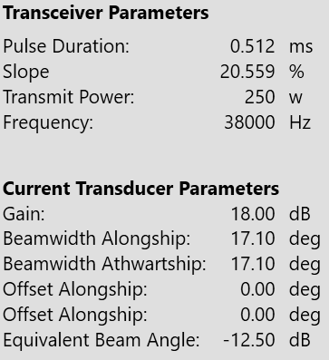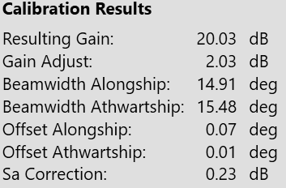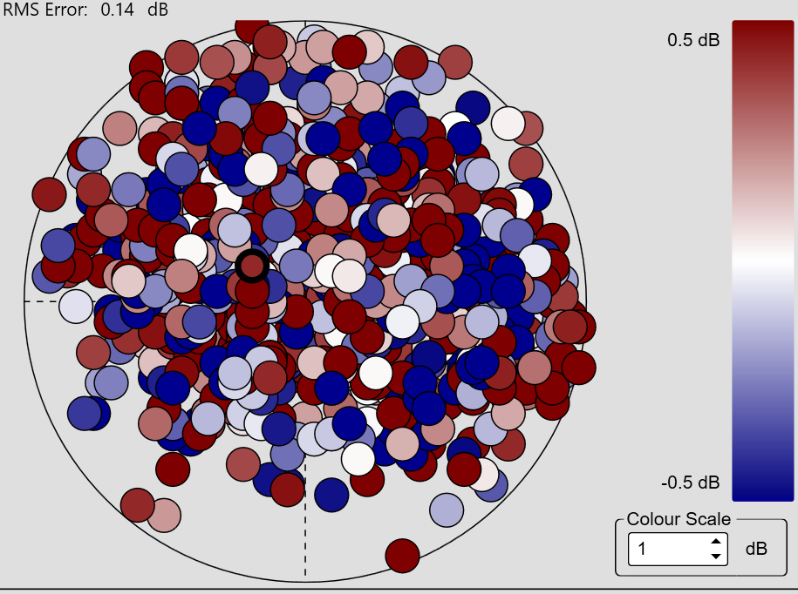

Post-deployment – DockCalOct2018.xml (SD2018_Chukchi_v2-Phase0-D20181024-T162118-0.raw)

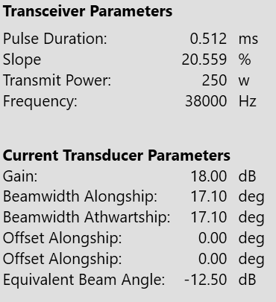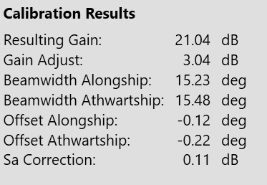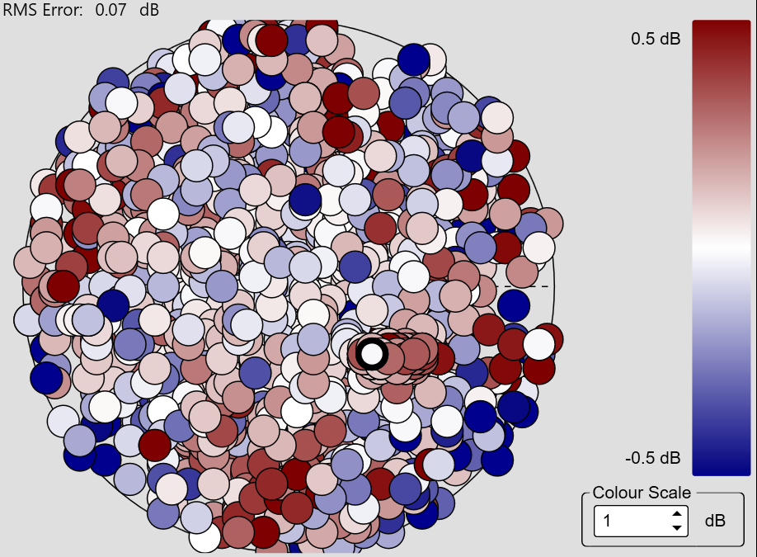

Set 7 – 264037, XDucer 107

Pre-deployment – DockCalMay2018.xml (DockTest_25May18-Phase0-D20150525-T120346-0.raw)

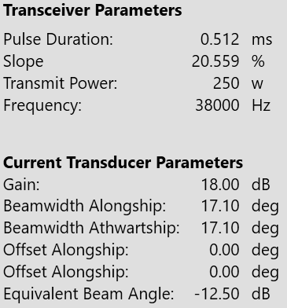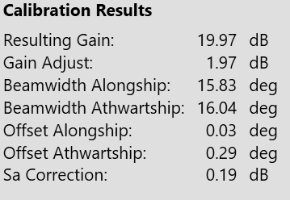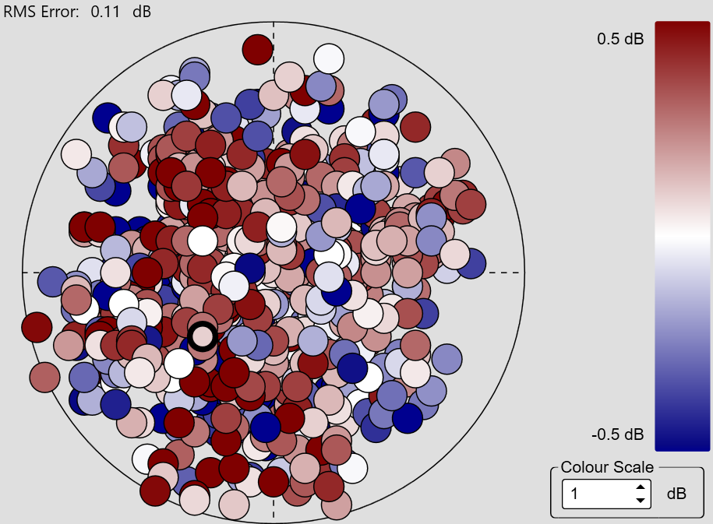

Pre-deployment – DockCalMay2018-2.xml (Hayes_29May18-Phase0-D20180530-T144415-0.raw, Hayes_29May18-Phase0-D20180530-T152501-0.raw)

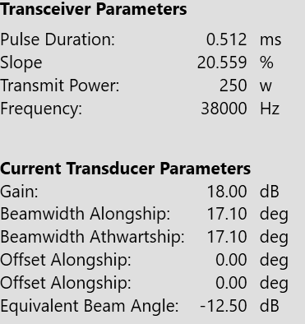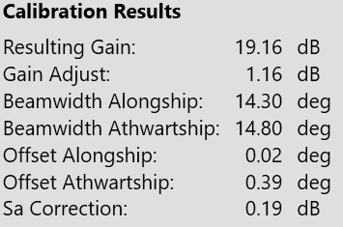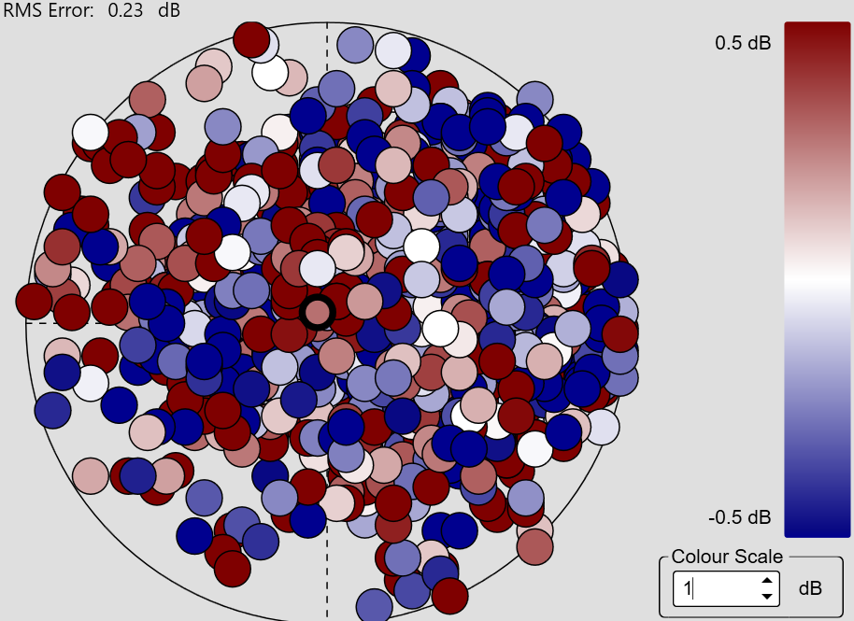

Post-deployment – DockCalOct2018.xml (SD2018_Chukchi_v2-Phase0-D20181024-T151327-0.raw)

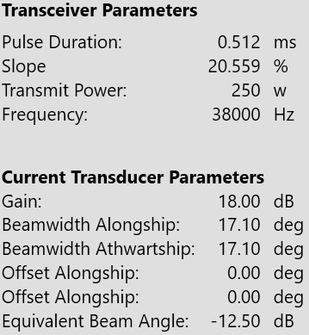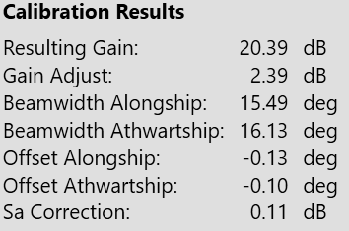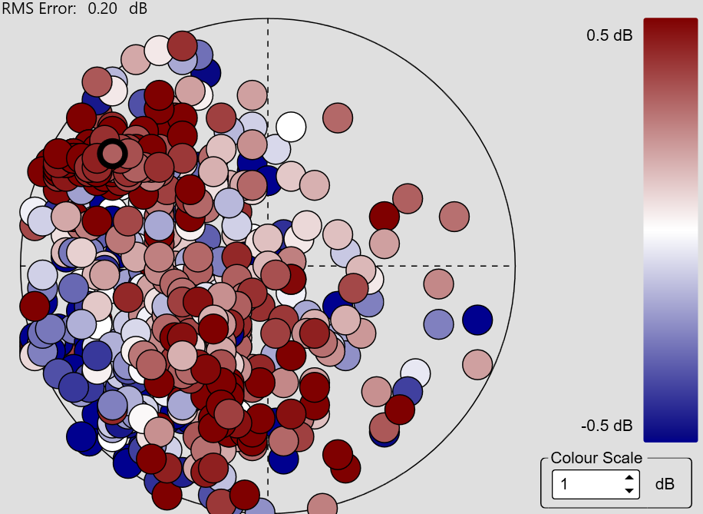

10/26/18 Copper Sphere Cals Post-Deployment

Set 6 – 264033, XDucer 106

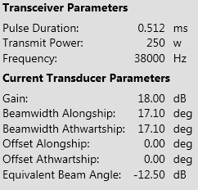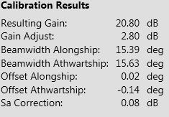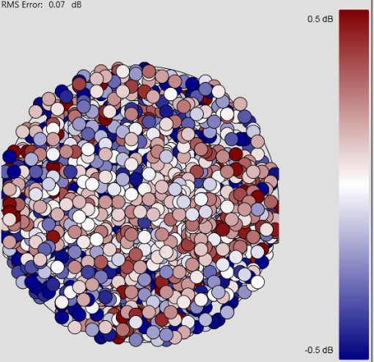

Set 7 – 264037, XDucer 107

