AFRICAN LEADERSHIP UNIVERSITY
School of Software Engineering

ALU Graduate Entrepreneurship and Funding Platform
Research Proposal
A full stack application for graduate venture verification
and investor and funding opportunity connections

BSc. in Software Engineering
Levis Ishimwe
i.levis@alustudent.com
Supervisor David Neza Tuyishimire
September 2026

Table of Contents
CHAPTER ONE INTRODUCTION 6
1.1 Background to the Study 6
1.2 Statement of the Problem 6
1.3 Aim and Objectives of the Study 7
1.3.1 Specific Objectives 7
1.4 Research Questions 8
1.5 Project Scope 8
1.6 Significance and Justification 9
1.7 Research Budget 9
1.8 Research Timeline 10
1.9 Definition of Terms 11
CHAPTER TWO LITERATURE REVIEW 12
2.1 Introduction 12
2.2 Conceptual Review 12
2.3 Historical Background of the Research Topic 13
2.3.1 Origins and Early Context 13
2.3.2 Key Milestones 13
2.3.3 Historical Gaps and Transition to the Current Study 13
2.4 Theoretical Review 13
2.4.1 Foundational Theories and Framework 13
2.5 Overview of Existing Systems 14
2.5.1 Strengths and Weaknesses of Existing Systems 14
2.6 Review of Related Works 15
2.6.1 Summary of Reviewed Literature 15
2.7 General Comments 16
CHAPTER THREE SYSTEM ANALYSIS AND DESIGN 17
3.1 Introduction 17
3.2 Research Design and Development Method 17
3.2.1 Participants and Sampling Strategy 17
3.2.2 Data Collection and Analysis 17
3.2.3 Agile Development and Research Ethics 18
3.2.4 Metrics for Evaluation 19
3.3 System Analysis 20
3.3.1 Functional Requirements of the System 20
3.3.2 Nonfunctional Requirements of the System 24
3.3.3 Proposed System Model 25
3.4 System Design 25
3.4.1 Full Stack Architecture 27
3.4.2 Database Design 28
3.4.3 Use Case Diagram 30
3.4.4 Class Diagram 31
3.4.5 Graduate and Project Workflow 32
3.4.6 Opportunity Selection Workflow 33
3.4.7 Introduction Sequence Diagram 34
3.5 Development Tools 35
3.6 Future Work and Recommendations 36
References 37

List of Tables
Table 1 Estimated research budget 9
Table 2 Comparison of relevant software platforms 14
Table 3 Literature synthesis and design implications 15
Table 4 Evaluation measures and proposed targets 19
Table 5 Development tools and intended use 35

List of Figures
Figure 1 Research and development timeline 10
Figure 2 Full stack system architecture 27
Figure 3 Entity relationships for identity and project evidence 28
Figure 4 Entity relationships for opportunities and introductions 29
Figure 5 Actor responsibilities and system use cases 30
Figure 6 Backend service classes and dependencies 31
Figure 7 Graduate registration and project review workflow 32
Figure 8 Opportunity eligibility and institutional selection 33
Figure 9 Investor introduction with graduate consent 34

List of Acronyms and Abbreviations
ALU African Leadership University
API Application Programming Interface
CSRF Cross Site Request Forgery
ERD Entity Relationship Diagram
FK Foreign Key
HTTPS Hypertext Transfer Protocol Secure
OCR Optical Character Recognition
OTP One Time Password
PK Primary Key
PWA Progressive Web Application
RDB Rwanda Development Board
RRA Rwanda Revenue Authority
REST Representational State Transfer
SDLC Software Development Life Cycle
SMTP Simple Mail Transfer Protocol
SQL Structured Query Language
TLS Transport Layer Security
UML Unified Modeling Language
UQ Unique Constraint

CHAPTER ONE INTRODUCTION

1.1 Background to the Study
ALU graduate entrepreneurs in Kigali need a reliable way to present their ventures, establish their connection to those ventures, and reach investors and funding competitions. The wider market already uses digital venture directories: VC4A reports more than 29,000 venture profiles on its platform (VC4A, n.d.). This shows that online discovery is established, but the size of a directory does not explain whether a particular university can verify its graduates and manage their applications consistently.
Preliminary stakeholder discussions recorded by the researcher with Mushrafat Abdul-Rahman and Benita Mulungi identified a more specific concern: names on some company registration documents did not match the individuals pitching the ventures. Such a discrepancy requires clarification; it does not by itself establish fraud, because a presenter may be an authorised representative. The stakeholders expressed support for promoting a dedicated platform to ALU graduate entrepreneurs. These discussions provide an initial requirements basis, while the planned needs assessment will establish how often the problem occurs and how it is currently handled.
Email, personal referrals and general venture platforms can support introductions, but they do not automatically provide the particular review and selection process described by these stakeholders. This project therefore proposes a full-stack Progressive Web Application (PWA) combining verified graduate accounts, reviewed venture records, consent-based investor introductions and managed opportunities. A PWA can provide an installable browser experience, although installation and offline capabilities must be deliberately implemented (Mozilla, n.d.). All graduate services will be free.

1.2 Statement of the Problem
First, ALU needs a consistent way to distinguish a verified graduate account from a substantiated claim to represent a business. The preliminary stakeholder feedback describes mismatches between presenters and registration records. This reflects the broader problem of information asymmetry: one party may possess information that another cannot readily assess (Akerlof, 1970). An alumni email, uploaded certificate or matching name alone cannot resolve that problem. A documented review process is needed to examine degree evidence, company information and the applicant’s authority to represent the venture.
Second, graduate projects and funding applications need a shared record through which authorised staff can check eligibility and make traceable decisions. Existing platforms demonstrate that venture directories and programme applications are technically feasible (Gust, n.d.; VC4A, n.d.), but their public descriptions do not establish the ALU-specific combination of alumni checks, representation review and delegated selection required here. Without that workflow, staff must repeatedly assemble evidence from separate submissions, while graduates have limited visibility into their application status.
Third, investor interest needs a clear path from a reviewed project to a consensual, recorded introduction. Research on venture capital decision-making highlights the importance of team information and the sourcing process, but does not establish that institutional affiliation guarantees investment (Gompers et al., 2020). This work introduces a solution containing graduate and investor review, project and document management, an introduction workflow, opportunity eligibility checks, an ALU selection dashboard and automatic notifications. It will evaluate whether these functions improve review efficiency, traceability and relevant connections during a small pilot.

1.3 Aim and Objectives of the Study
The aim is to design, develop and evaluate a free-to-use PWA that helps ALU verify graduate venture submissions, organise funding opportunities and facilitate investor introductions within a Kigali-based pilot by 30 November 2026.

1.3.1 Specific Objectives
1. By 30 September 2026, review relevant research and software systems and collect requirements from at least 20 ALU graduates, five potential investors or sponsors, and two institutional stakeholders, producing a prioritised requirements list and a baseline description of the current workflow.
2. By 15 November 2026, implement and test a full-stack PWA covering alumni email confirmation, graduate and investor approval, project and evidence review, investor introductions, opportunities, selection notifications and role-based dashboards, with all critical acceptance scenarios passing before the pilot.
3. Between 16 and 27 November 2026, pilot the system with a target of 30 graduates and five investors or sponsors, with administrator and ALU authority participation; measure review time, eligibility accuracy, completed introductions, confirmed follow-up and usability, and report the results by 30 November 2026.

1.4 Research Questions
1. What verification, venture discovery and opportunity-management difficulties do ALU graduates, investors and institutional stakeholders experience in the current process?
2. How can a full-stack PWA implement the required verification, introduction and opportunity workflows with clear role boundaries and traceable decisions?
3. What changes in review time, decision completeness and investor connection outcomes are observed during the pilot, and how usable do participants find the system?

1.5 Project Scope
The research will focus on ALU graduates from the 2022–2026 cohorts who are based in Kigali and have a business idea or an active venture. The pilot target is 30 graduates and five investors or sponsors, rather than a country-wide rollout. Investors may participate remotely. The needs-assessment and pilot samples may overlap. Recruitment targets are planning assumptions; actual participation and any shortfall will be reported.
The system will support four authenticated roles: graduate, investor or sponsor, platform administrator and designated ALU authority. Levis Ishimwe will operate the administrator workflow during the pilot. Mushrafat Abdul-Rahman and Benita Mulungi are identified as ALU staff stakeholders who support student venture development and pitching. Subject to institutional confirmation and controlled staff accounts, they will help communicate the platform to graduates and investors, provide relevant graduate funding and hackathon opportunities for publication, and perform the institutional shortlisting or selection work that falls within their existing responsibilities. Public visitors will see only approved summaries whose owners have consented to publication.
Registration, project listing and all core platform features will be free for graduates, investors or sponsors, administrators and ALU authorities within this capstone. The system will not collect payment information, charge fees, process transactions or integrate a payment gateway. The investor interface may display a Billing / Premium Plans option solely as a non-functional prototype placeholder; selecting it will show “Coming Soon.” It demonstrates a possible future direction for tiered investor or sponsor subscriptions and is not part of the current implementation or evaluation.
The technical scope includes a React and Tailwind frontend, a Node.js/Express API, Aiven for MySQL, private document storage and email notifications. Company submissions require RDB registration evidence and evidence of the presenter’s relationship to the company when needed; idea-stage projects use a declaration and do not require an RDB certificate. Each submitted project receives a unique public verification code, and approved public profiles can be retrieved directly through a Verify a Project search. Rule-based sector suggestions and fuzzy similarity checks assist graduates and administrators, while the graduate confirms the sector and an administrator resolves flagged similarities. Tesseract.js-assisted document extraction, rule-based pattern checks and fuzzy name comparison likewise support administrative review; the platform assigns a preliminary “Likely Valid” or “Suspicious” flag, but an administrator always makes the final decision. Direct integration with an RDB or other government API, automated legal authentication, payment processing, custom machine-learning training, native mobile applications, video calls and guaranteed funding outcomes are excluded. Internet access is required for account, upload and decision actions; offline support is limited to the app shell and suitable public content.

1.6 Significance and Justification
For graduates, the platform would provide a free, organised place to present ventures and follow applications. Clear review feedback would help legitimate applicants correct missing evidence without treating every discrepancy as misconduct.
For investors and sponsors, reviewed profiles and consensual introductions would make relevant ventures easier to discover. Review status would describe checks performed without promising investment quality or eliminating due diligence.
For ALU, a common record of submissions and decisions would support coordination and accountability. The proposed staff workflow would allow authorised entrepreneurship-support staff to supply opportunities, review eligible applications and record institutional selection decisions, while the administrator manages publication and platform operations. The capstone would also provide evidence about whether this workflow is useful enough to justify continued operation.

1.7 Research Budget
Table 1 presents a planning ceiling in Rwandan francs. Existing equipment, campus connectivity and open-source software will be used where available. Hosting and email amounts are contingency allowances rather than supplier quotations; paid services will be used only if existing resources cannot support the pilot. Graduates will not fund these costs.
Table 1 Estimated research budget
Item | Basis | RWF
Internet and mobile data | 15,000 × 4 months | 60,000
Participant travel and local logistics | Needs assessment and pilot allowance | 30,000
Hosting, storage and email reserve | Only if existing resources are insufficient | 40,000
Printing and materials | Consent or test materials when needed | 5,000
Contingency | 10% of RWF 135,000 | 13,500
Total planning ceiling |  | 148,500

1.8 Research Timeline
Figure 1 covers September to 30 November 2026. Requirements and literature work precede the main implementation sprints. A two-week pilot follows acceptance testing, leaving time for analysis and final reporting by 30 November 2026. The research proposal is scheduled for submission on 18 September 2026, as stated in the assignment instructions.
Figure 1 Research and development timeline
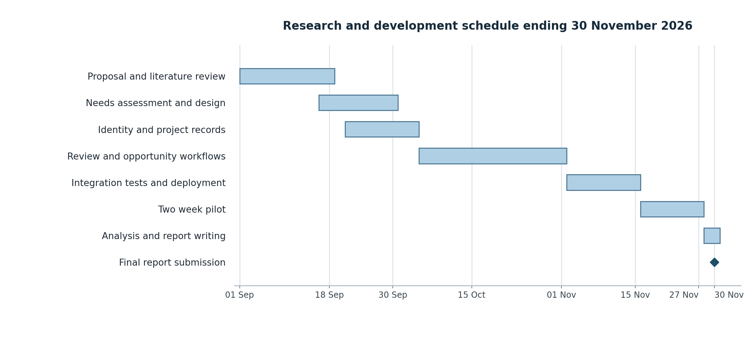
Source: Author’s proposed schedule (2026). Shaded cells indicate planned activity.

1.9 Definition of Terms
Verified graduate. An account with confirmed alumni email and administrator-reviewed graduation evidence.
Representation review. A documented assessment of an applicant’s evidence of their relationship or authority to represent a venture.
Project verification code. A unique, system-generated public identifier that retrieves an approved project profile on the platform. It confirms the existence of a platform record, not legal registration, investment quality or ALU endorsement.
Similarity Flagged. A temporary project status applied when a configurable fuzzy-matching threshold identifies material similarity with an approved project; the status remains until the graduate clarifies the distinction and an administrator reviews it.
Approved project. A submission accepted for publication after administrative review, without a legal or investment guarantee.
Introduction. A connection between an approved investor and a graduate who consents to share contact details.
Opportunity. A hackathon, grant call or competition with defined entry criteria and a deadline.
Fuzzy string matching. A similarity comparison that tolerates small differences in spelling, spacing or formatting instead of requiring two names to be identical.

CHAPTER TWO LITERATURE REVIEW

2.1 Introduction
This targeted review examines software-enabled venture discovery, document-assisted review and digital programme administration. Sources were identified through title and keyword web searches and checked against publisher or university records, official product pages and technical documentation. Search terms included ‘digital entrepreneurial ecosystems’, ‘venture capital decision-making’, ‘startup platform applications’, ‘PWA’ and ‘document OCR’. The review draws on 12 sources: five scholarly works and seven official product, technical or institutional sources. Selection prioritised relevance to the proposed workflow, traceability and explicit limitations. It is a focused proposal review, not an exhaustive systematic review or a claim to have searched every indexed database.

2.2 Conceptual Review
A digital entrepreneurial ecosystem combines participants, relationships and digital infrastructure that support venture creation and development. Bejjani et al. (2023) synthesise a dispersed body of research on this concept. For this capstone, the relevant participants are graduates, capital providers and ALU staff; the software supports their interactions rather than replacing the judgement and relationships on which the ecosystem depends.
Verification has several distinct meanings in this system. Email confirmation establishes control of an official ALU alumni inbox; degree review supports an institutional affiliation claim; and company-document review supports a claimed relationship to a venture. Optical character recognition (OCR) extracts words from images so that the system can locate issuer phrases, registration numbers, dates and names. Tesseract.js provides the extraction capability, while fuzzy string matching tolerates minor spelling or formatting differences when comparing the company or director name with the graduate profile name. These checks only produce “Likely Valid” or “Suspicious” review flags; they do not authenticate the issuing organisation, prove that a document is genuine or replace the administrator’s final decision (Naptha, n.d.).
The intervention consists of structured profiles, recorded reviews, transparent eligibility rules and consent-based introductions. The intended outcomes are shorter review time, more complete decision records and useful investor follow-up. Adoption, investor availability and the quality of submitted evidence may influence those outcomes. Consequently, the evaluation will measure workflow performance and user experience rather than attributing venture funding directly to the software.

2.3 Historical Background of the Research Topic

2.3.1 Origins and Early Context
Entrepreneurial introductions have traditionally depended on professional relationships and manual information exchange. Gompers et al. (2020) study how venture capitalists source, assess and manage investments, providing a basis for treating discovery and evaluation as related but separate activities. A digital directory can broaden visibility, while the assessment of a venture still requires contextual information and human judgement.

2.3.2 Key Milestones
Research moved beyond descriptions of networking to experiments on how information affects investor attention. Bernstein et al. (2017) examine early-stage investor responses through a randomised field experiment. More recent work synthesises digital entrepreneurial ecosystems as a broader research area (Bejjani et al., 2023). In practice, platforms such as Gust and VC4A now combine profiles with funding or programme workflows, showing that the basic platform pattern already exists.

2.3.3 Historical Gaps and Transition to the Current Study
The remaining question is local implementation: how should ALU combine graduate confirmation, representation checks, project publication and institutional selection in one manageable workflow? The proposed contribution is the design and evaluation of that combination. It does not depend on claiming that startup directories, investor introductions or application management are new inventions.

2.4 Theoretical Review

2.4.1 Foundational Theories and Framework
Information asymmetry provides the main explanatory lens. Akerlof (1970) shows how uncertainty about quality can undermine exchange. Applied cautiously here, better documented evidence may help reviewers and investors assess claims more consistently. The theory does not imply that every discrepancy is fraudulent or that the software can certify legal ownership.
Design Science Research provides the research framework: an information-system artefact is designed to address a practical problem and is evaluated for utility (Hevner et al., 2004). The project will move from stakeholder requirements to implementation, demonstration and pilot evaluation. The proposed relationship is that clearer evidence and traceable processes support more reliable decisions and easier introductions. This will be examined through review-time comparisons, decision audits and connection outcomes.

2.5 Overview of Existing Systems
Gust and VC4A are selected because both are operational software platforms with venture profiles and workflows relevant to this project. Their official descriptions provide evidence of advertised functionality; they do not independently prove effectiveness. Table 2 separates documented capabilities from the ALU-specific requirements that remain to be evaluated.

2.5.1 Strengths and Weaknesses of Existing Systems
Table 2 Comparison of relevant software platforms
System | Documented strengths | Fit limitation for this study
Gust | Company profiles, investor discovery and accelerator application management. | Public descriptions do not establish ALU degree checks or the proposed local approval and selection roles.
VC4A | Venture profiles, programme applications and investor connections with an African ecosystem focus. | ALU-specific identity, representation review and delegated competition decisions are not established by the reviewed public pages.

The comparison identifies a contextual fit gap, not proof that these systems lack configurable review tools. A broader platform may provide greater investor reach, while a smaller ALU platform may better control local verification and decision responsibilities. The capstone must therefore test whether those local benefits justify the additional administration and recruitment effort.

2.6 Review of Related Works
Gompers et al. (2020) surveyed 885 institutional venture capitalists at 681 firms and emphasise management-team information. This supports clear team profiles, but does not establish that university affiliation is the strongest predictor of investment. The population differs from the ALU pilot, so the findings cannot determine its expected effect size.
Bernstein et al. (2017) used a randomised field experiment to examine investor responses to startup information. It motivates measuring engagement beyond profile creation. Because the setting differs from this university pilot, the platform will record accepted introductions and confirmed follow-up without assuming an equivalent effect.
Bejjani et al. (2023) synthesise research on digital entrepreneurial ecosystems, supporting attention to the surrounding actors and resources. This motivates including graduates, investors and staff in requirements collection. The review does not validate a certificate-checking mechanism or specify ALU’s approval responsibilities.

2.6.1 Summary of Reviewed Literature
Table 3 Literature synthesis and design implications
Source | Evidence and implication | Limit relevant to this study
Gompers et al. (2020) | Investor survey; motivates clear team and venture records. | Different market and population; no ALU-specific effect estimate.
Bernstein et al. (2017) | Field experiment; motivates measuring actual investor engagement. | Investor attention is not equivalent to funding or document authenticity.
Bejjani et al. (2023) | Research synthesis; motivates evaluating the surrounding participants and processes. | Does not specify a validated institutional verification workflow.
Hevner et al. (2004) | Design Science Research; guides artefact creation and evaluation. | Provides a method, not evidence that this artefact will succeed.

2.7 General Comments
The review supports structured records and traceable decisions but leaves ALU’s local workflow untested. This project evaluates whether the combined process reduces review effort and improves useful connections, with free graduate participation.

CHAPTER THREE SYSTEM ANALYSIS AND DESIGN

3.1 Introduction
The project will use Design Science Research with mixed-methods evidence and iterative full-stack development. Quantitative measures will capture workflow time and connection outcomes; interviews and observation will explain usability difficulties. The design uses a modular web application and relational data model. OCR is a supporting extraction tool, so model training datasets and machine-learning baseline sections are not applicable.

3.2 Research Design and Development Method

3.2.1 Participants and Sampling Strategy
Purposive sampling will recruit graduates with an idea or active venture, investors or sponsors interested in early-stage enterprises, and staff familiar with ALU entrepreneurship opportunities. ALU communication channels, staff-led email communication and Google Meet sessions may be used following institutional agreement. The needs assessment targets 20 graduates, five investors or sponsors and two institutional stakeholders. Mushrafat Abdul-Rahman and Benita Mulungi are the proposed ALU staff stakeholders because their work relates to student project development, venture pitching and opportunity coordination. The pilot targets 30 graduates and five investors or sponsors, alongside the researcher as administrator and at least one designated ALU authority.
Graduates must be from the stated cohorts, based in Kigali, able to use their ALU alumni email and willing to provide informed consent. Recruitment will seek variation in venture sector, stage and participant gender rather than a statistically representative sample. Participants may join both phases. Non-participation will not affect eligibility for university support; actual sample sizes and any missing responses will be reported.

3.2.2 Data Collection and Analysis
The needs assessment will use a short questionnaire covering current discovery channels, verification difficulties and response times, followed by semi-structured interviews with approximately six graduates, three investors and the two stakeholders. Interview prompts will ask participants to describe a recent submission, explain how evidence was checked and identify where follow-up became difficult. An agreed checklist will turn those findings into acceptance scenarios.
For the baseline comparison, the administrator and authority will review the same set of ten de-identified or synthetic cases using the current document-and-email approach and the platform. Task order will be counterbalanced where feasible. Cases will include an idea-stage project, complete company evidence, a name discrepancy, missing authorisation, unreadable evidence and an ineligible application. Median completion time and decision completeness will be compared. The exercise measures review-process performance, not the legal authenticity of real certificates.
During the pilot, timestamped records will capture submissions, decisions, introduction requests, graduate acceptance and confirmed follow-up. A five-point satisfaction questionnaire and short exit interviews will collect user feedback. Analysis will use counts, proportions, medians and recurring interview themes. Baseline and pilot figures will be reported separately, with denominators and missing data stated. A small purposive sample and the absence of a randomised control group limit causal and population-wide conclusions.

3.2.3 Agile Development and Research Ethics
Requirements and interface design will be refined from 16 to 30 September. Four two-week implementation sprints will run from 21 September to 15 November: identity and project records; evidence review and roles; introductions and opportunities; and integration testing and deployment. Each sprint will end with a demonstration and backlog review. The four-week pilot and reporting period follow development rather than being treated as additional coding sprints.
Participation will be voluntary, with separate consent for research, public profile publication and sharing contact details with an investor. Only necessary evidence will be collected. Documents will be private, access will follow role and purpose, and de-identified data will be used in reporting. The institution will confirm responsibilities, retention and applicable hosting requirements before real personal records are used. Rwanda’s Data Protection and Privacy Office provides guidance and processes for controller registration and overseas storage or transfers (Data Protection and Privacy Office, n.d.). This is a deployment requirement, not a dependency on government system integration.
The proposed retention period for pilot verification documents is 90 days after the final report, unless a documented institutional requirement or participant request requires a different lawful period. Withdrawal and correction requests will be handled through the administrator. During development, synthetic documents will be used. No participant certificates or private contact details will appear in the dissertation or public demonstration.

3.2.4 Metrics for Evaluation
Table 4 distinguishes intended success criteria from results that will be observed. Thresholds are proposed acceptance targets, not completed findings. Funding raised is outside the short pilot’s primary outcomes.
Table 4 Evaluation measures and proposed targets
Measure | Calculation or method | Proposed criterion
Review efficiency | Compare median task time on ten common cases using current and platform workflows. | At least 25% less time; report the baseline and both medians.
Decision traceability | Decisions with actor, timestamp and reason ÷ all reviewed decisions. | 100% completeness in the evaluated cases.
Eligibility correctness | Correct allow/block results ÷ all pre-labelled eligibility cases. | 100% on agreed critical scenarios before pilot.
Introduction acceptance | Accepted requests ÷ all valid requests; report numerator and denominator. | Observe during pilot; seek at least five accepted introductions.
Useful follow-up | Distinct introductions with a meeting confirmed by both parties. | Target at least three; do not count emails as meetings.
Graduate task completion | Graduates completing registration and submission without researcher intervention ÷ those attempting. | At least 80% during observed sessions.
User satisfaction | Median overall ease-of-use rating on a five-point scale. | At least 4/5; report response count and comments.
Review flags | Correct “Likely Valid” or “Suspicious” flags ÷ all pre-labelled RDB certificate cases; record the administrator’s final decision separately. | All critical suspicious cases surfaced; report false flags, unresolved cases and any administrator overrides.
Assisted classification and similarity | Sector suggestions confirmed or overridden correctly; pre-labelled similar cases surfaced for review, with false flags and administrator outcomes reported. | All critical seeded similarities surfaced; report sector overrides, missed cases, false flags and unresolved clarifications.

3.3 System Analysis

3.3.1 Functional Requirements of the System
FR01 Free platform access. The system shall provide registration, verification, project publication, introductions and opportunity applications without charging any role, collecting payment information or processing transactions. A Billing / Premium Plans control may appear for investors or sponsors only as a non-functional “Coming Soon” placeholder for future work.
FR02 Graduate registration. The system shall require an official ALU alumni email address on the institution-approved domain and verify the registrant through a one-time password delivered by email or SMS. Domain and OTP checks shall not grant graduate status by themselves. The applicant shall also upload an ALU degree, and an administrator shall approve or reject the account after reviewing the evidence. Applicants without access to a working alumni account shall be directed to ALU account support.
FR03 Investor and staff access. The system shall collect investor or sponsor identity, organisation, website and interests for administrator review. Staff roles shall be assigned through controlled provisioning. Users shall not be able to grant themselves an administrator or authority role.
FR04 Project submission. An approved graduate shall create or revise a venture with a title, sector, stage, description and idea or company classification. Company records shall include registration evidence and a stated relationship to the presenter; idea records shall use a declaration. Material changes to approved evidence shall trigger renewed review. Before final submission, the graduate shall confirm or override any rule-based sector suggestion and respond to any similarity warning.
FR05 OCR-assisted RDB certificate review. The system shall accept an RDB certificate as PDF, PNG or JPEG, store it privately and use Tesseract.js to extract embedded or image text. It shall check for “Republic of Rwanda,” “Rwanda Development Board,” a registration number and an unexpired date, then use fuzzy string matching—not exact matching—to compare the extracted company or director name with the graduate profile name. The workflow shall label the submission “Likely Valid” when the defined checks are satisfied or “Suspicious” when one or more checks require attention. An administrator shall always make the final approve, request-revision or reject decision; the system shall never auto-approve. No direct RDB or other government API integration shall be implemented.
FR06 Discovery and publication. Only approved projects with publication consent shall appear in the public catalogue. Approved investors shall filter projects by sector, stage and type. A public Verify a Project search shall retrieve one approved public profile when a valid project code is supplied, without requiring catalogue browsing. Private degree, RDB, RRA and other supporting evidence shall not be included in public responses.
FR07 Investor introductions. An approved investor shall request an introduction to an approved project. The graduate shall accept or decline before contact details are shared. The platform shall distinguish an introduction, a confirmed follow-up and a confirmed investment outcome. An introduction request or accepted introduction alone shall not count as funding or close a project. Duplicate requests shall return the existing record.
FR08 Opportunity administration. Authorised ALU staff, including the identified entrepreneurship-support stakeholders, shall provide or enter relevant hackathons, grants and other graduate funding opportunities. The administrator shall review, publish and manage each opportunity with its type, eligibility criteria, deadline and application instructions. The server shall require approved graduate status, an approved project and compliance with the stated criteria before accepting one application per project per opportunity.
FR09 Institutional selection. A designated ALU authority, rather than the platform administrator, shall inspect eligible hackathon or competition applications and record shortlist, selected or not-selected decisions with reasons. Mushrafat Abdul-Rahman and Benita Mulungi may perform this function through their controlled staff accounts when it falls within their assigned ALU responsibilities. The platform shall send relevant notifications only after the authorised staff member records the decision.
FR10 Monitoring and audit. The platform shall preserve timestamped account, document, project-code, sector-confirmation, similarity, clarification, opportunity, introduction, funding-confirmation, archive and selection actions with the actor and reason. Notifications shall use a persistent outbox with retry status, and failures shall be visible for administrative follow-up. Project records and confirmed investment history shall be archived rather than permanently deleted.
FR11 Administrator dashboard. The administrator shall use a dedicated dashboard to review OCR-flagged RDB certificates and projects in a Similarity Flagged queue; inspect graduate clarifications and private supporting evidence; approve or reject graduate and investor accounts; approve, request revision of or reject project submissions; post and manage hackathons and other opportunities; close or archive projects; and view platform-wide analytics. Required dashboard totals shall include registered and approved graduates, investors or sponsors, hackathons and other opportunities, submitted and approved projects, active projects seeking investment, Similarity Flagged projects, fully funded projects, projects with one confirmed investor, projects that reached the two-investor limit, investor introductions and the RDB verification rate.
FR12 Password recovery. Every account role shall have access to a “Forgot Password?” link on the sign-in page. After a user submits a registered email address, the system shall return a neutral response and send a single-use reset link or one-time password to the verified email address or approved phone number. The credential shall expire after ten minutes, permit no more than five attempts and become invalid after successful use. The user shall set and confirm a new password, receive a confirmation notification and have existing sessions invalidated. Administrators shall not view, retrieve or manually assign user passwords.
FR13 Investment lifecycle and discovery fairness. The system shall allow the administrator to record a funding outcome only after confirmation from the relevant graduate and investor. A project shall be removed from active investor discovery when it is marked fully funded or when confirmed investment has been recorded from two distinct investors. The system shall then assign “Funded” or “Investor Limit Reached” status and retain the project in the administrator dashboard. The administrator may archive or restore the record but shall not permanently delete its decisions, introduction history or funding confirmations. This workflow records outcomes only; it does not process payments or investment transactions.
FR14 Project verification code. At first submission, the system shall generate a unique code in the format ALU-2026-XXXXX, where the final characters are generated from a secure random source and uniqueness is enforced by the database. The code shall remain stable through revisions and shall not function as an authentication credential. A public Verify a Project feature shall accept an exact valid code and retrieve the corresponding approved, publication-consented profile. Invalid, pending, rejected or private records shall return a neutral response. The lookup confirms only that the project has an approved platform record and shall not be presented as proof of legal registration, investment quality or ALU endorsement.
FR15 Rule-based sector suggestion. When a graduate enters a project description, the system shall compare normalised text with an administrator-maintained keyword map, such as “farm,” “crop” and “harvest” for Agriculture or “app,” “software” and “platform” for Technology. It shall suggest a likely sector and display the matched basis where practical. The graduate shall confirm or override the suggestion before submission, and the confirmed value shall be stored. This lightweight rule-based approach is not a machine-learning classifier and is appropriate to the four-month implementation period.
FR16 Similarity detection and clarification. At submission, the system shall compare the normalised title and description with existing approved projects using a maintained library for fuzzy string similarity and a configurable threshold. When the threshold is exceeded, the system shall display up to three highest-scoring similar projects as a warning, assign Similarity Flagged status and enqueue a clarification email. The graduate shall submit distinguishing information through a clarification form. For project types requiring additional evidence, such as an NGO claim, the administrator may request a privately stored supporting document, including an RRA registration certificate. The project shall remain unavailable for approval and public discovery until an administrator reviews the clarification and either clears the flag, requests revision or rejects the submission. Similarity is an administrative review signal, not a plagiarism or fraud verdict.

3.3.2 Nonfunctional Requirements of the System
NFR01 Performance. During a documented 50-user concurrent test, the warmed API shall achieve a 95th-percentile response time below one second for ordinary reads, excluding uploads and background OCR. Key public pages shall target a Largest Contentful Paint below three seconds under a recorded mobile test profile. Cold-start behaviour shall be reported separately.
NFR02 Security. All connections shall use HTTPS. Passwords shall be hashed with a maintained password-hashing library. Authentication shall use secure, HttpOnly cookies, server-side role checks, request validation and CSRF protection where applicable. Email verification and password-reset credentials shall be hashed, expire after ten minutes, allow at most five attempts and be single-use. Reset requests and invalid project-code lookups shall use neutral, account- or record-enumeration-resistant responses. Login, verification, reset, project-code lookup and upload routes shall be rate limited, and successful password changes shall invalidate existing sessions. Project codes shall be generated with a secure random source and protected by a database uniqueness constraint, but shall not be treated as secret credentials.
NFR03 Document protection. Uploads shall allow PDF, PNG and JPEG only, with a 10 MB and ten-page limit. File signatures, sizes and content shall be checked; processing shall have resource limits and use isolated temporary files. Documents shall be stored outside public access, encrypted at rest and retrieved only through authorised, short-lived access. These controls address risks described by OWASP Foundation (n.d.).
NFR04 Usability and access. Layouts shall support mobile and desktop screens, labelled controls, keyboard navigation and clear error messages. The interface shall use institutionally approved ALU logo assets and consistent icons to distinguish project and business-idea content from navigation, verification and status controls. Public pages may be cached, but private documents and authenticated API responses shall not be cached by the service worker. Core account and decision actions shall require connectivity.
NFR05 Reliability and maintainability. The pilot shall target 99% measured availability, with outages reported rather than hidden. Daily database backups and a restore exercise shall be completed before pilot launch. Versioned migrations, automated critical-path tests, error logging and environment-based secrets shall support maintenance.

3.3.3 Proposed System Model
The model separates presentation, application and data responsibilities. React renders the public and role-specific interfaces, including the Verify a Project lookup. Express enforces access and workflow rules, and Aiven for MySQL stores relational records. A lightweight Categorization and Similarity module generates unique project codes, suggests sectors from a maintained keyword map, compares submitted titles and descriptions with approved projects through fuzzy matching, and creates administrator-review flags. A background worker handles PDF preparation, Tesseract.js OCR, required-pattern checks, fuzzy comparisons and queued clarification or other email. The API controls access to private object storage. These are modules of one deployable backend, not separately operated microservices, and none makes final approval decisions. Figure 2 shows the full-stack arrangement.

3.4 System Design
Figures 2–9 are original designs for the proposed system. The architecture, two complementary database views, use cases, class structure, workflows and sequence diagram share the same actors and terminology. The accompanying ALU_Capstone_Diagrams.drawio file contains an editable page for each system diagram.
The two ERD views form one logical schema with 11 entities. Graduate and investor profile records are optional one-to-one extensions of USERS. The role field controls which extension is valid. PROJECTS.owner_id identifies the responsible graduate account; it is not proof of exclusive legal ownership. PROJECTS.project_code stores a unique, stable public verification code. Its suggested_sector records the rule-based recommendation, while sector stores the graduate-confirmed value. The similarity_status, similarity_score and clarification_requested_at fields support a Similarity Flagged queue without treating the score as a final decision. A project status distinguishes pending review, revision required, similarity flagged, approved and seeking investment, funded, investor limit reached, rejected and archived records. DOCUMENTS.project_id is null for account-level degree evidence; project-linked RRA or other clarification evidence remains private. A review references exactly one user, project or document, enforced by a constraint and transactional service validation.
Application uniqueness is enforced on project and opportunity, introduction uniqueness on investor and project, and project-code uniqueness on every project. The code is generated at first submission and remains unchanged through revisions. Sector and similarity rules are configuration data maintained by the administrator; similarity comparisons use approved projects only and retain the highest-scoring candidates needed for review. An introduction stores graduate and investor confirmation separately from a confirmed investment outcome. A transactional rule counts distinct investors with confirmed investment outcomes; it closes active discovery when the project is fully funded or reaches two confirmed investors. Closing removes the project from discovery but retains the project, introduction, decision and audit records. Notifications, including clarification requests, use a unique event key per event and recipient. Supporting authentication-token tables and standard created/updated timestamps are omitted from the logical diagrams for readability.
For PDFs, the worker first extracts embedded text. When a certificate is a scan or uploaded image, it renders bounded pages where necessary before calling Tesseract.js, whose core interface does not directly process PDF files (Naptha, n.d.). The worker checks for the phrases “Republic of Rwanda” and “Rwanda Development Board,” a registration number and an unexpired date. It then uses a normalised fuzzy comparison rather than an exact match to compare the extracted company or director name with the graduate profile name. The result is a preliminary “Likely Valid” or “Suspicious” flag for the administrator, never an automatic approval or fraud verdict.
No certificate-template training dataset is required. The administrator uses the extracted evidence and review checklist to approve, request revision or reject the submission. The administrator’s decision remains final even when every automated check passes. The platform does not claim an RDB-backed validation result and does not connect to an RDB or other government verification API. RDB’s official portal remains the source of information about its registration procedures (Rwanda Development Board, n.d.).
The same assisted-review principle governs project categorization and similarity. Keyword matching proposes a sector that the graduate must confirm or override. Fuzzy similarity produces a warning, candidate list and review status, after which the graduate clarifies the distinction and the administrator decides whether the project may proceed. The threshold and keyword map will be documented and tested with seeded cases. A similarity flag does not establish copying, fraud or legal duplication. Public project-code lookup exposes only the approved, consented profile; supporting documents and review notes remain restricted.

3.4.1 Full Stack Architecture
Figure 2 Full stack system architecture
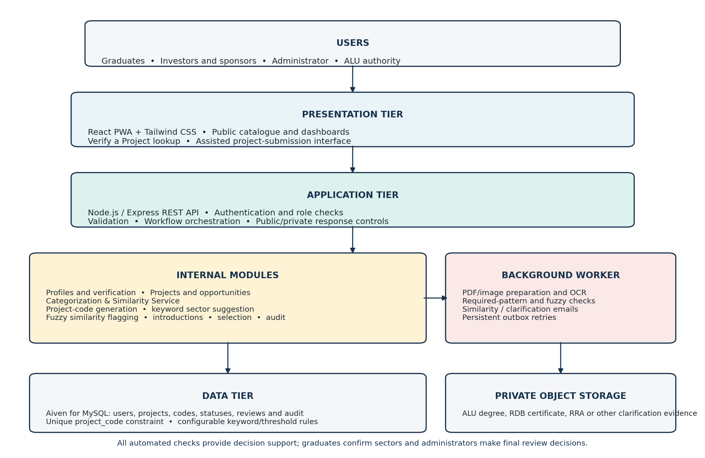
The application tier controls data and document access. A background worker processes extraction and notification jobs.
Source: Author’s design (2026). Editable draw.io page: 01_System_architecture.

3.4.2 Database Design
Figure 3 Entity relationships for identity and project evidence
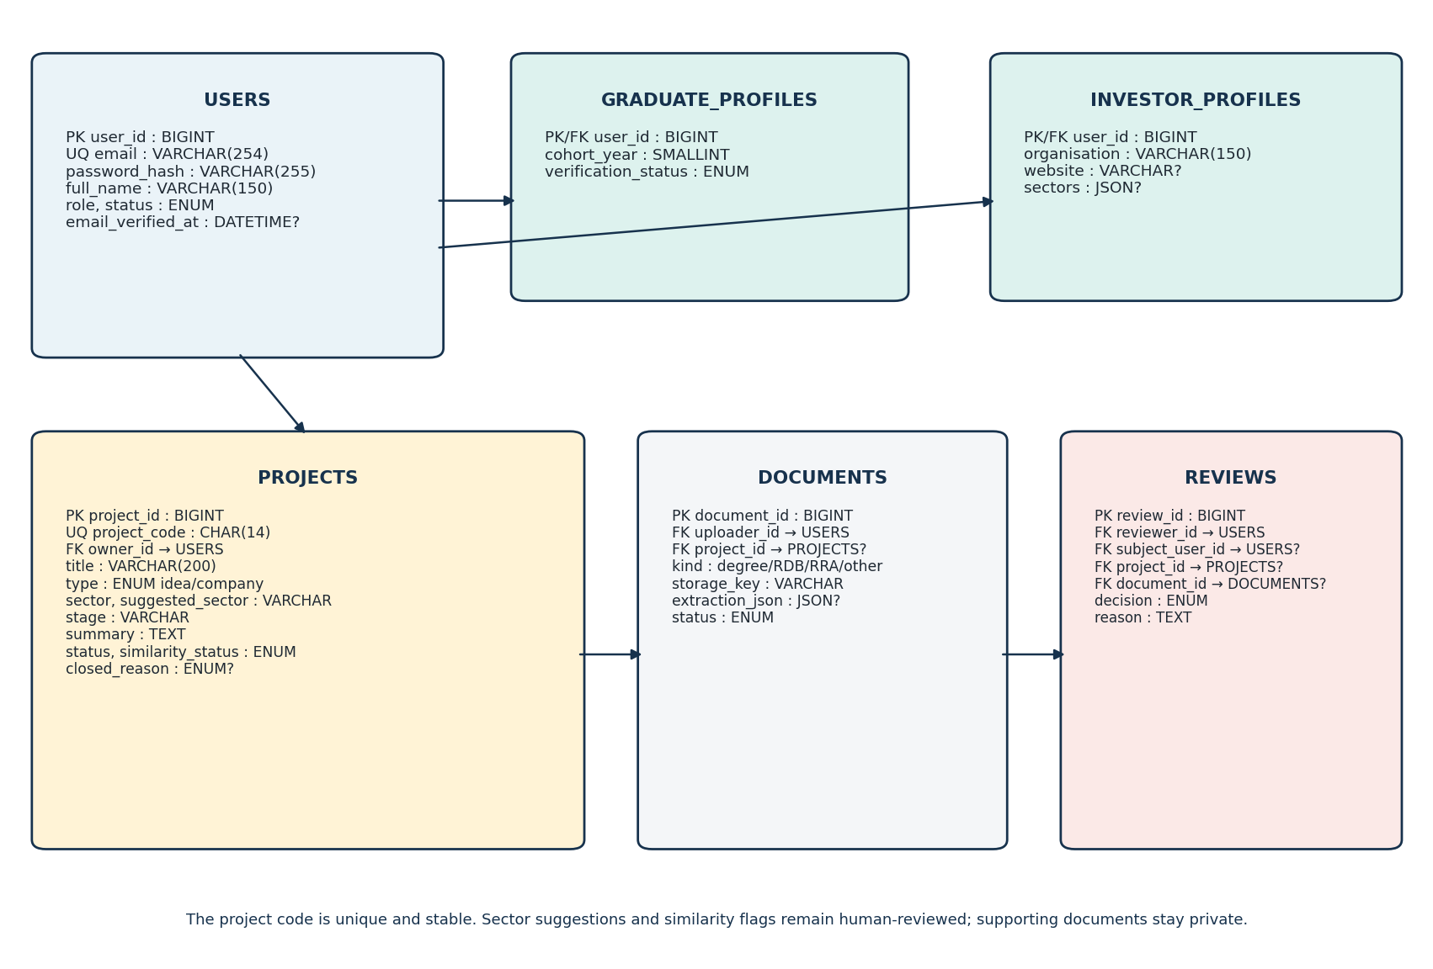
Cardinalities describe the number of records at each end. This view covers identity, project submission and review.
Source: Author’s design (2026). Editable draw.io page: 02_ERD_identity_and_projects.
Figure 4 Entity relationships for opportunities and introductions
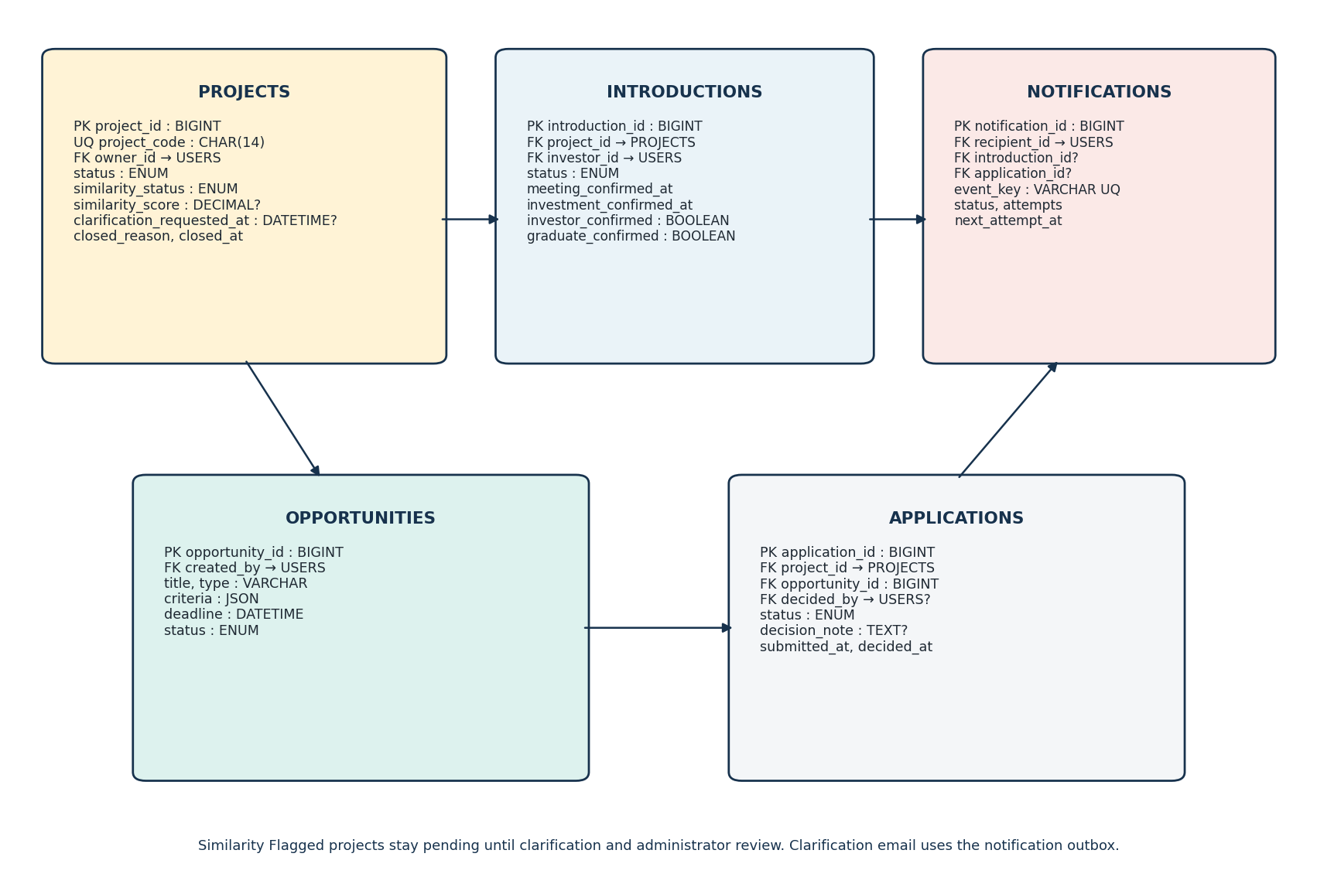
This complementary view shares USERS and PROJECTS with Figure 3. Together the views define one relational model.
Source: Author’s design (2026). Editable draw.io page: 03_ERD_workflows.

3.4.3 Use Case Diagram
Figure 5 Actor responsibilities and system use cases
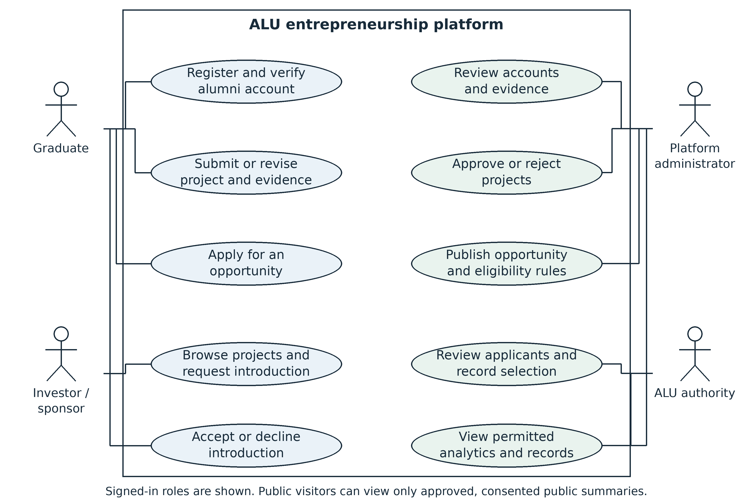
The administrator manages verification and publication. The ALU authority records competition selection decisions.
Source: Author’s design (2026). Editable draw.io page: 04_Use_cases.

3.4.4 Class Diagram
Figure 6 Backend service classes and dependencies
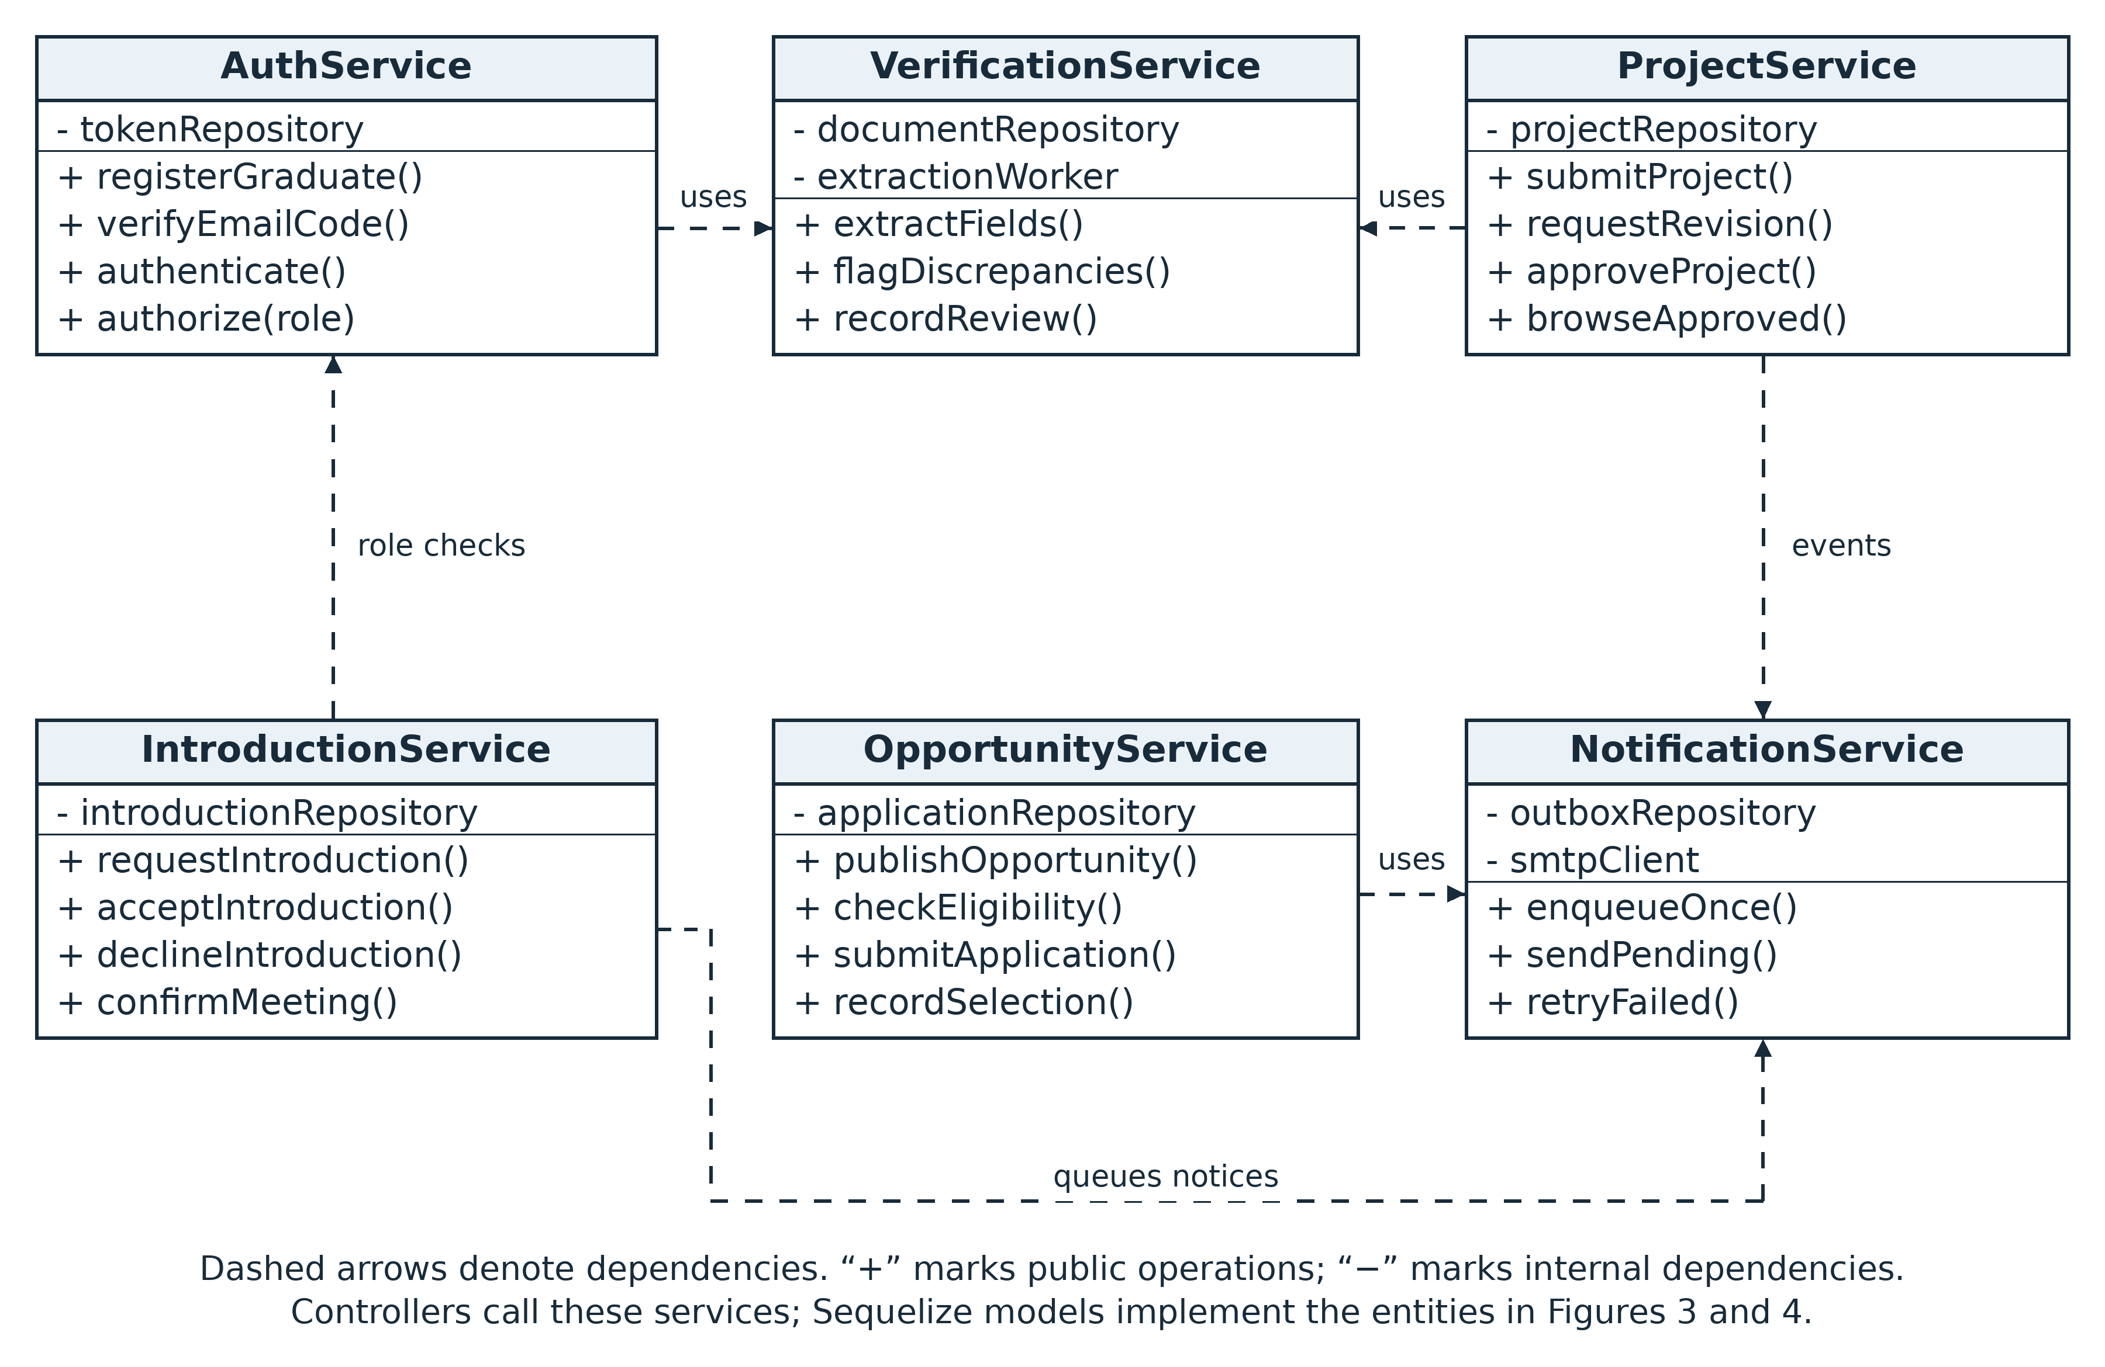
The services encapsulate business operations and access the relational entities through repositories and Sequelize models.
Source: Author’s design (2026). Editable draw.io page: 05_Service_classes.

3.4.5 Graduate and Project Workflow
Figure 7 Graduate registration and project review workflow
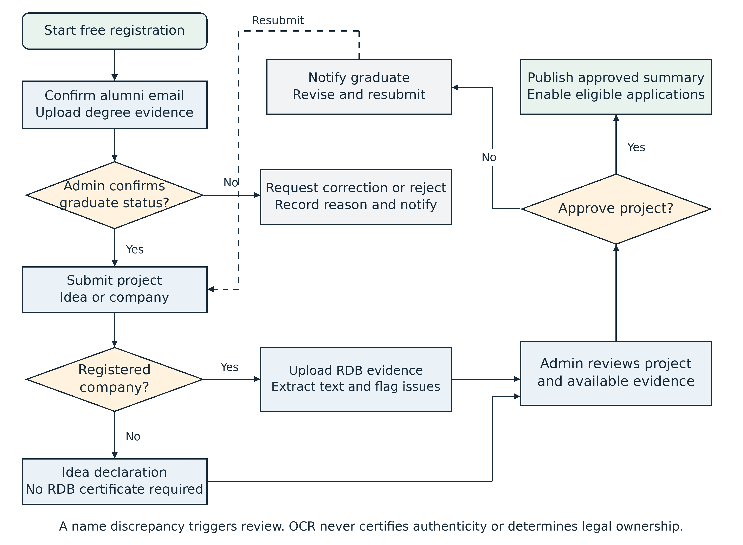
Graduate approval precedes submission. Company evidence receives administrative review; idea-stage projects follow a separate evidence path.
Source: Author’s design (2026). Editable draw.io page: 06_Graduate_and_project_flow.

3.4.6 Opportunity Selection Workflow
Figure 8 Opportunity eligibility and institutional selection
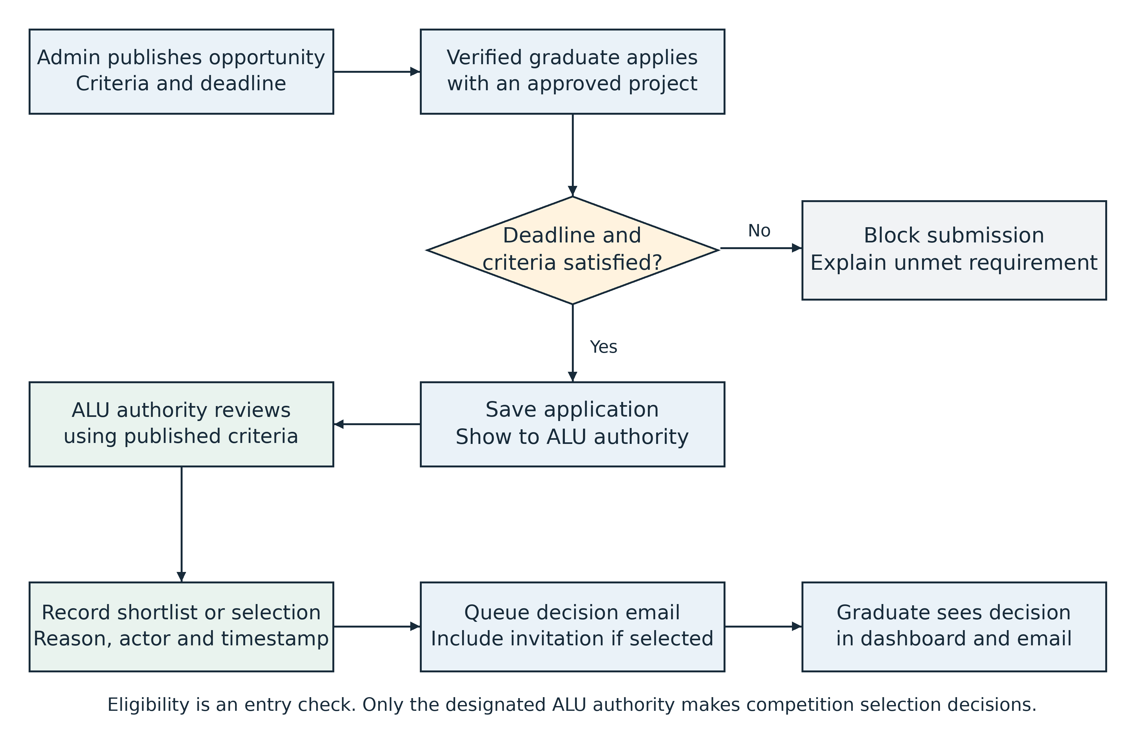
The server checks entry eligibility. The designated authority makes and records the selection decision before notifications are sent.
Source: Author’s design (2026). Editable draw.io page: 07_Opportunity_selection.

3.4.7 Introduction Sequence Diagram
Figure 9 Investor introduction with graduate consent
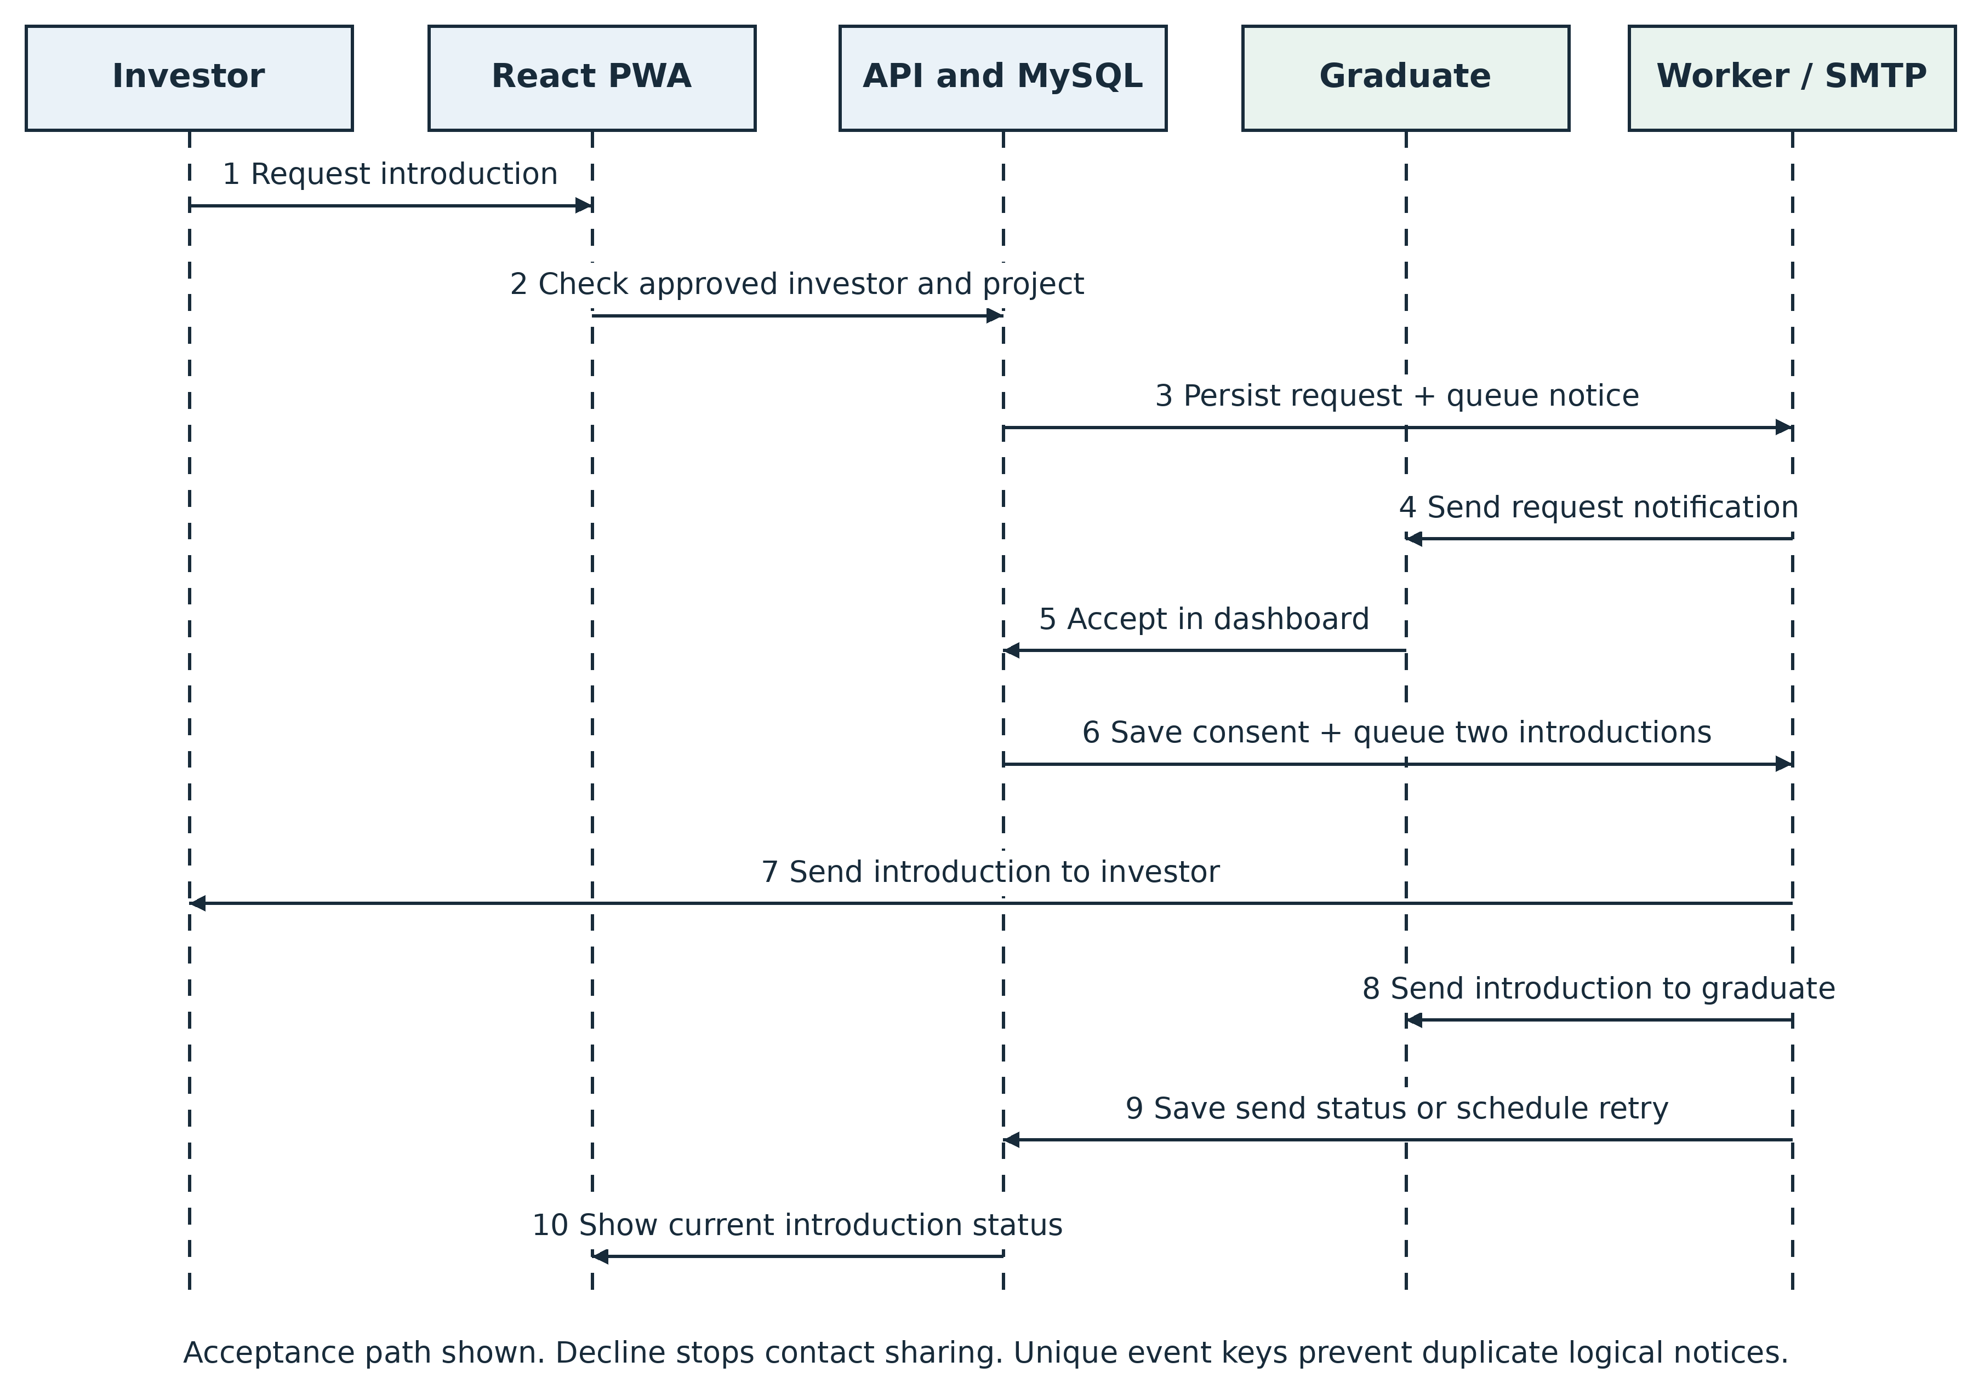
This sequence shows the consent-based introduction path. A decline ends the request without exchanging contact information; delivery failures are retried. Subsequent meeting or investment confirmation is recorded separately. Only a confirmed investment outcome contributes to the two-investor limit or funded status.
Source: Author’s design (2026). Editable draw.io page: 08_Introduction_sequence.

3.5 Development Tools
Table 5 Development tools and intended use
Area | Tools | Purpose
Frontend | React, Vite, Tailwind CSS | Responsive PWA interface, Verify a Project lookup, assisted submission flow and role-based dashboards.
Backend | Node.js LTS, Express | REST API, access control, project-code generation, keyword categorization, fuzzy similarity and workflow services.
Persistence | Aiven for MySQL, Sequelize | Relational records, unique project codes, review statuses, constraints and migrations.
Documents | PDF.js, Tesseract.js, private object storage | PDF/image preparation, Tesseract.js OCR, required-pattern checks, fuzzy name comparison and protected evidence storage.
Notifications | Nodemailer and SMTP | Email codes, clarification requests, introductions and selection notices with retry tracking.
Testing | Jest, Supertest, Playwright, Lighthouse | Business-rule, API and browser tests; performance and accessibility checks.
Design and delivery | Figma, draw.io, Git and GitHub | Interface design, diagrams, version control and deployment workflow.

Dependency versions will be pinned at implementation using maintained compatible releases. The project will use the smallest hosting arrangement that supports the pilot. Aiven for MySQL will provide the managed relational database, while frontend and API hosting will be selected after checking resource limits and data-handling requirements. No service is assumed to provide free capacity or guaranteed uptime. Draw.io will maintain editable technical diagrams.
A complete UI/UX prototype has been designed in Figma for the public landing page, authentication flow, Graduate Dashboard, Project Submission form, Verify a Project lookup, Investor Discovery Portal, Project Detail view, Admin Verification and Similarity Flagged queues, and Account Settings. Together, these screens demonstrate the principal user flows for Graduate, Investor/Sponsor, Administrator and Public Viewer roles. The prototype uses a consistent responsive dashboard system across authenticated pages, institutionally approved ALU logo assets and consistent icons that distinguish project or business-idea content from navigation, verification and status controls. Any Billing / Premium Plans screen or control is marked as future work and is a non-functional placeholder in the current design.

3.6 Future Work and Recommendations
Recommended next phases include replacing or complementing the maintained keyword map with an evaluated natural-language-processing classifier when a suitable labelled dataset, governance process and longer development period are available. Any such model should retain graduate confirmation, explainable suggestions, bias and error evaluation, and administrator review for similarity flags. A separate future phase may introduce optional tiered subscriptions for investors or sponsors. This would require a payment gateway, such as Flutterwave, together with secure billing records, transaction reconciliation, privacy and regulatory review, refund and dispute procedures, and separate acceptance testing. No machine-learning classifier, payment gateway, billing backend or transaction processing is included in the present capstone.

References
Akerlof, G. A. (1970). The market for “lemons”: Quality uncertainty and the market mechanism. The Quarterly Journal of Economics, 84(3), 488–500. https://doi.org/10.2307/1879431
Bejjani, M., Göcke, L., & Menter, M. (2023). Digital entrepreneurial ecosystems: A systematic literature review. Technological Forecasting and Social Change, 189, Article 122372. https://doi.org/10.1016/j.techfore.2023.122372
Bernstein, S., Korteweg, A., & Laws, K. (2017). Attracting early-stage investors: Evidence from a randomized field experiment. The Journal of Finance, 72(2), 509–538. https://doi.org/10.1111/jofi.12470
Data Protection and Privacy Office. (n.d.). Rwanda Data Protection and Privacy Office. Retrieved September 16, 2026, from https://dpo.gov.rw/
Gompers, P. A., Gornall, W., Kaplan, S. N., & Strebulaev, I. A. (2020). How do venture capitalists make decisions? Journal of Financial Economics, 135(1), 169–190. https://doi.org/10.1016/j.jfineco.2019.06.011
Gust. (n.d.). Gust. Retrieved September 16, 2026, from https://gust.com/
Hevner, A. R., March, S. T., Park, J., & Ram, S. (2004). Design science in information systems research. MIS Quarterly, 28(1), 75–105. https://doi.org/10.2307/25148625
Mozilla. (n.d.). Progressive web apps. MDN Web Docs. Retrieved September 16, 2026, from https://developer.mozilla.org/en-US/docs/Web/Progressive_web_apps
Naptha. (n.d.). Tesseract.js [Computer software]. GitHub. Retrieved September 16, 2026, from https://github.com/naptha/tesseract.js
OWASP Foundation. (n.d.). Unrestricted file upload. Retrieved September 16, 2026, from https://community.owasp.org/vulnerabilities/Unrestricted_File_Upload
Rwanda Development Board. (n.d.). Business procedures in Rwanda. Retrieved September 16, 2026, from https://businessprocedures.rdb.rw/
VC4A. (n.d.). VC4A. Retrieved September 16, 2026, from https://vc4a.com/

