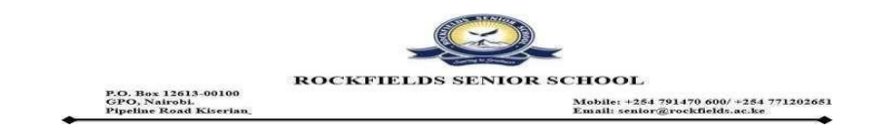

RE: VISIT TO CAPE MEDIA LIMITED (TV47) – Saturday, 14th February 2026

Dear Parent/Guardian,
Warm greetings from Rockfields Senior School.
We are pleased to inform you that your son is among the students selected to visit Cape Media Limited (TV47/Radio 47) on Saturday, 14th February 2026, departing the school at 7:30 a.m.
This educational visit is intended to provide learners with practical exposure to media technology in the field as part of their selected subject area and participation in the Journalism Club. This message therefore serves to formally notify you of the school’s intention to travel with him to the media station.
Among the learners visiting the station, a select group of students will have the special opportunity to go live on air during the Bahati ya Elimu show, which airs from 7:00 a.m. to 11:00 a.m. on Radio 47. We warmly invite you to tune in and support them as they participate in the conversation.
Should you have any questions or require further clarification, please do not hesitate to get in touch.

Regards,
Rockfields Senior School Team

