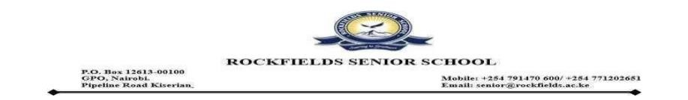
Date 23.2.2026
Midterm 1 2026 Transport Teachers
 | ROUTE | BUS | NO. | CAPACITY | STUDENTS ALLOCATED | TEACHER ASSIGNED
1 | RJS | KBH 671Q | 5 | 51 | 49 | Stanley Ng'ang'a
1 | RJS | KCP 807M | 15 | 51 | 49 | Makara Douglas
1 | RJS | KCY 067F | 16 | 46 | 47 | Duncan Ombati
1 | RJS | KDE 241P | 11 | 46 | 45 | Albert Wasonga
2 | GALLERIA | KCK 824K | 14 | 51 | 43 | Mr. Navy Ochieng'
2 | GALLERIA | KDT 876D | 18 | 33 | 25 | Elizabeth Maithya
3 | RSS |  |  |  |  | Mr. Bwire Levis
4 | KITENGELA | KBR 374K | 9 | 37 | 37 | Mr. Kioko Henry

