Feature Description

Rev Date: March 7th 2005

Release Version 1.0

A short description of each feature.

Common Variables
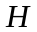 | Image height
 | Image Width
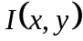 | Intensity at x, y 0 = Background, 255 = Foreground
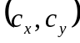 | Center of Image
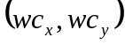 | Weighted center
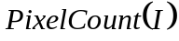 | Number of foreground pixels in image .
 | Image Size in number of Pixels

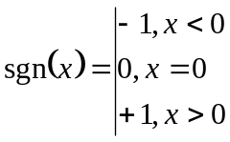

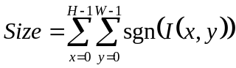

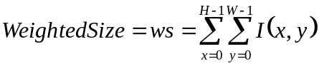

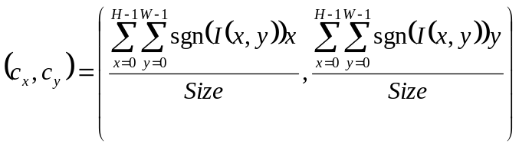

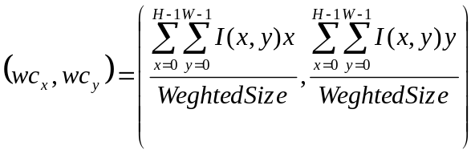

There are three groups of moment features, 1) moments on whole image(0-7), 2) Edge Image(8-15) , and 3) weighted(31-38). These moments features are based off work introduced by HU

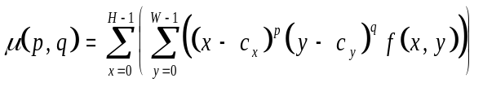
Equation used by all moment calculations, where 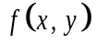 is equal to 1 for the first two groups, and 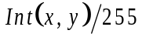 for the Weighted Moments.

Definition of the eight basic moment features used in the three different moment groups.
0 | 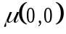
1 | 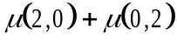
2 | 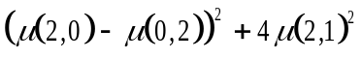
3 | 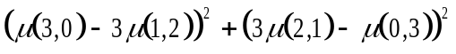
4 | 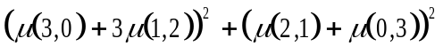
5 | 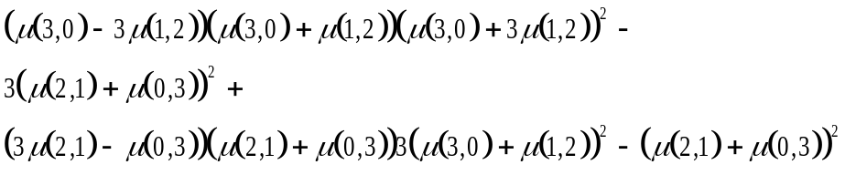
6 | 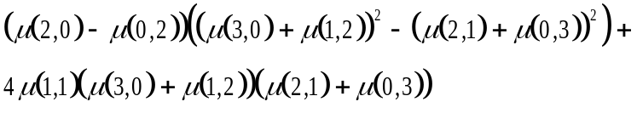
7 | 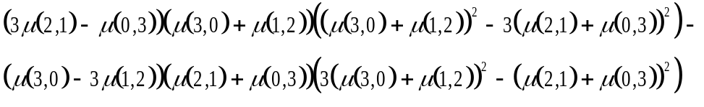
Table 1, Moment Calculations

Feature  Num | Description
0 – 7 | Moment Features where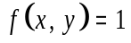, if x, y is a foreground pixel.  *Note that feature 0 will be pixel count of image.
8 – 15 | Edge Moments  - Image is reduced to just edge pixels.  - New center 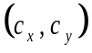 is calculated  *Note that feature[8] will be the number of pixels in edge.
16 | 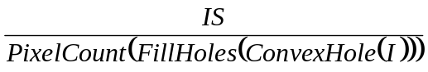
17 | 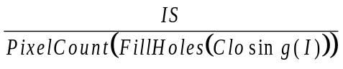
18 | 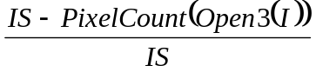
19 | 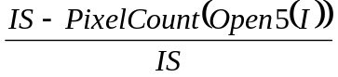
20 | 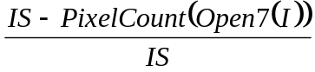
21 | 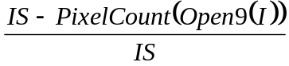
22 | 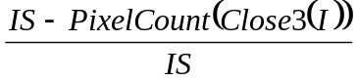
23 | 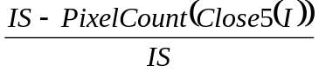
24 | 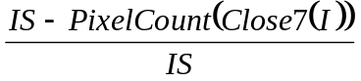
25,26 | a. Create covariance matrix of image .  b. Calculate 1st and 2nd Eigen vectors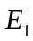, 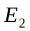 of .  c. 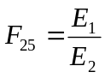  d. Determine orientation of image, 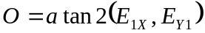  e. Using orientation , rotate Image so that it lies horizontal.  f. 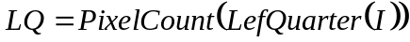,  g. 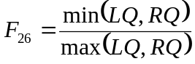, Helps to determine if organism has head.
27
28 | 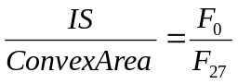
29 | 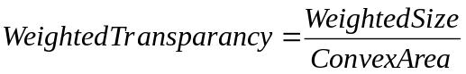
30 | 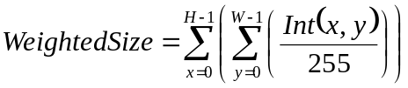
31-38 |  using table 1, where 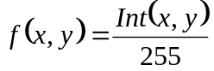
39-43 | Texture, Fourier
44-48 | Contour, using 1 Dimensional Fourier
49-55 | Intensity Histogram Field [0-6]
56 | Height / Width, Using information used to calculate the eigen ratio  a. Image is rotate so that its longest dimension run parallel to bottom.  b. Tight bounding box is drawn.  c. The shortest dimension is considered the Height while the longest is the length.
57
58
59 | Hole filled area.  1) All white space pixels that are enclosed with in the contour of the image are filled with foreground pixels.  2) A count of all foreground pixels is then made.

References

M.K. Hu Visual pattern recognition by moment invariants. IEE Trans. Information Theory, pages 179-187, February 1962

