# Testing / Code Output

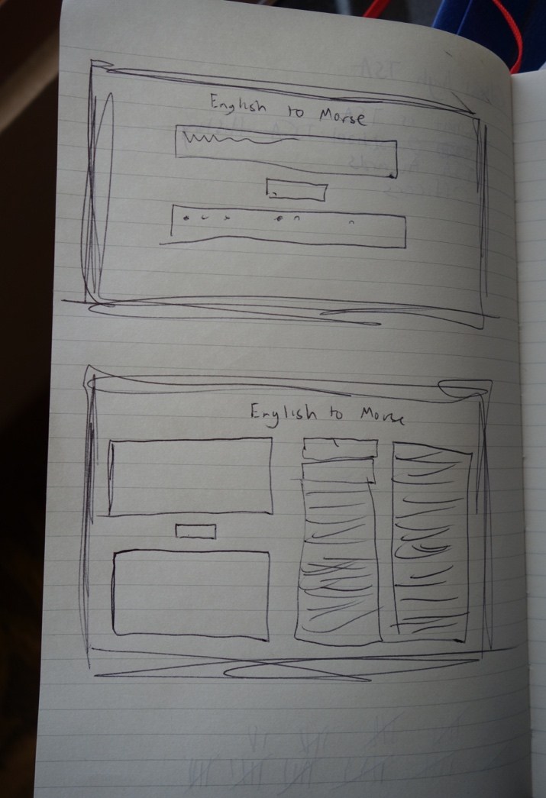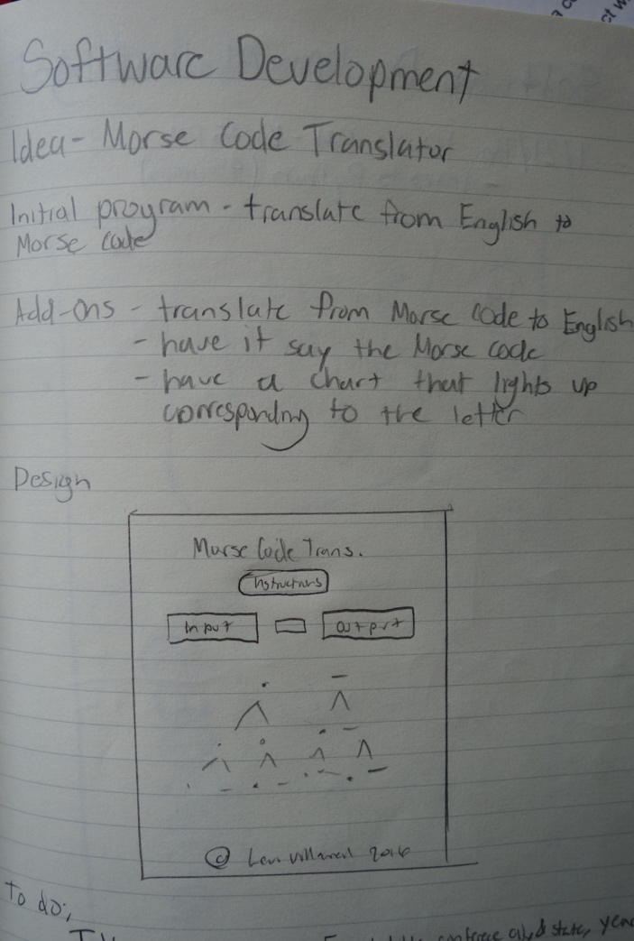

*Initial and final sketches*

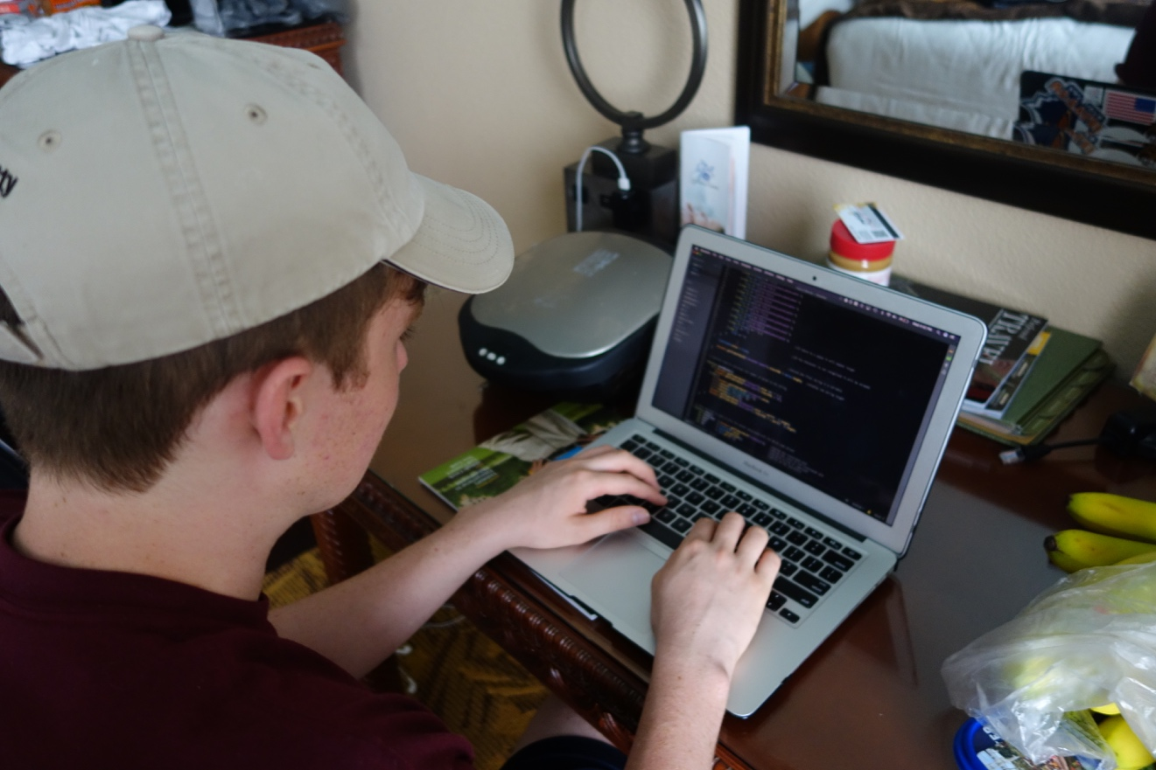

*Code Development*

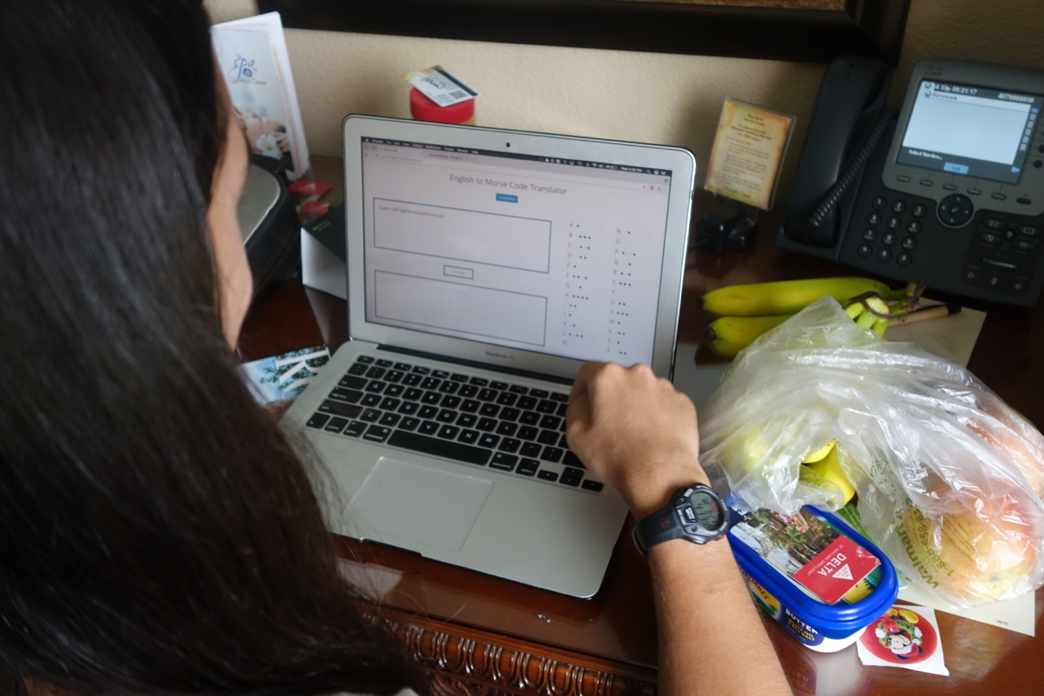

*Code Testing*

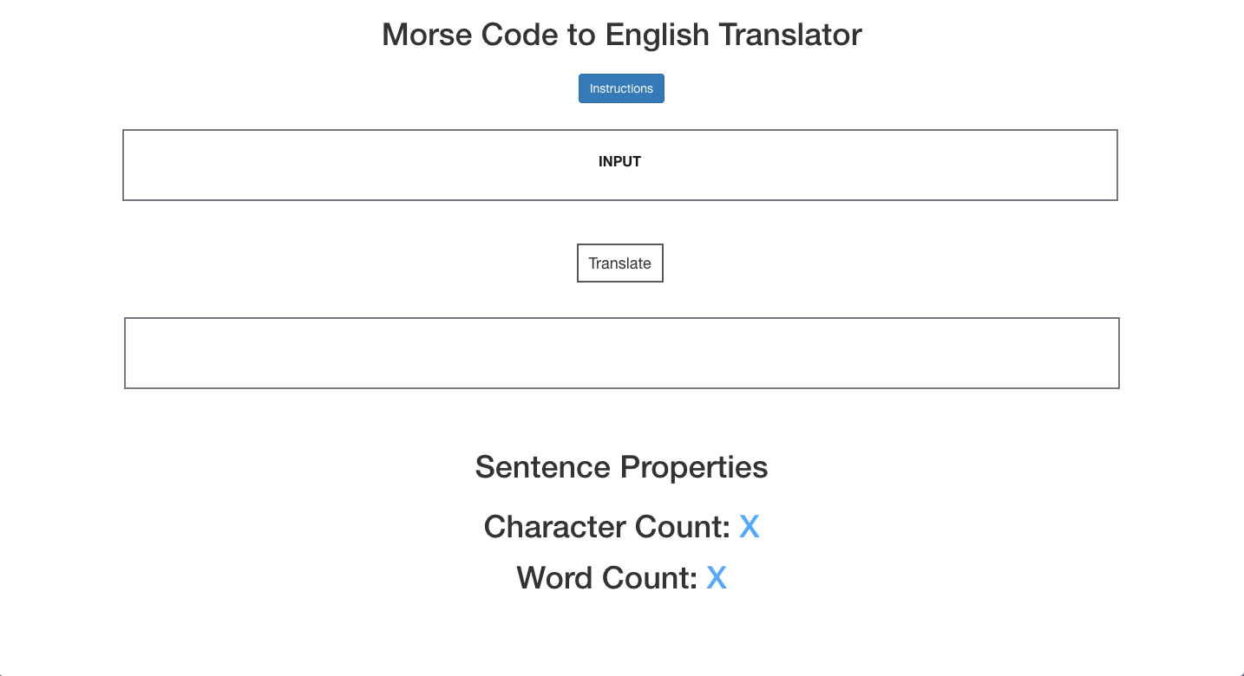

*Early Software Design*

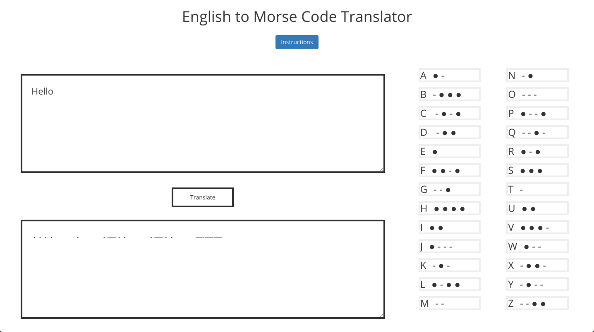

*Final Software Design*

JavaScript Used

//Run the function if the enter key is pressed

if (document.layers) {

document.captureEvents(Event.KEYDOWN);

}

document.onkeydown = function(evt) {

var keyCode = evt ? (evt.which ? evt.which : evt.keyCode) : event.keyCode;

if (keyCode == 13) {

countWords()

translate();

play();

}

};

// Variables for the translation

function translate() {

var text = document.getElementById("txtInput"); //Stores the text in the input field

var translated = document.getElementById("txtOutput"); //Stores the text in the output field

var morse = text.value; //Stores the value of the text from the input field

var res1 = morse.toLowerCase(); //Converts the string to lowercase

var res = res1.split(""); //Splits up the characters

var prop = res1.length; //Calculates the length of the string

var i; //Used in the for loop

var final = ""; //Used to build the final statement

/*

The Morse code characters are as follows

\u2219 is the dot

\u2014 is the dash

*/

for (i = 0; i < prop; i++) { //The function will repeat until the string runs out of characters

if (res[i] == "a") {

final += "\u2219\u2014 "; //Has the correct Morse code translation for each character

} else if (res[i] == "b") {

final += "\u2014\u2219\u2219\u2219 ";

} else if (res[i] == "c") {

final += "\u2014\u2219\u2014\u2219 ";

} else if (res[i] == "d") {

final += "\u2014\u2219\u2219 ";

} else if (res[i] == "e") {

final += "\u2219 ";

} else if (res[i] == "f") {

final += "\u2219\u2219\u2014\u2219 ";

} else if (res[i] == "g") {

final += "\u2014\u2014\u2219 ";

} else if (res[i] == "h") {

final += "\u2219\u2219\u2219\u2219 ";

} else if (res[i] == "i") {

final += "\u2219\u2219 ";

} else if (res[i] == "j") {

final += "\u2219\u2014\u2014\u2014 ";

} else if (res[i] == "k") {

final += "\u2014\u2219\u2014 ";

} else if (res[i] == "l") {

final += "\u2219\u2014\u2219\u2219 ";

} else if (res[i] == "m") {

final += "\u2219\u2219 ";

} else if (res[i] == "n") {

final += "\u2219\u2014 ";

} else if (res[i] == "o") {

final += "\u2014\u2014\u2014 ";

} else if (res[i] == "p") {

final += "\u2219\u2014\u2014\u2219 ";

} else if (res[i] == "q") {

final += "\u2014\u2014\u2219\u2014 ";

} else if (res[i] == "r") {

final += "\u2219\u2014\u2219 ";

} else if (res[i] == "s") {

final += "\u2219\u2219\u2219 ";

} else if (res[i] == "t") {

final += "\u2014 ";

} else if (res[i] == "u") {

final += "\u2219\u2219\u2014 ";

} else if (res[i] == "v") {

final += "\u2219\u2219\u2219\u2014 ";

} else if (res[i] == "w") {

final += "\u2219\u2014\u2014 ";

} else if (res[i] == "x") {

final += "\u2219\u2014\u2014 ";

} else if (res[i] == "y") {

final += "\u2014\u2219\u2014\u2014 ";

} else if (res[i] == "z") {

final += "\u2014\u2014\u2219\u2219\u2219 "; //Contains the translation for numbers

} else if (res[i] == "0") {

final += "\u2014\u2014\u2014\u2014\u2014 ";

} else if (res[i] == "1") {

final += "\u2219\u2014\u2014\u2014\u2014 ";

} else if (res[i] == "2") {

final += "\u2219\u2219\u2014\u2014\u2014 ";

} else if (res[i] == "3") {

final += "\u2219\u2219\u2219\u2014\u2014 ";

} else if (res[i] == "4") {

final += "\u2219\u2219\u2219\u2219\u2014 ";

} else if (res[i] == "5") {

final += "\u2219\u2219\u2219\u2219\u2219 ";

} else if (res[i] == "6") {

final += "\u2014\u2219\u2219\u2219\u2219 ";

} else if (res[i] == "7") {

final += "\u2014\u2014\u2219\u2219\u2219 ";

} else if (res[i] == "8") {

final += "\u2014\u2014\u2014\u2219\u2219 ";

} else if (res[i] == "9") {

final += "\u2014\u2014\u2014\u2014\u2219 ";

} else if (res[i] == " ") { //If there is a space it will appear larger

final += " ";

} else {

final += ""; //If the character is not recognized it will be skipped

}

}

translated.value = final; //Stores the final string in a variable

document.getElementById("character-count").innerHTML = morse.length; //Display the string length

}

// Function used to calculate the number of words in the string

function countWords() {

if (document.getElementById("txtInput").value === "") {

document.getElementById("word-count").innerHTML = "0";

} else {

s = document.getElementById("txtInput").value;

s = s.replace(/(^\s*)|(\s*$)/gi, "");

s = s.replace(/[ ]{2,}/gi, " ");

s = s.replace(/\n /, "\n");

document.getElementById("wordcount").value = s.split(' ').length;

document.getElementById("word-count").innerHTML = s.split(' ').length;

}

}

// This function is used to play the sounds associated with the Morse code phrase

function play() {

var translated = document.getElementById("txtOutput"); //Stores the translated text

var sound = translated.value; //Stores the value of the translated text

var res1 = sound.toLowerCase(); //Converts string to lowercase

var res = res1.split(""); //Splits up the characters

var prop = res1.length; //Calculate the length of the string

var i; //Used in the for loop

var dit = new Audio('dit.mp3'); //Create an audio element for the dot

dit.playbackRate = 1.5; //Establish the playback speed

var dah = new Audio('dah.mp3'); //Create an audio element for the dash

dah.playbackRate = 1.5; //Establish the playback speed

for (i = 0; i < prop; i++) { //The function will repeat until the string runs out of characters

if (res[i] == "\u2219") { //If the character is a dot

setTimeout(function() {

dit.play(); //Play the dit sound

}, i * 750); //Wait for the dit sound to finish

} else if (res[i] == "\u2014") { //If the character is a dash

setTimeout(function() {

dah.play(); //Play the dit sound

}, i * 750); //Wait for the dit sound to finish

} else {}

}

}

//When the translate button is pressed these functions will be called

function someFunc() {

countWords()

translate();

play();

}

//When the play button is pressed these functions will be called

function anotherFunc() {

countWords()

translate();

play();

}