Levi Winters

Dr. M

CS-210

8/7/2023

Grocery-Tracking Program: Documentation

After developing an item-tracking program for the Corner Grocer, I will explain the code's design and functionality, demonstrating my C++ thought process.

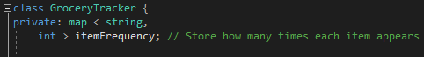

I created a GroceryTracker class that uses a map to track the frequency of purchased items.



The itemFrequencies function displays the frequency of each purchased item.



The itemHistogram function creates a histogram for visualizing purchase frequency.



The run function drives the program by processing file input, updating frequencies, and offering user menu options.

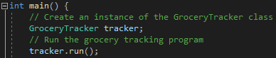

The main function initializes the GroceryTracker class and initiates the item-tracking program.