PHASE I REPORT
Admissions, Recruitment & Outreach Platform
Team 4
Bogdan Borachuk
Lev Lavryniuk
Antonii Maltsev
September 29, 2026
Public GitHub repository: https://github.com/levlavryniuk/intro-to-swe

Project Overview
1. Purpose and scope
The Admissions, Recruitment & Outreach module helps prospective students move from a first inquiry to an admissions decision. Visitors can send inquiries and register for recruitment events; applicants can submit an application with supporting documents; admissions staff review applications, record decisions, send email campaigns and manage events. The module is one part of the university platform described in the project brief. It records whether an admitted applicant has enrolled, but it does not perform program or course registration or manage grades or academic records; those belong to other teams.
This overview documents the requirements for the first release of the module, which will be built and demonstrated by the end of the semester. Features left out of the first release are listed in section 5. Interfaces with other teams will be defined in Phase II, after the team reviews their APIs.
2. Users and main workflow
The module has three user roles. A visitor uses the public pages without signing in; a visitor who submits an inquiry or registers for an event becomes a lead. An applicant is a visitor who has created an account and applies to a program. Admissions staff read inquiries, review applications, record decisions, send email and manage events and programs.
A typical path is: inquiry → submitted application → review → decision. For reporting, application statuses are grouped into three stages: applied (submitted, under review or waitlisted), admitted (accepted or conditional offer) and enrolled. Rejected and withdrawn applications are closed. Admission itself is not program enrollment.
3. Functional requirements
FR-01 Inquiries. A visitor can submit an inquiry with a name, email address, program of interest, optional question and an opt-in choice for promotional email. Admissions staff can view the list of inquiries, filter it by program and mark each inquiry as high, medium or low interest for follow-up.
FR-02 Applications. An applicant can submit one application to one program, with contact information and educational background (last school attended, graduation year and grade average). Required fields must be filled in. The applicant can edit the application while its status is submitted and can withdraw it at any time before a decision. The applicant can see the current status of the application, including any condition attached to an offer.
FR-03 Documents. Each application requires three documents: an academic transcript, a proof of identity and a motivation essay. Each file must be a PDF of at most 15 MB, to allow for scanned documents; the application cannot be submitted until all three are uploaded. Admissions staff can open the documents of any application.
FR-04 Review and decisions. Admissions staff can view applications, filter them by program and status and set an application’s status to under review, accepted, conditional offer, waitlisted, rejected or enrolled. For a conditional offer, staff enter the condition as a short text. Each decision is made by a single staff member, who can change it later, for example from waitlisted to accepted.
FR-05 Email. Admissions staff can send an email to one lead or applicant or to a group of leads, such as everyone interested in one program or everyone registered for an event. Group emails go only to leads who opted in; staff can remove a lead’s opt-in on request. The module shows whether sending succeeded. An applicant is emailed automatically when a decision is recorded.
FR-06 Events. Admissions staff can create a recruitment event, such as an open day or webinar, with a name, date and location or online link. A visitor can register with a name, email address and an opt-in choice for promotional email. Staff can view the registration list for each event.
FR-07 Pipeline overview. Admissions staff can see the number of inquiries, event registrations and applications in each stage and status.
FR-08 Programs and deadlines. Admissions staff maintain a list of programs and set an application deadline date for each. After the deadline, the module does not accept new applications or edits for that program.
FR-09 Decision log. The module records every status change with the user who made it and the date and time. Admissions staff can view this history for each application.
FR-10 Integration with other modules. Accepted applicants will be passed to the Student Registration & Records (SIS) module (Team 5) so that student records can be created. Sign-in, email sending and campaign and event data will connect to the shared platform (Team 2). The interfaces will be defined in Phase II; until then, the module uses a simple local sign-in and a test mail server so it can be developed and demonstrated on its own.
4. Non-functional requirements
NFR-01 Access control. Applicants see only their own application and documents. Only admissions staff can view all applications and documents, send email or change statuses. Uploaded documents are never publicly accessible.
NFR-02 Data privacy. The module stores only the personal data needed for admissions. The deployed module uses HTTPS.
NFR-03 Performance. Pages respond within 2 seconds with a test data set of about 1,000 applications.
NFR-04 Accessibility. Every function works with a keyboard, form fields have labels, text has sufficient color contrast and error messages explain how to fix the problem. Pages are checked with an automated accessibility tool such as Lighthouse.
NFR-05 Browser and device support. The module works in the latest versions of Chrome, Firefox, Safari and Edge. Its pages are usable on phone and desktop screens.
NFR-06 Reliability and validation. Errors must not crash the module or lose entered data. Required fields, file type and file size are checked on the server before saving and forms show clear error messages.
NFR-07 Technology. The module uses React/HTML5 on the front end, Java with Spring Boot on the back end, MySQL for storage and REST APIs, as required by the overall course project.

5. Scope decisions
SMS is not included because it requires a paid provider; email is used instead. Each admissions decision is made by one staff member and every decision is logged. Automated lead scoring is not included; staff rate inquiries by hand.
Left out of the first release and possible later additions: automated email sequences, unsubscribe links, more than one application per applicant, intake terms, spam protection for public forms and automatic deletion of old applicant data. Still to confirm with the customer: one application per applicant and no offer confirmation step for applicants.

User's Guide
1. Purpose and users
The Admissions, Recruitment & Outreach module of the American University Kyiv (AUK) management platform takes prospective students from a first inquiry to an admissions decision. Visitors send inquiries and register for events; applicants submit an application with documents and follow its status; admissions staff review applications, record decisions, send email and manage programs and events.
This guide shows the first release. Until the interfaces with Team 2 and Team 5 are defined in Phase II, the module uses a simple local sign-in and a test mail server. Screens are mockups with sample data; the numbered markers on each screen match the steps below it.
User | Account | Can do
Visitor | No account | Send an inquiry, register for events
Applicant | Applicant account | Submit one application with documents, follow, edit or withdraw it
Admissions staff | Staff account | Inquiries, applications, decisions, email, programs, deadlines, events, overview

2. Visitor
2.1 Send an inquiry or register for an event
Requirements: FR-01, FR-06. The public admissions pages need no account. Sending an inquiry or registering for an event makes the visitor a lead.
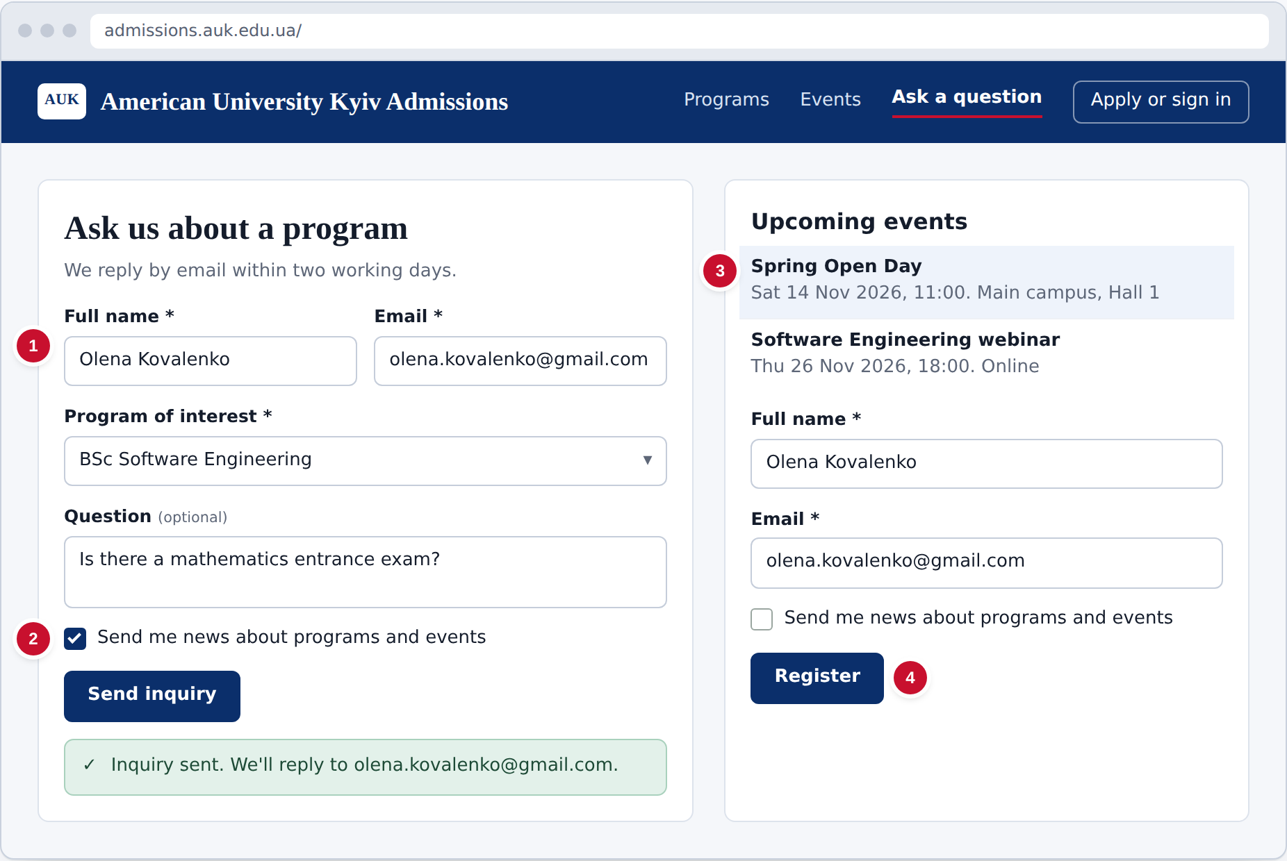
Figure 1. Send an inquiry or register for an event
- Enter your name and email, choose a program and, if you like, type a question.
- Tick the box only if you want promotional email. Then select Send inquiry.
- To attend an event, choose it from the list.
- Enter your name and email, choose whether to receive promotional email and select Register.
3. Applicant
3.1 Submit an application
Requirements: FR-02, FR-03, FR-08. After creating an account and signing in, an applicant submits one application to one program before that program's deadline.
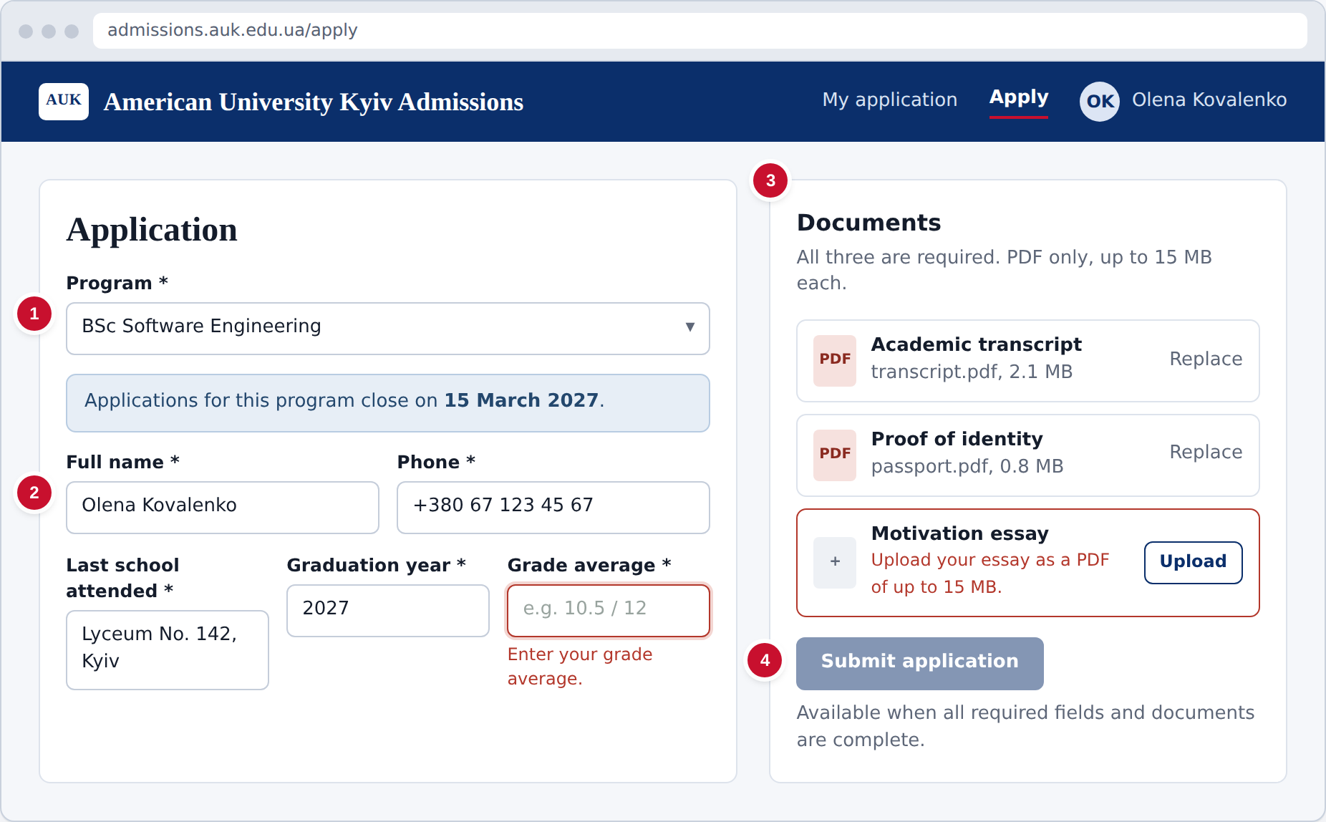
Figure 2. Submit an application
- Choose the program. Its application deadline is shown below.
- Fill in your contact details and educational background. A missing or invalid field is outlined in red with a message.
- Upload the academic transcript, proof of identity and motivation essay. Files that are not PDFs or are over 15 MB are rejected.
- Select Submit application. It becomes available once everything required is complete.
3.2 Follow my application
Requirements: FR-02, FR-05. My application shows the current status. The applicant is also emailed when a decision is recorded.
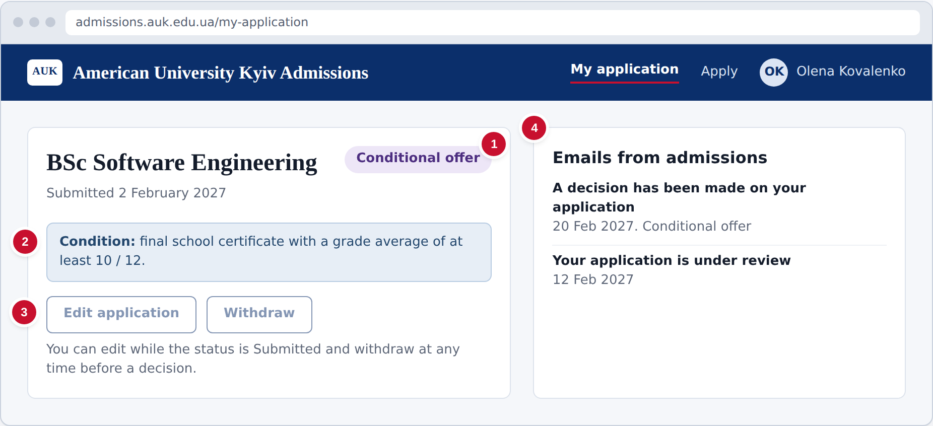
Figure 3. Follow my application
- The badge shows your status: Submitted, Under review, Waitlisted, Accepted, Conditional offer, Rejected, Withdrawn or Enrolled.
- If you have a conditional offer, its condition is shown here.
- Use Edit application while the status is Submitted, and Withdraw at any time before a decision.
- Decision emails sent to you are listed here.
4. Admissions staff
4.1 Pipeline overview
Requirements: FR-07. The overview counts inquiries, event registrations and applications in each stage and status.
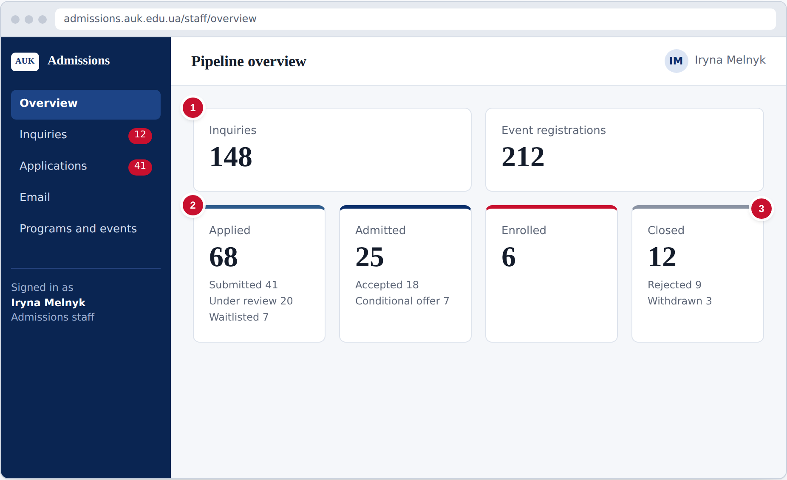
Figure 4. Pipeline overview
- The top row shows the total inquiries and event registrations.
- Each card shows one stage: applied, admitted or enrolled, with the count for each status in it.
- Rejected and withdrawn applications are counted as closed.
4.2 Manage inquiries
Requirements: FR-01, FR-05. All inquiries arrive in one list. Staff rate each one for follow-up.
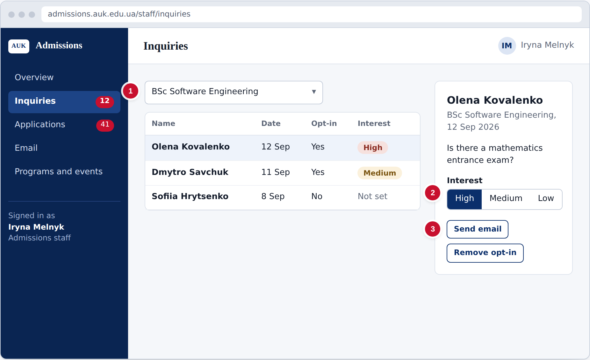
Figure 5. Manage inquiries
- Filter the list by program.
- Open an inquiry and set its interest to High, Medium or Low.
- Select Send email to reply. If the lead asks to stop promotional email, select Remove opt-in.
4.3 Find applications
Requirements: FR-04. The applications list shows every application and can be filtered by program and status.
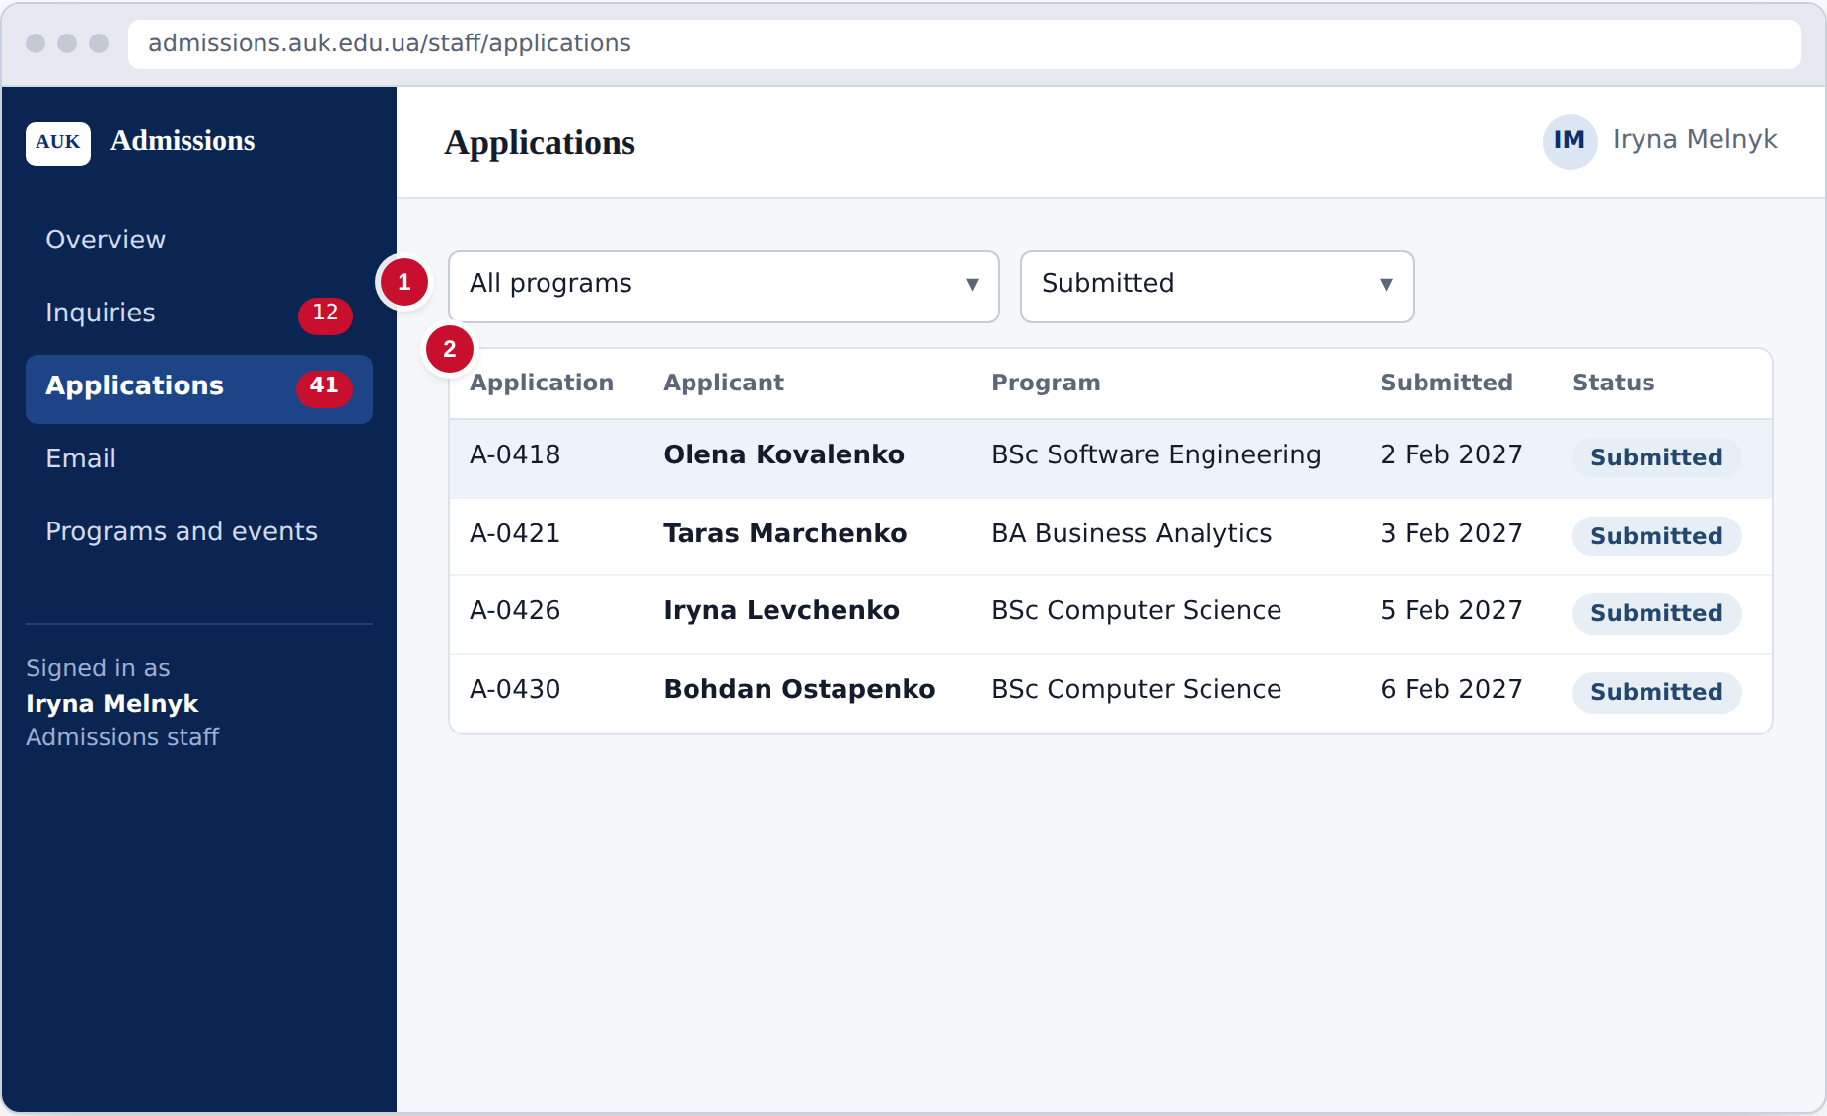
Figure 6. Find applications
- Choose a program and a status to narrow the list.
- Select an application to open it for review.
4.4 Review an application and decide
Requirements: FR-03, FR-04, FR-05, FR-09. The review screen shows the documents, the decision and the history of status changes. Recording a decision emails the applicant automatically.
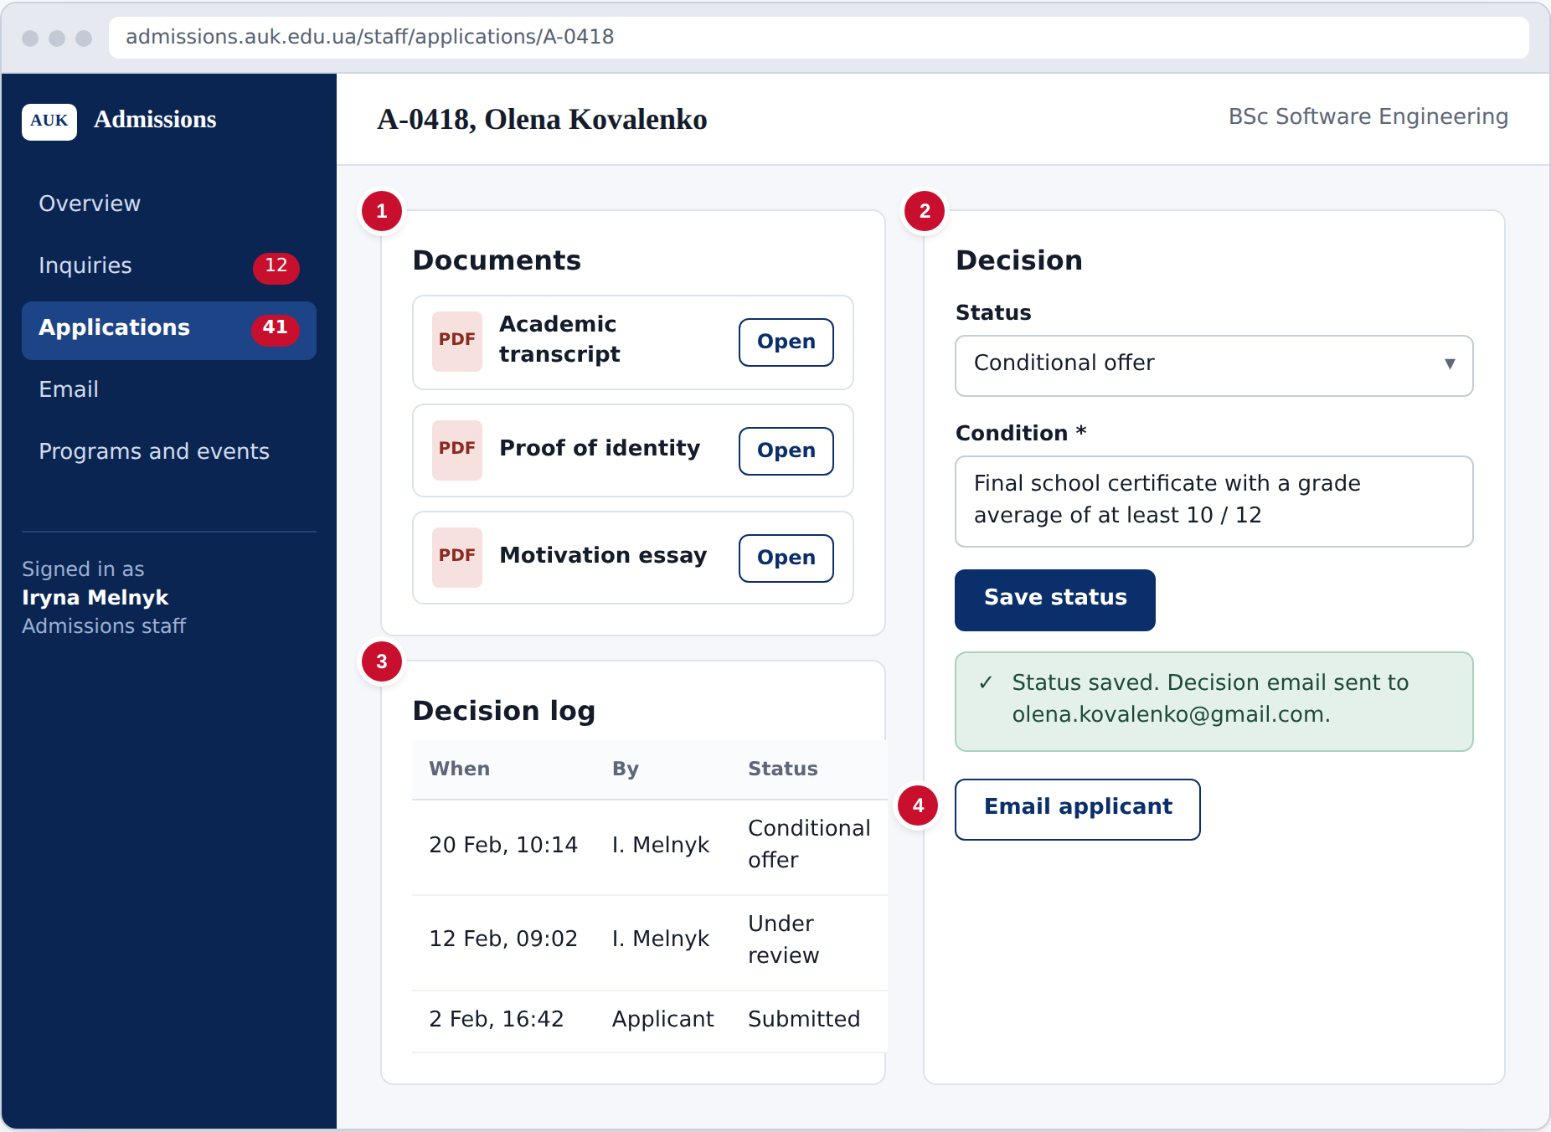
Figure 7. Review an application and decide
- Open each document to read it.
- Choose a status: Under review, Accepted, Conditional offer, Waitlisted, Rejected or Enrolled. For a conditional offer, enter the condition. Select Save status; the applicant is emailed automatically. A decision can be changed later.
- The decision log shows every status change with who made it and when.
- Select Email applicant to send a personal message.
4.5 Send email to a group of leads
Requirements: FR-05. Staff can email everyone interested in one program or everyone registered for an event. Group emails go only to leads who opted in.
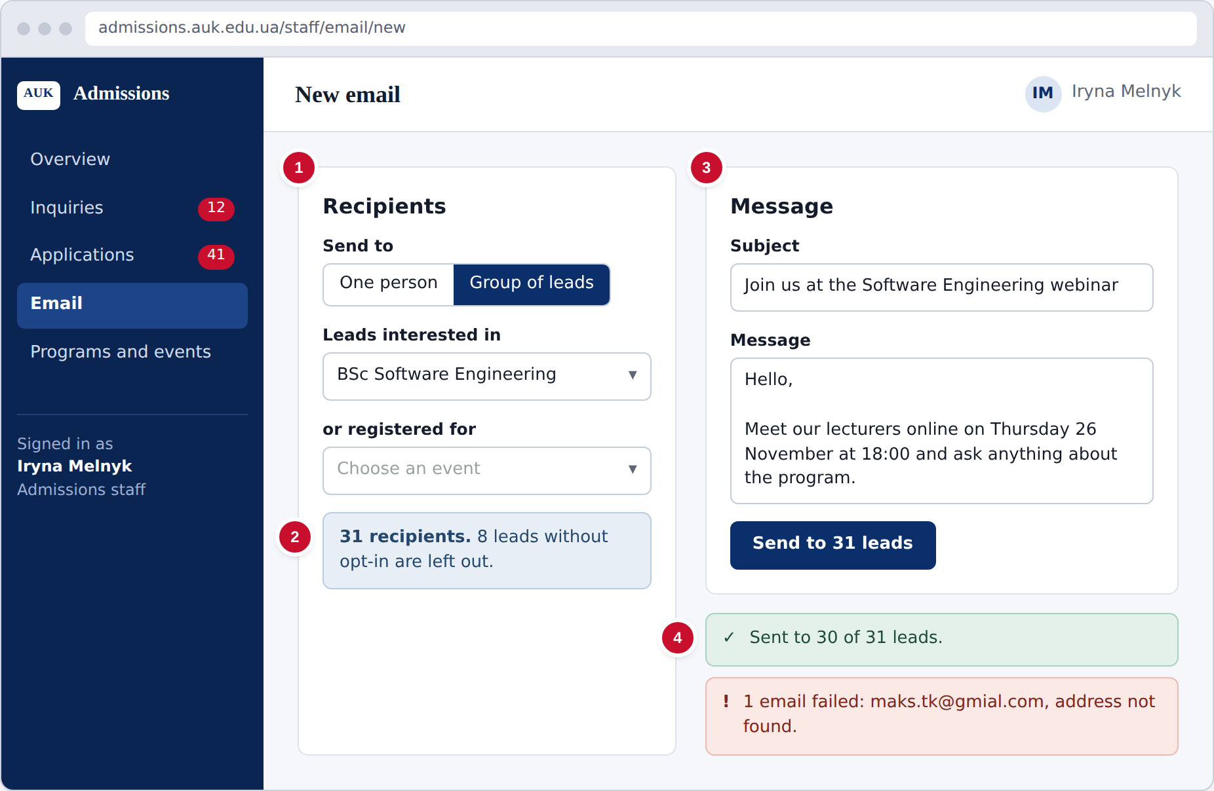
Figure 8. Send email to a group of leads
- Choose Group of leads, then a program or an event. Choose One person to email a single lead or applicant.
- Check the recipient count. Leads who did not opt in are left out automatically.
- Write the subject and message and select Send.
- The result shows which emails were sent and which failed.
4.6 Manage programs, deadlines and events
Requirements: FR-06, FR-08. Staff keep the list of programs with their deadlines and create the events shown on the public pages.
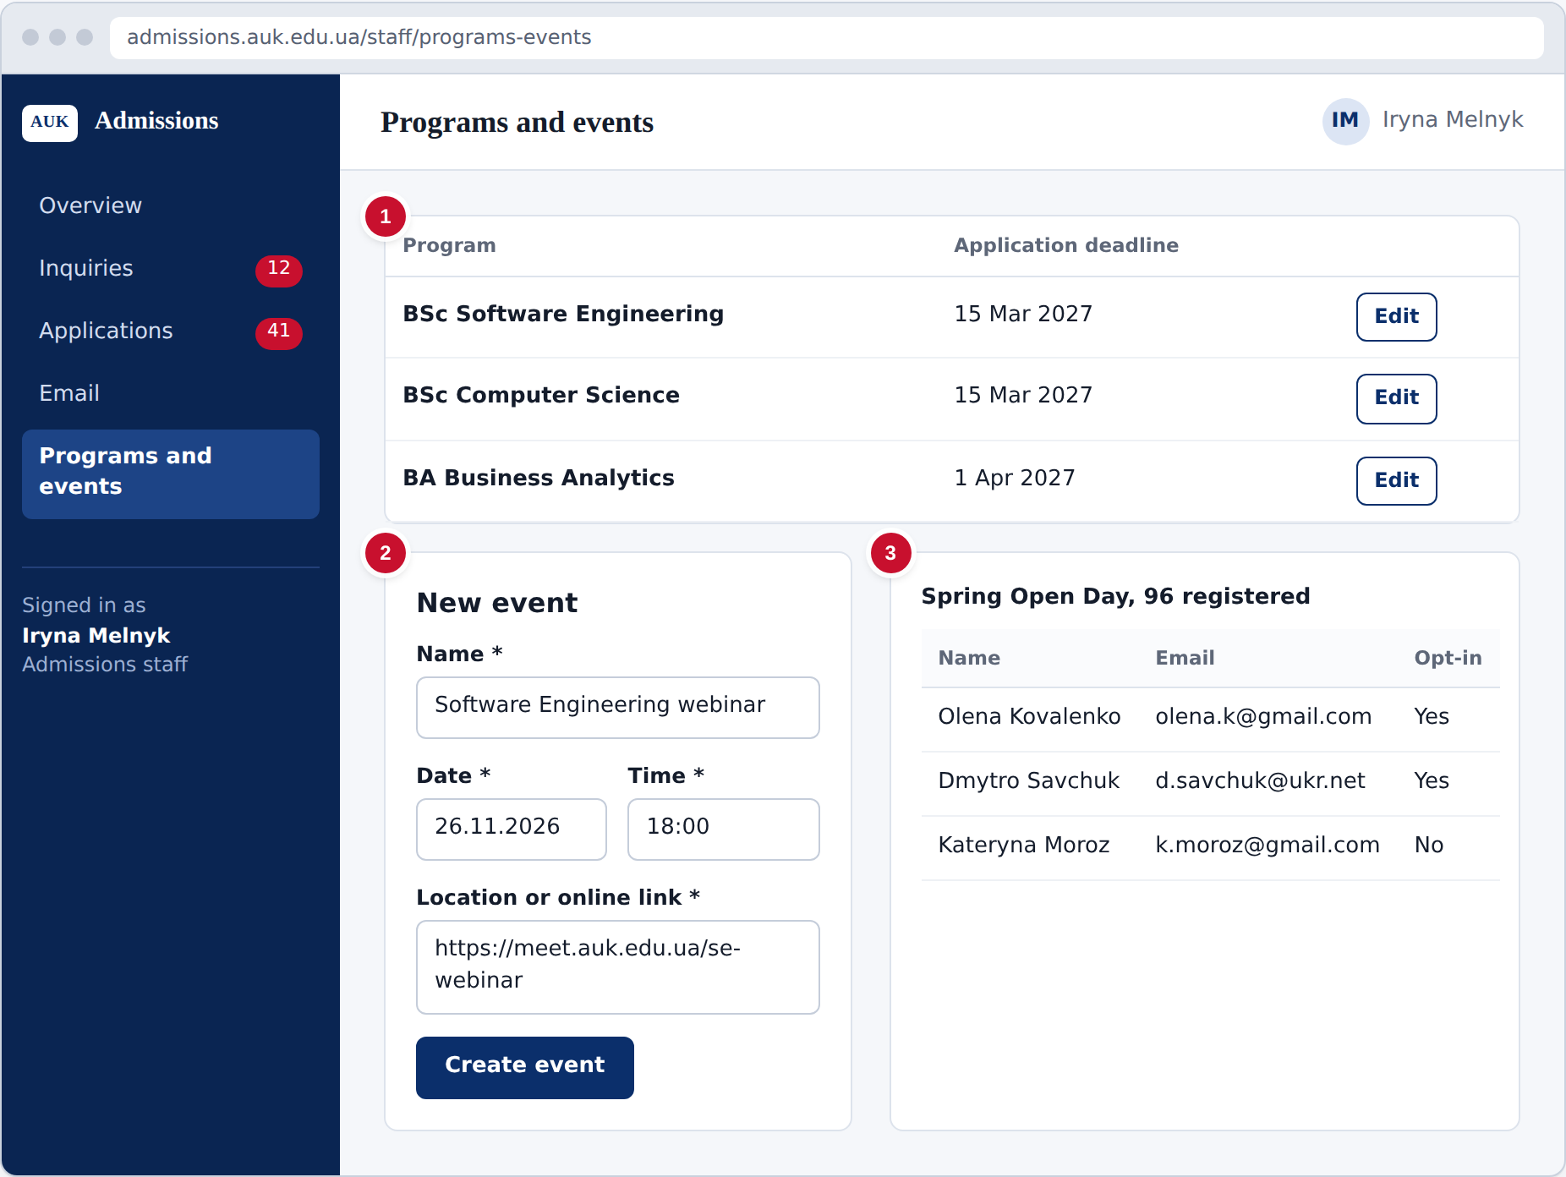
Figure 9. Manage programs, deadlines and events
- Add programs and select Edit to set each deadline. After the deadline, new applications and edits for that program are refused.
- Create an event with its name, date, time and location or online link. It appears on the public pages.
- Select an event to see its registration list.

Project Schedule
