PHASE II REPORT
Admissions, Recruitment & Outreach Platform
Team 4
Bogdan Borachuk
Lev Lavryniuk
Antonii Maltsev
October 20, 2026
Public GitHub repository: https://github.com/levlavryniuk/intro-to-sw
Use Case Diagram and Use Case Scenarios
Use Case Diagram
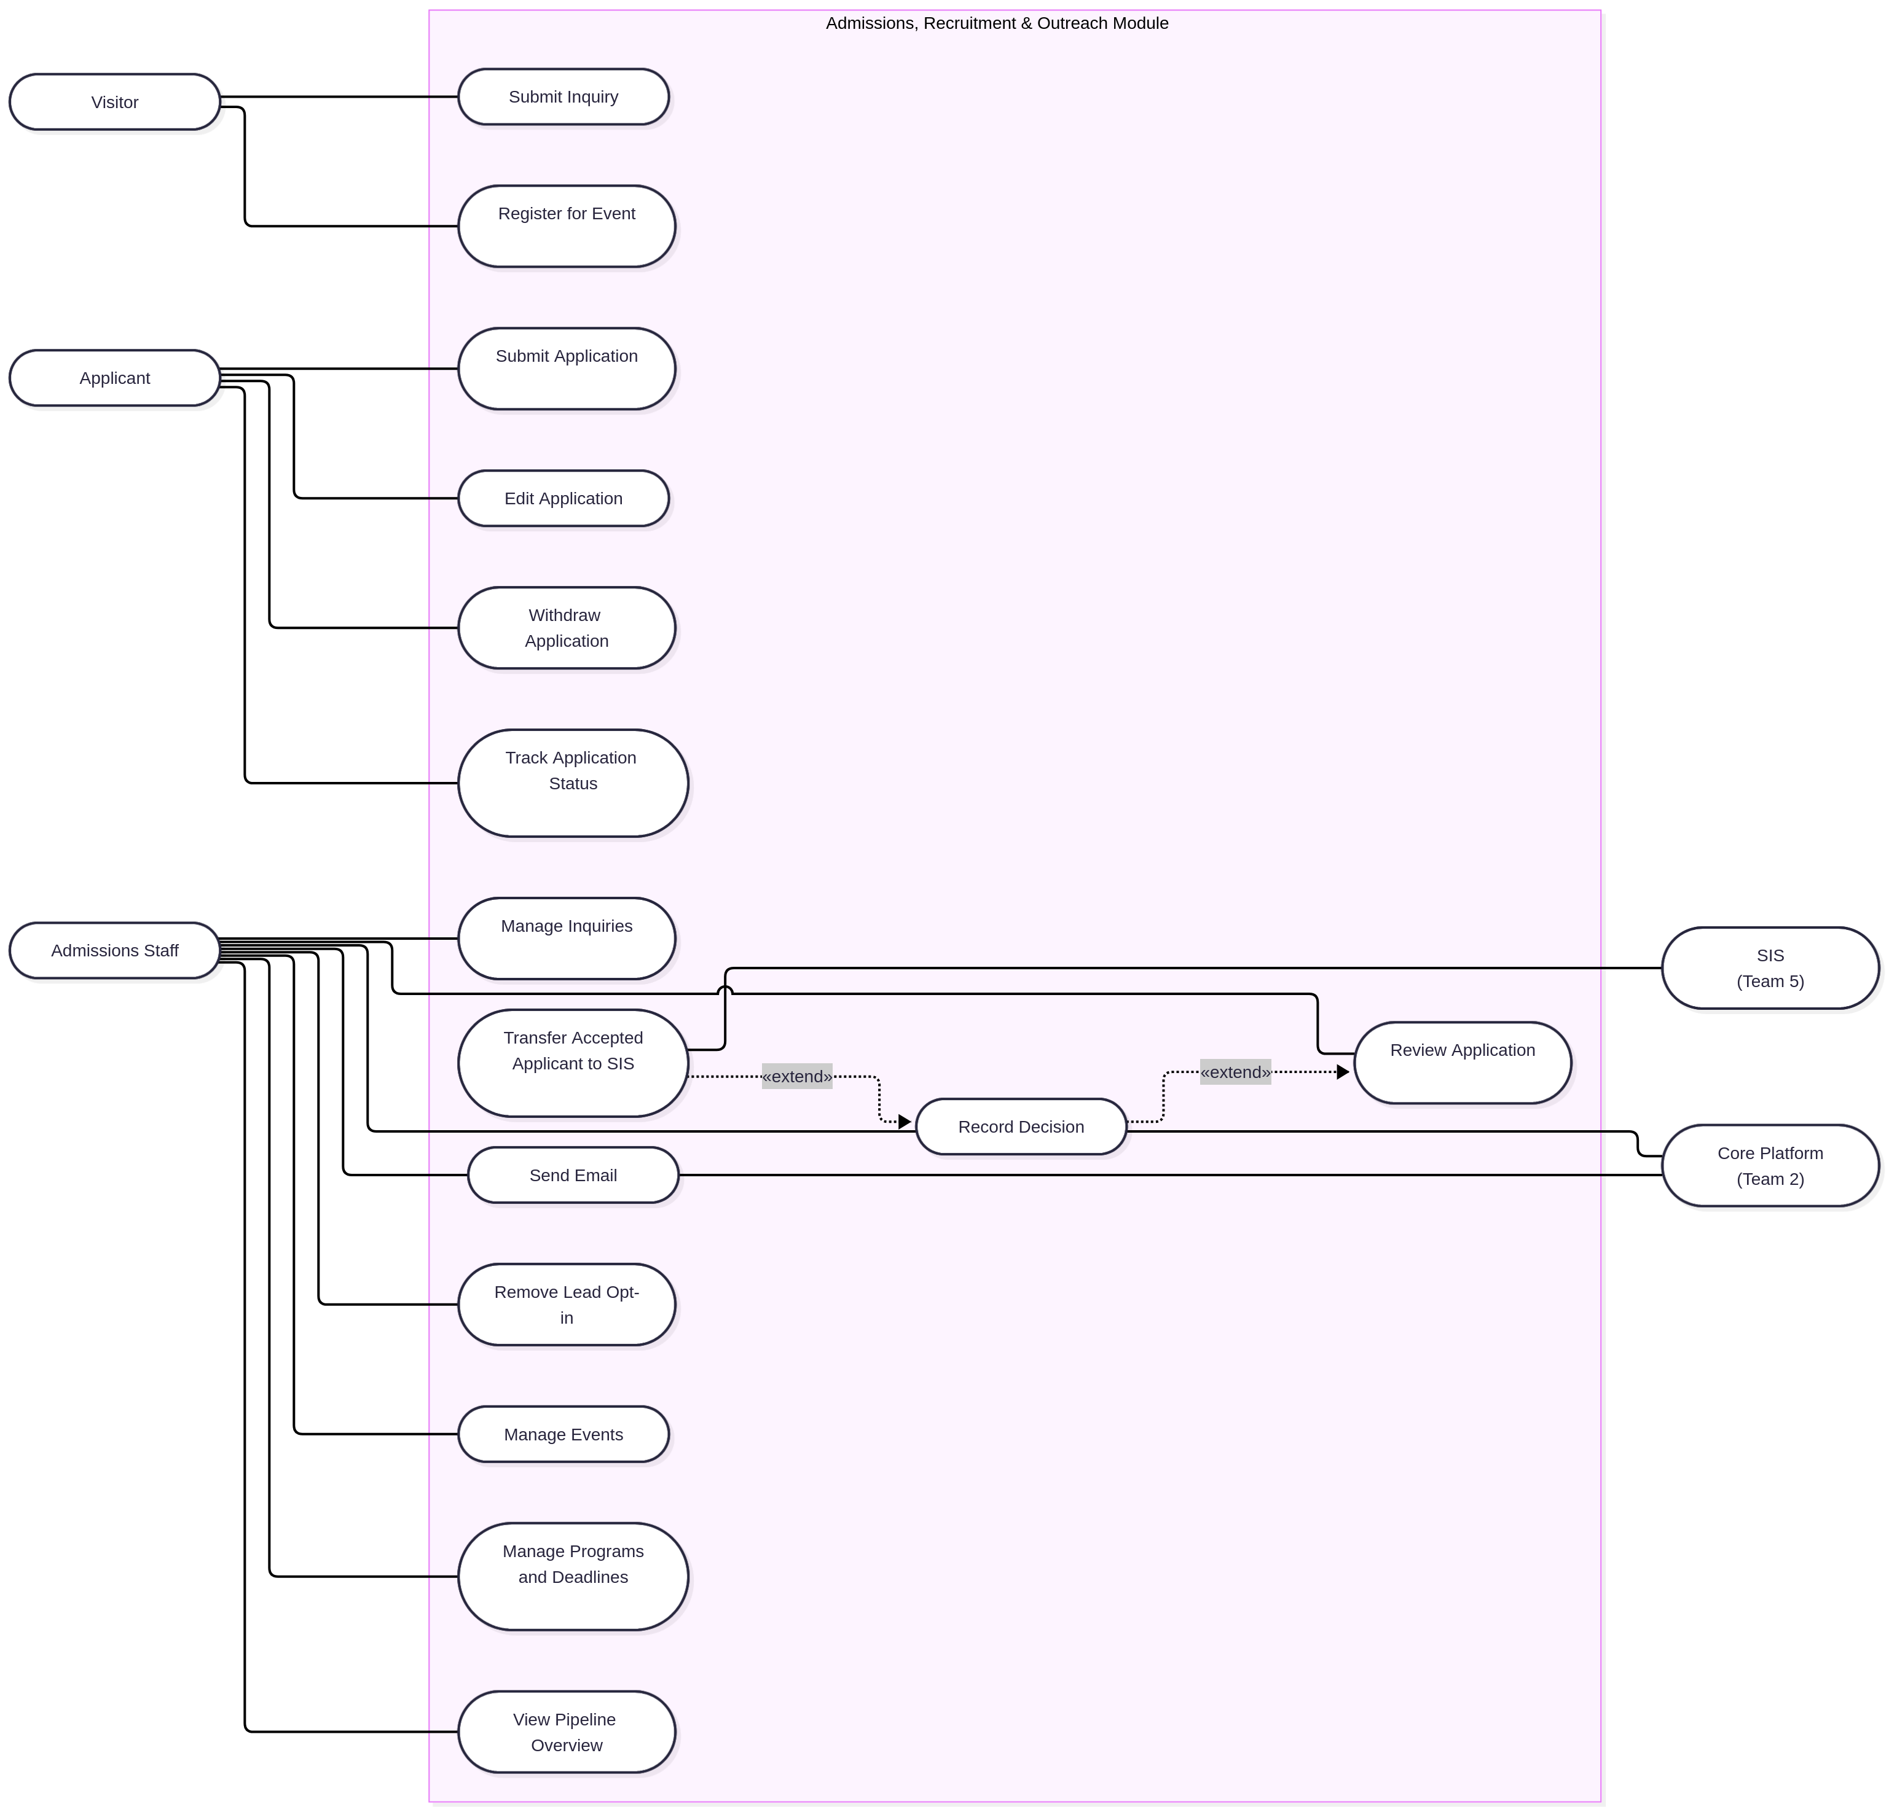
Use case diagram of the Admissions, Recruitment & Outreach module
Use Case Scenarios
Sign-in for applicants and staff is provided by the Core Platform (Team 2), so every use case done by a signed-in user assumes the user is already signed in. Until the shared sign-in exists, the module uses the local sign-in from the Phase 1 overview.
UC-1 Submit Inquiry
Description. A visitor asks the admissions office about a program. The visitor becomes a lead.
Primary actor. Visitor
Requirements. FR-01
Basic flow.
- The visitor opens the public inquiry page.
- The visitor enters a name and email address, chooses a program of interest, optionally types a question, and ticks the promotional email box only if they want those emails.
- The visitor selects Send inquiry.
- If the name is empty, the email address is not valid or no program is chosen, the system shows a message next to the field, keeps everything else that was typed, and goes back to step 2.
- Otherwise the system saves the inquiry and the opt-in choice. If a lead with the same email address already exists, the inquiry is attached to that lead; if not, a new lead is created.
- The system confirms on screen that the inquiry was received.
UC-2 Register for Event
Description. A visitor signs up for a recruitment event such as an open day or a webinar. The visitor becomes a lead.
Primary actor. Visitor
Requirements. FR-06
Basic flow.
- The visitor opens the public events page and picks an upcoming event from the list.
- The visitor enters a name and email address and chooses whether to receive promotional email.
- The visitor selects Register.
- If the name or email is missing or invalid, the system shows a message and goes back to step 2.
- If this email address is already registered for the event, the system says so and does not create a second registration.
- Otherwise the system saves the registration, attaches it to the lead with that email address (creating the lead if needed) and confirms on screen.
UC-3 Submit Application
Description. An applicant applies to one program by filling in a form and uploading the three required documents.
Primary actor. Applicant
Requirements. FR-02, FR-03, FR-08
Basic flow.
- The applicant opens the application page. If the applicant already has an application, the system shows it instead and the use case ends, because only one application per applicant is allowed.
- The applicant chooses a program. The system shows the program’s deadline.
- If the deadline has passed, the system tells the applicant the program is closed and the use case ends.
- The applicant fills in contact information and educational background: last school attended, graduation year and grade average.
- The applicant uploads the academic transcript, the proof of identity and the motivation essay. The system checks each file on the server. If a file is not a PDF or is larger than 15 MB, it is rejected with a message and the other files stay as they are.
- The Submit application button stays disabled until every required field is filled in and all three documents are uploaded.
- The applicant selects Submit application. The system saves the application with status Submitted, writes the first entry in the decision log and shows the application status page.
UC-4 Edit Application
Description. An applicant corrects the details or replaces a document of an application that nobody has started reviewing.
Primary actor. Applicant
Requirements. FR-02, FR-03, FR-08
Basic flow.
- The applicant opens their application.
- If the status is anything other than Submitted, the system does not offer Edit application and the use case ends.
- If the program’s deadline has passed, the system refuses the edit with a message and the use case ends.
- The applicant changes fields, replaces documents, or both. Uploaded files are checked as in UC-3: PDF only, 15 MB at most.
- The applicant selects Save. If a required field is now empty or invalid, the system shows a message and the applicant goes back to step 4. Otherwise the system saves the changes and shows the updated application.
UC-5 Withdraw Application
Description. An applicant withdraws an application before a decision has been made on it.
Primary actor. Applicant
Requirements. FR-02, FR-09
Basic flow.
- The applicant opens their application and selects Withdraw.
- If staff have already recorded a decision, the system does not offer Withdraw and the use case ends.
- The system asks the applicant to confirm. If the applicant cancels, nothing changes.
- On confirmation the system sets the status to Withdrawn, adds a decision log entry with the applicant as the user, and shows the new status. A withdrawn application is closed and cannot be edited.
UC-6 Track Application Status
Description. An applicant checks where their application stands.
Primary actor. Applicant
Requirements. FR-02, FR-05
Basic flow.
- The applicant opens the My application page.
- If the applicant has not submitted an application, the system invites them to start one (UC-3) and the use case ends.
- Otherwise the system shows the current status: Submitted, Under review, Waitlisted, Accepted, Conditional offer, Rejected, Withdrawn or Enrolled.
- If the status is Conditional offer, the system also shows the condition staff entered.
- The page lists the decision emails the system has sent to the applicant.
UC-7 Manage Inquiries
Description. Admissions staff go through the incoming inquiries and mark which ones deserve a follow-up.
Primary actor. Admissions Staff
Requirements. FR-01
Basic flow.
- Staff open the inquiry list. It shows every inquiry, newest first.
- Staff can filter the list by program. If nothing matches, the list says so.
- Staff open an inquiry and read the name, email, program, question and opt-in choice.
- Staff set the interest to High, Medium or Low, and the system saves it. Staff can change it again at any time.
- If staff want to reply, they continue with UC-10 Send Email, with this lead already filled in as the recipient.
UC-8 Review Application
Description. Admissions staff find an application, read it and its documents, and look at what has happened to it so far.
Primary actor. Admissions Staff
Requirements. FR-03, FR-04, FR-09
Basic flow.
- Staff open the applications list, which shows every application.
- Staff narrow the list by program, by status, or both. If nothing matches, the list says so.
- Staff select an application. The system shows the applicant’s details, the chosen program and the current status.
- Staff open each of the three documents. The system serves them only to signed-in staff; a document link is never publicly reachable.
- Staff read the decision log: every status change with the user who made it and the date and time.
- If staff want to change the status, they continue with UC-9 Record Decision.
UC-9 Record Decision
Description. A staff member sets a new status on an application and the applicant is told about it. The same steps are used to change an earlier decision.
Primary actor. Admissions Staff
Supporting actor. Core Platform (sends the email)
Requirements. FR-04, FR-05, FR-09
Basic flow.
- From the review screen (UC-8), staff choose a status: Under review, Accepted, Conditional offer, Waitlisted, Rejected or Enrolled.
- If the status is Conditional offer and the condition text is empty, the system asks for it and goes back to step 1.
- Staff select Save status.
- The system saves the new status and the condition, if any, and adds a decision log entry with the staff member’s name, the old and new status, and the current date and time.
- The system sends the applicant an email about the decision through the Core Platform’s mail service.
- If sending fails, the new status stays saved and the screen tells staff that the email failed. Otherwise it confirms that the email was sent.
- If the new status is Accepted, the system continues with UC-15.
UC-10 Send Email
Description. Staff write an email to one person or to a group of leads.
Primary actor. Admissions Staff
Supporting actor. Core Platform (sends the email)
Requirements. FR-05
Basic flow.
- Staff choose One person or Group of leads.
- For One person, staff pick a lead or an applicant. The email goes out whether or not the lead opted in, because it is a personal reply.
- For Group of leads, staff pick a program or an event. The system builds the recipient list from the leads that opted in, leaves the others out and shows how many people will get the email. If the count is zero, the system says so and staff go back to step 1.
- Staff write a subject and a message and select Send.
- If the subject or the message is empty, the system asks for it and goes back to step 4.
- The system hands each email to the Core Platform’s mail service and shows the result: which emails were sent and which failed.
UC-11 Remove Lead Opt-in
Description. A lead asks to stop receiving promotional email and staff switch it off.
Primary actor. Admissions Staff
Requirements. FR-05
Basic flow.
- Staff find the lead in the inquiry list or in an event’s registration list.
- Staff select Remove opt-in.
- If the lead has already opted out, the system tells staff there is nothing to change.
- Otherwise the system clears the opt-in and confirms. From then on, group emails (UC-10) skip this lead.
UC-12 Manage Events
Description. Staff create recruitment events and look at who registered.
Primary actor. Admissions Staff
Requirements. FR-06
Basic flow.
- Staff open the events page and select Create event.
- Staff enter a name, a date and time, and either a location or an online link.
- If the name, date, or both location and link are missing, the system shows a message and goes back to step 2.
- Otherwise the system saves the event and it appears on the public events page.
- To see who signed up, staff select an event. The system lists each registration with name, email and opt-in choice, or says that nobody has registered yet.
UC-13 Manage Programs and Deadlines
Description. Staff keep the list of programs and the application deadline of each one.
Primary actor. Admissions Staff
Requirements. FR-08
Basic flow.
- Staff open the programs page, which lists each program with its deadline.
- To add a program, staff select Add program and enter its name. A program with the same name as an existing one is refused with a message.
- To set or change a deadline, staff select Edit on a program and enter a date, and the system saves it.
- From the end of that date, the system refuses new applications (UC-3) and edits (UC-4) for the program. Moving the deadline to a later date opens the program again.
UC-14 View Pipeline Overview
Description. Staff see how many people are at each point of the admissions pipeline.
Primary actor. Admissions Staff
Requirements. FR-07
Basic flow.
- Staff open the overview page.
- The system shows the total number of inquiries and the total number of event registrations.
- The system shows the applications grouped in three stages, with the count for each status inside the stage: Applied (Submitted, Under review, Waitlisted), Admitted (Accepted, Conditional offer) and Enrolled.
- Rejected and withdrawn applications are shown as closed, outside the three stages.
- If there is no data yet, all counts are shown as zero.
UC-15 Transfer Accepted Applicant to SIS
Description. When an applicant is accepted, the module passes the applicant’s data to the Student Registration & Records module so a student record can be created there.
Primary actor. Admissions Staff, through Record Decision (UC-9)
Supporting actor. SIS (Team 5)
Requirements. FR-10
Basic flow.
- UC-9 saves a status of Accepted.
- The system sends the applicant’s contact details, program and decision to the SIS module.
- If the SIS confirms, the system notes on the application that the transfer is done.
- If the SIS cannot be reached or refuses the data, the application stays Accepted, the transfer stays pending and staff see a warning.
The format of the data and the call itself are not defined yet. They will follow the SIS API once Team 5 publishes it.
Requirements coverage
Requirement | Covered by
FR-01 Inquiries | UC-1, UC-7
FR-02 Applications | UC-3, UC-4, UC-5, UC-6
FR-03 Documents | UC-3, UC-4, UC-8
FR-04 Review and decisions | UC-8, UC-9
FR-05 Email | UC-6, UC-9, UC-10, UC-11
FR-06 Events | UC-2, UC-12
FR-07 Pipeline overview | UC-14
FR-08 Programs and deadlines | UC-13 (enforced in UC-3, UC-4)
FR-09 Decision log | UC-3, UC-5, UC-8, UC-9
FR-10 Integration | UC-15 (SIS), UC-9 and UC-10 (Core Platform mail), sign-in as a precondition
Object Identification and CRC Cards
Object Identification
Use case | Outside the system | Inside the system
UC-1 Submit Inquiry | Visitor | Lead, Inquiry, Program
UC-2 Register for Event | Visitor | Lead, Event, EventRegistration
UC-3 Submit Application | Applicant | Applicant, Program, Application, Document, StatusChange
UC-4 Edit Application | Applicant | Applicant, Program, Application, Document
UC-5 Withdraw Application | Applicant | Applicant, Application, StatusChange
UC-6 Track Application Status | Applicant | Applicant, Application, EmailMessage
UC-7 Manage Inquiries | Admissions Staff | StaffMember, Inquiry, Lead, Program
UC-8 Review Application | Admissions Staff | StaffMember, Application, Program, Document, StatusChange
UC-9 Record Decision | Admissions Staff, Core Platform | StaffMember, Application, StatusChange, EmailMessage, MailGateway
UC-10 Send Email | Admissions Staff, Core Platform | StaffMember, Lead, Applicant, Application, Program, Event, EventRegistration, EmailMessage, MailGateway
UC-11 Remove Lead Opt-in | Admissions Staff | StaffMember, Lead, Inquiry, Event, EventRegistration
UC-12 Manage Events | Admissions Staff | StaffMember, Event, EventRegistration, Lead
UC-13 Manage Programs and Deadlines | Admissions Staff | StaffMember, Program
UC-14 View Pipeline Overview | Admissions Staff | StaffMember, PipelineReport, Inquiry, EventRegistration, Application
UC-15 Transfer Accepted Applicant to SIS | Admissions Staff, SIS | StaffMember, Application, SisGateway
CRC Cards
Objects outside the system
Visitor
Responsibilities | Collaborators
Asks the admissions office about a program (UC-1) | Lead, Inquiry, Program
Registers for recruitment events (UC-2) | Lead, Event, EventRegistration
Chooses whether to receive promotional email | Lead

Applicant (person)
Responsibilities | Collaborators
Fills in and submits one application with the three required documents (UC-3) | Applicant, Application, Document
Corrects or withdraws the application while that is still allowed (UC-4, UC-5) | Applicant, Application
Follows the status and reads the decision emails (UC-6) | Applicant, Application, EmailMessage

Admissions Staff (person)
Responsibilities | Collaborators
Rates inquiries and reviews applications (UC-7, UC-8) | StaffMember, Inquiry, Application
Records decisions on applications (UC-9) | StaffMember, Application
Writes emails to leads and applicants and removes opt-ins (UC-10, UC-11) | StaffMember, EmailMessage, Lead
Maintains events, programs and deadlines (UC-12, UC-13) | StaffMember, Event, Program
Follows the pipeline overview (UC-14) | StaffMember, PipelineReport

Core Platform (Team 2)
Responsibilities | Collaborators
Signs applicants and staff in and gives each one a platform account id | User
Delivers the emails the module hands over and reports whether each one went through (UC-9, UC-10) | MailGateway, EmailMessage

SIS (Team 5)
Responsibilities | Collaborators
Receives accepted applicants and creates a student record for each (UC-15) | SisGateway, Application
Confirms or refuses each transfer | SisGateway
Users
User (abstract)
Responsibilities | Collaborators
Knows the name, email address and platform account id of a signed-in person | Core Platform
Decides whether this person may open a given application (NFR-01) | Application
Is recorded as the person who made a status change | StatusChange

Applicant
Responsibilities | Collaborators
Owns at most one application (FR-02) | Application
Starts an application for a program that is still open (UC-3) | Program, Application
Asks for edits to its own application and for its withdrawal (UC-4, UC-5) | Application
Shows its application and the decision emails sent to it (UC-6) | Application, EmailMessage

StaffMember
Responsibilities | Collaborators
Lists and filters inquiries and rates their interest (UC-7) | Inquiry, Program
Lists and filters applications, opens documents and reads the decision log (UC-8) | Application, Program, Document, StatusChange
Records decisions on applications (UC-9) | Application, StatusChange
Writes single and group emails and removes opt-ins (UC-10, UC-11) | EmailMessage, Lead, Program, Event, MailGateway
Creates events and looks at their registrations (UC-12) | Event, EventRegistration
Adds programs and sets their deadlines (UC-13) | Program
Opens the pipeline overview (UC-14) | PipelineReport
Prospects
Lead
Responsibilities | Collaborators
Knows the name and email address of a prospective student; one lead per email address | None
Keeps the inquiries and event registrations the lead made | Inquiry, EventRegistration
Knows whether the lead accepts promotional email and switches it off on request (UC-11) | None
Says whether it may receive a group email (FR-05) | EmailMessage

Inquiry
Responsibilities | Collaborators
Knows the question, the program asked about and when it was sent (UC-1) | Lead, Program
Holds the interest rating staff give it: high, medium or low (UC-7) | StaffMember

Event
Responsibilities | Collaborators
Knows its name, date and time, and location or online link (UC-12) | None
Registers a lead and refuses a second registration with the same email address (UC-2) | Lead, EventRegistration
Lists its registrations and the opted-in leads who signed up (UC-10, UC-12) | EventRegistration, Lead

EventRegistration
Responsibilities | Collaborators
Records that one lead registered for one event, and when | Lead, Event
Applications
Program
Responsibilities | Collaborators
Knows its name and application deadline | None
Says whether new applications and edits are still accepted (FR-08) | Application
Changes its deadline when staff set a new date (UC-13) | StaffMember
Lists the opted-in leads who asked about it, for group emails (UC-10) | Inquiry, Lead

Application
Responsibilities | Collaborators
Knows the program, contact details, educational background and current status | Applicant, Program
Keeps the three required documents and says whether it is complete enough to submit (UC-3) | Document
Says whether it can still be edited: status Submitted and deadline not passed (UC-4) | Program
Changes its status, keeps the condition of a conditional offer and writes a decision log entry for every change (UC-5, UC-9) | StatusChange, User
Notes whether it has been passed to the SIS (UC-15) | SisGateway

Document
Responsibilities | Collaborators
Knows its type, file name, content type, size and where the file is stored | Application
Checks that it is a PDF of at most 15 MB (FR-03) | None

StatusChange
Responsibilities | Collaborators
Records the old and new status, who made the change and when; never edited once written (FR-09) | Application, User
Email
EmailMessage
Responsibilities | Collaborators
Knows the subject, body, sender and recipient | StaffMember, Lead, Applicant
Records whether it is pending, sent or failed, and why it failed (UC-9, UC-10) | MailGateway
Appears on the applicant’s status page when it is a decision email (UC-6) | Applicant

MailGateway
Responsibilities | Collaborators
Hands each email to the Core Platform’s mail service and returns the delivery result | EmailMessage, Core Platform
Hides which mail service is used, so the test mail server can be replaced by Team 2’s service | None
Integration and reporting
SisGateway
Responsibilities | Collaborators
Passes an accepted applicant’s contact details, program and decision to the SIS (UC-15) | Application, SIS
Reports whether the SIS took the data, so the transfer is marked done or stays pending | Application, SIS

PipelineReport
Responsibilities | Collaborators
Counts inquiries and event registrations (UC-14) | Inquiry, EventRegistration
Counts applications per status and groups them into stages; rejected and withdrawn ones are closed | Application
Class Diagram and Class Descriptions
Class Diagram
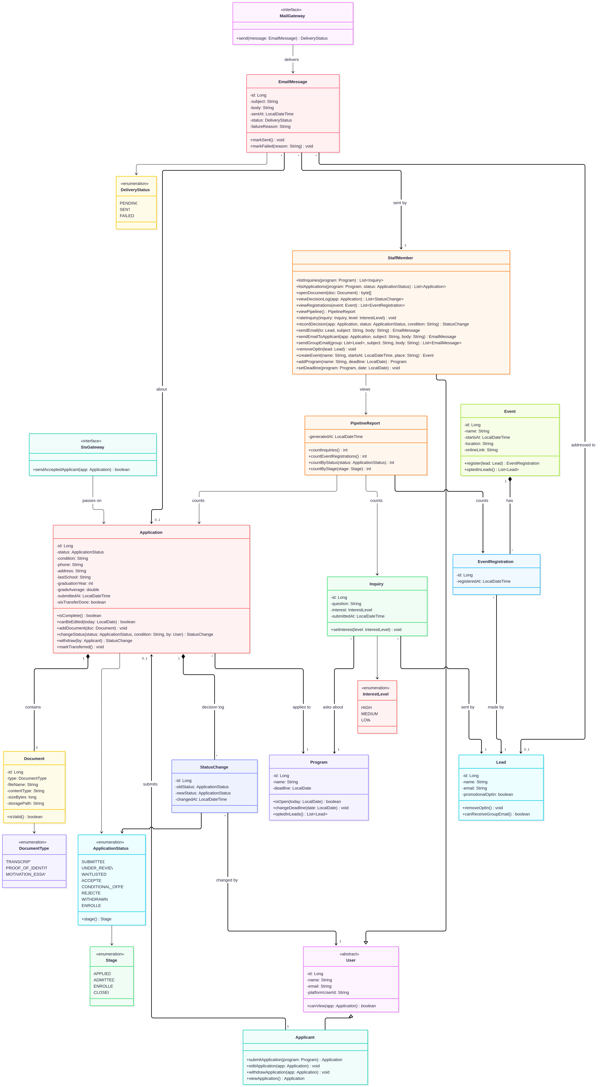
Class Descriptions
The module is built in Java with Spring Boot and MySQL, so most classes below become Spring Boot entities stored in MySQL. The enumerations, the two gateways and PipelineReport are not stored. Sign-in belongs to the Core Platform (Team 2); the module keeps only a reference to the platform account.
Users
User is the abstract base for everyone who signs in. It holds a name, an email address and platformUserId, the id of the matching account in the Core Platform. It exists so that Applicant and StaffMember share these fields and so that a StatusChange can point at “whoever made the change” without caring which kind of person it was. Its one operation, canView, answers the access rule from NFR-01: an applicant can open only their own application, staff can open any.
Applicant is a visitor who has created an account and applies to a program. An applicant owns at most one Application (FR-02) and can submit, edit, withdraw and look at it. The class mostly hands the real work to Application; it decides who is allowed to ask for it.
StaffMember is an admissions employee. Staff rate inquiries, record decisions, send single and group emails, remove opt-ins, and maintain events, programs and deadlines. They can also list and filter inquiries and applications, open documents, read the decision log, see an event’s registrations and open the pipeline overview. Each operation matches one use case from UC-7 to UC-14. Every decision a staff member records ends up in the log as a StatusChange with their name on it, and it also produces the decision email to the applicant (UC-9).
Prospects
Lead is a visitor who has sent an inquiry or registered for an event. A lead is identified by their email address, so a person who does both is still one lead. The class stores the promotional-email choice, which is what group emails check before sending (FR-05).
Inquiry is one message from a lead about one program. It carries the optional question and the interest rating staff give it by hand (high, medium or low). A lead can send many inquiries, which is why the inquiry is its own class and not a field on Lead.
Event is a recruitment event such as an open day or a webinar. It has a date and time and either a location or an online link. It creates registrations and can list the opted-in leads who signed up, which is what a group email to an event uses.
EventRegistration records that one lead registered for one event. It has no behaviour of its own. It is separate from Event and Lead so that the same lead can attend many events, and so that staff can see the registration list for an event (FR-06).
Applications
Program is something a student can apply to. It has a name and an application deadline. isOpen is the single place that decides whether new applications and edits are still accepted (FR-08), and optedInLeads returns the leads who asked about the program, for group emails.
Application is the center of the module. It holds the status, the optional condition of an offer, the contact details and the educational background (last school, graduation year, grade average). It knows whether it is complete enough to submit (all fields and all three documents) and whether it can still be edited. Every status change goes through it, so a log entry is always written. sisTransferDone tells us whether an accepted applicant has been handed to the SIS yet.
Document is one uploaded file: a transcript, a proof of identity or a motivation essay. It stores the file name, content type, size and where the file lives on disk. isValid checks the rules from FR-03 (PDF, at most 15 MB). An application always has exactly three.
StatusChange is one line of the decision log (FR-09): the old and new status (the first entry, made when an application is submitted, has no old status), who changed it and when. Entries are created and never edited, and they belong to the application so they disappear with it. It is a plain record with no behaviour of its own.
Email
EmailMessage is a message the module sends, whether a personal reply, a group email or an automatic decision email. It keeps the subject, body, who sent it, who it was for and whether it went through. Applicants see the decision emails on their status page (UC-6), and staff see the sent or failed result after sending (FR-05).
MailGateway is the only way the module sends mail. It hides the Core Platform’s messaging service behind one operation. Until Team 2’s service exists the implementation talks to a test mail server, and nothing else in the module has to change when that is swapped.
Integration and reporting
SisGateway is the matching boundary to the Student Registration & Records module (Team 5). Its one operation passes an accepted application on so a student record can be created (FR-10). The real call is not defined yet; this interface marks the place it will plug in.
PipelineReport computes the numbers on the overview screen (FR-07): inquiries, event registrations, and applications per status and per stage. It stores nothing; it counts what is already in the database when staff open the page.
Enumerations
ApplicationStatus lists the eight statuses an application can have. stage() maps each to a Stage, which is how the pipeline overview groups them.
Stage is applied, admitted, enrolled or closed. Rejected and withdrawn applications are closed.
DocumentType names the three required documents.
InterestLevel is the high, medium or low rating staff give an inquiry.
DeliveryStatus says whether an email is still pending, was sent or failed.
Where each class is used
Class | Use cases
User, Applicant | UC-3, UC-4, UC-5, UC-6
StaffMember | UC-7 to UC-14
Lead | UC-1, UC-2, UC-7, UC-10, UC-11
Inquiry | UC-1, UC-7
Event, EventRegistration | UC-2, UC-10, UC-11, UC-12
Program | UC-1, UC-3, UC-4, UC-10, UC-13
Application | UC-3 to UC-10, UC-14, UC-15
Document | UC-3, UC-4, UC-8
StatusChange | UC-3, UC-5, UC-8, UC-9
EmailMessage, MailGateway | UC-6, UC-9, UC-10
SisGateway | UC-15
PipelineReport | UC-14
ApplicationStatus, Stage | UC-6, UC-9, UC-14
DocumentType | UC-3, UC-4
InterestLevel | UC-7
DeliveryStatus | UC-9, UC-10
Test Plan for Functional Testing
What We Test
The plan checks that the module does what use cases UC-1 to UC-15 describe. Test cases are taken straight from the scenarios: the basic flow gives one case, and each “if” step in a scenario (an alternative or an error) gives at least one more. We also test the access rules from NFR-01 and the server-side checks from NFR-06, since they decide what a user is allowed to do.
Performance, accessibility and browser support (NFR-03 to NFR-05) are not functional tests, so they wait for the testing report in Phase IV. The Core Platform (Team 2) and the SIS (Team 5) have no interface yet. Until they do, UC-9, UC-10 and UC-15 are tested against a fake mail gateway and an SIS stub, and we will repeat them when the real services exist.
How We Design the Cases
We use three techniques from the use-case based testing lecture. Scenario coverage means every path through every scenario runs at least once. Equivalence classes split the inputs into valid and invalid groups, for example a PDF, a file that is not a PDF, and no file at all. Boundary values test a limit and the value just past it: a 15 MB document passes and 15 MB plus one byte fails, and an application on the deadline date is accepted while one a day later is refused.
A case is run in one of three ways, shown in the last column of the table. Auto cases are JUnit 5 tests in the GitHub repository. Most of them start the whole module (Spring Boot, database and security) and call the REST API the way the web pages do. Each test name begins with the case ID, such as “TC-3.4 A file that is not a PDF is rejected”, and ./mvnw test runs them all. Manual cases are done by a person in the React app, because only the screen shows the result: a disabled button, a confirmation dialog, values that stay in a form after an error. Both means the server part is automated and someone also looks at the screen.
Environment and Test Data
The tests run on Java 17 and Spring Boot 3.5 with MySQL 8, or an in-memory H2 database when we want a quick run. Manual tests use the latest Chrome, Firefox and Edge. Each automated test creates its own accounts, programs and leads, so the tests do not depend on each other or on their order.
The data covers four programs (deadline in the future, today, in the past, and none), small valid PDFs, a PDF of exactly 15 MB and one a byte larger, and a Word file and a PNG renamed to .pdf. The server looks at the file content, not the name. The fake mail and SIS gateways record what they were sent and can be told to fail, which is how we reach the error paths.
Passing, Failing and Schedule
Testing starts when the scenarios are agreed, the code builds and the demo data loads. A case passes only if the result matches the expected result, including the message the user sees. We are done when all automated tests pass and every manual case has been run once on the version we submit; any defects still open go into the phase report. A failure is logged in Jira with the case ID, the steps, the expected and actual result and a severity (blocker, major or minor). After a fix we rerun that case and the other cases of the same use case.
When | What | Who
Phase II (Oct 20) | Test plan; automated tests for the initial prototype pass. | Antonii
Every change | Run ./mvnw test before pushing. A change that breaks a test is not merged. | Everyone
Phase III (Nov 10) | Tests for the new code; first full manual run. | Antonii (automated), Bogdan and Lev (manual)
Phase IV (Nov 30) | Final run of every case; testing report. | Whole team
Test Cases
Cases of the same kind in one use case share a row, for example TC-3.4 to 3.5. Visitors are not signed in; applicants and staff are. Every use case assumes the data it needs already exists, such as an application with status Submitted, or leads with and without opt-in.
Use case | ID | Test case | Expected result | Run
UC-1 Submit Inquiry | TC-1.1 to 1.2 | Valid inquiry, with and without a question and opt-in | Confirmation shown; the lead is created with the chosen opt-in | Both
 | TC-1.3 to 1.5 | Empty name; email “anna@”; no program chosen | Message next to the field; nothing saved | Auto
 | TC-1.6 | Same email again in capitals, opt-in unticked | Still one lead; it takes the latest opt-in (No) | Auto
 | TC-1.7 | Error after the form was filled in | Typed values stay in the form | Manual
UC-2 Register for Event | TC-2.1 | Valid registration with opt-in | Confirmation; registration is in the event’s list for staff | Auto
 | TC-2.2 | Blank name; email “nope” | Message for each field; nothing saved | Auto
 | TC-2.3 | Same email registers twice for one event | “This email address is already registered for the event.”; still one registration | Auto
 | TC-2.4 to 2.5 | Email of an existing lead; public events page | One lead per email; only upcoming events are listed | Auto
UC-3 Submit Application | TC-3.1 | Complete form with three PDFs | Status Submitted; three documents listed; one decision log entry | Both
 | TC-3.2 | Second application by the same applicant | Refused; the first one is unchanged | Auto
 | TC-3.3, 3.8 | Deadline yesterday; deadline day and the day after | Closed program refused; accepted on the deadline date, refused the day after | Auto
 | TC-3.4 to 3.5 | Word file renamed .pdf; transcript of 15 MB and of 15 MB + 1 byte | Non-PDF rejected by content; 15 MB accepted, one byte more refused | Both
 | TC-3.6 to 3.7 | Only two documents; empty phone and graduation year 1900 | Message for each problem; no application created | Auto
 | TC-3.9 | Fill the form step by step | Submit stays disabled until all fields and all three documents are there | Manual
UC-4 Edit Application | TC-4.1 | Change the last school, replace the essay | New values shown; still three documents | Auto
 | TC-4.2 to 4.3 | Review has started; deadline has passed | Edit not offered and refused: “The application can only be edited while its status is Submitted.”; deadline message | Both
 | TC-4.4 to 4.5 | Required field emptied; replacement is not a PDF | Message; saved data and old document unchanged | Auto
UC-5 Withdraw Application | TC-5.1 | Withdraw and confirm | Status Withdrawn (Closed); log entry by the applicant; Edit and Withdraw gone | Auto
 | TC-5.2 | Cancel in the confirmation dialog | Nothing changes | Manual
 | TC-5.3 | Withdraw after staff recorded a decision | Withdraw not offered; request refused | Both
UC-6 Track Application Status | TC-6.1 to 6.3 | No application yet; after a decision; conditional offer | Invitation to apply; status and decision email listed; condition text shown | Auto
UC-7 Manage Inquiries | TC-7.1 to 7.2 | List; filter by a program, then by one with no inquiries | Newest first with all fields; only matching inquiries; “nothing matches” message | Auto
 | TC-7.3 | Set interest High, then Low | Each choice saved and shown after reload | Auto
 | TC-7.4 | Select Email on an inquiry | Send Email opens with the lead as recipient | Manual
UC-8 Review Application | TC-8.1 to 8.2 | Filter by program, status, both and a combination with no match; open an application | Exactly the matching applications; details shown; empty list says so | Auto
 | TC-8.3 to 8.4 | Open the three documents; open a document link as visitor, owner and other applicant | PDFs open for staff; visitor 401, applicants 403 | Both
 | TC-8.5 | Make two status changes | Each is logged with old and new status, user, date and time | Auto
UC-9 Record Decision | TC-9.1 | Set Under review | Saved; log entry with staff name; applicant emailed; screen confirms | Both
 | TC-9.2 to 9.3 | Conditional offer without and with a condition | Without: message, nothing changes. With: condition saved and in the email | Auto
 | TC-9.4 | Waitlisted, then Accepted | Accepted; log shows Waitlisted to Accepted | Auto
 | TC-9.5 | Mail service fails | Status saved; screen says the email failed and why | Auto
 | TC-9.6 to 9.7 | Enrolled before Accepted; decision on a withdrawn application | Enrolled refused until Accepted; closed application refused | Auto
UC-10 Send Email | TC-10.1 | One lead who did not opt in | Sent; a personal reply ignores opt-in | Auto
 | TC-10.2 to 10.3 | Group by program; group by event | Count and emails only for opted-in leads | Auto
 | TC-10.4 to 10.5 | Nobody opted in; empty subject and message | Message shown; nothing sent | Auto
 | TC-10.6 | Delivery fails for one of two recipients | Result lists one Sent and one Failed | Auto
UC-11 Remove Lead Opt-in | TC-11.1 to 11.2 | Remove opt-in; remove it again | Lead no longer counted for group emails; “This lead has already opted out. Nothing to change.” | Auto
UC-12 Manage Events | TC-12.1 to 12.2 | Event with a location; online event | Saved and shown on the public events page | Auto
 | TC-12.3 | No name and date; no location and no link | Message for each; “Enter a location or an online link.” | Auto
 | TC-12.4 | Registrations of a new event | Says nobody has registered yet | Auto
UC-13 Manage Programs and Deadlines | TC-13.1 to 13.2 | Add a program; add the same name in capitals | Listed without deadline; duplicate refused | Auto
 | TC-13.3 to 13.4 | Set a deadline; move a past deadline to next week | New deadline shown; program is open again and accepts an application | Auto
UC-14 View Pipeline Overview | TC-14.1 to 14.3 | Add data and reload; empty database; reject one and withdraw one | Counts rise by exactly what was added; all zero; rejected and withdrawn counted as Closed | Auto
UC-15 Transfer Accepted Applicant to SIS | TC-15.1 to 15.3 | Set Accepted; SIS not reachable; set Waitlisted | Sent once and marked done; stays Accepted, transfer pending, warning shown; nothing sent | Auto
Access control (NFR-01, NFR-06) | TC-A.1 to A.3 | Visitor on applicant and staff pages; applicant on staff pages; staff on applicant pages | Sign-in required (401); access denied (403) | Auto
 | TC-A.4 to A.5 | Withdraw without CSRF token; view another applicant’s application | Refused, application unchanged; not possible (staff see all) | Auto
Traceability
Requirement | Test cases
FR-01 Inquiries | TC-1.1 to 1.7, TC-7.1 to 7.4
FR-02 Applications | TC-3.1 to 3.9, TC-4.1 to 4.5, TC-5.1 to 5.3, TC-6.1 to 6.3
FR-03 Documents | TC-3.4 to 3.6, TC-4.1, TC-4.5, TC-8.3, TC-8.4
FR-04 Review and decisions | TC-8.1 to 8.5, TC-9.1 to 9.7
FR-05 Email | TC-6.2, TC-9.1, TC-9.3, TC-9.5, TC-10.1 to 10.6, TC-11.1 to 11.2
FR-06 Events | TC-2.1 to 2.5, TC-12.1 to 12.4
FR-07 Pipeline overview | TC-14.1 to 14.3
FR-08 Programs and deadlines | TC-13.1 to 13.4, TC-3.3, TC-3.8, TC-4.3
FR-09 Decision log | TC-3.1, TC-5.1, TC-8.5, TC-9.1, TC-9.4
FR-10 Integration | TC-9.5, TC-10.6, TC-15.1 to 15.3
NFR-01, NFR-06 | TC-8.4, TC-A.1 to A.5 and every invalid-input case above
Where We Are Now
There are 75 test cases: 62 automated, 8 automated with a manual check of the screen, and 5 manual. The automated ones are 80 JUnit tests in the repository under src/test/java (a few tests cover more than one case). On October 18, 2026 all 80 passed against the initial prototype, on H2 and on a real MySQL 8 server. The manual cases wait for Phase III, when the React screens are finished.

