LeVonte Abercrombie

June 30, 2024

Assignment 5

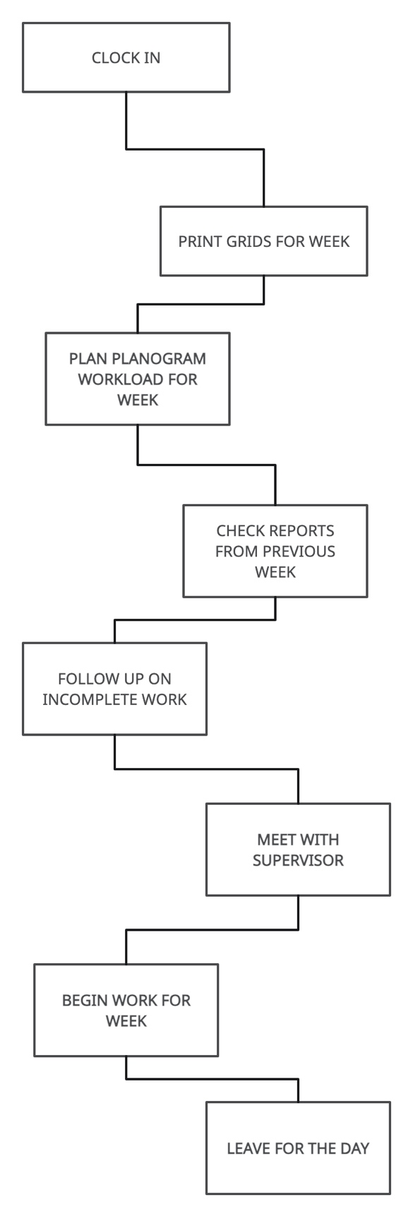

Optimizing the Process

Streamline Printing Grids:

* Automate the printing process to ensure grids are ready in advance, reducing initial wait time.

Efficient Planogram Planning:

* Use digital tools to plan the planogram workload more efficiently and reduce non-value-added time.

Report Checking:

* Implement a system for easy access and analysis of reports to reduce wait time.

Follow-up Efficiency:

* Create a follow-up tracker to ensure that previous week's tasks are completed promptly, minimizing follow-up time.

Meeting with Supervisor:

* Schedule regular, brief check-ins to keep meetings concise and productive.