User Manual: FLIMPA v2.0.0
Original publication
FLIMPA: A Versatile Software for Fluorescence Lifetime Imaging Microscopy Phasor Analysis

Sofia Kapsiani¹, Nino F. Läubli¹, Edward N. Ward¹, Mona Shehata², Clemens F. Kaminski¹, Gabriele S. Kaminski Schierle¹
¹Department of Chemical Engineering and Biotechnology, University of Cambridge, Cambridge, CB3 0AS, UK
²Analytical Sciences, Bioassay, Biosafety and Impurities, BioPharmaceutical Development, AstraZeneca, Cambridge, UK

* Corresponding author: gsk20@cam.ac.uk
___________________
FLIMPA v2.0.0: Additional features developed by Lev Gerasimov¹
¹Department of Chemical Engineering and Biotechnology, University of Cambridge, Cambridge, CB3 0AS, UK

Contents
1. Installation and getting started 4
1.1 System requirements 4
1.2 Installing from release — macOS (.dmg) 4
1.3 Installing from release — Windows (.exe) 4
1.4 Installing from source 4
1.5 First launch and main window layout 4
1.6 Menus: Load data, Reference, Mask save, Save data 4
2. Loading data 5
2.1 Supported file formats 5
2.2 Load data menu options 5
2.3 Loading .tif and .tiff files 5
2.4 Loading .ptu files 5
2.5 Loading data with manual masks 5
2.6 File list and sample data 6
3. Reference and calibration 6
3.1 Import reference file 6
3.2 Reference lifetime and donor τ_D for FRET 6
3.3 Import IRF 6
4. Running phasor plot analysis 6
5. Phasor plot 7
5.1 G and S axis labels 7
5.2 Visualisation modes and gallery Layers list 7
5.3 Phasor ROI (ellipse) 7
6. Image tabs and navigation 7
6.1 Intensity display and colormaps 7
6.2 Lifetime maps 8
6.3 FRET efficiency maps 8
6.4 Pan, zoom, and reset 8
7. Baseline check (decay curve inspector) 8
8. Masking 8
8.1 Masking tools (polygon, lasso, brush, delete region, eraser) 9
8.2 Mask save menu 9
8.3 Importing and re-importing saved masks 9
9. Results overview 10
9.1 Lifetime values table 10
9.2 Lifetime maps 10
9.3 Gallery (tau) and Gallery (I) 10
9.4 Violin plots 10
10. Saving and exporting data 10
10.1 Save data menu 10
10.2 Export phasor points (G, S) 11
11. Understanding the outputs (G, S, M, phi, row, col) 11
12. Troubleshooting and FAQ 11
Appendix A. Changes from FLIMPA 1.4.2 to 2.0.0 11

1. Installation and getting started
FLIMPA 2.0.0 is a modified fork of upstream FLIMPA v1.4.2 for phasor-plot analysis of TCSPC-FLIM data.

1.1 System requirements
• Python 3.11+ when running from source; macOS, Windows or Linux.
• Images ≤512×512 px are recommended; very large stacks can require substantial memory.
• Single files/samples are supported; time-lapse analysis is not supported.

1.2 Installing from release — macOS (.dmg)
Download FLIMPA.v2.0.0.dmg from the v2.0.0 fork release, open it, drag FLIMPA to Applications, and launch it. If Gatekeeper blocks the unsigned app, click on apple icon in top left corner, System Settings, Privacy & Security, Open Anyway

1.3 Installing from release — Windows (.exe)

1. Download the latest Windows release from the FLIMPA 2.0.0 repository release page.

2. Open the downloaded installer or executable file.

3. If Windows displays a Microsoft Defender SmartScreen warning because the application is not digitally signed, select More info, then choose Run anyway.

4. Follow the installation prompts, if shown, and launch FLIMPA.

The Windows release contains the FLIMPA 2.0.0 features described in this manual, including masking tools, FRET efficiency maps, Baseline check, custom colormaps, improved image navigation, and additional export options.

1.4 Installing from source
• git clone https://github.com/SofiaKapsiani/flimpa-dev
• cd Flimpa---modifications
• python -m venv .venv
• activate the environment
• pip install -r requirements.txt
• python main.py

1.5 First launch and main window layout
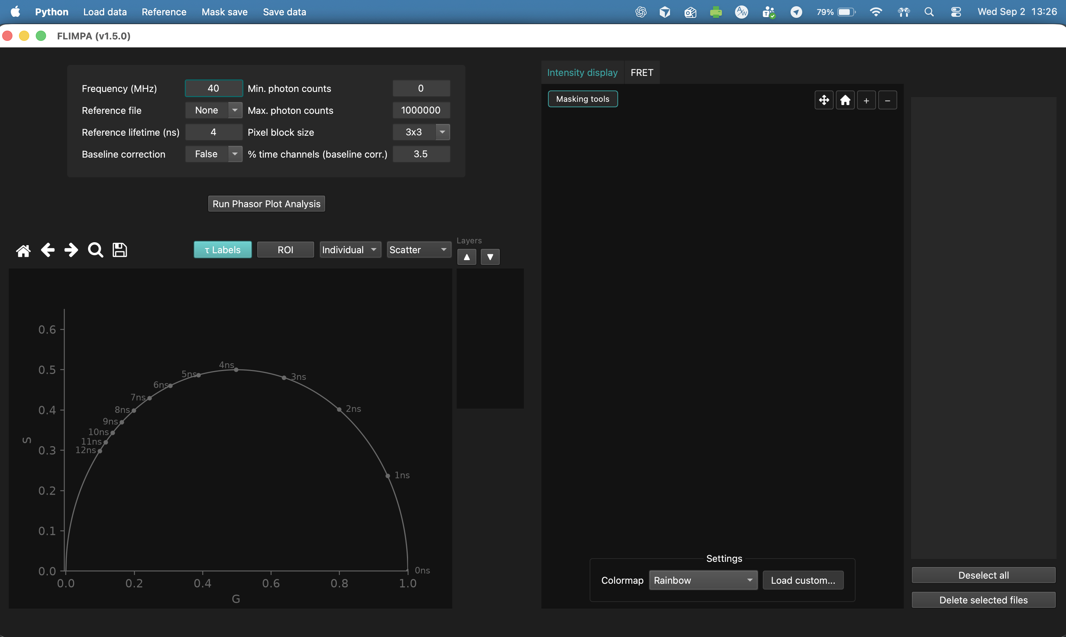
Left: analysis parameters and phasor plot. Centre: image/result tabs. Right: loaded-file table. Before analysis the principal tabs are Intensity display and FRET; after analysis Lifetime values, Lifetime maps, Gallery (tau), Gallery (I), and Violin plots are added, with FRET moved to the right end.
Figure 1 FLIMPA GUI upon launching the software

1.6 Menus: Load data, Reference, Mask save, Save data
• Load data — raw-data import, conditions, optional masks.
• Reference — reference-file and IRF import.
• Mask save — save manual/ROI masks or clear the manual mask.
• Save data — export maps, galleries, plots, tables, intensity images, and phasor points.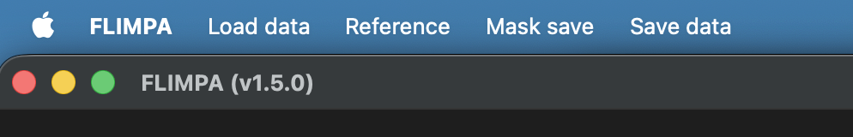
Figure 2 Menu loadout

2. Loading data

2.1 Supported file formats
Supported raw formats are .sdt, .ptu and .tif/.tiff. TIFF data must be ordered (time, x, y). Equal x/y dimensions are recommended for gallery visualisation.

2.2 Load data menu options
• Import raw data
• Import raw data by condition
• Import raw data with manual masks
• Import raw data by condition with manual masks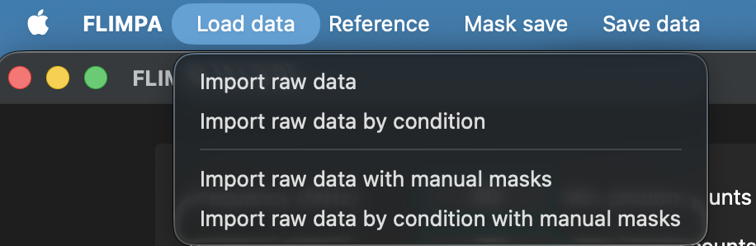
Figure 3 . Load data by clicking the “Load Data” button located in the top left corner of the GUI.

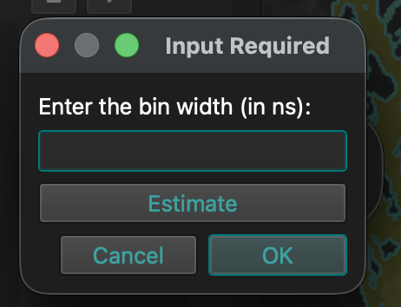
2.3 Loading .tif and .tiff files
Figure 4 Upon loading .tif or .tiff user will be requested to provide the bin number (in ns). If this is unknown an “estimate” option is available but can lead to inaccurate results.
- Please ensure that your .tif data is in the format (time, x, y).
- When loading your data, users will be prompted to enter the bin width (in ns), which is essential for accurate analysis as the file format does not contain temporal metadata.
- If the exact bin width is unknown, FLIMPA provides an estimate option, with the bin width calculated as:
$$\frac{1}{Frequency \left(Hz\right)×Number of bins}×{10}^{9}$$

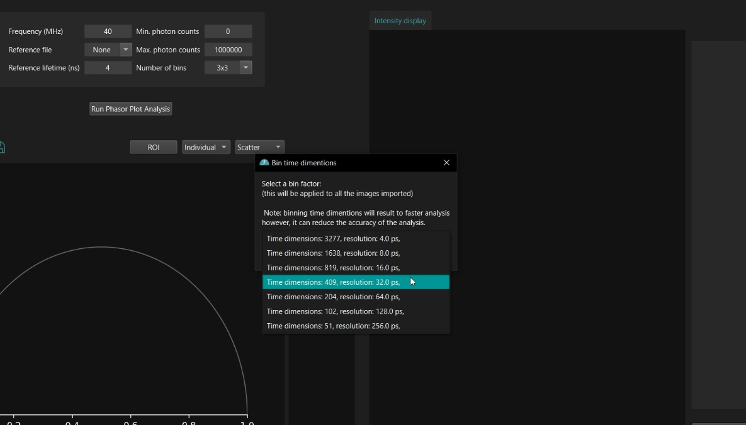
- However, this estimate may be inaccurate depending on your data acquisition settings. For the most accurate results, it is recommended to use the actual bin width provided by your instrument.

2.4 Loading .ptu files
- Analysing .ptu files often takes longer than other formats, as these files tend to be larger in both the time and spatial dimensions.
- If your time dimension exceeds 512, we recommend binning the time dimension to reduce the risk of Python running into memory issues.
- Binning the time dimension will also make the analysis faster. However, if the data have very low photon counts, i.e. fewer than 100 photons per pixel, excessive binning may reduce the accuracy of the results.
Figure 5. Example ` binning options for large .ptu file

2.5 Loading data with manual masks
Masks are uint16 labelled TIFFs. FLIMPA pairs masks named {stem}_mask_polygon.tif, {stem}_mask_ROI.tif, or {stem}_segmentation.tif. Select raw data and then the corresponding mask folder or file.

2.6 File list and sample data
The right table lists files and conditions. Checkboxes select files for analysis. Deselect all clears selection; Delete selected files removes unneeded entries. Sample data are available in the project repository.

3. Reference and calibration
A reference is required for instrumental correction. A mono-exponential dye with a known lifetime is recommended.

3.1 Import reference file
Use Reference → Import reference file and enter the known Reference lifetime (ns). Reference images should have equal x and y dimensions.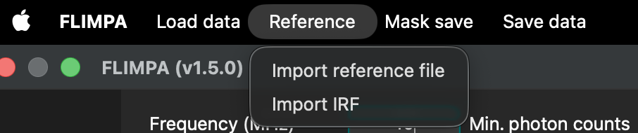
Figure 5 Importing reference file

3.2 Reference lifetime and donor τ_D for FRET
Reference lifetime is the known lifetime used for correction. The same entered value is used as donor τ_D for FRET, so set it to the intended donor reference lifetime before interpreting FRET maps.

3.3 Import IRF
Reference → Import IRF accepts .sdt or .csv. CSV contains exactly two columns: time in seconds and intensity, with the full uncropped IRF and no titles. IRF correction is less accurate than a mono-exponential reference. Baseline check can use the IRF for the IRF-convolved exponential display.

4. Running phasor plot analysis
Control | Description
Frequency (MHz) | Laser repetition rate.
Reference file | Loaded from Reference menu.
Reference lifetime (ns) | Known reference lifetime; also donor τ_D for FRET.
Pixel block size | Spatial N×N binning: None, 3×3, 7×7, 9×9, 12×12; not time-axis binning.
Min / max photon counts | Threshold mask; excluded pixels shown by teal intensity overlay.
Baseline correction | Subtract offset estimated from earliest time channels.
% time channels (baseline corr.) | Fraction used for baseline estimate; default 3.5%.

Baseline correction can create artefacts if real fluorescence signal is present in the earliest bins. Select files, verify parameters, then click Run Phasor Plot Analysis.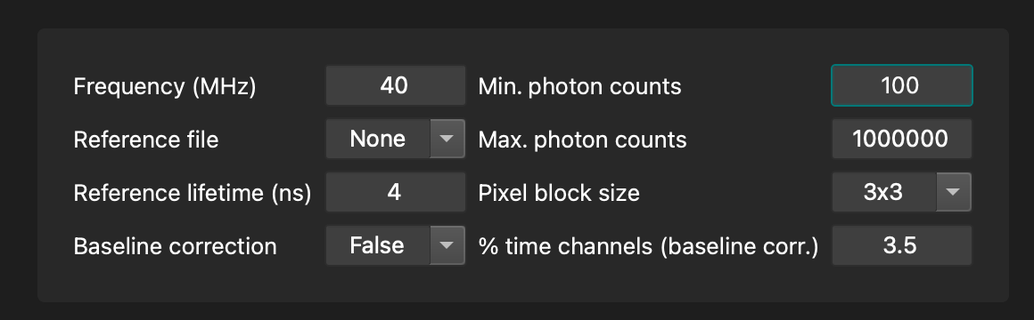
Figure 6 Phasor Plot parameters

5. Phasor plot

5.1 G and S axis labels
G is the horizontal axis and S the vertical axis. The universal circle and τ Labels support lifetime interpretation.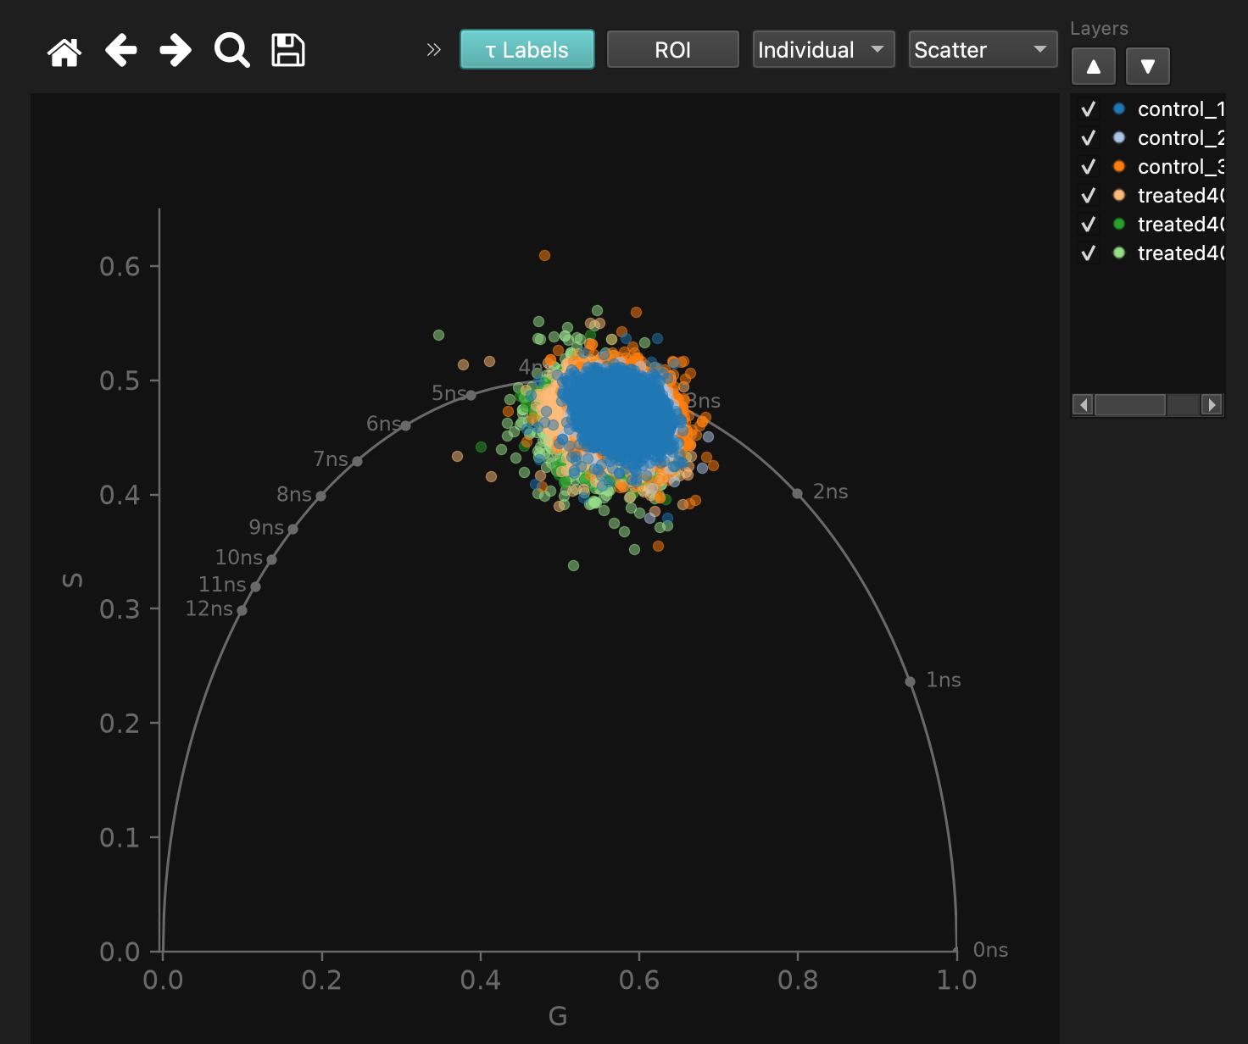
Figure 7 Phasor plot with G/S axes and tau Labels

5.2 Visualisation modes and gallery Layers list
Display phasor clouds as Scatter, Histogram or Contour, coloured by Individual sample or Condition. In Gallery (tau), Layers can show/hide files and reorder them with ▲/▼.

5.3 Phasor ROI (ellipse)
Draw an elliptical phasor ROI to restrict corresponding image pixels. Pixels outside the ROI are dimmed in the lifetime-map preview. Save it with Mask save → Save ROI mask. 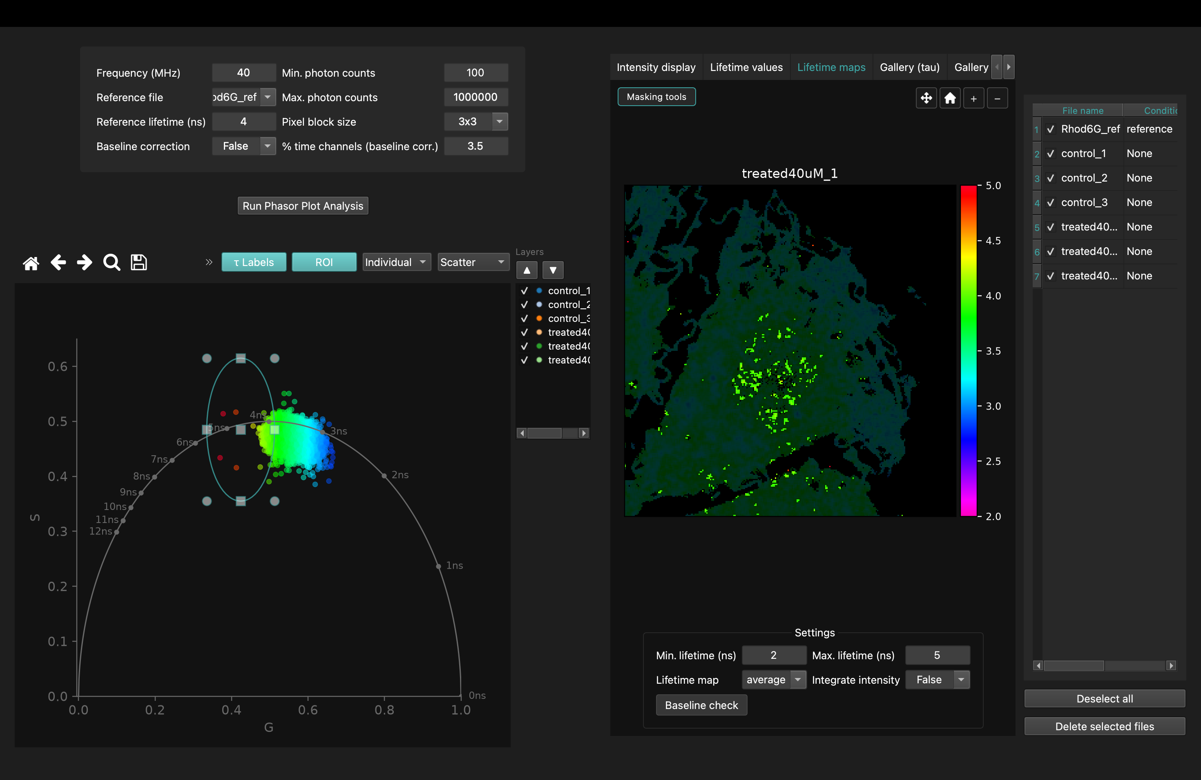
Figure 8 Ellipse phasor ROI and dimmed lifetime-map preview

6. Image tabs and navigation

6.1 Intensity display and colormaps
Choose a colormap or Load custom. Custom maps may be CSV RGB rows or a colour-strip image. Photon thresholds appear as a teal overlay.

6.2 Lifetime maps
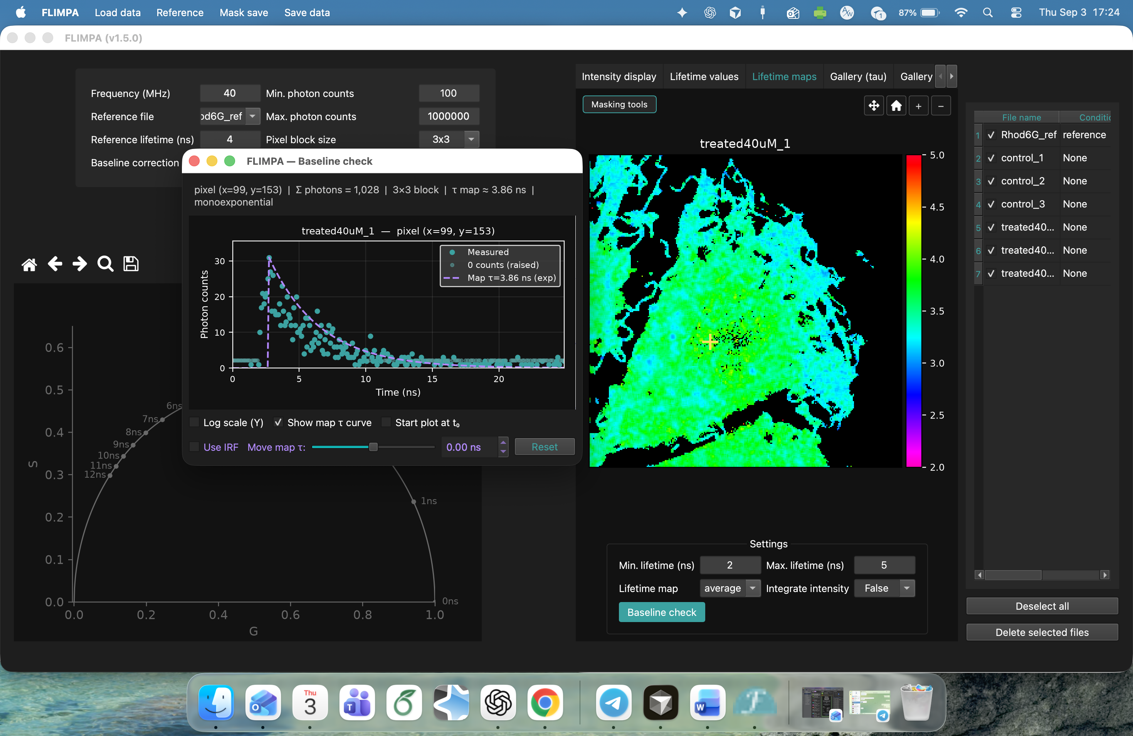
Choose average, M, or phi lifetime; set min/max ns; optionally integrate intensity; enable Baseline check to inspect pixel decay curves.
6.3 FRET efficiency maps
Figure 9 Baseline-check decay window with purple tau curve and IRF option.
FRET efficiency is E = 1 − τ/τ_D and is displayed from 0 to 1. τ is the lifetime-map value used for the display and τ_D is the donor/reference lifetime entered for analysis. After analysis FRET is the rightmost tab.

6.4 Pan, zoom, and reset
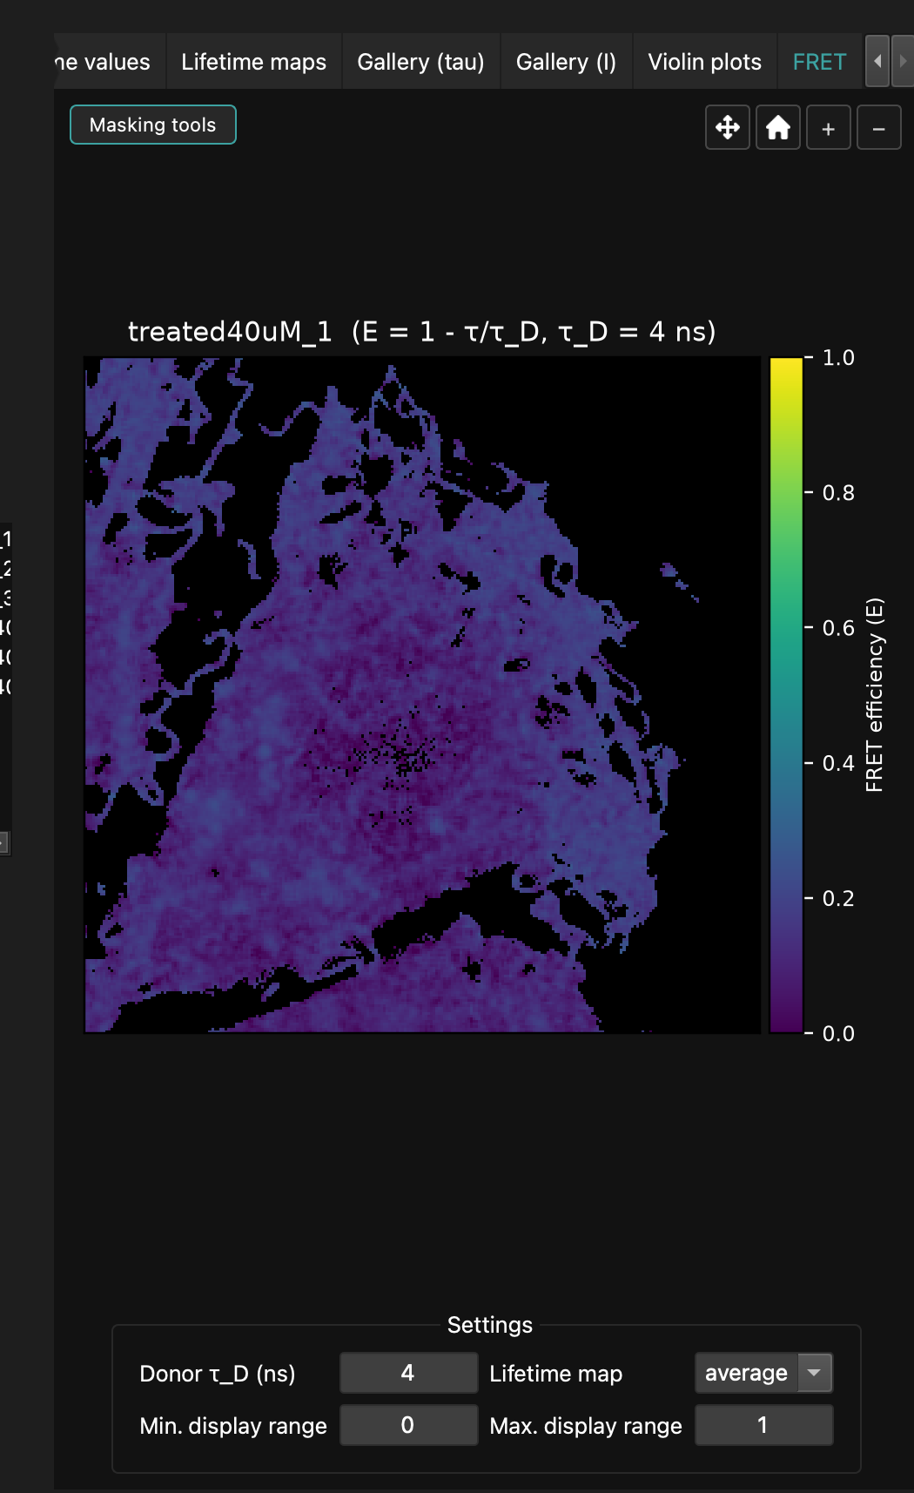
Intensity, lifetime, and FRET views provide pan, zoom (−/+), and home/reset controls at top-right. Masking tools is at top-left.
Figure 10 FRET efficiency map, rightmost after analysis.
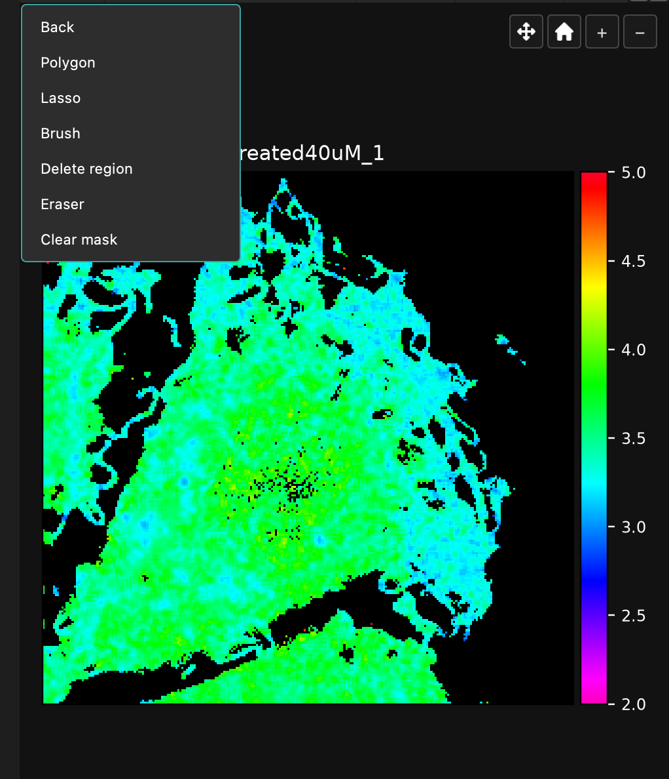
Figure 11 Masking tools plus pan, zoom and reset controls.

7. Baseline check (decay curve inspector)
Baseline check is a separate window created by FLIMPA, so, if the FLIMPA is opened at full screen, then baseline check window will load on a separate window.
Enable Baseline check in Lifetime maps, then click a pixel. FLIMPA — Baseline check opens the decay for the same pixel block size used in analysis.
• Log scale (Y) toggles logarithmic Y display.
• Show map τ curve displays the purple lifetime-model curve.
• Start plot at t₀ shifts the visible start to the decay onset.
• Use IRF incorporates the imported IRF into the displayed model (not accurate)
• Move map τ shifts the displayed map-τ curve by up to ±5 ns; this is display-only.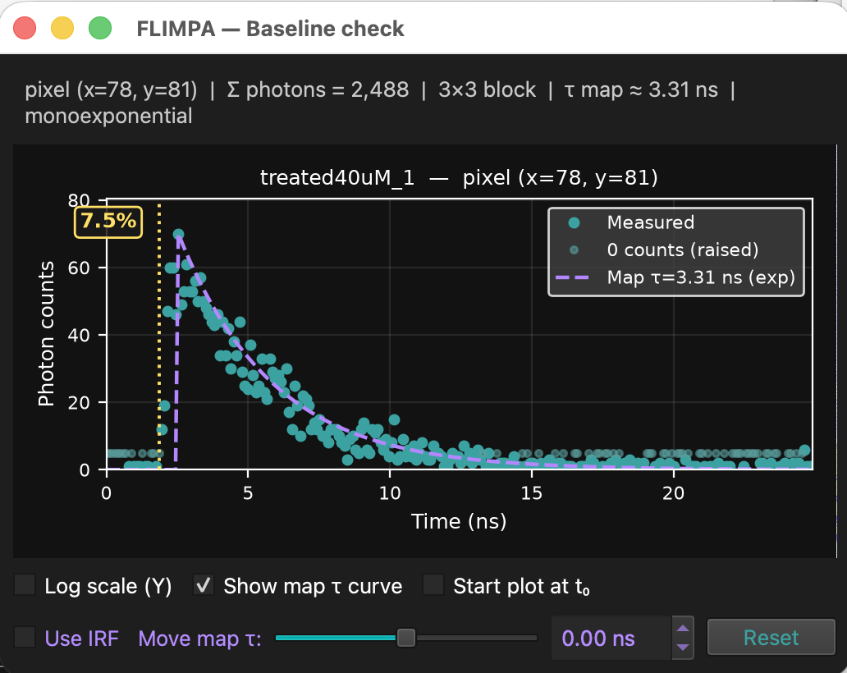
Figure 12 Baseline-check decay window with purple tau curve and IRF option, move tau option and baseline error check

8. Masking
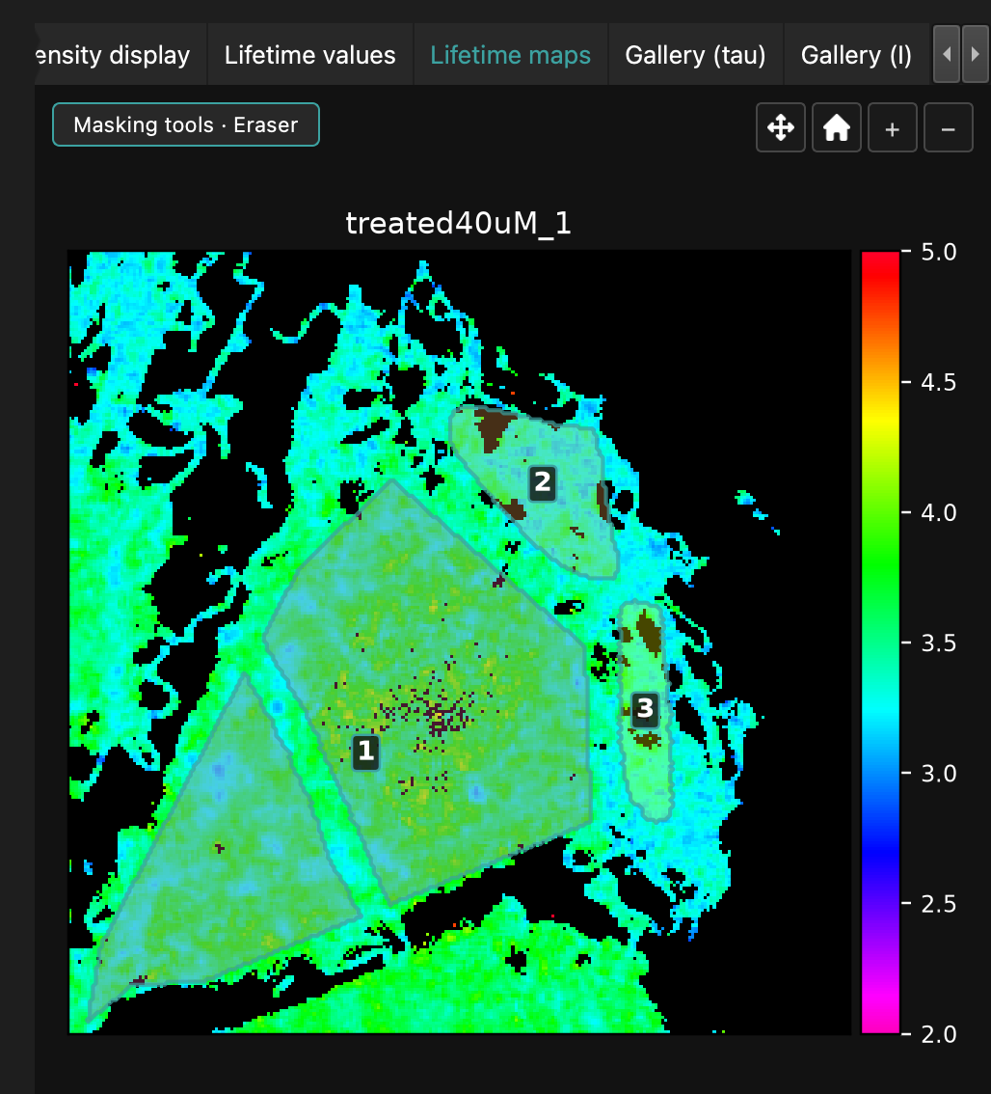
Three restriction methods are available: manual masks, phasor ROI masks, and photon-count thresholds. Photon thresholds are not saved as TIFF masks. Saved masks are uint16 labelled TIFFs: 0 is background and labels 1…N are regions.
Figure 13 Masking tools: Polygon, Lasso, Brush, Delete region, Eraser, Clear mask.

8.1 Masking tools (polygon, lasso, brush, delete region, eraser)
• Polygon — click vertices to define a region.
• Lasso — draw a free-form closed region.
• Brush — paint labelled pixels; Brush size is 1–30 px.
• Delete region — click a label to remove that entire region ID.
• Eraser — remove pixels locally; Eraser size is adjustable.
• Clear mask — remove the current manual mask.
• Back — leave masking mode.
• Switching to another tool turns Eraser mode off. Eraser removes pixels; Delete region removes the whole label.

8.2 Mask save menu
• Save manual mask — writes the manual polygon/lasso/brush mask.
• Save ROI mask — writes the mask generated from the phasor ellipse.
• Clear manual mask for selected file — clears the manual mask for the current file.
Mask save is separate from Save data. Saving a mask writes the TIFF and applies it in the current session.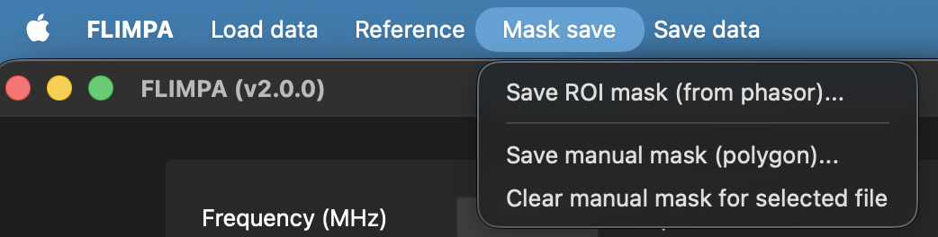
Figure 14 Mask save menu

8.3 Importing and re-importing saved masks
Important: after restarting FLIMPA, a saved mask is not automatically rediscovered. To see it again, re-import the raw file using Load data → Import raw data with manual masks and select the saved mask. This applies to names such as {stem}_mask_polygon.tif.

9. Results overview
After analysis, results are available in Lifetime values, Lifetime maps, Gallery (tau), Gallery (I), Violin plots, and FRET.

9.1 Lifetime values table
The table reports modulation (M), phase (phi), and average lifetime for each image. With multi-ROI manual masks, values are listed per ROI. Group by Condition gives the mean by experimental condition; Group by Sample gives the mean per image when multiple ROIs exist.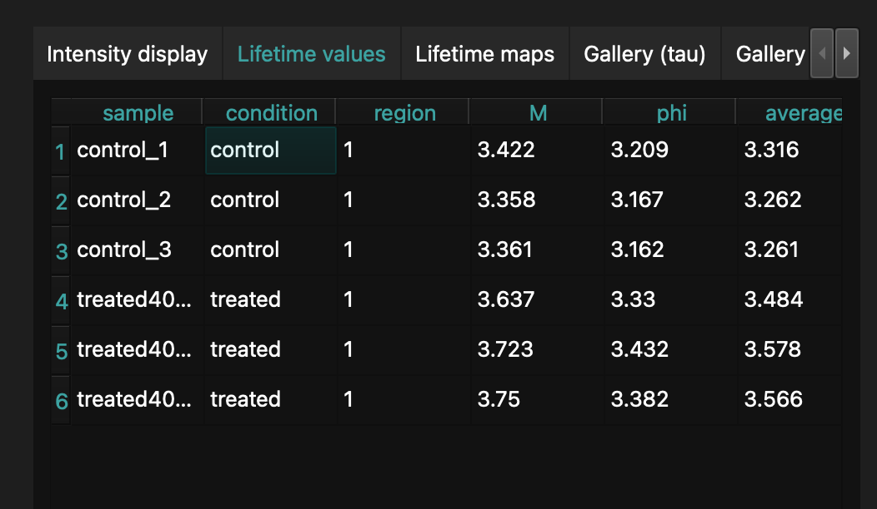
Figure 15 Lifetime values with Group by Condition / Sample.

9.2 Lifetime maps
Lifetime maps show localised lifetime variation. Choose M, phi, or average, adjust the colour-bar lifetime range, integrate intensity if desired, and use image masking/ROI tools for local investigation.

9.3 Gallery (tau) and Gallery (I)
Gallery (tau) compares lifetime maps and phasor clouds across samples or conditions. Gallery (I) compares intensity maps and permits minimum/maximum photon-count display limits.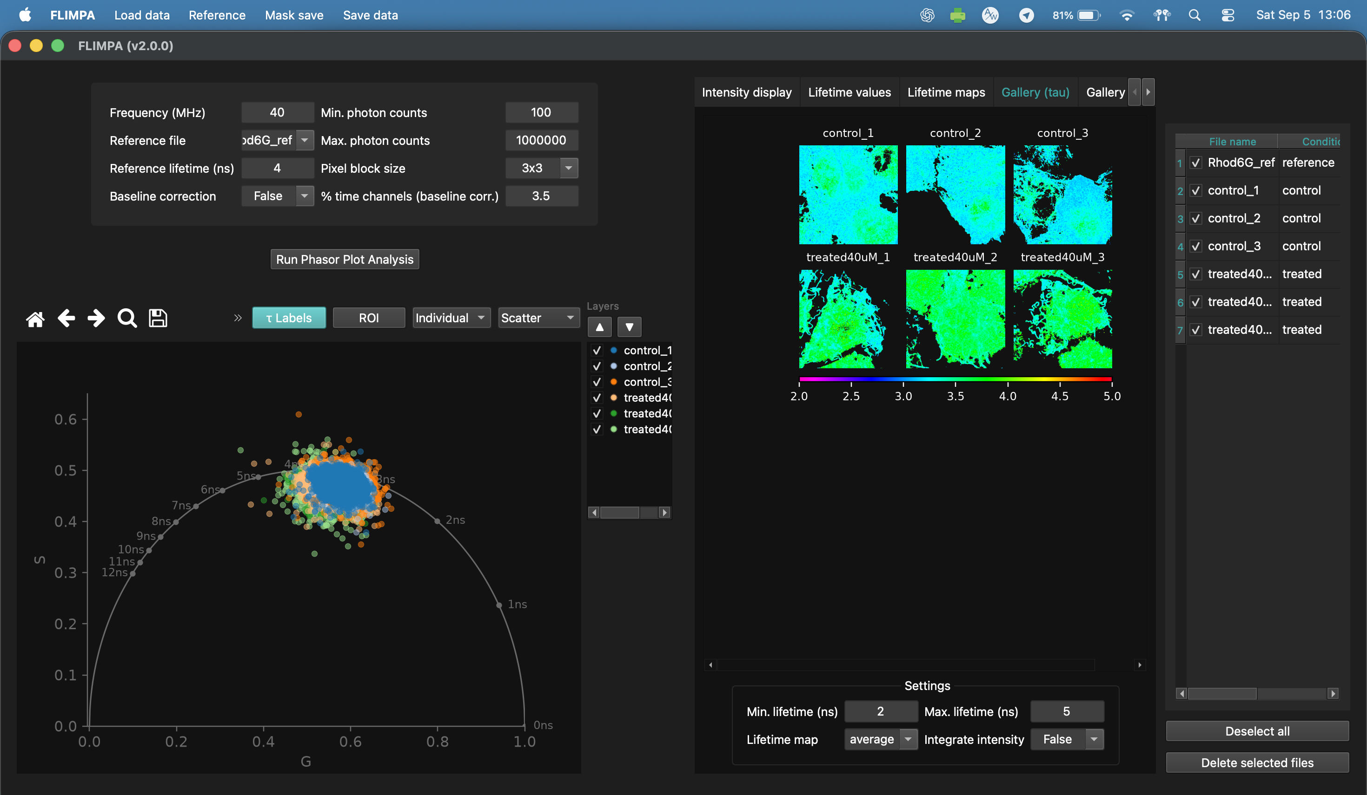
Figure 16 Gallery (tau) overview

9.4 Violin plots
Violin plots display distributions by treatment group. Plot average, M, or phi lifetime per image, or per ROI when multi-ROI masks are supplied.
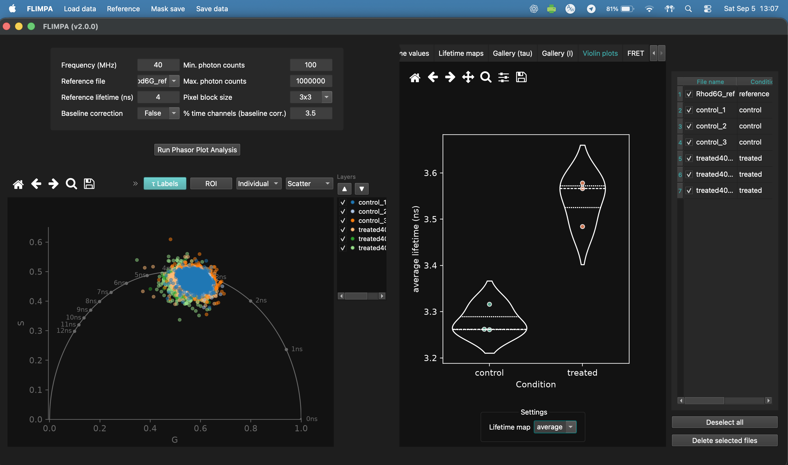
Figure 17 Violin plots overview.

10. Saving and exporting data

10.1 Save data menu
• Save lifetime maps (.png + raw .tif).
• Save lifetime gallery, intensity gallery, and intensity images.
• Save transparent phasor plot and violin plot.
• Export lifetime values table (.csv).
• Export phasor points (G,S)... for a selected file.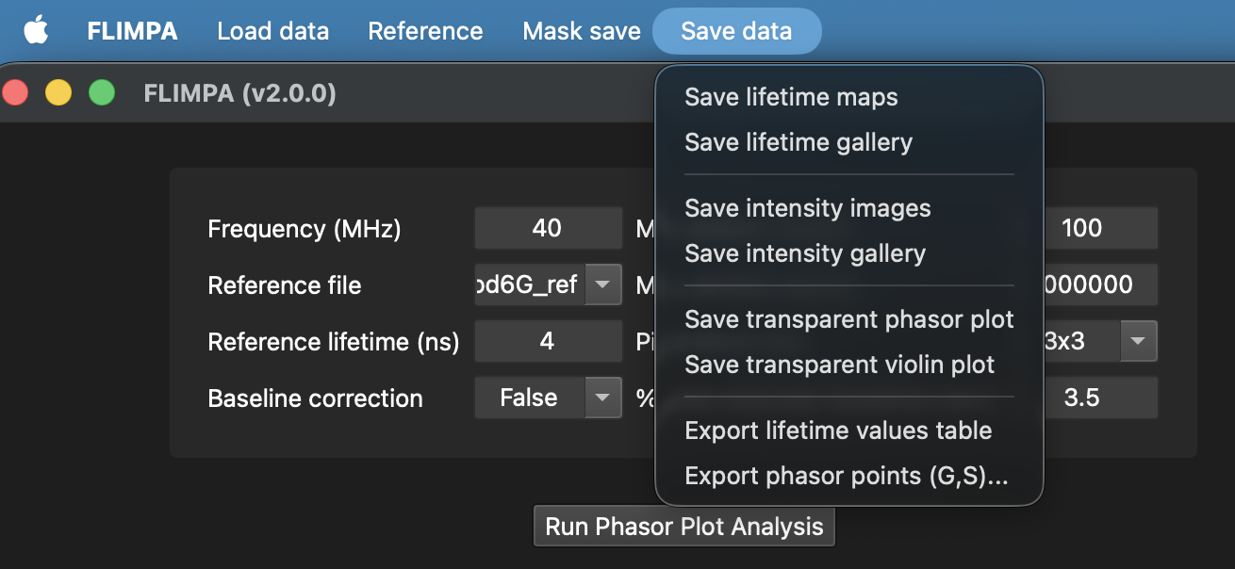
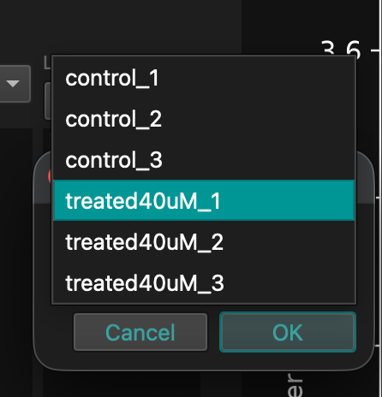
Figure 19 Save data menu with export actions.

10.2 Export phasor points (G, S)
Choose Save data → Export phasor points (G,S)..., select the source file from the file picker, and choose the CSV destination. The CSV contains G, S, row, col for non-zero pixels only. row is y and col is x; both are zero-based image coordinates.
Figure 18 Export phasor points file picker; G,S,row,col CSV.

11. Understanding the outputs (G, S, M, phi, row, col)
Control | Description
G, S | Each analysed pixel maps to a phasor point (G,S).
row, col | Pixel location in the source image: row=y, col=x, zero-based.
M / τ_M | Modulation-derived lifetime.
phi / τ_φ | Phase-derived lifetime.
average | (τ_M + τ_φ)/2.
FRET E | E = 1 − τ/τ_D.
The phasor CSV exports G,S,row,col only. Lifetime maps and lifetime-value tables contain M, phi, and average lifetime quantities.

12. Troubleshooting and FAQ
• ModuleNotFoundError: activate the intended virtual environment and reinstall requirements.txt.
• Large images or PTU files exhaust memory: reduce the number of loaded files, use smaller spatial images where possible, and time-bin long PTU decays.
• Baseline correction produces artefacts: disable it or reduce the baseline fraction if the earliest channels contain real signal.
• Saved masks are missing after restart: re-import through Load data → Import raw data with manual masks.
• macOS blocks the app: right-click the app, choose Open, then confirm.
• Upstream 1.4.2 .exe differs from this fork: it does not include the v2.0.0 masking, FRET, baseline-check, navigation, colormap, and phasor-export features.

Appendix A. Changes from FLIMPA 1.4.2 to 2.0.0
• In-app manual masking: polygon, lasso, brush, Delete region, Eraser with 1–30 px size.
• Mask save menu for manual mask, phasor ROI mask, and clear mask.
• Mask import/re-import workflow with raw data.
• FRET efficiency maps using E = 1 − τ/τ_D.
• Baseline check decay-curve window.
• G and S phasor axis labels and Gallery Layers list.
• Pan, zoom, and reset on intensity/lifetime/FRET images.
• Lifetime colormap presets and custom colormap loading.
• Save data menu renamed from Save; added Export phasor points (G,S) CSV.

