Gremlin Janitor: The Thought Process
How a Discord cleanup problem became a safe automation project.

Where it started
When World of Warcraft allowed guild chat to be linked to Discord and viewed there in real time, an edge case appeared: what happens to the people who don't use Discord or haven't linked their Discord account?
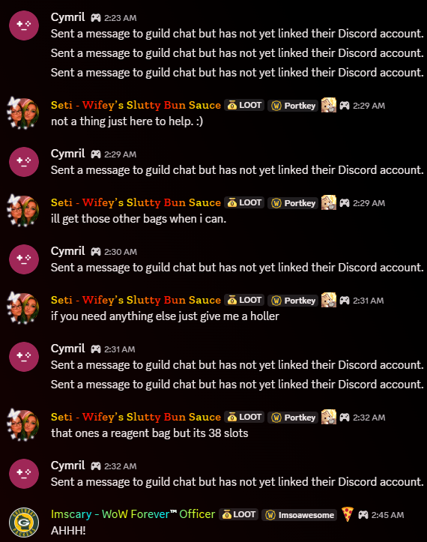
Discord without Gremlin Janitor running: the unlinked-account placeholder repeatedly interrupts the real guild conversation.
The first proposed solution wasn't “write Python.” It was much simpler:
“Fine. I'll just mute the people generating the junk.”
Except the screenshots show why that falls apart.
The messages aren't behaving like ordinary Discord messages from the WoW players. In WoW, the actual guild conversation is visible normally, and a linked account can be represented properly in Discord. But when an unlinked player speaks, the Discord integration produces the generic “Sent a message to guild chat but has not yet linked their Discord account” representation.
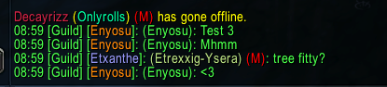
The conversation as it exists in WoW guild chat.
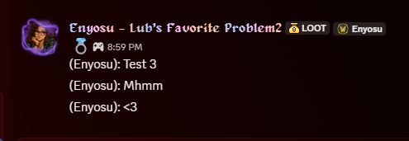
A linked player's guild-chat message represented normally in Discord.
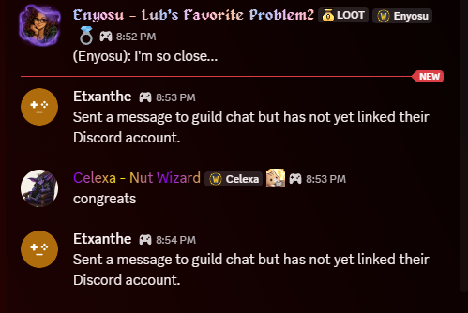
The same bridge's edge case: unlinked players produce generic Discord placeholder artifacts.
Problem: Discord is cluttered.
↓
Simplest solution: mute the offending people.
↓
🛑 Not so fast. Who exactly am I muting?
The integration has inserted an abstraction layer between the WoW player who spoke and the Discord object representing that activity.
During development, the apparent Discord author wasn't necessarily the identity that needed to be targeted. Runtime output showed placeholder candidates with generated-looking authors such as delightful_dolphin_31442, webhook=None, and an application identifier. That's very different from “mute Bob because Bob keeps posting garbage.”
“My first thought wasn't actually to build anything. I thought I'd just mute the people creating the messages. But that's where the integration told me, ‘not so fast.’ The person talking in World of Warcraft wasn't necessarily represented as a normal Discord user I could simply mute. There was another layer between the WoW user and what Discord was displaying.”
“That changed the problem. I wasn't really trying to moderate users anymore. I was trying to identify an artifact created by an integration.”
That's the major conceptual pivot.

The next 'not so fast'
Once the problem became “identify and remove the integration artifact,” the obvious automation was to delete messages matching the known placeholder text.
Obvious automation: delete matching text.
↓
🛑 Not so fast #2: text alone doesn't establish provenance.
A text match can say what a message contains. It does not prove that the integration produced it. Before deletion could be trusted, the source had to be understood.
Investigate: OBSERVE before CLEAN.
Inspect Discord's representation. The useful discovery was that authors could vary, the webhook was absent, and the application identifier provided a stable source signature.
Define the safety rule: exact content AND configured source signature.

Then the implementation failed — usefully
The screenshots capture the next pivot because the first important failure happened after the identification logic had already worked.
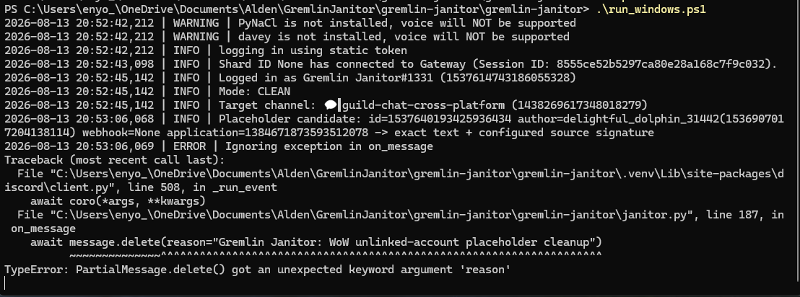
The bot identifies the placeholder candidate correctly, then fails when attempting deletion.
The bot correctly identified:
Placeholder candidate
exact text + configured source signature
So the detection logic worked.
Then deletion blew up:
TypeError: PartialMessage.delete() got an unexpected keyword argument 'reason'
“Can I identify the correct thing?” → Yes.
“Can I perform the action the way I've implemented it?” → Nope. 😄
The traceback points directly into janitor.py at the deletion call using message.delete(reason=...).
Identification is correct
↓
Action fails
↓
Don't redesign the filter.
↓
Read the exception.
↓
PartialMessage.delete() doesn't accept reason.
↓
Correct the deletion implementation.
↓
Retest.

The retest
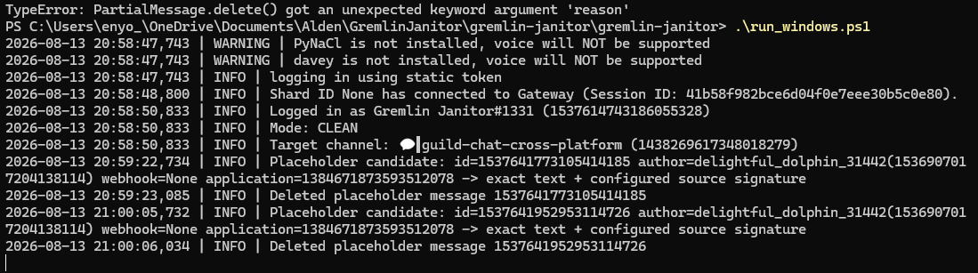
After the correction: candidate identified by exact text + configured source signature, then successfully deleted.
The later runtime output shows:
Placeholder candidate ... exact text + configured source signature
followed by:
Deleted placeholder message ...
Twice.
That creates a real debugging story rather than a manufactured interview example.
“Did I identify the right thing?” and “Did my action succeed?” are two different questions.
That matters enormously in automation. If deletion fails, the response is not to loosen filters or start changing detection logic. First determine which stage failed.

The whole thought process
New WoW/Discord capability → cool, real-time guild chat
↓
Edge case appears → unlinked WoW players generate Discord artifacts
↓
First instinct → mute them
↓
Not so fast → Discord's integration layer obscures the relationship between player and generated message
↓
Reframe the problem → don't moderate the person; clean the integration artifact
↓
Obvious automation → delete matching text
↓
Not so fast #2 → text alone doesn't establish provenance
↓
Investigate → OBSERVE before CLEAN
↓
Inspect Discord's representation → authors vary → webhook absent → application identifier is stable
↓
Define safety rule → exact content AND configured source signature
↓
Implement
↓
Test
↓
Detection succeeds → ✅
↓
Deletion throws TypeError → ❌
↓
Diagnose the failed layer → deletion call, not identification logic
↓
Correct
↓
Retest → candidate detected → candidate verified → candidate deleted
↓
Deploy → Gremlin Janitor sits downstream and quietly cleans Discord. 🧹

Running state
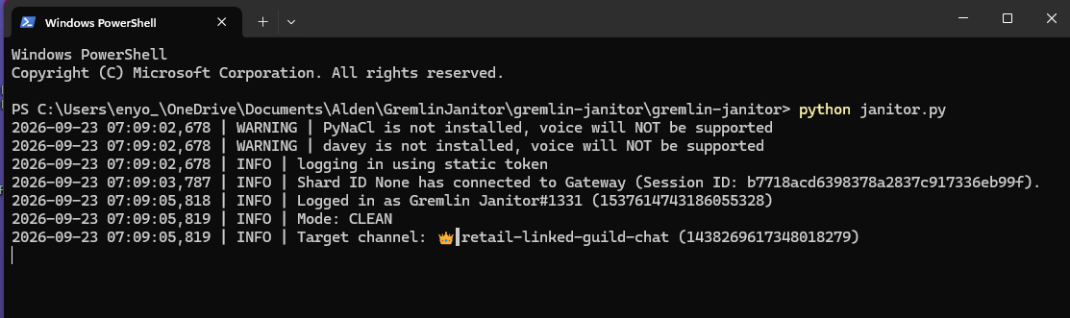
Gremlin Janitor running in CLEAN mode: authenticated, connected to Discord's Gateway, and scoped to the configured target channel.
Gremlin Janitor does not fix World of Warcraft or the upstream integration. It sits downstream and cleans the Discord side of a behavior the project does not control.
The project is therefore less a story about Python than a story about successively refining a mental model of a system every time reality says, “Not so fast.”

