Gremlin Janitor
From integration artifact to safe downstream automation
Observe → understand → constrain → automate → verify
The core idea: Gremlin Janitor does not fix World of Warcraft or the upstream guild-chat integration. It cleans a specific integration artifact from the Discord side of a system boundary I can control.

1. The problem appeared at the integration boundary
World of Warcraft introduced real-time guild-chat visibility in Discord. For linked users, that creates a useful bridge between the in-game guild conversation and Discord. The edge case was guild members who use WoW guild chat but have not linked a Discord account.
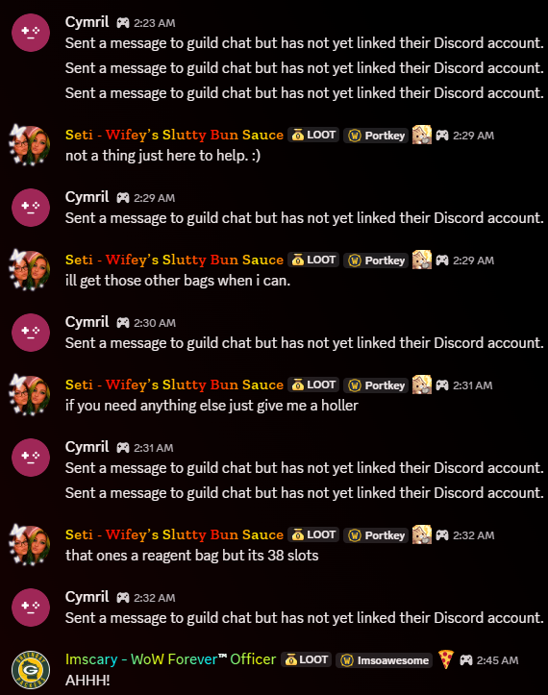
Without Gremlin Janitor running, legitimate conversation is repeatedly interrupted by the unlinked-account placeholder.
The integration still emits a Discord-side representation for those messages: “Sent a message to guild chat but has not yet linked their Discord account.” In an active conversation, those artifacts can appear repeatedly or several times in succession. The operational problem is therefore not the guild conversation itself; it is clutter created downstream by an integration behavior.

2. The first idea was simpler: mute the people
My first thought was not to write a bot. It was to mute the people generating the noise. The integration added a layer of “not so fast”: the WoW player speaking in guild chat was not simply a normal Discord user producing an ordinary Discord message that I could reliably mute.
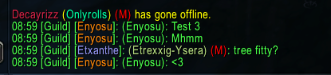  In-game guild chat | 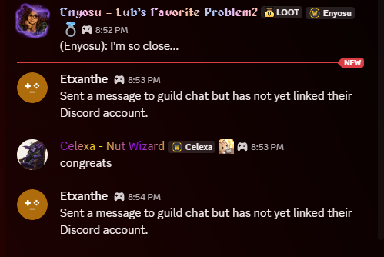  Discord representation of unlinked users
That changed the problem. I was no longer trying to moderate individual users. I needed to identify and clean an artifact created by the integration.

3. Reframe: clean the part of the system I control
Upstream: WoW guild chat and the bridge behavior are outside Gremlin Janitor’s control. Downstream: Discord is the environment where the unwanted artifact appears and where remediation is possible.
The new question became: Can I distinguish the integration artifact reliably enough from legitimate guild conversation to automate its removal safely?

4. Before automating deletion, automate the investigation
The obvious rule would have been: if the message text equals the unwanted phrase, delete it. I did not consider text alone sufficient. Text tells me what a message says; it does not prove where the message came from.
Gremlin Janitor therefore began with observation. I used Discord’s available message/API metadata to learn how these integration-generated messages were represented before allowing the program to take a destructive action.
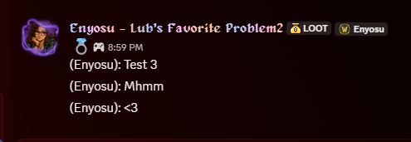
A normal linked-account message provides a useful contrast with the placeholder behavior.

5. Find a stable source signature
The investigation showed that the apparent authors could vary and the messages did not present a webhook identifier, while a consistent application identifier was available. That gave me a stronger provenance signal than the visible author alone.
Question | What the investigation established
What is the message? | An exact known placeholder phrase.
Where did it come from? | A configured source signature, using stable Discord metadata rather than relying on the changing visible author.

6. Turn the discovery into a safety rule
EXACT CONTENT + CONFIGURED SOURCE SIGNATURE = ELIGIBLE FOR DELETION
Content match | Source verified | Action
Yes | Yes | Delete
Yes | No / unknown | Keep
No | Yes | Keep
No | No | Keep
This is the central design decision in Gremlin Janitor: destructive behavior requires both conditions. If provenance cannot be established, the safer result is to leave the message alone.

7. Testing exposed a different failure layer
During testing, Gremlin Janitor successfully identified a placeholder candidate using the intended rule, but deletion failed. The exception was specific: PartialMessage.delete() did not accept the supplied reason argument.
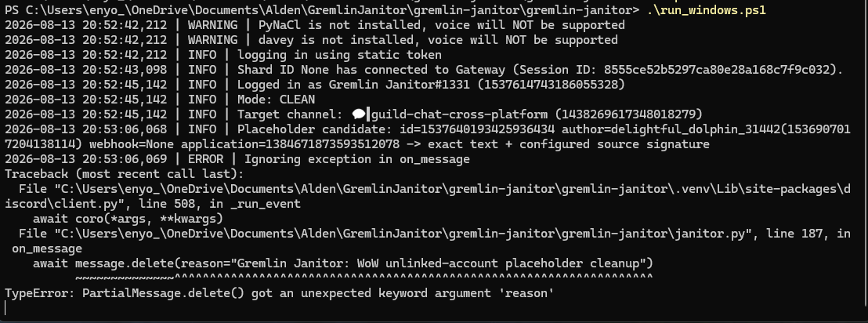
Detection succeeded; the action failed. The traceback localized the problem to the deletion call rather than the filtering logic.
That distinction mattered. The evidence said the identification stage was working, so there was no reason to loosen or redesign the safety filter. I corrected the action implementation and retested the same path.

8. Retest: candidate identified, verified, deleted
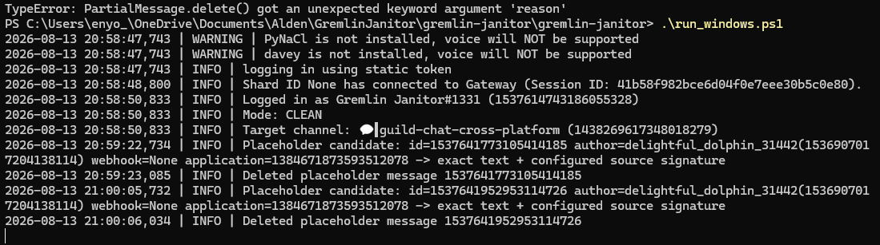
After correction, the runtime log shows the candidate qualifying by exact text + configured source signature, followed by successful deletion.
This gave me a concrete end-to-end result: the program could recognize the intended artifact, explain why it qualified, perform the deletion, and log the outcome.

9. Operational state is visible when the bot starts
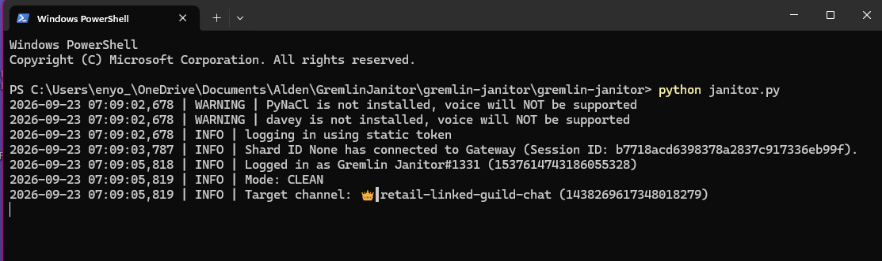
Current startup: authentication, Discord Gateway connection, bot identity, CLEAN mode, and the configured target channel are visible immediately.
At startup I can verify that the application authenticated, connected to Discord’s Gateway, which operating mode it is using, and which channel it is targeting. Runtime logging then shows candidate identification and deletion results. The voice-library warnings are unrelated to Gremlin Janitor’s function because it does not use Discord voice features.

10. What Gremlin Janitor demonstrates
• Start with the operational problem, not the tool.
• Identify the boundary I can actually control.
• When the system is ambiguous, observe before acting.
• Separate content matching from source provenance.
• Fail closed when a destructive action cannot be justified.
• Treat detection and action as separate stages when troubleshooting.
• Make operating state and outcomes visible in logs.
• Use code only after the decision being automated is understood.
Interview summary: “I didn’t control the system producing the problem, so I looked at the boundary I did control. Before I automated deletion, I automated the investigation. Once I could identify both the exact artifact and a trustworthy source signature, I could make the cleanup narrow, observable, and safe.”

