Conditional Inference Trees and Random Forests

1. Introduction

Conditional inference trees (CIT) and conditional random forests (CRF) are gaining popularity in corpus linguistics. They have been fruitfully used in models of linguistic variation, when the task is to find out which linguistic and extralinguistic factors determine the use of near-synonyms (e.g. let, allow or permit), alternating syntactic constructions (e.g. the double-object vs. to-dative) or sociolinguistic variants (e.g. the type of /r/ used by speakers of a particular dialect). The methods have been implemented in a user-friendly way in the packages party (Hothorn et al. 2006b; Strobl et al. 2007) and partykit (Hothorn & Zeileis 2015), which has contributed to the popularity of the methods.
CIT and CFR are based on recursive binary partitioning. The main steps of analysis are as follows.
Step 1. Select the variable which is the most strongly associated with the response, using some statistical criterion.
Step 2. Make a split in this variable, splitting the data in several data sets. Most algorithms use binary partitioning, although non-binary splits have also been implemented (e.g. in CHAID, see below).
Step 3. Repeat Steps 1 and 2.
Figure 1 illustrates the main idea behind binary partitioning. Imagine that you want to test how the shape (a circle or a star) helps one to classify a set of objects depending on the colour (white or blue). The shape is a predictor, and the colour is the response. The shape allows one to separate the white objects from the blue ones by splitting the entire data set into two subsets, one with stars and the other with circles. As a result, 80% of the colours are identified correctly (i.e. 8 out of 10 white objects and 8 out of 10 blue objects; 16 out of 20 in total). The goal is to achieve maximal purity (or minimal impurity) in the nodes. In other words, we would like to have as few blue objects in the bottom left-hand node as possible, and as few white objects in the bottom right-hand node as possible. If there are other predictors that can further contribute to the decrease in impurity, new splits will be made within each of the subsets.

Figure 1. Binary partitioning of a data set. Colour is the response variable and shape is an associated predictor, which helps to separate the colours with 80% accuracy.

Unlike logistic regression, which has been the default tool in corpus-based studies of language variation (cf. Hilpert & Blasi, this volume), CIT and CFR are non-parametric methods, which gives them a number of advantages with some types of linguistic data. These advantages are described below.
First, they are useful in the situations of small n, large p, i.e. when the number of observations is small relative to the number of predictors. This may be the case in many subfields of corpus linguistics, where data are small and costly, e.g. analysis of spoken data (e.g. Tagliamonte & Baayen 2012), multilingual data (e.g. Levshina 2016) or data from minor languages. For such datasets, logistic regression would not be suitable.
Second, CRF can be used in the situations when the predictors are highly intercorrelated. This happens quite often in corpus-linguistic research. For instance, one and the same underlying theoretical construct, such as transitivity in Hopper & Thompson’s (1980) sense, can be represented by several correlated formal variables. Another example is entrenchment of a word, which can be operationalized as frequency, dispersion and contextual diversity of a word in a corpus (e.g. Baayen 2010).
Third, CIT and CRF represent an attractive alternative when some of the regression assumptions are not met, e.g. the assumptions of homoschedasticity (equal variability of the response variable across the range of values of the predictors) and non-linearity of the relationship between a predictor and the outcome. CIT and CRF can also be used when this relationship is non-monotonic (i.e. positive correlation between the predictor and the response within some range of the predictor’s values, and negative within another). This is particularly convenient if one wants to keep the original scale of the response variable rather than perform transformations. Moreover, such problems as complete and quasi-complete separation, which leads to unidentifiable regression models, are easily solved with the help of these methods, as will be demonstrated in Section 2.1.
Fourth, the methods are particularly attractive when one has to deal with high-order interactions. In particular, CIT allow one to interpret them in a very convenient and intuitive way. This is very useful in the studies of multifactorial probabilistic grammar, which compare the direction and strength of semantic and grammatical constraints across different language varieties. The differences in the constraints are often modelled as interactions between language varieties and diverse contextual factors (e.g. Szmrecsanyi et al. 2016).
Fifth, one can easily model response variables with many different categories, when performing a multinomial logistic model may be too cumbersome. For instance, one can use that for predicting the senses of a word from many different contextual variables. Or model a large group of near-synonyms. Although most applications (see examples below) still focus on two to four variants, there are no reasons not to perform such analyses.
In the remaining part of this chapter, I will describe the main characteristics, applications and pitfalls of CIT and CRF (Section 2), followed by a case study of the T/V forms in Russian (Section 3). Section 4 concludes the chapter by giving some general recommendations and reading suggestions and mentioning a few open methodological questions.

2. Fundamentals

2.1. Types of data

An attractive feature of CIT and CRF is that one can model the relationships between the response variable and predictors at any scale of measurement. Moreover, no distributional assumptions need to be met. Also, one can fit models with multivariate response variables and censored data. Yet, most applications of these methods in corpus linguistics involve categorical response variables and predominantly categorical predictors.
There are no fixed rules regarding the minimum number of observations, but it is possible to have a relatively high number of predictors. For example, Strobl et al. (2008) use CFR to investigate a binding property of 310 amino acid sequences depending on 105 predictors. CRF can also deal with correlated predictors successfully. A multiple regression analysis of such data would be inappropriate.
Another advantage of CIT and CRF is that one can model data with complete and quasi-complete separation. Consider the data in Table 1, which has a predictor x with values a and b and a binary response variable y with levels i and j. This is an example of complete separation, when each value of the predictor co-occurs only with one value of the response. If one fits a traditional logistic model, the algorithm will return a very large estimate (b = 53.13), a huge standard error (SE 75545.22) and a p-value close to 1 (p = 0.999). However, a conditional tree will represent the data correctly, as shown in Figure 2.

 | Response y = i | Response y = j
Predictor x = a | 50 | 0
Predictor x = b | 0 | 40

Table 1. Imaginary data with complete separation.

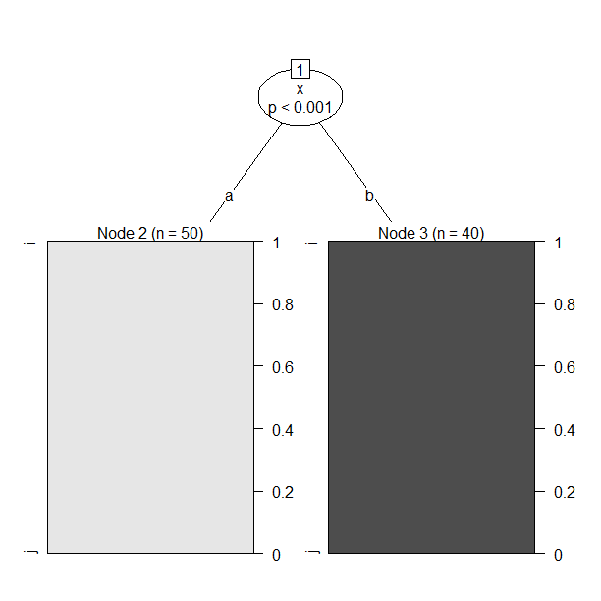
Figure 2. A CI tree based on data with complete separation.

2.2. The assumptions

There are no traditional assumptions that should be met, such as constant variance, non-linearity or normally distributed errors. However, a word of caution should be said about the independence of observations. At the moment of writing, the only working method for dealing with dependent observations seems to be including the grouping factor (e.g. the speaker or text IDs) on a par with all other predictors. This has been done, for instance, by Tagliamonte & Baayen (2012), who added the individual speakers as a covariate in their CIT and CRF. There are a few conceptual and practical problems with this solution, however, which will be discussed in Section 2.5.

2.3. Research questions

The research questions that can be answered with the help of CIT and CRF are the same as the ones that are answered with the help of regression analysis. Examples are variation of was/were in York English (Tagliamonte & Baayen 2012), transitivity patterns with the verb give in South Asian Englishes (Bernaish et al. 2014), fore- and backclipping (e.g. technology > tech, but racoon > coon, cf. Lohmann 2013), particle placement, the dative and genitive alternations in World Englishes (Szmrecsanyi et al. 2016), and positioning of adverbial concessive clauses (Wiechmann & Kerz 2012). Most work has been done in English grammar. Some exceptions are Baayen et al. (2013), who investigate Russian aspectual prefixes and suffixes and Levshina (2016), who compares causative constructions in fifteen European languages. Usually, the task is to find the contextual (corpus) variables that best predict the use of two or more linguistic variants. In variationist probabilistic grammar, one also tries to pinpoint the differences in the effect of these variables in varieties of a language (e.g. Szmrecsanyi et al. 2016).
Similar to regression, one can use these methods for explanation and prediction (or classification, in the case of categorical variables). CIT can be particularly useful for interpretation and explanation, whereas CRF are usually better in prediction and classification.

2.4. The algorithm

CRF are grown from numerous CIT. The latter belong to a large family of recursive partitioning methods used for regression and classification. Other approaches include CART (Classification And Regression Trees), CHAID (CHi-squared Automatic Interaction Detector), and QUEST (Quick, Unbiased and Efficient Statistical Tree) (see an overview in Loh 2014). The main differences of the CIT from the other approaches are presented below (Hothorn et al. 2006b).
First, the method is based on testing the null hypothesis that the distribution of the response variable D(Y) is equal to the conditional distribution of the response variable given some predictor D(Y|X). The global null hypothesis is that this holds for all predictors (Hothorn et al. 2006b). That is why the name of the method contains “conditional inference”. In order to test the hypothesis, one uses permutation (reshuffling) of the labels in the response variable Y. By permuting Y, its association with the predictor X is broken. As a result of this permutation, the null distribution is derived directly from the data. In contrast, unconditional tests impose assumptions on the distribution of the data, so that the null distribution of a test statistic can be derived analytically.
This process is illustrated by Table 2. Imagine that we study the dative alternation in English. We investigate the dependence between the response (i.e. the use of the double object dative and the to-dative) and a number of predictors, including the information status of the Recipient (given or new). A permuted version of the response is shown in the third column of the table.

Example ID | Observed response Y (dative variant) | Permuted response Y  (dative variant) | Observed predictor X  (information status of Recipient)
1 | to-dative | DO-dative | new
2 | DO-dative | DO-dative | new
3 | to-dative | to-dative | given
101 | DO-dative | DO-dative | new
102 | to-dative | to-dative | given
103 | DO-dative | to-dative | given
… | … | … | …

Table 2. Permutation of the response variable: an example.

Based on this information, one computes a statistic that takes into account the difference in the association between response Y and predictor X before and after the permutation. The greater this difference, the stronger the association between Y and X. One could then compare the statistics from different covariates and choose the largest one as the best candidate for the next split. However, this is not a good idea when the predictors are on different measurement scales. In order to make the statistics comparable across different variables, the p-values are used (the default option). For the global null hypothesis test, the p-values are adjusted (a simple Bonferroni correction is used by default).
Another important difference is that the p-values are used as a stopping criterion, so that the tree does not need to be pruned. As a result, overfitting is avoided. If the global null hypothesis cannot be rejected at a certain level of statistical significance α (by default, 0.05), no further splits are made. This cut-off value can be regulated with the help of the mincriterion parameter in party::ctree_control, which equals 1 - α and is set to 0.95 by default. This parameter can be used in two ways: as the significance criterion (and therefore it should not be changed without a very good reason, since it strikes a balance between Type I and Type II errors), and a hyperparameter determining the size of a tree. One can decrease this parameter for exploratory purposes or increase it when the tree becomes too complex. However, one should remember that the null hypothesis significance testing function is no longer fulfilled in that case.
The next step is splitting the selected covariate into two disjoint sets. For variables with many possible splits, the spit is made such that the difference between the two resulting samples is maximized. Importantly, the algorithm, unlike most other approaches, separates the steps of variable selection and making a split, whereas most other methods merge this in one step. As a result, the variables with multiple splits (e.g. categorical variables with many different values) do not have advantages in comparison with the variables with few splits. The same holds for predictors with missing values.
As for CRF, they are based on an ensemble of multiple CIT. The algorithm uses resampling with or without replacement to create a random sample (different options are available to the user). Importantly, only a sample of candidate predictors is randomly drawn for each individual CIT. One often sees a recommendation to use the square root of the total number of predictors (see Section 3 on the default settings and how to modify them). Due to this random sampling, random forests usually provide a more accurate classification than individual trees. Since only a restricted number of predictors is selected for every individual tree, each variable has the chance to appear in different contexts with different covariates. This may better reflect its potentially complex effect on the response variable. (Strobl et al. 2009). If some variable only matters in a very specific type of contexts, it gets a chance to tell its story when the stronger variables are out of the competition. Of course, it is also possible to test all predictors in each tree. This method is called bagging.
Probably, the most interesting part of information provided by random forests for a linguist is the conditional variable importance measure. To compute this measure, the algorithm averages the results from many trees and measures the decrease in prediction power if one randomly permutes each of the predictors. If a predictor is associated with the response strongly, there will be a substantial decrease in prediction accuracy. More exactly, a conditional permutation method is applied, as described by Strobl et al. (2008). For example, if Y is the response, and X and Z are categorical predictors, the dependence between Y and X is measured within the levels of Z. Let us revisit the example with the dative alternation. Imagine we are testing two predictors: information status of the Recipient (given or new) and the semantics of the Recipient (animate or inanimate). In order to compute the conditional importance of X (information status) given Z (semantics) in an individual tree, we will reshuffle the value of X within the levels of Z, as shown in Table 3. Next, we will compare how much worse the individual conditional tree with the permuted data will predict the observed scores of the response variable in comparison with the original data. The conditional importance score of X for the entire forest is computed as an average over all trees.

ID of observation | Response | Observed X  (information status of Recipient) | Permuted X|Z | Predictor Z  (semantics of Recipient)
1 | to-dative | new | given | animate
2 | DO | new | new | animate
3 | to-dative | given | new | animate
101 | DO | new | given | inanimate
102 | to-dative | given | given | inanimate
103 | DO | given | new | inanimate
… | … | … | … | …

Table 3. Conditional permutation scheme: an example.

The conditional permutation approach has an important advantage in comparison with other types of variable importance provided by random forests (Strobl et al. 2008). Namely, it does not have a bias towards correlated predictors. Conditional importance scores take into account the effect of all other variables, their correlations with X and their possible interactions, unlike the other methods. If X is a real predictor and Z is a spurious one, and X and Z are correlated, the importance value of Z will increase if the traditional method is used. This undesirable effect can be avoided if one uses the conditional permutation schema as described above.
As already mentioned, random forests are a good tool for prediction and classification. Imagine we want to predict the outcome of Y for a specific observation, and we have many outcomes predicted by the individual trees in our forest. How do we get the average predicted value? If the response variable is numeric, such as the corpus dispersion measure, one computes the average predicted value over all individual tees, using some weighting procedures, if necessary. If it is categorical (e.g. the double object dative or to-dative), one uses ‘voting’, i.e. takes the most frequently predicted outcome.

2.5. When alternative methods are preferable

There is no universal statistical method that can be used in all circumstances. CIT and CRF are no exception to the rule. There are several cases when one might prefer to use a different method because CIT and CRF do not perform optimally. They are discussed in this subsection.
The cases when CIT may yield misleading results are as follows:
(1) Linear and additive effects. Paradoxically, although CIT can be more successful than regression in tricky situations, e.g. with high-order interactions and non-linear patterns, CIT may be quite useless in very simple situations, i.e. when the relationships between the response and the predictors are linear and additive. As an illustration, consider Figure 3. This tree represents an attempt of CIT to analyse the relationships between a numeric response variable y and predictors x1 and x2 , which were randomly generated from the normal distribution. The response variable was created using the following linear regression formula:

(1) y = 0.7 + 5.4 x1 – 2.8 x2 + ε

where ε contained random normally distributed errors. The predictors do not interact and the relationship between them and the response variable is linear. One can see that the tree presentation is not very helpful in modelling these simple relationships. It creates an illusion of interactions that are not there. Moreover, the numeric predictors are split multiple times, which masks the linear relationships between them and the response variable. A multiple regression would be a much better choice in such cases.

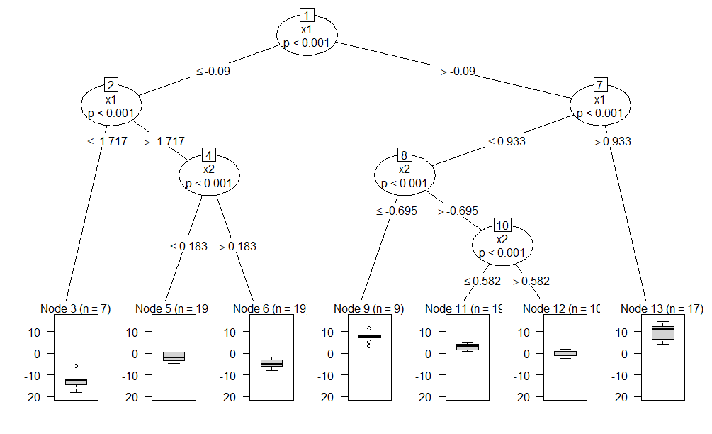
Figure 3. A conditional inference tree model of data with a simple linear additive relationship between two continuous predictors and a continuous response variable.

(2) Crossover interactions. Alternatively, CIT can run into problems when some predictors have a strong crossover interaction. As an illustration, consider imaginary data with corpus counts of different subjects and objects in a language with differential subject and object marking, as shown in Table 3. The response variable reflects the presence of case marking: marked or unmarked. There are two interacting predictors of case marking: the semantic class (animate or inanimate) and syntactic role (subject or object). If the argument is a subject, it is usually unmarked when it is animate and marked when it is inanimate. As for objects, it is the other way round, which is why we can speak of a near-perfect crossover interaction.

Role = Subject
 | Response = marked | Response = unmarked
Semantics = Animate | 5 | 20
Semantics = Inanimate | 20 | 5
Role = Object
 | Response = marked | Response = unmarked
Semantics = Animate | 19 | 6
Semantics = Inanimate | 5 | 20

Table 4. Distribution of imaginary corpus data of differential argument marking.

When one fits a logistic regression model (the lrm function in the rms package, Harrell 2017), one obtains the coefficients shown in Table 5. The interaction term is highly significant. Figure 4, which visualizes the interaction with the help of the package visreg (Breheny & Burchett 2016), demonstrates that the effect of semantics is almost perfectly reverse for subjects and objects.

Term | Coefficient | SE | Wald Z | P-value
Intercept | 1.39 | 0.5 | 2.77 | 0.0056
Semantics = Inanimate | -2.77 | 0.71 | -3.92 | < 0.0001
Role = Object | -2.54 | 0.69 | -3.71 | 0.0002
Semantics = Inanimate * Role = Object | 5.31 | 0.98 | 5.4 | < 0.0001

Table 5. The coefficient table of a logistic regression model based on the data in Table 1.

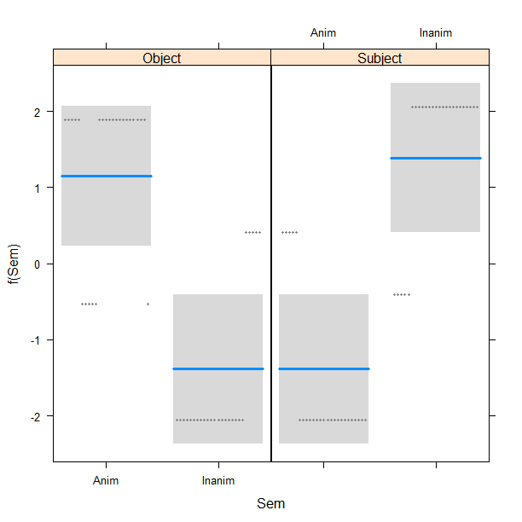
Figure 4. Cross-over interaction between semantics and syntactic role in imaginary corpus data of differential argument marking.

In such cases, CIT may be unable to identify any splits. Figure 5 displays the result of a CIT analysis with the default settings. It only contains a bar plot with the marginal proportions of the response categories. No splits are made. The method thus fails to uncover the underlying relationships between the predictors and the response.

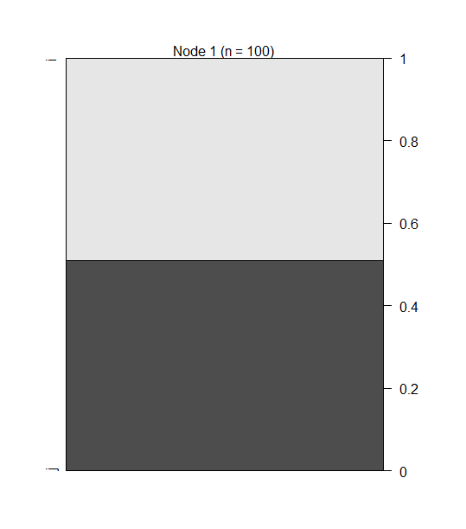
Figure 5. A bar plot representing the tree model for the imaginary differential argument marking data with a cross-over interaction. No splits are made.

(3) Instability. Simple CIT may be instable even to small changes in the data (Strobl et al. 2009). I have often observed that in models with numerous correlated predictors. The stability can be checked with the help of bootstrap. One can take a subset of the data without replacement and compare the new tree with the one based on the original data. If the tree looks different, the model is not stable. This is why individual trees need to be complemented by a random forest analysis, which aggregates the results from many individual trees. See an example in Section 3.
CRF are less prone to all these problems than individual CIT. However, forests also have their pitfalls. One of them is skewed response. Random forests of any kind do not predict very well when the response is very skewed. For example, if the proportions of two outcomes are 98% and 2%, it is possible to achieve 98% classification accuracy just by assigning the more frequent category. It will be difficult to find the predictors that perform better than this (Berk 2006). As a result, the predicted frequency of the rare category may be zero, i.e. the model will not discriminate between the categories. A CIT is more likely to be able to identify and represent such relationships.
As mentioned in Section 2.2, both CRF and CIT have a problem with dependent observations, in the situations when one normally uses mixed-effects regression. Some studies have treated the grouping factor as one of the predictors (e.g. Tagliamonte & Baayen 2012). However, this is not always fortunate. First, CIT are based on the permutation framework which measures the association between the response and a predictor by permuting the response variable, without taking into account the levels of the grouping factor (see Section 2.4). Therefore, the information about the dependence of the data points is lost. As Hothorn et al. (2006a: 258) write, “in the presence of a grouping of the observations into independent blocks, only permutations within blocks are eligible and that the conditional expectation and covariance matrix need to be computed separately for each block.” This has not been implemented and tested yet. As for CRF, the labels of a predictor are reshuffled within the levels of the other predictors in a subset, including those of a grouping factor only if it is present in the subset (unless one uses bagging). Thus, the information about the groups is sometimes kept, and sometimes lost even if we include it in the model. Moreover, it is not clear how to use the same model with the grouping factor as a covariate on new data, where the grouping categories (speakers or subcorpora) will be different (cf. Gelman & Hill 2007: 246). The model will therefore lose generalizability. Finally, as Baayen et al. (2013) demonstrate, the recursive partitioning methods do not perform very well when the grouping factor has many levels. In such cases, the mixed-effects model is the best choice.
From all this follows that CIT and CRF should be applied in tandem in order to counterbalance their strengths and weaknesses, and preferably in a combination with other methods, most importantly, linear or generalized linear regression.

3. A practical guide with R

3.1. Software

At the moment of writing, there are two add-on packages in R, in which conditional inference trees and random forests are implemented. One is party and the other one is partykit. The latter is a more recent version, which contains a new improved procedure for conditional inference trees. There are also some differences in the R syntax. The package partykit is still under development, though, and some functionalities available in party cannot be used at the moment in partykit. For example, one cannot use the Monte-Carlo resampling method of permutation in order to approximate the p-values in conditional inference trees. Only the default asymptotic method can be used. This is why the R code provided in the supplementary materials is based only on the functions from party.

3.2. T/V forms in Russian: Theoretical background and research question

This case study is a part of a larger project on European T and V politeness forms (Levshina 2017), which represent different degrees of politeness in addressing the hearer, e.g. French tu and vous, German du and Sie, Russian ty and vy, usually accompanied by a corresponding verb form. This cross-linguistic study is based on the parallel corpus of film subtitles called ParTy. The observations come from several films of different genres (see below). Since standard English has no politeness distinctions in the 2nd person, the translators of subtitles to languages with the T/V distinction have to choose between these forms. This may be a difficult thing to do because the norms of T/V use are multifactorial and very fluid.
According to Brown & Gilman (1960), the politeness forms in European languages can be described as in terms of two dimensions: power and solidarity. Power means the ability of one person to control the behaviour of another one. In a one-to-one interaction, the participant with greater power addresses the participant with less power using T, while the participant with less power uses V. It used to play an important role earlier, but has been gradually replaced by solidarity semantics, with T for intimate communication, e.g. between family members and friends, and V for formal communication. Virtually any characteristic, e.g. gender, age, hobbies, political beliefs and even physical appearance (e.g. dreadlocks or tattoos) can be basis for the perception of solidarity. See Levshina (2017) for an overview of these and more recent views. In what follows, we will discuss which factors influence the use of the Russian T and V forms, which are ty (2nd person singular) and vy (2nd person plural), respectively.

3.3. Data: film subtitles

The data for the present study come from online subtitles of nine popular films of different genres. The films are displayed in Table 6. The meta-information about the year and genres is taken from the International Movies Database.
The data set for the study was created as follows. First, over 200 interactive contexts with the pronouns you or yourself were identified in the English data. All plural references were excluded. Their translations were found in ten other languages, including Russian. It is important to mention that one should speak about T/V forms, rather than about T/V pronouns in this context. The reason is that often it is only the verb form that helps us to distinguish between T and V. Consider an example in (2) from Russian, where the first T form has no explicit pronominal subject, while the second one has both the pronoun and the verb form.

(2) Duma-ješ, ona tut? Ty ošiba-eš-sja.
think-Pres.2sg she here you.nom be.mistaken-Pres.2sg-Refl
“Do you really think she’s here? You’re mistaken.”

The data set with the Russian responses contains 228 instances of T/V forms.

Film | Year | Genres
Avatar | 2009 | Action, adventure, fantasy
Black Swan | 2010 | Drama, thriller
Bridge of Spies | 2015 | Drama, history, thriller
Frozen | 2013 | Animation, adventure, comedy
Inception | 2010 | Action, adventure, sci-fi
Spectre | 2015 | Action, adventure, thriller
The Grand Budapest Hotel | 2014 | Adventure, comedy, crime
The Imitation Game | 2014 | Biography, drama, thriller
The Iron Lady | 2011 | Biography, drama, history

Table 6. Films represented in the data set.

3.4. Variables

The film situations with you or yourself were coded for sixteen variables, which are presented in Table 7.

Relational (dyadic) variables
Name | Meaning | Values
Rel_Age | whether the Hearer is older or younger than the Speaker | “Same”, “Older” or “Younger”
Rel_Power | whether there is power asymmetry between the participants in general or in the given situation, e.g. a parent and a child, a general and a soldier, a boss and his/her employee | “Greater” (the Hearer has power over the Speaker), “Less” (the Speaker has power over the Hearer) or “Equal”
Rel_Class | the social class difference in the dyad | “Higher” (the Hearer belongs to a higher social class than the Speaker), “Lower” (the Hearer belongs to a lower social class than the Hearer) or “Equal”
Rel_Sex | the sex of the Speaker and the Hearer | “F_F” (female Speaker and female Hearer), “F_M” (female Speaker and male Hearer), “M_F” (male Speaker and female Hearer) and “M_M” (male Speaker and male Hearer)
Rel_Circle | the social circle to which the Speaker and the Hearer belong | “Fam” (family), “Fri” (friends), “Rom” (romantic partners), “Work” (colleagues at work), “Str” (strangers) and “Acq” (acquaintances)
Speaker-related and hearer-related variables
S_Age, H_Age | the Speaker’s age,  the Hearer’s age | “Child” (younger than 18), “Young” (approximately 18–35), “Middle” (approximately 35–60), “Old” (approximately older than 60)
S_Class,  H_Class | the Speaker’s social class,  the Hearer’s social class | “Upper” (top-rank politicians and civil servants, owners of multinational corporations, etc.), “Middle” (white-collar workers, small business owners, military officers, etc.), “Lower” (blue-collar workers, servants, etc.) and “Other” (aliens, animals, as well as gangsters, tramps, prostitutes and other declassed elements);
S_Sex,  H_Sex | the Speaker’s sex,  the Hearer’s sex | “M” or “F” (there were no transgenders in the data)
Variables describing the communicative settings

Others | the presence of other people who could hear the Speaker | “Yes” or “No”
Office | whether the interaction takes place in an office, a government building, prison, school, etc. | “Yes” or “No”
Before68 | whether the action takes place before 1968, | “Yes” or “No”
Place | where the action of the film takes place | “UK” (in the United Kingdom, “US” in the USA, “Fictive” (in an imaginary world), “Global” (in different parts of the world), “Europe” (somewhere in Europe)
Other variables
Film | the film | see Table 6.

Table 7. Variables for the case study of T/V forms.

3.5. Conditional random forest

First, let us grow a random forest and compute the conditional variable important scores in order to see which variables have impact on the choice between ty and vy. The dataset and R code are provided in the supplementary materials. Note that traditional non-conditional approach, when the permutation of a predictor X is performed over the entire range of predictor Z and others (cf. Section 2.4), is the default method. To visualize the scores, one can use different plot types: bar plots, dot charts, etc. Here I use a bar plot of sorted values. It is shown in Figure 6. The red line separates the important scores from the unimportant scores. Note that unimportant predictors fluctuate randomly around zero, with positive or negative values. Negative values appear when the randomly permuted versions of a predictor tend to be better than the original one. The rule of thumb is to take the absolute minimum value as a cut-off point. Note that the importance scores should only be interpreted with regard to their ranking, and not as absolute values. It would be a mistake to compare the scores across different models and data.
The plot in Figure 6 demonstrates that the variable Rel_Circle is the most important predictor. It is followed by the difference in the social class (Rel_Class) and the Hearer’s age (H_Age). Also, the individual differences between the films (Film) play a role. One can attribute that to some pragmatic variables that our course-grained schema does not take into account, or to the translators’ individual preferences. The place where the action takes place is of some importance, as well, followed by the Speaker’s class and age (S_Class and S_Age), communication in an official location (Office) and the presence of others (Others). The other predictors have only a marginal effect. Interestingly, this graph shows that the sex of the Speaker and Hearer does not matter. The individual power relationships do not matter, either.

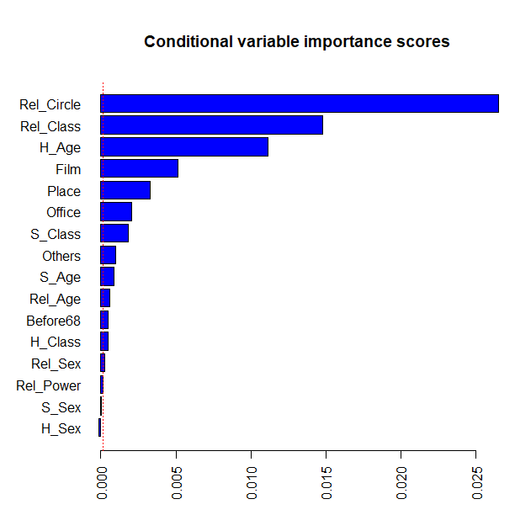
Figure 6. Conditional variable importance scores of the CRF based on Russian T/V data.

It is also necessary to evaluate how well the model discriminates between T and V. We achieve a classification accuracy of almost 0.88 (or 88%). The C-index, which is commonly used for estimation of the goodness of fit of logistic models, is 0.95. This means that the model performs well.
The results suggest that the dimension of solidarity, as represented by Rel_Circle, is the most important one, as one could expect from Brown & Gilman’s (1960) theory. However, it is followed by Rel_Class, which may represent the power dimension. In order to find the right interpretation, we need to perform additional analyses. First, we will create an individual conditional inference tree (Section 3.6). Next, we will compute the proportions of ty and vy, as predicted by the random forest, for each value of the predictors (Section 3.7).

3.6. Conditional inference tree

Figure 7 shows an individual CIT fitted to our data. The plot should be interpreted from the top down. The top split (Node 1) is made in the variable Rel_Circle. This means that it is the most strongly associated with the variation of ty and vy. The data are then split in two subsets. The one on the left includes the situations when the Speaker and the Hearer are friends, family or romantic partners. As one can see from the bar plot in Node 2, the proportion of ty is very high in those contexts. The right-hand branch from the top node represents the situations when the Speaker and the Hearer are colleagues, acquaintances or strangers. Further splits are made in these contexts. The first spit is made in the H_Age (Node 3). Let us first look at the right-hand branch, which includes middle-aged and old Hearers, and the resulting final Node 7. The propotions in the bar plot show that these contexts are characterized by a high chance of vy. No more splits are made here. As for the left-hand branch from Node 3, which includes the Hearers who are younger or have no human age at all (like magic creatures), then the relative social class (Rel_Class) plays a role, and another split is made (Node 4). If the social classes of the Speaker and Hearer are not equal, then the V form is slightly preferred (see the proportions in Node 5). If the Hearer and the Speaker belong to the same class or the class is not identifiable, the T form is obviously preferred (Node 6). Interestingly, this variable in fact represents solidarity, rather than power, as we hypothesized in the previous section without looking at the actual split. This split thus contributes to the importance of the solidarity dimension.

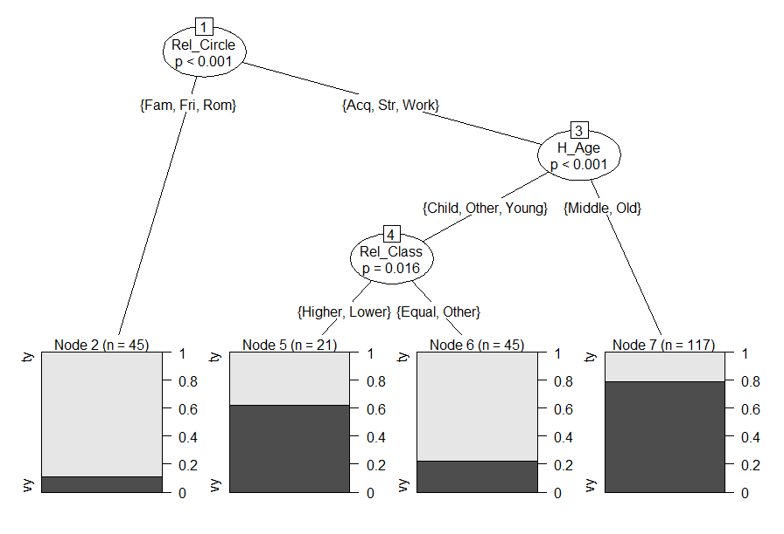
Figure 7. CIT based on the Russian T/V data.

Since there are two non-final, internal splits in the tree, it may be difficult to interpret them in terms of proportions of T and V. To facilitate the interpretation of those splits, one can create bar plots with proportions in each node, including the inner ones. Such a plot is shown in Figure 8. One can compare, for example, the proportions of T and V after the first split, looking at the final Node 2 and the inner Node 3. The bar plots show clearly that the propotion of V is greater in Node 3 than in Node 2.

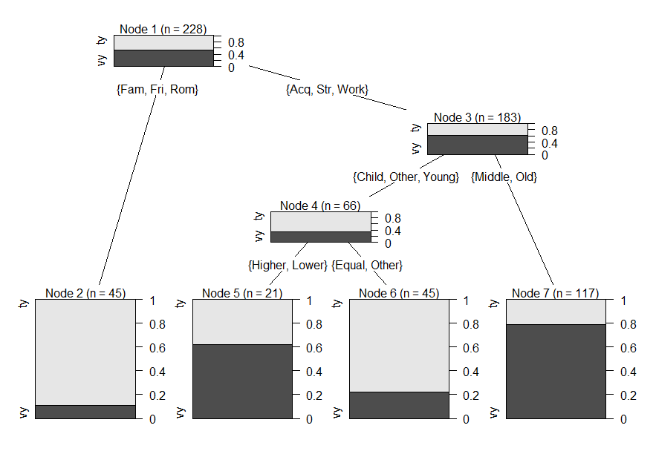
Figure 8. CIT with bar plots in the inner nodes.

The classification accuracy of the individual CIT is lower than that of the random forest (0.79, as compared with 0.88). The C-index is also lower (0.81 against 0.95). This supports the above-mentioned observation that random forests outperform individual trees in terms of prediction and classification.

3.7. Predicted proportions: a snake plot

Unfortunately, the tree only shows the effect of three predictors, whereas more variables display a relatively high conditional variable importance score, as was shown in Figure 7. What is the direction of the effects that we find there? Random forests do not return any coefficients similar to a regression model. However, we can compute the average proportions of predicted T and V for all levels of the categorical predictor using the predicted values for each observation. Since there are quite a few variables and their values, it is convenient to represent them in a snake plot (Gries & Otani 2010), which is shown in Figure 9. It displays the proportions of T and V predicted by the random forest.

Figure 9. A snake plot of the proportions of T and V predicted by the CRF.

The further to the right, the higher the predicted proportion of the informal form ty and the lower the predicted proportion of the formal pronoun vy. We will focus here only on those tendencies that were not captured by the individual tree in Section 3.6 (suffice it to say that the plot clearly supports our conclusions based on the tree) and that represent the variables that had relatively high or moderate relative importance scores discussed in Section 3.5:
- Film. Ty is very frequently predicted in Black Swan, Inception and Frozen. In contrast, vy is predicted to be particularly popular in the two spy films (SPECTRE and Bridge of Spies).
- Place: The model predicts very high proportions of ty when the action takes place in the US, and moderately high when a fictive world is shown. In contrast, the plot displays a relatively high proportion of vy when the settings are global (i.e. travel) or the action takes place in the UK or in Europe.
- Office: There is a tendency to prefer vy in an official location.
- S_Class: Interestingly, the classless characters (aliens or magic creatures) use ty, whereas all others display a weak tendency to prefer vy.

3.8. Conclusions and reporting the results

We can conclude that the solidarity dimension is the most prominent in the Russian data. There is a divide between friends, family and romantic partners, on one side, and strangers, acquaintances and colleagues on the other side. Also, if the film characters have equal positions on the social ladder, they tend to address each other with ty in the translations.
The properties of the speakers and hearers play an important role, as well. In particular, the age of the Hearer and (less so) that of the Speaker play a role. Younger communicators, especially children, address others and are addressed with ty. There is also a similar tendency for non-human creatures. This can be also interpreted in terms of solidarity: children, aliens and magic creatures care about class differences less than human adults.
The communicative settings are important, too. For example, if the action takes place in the US, the translators will be more likely to prefer the T forms. If it is an official institution, the V form is likely to be chosen.
The individual films also matter. Interestingly, the two spy films in the data show higher proportions of V. This may have to do with the romantic image of a spy in fiction – a mysterious lone wolf, who exists separately from the rest of the society.
When reporting the results, one should include the following information:
- conditional variable importance scores of the forest (e.g. in the form of a plot, as shown in Figure 6);
- an individual tree (cf. Figures 7 and 8);
- description of interactions based on individual trees (if there are any);
- measures of predictive accuracy and goodness of fit of the tree and forest.
One also needs to mention the settings that were used to create the trees and forests. For CRF, these settings are as follows:
- the number of trees in the ensemble;
- the type of the resampling procedure (with or without replacement);
- the number of predictors randomly selected for each individual tree;
- conditional or traditional variable importance;
- the tuning parameters of the individual trees (see below).
For individual trees, one should mention the following:
- asymptotic method or Monte-Carlo approximation; if the latter, the number of samples drawn;
- the minimum criterion for making a split (or α);
- the minimum number of cases in a node;
- the minimum number of cases before a split;
- and possibly other parameters that differ from the default settings.

4. Conclusions and reading suggestions

CIT and CRF are very flexible and convenient tools that can be used in many situations when traditional parametric methods will fail. They provide easily interpretable results and do not require a tedious check of numerous assumptions. However, these methods may be misleading in some special cases and therefore must be used in a combination with other methods, most importantly, mixed-effects logistic models.
There are still a few open questions. Most importantly, we need to have a more generalizable and appropriate way of dealing with the situations when the observations are not independent. Such situations are very common in corpus linguistics. In fact, this is a matter of ongoing research (Torsten Hothorn, p.c.), so hopefully we will see some important innovations in the near future. Second, the software is currently in a state of flux. We still have to wait until all functionalities that are available in the R package party are implemented in the optimized R package partykit.
For those interested in the statistical details, one could recommend an excellent introduction to recursive partitioning methods by Strobl et al (2009), where one can find the main principles of recursive partitioning, its advantages and methodological improvements, but also its limitations and pitfalls. The R code is provided, as well. On the linguistic side, one should mention the paper by Baayen et al. (2013) on functionally similar Russian constructions, which compares the advantages and disadvantages of several popular methods (CIT and CRF, mixed-effects logistic regression and naïve discriminative learning) along various dimensions, which are important to quantitative linguists, including classification accuracy, cognitive realism and ease of interpretation.

Abbreviations

2sg 2nd person singular
Nom Nominative case
Pres Present tense
Refl Reflexive

Representative studies

1. Tagliamonte & Baayen (2012)
Research question. The study investigates the factors that determine variation between was and were in plural past tense existential constructions in York English, as in There was/were a lot of people.
Data. The data come from a corpus of spoken York English at the turn of the 21st century. All plural past tense existential constructions (e.g. There was/were + PL noun) were extracted. The dataset contains 489 tokens from 83 individuals. Nine covariates are tested, which represent such social factors as the sex, age and education level of the speakers, and such linguistic factors as polarity, type of determination and proximity of the copula to its referent.
Methods. The paper utilizes fixed-effects and mixed-effects logistic models, as well as CIT and CRF, where the speakers’ IDs are added as a covariate.
Results. The CRF provides the best prediction. The most important predictors are the speaker’s age, polarity, type of determination and proximity. There is also very substantial interspeaker variation. The CIT shows that the individuals split the picture, and that linguistic and social factors play a role only for a subset of speakers. For that subset, the non-standard form was is more likely to occur in affirmative contexts than in negative ones. Further, the differentiation by age is only relevant in affirmative contexts. Younger speakers are more likely to use was than the older speakers.

2. Szmrecsanyi et al. (2016)
Research questions. This study focuses on three alternations in different geographic varieties of English: the dative alternation, the genitive alternation and variation in particle placement. The lects include two native varieties (Great Britain and Canada) and two non-native varieties (India and Singapore). The research questions are as follows:
1. Do the varieties of English share a core probabilistic grammar?
2. Is there a split between the native and non-native varieties of English?
3. Do the alternations under study differ in terms of their probabilistic sensitivity to variety effects?

Data. The authors use the relevant components of the International Corpus of English. In addition, some frequency information was collected from the GloWbE.
Methods. A CIT and a CRF are fit for each of the alternations.
Results. The results are as follows:
1. The directions of the effects of the contextual variables are stable across the varieties in all three alternations, although there are quantitative differences with regard to the effect size.
2. As for the second research question, the data provide no conclusive results.
3. The particle placement alternation exhibits the most robust variety effects, and the genitive alternation the least. The authors explain this finding by the fact that the particle placement alternation is more tightly associated with specific lexical items (i.e. verb slots in the particle
placement), which makes cross-varietal indigenization effects more likely.

References

Baayen, R. Harald. 2010. Demythologizing the word frequency effect: A discriminative learning perspective. The Mental Lexicon 5: 436–461.
Baayen, R. Harald, Anna Endresen, Laura A. Janda, Anastasia Makarova, and Tore Nesset. 2013. Making Choices in Russian: Pros and Cons of Statistical Methods for Rival Forms. Russian Linguistics 37: 253–291.
Berk, Richard A. 2006. An introduction to ensemble methods for data analysis. Sociological Methods & Research 34(3): 263–295.
Bernaisch, Tobias, Stefan Th. Gries & Joybrato Mukherjee. 2014. The dative alternation in South Asian English(es). English World-Wide 35(1): 7–31.
Breheny, Patrick & Woodrow Burchett. 2016. visreg: Visualization of Regression Models. R package version 2.3-0. https://CRAN.R-project.org/package=visreg.
Brown, Roger & Albert Gilman. 1960. The pronouns of power and solidarity. In Thomas A. Sebeok (ed.), Style in Language, 253–276. Cambridge, MA: MIT Press.
Gelman, Andrew & Jennifer Hill. 2007. Data Analysis Using Regression and Multilevel/Hierarchical Models. Cambridge: Cambridge University Press.
Gries, Stefan Th. & Naoki Otani. 2010. Behavioral profiles: a corpus-based perspective on synonymy and antonymy. ICAME Journal 34: 121–150.
Harrell, Frank E. Jr. 2017. rms: Regression Modeling Strategies. R package version 5.1-1. https://CRAN.R-project.org/package=rms.
Hopper, Paul & Sandra A. Thompson. 1980. Transitivity in grammar and discourse. Language 56: 251–299.
Hothorn, Torsten, Kurt Hornik, M.A. van de Wiel & Achim Zeileis. 2006a. A Lego System for Conditional Inference. The American Statistician 60: 257–263.
Hothorn, Torsten, Kurt Hornik & Achim Zeileis. 2006b. Unbiased Recursive Partitioning: A Conditional Inference Framework. Journal of Computational and Graphical Statistics 15(3): 651–674.
Hothorn, Torsten & Achim Zeileis. 2015. partykit: A Modular Toolkit for Recursive Partytioning in R. Journal of Machine Learning Research 16: 3905-3909. URL http://jmlr.org/papers/v16/hothorn15a.html.
Levshina, Natalia. 2016. Why we need a token-based typology: A case study of analytic and lexical causatives in fifteen European languages. Folia Linguistica 50(2): 507–542.
Levshina, Natalia. 2017. A Multivariate Study of T/V Forms in European Languages Based on a Parallel Corpus of Film Subtitles. Research in Language 15(2): 153-172.
Loh, Wei-Yin. 2014. Fifty years of classification and regression trees. International Statistical Review 82(3): 329–348.
Lohmann, Arne. 2013. Is tree hugging the way to go? Classification trees and random forests in linguistic study. Vienna English Working Papers 22. http://anglistik.univie.ac/views/
Strobl, Carolin, Anne-Laure Boulesteix, Achim Zeileis & Torsten Hothorn. 2007. Bias in Random Forest Variable Importance Measures: Illustrations, Sources and a Solution. BMC Bioinformatics 8: 25. http://www.biomedcentral.com/1471-2105/8/25
Strobl, Carolin, Anne-Laure Boulesteix, Thomas Kneib, Thomas Augustin & Achim Zeileis. 2008. Conditional variable importance for random forests. BMC Bioinformatics 9: 307. http://www.biomedcentral.com/1471-2105/9/307
Strobl, Caroline, James Malley & Gerhard Tutz. 2009. An introduction to recursive partitioning: Rationale, application, and characteristics of classification and regression trees, bagging, and random forests. Psychological Methods 14(4): 323–348.
Szmrecsanyi, Benedikt, Jason Grafmiller, Benedikt Heller & Melanie Röthlisberger. 2016. Around the world in three alternations: Modeling syntactic variation in varieties of English. English World-Wide 37(2): 109–137.
Tagliamonte, Sally & R. Harald Baayen. 2012. Models, forests and trees of York English: Was/were variation as a case study for statistical practice. Language Variation and Change 24(2): 135–178.
Wiechmann & Kerz. 2012. The positioning of concessive adverbial clauses in English: Assessing the importance of discourse-pragmatic and processing-based constraints. English Language & Linguistics 17(1): 1–23.

R code with comments

The dataset is called tv.rus. You will need to install the package party first.

1. Grow a CRF.

library(party)
set.seed(2450)#if you want to reproduce the results shown in the chapter
tv.rus.rf <- cforest(rus ~., data = tv.rus, controls = cforest_unbiased(mtry = 4, ntree = 1000))

The function cforest_unbiased() provides the settings suggested for the construction of unbiased random forests by Strobl et al. (2007). The settings are as follows: teststat = "quad", testtype = "Univ", replace = FALSE. This means that for each individual tree that is grown for this forest, the algorithm uses the quadratic statistic for variable selection (Hothorn et al. 2006), no Bonferroni correction is made, and the random sample used for constructing an individual tree is created without replacement. This has been the default option since party 0.9-90. In order to use other settings, one should use cforest_control(), which has other default parameters (see ?cforest_control).
The argument mtry determines the number of variables that are selected for splits in an individual tree. The default value is 5 (for some technical reasons). If mtry is equal to the number of predictors, the method is called bagging. Note that in that case, you will lose the advantage of weakening the competition for highly specialized predictors. As a result, the trees will be less diverse than if non-bagging, and the prediction will be less accurate. According to a rule of thumb, the recommended value of mtry is the square root of the number of predictors. Since we have sixteen predictors, four is an appropriate number.
Finally, the argument ntree tells R to grow 1,000 trees (by default, 500 are grown).
Other possible tuning parameters, which are not modified here, are minsplit (i.e. the minimum number of observations to be considered for splitting; 20 by default), mincriterion (1 – p-value, which must be exceeded in order to implement a split; 0.95 by default) and minbucket (the minimum number of data points in a branch after a split; 7 by default). For small samples, for example, it may be useful to reduce minsplit and decrease mincriterion (Strobl et al. 2009).

2. Compute and plot the conditional variable importance scores.

set.seed(32) #if you want to reproduce the results shown in the chapter
tv.rus.varimp <- varimp(tv.rus.rf, conditional = T) #this may take a while, depending on the number of trees
par(mar = c(5, 6, 5, 2)) #to make sufficient space for plotting the vertical axis labels on the bar plot
barplot(sort(tv.rus.varimp), horiz = T, las = 2, col = "blue")
abline(v = abs(min(tv.rus.varimp)), lty = 3, col = "red")

3. Evaluate the goodness of fit of the forest.

a) Compute the classification accuracy:

pred.rf <- predict(tv.rus.rf)

table(pred.rf, tv.rus$rus)

#pred.rf ty vy
# ty 91 11
# vy 17 109

(91 + 109)/228
#[1] 0.877193 #classification accuracy

b) Compute the C-index:

library(Hmisc)
prob.rf <- unlist(treeresponse(tv.rus.rf))[c(FALSE, TRUE)]

somers2(prob.rf, as.numeric(tv.rus$rus) - 1)
# C Dxy n Missing
# 0.9510031 0.9020062 228.0000000 0.0000000

4. Grow an individual tree.

tv.rus.ctree <- ctree(rus ~ ., data = tv.rus, controls = ctree_control(teststat = "quad", testtype = "Bonferroni"))
plot(tv.rus.ctree)

plot(tv.rus.ctree, inner_panel = node_barplot)

5. Evaluate the goodness of fit of the tree.

a) Compute the classification accuracy:

pred.ctree <- predict(tv.rus.ctree)

table(pred.ctree, tv.rus$rus[complete.cases(tv.rus)])

#pred.ctree ty vy
# ty 75 15
# vy 33 105

(75 + 105)/228
#[1] 0.7894737

b) Compute the C-index:

prob.ctree <- unlist(treeresponse(tv.rus.ctree))[c(FALSE, TRUE)]

somers2(prob.ctree, as.numeric(tv.rus$rus) - 1)
# C Dxy n Missing
# 0.8092593 0.6185185 228.0000000 0.0000000

6. Create a snake plot of predicted proportions.

#caution: this function only works for binary response variables!
forest_snake <- function (data, pred.val, level = 1) {
y <- c()
for (v in 1:ncol(data)){
y1 <- prop.table(table(pred.val, data[, v]), 2)[level, ]
names(y1) <- paste(colnames(data)[v], names(y1), sep = ".")
y <- c(y, y1)
}
return (y)
}

var.ty <- forest_snake(tv.rus[, -1], pred.rf)
plot <- plot(sort(var.ty), 1:length(var.ty), type = "n", xlab = "V <---> T", yaxt = "n", ylab = "", main = "Predicted proportions of T")
abline(v = 0.5, lty = 3)
text(sort(var.ty), 1:length(var.ty), names(sort(var.ty)), cex = 0.6, col = c("blue", "red"))

E.g. where some observations only specify an interval instead of an exact value, such as age older than 80 years or size of clothes smaller than XS.
A solution with random effects seems to be implemented in the package REEMtree (regression trees with random effects for longitudinal data), but it is only available for a specific type of statistical problems.
There are two options for computing the p-values. By default, the algorithm returns the asymptotic p-values because the test statistics used in the algorithm are shown to tend to well-known distributions. More precisely, a χ² distribution in the case of the test statistic c_{quad} (argument teststat = 'quad' in party::ctree_control and party::cforest_control) and a multivariate normal distribution in the case of c_{max} (teststat = 'max') (Hothorn et al. 2006a). Alternatively, one can approximate the p-values by using Monte-Carlo resampling and simulate the distribution of the test statistic (testtype = 'MonteCarlo'). The number of samples can be specified, e.g. nresample = 20000 (9,999 by default).
Available at https://github.com/levshina/ParTy-1.0
www.imdb.com, last access 04.09.2017.

