Solent University

Faculty of Business, Law and Digital Technologies

**The Python Software Project**

Author : **Lev Rubinov**

Course Title : **Your Course Title**

Module Leader : **Jarutas Andritsch**

Date : **Current Date**

Table of Contents

1. Overview 3

2. Project Implementation 4

2.1 Project structure 4

2.2 Modules/ Functions 5

2.2.1 Module/ function name 5

2.2.2 Module/ function name 5

2.2.3 Module/ function name 5

2.2.4 … 5

3. GitHub Repository Evidence 6

Table of Figures

Figure 1 Customer Behaviour of Car Sale Market Project Structure (Andritsch, J., 2022) 4

Figure 2 Code to perform size checks on entities 5

Figure 3 Github commit 6

Index of Tables

Table 1: Task Completion 4

# 1. Overview

In this project, I worked with a CSV file using Python. I retrieved, analysed data from the file, as well as making graphs using this data. The modules used were Pandas and Matplotlib.

You should also include a table summarising what requirement have been achieved.

Table 1: Requirement Completion

|  |  |
| --- | --- |
| **Requirement** | **Status** |
| retrieve devices by oem_id | completed |
| retrieve devices by code name | completed |
| retrieve devices by RAM capacity | completed |
| retrieve devices by model (custom) | completed |
| identify the top 5 regions | completed |
| analyse the average price of devices | completed |
| analyse the average mass for each manufacturer | completed |
| analyse the average weight and height of devices (custom) | completed |
| chart for proportion of RAM types | completed |
| chart for each USB connector type | completed |
| monthly average price trends | completed |
| Making an interface within a console. | completed |
|  |  |
|  |  |
|  |  |

**Status options:** Completed/ Partially Completed/ Not Attempted

# 2. Project Implementation

My project is completed within one ipynb file.

#### 2.1 Project structure

The structure of my project is completed using each several functions at the start for different tasks, and the main function at the end.

#### 2.2 Modules/ Functions

My project is completed using

1. Menu function, where each option is shown in the console
2. Separate functions for each task from a) and b):
   1. retrieve1 for a. This function is applied for all subtasks with different parameters for each.
   2. retrieve_regions for b1
   3. average_price_for_brand for b2
   4. average_weight_by_manufacturer for b3
   5. average_width_height_for_brand for b4
3. Main function. Here I link the CSV file with my Python file. The function has a ‘while’ loop with several if’s, where the choice for each function is listed. Based on the number of the user’s input, the function linked to that number is performed. The choices from 1 to 8 are for tasks a and b, the choices from 10 to 13 are for task c. Task c choices don’t use a function. Choice 13 is for exiting the code.

##### 2.2.1.1 menu_function

This function is needed for printing the options for the user in the console. It consists of several “print” commands.

##### 2.2.1.2 retrieve1

We need this for retrieving values using columns from the dataset. First we get the index of the value name directly, then the loop is made through which the value is printed out.

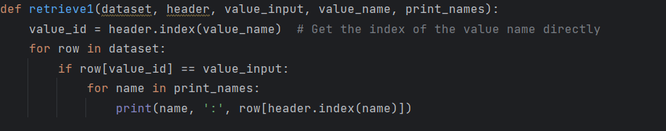That’s how we retrieve:

1. model name, manufacturer, weight, price, and price unit for the devicesbased on the oem_id
2. brand, model name, RAM capacity, market regions, and the date when the information was added for device(s) associated with a specified code name
3. oem_id, release date, announcement date, dimensions, and devicecategory of the device(s) based on a specified RAM capacity.
4. released date, announced date, hardware designer by code name (custom option)

I will explain the following loop later in 2.2.2 main function section.

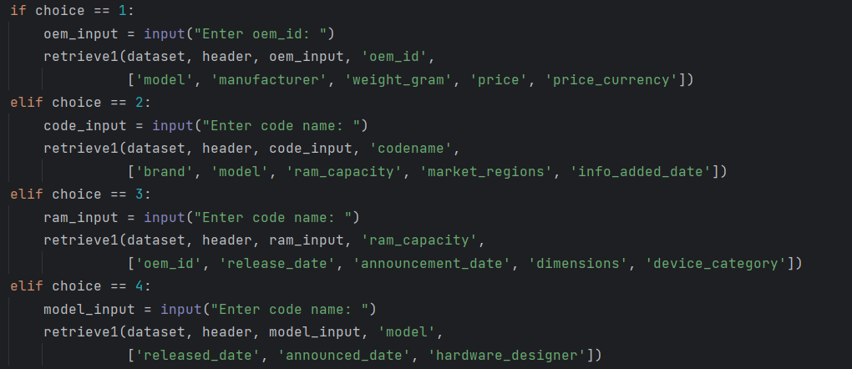

##### 2.2.1.3 retrieve_regions

This is used in order to identify the top 5 regions where a specific band of devices was sold. Here we split the market regions by comma, explode the resulting lists to separate rows, count occurrences of each region and select top 5 regions and return as a list.

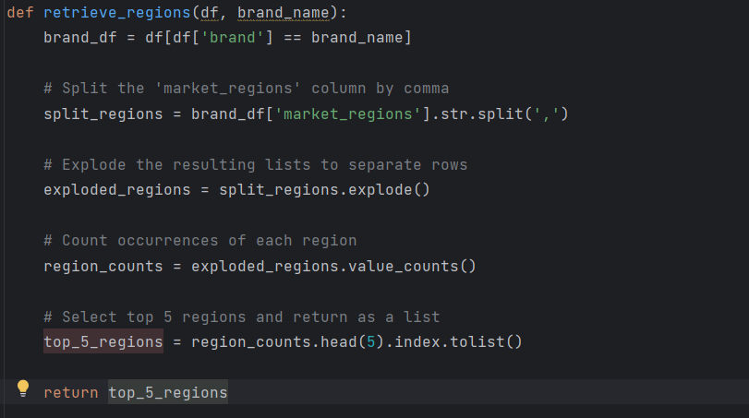

Here we execute the function with the price rounded up to 2 decimals.

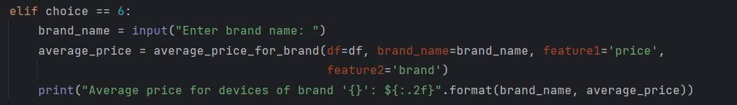

##### 2.2.1.4 average_price_for_brand

Here we analyse the average price of devices within a specific band, all in the same currency.

First, we filter DataFrame for a specific brand, and then calculate and return the average price.

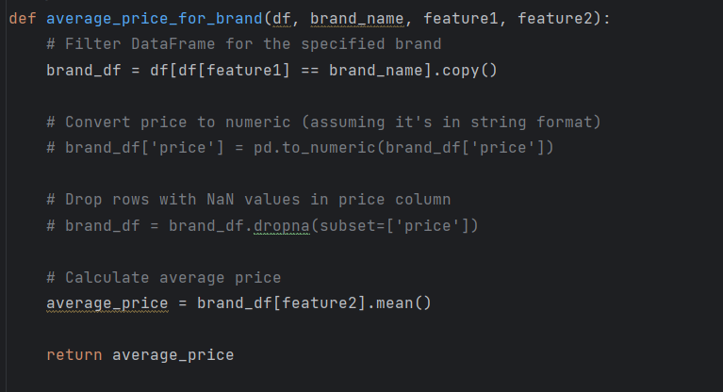

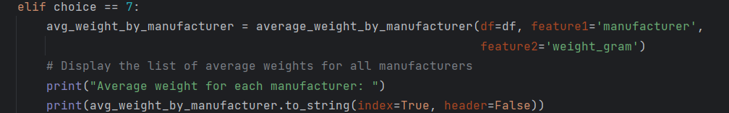

##### 2.2.1.5 average_weight_by_manufacturer

Here we analyse the average mass for each manufacturer and display the list of average massfor all manufacturers. First we group the DataFrame by 'manufacturer', then select the 'weight_gram' column from the grouped DataFrame and calculate the mean of the 'weight_gram' column.

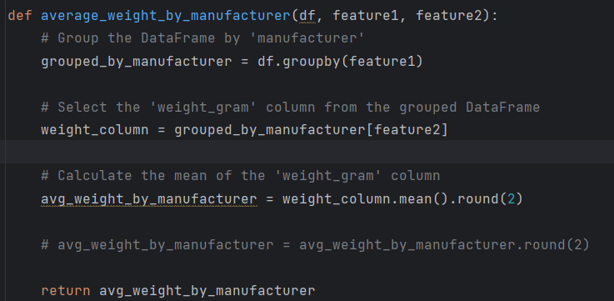

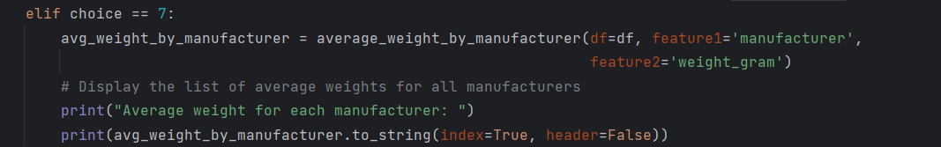

##### 2.2.1.6 average_width_height_for_brand (custom)

For a custom function, I decided to analyse average width and height for brand. First we filter DataFrame for the specified brand, and then calculate average width and height.

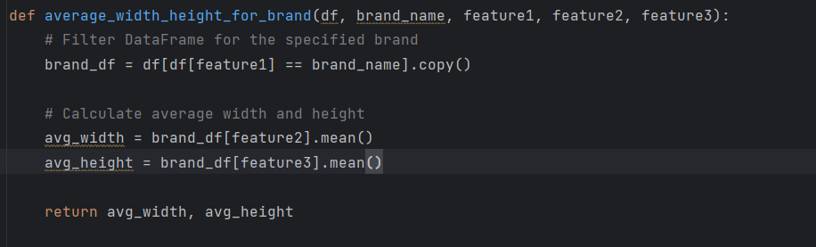

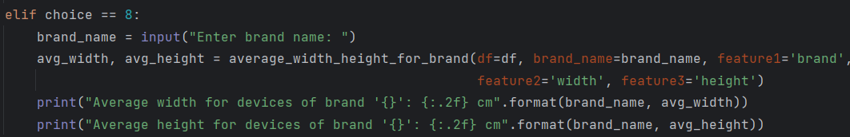

##### 2.2.2 main function

Here we start with specifying the link to our CSV dataset. Then we proceed try function and while loop.

##### 2.2.2.1 try

Here we specify the pandas link and and use the “numeric values” variable to handle errors that may occur during the conversion to numeric process.

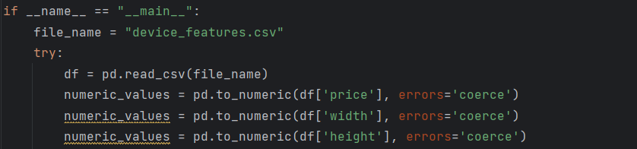

##### 2.2.2.2 ‘while’ loop and ‘choice’

Here we realise all of our previous functions. We create a loop which executes functions based on the input number.

I covered the choices from 1 to 8. In 9 to 11 we visualise the proportion of RAM types for devices in the current market, number of devices for each USB connector type, the monthly average price trends (in GBP) for devices released in each year from 2020 to 2023.

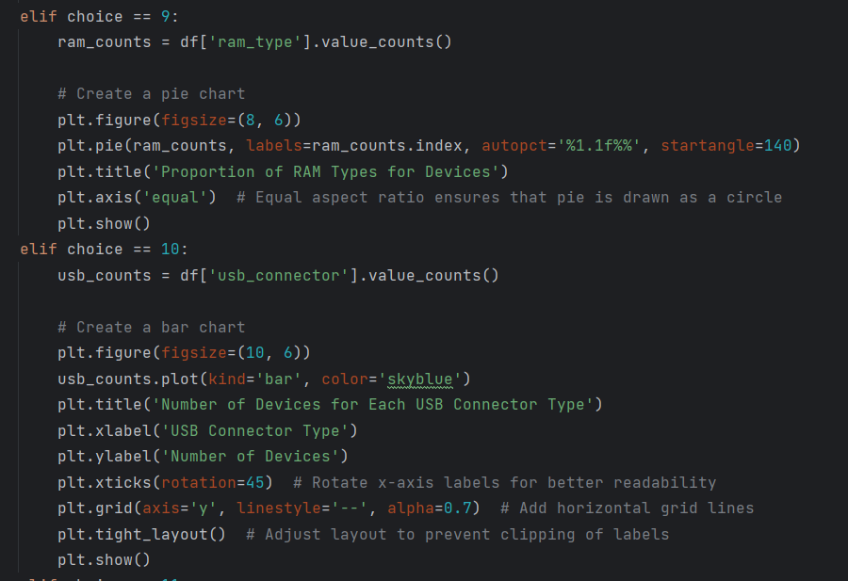

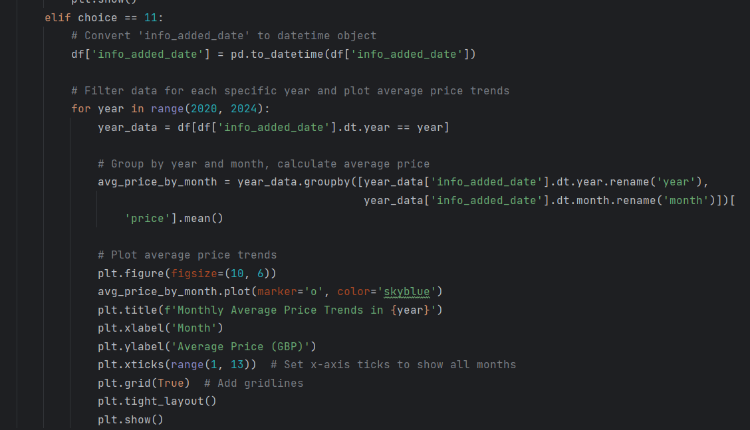

# 3. GitHub Repository Evidence

A screen shot of your private Git repository. The screen shot need to **clearly show your history of your commit of your project implementation**. You need to click on the clock symbol on the right conner of your repo.

Figure 3 Github commit

Sample screen shot of your commit history:

