Week 9 Individual Assignment
Damon Levy | MIS 310 | Professor Djangone | October 19, 2026

Part A Calculator Questions
The calculator follows the class video example. It uses simple functions to handle button clicks, clear the display, and calculate an answer. The explanations below describe how the program works.

1 Role of StringVar
StringVar() connects the calculator’s text to the Entry widget through textvariable. When input_text.set(expression) runs, the display updates. A regular string can store the expression, but changing that string alone will not update the display. StringVar makes that connection for us.

2 Layout manager and widget placement
The calculator uses grid() to arrange the buttons in rows and columns. Each button has a row and column number. Clear spans three columns, and zero spans two. This keeps the buttons lined up. The program also uses pack() to put the input frame above the button frame. These layout managers work together because they position widgets in different containers.

3 Button clicks and the command parameter
When a button is clicked, its command runs a function. For example, command=lambda: btn_click(7) calls btn_click with the number 7. That function adds 7 to the expression and updates the display. Clear uses command=btn_clear, and equals uses command=btn_equal. These functions are passed without parentheses so they run when the user clicks, rather than when the button is created.

4 Incorrect input and better error handling
btn_equal() uses try and except to handle errors. The try block uses eval(expression) to calculate the answer. If the expression is invalid or divides by zero, the except block displays Error and clears the stored expression. I would improve this by catching ZeroDivisionError separately and showing Cannot divide by zero. That would tell the user what needs to be fixed.

Part A Calculator Questions Continued

5 User interface improvements
I would keep the buttons evenly spaced and make the display easy to read. A Backspace button would let users remove one wrong digit without clearing the whole expression. I would also make the error message more specific. These are possible improvements; the current program keeps the simple layout shown in the demo.

6 Why choose grid
I would choose grid() because a calculator has rows and columns. It makes it easy to line up the number buttons and keep the operators in one column. pack() is useful for stacking the two main frames, but arranging a keypad with it would require more frames. place() uses specific positions, so I would need to work out the location of each button.

7 Purpose of the three functions
btn_click(item) adds the selected number or operator to the expression. It then uses input_text.set(expression) to show the updated expression.
btn_clear() sets expression to an empty string and clears the display. The user can then start a new calculation.
btn_equal() uses eval(expression) to calculate the answer and displays it with input_text.set(result). It clears the stored expression after showing the answer, so the next button starts a new calculation. If something goes wrong, it displays Error and clears the stored expression.

Source materials
Djangone, A. (n.d.). Assignment 6 part 1 and part 2 [Course videos]. MIS 310, Blackboard. Linked in the Week 9 assignment.
Python Software Foundation. (n.d.). tkinter — Python interface to Tcl/Tk. https://docs.python.org/3/library/tkinter.html
AI assistance helped draft the code, explanations, and GUI plan. The summarizer interface is still a design plan, rather than a completed summarization application.

Part B Lecture to Notes GUI Plan
Damon Levy | Individual interface proposal | Page 1 of 2

Project purpose and intended users
Our group plans to develop a Python application that turns lecture transcripts and text-based PDFs into organized study notes. We are mainly designing it for college students who need shorter material to review. Professors could also use it to prepare an initial study guide. I propose keeping the source and generated notes visible together. This would let users check the summary against the original material and decide whether it has kept the important ideas.

Interface design
I would use one resizable Tkinter window. At the top, users would enter a lecture title and choose an input method. Two scrollable text areas would take up the center: the source on the left and editable notes on the right. The summary settings and action buttons would sit below them. I would use grid() to align controls within frames and allow the text areas to expand with the window. Save would remain disabled until notes are available. Generate would also be disabled during processing.

Widgets and their purposes
Widget | Purpose
Label | Identify sections, fields, and current status.
Entry with StringVar | Enter a lecture title used in the notes heading and suggested filename.
Radiobuttons | Choose Paste transcript or Import PDF; enable the relevant input controls.
Button and file dialog | Browse for a PDF and load extracted text into the source area.
ScrolledText widgets | Enter or inspect source text; review and edit generated notes.
Readonly Combobox | Select Brief, Standard, or Detailed summary length.
Checkbutton | Include a separate key-terms section when selected.
Generate Notes button | Validate the input and request an AI summary using the chosen settings.
Clear button | Reset both text areas and settings after confirmation if content exists.
Save button and save dialog | Export the reviewed notes to a user-selected Markdown (.md) file.
Message boxes | Explain empty input, PDF extraction, processing, or file-saving errors.
Status label and Progressbar | Show Ready, Processing, or Saved; indicate work during summarization.

Part B GUI Mockup and User Flow
Damon Levy | Individual interface proposal | Page 2 of 2
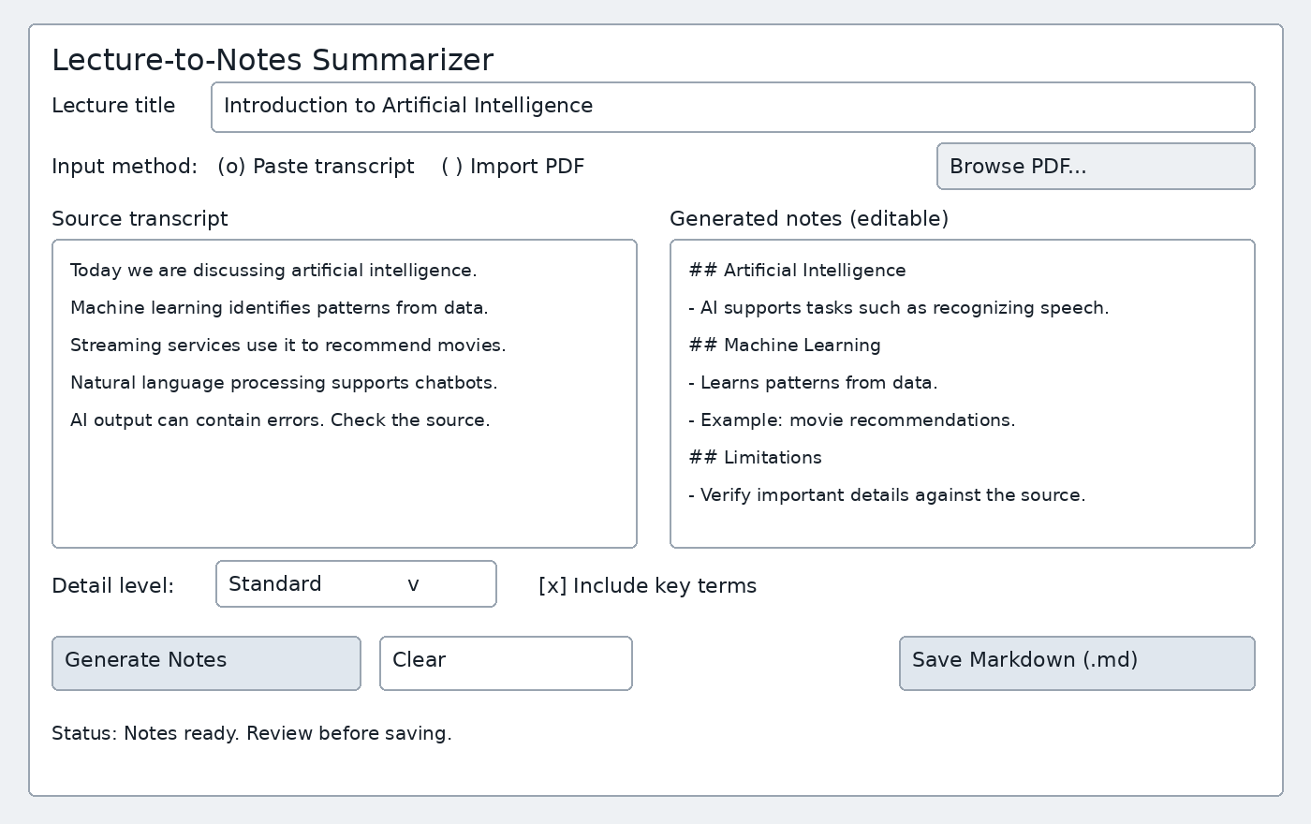
This mockup shows the proposed screen after notes have been generated. The sample text illustrates the layout and the kind of output users would see.

User interaction flow
1. Enter a lecture title, then choose Paste transcript or Import PDF.
2. Paste the lecture text or select a file through Browse PDF. Check the extracted text before moving on. If the PDF contains only scanned images, the app will explain that it needs OCR and ask the user to provide a text transcript instead.
3. Select a detail level and decide whether to include key terms, then click Generate Notes. If the input is empty, the app will ask for lecture content.
4. While the app processes the text, it will show progress and prevent duplicate requests. Summarization will run outside the GUI event loop to keep the window responsive.
5. Review the generated Markdown notes in the right text area. Compare them with the source and correct inaccuracies, including any details that should be retained. If processing fails, the app will keep the input and display a clear message about trying again.
6. Click Save Markdown and select a filename and location. Confirm any overwrite. The app will display Saved only after it writes the file successfully. Clicking Clear will ask for confirmation before discarding existing content.

Expected output
The app will show a lecture heading, topic headings, and concise bullet points. If selected, the key-terms section will provide definitions supported by the source. The saved .md file will match the reviewed notes in the preview. I think users need to check the source for omitted details and incorrect interpretations, even when notes retain the core concepts and examples. Live audio transcription and automatic Zoom or Teams integration are outside the initial scope.

