EasyAvatar Tutorial

EasyAvatar is a simple project to show beginners how to attach objects that have Unity’s SkinnedMeshRenderer to another object with the same Armature/Rigged Bone set-up. An example of this would be clothing, armor or physical additions like different hair styles or body parts for a character.

When creating your character avatar system, there are several things to keep in mind in order for Unity to work with your imported objects;

1. All objects that will be attached to each other MUST have the same rig/bone set up.
2. **The bone set up MUST be in the same order when exported into Unity!!**

(If you are having issues where the mesh is being distorted/won’t show up, this is probably the case. Make sure if the Character file is a .blend, that the object to be attached is also a .blend. Taking an .fbx to .blend has a good chance of having severe results!)

1. Objects must be SkinnedMeshRenderer’s. If you have imported into unity and it says, “Mesh Renderer” instead, that means somehow in the export you screwed up, and there are no bones in the object.

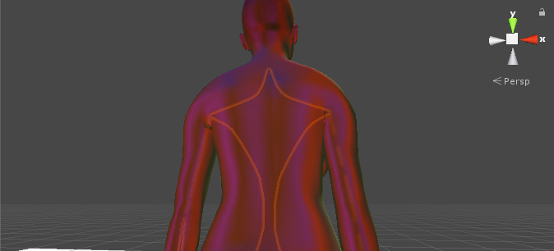

(In this picture I am using the same mesh/rig from blender, but exported the character as a .blend and the article of clothing as an fbx file. The fbx exporter on blender has a different sort order than the .blend, twisting and contorting the mesh badly.)

Basic Setup

The only script you need to apply objects to your avatar is the AvatarManager.cs file. Simply pass the object and the avatar to the AddObjectToMesh() function.

Everything else in the files is just an example.

In the example, I use ItemDatabase.cs to add items used in the scene to a set of lists. This script is a Singleton, which is attached to a GameObject in the scene.

Each list is just an easy example of how to arrange objects together. To add your own objects to the example, simply drag and drop SkinnedMeshRender GameObjects into whatever list you want them to relate to.

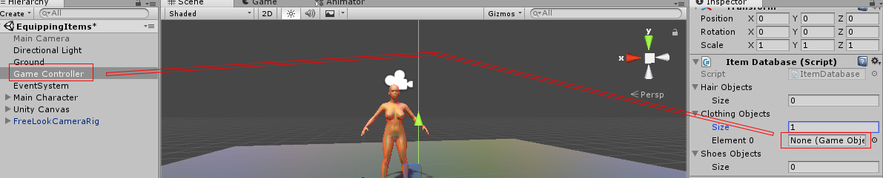

Each list simply corresponds to a button on the canvas in the example scene for you to experiment with adding equipment to the tutorial mesh after pressing play.

Troubleshooting

Other than the issues already mentioned, there are many other issues resolved and look over during the free, short youtube video tutorial series linked at the end of this document.

A common issue is meshes disappearing at different angles in unity. Without expanding in why this is happening, the fix is to click the rigged mesh renderer object and select the, “Update when offscreen” option seen below:

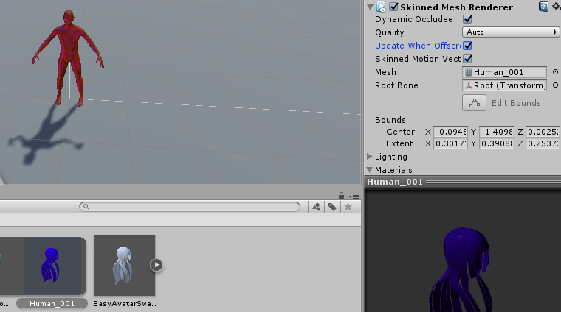

Resources

I used makeHuman to create the model, and makeClothes for Blender to make the clothing/hair.

You can download makeHuman here:

<http://www.makehuman.org/download.php>

You can download the makeClothes plugin for Blender here:

<http://www.makehumancommunity.org/wiki/Documentation:Getting_and_installing_BlenderTools>

This video is a tutorial for this PDF. Watch to see how I import models and set them up:

<https://youtu.be/XAAwFW6iE8A>

This video is a tutorial series on how to make blender clothing for avatars:

<https://youtu.be/eTT3P4ZczFs>

Thank you for purchasing this asset. This is the first thing I have ever accomplished in the c# world, and appreciate the support a great deal. This would not have been possible without all of the people on the internet who teach and give help and advice.

Good luck!