# Screenshot_1

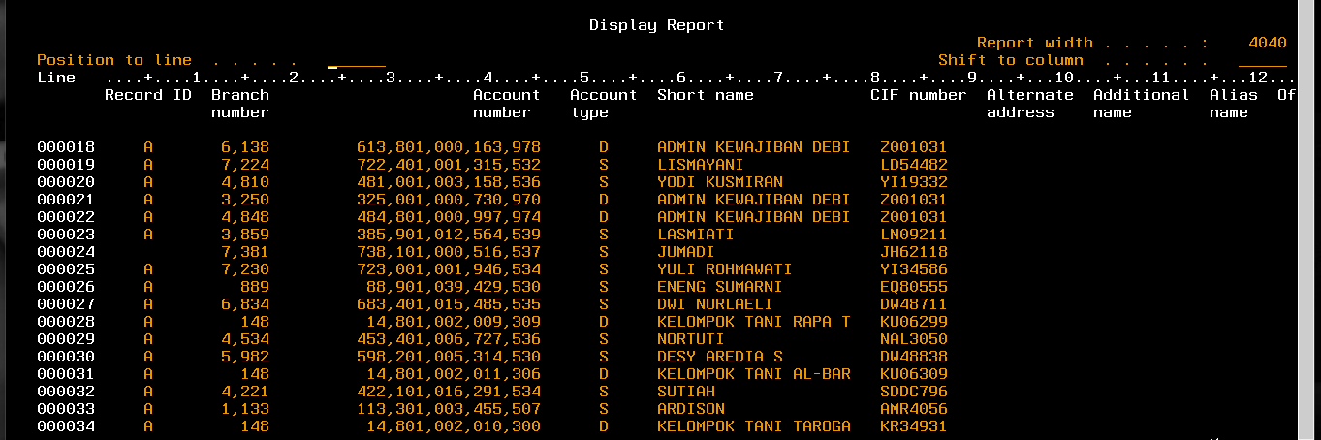

# Screenshot_2

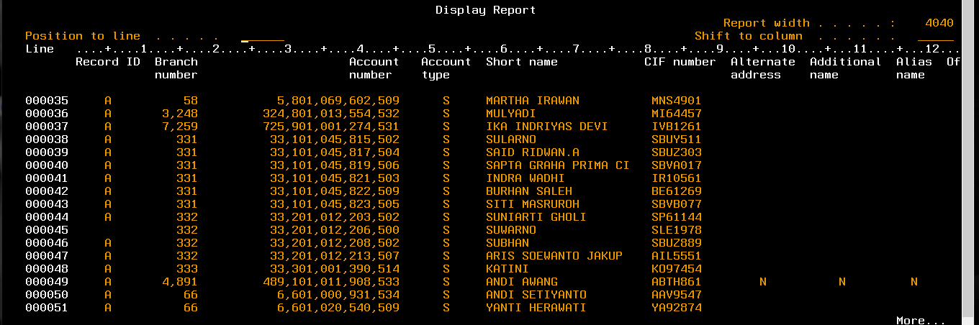

# Screenshot_3

