RL Project Report
057931354

Question 1:
See the plot below. Reached score (best mean reward) of 18.04 with default hyperparameters. Ran beyond 4m steps.

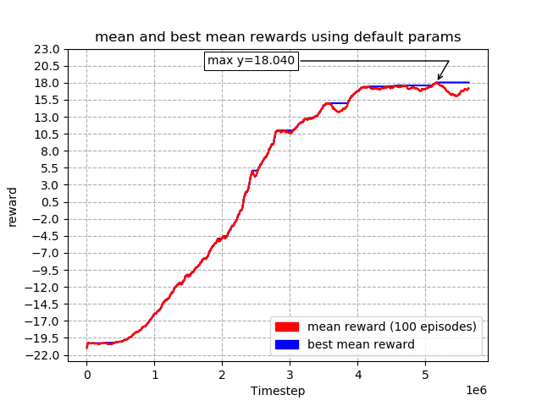

Question 2:
See plots below.

