Reinforcement learning - Exercise 3
Rafi Levy
057931354
raffilevy@gmail.com

Programing
Question 1: 1
Number of failures is 263
Question 2: 2 (below)

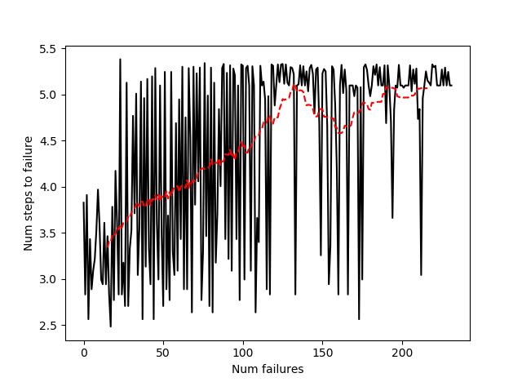

Question 2: 1
Score over time: 0.4975
Final Q-Table Values
[[8.05641502e-03 1.08484772e-01 1.08515938e-02 6.14146233e-03]
[8.03869925e-04 1.09495602e-03 4.38933470e-03 3.66071479e-02]
[3.59953918e-03 1.14032958e-03 9.67777561e-04 3.16413782e-02]
[7.38694342e-04 1.75424540e-05 9.36806030e-04 1.46402907e-02]
[2.12732285e-01 3.36814602e-04 6.01291716e-04 1.70556054e-03]
[0.00000000e+00 0.00000000e+00 0.00000000e+00 0.00000000e+00]
[3.50369247e-04 3.36869149e-04 1.06080403e-01 1.61696186e-04]
[0.00000000e+00 0.00000000e+00 0.00000000e+00 0.00000000e+00]
[3.88770932e-04 9.55715332e-04 7.37836439e-04 2.77954143e-01]
[0.00000000e+00 4.38667394e-01 0.00000000e+00 0.00000000e+00]
[5.64755528e-01 2.57489642e-04 5.62284834e-04 2.65209406e-04]
[0.00000000e+00 0.00000000e+00 0.00000000e+00 0.00000000e+00]
[0.00000000e+00 0.00000000e+00 0.00000000e+00 0.00000000e+00]
[1.81699361e-03 0.00000000e+00 7.74119803e-01 2.41435019e-04]
[0.00000000e+00 0.00000000e+00 5.82846163e-01 0.00000000e+00]
[0.00000000e+00 0.00000000e+00 0.00000000e+00 0.00000000e+00]]
Question 2: 2
Score over time: 0.554
Yes, the Q-network model is better than the Q-tabular!

