Bridging the Rural Digital Divide: Digital Literacy in Rural India
PREPARED BY  Aditya Singh | INTERNSHIP  InAmigos Foundation | DATE  09 Aug 2026

Executive Summary
- Rural smartphone ownership jumped from 36% (2018) to 84% (2024) — but only 57% of digitally-skilled teens use it to study, versus 76% for social media.
- A consistent gender gap runs through ownership and skills, except in states with targeted programs (Kerala, Karnataka) — proof the gap is fixable.
- India's rural internet access (24%) trails Bangladesh (42%) and is on par with Kenya (25%) — a shared developing-world challenge, not an isolated one.
- States with higher educational phone use (e.g. Kerala) also show stronger learning outcomes — suggestive, not proof of causation.
- The clearest lever: sustained, community-based digital skills training — not device distribution alone.

Key Statistics
ACCESS & SKILLS
SMARTPHONE AT HOME  84% | CAN USE A COMPUTER  18% | TEENS WHO CAN USE A PHONE  82.2% | ...USED IT TO STUDY LAST WEEK  57%
GENDER GAP & RURAL-URBAN DIVIDE
PHONE OWNERSHIP: BOYS VS GIRLS  36% vs 27% | TASK SKILL: BOYS VS GIRLS  82% vs 72% | INTERNET ACCESS: RURAL VS URBAN  24% vs 66% | COMPUTER LITERACY: RURAL VS URBAN  18% vs 40%
Sources: ASER 2023 & 2024 (Pratham); NSSO 78th Round.

Trends, Correlation & Global Benchmarking
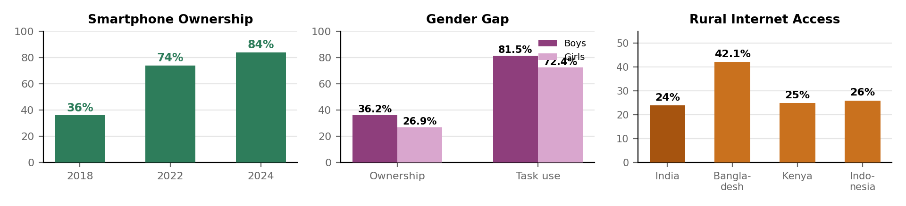

Access has surged, but skills lag behind
Rural smartphone ownership has been essentially solved in six years, rising from 36% to 84%. But that access hasn't carried over to computers — only 18% of households have a member who can operate one — so the bottleneck has clearly shifted from hardware to structured skills training.

A persistent gender gap — except where programs target it
Boys consistently out-own and out-perform girls in both ownership (36% vs. 27%) and hands-on tasks (82% vs. 72%). Notably, this gap disappears in states like Kerala and Karnataka that run gender-responsive digital literacy programs, showing the gap is a design failure, not a fixed outcome.

A suggestive link with learning outcomes
Kerala's high rate of educational smartphone use (80%+, versus a 57% national average) coincides with some of India's strongest ASER reading scores. This is a correlation worth watching, not proof of causation — state capacity, teacher quality, and other factors likely play a larger role — but it favors programs that actively direct existing device access toward learning.

India in global context
India's rural internet access (24%) trails Bangladesh (42.1%) and sits close to Kenya (25%) and remote Indonesia (26%). Across all four countries, infrastructure investment has consistently outpaced digital-skills investment — India's core challenge is a shared, solvable regional pattern, not an isolated shortfall.

NGOs fill a critical last-mile gap
Organizations such as Pratham, the NIIT Foundation, Bal Raksha Bharat, and the Mukul Madhav Foundation are delivering hands-on, community-based digital training that complements government infrastructure projects like BharatNet and PMGDISHA. Evidence from a multi-year digital literacy program for adolescent girls in Jharkhand shows measurable gains in digital skills and downstream benefits — including greater use of government schemes and improved mobility — when training is sustained and localized rather than one-off.

Insights & Conclusion
- Pair infrastructure with skills training — device access without instruction drives entertainment use, not learning.
- Gender-responsive design works, and computer literacy remains a bigger, more overlooked gap than smartphone literacy.
- Trusted, community-based educators (Pratham, NIIT Foundation, Bal Raksha Bharat) convert access into capability better than one-off campaigns.
Rural India has crossed the access threshold; the next challenge is converting it into learning and economic opportunity through sustained, localized digital literacy programs — a challenge shared with, and solvable alongside, peer countries facing the same gap.

Limitations
- ASER digital data is self-reported by households and covers only the 14–16 age group, so it may not generalize to younger children or adults.
- The Kerala learning-outcome pattern is a correlation drawn from state-level averages, not a controlled study — it cannot isolate the effect of digital use from other factors like teacher quality or funding.
- International figures use differing survey years, methodologies, and definitions of "rural," so cross-country comparisons should be read as directional, not exact.
Sources: ASER 2023–24 (Pratham) • NSSO 78th Round • IDR • PLOS Digital Health (2025) • The Print, Business Standard • CRY, Bal Raksha Bharat, Mukul Madhav Foundation • The Daily Star/DataReportal (Bangladesh) • KICTANet/Internet Society (Kenya) • UNDP/KICSS 2025 (Indonesia).

