Slide 1



The DriverPass system aims to train students to pass their driving test because too many people fail it at their local DMV. The system will provide better driver training than currently available by providing in-person training, online courses, and practice tests. The system will provide users with the tools and functionality to make reservations for behind-the-wheel training.

Slide 2

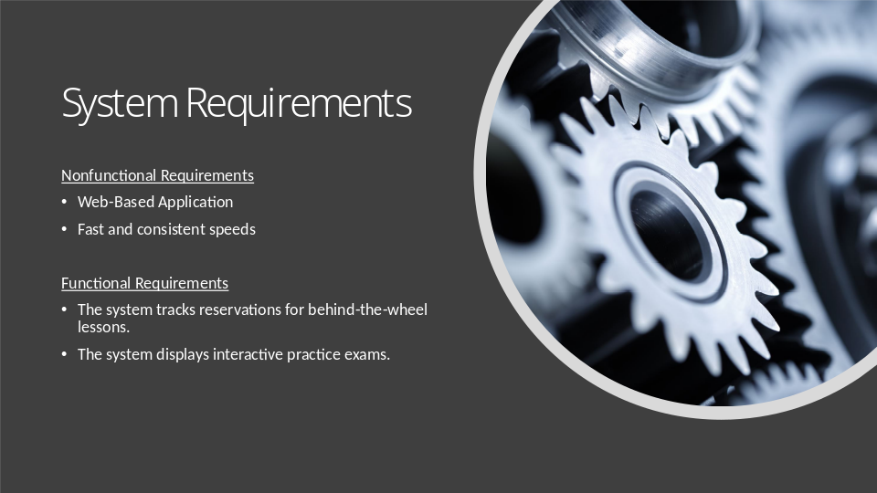

The DriverPass system should be a web-based application to ensure that all users can access the system with their devices. Safari, Edge, and Chrome are the three most common web browsers. Adding Firefox and Brave to the three most common web browsers will ensure users can access the DriverPass system from any device and web browser. Users should be able to navigate the content swiftly and smoothly with consistent speeds. The system should respond as fast as possible while maintaining consistent results. Speeds should be fast and consistent with other LMSs. The system speed should be adjusted to maintain consistency and optimal performance. The DriverPass system should update weekly, including updates from the DMV, to ensure optimal results for users. The DriverPass system will be a web application containing several pages. The home pages will be different for the five types of users. The users will utilize the system for various reasons and require different home page components.

Slide 3

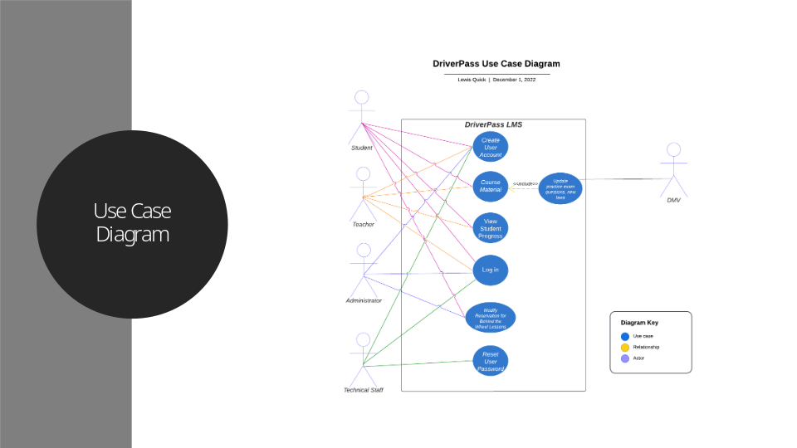

The Use Case Diagram represents the various scenarios that DriverPass users will encounter with the DriverPass system. The various DriverPass users are students, teachers, administrators, technical staff, and the DMV. The various scenarios that users will encounter with the system are creating a user account, accessing the course material, viewing student progress, logging in, resetting the user password, and modifying reservations.

Slide 4

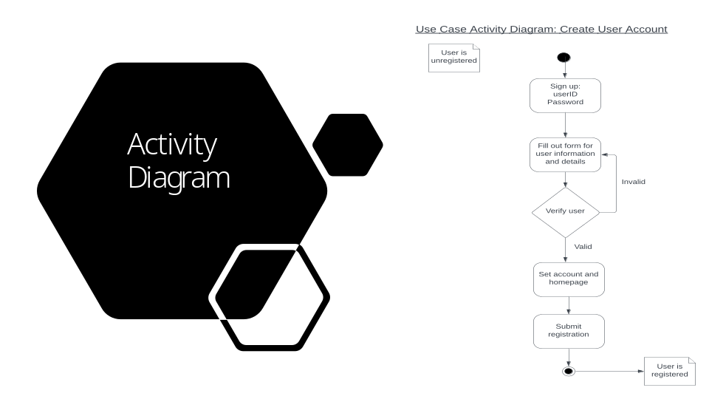

The diagram depicts registering a user account into the DriverPass system. The diagram begins with an unregistered user creating a userID and password. The user then fills out a form with user details like first name, last name, address, and phone number. The system then verifies if the application is valid or invalid; if it is valid, it sets the user’s homepage and registers the account. If the application is invalid, it will return the user to the application form.

Slide 5

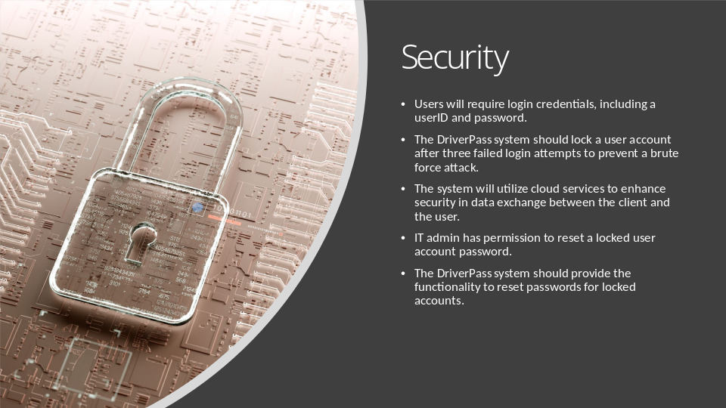

The DriverPass system starts with basic security features, like creating a unique user ID and password. The system builds on simple security features to create a robust set of security features, like locking an account after three failed login attempts. Security is essential for the DriverPass system because it contains sensitive data like users’ personal information. Cloud services provide enhanced security features to protect data stored on cloud services. The DriverPass system will utilize the enhanced security features the cloud services offer.

Slide 6

