Final Project Design Phase
Computer Science - Week 11
Oct 3, 2026 - Version 0.0.4

For complete instructions and project ideas, refer to the assignment in Canvas. Specifically, review the final project requirements before you continue below. If you have not reviewed the project requirements in Canvas (you might have to go to the modules view and check the current or past week's content), you will not be able to properly complete the parts below. In addition, it may be helpful to review the information on this Drafter documentation page.

0) Project Planning and Preparation
Successful programmers spend time planning before they begin coding. After reviewing the project requirements, answer the following questions to help guide your design and development process.
- What concepts from class or previous assignments might help you complete this project? Which programming concepts (loops, conditionals, lists, classes, etc.) do you expect to use? What programming skills do you want to improve while completing this project?
I think that loop types and dataclasses will be helpful when I am making this project.
I want to improve my understanding of drafter while I complete this project.

- Which parts of the project do you expect to be the easiest for you? The hardest? Why?
I think that the easiest parts of this project will be to make the functions that filter through the music because I feel that I have had a lot of experience in doing that.
I think that the hardest parts of this project will be using drafter as I haven’t really coded much with it.

- Even though you have not yet designed the final project, estimate which tasks will likely require the most time and effort? Which features or components should be implemented first?
I think that creating the search function and testing it will take the most time and effort.
I think that I will have to implement a function that creates songs and albums from the data first, as it is the basis for the rest of the program.

- What distractions might interfere with your work and how will you minimize them? What resources will you need available while working? What questions, if any, do you still have about the assignment requirements?
I don’t think that I will have any distractions that interfere with my work.
I don’t have any questions about the assignment requirements.

1) Site Diagram
Create a mock-up of your planned website. We suggest you make the mockup on paper, although you can also use software like PowerPoint or Slides to make a mockup. There is other design software that could also be used, but we strongly encourage you to keep it simple. Do not spend more than 15-30 minutes detailing the mock-up. Your goal should be to make a very quick and dirty diagram, to show that you have some kind of idea.

We recommend drawing each page as a rectangle, and laying out the text, buttons, and other components inside. Then, use arrows to indicate links between pages. Label each page the way you will name each function, and then put labels on the arrows to indicate what the button links. Also write down any parameters that should come into the pages.

In addition to the pages and routes, write down what fields your `State` will have, both their names and types. Think clearly about what data will need to be persistent across the entire website.

Add photo(s) or screenshot(s) of your website mock-up and labeled diagram on the next page.

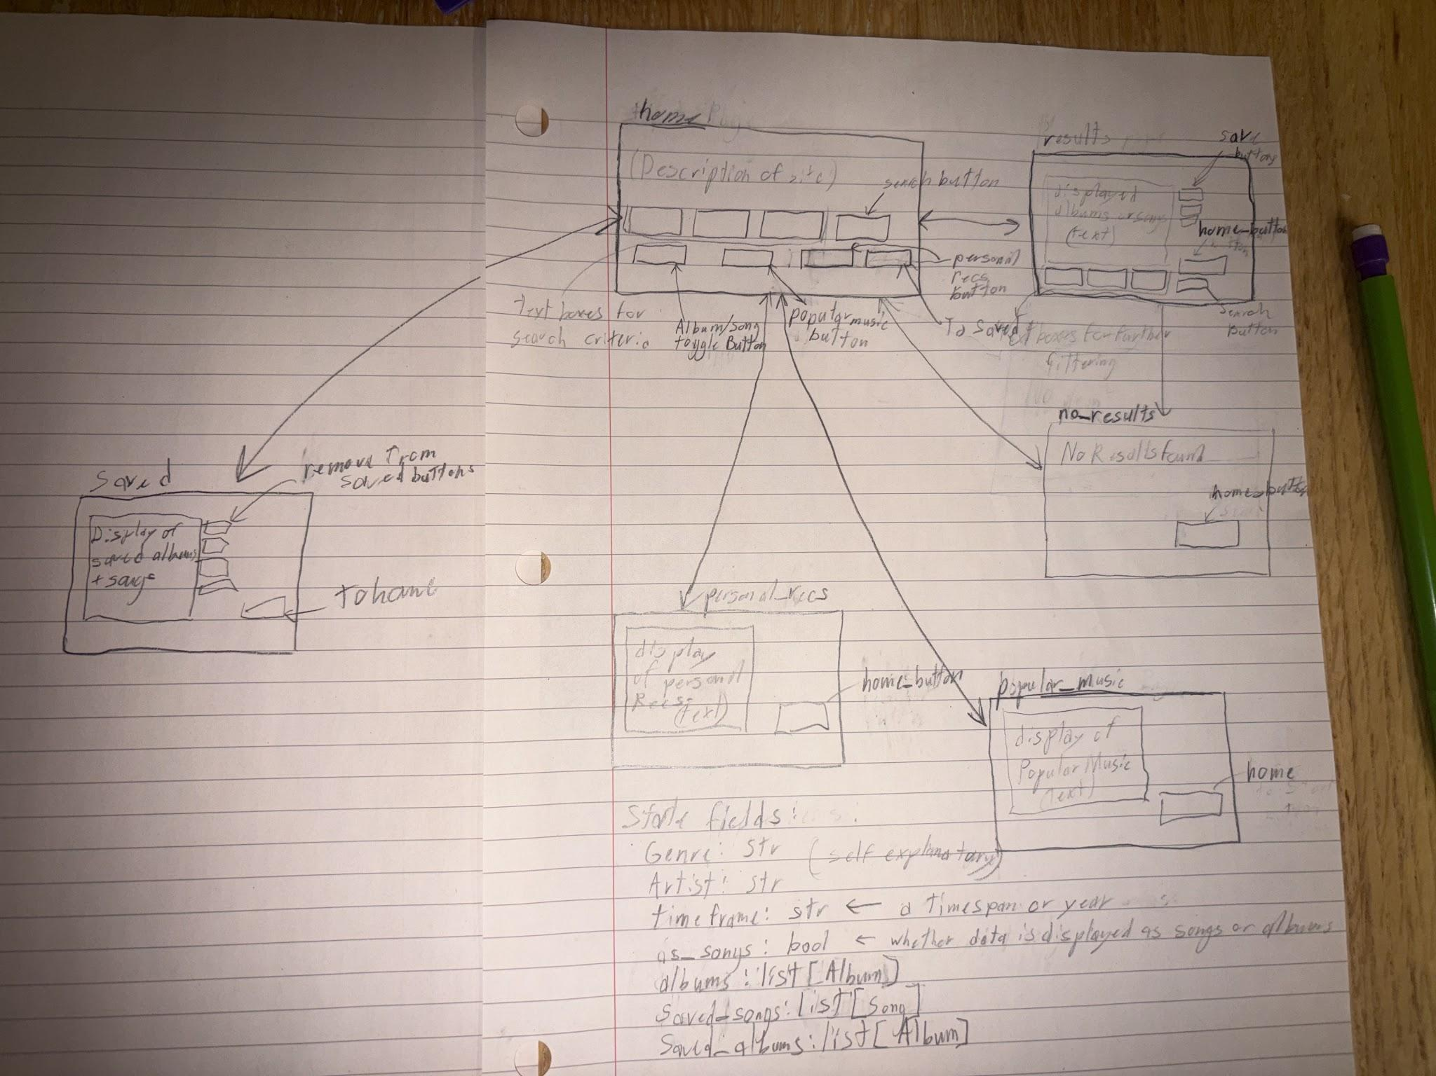
2) Implementing Requirements
This table should serve as a draft for how you will implement the requirements into your final project. You may change your ideas later on, but your final site must fulfill all the requirements.

Requirement | Implementation
Purpose/Functionality  A 1-2 sentence description of the purpose or functionality of your site | This website will recommend albums or songs based on the user’s input. The user can type in a genre, artist, or timeframe and the website will give a randomized list of either songs or albums that fit their search criteria.
State Dataclass Attributes  Minimum of 4 attributes, one of which must be a list/dict of instances of your second dataclass.  Briefly describe each attribute, its type, and how it will be meaningfully modified throughout the site. | genre (str): the genre that the user is searching for. This is updated through the genre text box  artist (str): the name of an artist that the user is searching for. This is is updated through the artist text box  timeframe (str): either a year or a span of years typed in as XXXX-XXXX no spaces between them. This will also be updated through its own text box.  as_songs (bool): a boolean that determines whether the data is being displayed as songs or as albums. This is changed through the use of a checkbox.  albums (list[Album]): a list of the albums that meet the current search criteria. This is updated after a search is made (the search button is pressed).  saved_songs (list[Song]): a list of songs that the user has saved. Songs are added by the user hitting the save button next to a song. Songs are removed by pressing the remove button next to them.  saved_albums (list[Album]): a list of albums that the user has saved. This is updated the same way as saved songs.
Second Dataclass  Your second dataclass, including its attributes, their types, and how they will be meaningfully modified (if they are modified) | Second Dataclass: Song  Fields: title (str), length (float), artist (str), album_name(str)  Third Dataclass: Album  Fields: title (str), genre (str), songs (list[Song])
Routes (minimum 7)  The names of your route functions | index  to_home  search  personal_recs  popular_music  to_saved  remove
Pages (minimum 5)  A brief description of the pages in your site | home: the start page. It will have a description of how the search works and what the buttons do. It will also have buttons for the personal_recs and popular_music pages.  no_results: the page that will be returned if no albums match the user’s search criteria and will have a button to return to the home page.  results: displays songs or albums that match the user’s search criteria. Will have text boxes for further filtering and will also have a button to return to the home page  personal_recs: displays songs or albums that I recommend. It will also have a button to return to the home page  popular_music: displays popular songs or albums. It will have a button to return to the home page.  saved: displays the albums and songs that the user has saved. Has buttons next to each item to remove it from the page and the list. Also has a button to return it to the home page.
User Input (minimum 3)  Description of user input components (TextBox, TextArea, CheckBox, or SelectBox) and their purposes  For more information on these input types, see Drafter Documentation. | TextBoxes: There will be three text boxes for the user’s search criteria (one for each: genre, artist, and timeframe)  CheckBox: There will be a check box to choose whether the music will be displayed as songs or as albums.
If Statements (minimum 3)  Brief description of what will be evaluated in your if statements and how they will meaningfully change the logic of the site | There will be an if statement to check what the format of the display should be, either by album or by song. This is because there will be different ways that the information is displayed.  There will also be an if statement in the loop for filtering albums in order to make sure that the results meet the search criteria.  There will also be additional if statements to check if the user imputed anything for certain criteria. This is important so that the program isn’t accidentally removing albums.
Loop (minimum 1)  This loop must iterate over the list/dict of dataclass instances in your State attribute.  Description of this loop and why it is meaningful to the site | A loop will be used to filter through the albums list so that the updated list will meet the user’s search criteria of artist, genre, and timeframe  This is meaningful to the website as it is how the website primarily functions.

LLM Conversation
If you used an LLM in any part of this work, copy and paste every part of that conversation below. Otherwise, you may be given a zero for the assignment. Obviously, these words will not all be yours, and this is the exception to the requirement at the top of this assignment that all responses be in your own words. If you did not use an LLM to assist you in this assignment, simply say so below.
I did not use an LLM for this assignment.

Final Submission
When you are finished, download this file as a Word Document (docx) and upload the file to the appropriate assignment on Canvas.

