Brodie Lewis 040 734 911– Lab 6: String Comparison

Lab Code:

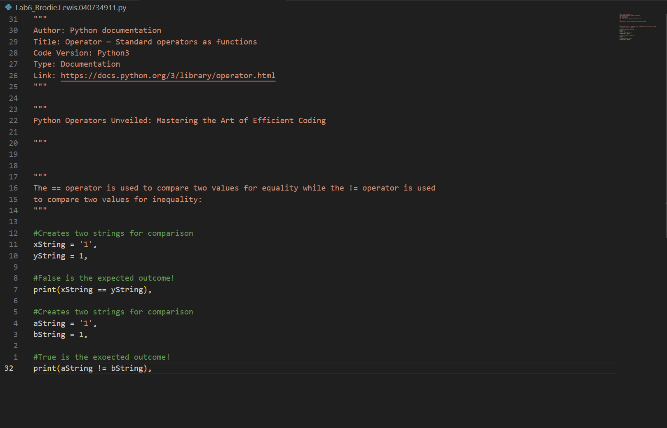  
  
Console:

