Brodie’s Lab 7: Tuples:

1. How do you access an element from a tuple? Give an example (embed a screenshot of your code):

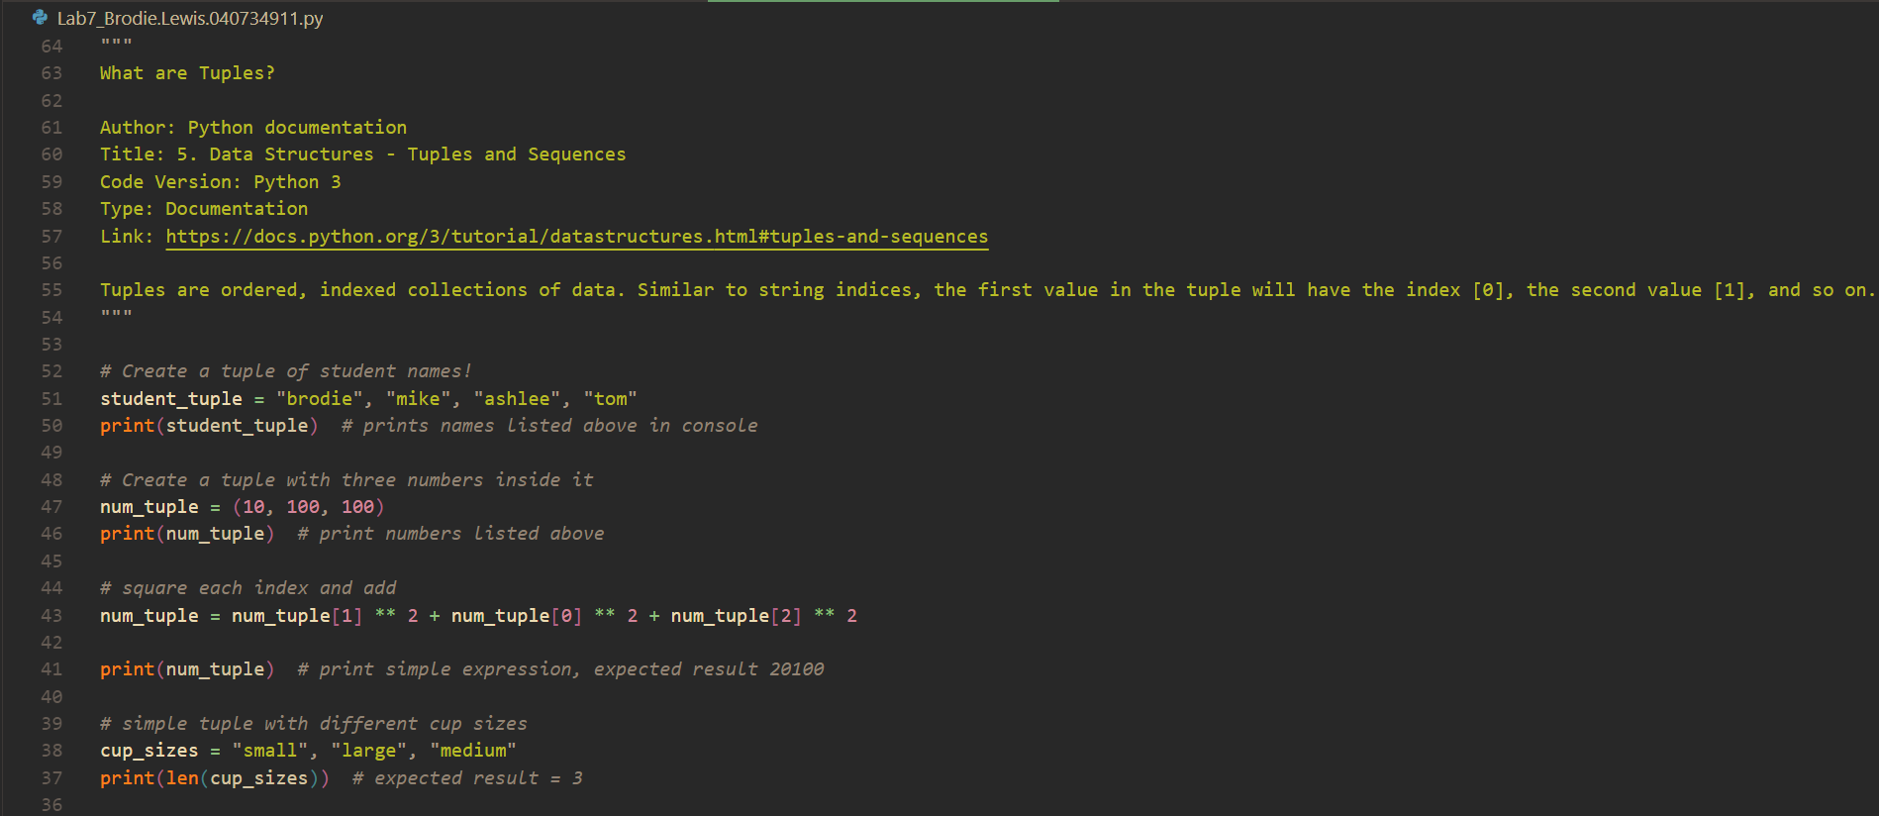

1. Does tule allow negative indexing? How? Give an example (embed a screenshot of your code):

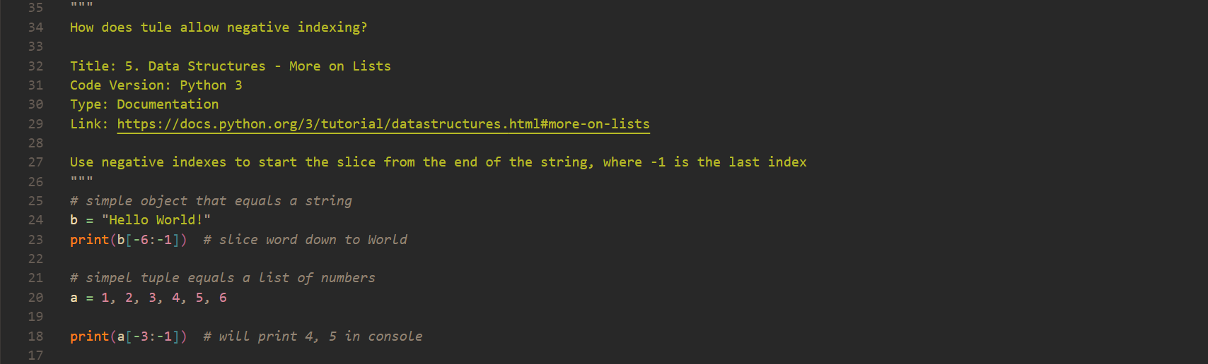

1. How does deleting work in a tuple? Give an example (embed a screenshot of your code):

