NAME OF THE MINI PROJECT

**AUTOMATIC REFFERAL SYSTEM**

**By**

**LEWIS.W.MASATU (14171055043)**

**A MINI-PROJECT REPORT**

**Submitted to the**

**FACULTY OF ENGINEERING &TECHNOLOGY in fulfillment of the requirement**

***For***

**BACHELOR OF ENGINEERING DEGREE**

**IN**

**COMPUTER SCIENCE AND ENGINEERING**

**Under the guidance of**

**DR. MANJULA (CSE)**

**ASSOCIATE PROFFESOR**

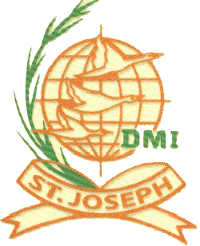

**DMI-ST.JOSEPH COLLEGE OF ENGINEERING AND TECHNOLOGY**

**DAR ES SALAAM, TANZANIA**

**AUGUST 2017**