BIT3208: Advanced Web Design and Development
Mount Kenya University

Hospital Ward Management System
Weekly Practical Logbook
Student Name | Lewis Leshan
Admission Number | BSCCS/2024/74848
Course / Class | Bachelor of Science in Computer Science
Unit Code | BIT3208
Unit Name | Advanced Web Design and Development
Lecturer | Michael Nyoro
Semester / Year | Year 3 Sem 2
Technologies Used | PHP + MySQL + HTML + CSS
GitHub / Portfolio | https://github.com/lewiiileshan/Hospital-ward.git

Project Weekly Work Plan
This table outlines what was done each week, the key tasks completed, and what was submitted as evidence.

Week | Theme | Key Tasks Completed | Evidence / Deliverables
Week 1 | Local Environment Setup | Installed XAMPP/Apache + MySQL. Tested localhost. Created Hello World page. Tested PHP-MySQL connection. | Screenshots of XAMPP running, localhost page, Hello World, DB connection
Week 2 | Wireframes & GUI Design | Drew wireframes for Login, Register, Dashboard and Add Patient pages. Planned color scheme (green). Designed navigation flow. | Hand-drawn wireframes, GUI mockups, color scheme screenshot
Week 3 | JS Validation & PHP Basics | Added JavaScript validation to login and register forms. Practiced PHP syntax. Built and tested database connection script (db.php). | Form validation screenshots, PHP code snippets, DB connection test
Week 4 | Authentication System | Built login.php and register.php with PHP sessions. Implemented password hashing using password_hash(). Added session-based auth guards. | Login page, register page, session working, protected dashboard redirect
Week 5 | Database CRUD Operations | Built dashboard.php to display patients. Built add-patient.php to insert records. Added discharge and delete functionality. Linked all pages. | Full working system screenshots: add, view, discharge, delete patients

Week 1: Local Environment Setup

Required Evidence
Figure 1: Installation of XAMPP on Kali Linux

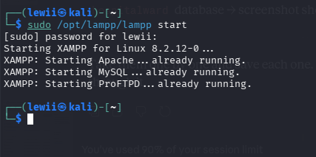
Figure 2: XAMPP/Apache and MySQL services running (terminal output)

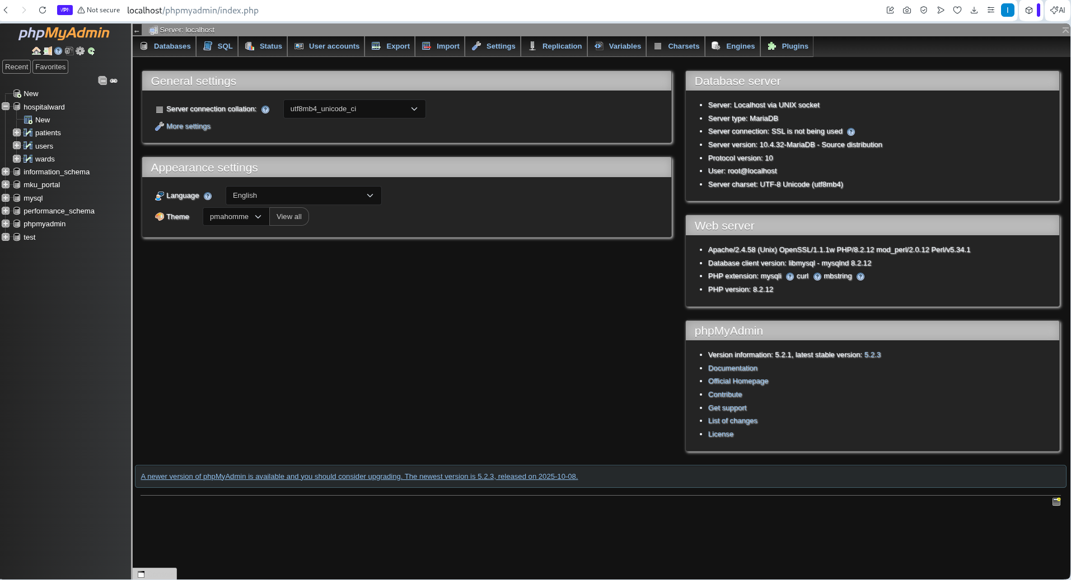
Figure 3: Browser showing phpmyadmin dashboard confirming Apache is serving pages

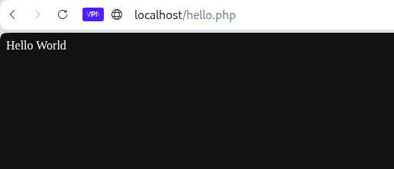
Figure 4: Hello World test page running successfully

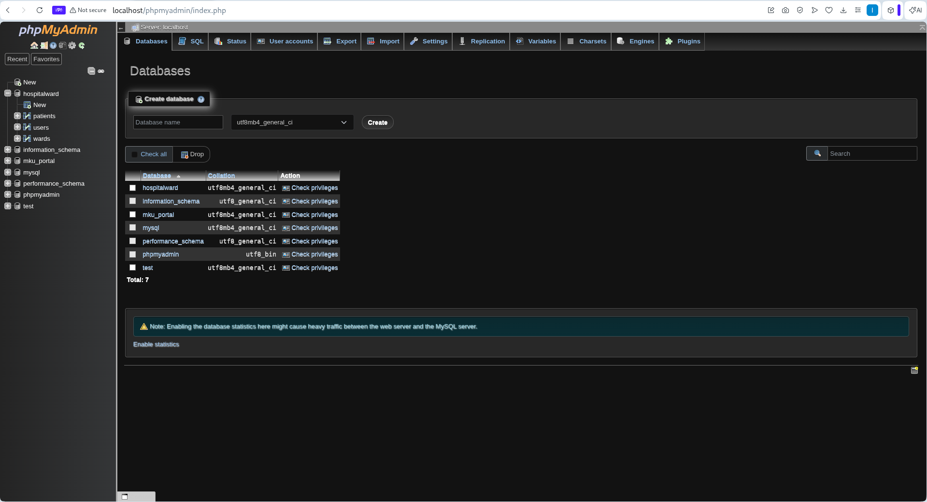
Figure 5: phpMyAdmin homepage at showing the database list

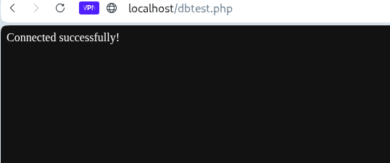
Figure 6: PHP-MySQL connection test -page confirming successful database connection

Student Reflection
This week I set up my local development environment. I installed and configured XAMPP on Kali Linux and verified that Apache and MySQL services were running. I tested the localhost server by creating a simple PHP Hello World page. I then opened phpMyAdmin and confirmed the database server was accessible. The connection test using PDO in PHP confirmed that the backend environment was ready for development. This setup is the foundation for all subsequent development work.

Week 2: Wireframes and GUI Design

Required Evidence
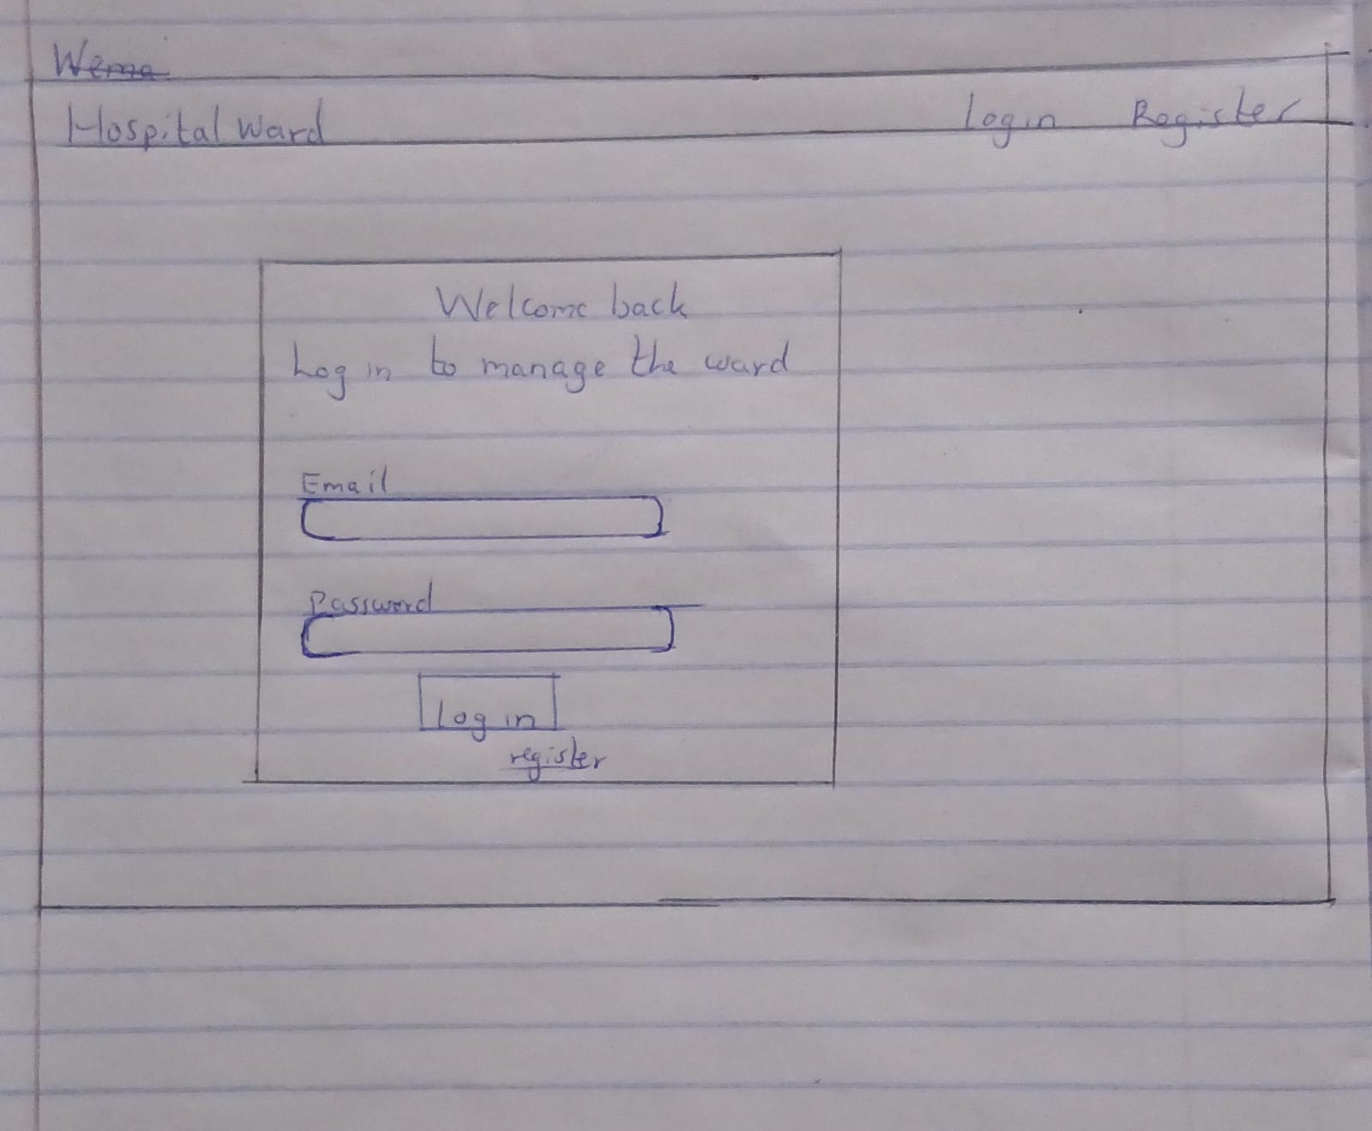
Fig 1: Hand-drawn wireframe of the Login page showing form fields and layout
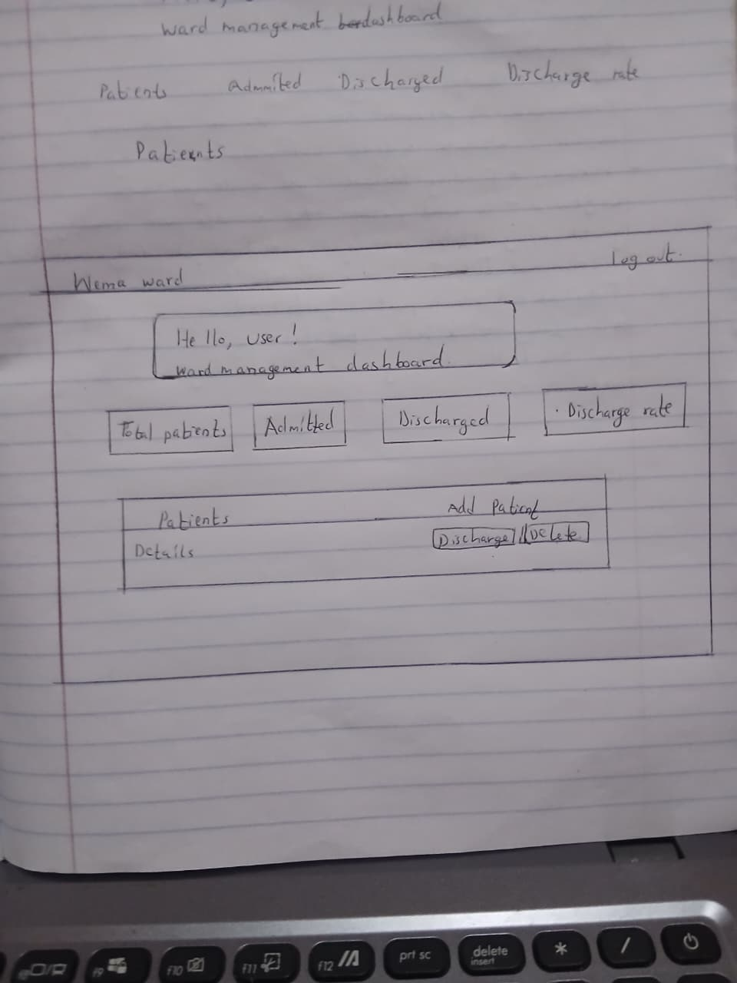
Fig 2: Hand-drawn wireframe of the Dashboard page showing patient list and stats
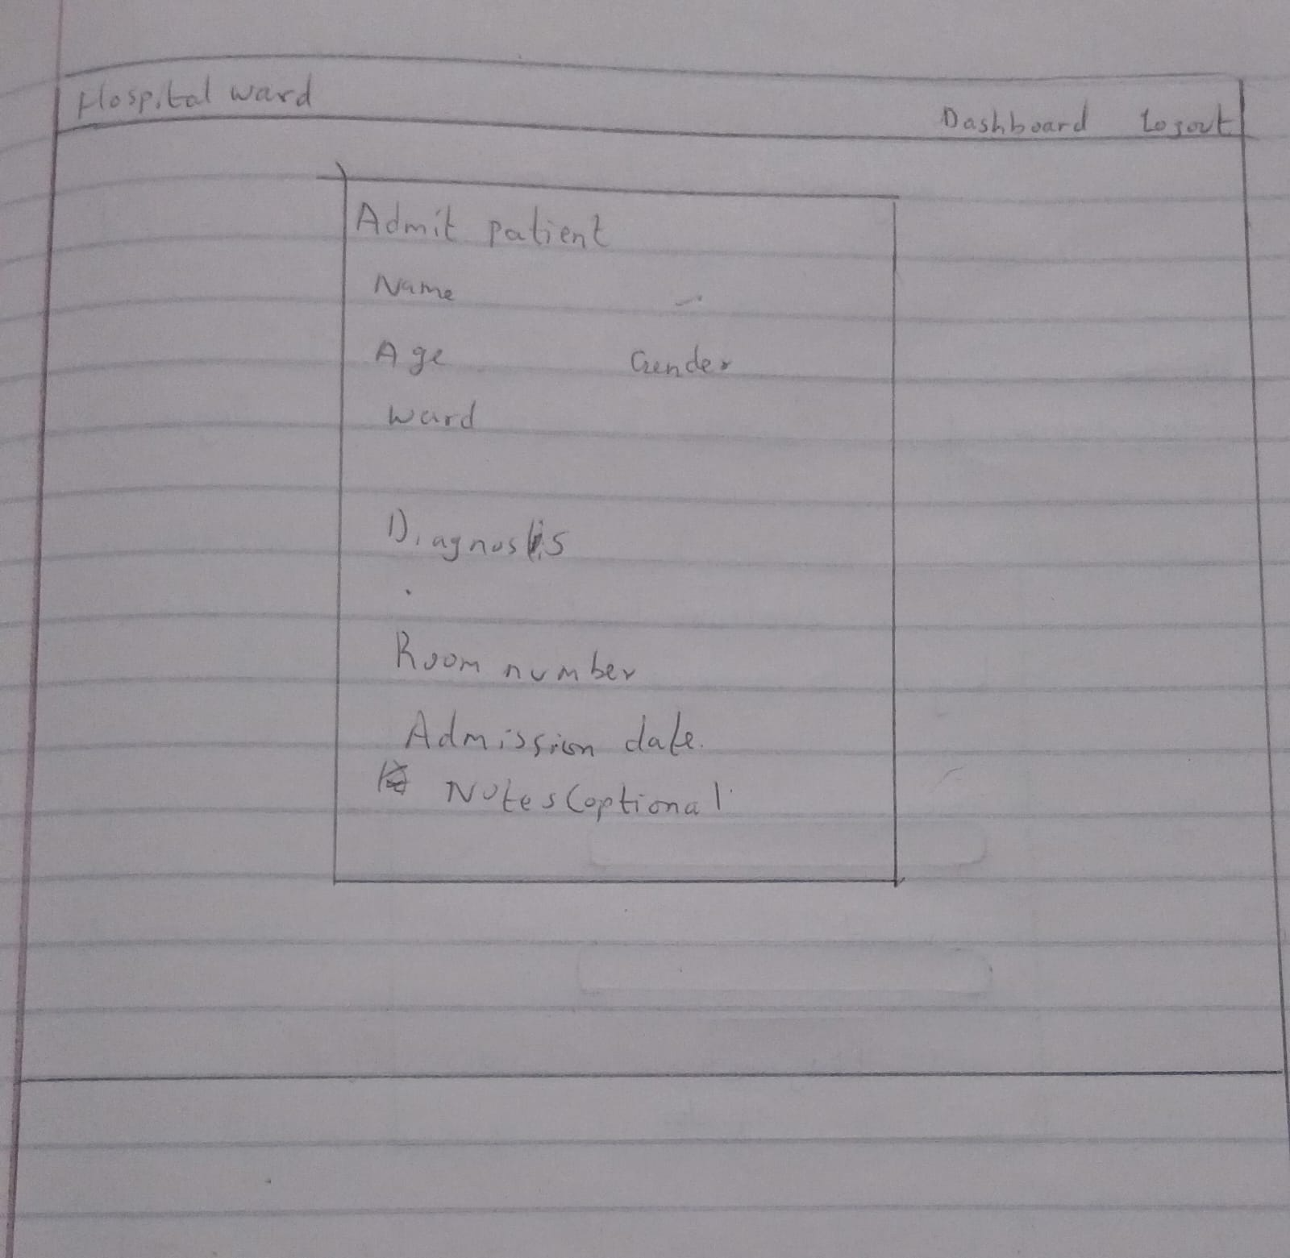
Fig 3: Hand-drawn wireframe of the Add Patient form page
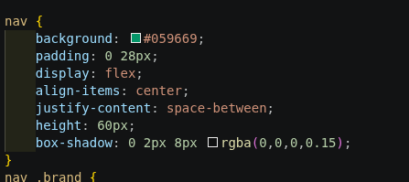

Fig 4: Color scheme selection — green (#059669) chosen as primary brand color
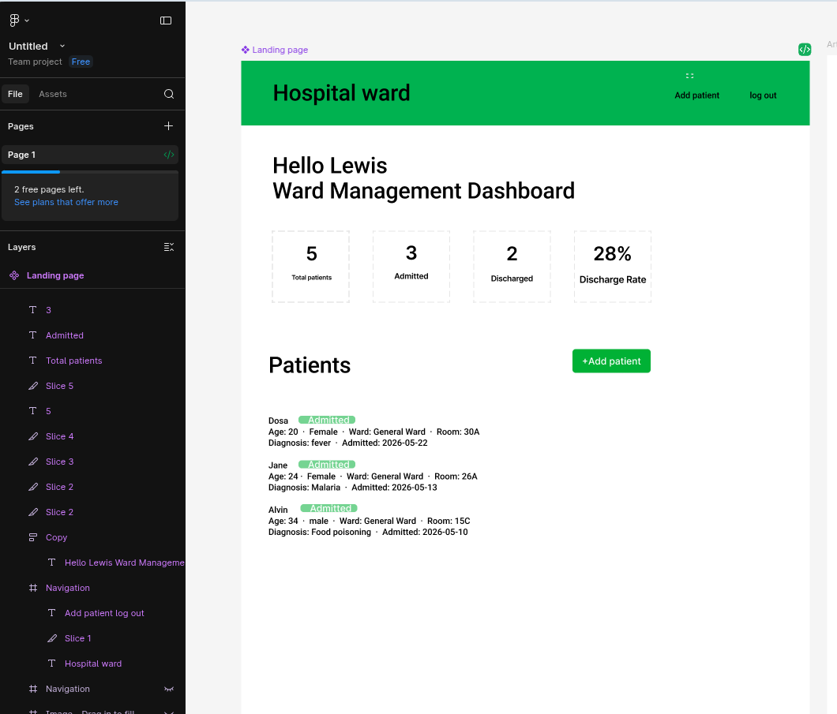
Fig 5: Digital mockup or Figma prototype of the system UI

Student Reflection
This week I planned the visual design of the Hospital Ward Management System. I drew wireframes for three main pages: the login/register forms, the patient dashboard, and the add patient form. Green was selected as the primary color to reflect a medical/health theme. The dashboard layout was designed to display patient information clearly with action buttons on the right.

Week 3: JavaScript Validation and PHP Basics

Required Evidence
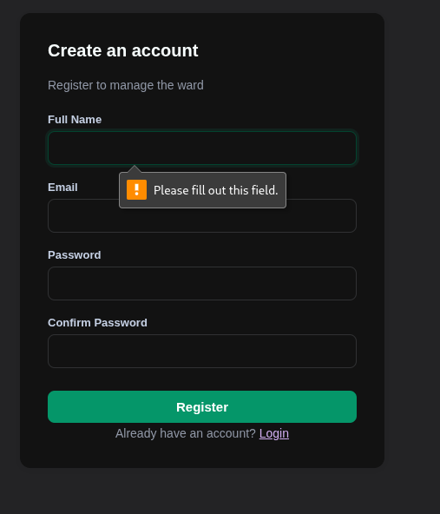
Fig 1: JavaScript form validation on the registration form preventing empty submissions
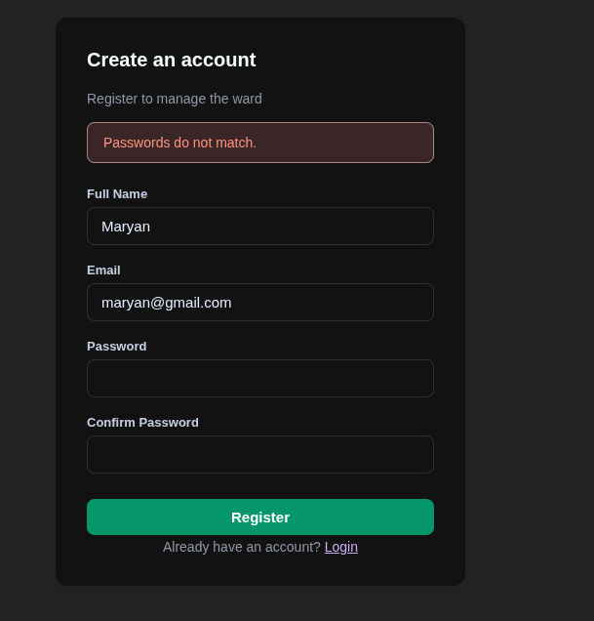
Fig 2: Password mismatch error shown when confirm password does not match
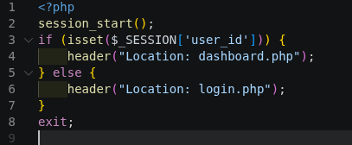
Fig 3: PHP syntax practice -simple variable echo and conditional statement output
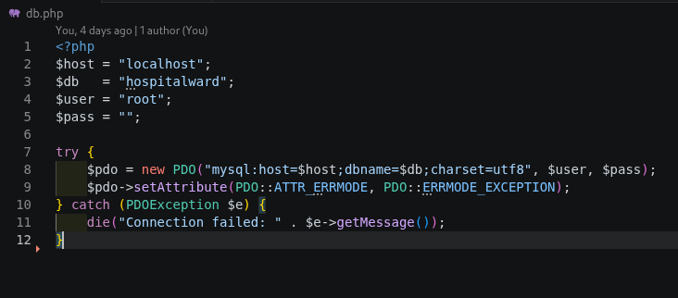
Fig 4: db.php code and successful database connection output in the browser
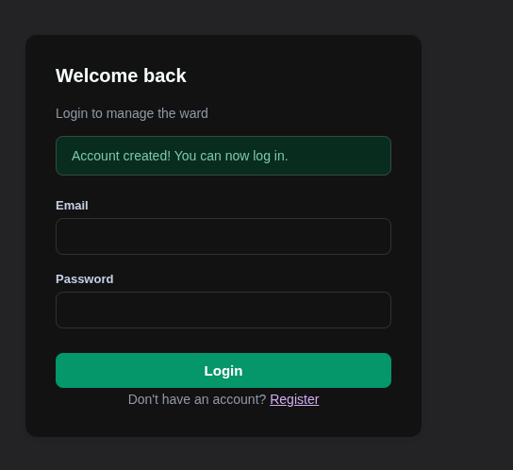
Fig 5: Dynamic PHP page displaying user-submitted form data back on screen

Student Reflection
This week I practiced JavaScript and PHP basics. I added client-side validation to the registration form to prevent empty fields from being submitted. I also added a password confirmation check. On the PHP side, I practiced outputting variables, using conditionals, and processing POST form data. I wrote the db.php using PHP's PDO library to connect to the MySQL database. The connection was confirmed to work perfrctly.

Week 4: Backend Authentication System

Required Evidence
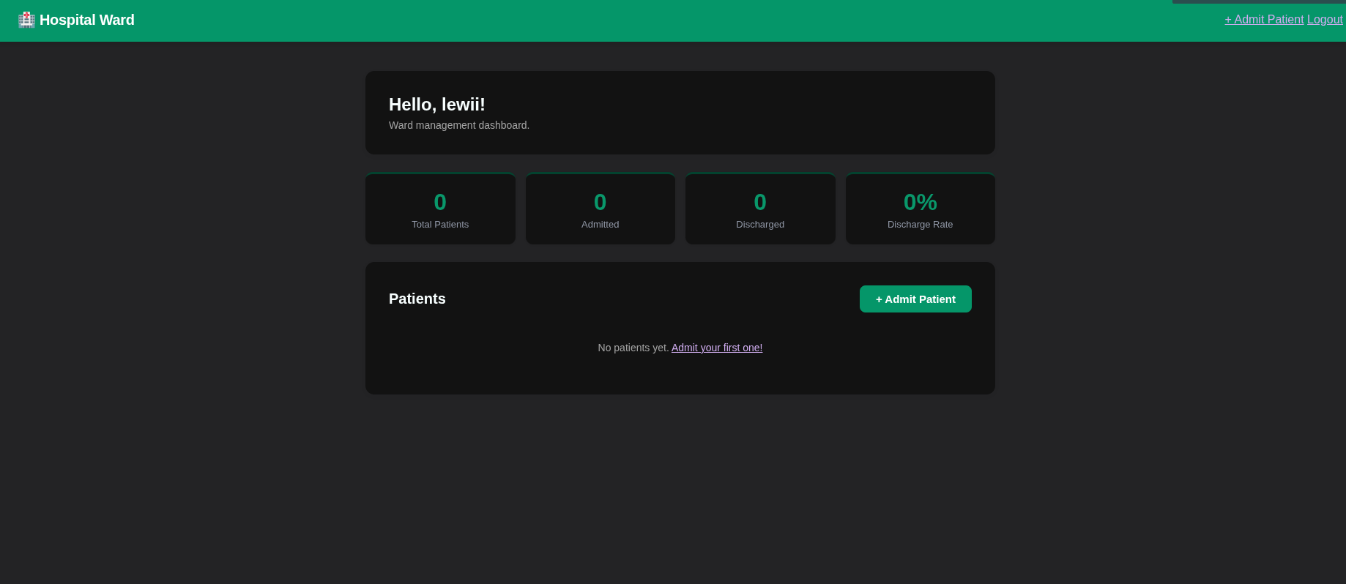
Fig 1: Login page showing the username feedback
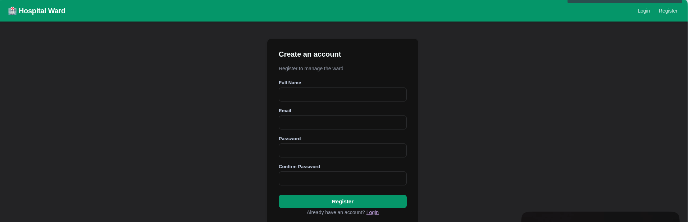
Fig 2: Registration form at http://localhost/HospitalWard/register.php with all fields
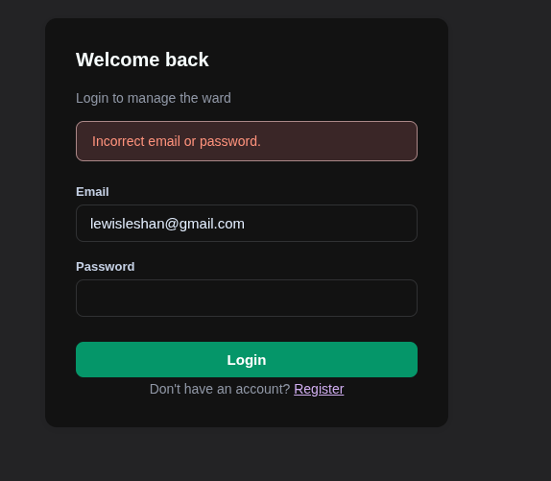
Fig 3: Error message shown on login page when wrong credentials are entered
[ INSERT SCREENSHOT — Fig 4 ]
Fig 4: Successful login redirecting to the dashboard — session working correctly
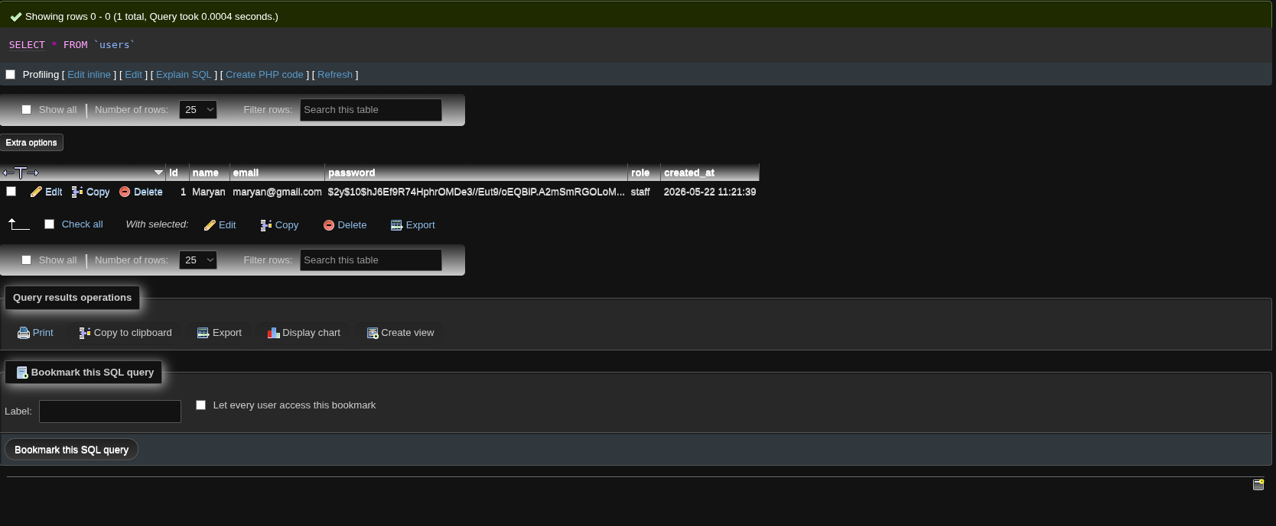
Fig 5: phpMyAdmin users table showing a registered account with a hashed password

Student Reflection
This week I built the full authentication system. The register.php page collects name, email, and password, validates the input, checks for duplicate emails, then stores the account using PHP's password_hash() function so passwords are never stored in plain text. The login.php page retrieves the user by email and uses password_verify() to check credentials. PHP sessions store the logged-in user's ID and name. All protected pages check for the session at the top and redirect to login.php if it is missing, securing the system.
(Maximum 100 words)

Week 5: Database Integration and CRUD Operations

Required Evidence
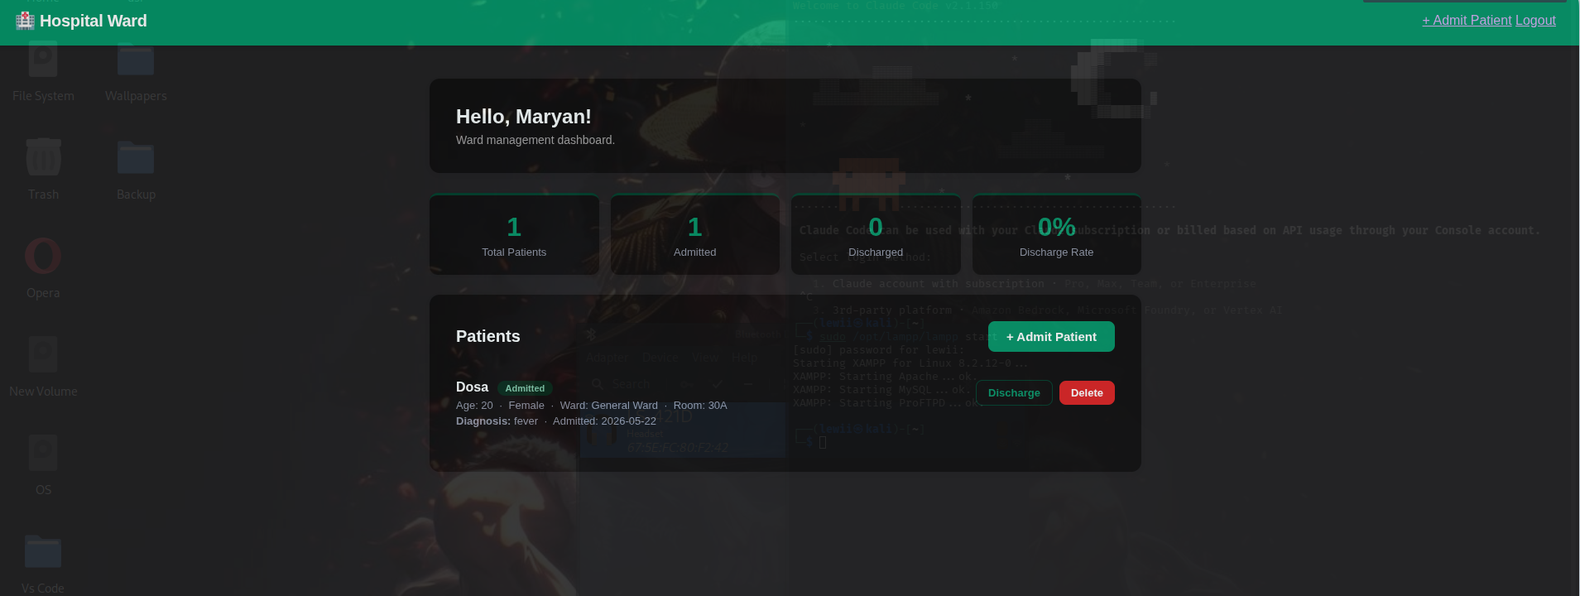
Fig 1: Dashboard at http://localhost/HospitalWard/dashboard.php showing patient stats (Total, Admitted, Discharged)
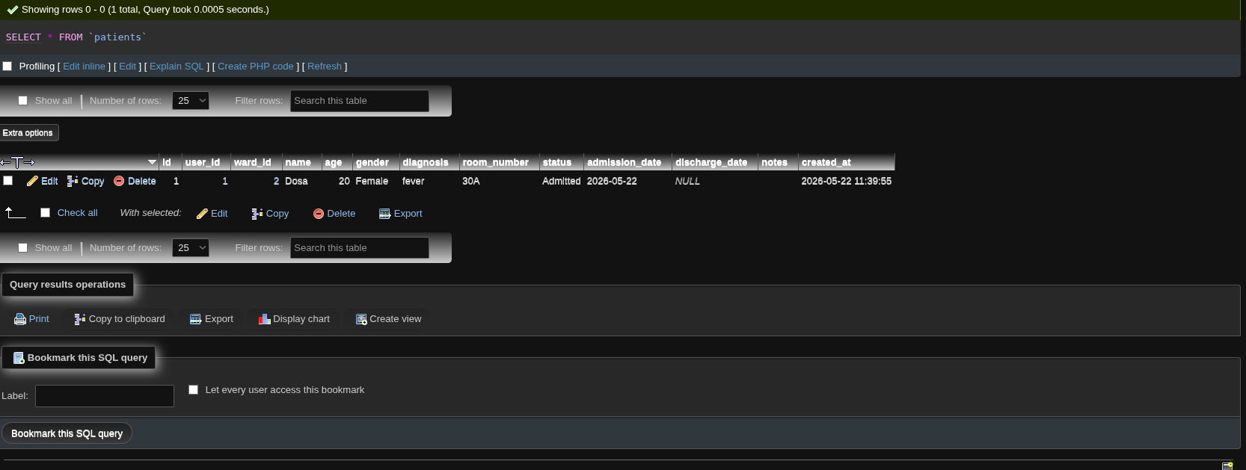
Fig 2: Patient list on the dashboard showing name, age, ward, diagnosis, and action buttons
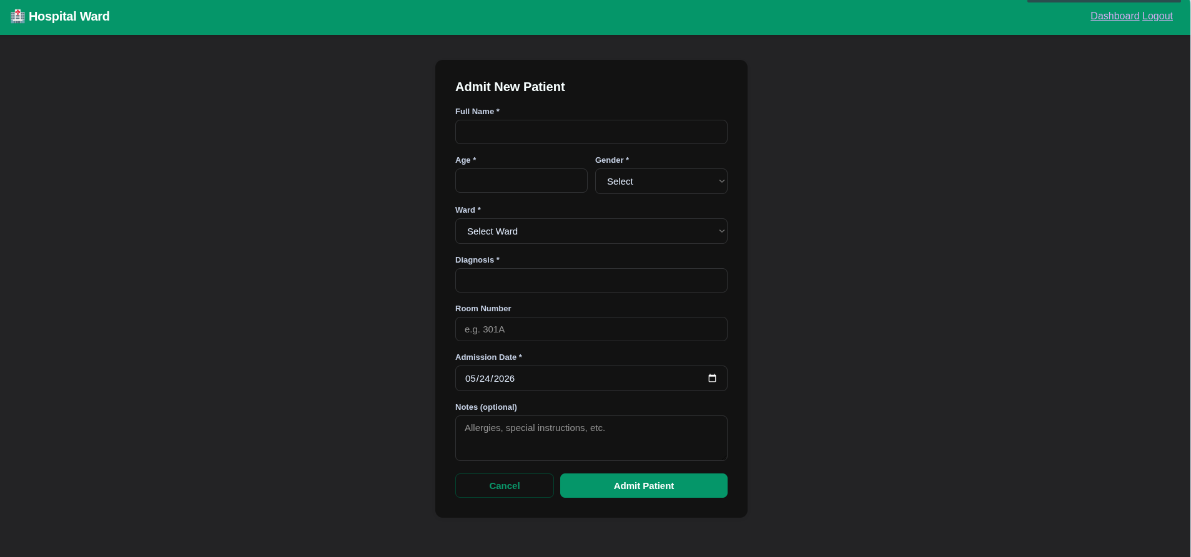
Fig 3: Add Patient form at http://localhost/HospitalWard/add-patient.php with all fields filled
[ INSERT SCREENSHOT — Fig 4 ]
Fig 4: Patient record appearing on the dashboard immediately after submission
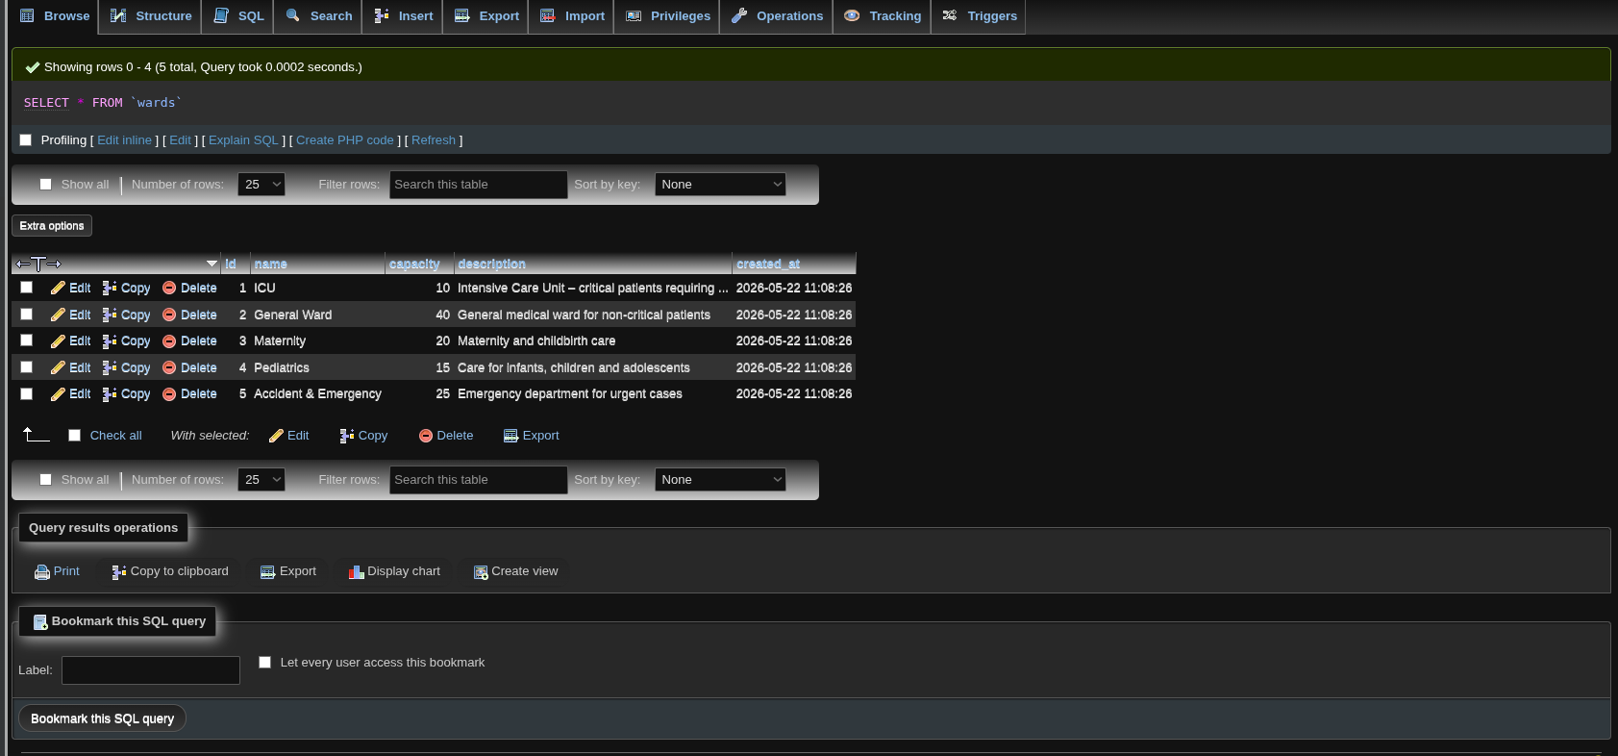
Fig 5: phpMyAdmin patients table showing inserted records linked to user_id via foreign key

Student Reflection
This week I connected the full system to the MySQL database. The add-patient.php page takes patient details (name, age, gender, ward, diagnosis, room number, admission date, and notes) and inserts them into the patients table using a prepared PDO statement. The dashboard.php page retrieves all patients for the logged-in user using a JOIN between the patients and wards tables. I also implemented discharge (UPDATE) and delete (DELETE) operations. This week demonstrated all four CRUD operations working in a live PHP-MySQL system.

