DECLARATION

We hereby declare that the project entitled “Movie World” submitted to the department of Information Technology, Hyderabad for partial fulfillment of the requirement for the award of Bachelor of Technology in Information Technology is a result of original work carried out by us.
This work in original has not been submitted so far in part or full for any other institute or University.

ACKNOWLEDGEMENT

We thank the almighty for giving us the courage & perseverance in completing the project. This project itself is an acknowledgement for all those who have given us their heart-felt-co-operation in making it a grand success.

We are thankful to our principal, Prof.------------ for providing the necessary infrastructure and labs. We are greatly indebted to, Head of Information Technology, Mr.------------ for providing valuable guidance at every stage of this project work.

We are also thankful to the project coordinator, Mr.------- for extending their sincere & heartfelt guidance through out this project work. Without their supervision and many hours of devoted guidance, stimulating & constructive criticism, this thesis would never come out in this form.

It is a pleasure to express our deep and sincere gratitude to the project Guide Mr,---------- and are profoundly grateful towards the unmatched help rendered by him. Our special thanks to all the lectures of Information Technology, for their valuable advises at every stage of this work.

Last but not the least; we would like to express our deep sense and earnest thanks giving to our dear parents for their moral support and heartfelt cooperation in doing the project. We would also like to thank our friends, whose direct or indirect help has enabled us to complete this work successfully.

COMPANY PROFILE

Datapoint has been actively in the profession of sourcing IT professionals from the year 2000. We have since placed scores of candidates from different skill sets, with varying levels of experience. Having established a reputation as a good placement organization, we are constantly approached by adept professionals, in pursuit of better opportunities, which helps us maintain an updated database of present and potential IT connoisseurs in demand home and abroad

Datapoint endeavors to be a pioneer in Recruiting and manpower consulting thanks to strategic alliances with leading multinational companies in India and US of America. Our technically competent, experienced, and certified consultants will help our clientele to get the right manpower at the right time. We take pride in having top-notch companies who make enable us to have faith in the future through maintaining high quality in screening, hiring and management.

Datapoint has identified a number of areas of thrust in the emerging and ever growing IT industry and virtue of which, we would focus all our energies to get on to the fast track in the shortest possible period. We pursue requirements from leading Corporate in India and abroad. The company is also entering into a memorandum of understanding with leading companies in India & USA for placements.

Abstract

- Objective:

The main aim of this Movie World is online booking tickets for various movies in Registered theatres by the users.
- Problem Definition:
Here details about Now playing movies and no of tickets available in a particular theatre for particular movie, Movie Details, ticket cost for registered users
- Existing System:
Present System developed in asp .In asp there are some limitations.
- It is scripting language
- It is very code complexity
- There is server controls in asp
- It Doesn’t Support language interoperabilty
.
- Proposed System:
Asp.net Support code behind technology
It supports different controls like html controls, server controls
It Supports language interoperability
This project contains three modules
1 .Admin
2. Booking tickets
3. Users

1 Admin: In this module administrator has to register the theatres assign movies to theatres, register users,
2. Booking tickets: In this details about booked tickets and tickets booking
Admin can update and delete purchase, sales and other details.
3. Users: In this users can see the showing movies and upcoming movies details , ticket booking and Registering as members.
CONTENTS

- INTRODUCTION
    - PURPOSE OF PROJECT
    - SCOPE OF PROJECT
    - PROJECT OVERVIEW
- PROJECT ANALYSIS
    - EXISTING SYSTEM
    - PROPOSED SYSTEM
    - H/W and S/W SPECIFICATIONS
- SYSTEM DEVELOPMENT ENVIRONMENT
- PROJECT DESIGNING
    - DFD (Data Flow Diagrams)
    - UML Diagrams
    - ER Diagrams
    - DB Design
    - Screens
- PROJECT TESTING
    - Performance Testing
    - Unit Testing
    - Integration Testing
- CONCLUSION
- FUTURE ENHANCEMENT
- BIBLIOGRAPHY

Project Introduction

The purpose of this document is to present an overall description and listing of the functionality of The Testing Assistant for Regression Testing. It will explain the scope of the project as well as describe the system environment. This document will also include an easily traceable means by which the user can trace each functionality’s brief description to its full description. Also included is a user interface specification whereby the user can demonstrate interface standards to be used in designing the system. Furthermore, considerations regarding non-functional requirements and system evolution are addressed.
This document is intended for users of the system including Unit Testers, unit test supervisors, and any individuals involved in testing a new system in development. This document will also be used as a reference for the developers of The Testing Assistant for Regression Testing.

PROJECT OVERVIEW

Describe the contents and organization of the rest of this document. Since there is already a Table of Contents, this overview will be less formal but more informative. Describe the two basic remaining sections, the Overall Description and the Requirements Specification.

1.PURPOSE OF PROJECT

Manual Process

users

Searching
Select
movie
Select Theatre
Book tickets

Display ticket



Why the new system?
With the new system the following activities get more momentum.
- The actual process of the organization can be modularized into two different independent views
  - User view
  - System administrators view

2. The user at any time can view the required information whether seats available for particular movie in a particular theatre.He can collect all information like as Movie Details,theatre Details.

3. The information while it is collected can referentially be segregated into their respective databases from single window, saving the time of multiple data entries.

4. If planned in an organized manner the users can be provided an online terminal where they can access the information at their own hands with out the basic intervention manually.
5. The user can first Registration in enter the Personal details, and User login and
If you want to update personal Details and you and update.
6.The User Can book tickets and After insert movie and theatre Details and display Payment Details.
7. The user collect all information like as theatre Details and movie
8. Administrator is maintain the Movie Details ,Theatre details, and Check the user details .
9. The Administrator check the user account details, admin got the DD/Check ,
Offer clear the Payment in bank. Administrator is Active the user for tickets
2. SCOPE OF THE PROJECT
The scope of project “Movie World” is to enable the User to select theatre and then book the desired seatnos in available seates.Motive of this is to booking tickets online

3. PROJECT OVERVIEW
It is a web based online project . The main aim of the project is any user they can access the system through website at any time without going to the company. As a new user also he can collect all information like as a movies Available ,list of theatres
- Administrator module
- User module
- Ticket booking module

- Administrator module:
The Administrator is maintain the user Details ,Movie details, Theatre details, and Check the No of seats available . .

2. User module
The user can first Registration in enter the Personal details, and User login and If you want to update personal Details and you and update. The user collect all information like Movies details,Theatre Details.
3. Booking module:
The Users will search for the movie and then go for theatre then booking the tickets
online

PROJECT ANALYSIS
- Existing System:
Present System developed in asp .In asp there are some limitations.
- It is scripting language
- It is very code complexity
- There is server controls in asp
- It Doesn’t Support language interoperability
.
- Proposed System:
Asp.net Support code behind technology
It supports different controls like html controls, server controls
It Supports language interoperability

After understanding the existing system and understanding the need for developing a new system different people involved in the related activities have been consulted. The data needed for the study has been collected from company records.

The computerization of this system would avoid the wrong interpretation and bad calculation of data .The system help the user to see any documents, source code, tasks, activities, team information with details at the click of a button. The record data is maintained and backed up such a way that data is not loss. The speed of the system could also increase.

3. H/W AND S/W SPECIFICATION

SOFTWARE CONFIGURATION

OPERATING PLATFORM : WINDOWS 2000/NT/XP

RDBMS : SQLSERVER 2000

SOFTWARE : VS.NET 2003

FRONT END TOOL : ASP.NET

HARDWARE CONFIGURATION

RAM : 128MB

HARD DISK : MINIMUM 20 GB

SYSTEM DEVELOPMENT ENVIRONMENT

1.HTML

WHAT IS HTML?
To publish information for global distribution, one needs a university-understood language, a kind of publishing mother tongue that all computers may potentially understand. The publishing language used by the World Wide Web is HTML (Hyper Text Markup Language)

HTML Gives Authors The Means To

- Publish online documents with headings, text, tables, list, photos etc.
- Retrieve online information via hypertext links, at the click of a button
- Design forms for conducting transactions with remote services, for use in searching information, making reservation, ordering products etc.;
- Includes spreadsheets, video clips, sound clips, and other applications directly in the documents.

Some HTML Tags

<HTML> :Starting an HTML tag

<HEAD> : Creating a web page’s head

<TITLE> : Giving a web page ‘s body

</HEAD> : Ending a web pages head

</BODY> : Ending a web pages body

</HTML> :Ending a web page

<FORM> : Creating a HTML forms

<INPUT TYPE=BUTTON> : Creating a buttons

<INPUT TYPE=CHECKBOX> : Creating a checkboxes

<INPUT TYPE=SUBMIT> : Creating a submit button

<INPUT TYPE=TEXT> : Creating a text fields

HTML 4.0

HTML 4.0 extends with mechanisms for style sheets, scripting, frames embedding objects, improved support for right to left and mixed direction texts, richer tables and enhancements to form, offering improved accessibilities for people with disability
2. INTRODUCTION TO JAVA SCRIPT

WHAT IS JAVA SCRIPT?

JavaScript, originally supported by Netscape Navigator, is the most popular Web scripting language today. JavaScript lets you embed programs right in your Web pages and run these programs using the Web browser. You place these programs in a <SCRIPT> element. If you want the script to write directly to the Web page, place it in the <BODY> element.

EX: <HTML>
<HEAD>
<TITLE></TITLE>
</HEAD>
<BODY>
<SCRIPT LANGUAGE=”JavaScript”>
</SCRIPT>
</BODY></HTML>

JAVASCRIPTS OBJECTS

JavaScript is an object-oriented language. JavaScript comes with a number of predefined objects.

Objects of the JavaScript

- Document: Corresponds to the current Web page’s body. Using this object, you have access to the HTML of the page itself, including the all links, images and anchors in it.
- Form: Holds information about HTML forms in the current page.
- Frame: Refers to a frame in the browser’s window.
- History: Holds the records of sites the Web browser has visited before reaching the current page.
- Location: Holds information about the location of the current web page.
- Navigator: Refers to the browser itself, letting you determine what browser the user has.
- Window: Refers to the current browser window.

JAVASCRIPTS EVENTS

Some of the events of JavaScript
- on Change: Occurs when data in a control, like a text field, changes.
- on Click: Occurs when an element is clicked.
- on Focus: Occurs when an element gets the focus.
- on Mouse Down: Occurs when a mouse button goes down.
- on Reset: Occurs when the user clicks the reset button.

JAVASCRIPTS FUNCTIONS

Declaration of function

Syntax: function function name ()
{
…
…
}

Write these functions in <SCRIPT> tag.

3. INTRODUCTION ABOUT .NET

Overview of the .NET Framework
The .NET Framework is a new computing platform that simplifies application development in the highly distributed environment of the Internet. The .NET Framework is designed to fulfill the following objectives:
- To provide a consistent object-oriented programming environment whether object code is stored and executed locally, executed locally but Internet-distributed, or executed remotely.
- To provide a code-execution environment that minimizes software deployment and versioning conflicts.
- To provide a code-execution environment that guarantees safe execution of code, including code created by an unknown or semi-trusted third party.
- To provide a code-execution environment that eliminates the performance problems of scripted or interpreted environments.
- To make the developer experience consistent across widely varying types of applications, such as Windows-based applications and Web-based applications.
- To build all communication on industry standards to ensure that code based on the .NET Framework can integrate with any other code.
The .NET Framework has two main components: the common language runtime and the .NET Framework class library. The common language runtime is the foundation of the .NET Framework. You can think of the runtime as an agent that manages code at execution time, providing core services such as memory management, thread management, and remoting, while also enforcing strict type safety and other forms of code accuracy that ensure security and robustness. In fact, the concept of code management is a fundamental principle of the runtime. Code that targets the runtime is known as managed code, while code that does not target the runtime is known as unmanaged code. The class library, the other main component of the .NET Framework, is a comprehensive, object-oriented collection of reusable types that you can use to develop applications ranging from traditional command-line or graphical user interface (GUI) applications to applications based on the latest innovations provided by ASP.NET, such as Web Forms and XML Web services.
The .NET Framework can be hosted by unmanaged components that load the common language runtime into their processes and initiate the execution of managed code, thereby creating a software environment that can exploit both managed and unmanaged features. The .NET Framework not only provides several runtime hosts, but also supports the development of third-party runtime hosts.
For example, ASP.NET hosts the runtime to provide a scalable, server-side environment for managed code. ASP.NET works directly with the runtime to enable Web Forms applications and XML Web services, both of which are discussed later in this topic.
Internet Explorer is an example of an unmanaged application that hosts the runtime (in the form of a MIME type extension). Using Internet Explorer to host the runtime enables you to embed managed components or Windows Forms controls in HTML documents. Hosting the runtime in this way makes managed mobile code (similar to Microsoft® ActiveX® controls) possible, but with significant improvements that only managed code can offer, such as semi-trusted execution and secure isolated file storage.

Features of the Common Language Runtime
The common language runtime manages memory, thread execution, code execution, code safety verification, compilation, and other system services. These features are intrinsic to the managed code that runs on the common language runtime.
With regards to security, managed components are awarded varying degrees of trust, depending on a number of factors that include their origin (such as the Internet, enterprise network, or local computer). This means that a managed component might or might not be able to perform file-access operations, registry-access operations, or other sensitive functions, even if it is being used in the same active application.
The runtime enforces code access security. For example, users can trust that an executable embedded in a Web page can play an animation on screen or sing a song, but cannot access their personal data, file system, or network. The security features of the runtime thus enable legitimate Internet-deployed software to be exceptionally feature rich.
The runtime also enforces code robustness by implementing a strict type- and code-verification infrastructure called the common type system (CTS). The CTS ensures that all managed code is self-describing. The various Microsoft and third-party language compilers generate managed code that conforms to the CTS. This means that managed code can consume other managed types and instances, while strictly enforcing type fidelity and type safety.
In addition, the managed environment of the runtime eliminates many common software issues. For example, the runtime automatically handles object layout and manages references to objects, releasing them when they are no longer being used. This automatic memory management resolves the two most common application errors, memory leaks and invalid memory references.
The runtime also accelerates developer productivity. For example, programmers can write applications in their development language of choice, yet take full advantage of the runtime, the class library, and components written in other languages by other developers. Any compiler vendor who chooses to target the runtime can do so. Language compilers that target the .NET Framework make the features of the .NET Framework available to existing code written in that language, greatly easing the migration process for existing applications.
While the runtime is designed for the software of the future, it also supports software of today and yesterday. Interoperability between managed and unmanaged code enables developers to continue to use necessary COM components and DLLs.
The runtime is designed to enhance performance. Although the common language runtime provides many standard runtime services, managed code is never interpreted. A feature called just-in-time (JIT) compiling enables all managed code to run in the native machine language of the system on which it is executing. Meanwhile, the memory manager removes the possibilities of fragmented memory and increases memory locality-of-reference to further increase performance.
Finally, the runtime can be hosted by high-performance, server-side applications, such as Microsoft® SQL Server™ and Internet Information Services (IIS). This infrastructure enables you to use managed code to write your business logic, while still enjoying the superior performance of the industry's best enterprise servers that support runtime hosting.

Common Type System
The common type system defines how types are declared, used, and managed in the runtime, and is also an important part of the runtime's support for cross-language integration.
Language Interoperability
Describes built-in support for cross-language interoperability and introduces the Common Language Specification.

What is the Common Language Specification?
Explains the need for a set of features common to all languages and identifies CLS rules and features.

Writing CLS-Compliant Code
Discusses the meaning of CLS compliance for components and identifies levels of CLS compliance for tools.

Common Type System
Describes how types are declared, used, and managed by the common language runtime.

Metadata and Self-Describing Components
Explains the common language runtime's mechanism for describing a type and storing that information with the type itself.

. NET Framework Class Library
The .NET Framework class library is a collection of reusable types that tightly integrate with the common language runtime. The class library is object oriented, providing types from which your own managed code can derive functionality. This not only makes the .NET Framework types easy to use, but also reduces the time associated with learning new features of the .NET Framework. In addition, third-party components can integrate seamlessly with classes in the .NET Framework.
. In addition to these common tasks, the class library includes types that support a variety of specialized development scenarios. For example, you can use the .NET Framework to develop the following types of applications and services:
- Console applications.
- Scripted or hosted applications.
- Windows GUI applications (Windows Forms).
- ASP.NET applications.
- XML Web services.
- Windows services.

Client Application Development
Client applications are the closest to a traditional style of application in Windows-based programming. These are the types of applications that display windows or forms on the desktop, enabling a user to perform a task. Client applications include applications such as word processors and spreadsheets, as well as custom business applications such as data-entry tools, reporting tools, and so on. Client applications usually employ windows, menus, buttons, and other GUI elements, and they likely access local resources such as the file system and peripherals such as printers.Another kind of client application is the traditional ActiveX control (now replaced by the managed Windows Forms control) deployed over the Internet as a Web page. it is executed natively, has access to local resources, and includes graphical elements.

Managed Execution Process
The managed execution process includes the following steps:
- Choosing a Complier
To obtain the benefits provided by the common language runtime, you must use one or more language compilers that target the runtime.
- Compiling your code to Microsoft Intermediate Language (MSIL)
Compiling translates your source code into MSIL and generates the required metadata.
- Compiling MSIL to native code
At execution time, a just-in-time (JIT) compiler translates the MSIL into native code. During this compilation, code must pass a verification process that examines the MSIL and metadata to find out whether the code can be determined to be type safe.
- Executing your code
The common language runtime provides the infrastructure that enables execution to take place as well as a variety of services that can be used during execution.

Assemblies Overview
Assemblies are a fundamental part of programming with the .NET Framework. An assembly performs the following functions:
- It contains code that the common language runtime executes. Microsoft intermediate language (MSIL) code in a portable executable (PE) file will not be executed if it does not have an associated assembly manifest. Note that each assembly can have only one entry point (that is, DllMain, WinMain, or Main).
- It forms a security boundary. An assembly is the unit at which permissions are requested and granted. For more information about security boundaries as they apply to assemblies, see Assembly Security Considerations
- It forms a type boundary. Every type's identity includes the name of the assembly in which it resides. A type called MyType loaded in the scope of one assembly is not the same as a type called MyType loaded in the scope of another assembly.
It forms a reference scope boundary. The assembly's manifest contains assembly metadata that is used for resolving types and satisfying resource requests. It specifies the types and resources that are exposed outside the assembly. The manifest also enumerates other assemblies on which it depends.

4. DOT NET DATABASE CONNECTIVITY (ADO.NET)

ADO.NET uses a multilayered architecture that revolves around a few key concepts, such as Connection, Command, and Dataset objects. However, the ADO.NET architecture is quite a bit different from classic ADO.

One of the key differences between ADO and ADO.NET is how they deal with the challenge of different data sources. In ADO, programmers always use a generic set of objects, no matter what the underlying data source is. For example, if you want to retrieve a record from an Oracle database, you use the same Connection class you would use to tackle the same task with SQL Server. This isn’t the case in ADO.NET, which uses a data provider model.
ADO.NET Data Providers
A data provider is a set of ADO.NET classes that allows you to access a specific database, execute SQL commands, and retrieve data. Essentially, a data provider is a bridge between your application and a data source.

The classes that make up a data provider include the following:
- Connection: You use this object to establish a connection to a data source.
- Command: You use this object to execute SQL commands and stored procedures.
- Data Reader: This object provides fast read-only, forward-only access to the data retrieved from a query.
- Data Adapter: This object performs two tasks. First, you can use it to fill a Dataset (a disconnected collection of tables and relationships) with information extracted from a data source. Second, you can use it to apply changes to a data source, according to the modifications you’ve made in a Dataset.
ADO.NET doesn’t include generic data provider objects. Instead, it includes different data providers specifically designed for different types of data sources. Each data provider has a specific implementation of the Connection, Command, DataReader and DataAdapter classes that’s optimized for a specific RDBMS (Relational database management system). For example, if you need to create a connection to a SQL Server database, you’ll use a connection class named SQL Connection.
One of the key underlying ideas of the ADO.NET provider model is that it’s extensible. In other words, developers can create their own provider for proprietary data sources. In fact, numerous proof-of-concepts examples are available that show how you can easily create custom ADO.NET providers to wrap no relational data stores, such as the file system or a directory service. Some third-party vendors also sell custom providers for .NET.
The .NET Framework is bundled with a small set of four providers:
- SQL Server Provider: Provides optimized access to a SQL Server database(version 7.0 or later).
- OLEDB Provider: Provides access to any data source that has an OLEDB driver. This includes SQL Server databases prior to version 7.0.
- Oracle Provider: Provides optimized access to an Oracle database(version 8i or later).
- ODBC Provider: Provides access to any data source that has an ODBC driver.
5.RDBMS CONCEPTS
- DATA ABSTRACTION
A major purpose of a database system is to provide users with an abstract view of the data. This system hides certain details of how the data is stored and maintained. However in order for the system to be usable, data must be retrieved efficiently. The efficiency lead to the design of complex data structure for the representation of data in the database. Certain complexity must be hidden from the database system users. This accomplished by defining several levels of abstraction at which the database may be viewed.
- CLASSIFICATION OF DATABASE
There are 3 types of database approaches given below,
  - Hierarchical Database:
In this type of model data is represented in simple tree structured. The record at the top of three is known as root, the root may have any number of dependents. Each of these may have any number of low level dependents and so on up to any number of levels. The disadvantages of the approach are that no independent record occurrence can exist without it’s superior.
  - Network Database:
In a Network database, data is represented by Network structure. In this approach record occurrence can have any number of superiors as well as any number of immediate dependents thus allow many to many correspondence directly than an hierarchical approach. The main disadvantage of the Network model is data representation is very complex resulting in complexity of the DML (Data Manipulation Language).
  - Relational Database:
The Relational model represents data and relationships among data by a collection of tables each of which has a number of columns with unique names.

6.THE SQL LANGUAGE

SQL is a language for relational database. SQL is a non-procedural i.e., when we use SQL we specify what we want to be done not how to do it.

Features Of SQL
- SQL is an interactive query language.
- SQL is a database administration language.
- SQL is a database programming language.
- SQL is a client/server language.
- SQL is a distributed database language.
- SQL is a database gateway language.

Basic SQL Commands

Data Definition Language commands (DDL)
Data Manipulation Language commands (DML)
Transaction Control Language commands (TCL)
Data control Language commands (DCL)

PROJECT DESIGNING

Design Document

  - The entire system is projected with a physical diagram which specifics the actual storage parameters that are physically necessary for any database to be stored on to the disk. The overall systems existential idea is derived from this diagram.

  - The relation upon the system is structure through a conceptual ER-Diagram, which not only specifics the existential entities but also the standard relations through which the system exists and the cardinalities that are necessary for the system state to continue.

  - The content level DFD is provided to have an idea of the functional inputs and outputs that are achieved through the system. The system depicts the input and out put standards at the high level of the systems existence.
1.Data Flow Diagrams:

Data flows are data structures in motion, while data stores are data structures. Data flows are paths or ‘pipe lines’, along which data structures travel, where as the data stores are place where data structures are kept until needed.
Data flows are data structures in motion, while data stores are data structures at rest. Hence it is possible that the data flow and the data store would be made up of the same data structure.
Data flow diagrams is a very handy tool for the system analyst because it gives the analyst the overall picture of the system, it is a diagrammatic approach.
A DFD is a pictorial representation of the path which data takes From its initial interaction with the existing system until it completes any interaction. The diagram will describe the logical data flows dealing the movements of any physical items. The DFD also gives the insight into the data that is used in the system i.e., who actually uses it is temporarily stored.
A DFD does not show a sequence of steps. A DFD only shows what the different process in a system is and what data flows between them.
The following are some DFD symbols used in the project
External entities

Process: A transaction of information that resides within the bounds of the system to be module.

DATAFLOWS

DATASTORE:A repository of data that is to be stored for use by one or more processes, may be as simple as buffer of queue or as a relational database.

RULES FOR DFD:

- Fix the scope of the system by means of context diagrams.
- Organize the DFD so that the main sequence of the actions reads left to right and top to bottom.
- Identify all inputs and outputs.
- Identify and label each process internal to the system with rounded circles.
- A process is required for all the data transformation and transfers. Therefore, never connect a data store to a data source or the destinations or another data store with just a data flow arrow.
- Do not indicate hardware and ignore control information.
- Make sure the names of the processes accurately convey everything the process is done.
- There must not be unnamed process.
- Indicate external sources and destinations of the data, with squares.
- Number each occurrence of repeated external entities.
- Identify all data flows for each process step, except simple Record retrievals.
- Label data flow on each arrow.
- Use details flow on each arrow.
- Use the details flow arrow to indicate data movements.
- There can’t be unnamed data flow.
- A data flow can’t connect two external entities.
LEVELS OF DFD:

The complexity of the business system means that it is a responsible to represent the operations of any system of single data flow diagram. At the top level, an Overview of the different systems in an organization is shown by the way of context analysis diagram. When exploded into DFD
They are represented by:
- LEVEL-0 : SYSTEM INPUT/OUTPUT
- LEVEL-1:SUBSYSTEM LEVEL DATAFLOW FUNCTIONAL
- LEVEL-2 : FILE LEVEL DETAIL DATA FLOW.
The input and output data shown should be consistent from one level to the next.

LEVEL-0: SYSTEM INPUT/OUTPUT LEVEL
A level-0 DFD describes the system-wide boundaries, dealing inputs to and outputs from the system and major processes. This diagram is similar to the combined user-level context diagram.

LEVEL-1: SUBSYSTEM LEVEL DATA FLOW
A level-1 DFD describes the next level of details within the system, detailing the data flows between subsystems, which makeup the whole.

LEVEL-2: FILE LEVEL DETAIL DATA FLOW
All the projects are feasible given unlimited resources and infinite time. It is both necessary and prudent to evaluate the feasibility of the project at the earliest possible time. Feasibility and the risk analysis are pertained in many ways. If project risk is great.

FIRST LEVEL DTAFLOW DIAGRAM

Reports on the user Information

Administrator Information Module

Reports on the

movie information

Reports on the Theatre Information

Movie
World

Management

Reports user Profile and
Available seats

User information Module

2nd Level DFDs

DFD For Admin

Insert Admin
Verify Data
3.1
Verify Data

3.1
Check for Employee
Admin Master
Admin Master
Verify Data

3.1
Admin Master
Check for
Schemes

Insert
Admin Master
Check for User Account

DFD For User Account

User Master
Insert User Account
Verify Data

2.1
Verify Data

2.2
Verify Data

2.3
User Master Page
Check for the User Profile
Insert
User Master
Check for the User Account Details

DFD For Booking

Home Master
Insert user
Verify Data

2.1
Verify Data

2.2
Verify Data

2.3
Home Master
Search for the
Available seats
Insert
Admin Master
Check for the Admin Address

2. Unified Modeling Language Diagrams(UML):
  - The unified modeling language allows the software engineer to express an analysis model using the modeling notation that is governed by a set of syntactic semantic and pragmatic rules.
  - A UML system is represented using five different views that describe the system from distinctly different perspective. Each view is defined by a set of diagram, which is as follows.
User Model View
    - This view represents the system from the users perspective.
    - The analysis representation describes a usage scenario from the end-users perspective.
Structural model view
◆ In this model the data and functionality are arrived from inside the system.
◆ This model view models the static structures.
Behavioral Model View
◆ It represents the dynamic of behavioral as parts of the system, depicting the interactions of collection between various structural elements described in the user model and structural model view.
Implementation Model View
  - In this the structural and behavioral as parts of the system are represented as they are to be built.
Environmental Model View
In this the structural and behavioral aspects of the environment in which the system is to be implemented are represented.
UML is specifically constructed through two different domains they are
  - UML Analysis modeling, which focuses on the user model and structural model views of the system.
  - UML design modeling, which focuses on the behavioral modeling, implementation modeling and environmental model views.

1)Use Case Diagrams

Admin:

The Administrator is the user of the system. He is the responsible person to define the Employee details User Account Details.

Login
Add movie
Add Theatre

Assign Movie
Admin
Movie Details

Theatre Deatails

User:

He is responsible for the registration of the User Account, The user can Change password, view No seats Available and booking the tickets.

Login

profile’ information

View theatre /movies
User
Book tickets

2)Elaborated Diagrams
Add movie Details
Authenticate login name
Login
Authenticate password
Enable privileged access
Check the authentic of information
Store
Add Theatre
Enter the required data as per the standards
Check the authenticity of information
<<Uses>>
<<Uses>>
<<Uses>>
<<Uses>>
<<Uses>>
<<Uses>>
Store
Assign movie to theatre
Enter Require data
As per the Standards
Check the authenticity of information

<<Uses>>
<<Uses>>
<<Uses>>
Enter the required data along with standards
<<Uses>>


<<Uses>>
System Administrator

<<Uses>>
Store

Authenticate login name
Login
Authenticate password
Enable privileged access
<<Uses>>
<<Uses>>
<<Uses>>

<<Uses>>
Raise request for password changing
Authorize the parameter
Display
Enter the required parameters
<<Uses>>
<<Uses>>

<<Uses>>
<<Uses>>
Book the Tickets
Enter the required Information
Collect Available
Seats
<<Uses>>

Book seat no
User

Administrator Login Sequence
Login screen
Administrator login master
Administrator login master

Admin Master

Enter log name
Validate

Log name ()
Validate

Password ()
Check for required privileges ()
Users
registration,

Creation of
User registration,
Change password

User Login Sequence
Login screen
User login master
User login master

User Master

Enter log name
Validate

Log name ()
Validate

Password ()
Check for required privileges ()
Profile,
Add User Account,
View user Status

Creation
User profilr,, ,booking tickets

3.ENTITY-RELATIONSHIP Diagrams

E-R (Entity-Relationship) Diagram is used to represents the relationship between entities in the table.

The symbols used in E-R diagrams are:
SYMBOL PURPOSE

Represents Entity sets.

Represent attributes.

Represent Relationship Sets.

Line represents flow
Structured analysis is a set of tools and techniques that the analyst.
To develop a new kind of a system:
The traditional approach focuses on the cost benefit and feasibility analysis, Project management, and hardware and software selection an personal considerations.

Admin
Password
Address
EmailID
gender
User Name
Age

User phno

New User Details

User Name

Add movie,
Theatre,tickets
Seat Nos

Theatre
name

No of tickets

Movie Name
Show time

Tickets
Cost
User name

4.DATABASE DIAGRAM
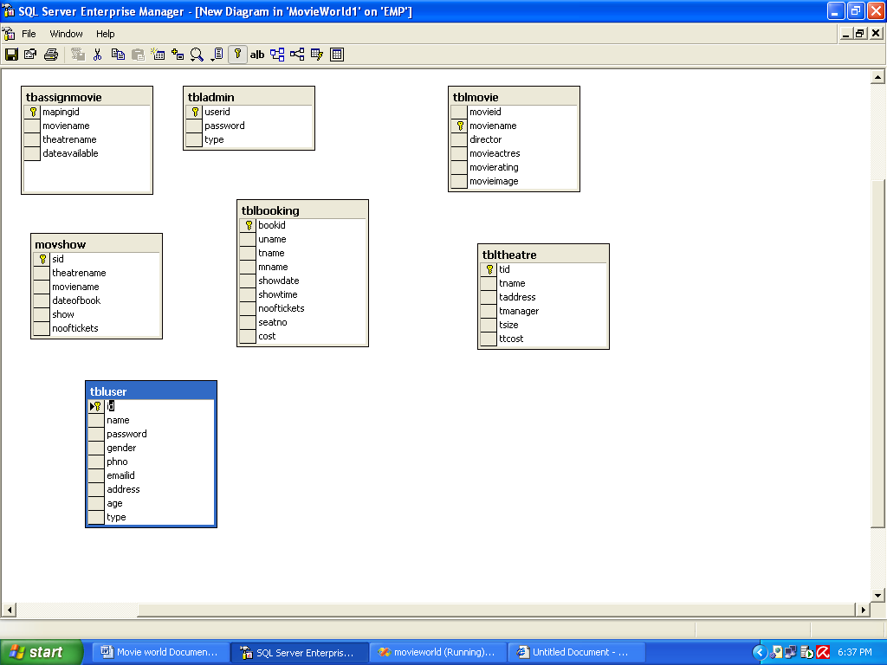

Home Page
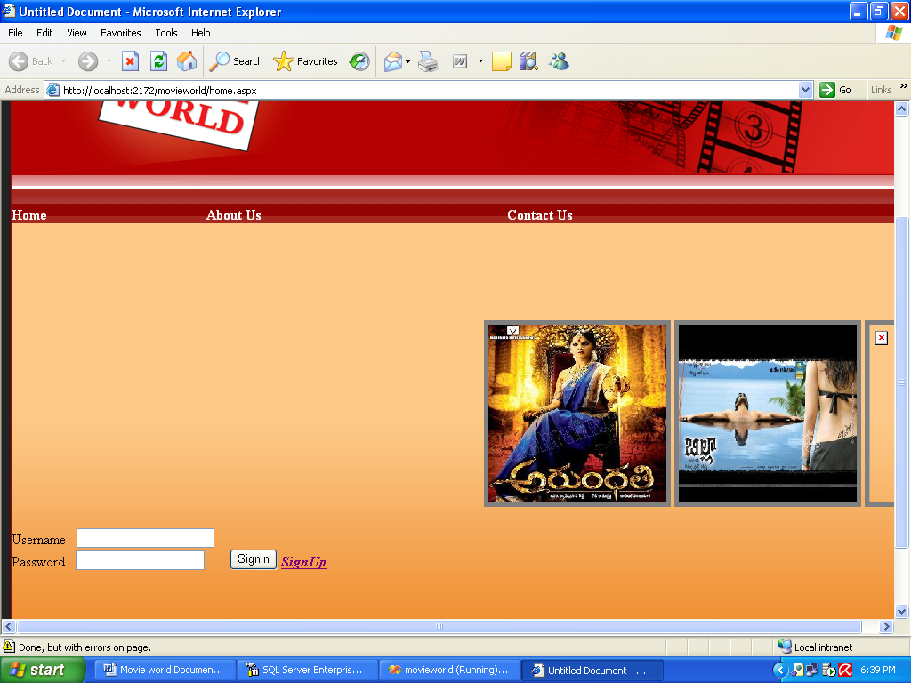

Admin Home

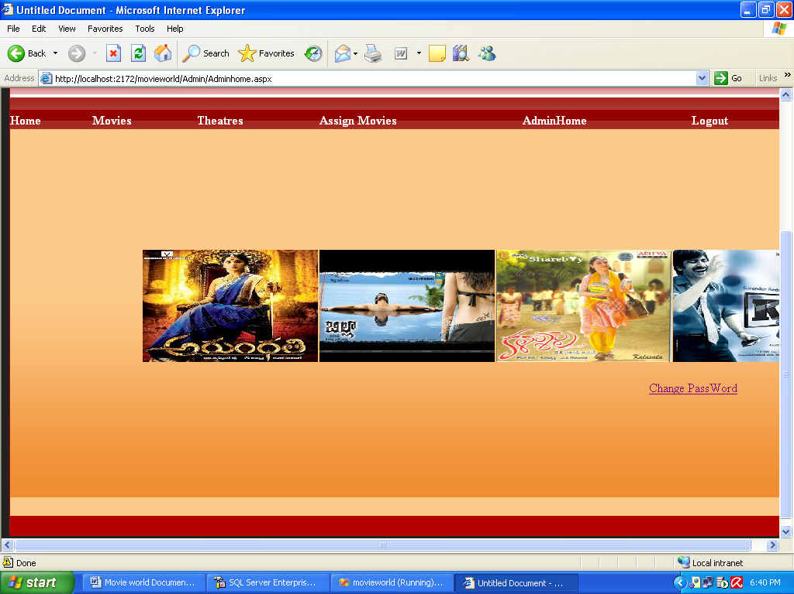

Add Movie Page
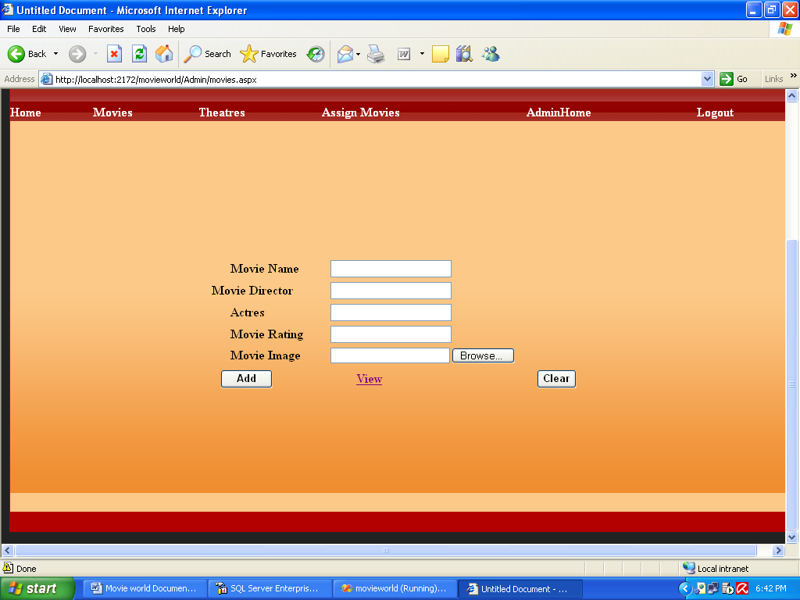

View Movie Page
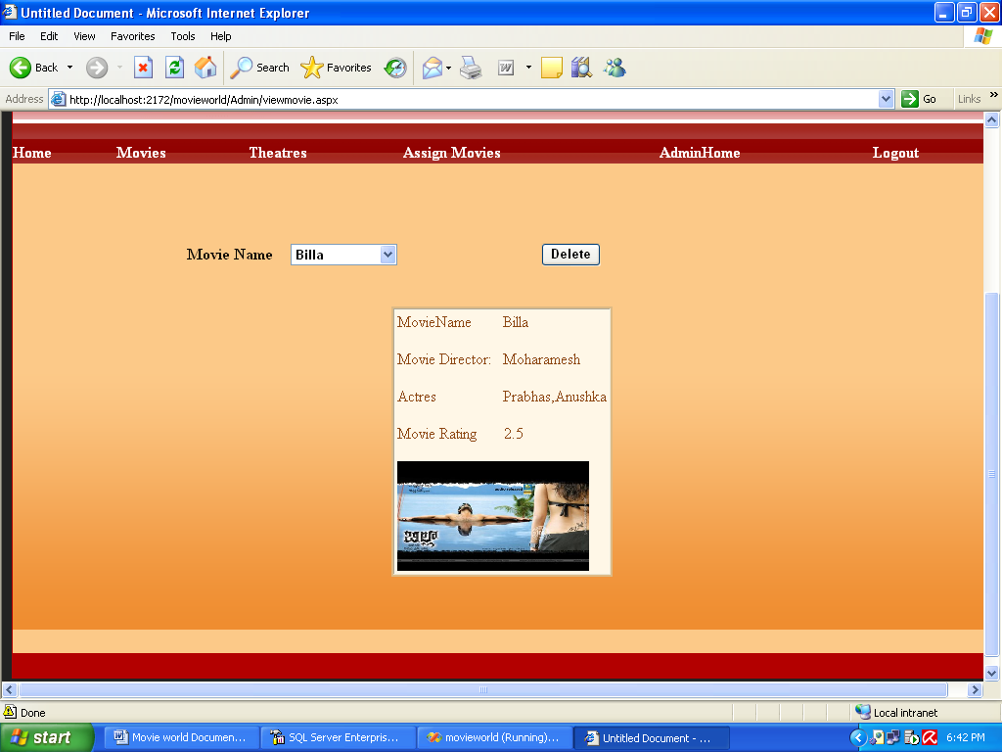

Add Theatre
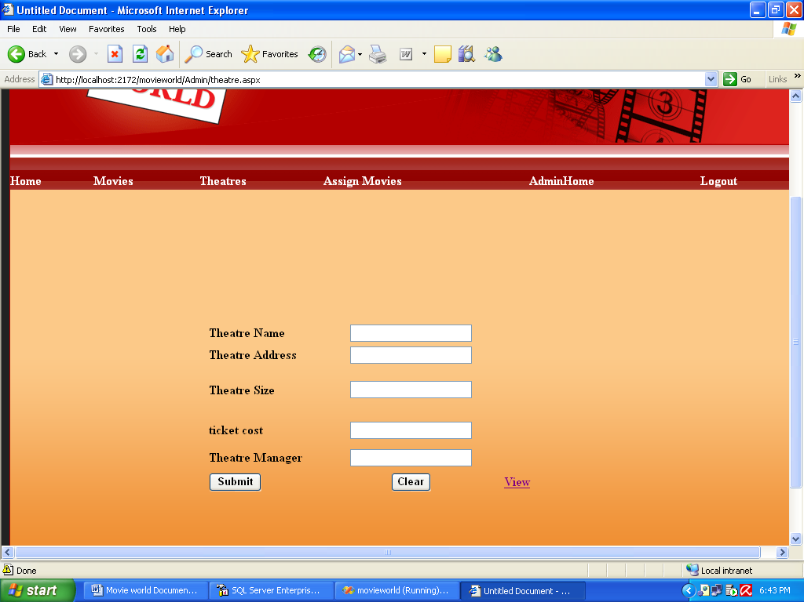

Viw Theatre
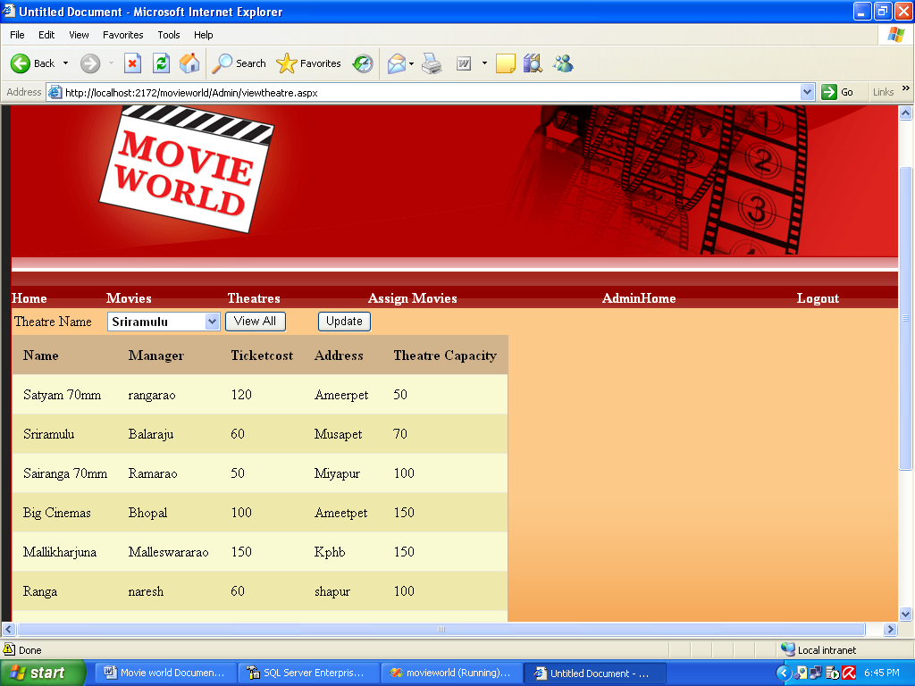

Update Theatre

Assign Movie
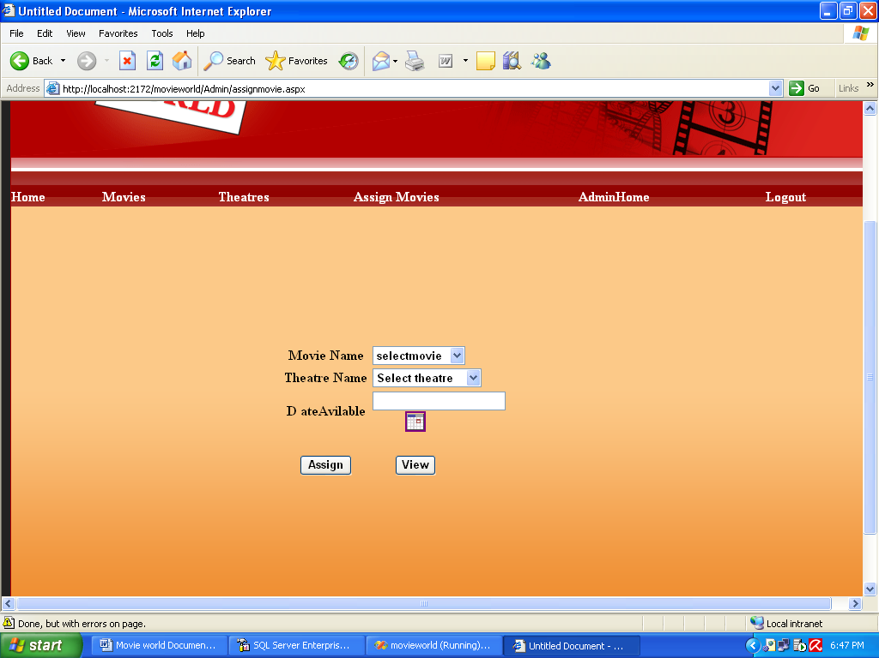

View Assigning
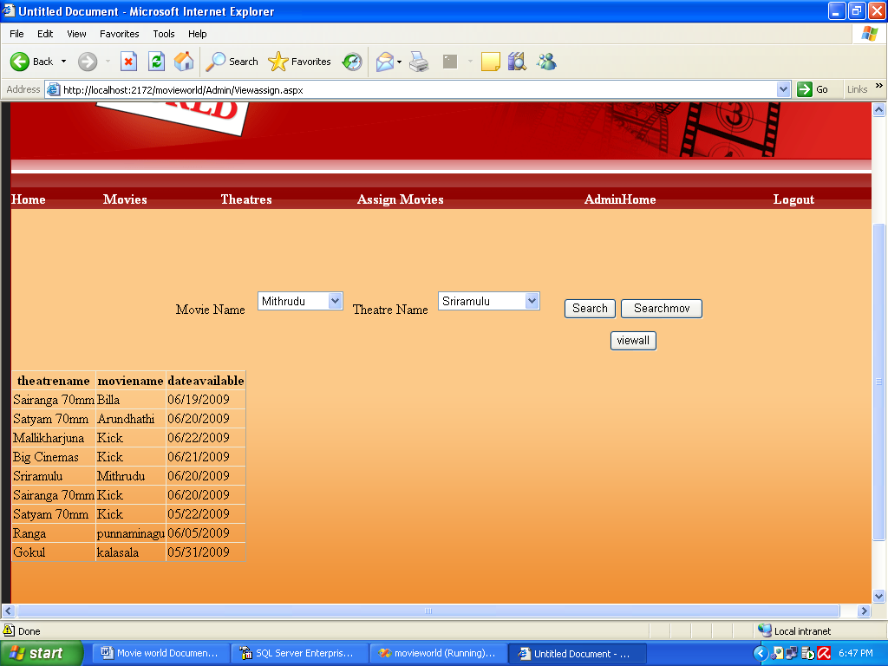

User Home
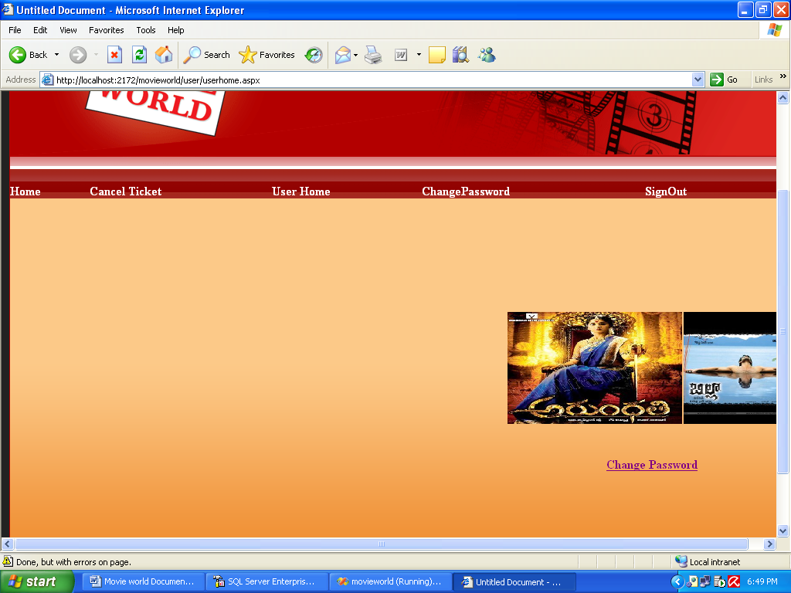

Change Password
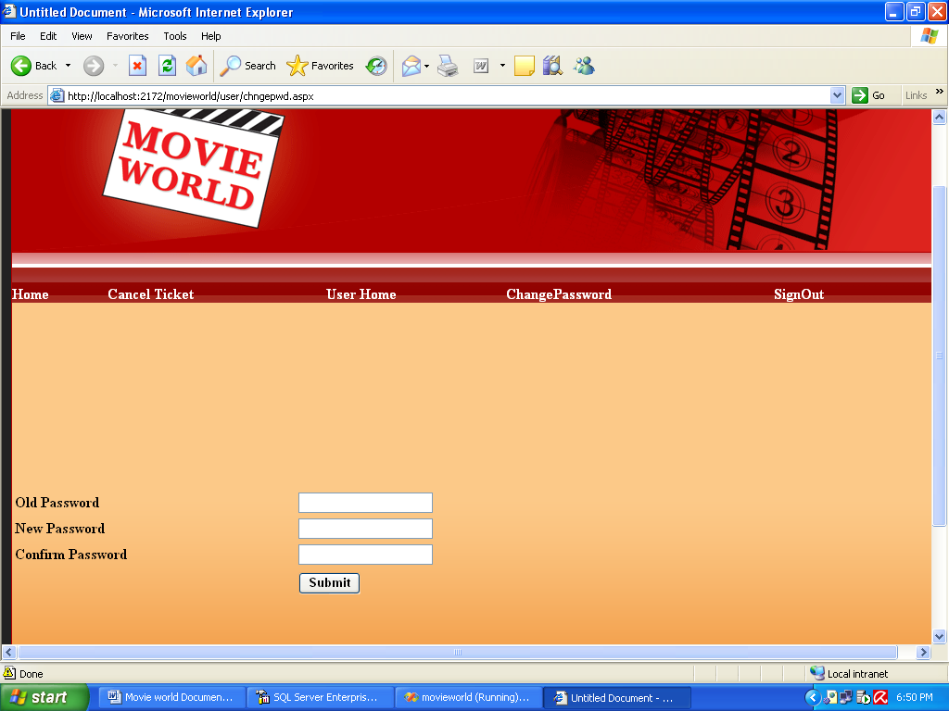

Theatre Booking
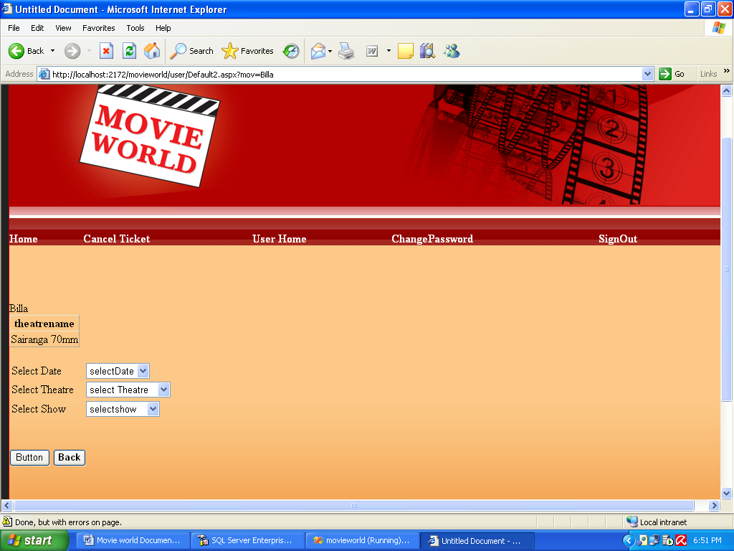

Book Seats
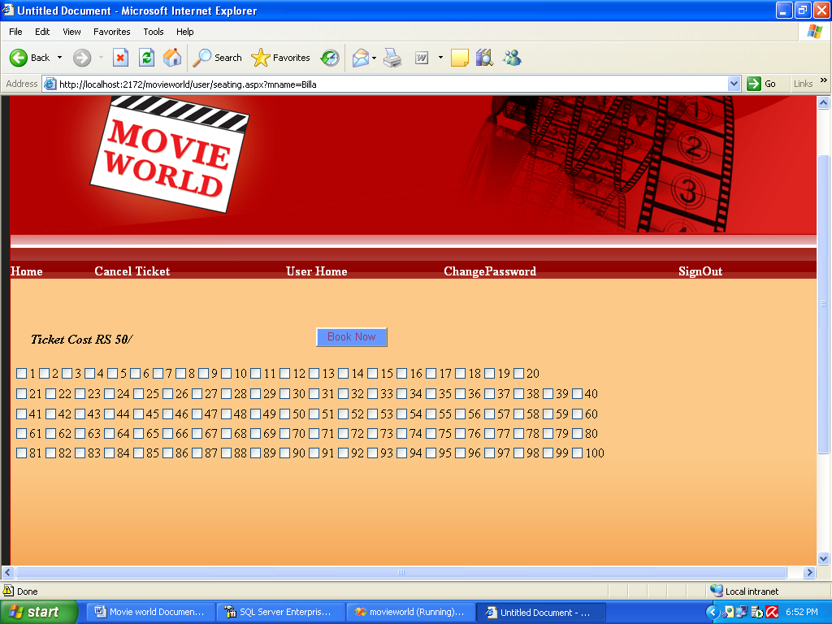

After Booking
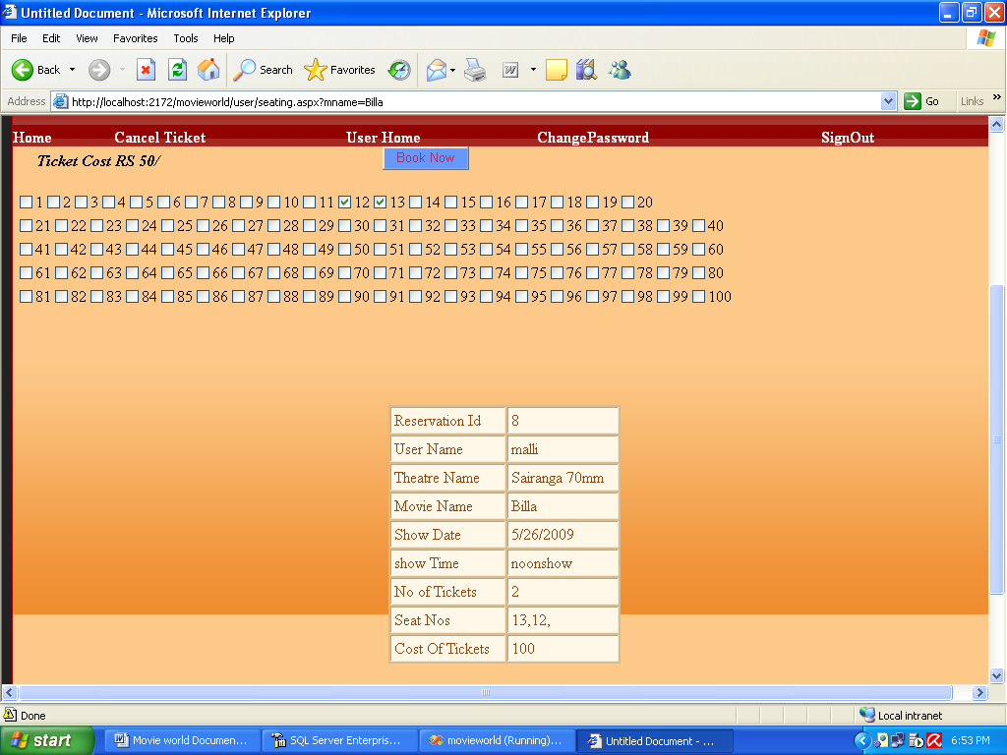

Cancel Ticket
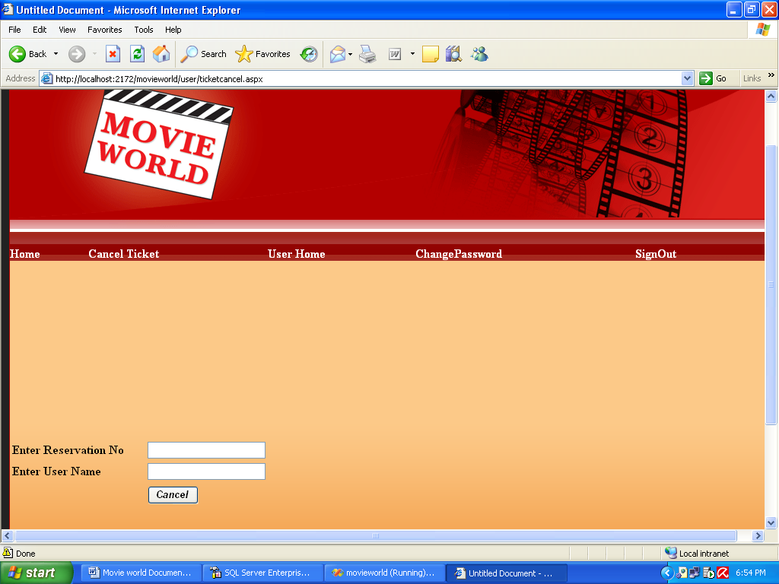

User Registration
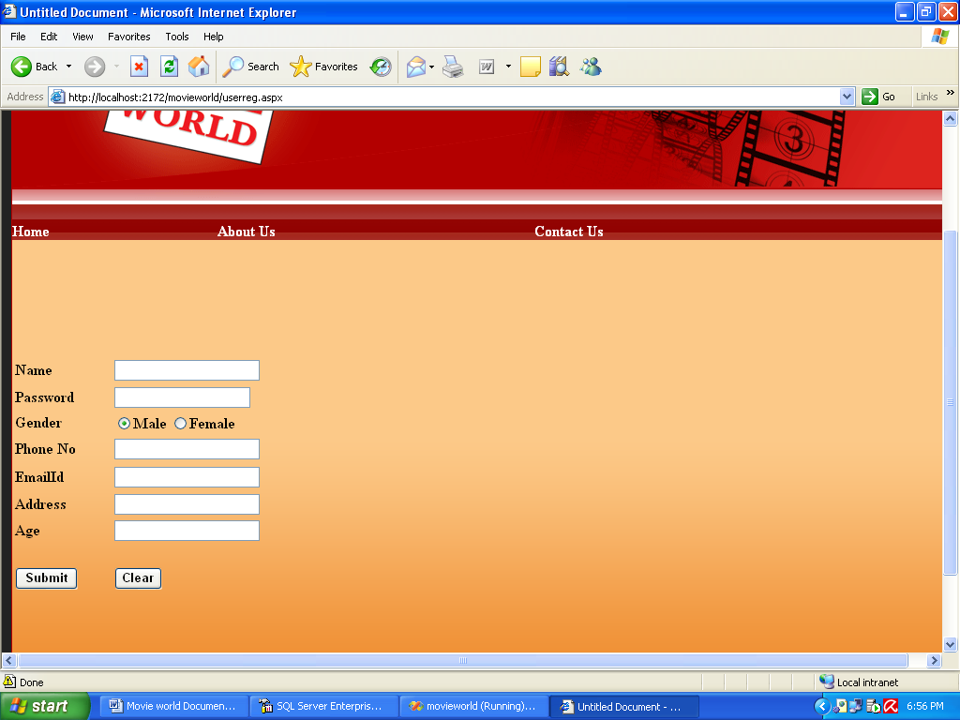

About us
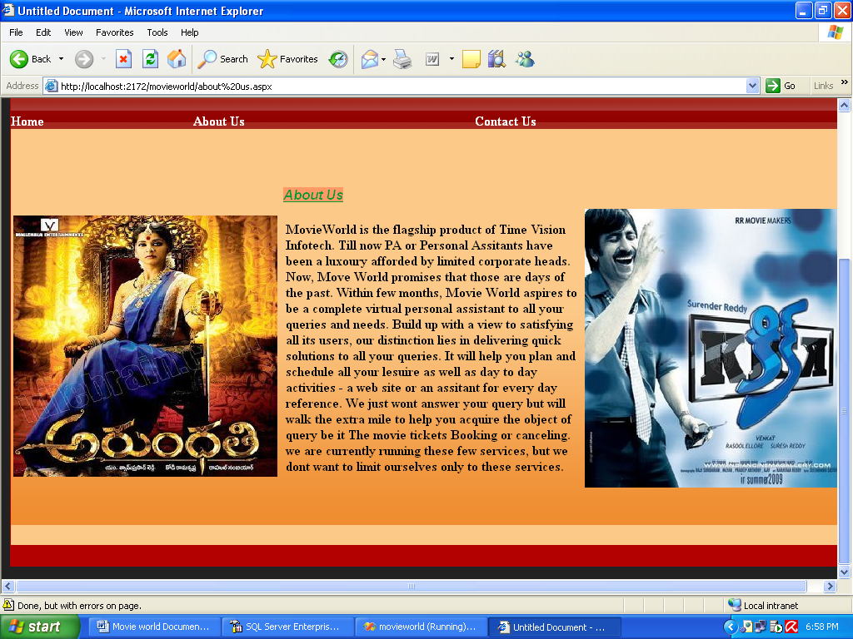

Contact Us
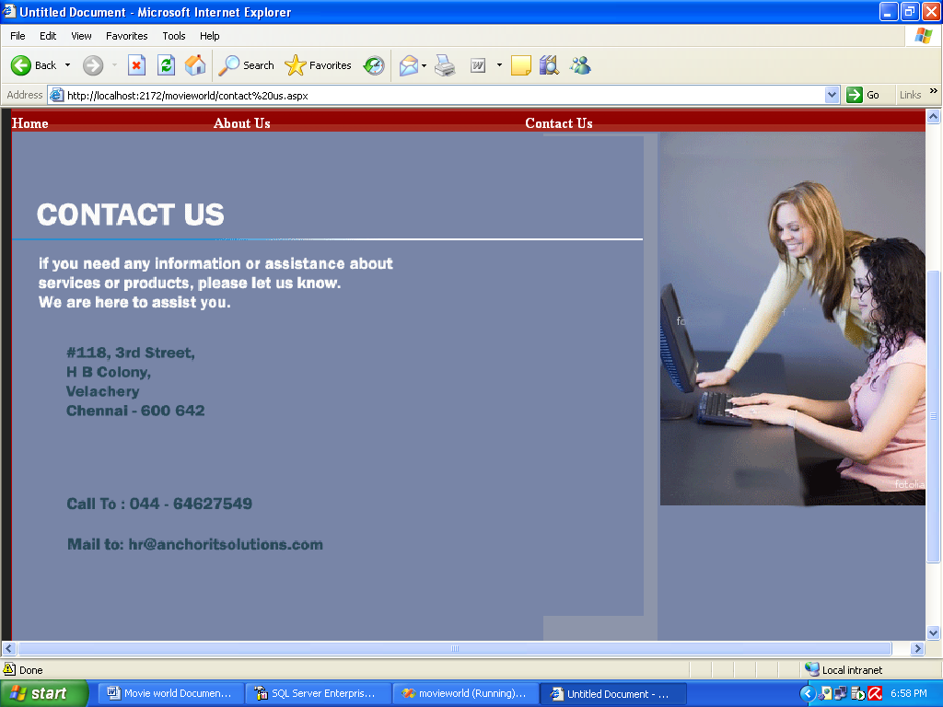

PROJECT TESTING

Software Testing Strategies

Testing is a set of activities that can be planned in advanced and conducted systematically. A strategy for software testing must accommodation low-level tests that are necessary to verify that a small source code segment has been correctly implemented as well as high-level tests that validate major system functions against customer requirements
There are three types of testing strategies

- Unit test
- Integration test
3. Performance test

Unit Testing:

Unit testing focuses verification efforts on the smallest unit of software design module. The unit test is always white box oriented. The tests that occur as part of unit testing are testing the module interface, examining the local data structures, testing the boundary conditions, execution all the independent paths and testing error-handling paths.

Integration Testing:

Integration testing is a systematic technique or construction the program structure while at the same time conducting tests to uncover errors associated with interfacing. Scope of testing summarizes the specific functional, performance, and internal design characteristics that are to be tested. It employs top-down testing and bottom-up testing methods for this case.

Performance Testing:
Timing for both read and update transactions should be gathered to determine whether system functions are being performed in an acceptable timeframe.

Conclusion

The entire project has been developed and deployed as per the requirements stated by the user, it is found to be bug free as per the testing standards that is implemented. Any specification-untraced errors will be concentrated in the coming versions, which are planned to be developed in near future. The system at present does not take care off the money payment methods, as the consolidated constructs need SSL standards and are critically to be initiated in the first face, the application of the credit card transactions is applied as a developmental phase in the coming days. The system needs more elaborative technicality for its inception and evolution.
Future Enhancement Of the Project
BIBILIOGRAPHY

1.ASP.NET (BIBLE)
-MRUDULA PARIHAR.

2. Mastering SQL Server 2000 by
-Gunderloy,Jorden BPB Publications
3. Beginning SQL Server 2000 by
-Thereon Willis wrox publications
.
4.SOFTWARE ENGINEERING (THEORETICAL APPROACH)
-ROGER S.PRESSMEN, T. Mc. GH.

5.C#.NET
-PROFESSIONAL VISUAL BASIC.NET
-WROX PUBLICATIONS.

6. MSDN LIBRARY.NET
-WWW.MICROSOFT.COM

