

**CLASSCOMM: INTERACTIVTY IN INSTANT**

**LECTURER-STUDENT CONNECTION PLATFORM.**

**(PROPOSAL JKUAT)**

**OTIENO ALPHONCE NEUVILLA**

**SCT222-0181/2020**

*A Proposal /Research project submitted to the Department of Information Technology, in the School of Communication and Information Technology in partial fulfillment of the requirement for the award of the degree of Bachelor in Business computing. Jomo Kenyatta University of Agriculture and Technology*

**OCTOBER 2023**

# 2. DECLARATION

This project proposal is my original work and has not been presented for a degree, diploma, or certificate.

OTIENO ALPHONCE NEUVILLA

SCT222-0181/2020

Signature: …………………………………….

DATE: …………………………….

This project has been presented for examination with my approval as the university supervisor.

SUPERVISOR

NAME: ……………………………………

Signature: …………………………………….

Department Of Information Technology

Jomo Kenyatta University of Agriculture and Technology

Signature: …………………………………...

Date: …………………………………...

# 3. DEDICATION

I would like to dedicate this work to my mother Rinter Atieno and Father Kotieno Michael who have been an everlasting source of inspiration in my life. I would not have been able to achieve what I have without their support.

# 4. ACKNOWLEDGMENT

First and foremost, my greatest gratitude goes to my Supervisor, Mr. **WAMUTI**, for his encouragement and perseverance during the whole process of creating this project proposal. I express my thankfulness to the Highest God for enabling and assisting me in carrying out this proposition successfully.

In addition, I express my heartfelt appreciation to my parents, friends, students, and extended family for their spiritual and financial support. May the Almighty Father bless you and reward you everyone for your good acts.

# 5. ABSTRACT

A group of individuals can quickly communicate with one another by placing or publishing virtual notes, announcements, and information on an online notice board. As the world tends to connect with the online notice board facility as a project, the main goal of this online notice board project is to make information much easier in a paperless community. Additionally, it considers the improvement of the current notice boards, making them more interactive to operate by local area network (LAN) or internet access to speed up the rate at which pertinent information is distributed to the general public with no location restrictions.

The main advantage of the created Electronic Notice Board, an online web application, is that its usability is completely capable of transmitting pertinent notices and announcements and periodically updating the users. A SMS is sent to the user each time the E-Notice Board is uploaded, taking into account their choices for the departments and categories. Additionally, users may use the web application E-Notice Board at any time from any location to see the notifications and articles, which makes our project extremely efficient and effective.

Table of Contents

2. DECLARATION ii

3. DEDICATION iii

4. ACKNOWLEDGMENT iv

5. ABSTRACT v

7. LIST OF TABLES ix

8.LIST OF FIGURES ix

9. LIST OF ACRONYMS AND ABBREVIATIONS ix

CHAPTER ONE: INTRODUCTION 1

1.1 Background of the Study 1

1.2 Introduction 2

1.3 Statement of the problem 2

1.4 Proposed Solution 3

1.5 Objective of The Study 4

1.5.1 General Objective 4

1.5.2 Specific Objectives 4

1.6 Research questions 4

1.7 Justification 5

1.8 Proposed Research and System Methodologies 6

1.9 Scope of the Study 8

1.10 Instruments 9

1.10.1 Online e-Notice Board System Specifications 9

1.10.2 User Survey Questionnaire 9

1.11 Budget 10

1.13 Request for Institutional Support from JKUAT 11

1.14 Work plan 12

1.12 Gantt Chart 13

CHAPTER TWO: LITERATURE REVIEW 14

2.1 Introduction 14

2.2 Theoretical Framework 14

2.3 Application of Research Area to the Problem Domain 15

2.4 E-noticeboard systems. 17

2.4.1 Components of e-noticeboard Interactivity 17

2.5 Design Methodologies 18

2.5.1 Agile (scrum) Methodology 18

2.6 User requirements gathering in e-noticeboard Systems. 20

2.7 Integration and Architecture 21

2.8 Current Application of e-noticeboard Systems 22

2.9 Summary 23

2.10 Research Gap 23

CHAPTER THREE: METHODOLOGY 24

3.1 Introduction 24

3.2 Feasibility Study 25

3.2.1. Technical Feasibility 25

3.2.2 Economic Feasibility 25

3.2.3 Operational Feasibility 26

3.2.4 Scheduling Feasibility 26

3.3 Data Gathering Procedure & Instruments 27

3.3.1 Questionnaire 27

3.3.2 Structured or Closed Ended Questions 27

3.3.3 Un-Structured or Open-Ended Question 27

3.3.4 Interview 28

3.4 Requirement Specification 29

3.4.1 Functional Requirements 29

3.4.2 Non-Functional Requirements 30

3.5 Design 31

3.5.1 Use Case Diagram or Data Flow Diagram 31

3.5.2 Activity Diagram 32

3.5.3 Class Diagram 33

3.5.4 Sequence Diagram 34

3.6 Database Design 35

3.6.1 Entity Relationship Diagrams 35

3.6.2 Tables 36

3.7 User Interface Design 38

3.8 Platforms for Front End & Back End 40

3.9 System Testing 40

3.9.1 Test Case 40

REFRENCES 41

CITATIONS 43

# 7. LIST OF TABLES

Table 1.0 Work Plan

Table 1.2 Gantt chart

# 8.LIST OF FIGURES

Figure 1.0 Agile Diagram

Figure 1.2 shows notice board for user view of lecture information

Figure 1.3 screenshot of E-noticeboard

# 9. LIST OF ACRONYMS AND ABBREVIATIONS

SMS Short Message Service

JKUAT Jomo Kenyatta University of Agriculture and Technology

WI-FI Wireless Fidelity

E-notice board electronic notice board

LAN Local Area Network

PHP Hypertext Preprocessor

# CHAPTER ONE: INTRODUCTION

## 1.1 Background of the Study

The client for this project is Jomo Kenyatta University of Agriculture and Technology (JKUAT), a leading academic institution in Kenya. Established in 1981, JKUAT is located in Juja, about 36 kilometers northeast of Nairobi, the capital city of Kenya. Established in 1981, it has grown to become one of the leading universities in East Africa, emphasizing applied sciences, technology, and agriculture. The university has multiple campuses, and its academic programs extend beyond agriculture and technology to include fields such as health sciences, business, and social sciences.

In the pursuit of its academic objectives.

JKUAT's business processes encompass a wide range of activities, from admissions and registration to academic scheduling, research, and administrative tasks. These processes involve multiple stakeholders, including students, faculty, administrative staff, and support personnel, all working together to ensure the smooth operation of the university.

## 1.2 Introduction

The research area of this project is centered on Human-Computer Interaction (HCI) with an emphasis on interactivity as it applies to web-based systems. Coupled with actions like clicking buttons, entering data and navigating menus. Interactivity conceptualizes and underscores the design of a dynamic and responsive online e-notice board for Jomo Kenyatta University of Agriculture and Technology (JKUAT), providing users with responsive feedback based on their actions creating a seamless and engaging experience with real-time responses from the system.

## 1.3 Statement of the problem

Communication within Jomo Kenyatta University of Agriculture and Technology (JKUAT) currently relies on traditional methods, such as emails and notice boards to disseminate important announcements, updates, and notices to its vast student and staff population. These methods have been the backbone of communication within the university for years, facilitating the exchange of vital information. While these methods have served their purpose for years, they are beginning to show limitations in the face of evolving communication needs and technological advancements. However, as the world continues to embrace digital transformation, there is an increasing need for JKUAT to modernize its communication methods.

The existing system presents several challenges:

1. Delayed Information Dissemination: The reliance on emails and physical notice boards often results in delayed communication, with important announcements reaching the intended recipients after critical timelines have passed.
2. Limited Accessibility: Not all members of the university community have equal access to these communication channels, leading to disparities in information access among students, faculty, and staff.
3. Missed Notices: In the vast campus environment of JKUAT, notices can easily go unnoticed, leading to students and staff missing out on important updates, deadlines, and events.
4. Inefficient Updates:The current system does not provide an efficient means for real-time updates or two-way communication, hindering interactive engagement among stakeholders.

## 1.4 Proposed Solution

To address these challenges and create a more effective communication environment, we propose the development of an online interactive e-notice board system for JKUAT. This solution will leverage modern technology to ensure timely, accessible, and interactive communication within the university community.

The proposed system will include the following key features:

1. Real-Time Communication: Users will have the ability to post and access notices in real time, ensuring that information reaches its intended audience promptly.
2. SMS Alerts: To enhance accessibility, the system will incorporate SMS alerts, allowing critical updates to be delivered directly to users' mobile devices.
3. Web Access: The platform will be accessible through web browsers, making it convenient for users to access information from various devices.
4. Interactive Features: Users will be able to engage with notices through comments, queries, and discussions, fostering a sense of community and collaboration.

This project seeks to tackle the existing communication challenges at JKUAT by introducing an online interactive e-notice board system that promotes real-time communication, accessibility, and engagement among students, faculty, and staff.

## 1.5 **Objective of The Study**

### 1.5.1 General Objective

To implement ClassComm e-noticeboard with application of interactivity within the field of Human-Computer Interaction (HCI). This system will aim to facilitate an engaging user experience through responsive design and feedback while ensuring the platform remains intuitive and efficient for all university stakeholders.

### 1.5.2 Specific Objectives

1. To explore the techniques used in designing an interactivity e-noticeboard.
2. To assess the elements comprising e-noticeboards and interactivity.
3. To collect the user requirements in e-noticeboards.
4. Create and validate a e-noticeboard with interactivity for lecture-student communication and passing notices.

## 1.6 Research questions

1. What are the various methodologies employed in designing e-noticeboards?
2. What are the key components that constitute e-noticeboards?
3. How can requirements be effectively determined within the context of interactivity in e-noticeboards?
4. How can a e-noticeboard system be developed and tested for the purpose of lecturer-student communication and passing notices?

## 1.7 Justification

The research is conducted with the aim of addressing critical communication challenges faced by Jomo Kenyatta University of Agriculture and Technology (JKUAT) and exploring innovative solutions to benefit both the university and its diverse community of students, faculty, and staff.

**Beneficiaries:**

1. JKUAT Community: The primary beneficiaries of this research are the students, faculty, and staff of JKUAT. The proposed solution will provide them with a more efficient and user-friendly communication platform, enhancing their overall experience within the institution.
2. Administrators: University administrators and management will benefit from improved communication capabilities, enabling them to disseminate information effectively and engage with stakeholders more efficiently.

**Problem Solving:**

The proposed solution, an online interactive e-notice board system, directly addresses the identified communication challenges at JKUAT. By introducing real-time communication, SMS alerts, and web accessibility, this system will streamline information dissemination, increase accessibility, and foster a sense of community within the university.

**Contributions to Research Area:**

This research contributes to the broader area of digital communication systems within educational institutions. It explores the practical implementation of modern technology to improve communication processes, which can serve as a valuable case study for similar institutions seeking to enhance their communication infrastructure.

**Relevance:**

In today's digital age, the relevance of this research is paramount. Educational institutions like JKUAT must adapt to the changing communication landscape to remain competitive and meet the evolving needs of their stakeholders. By conducting this research now, we align with the current urgency for efficient and accessible communication solutions, ensuring that JKUAT remains at the forefront of modern academia.

## 1.8 Proposed Research and System Methodologies

For this project, I have opted for an Object-Oriented (OO) approach over a structured one, given its inherent capacity for encapsulation, inheritance, and polymorphism which are beneficial for creating modular and scalable applications. This is particularly fitting for the development of an interactive e-notice board system.

The system implementation methodology will follow the Agile Development approach, specifically Scrum. This iterative and incremental methodology aligns well with the dynamic nature of software development and allows for flexibility in responding to changing requirements.

*Agile(scrum) Methods Diagram:*

Product Backlog

(Sprint Planning)

Sprint Backlog

(Daily Scrum)

Work in Progress (WIP)

(Developing and testing)

Testing/Review

(quality Assurance)

Deployment

(sprint Review & Retrospective)

(Back to Step 1 or Product Release)

*Figure 1.0 Agile Diagram*

The primary data collection tool will be questionnaires and user interviews. We will use questionnaires because they may elicit informed responses without requiring in-person encounters that can introduce bias, while interviews will provide qualitative insights into user experiences and expectations.

Project Management Tools:

1. Gantt Chart:

A Gantt chart will be used for project scheduling and timeline management, ensuring that tasks are executed in a coordinated manner.

1. Project Schedule: A detailed project schedule will be maintained to track progress, deadlines, and resource allocation.
2. Hardware and Software Resources: The project will require a development environment with necessary hardware and software resources, including servers, databases, development tools, and testing environments.
3. Budget: A budget plan will be established to allocate resources effectively and monitor project costs.

Validation for Agile (Scrum) Methodology:

The Agile (Scrum) methodology was chosen due to its suitability for software development projects with evolving requirements. Given that this project involves creating a dynamic online interactive e-notice board system, Agile allows for flexibility and responsiveness to user feedback and changing needs. It promotes iterative development, frequent testing, and collaboration, ensuring that the final system aligns closely with user expectations.

Life Cycle of the Research:

1. Initiation: Project kick-off, team formation, and initial stakeholder meetings.
2. Planning: Detailed project planning, including scope definition, resource allocation, budgeting, and scheduling.
3. Execution: Development of the e-notice board system using Agile (Scrum) methodology, data collection through surveys and interviews, and regular progress monitoring.
4. Monitoring and Controlling: Ongoing project monitoring, quality assurance, and risk management.
5. Closing: System deployment, user training, final data analysis, and project documentation.

By adopting the Agile (Scrum) methodology and utilizing appropriate project manager tools and data collection methods, this research will encompass the entire research life cycle, ensuring a systematic and efficient approach to the development and evaluation of the online interactive e-notice board system for JKUAT.

## 1.9 Scope of the Study

This study is primarily focused on enhancing communication within the confines of Jomo Kenyatta University of Agriculture and Technology (JKUAT). Geographically, the scope is limited to the JKUAT campus and its immediate vicinity. The study targets the university's entire community, including students, faculty, and administrative staff.

The study's scope is limited to JKUAT, and its findings may not be directly applicable to other institutions or settings.

The research acknowledges the constraints in terms of time, budget, and human resources. These limitations may impact the extent of data collection and analysis.

While every effort will be made to employ rigorous research methods, there may be limitations in the data collection process due to factors such as response rates and participant availability.

This study will confine itself to the development, implementation, and evaluation of the online interactive e-notice board system at JKUAT. It will specifically focus on assessing the system's impact on communication efficiency and community engagement within the university. The research will not delve into broader issues unrelated to the project's objectives, ensuring a concentrated and relevant study.

## 1.10 Instruments

### 1.10.1 Online e-Notice Board System Specifications

#### 1.10.1.1 hardware requirements

- HP EliteBook with a 1.90GHz 2.11 GHz CPU and 16GB of RAM

-A printer and a flash disk/compact disc to produce physical copies.

-Hard drive for backup

#### 1.10.1.2 software requirements

- Platform: Web-based

- OS: windows / Linux

- Backend Framework: Node.js, JSON

- Frontend Framework: HTML, CSS, JavaScript, Bootstrap, React.js

- Database: MongoDB, PostgreSQL

- SMS Alert System: Twilio API

### 1.10.2 User Survey Questionnaire

- Purpose: To evaluate the effectiveness and user-friendliness of the e-notice board.

- Questions:

1. On a scale from 1-10, how user-friendly did you find the e-notice board?

2. How frequently do you check the e-notice board?

3. Did you receive SMS alerts for important notices?

... [Additional questions based on the project's objectives]

## 1.11 Budget

|  |  |  |
| --- | --- | --- |
| **Requirements** | **Time** | **Price (Ksh)** |
| Web Hosting and Domain | yearly | 15,000/= |
| Database Maintenance | monthly | 5,000/= |
| Twilio SMS API (Ksh 1 per SMS) | monthly | 10,000/= |
| Deployment and design (HP EliteBook with 1.90GHZ 2.11GHZ CPU and 16GB of RAM,) |  | 70,000/= |
| Printer and Hard drive (printing and Backup) |  | 20,000/= |
| User testing and surveys |  | 20.000/= |
| Miscellaneous Costs (unforeseen expenses) |  | 50,000/= |
|  |  |  |
| TOTAL COST |  | 190,000/= |

## 1.13 Request for Institutional Support from JKUAT

Given the potential benefits of the "Online interactive e-notice board" for the JKUAT community, we kindly request the university's consideration for financial or in-kind support for this project.

Benefits to JKUAT:

1. Enhanced Communication: Real-time communication will make information dissemination faster and more effective.
2. Eco-friendly: Reduction in the usage of paper for notice dissemination.
3. Innovative Reputation: Showcases JKUAT's commitment to adopting technological advancements in education.

Areas of Support:

1. Monetary Contribution: Partial or full funding of the aforementioned budget (Appendix B) would greatly assist in the successful implementation of this project.
2. Infrastructure: Assistance with hosting or server space can reduce costs and ensure optimal performance.
3. Mentorship: Connecting the team with faculty or professionals who can guide or provide valuable insights can be invaluable.

I sincerely hope that JKUAT will consider my request and recognize the potential benefits this project can bring to the entire university community.

## 1.14 Work plan

|  |  |  |  |  |  |  |
| --- | --- | --- | --- | --- | --- | --- |
| **A** | **B** | **C** | **D** | **E** | **F** | **G** |
| Task name | Duration in days | Expected start time | Expected end date | Actual start date | Actual end date | Deliverables |
| System deployment | 180 |  |  | 25/9/2023 |  |  |
| Identifying problems | 7 | 3/10/2023 | 10/10/2023 | 3/10/2023 | 9/10/2023 | Feasibility report |
| Requirement gathering | 5 | 9/10/2023 | 15/10/2023 | 10/10/2023 | 14/10/2023 | User requirement |
| Analyzing system needs | 15 | 14/10/2023 | 29/10/2023 | 14/10/2023 | 18/10/2023 | Proposal |
| Design System | 30 | 25/10/2023 | 25/11/2023 |  |  | Logical design |
| Develop (coding) | 60 | 2/12/2023 | 3/2/2024 |  |  | Software system |
| Testing and Maintenance | 31 | 5/2/2024 | 6/3/2024 |  |  | Test results |
| Documentation | 180 | 25/9/2023 | 25/4/2024 |  |  | The whole project document |

Table 1.0 Work Plan

## 1.12 Gantt Chart

|  |  |  |  |  |  |  |  |  |
| --- | --- | --- | --- | --- | --- | --- | --- | --- |
| Task name | September | October | November | December | January | February | March | April |
| System deployment |  |  |  |  |  |  |  |  |
| Identifying problems |  |  |  |  |  |  |  |  |
| Requirement gathering |  |  |  |  |  |  |  |  |
| Analyzing system needs |  |  |  |  |  |  |  |  |
| Design System |  |  |  |  |  |  |  |  |
| Develop (coding) |  |  |  |  |  |  |  |  |
| Testing and Maintenance |  |  |  |  |  |  |  |  |
| Documentation |  |  |  |  |  |  |  |  |

*Table 1.2 Gantt Chart*

# CHAPTER TWO: LITERATURE REVIEW

## 2.1 Introduction

The assessment and analysis report of material connected to a digital notice board is known as a literature review. This chapter's purpose is to examine the work of other scholars in order to learn what they have accomplished and investigated.

## 2.2 Theoretical Framework

A "notice" is described as "a written or printed statement that offers people information or a warning".

Online bulletin boards include limitations on what, how, and who may communicate. These limitations lead to comparable structures, aesthetic elements, content, and targeted audiences for online notice boards (Dowling, 2008).

From any authorized device (PCs) on a Raspberry Pi card, Vinod et al(2016) .'s proposal said that it is feasible to remotely transmit a notice to a digital monitor. Wi-Fi was recommended as a method of data transfer. Postings may be added, deleted, or edited whenever you wanted. For transmitting or publishing alerts, an approved device or PC was used, and a Raspberry Pi was linked to Wi-Fi on the receiving end. An electronic device can exchange data wirelessly across a computer network using wireless technology, including high-speed wireless connections. The information comes from a verified user.

According to Arulmurugan et al. (2016), notice boards are a standard element in many institutions. These notice boards are being operated by hand. In their article, they suggested a method that uses Wi-Fi to make it easier to post notifications to a notice board. Wi-Fi can transmit data over a distance of around 100 meters. The data rate for Wi-Fi is 1 or 2 Mbps. It supports network interfaces and has several points of access. Additionally, it allows the system to be interoperable with a variety of wireless technologies.

## 2.3 Application of Research Area to the Problem Domain

In 2003, Riyad created a virtual notice board based on a computerized notification system that keeps records of announcements made by an organization's head, officials, and professors. The chief, officials, and faculty members must all register with legitimate accounts in order to access and post notices. Only then may notices be generated, edited, or updated. Members can examine a notification after choosing it by using a form that includes a data table and many other features.

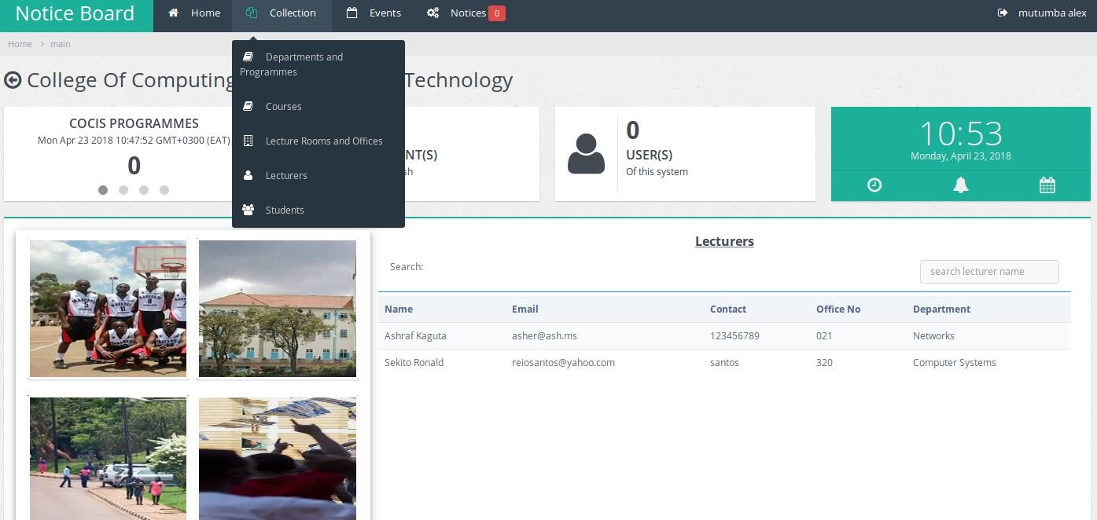

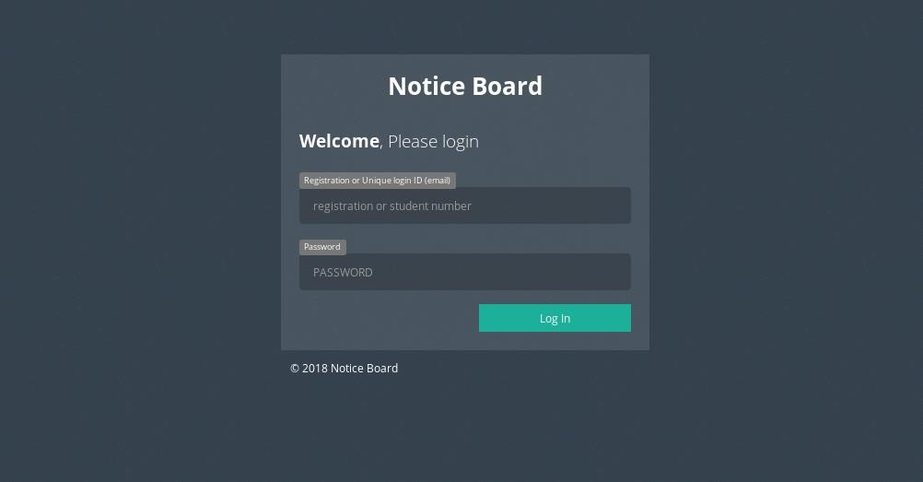

*Figure 1.2 shows e- notice board for user view of lecture information*

*Notice board for viewing lecture content,*

Additionally, the Notice Board Pro, a website application created in PHP and MySQL by Dixon (2011), was examined. Users of the Notice Board Pro program can create items and view those that other users have already created. Users can post advertisements on the notice board for things like cars for sale, apartments for rent, refrigerators for sale, services, and more. You can select to view all the products on the notice board, simply those that fit into a specific category, such as autos, household goods, or lodging, or even all three, while perusing items.

A learning technology project's design and execution were discussed in (Chang & Sheu, 2002). For teachers and students to create a classroom dynamically, regardless of location or time constraints, a wireless platform has been designed. In order to enable course teaching and discussion in an ad hoc classroom, they build information technology to give the instructor teaching tools such a blackboard, board rubber, colored chalk, microphone, voice recorder, video recorder, and so on. Additionally, they give each kid a digital schoolbag (or schoolbag) that has an electronic book, notepad, parents' contact information, pencil case, writing supplies, sheets, calculator, address book, and other items.

Students are intended to improve their learning abilities while taking classes in a vibrant, exciting, and novel learning environment, free from the stress of having to physically attend classes. Additionally, students benefit from more flexible learning opportunities at convenient times.

Members of a family can access an electronic bulletin board that was created by (Mansikkaniemi et al, 2002) via their wireless devices. The wireless devices used by different family members may access a single database, giving the impression of a bulletin board with notes taped to it. The notes may be produced manually, automatically (from a calendar, for example), or in response to a short messaging service interaction. The notes could come in different hues to denote their significance or place of origin. On the board, the notes may be moved about, and any family member can create new notes.

## 2.4 E-noticeboard systems.

"A written or printed statement that offers people information or a warning and is made, distributed, displayed, and saved electronically" is one possible definition for the term "e-notice." An e-notice, however, is more than simply a digital version of a conventional paper-based notice. Instead, it possesses characteristics that show the e-notice is becoming a distinct genre.

### 2.4.1 Components of e-noticeboard Interactivity

These components collectively contribute to an interactive, user-friendly, and secure e-noticeboard, fostering effective communication and engagement within the targeted community or organization.

1. User Authentication:

Ensuring a secure and reliable user authentication system is crucial. This component allows users to log in securely, access personalized information, and contribute content based on their roles, ensuring that only authorized users can interact with the noticeboard.

1. Notice Posting and Editing:

The ability for users to easily post and edit notices is fundamental. This ensures that information on the noticeboard is current and relevant. An intuitive interface for creating and updating content promotes user engagement.

1. Database Integration:

Integrating a robust database system is essential for efficient storage, retrieval, and management of notices and user data. This component enables organized storage, scalability, and advanced features like sorting and searching, contributing to a seamless user experience.

1. Real-time Updates:

Providing real-time updates or notifications is key for keeping users informed of new notices or updates. This feature enhances the immediacy and relevance of the information, encouraging users to stay engaged with the noticeboard.

1. User Roles and Permissions:

Defining different user roles and permissions ensures a structured and controlled environment. Administrators, moderators, and regular users should have specific access levels and capabilities, maintaining the security and integrity of the noticeboard.

## 2.5 Design Methodologies

For this project, I have opted for an Object-Oriented (OO) approach over a structured one, given its inherent capacity for encapsulation, inheritance, and polymorphism which are beneficial for creating modular and scalable applications. This is particularly fitting for the development of an interactive e-notice board system.

### 2.5.1 Agile (scrum) Methodology

The system implementation methodology will follow the Agile Development approach, specifically Scrum. This iterative and incremental methodology aligns well with the dynamic nature of software development and allows for flexibility in responding to changing requirements.

Product Backlog

(Sprint Planning)

Sprint Backlog

(Daily Scrum)

Work in Progress (WIP)

(Developing and testing)

Testing/Review

(quality Assurance)

Deployment

(sprint Review & Retrospective)

(Back to Step 1 or Product Release)

*Figure 1.0 Agile Diagram*

The primary data collection tool will be questionnaires and user interviews. We will use questionnaires because they may elicit informed responses without requiring in-person encounters that can introduce bias, while interviews will provide qualitative insights into user experiences and expectations.

Project Management Tools:

1. Gantt Chart:

A Gantt chart will be used for project scheduling and timeline management, ensuring that tasks are executed in a coordinated manner.

1. Project Schedule: A detailed project schedule will be maintained to track progress, deadlines, and resource allocation.
2. Hardware and Software Resources: The project will require a development environment with necessary hardware and software resources, including servers, databases, development tools, and testing environments.
3. Budget: A budget plan will be established to allocate resources effectively and monitor project costs.

Validation for Agile (Scrum) Methodology:

The Agile (Scrum) methodology was chosen due to its suitability for software development projects with evolving requirements. Given that this project involves creating a dynamic online interactive e-notice board system, Agile allows for flexibility and responsiveness to user feedback and changing needs. It promotes iterative development, frequent testing, and collaboration, ensuring that the final system aligns closely with user expectations.

Life Cycle of the Research:

1. Initiation: Project kick-off, team formation, and initial stakeholder meetings.
2. Planning: Detailed project planning, including scope definition, resource allocation, budgeting, and scheduling.
3. Execution: Development of the e-notice board system using Agile (Scrum) methodology, data collection through surveys and interviews, and regular progress monitoring.
4. Monitoring and Controlling: Ongoing project monitoring, quality assurance, and risk management.
5. Closing: System deployment, user training, final data analysis, and project documentation.

## 2.6 User requirements gathering in e-noticeboard Systems.

In the process of developing an e-noticeboard, it is essential to thoroughly gather user requirements to ensure that the final product effectively addresses the needs and expectations of its intended users.

This begins with the identification of key stakeholders, including administrators, staff, and students, who will interact with the e-noticeboard.

User interviews, surveys, and collaborative workshops provide valuable qualitative insights into user preferences and specific requirements.

Creating user personas based on collected data helps in shaping a user-centric design and functionality. Feedback from existing e-noticeboard systems, if applicable, can inform improvements in the new system.

Additionally, prototype testing allows users to interact with visual representations, enabling iterative feedback on design and functionality. Consideration of accessibility requirements, scalability, performance expectations, security, and privacy concerns is paramount during the requirements gathering phase.

The documentation of gathered requirements in a clear and comprehensive manner serves as a crucial reference for developers, ensuring that the final e-noticeboard aligns with and surpasses the specified user needs, ultimately enhancing user engagement and usability.

## 2.7 Integration and Architecture

For Web-Based Integration The online interactive e-notice board can be integrated seamlessly into JKUAT's existing web infrastructure. This integration would allow students, faculty, and staff to access notices through their web browsers, ensuring a familiar and accessible user experience. There is also SMS Gateway Integration To enable SMS alerts, the system can integrate with an SMS gateway service. This integration would involve setting up APIs to send automated SMS notifications to users' mobile devices based on their preferences and subscription to specific notices.

For authentication Integration, the system can be integrated with JKUAT's authentication system to ensure that only authorized users have access. This can be achieved by linking user accounts to their JKUAT credentials, enhancing security and user management.

Design Architectures or Frameworks:

* 1. Client-Server Architecture: The online interactive e-notice board system can adopt a client-server architecture. Clients (web browsers and mobile devices) connect to a central server to access and update notices. This architecture allows for centralized data storage and real-time communication.
  2. Microservices Architecture: To enhance scalability and maintainability, the system can be designed using a microservices architecture. Different functionalities, such as notice posting, SMS notification, and web access, can be developed as separate microservices that communicate through APIs.
  3. Cloud-Based Architecture: Consider implementing the system on a cloud platform (e.g., AWS, Azure) to leverage scalability and reduce infrastructure costs. Cloud services can provide the necessary computing power and storage for a system that may experience variable usage patterns.
  4. Responsive Web Design Framework: Ensure that the web access component of the system is built using a responsive web design framework (e.g., Bootstrap) to ensure optimal user experiences on various devices and screen sizes.

By exploring these integration options and design architectures or frameworks, the project can determine the most suitable technical approach to implementing the online interactive e-notice board system at JKUAT while addressing scalability, security, and usability considerations.

## 2.8 Current Application of e-noticeboard Systems

e-noticeboard systems find application across various sectors, serving as dynamic communication platforms in response to the evolving digital landscape.

In educational institutions, these systems are employed to disseminate important information, announcements, and schedules to students, faculty, and parents, fostering transparent communication.

Corporate organizations utilize e-noticeboards for internal communication, sharing company-wide updates, policy changes, and recognizing employee achievements, contributing to a connected workplace culture.

Government offices and public service institutions employ e-noticeboards to inform the public about policies, initiatives, and community events.

In healthcare, these systems assist in communicating critical information to staff, patients, and visitors.

Residential communities and housing complexes use e-noticeboards for centralized communication on announcements, events, and maintenance schedules.

The versatility of e-noticeboard systems extends to digital signage in public spaces, providing real-time information, advertisements, and emergency alerts. Community organizations leverage these systems for member communication, while event organizers use them to enhance the attendee experience during conferences and large-scale events.

Online learning platforms incorporate e-noticeboards for instructors to share updates and assignments, fostering engagement in virtual classrooms.

Retail businesses and the hospitality industry utilize e-noticeboards for dynamic content display, showcasing promotions and menus.

The continued evolution of technology suggests that e-noticeboard systems will likely find new and innovative applications in various sectors as communication needs evolve.

## 2.9 Summary

This chapter presents several researchers' beliefs on how people interpret online notice boards. It also identifies the work that has been done, leading to the identification of a gap such as SMS integration and other drawbacks in the current system.

## 2.10 Research Gap

The work that several scholars have done in creating an online notice board that allows users to see and publish notices, market items, and link student and lecturer for first-hand information has come to my attention through my review of those scholars. The proposed system will guarantee that users' information is safeguarded by utilizing a contemporary framework, and it will be connected with SMS so that people may get notifications anywhere, at any time. The old system still has several flaws.

JavaScript libraries will power the online notice board system's stringent validation, which will filter user input and alert users when erroneous data is supplied. This will ensure that only proper data is sent to the system for a specific field type. For instance, the system would reject certain unsupported file sizes and file types like executable (.exe) files as well as characters in places where only numbers are intended. To the users, the appropriate alerts will be delivered.

# CHAPTER THREE: METHODOLOGY

This is a thorough explanation of the methodology, or the step-by-step procedures, that I will use to accomplish the study's objectives.

## 3.1 Introduction

The analysis phase of this research plays a pivotal role in addressing the research questions outlined in Chapter 1, which are centered around the development and optimization of an online noticeboard for effective communication between lecturers, students, and administrators. This section introduces the analytical framework, highlighting its relevance to each research question.

Through a systematic examination of various methodologies, key components, and requirements related to interactivity, this analysis aims to inform the development and testing processes.

The scope of the analysis encompasses a multifaceted exploration of methodologies employed in noticeboard design, identification of key components, determination of interactive requirements, and the development and testing of the system for lecturer-student communication.

The analysis process is intricately linked to each research question. By systematically investigating various methodologies, components, requirements, and development processes, the analysis seeks to provide comprehensive and nuanced answers to each question. This linkage ensures that the outcomes of the analysis directly contribute to the overall understanding and successful implementation of the noticeboard system.

Subsequent sections will delve into the methodological approach for analysis, detailing the selection of methods to explore e-noticeboard design, identification of key components, determination of interactive requirements, and the systematic development and testing processes.

We'll employ a qualitative research design for this study. Designs, methods, and metrics used in qualitative research don't yield discrete data. Data is presented in words more frequently than in numerical form. Because it enables the researcher to go beyond the statistical findings, qualitative data is useful. Qualitative research also provides the finest explanations of human behavior.

## 3.2 Feasibility Study

This feasibility study was conducted to assess the viability of implementing an online e-noticeboard system tailored for lecturers, students, and administrators within the academic setting. The study encompassed technical, economic, operational, and scheduling aspects to ensure a comprehensive evaluation of the proposed project.

### 3.2.1. Technical Feasibility

#### 3.2.1.1 Overview

The technical feasibility assessment aimed to determine whether the proposed e-noticeboard system aligns with existing technological infrastructure, ensuring seamless integration and scalability.

#### 3.2.1.2 Findings

*Compatibility:* The proposed system is technologically compatible with existing platforms and infrastructure.

*Scalability:* The architecture allows for scalability to accommodate potential future enhancements.

*Security:* Robust security measures are in place to safeguard sensitive information.

#### 3.2.1.3 Recommendation

The technical feasibility assessment indicates a favorable environment for the implementation of the e-noticeboard system.

### 3.2.2 Economic Feasibility

#### 3.2.2.1 Overview

The economic feasibility study focused on estimating the financial aspects of the project, including development and maintenance costs, and conducting a cost-benefit analysis.

#### 3.2.2.2 Findings

*Cost-Benefit Analysis:* The benefits, including improved communication and efficiency, outweigh the development and maintenance costs.

*Return on Investment (ROI):* The calculated ROI supports the economic viability of the project.

#### 3.2.2.3 Recommendation

The economic feasibility assessment supports the investment in the e-noticeboard system, given the positive return on investment and anticipated benefits.

### 3.2.3 Operational Feasibility

#### 3.1 Overview

Operational feasibility assessed the practicality of implementing the e-noticeboard system within the academic context, considering user acceptance and readiness.

#### 3.2 Findings

*User Acceptance:* Stakeholder interviews and surveys indicate a positive inclination towards adopting the new system.

*Training:* Minimal training is required for users to effectively utilize the e-noticeboard system.

#### 3.3 Recommendation

Operational feasibility findings affirm the practicality of implementing the e-noticeboard system, with positive user acceptance and manageable training requirements.

### 3.2.4 Scheduling Feasibility

#### 4.1 Overview

Scheduling feasibility examined the timeline for project completion, ensuring a realistic and achievable schedule.

#### 4.2 Findings

*Project Plan:* A detailed project plan with milestones and deadlines was developed.

*Risk Mitigation:* Potential risks and contingencies were considered, allowing for proactive risk management.

#### 4.3 Recommendation

The scheduling feasibility assessment indicates a realistic and achievable timeline for the development and implementation of the e-noticeboard system.

## 3.3 Data Gathering Procedure & Instruments

Data collection techniques and tools will vary during the project. Two methods of gathering data are included in this. As follows:

1. Quantitative data collection

2. Quantitative data collection

Random sampling and structured data gathering tools are used in quantitative data collection techniques. They create unreported results as a result.

By offering information that is helpful to comprehend the processes that led to the observed results and to track changes in people's perceptions of their well-being, quantitative data gathering methods play a significant role in impact evaluation. Here are a few techniques for gathering information:

### 3.3.1 Questionnaire

Respondents fill out questionnaires, which are pre-written sets of questions to which they record their responses. We will use questionnaires because they may elicit informed responses without requiring in-person encounters that can introduce bias. It will also be the greatest instrument for data gathering given the respondents' hectic schedules. Respondents will be given questionnaires, and the opinions gained will be consistent with my research. This approach, which divides questions into two categories—structured, closed-ended questions, and unstructured, open-ended ones—is the one I'll utilize.

### 3.3.2 Structured or Closed Ended Questions

This approach to a closed-ended questionnaire is acceptable since it makes it simpler to examine the data because the answers were available right away. Because other solutions are provided for each item, they are simpler to administer.

### 3.3.3 Un-Structured or Open-Ended Question

This refers to questions, which give the respondents complete freedom of response. These free response questions permit an individual to respond in his or her words

### 3.3.4 Interview

Interviews are frequently more exploratory in nature and allow for more flexibility because the interviewees have a high response rate compared to written questionnaires, and it is also appropriate for use with both literate and illiterate participants. I will conduct face-to-face interviews with a small number of students and lecturers during the study to gain more insight on the system and its implementation.

#### 3.3.4.1 Types of Interviews

Structured interviews, based on prepared standard questions that allowed the interviewer to elicit responses based on certain discoveries

Unstructured interviews, using rapport-building techniques, these conversations were interactive and made it simple to learn about the thoughts and experiences of the subjects. Some inquiries were made on the spur of the moment and were not planned.

## 3.4 Requirement Specification

The requirement specification phase is crucial for clearly defining the functional and non-functional requirements of the proposed e-noticeboard system. This section outlines the detailed specifications that will guide the design and development process.

### 3.4.1 Functional Requirements

Functional requirements describe the specific functionalities and features that the e-noticeboard system must possess to meet the needs of lecturers, students, and administrators. These requirements are essential for ensuring that the system performs its intended tasks effectively.

#### 3.4.1.1 User Roles and Permissions

***Administrator:*** Manage user accounts and permissions:Create, edit, and delete notices:View and analyze system usage metrics.

***Lecturer:*** Post course announcements and materials:Manage course-specific notices: Communicate with students individually or as a group.

***Student:***View course-related announcements and materials: Receive personalized notices: Interact with lecturers and peers through the system.

#### Noticeboard Functionality

***Posting Notices:***Users can create, edit, and delete notices:Notices can include text, multimedia content, and attachments.

***Categorization:***Notices can be categorized by course, department, or other relevant criteria: Users can filter notices based on categories.

***Search Functionality:*** Users can search for specific notices based on keywords, dates, or categories.

***Notification System:***Users receive notifications for new notices or updates: Notification preferences can be customized.

### 3.4.2 Non-Functional Requirements

Non-functional requirements define the characteristics and qualities that the e-noticeboard system must possess. These requirements are essential for ensuring the system's performance, security, and user experience.

#### Performance

***Response Time:*** The system should respond to user actions within a maximum of 2 seconds: Noticeboard loading time should not exceed 5 seconds.

***Scalability:***The system should support an increasing number of users and notices without significant performance degradation.

#### 3.4.2.2 Security

***Authentication and Authorization:*** User authentication should be secure (e.g., using multi-factor authentication): Role-based access control to ensure proper authorization.

#### Data Encryption: Communication between the user's device and the server should be encrypted (HTTPS).

***Data Privacy:***User data should be handled in compliance with privacy regulations.

#### 3.4.2.3 Usability

***Intuitive User Interface:*** The user interface should be user-friendly and intuitive: Clear navigation and consistent design principles.

***Accessibility:***The system should be accessible to users with disabilities: Compliance with accessibility standards (e.g., WCAG).

#### Reliability

***System Uptime:***The system should aim for 99.9% uptime: Regular maintenance windows should be scheduled outside peak usage times.

#### Data Integrity: Measures should be in place to ensure the integrity of stored data.

## 3.5 Design

### 3.5.1 Use Case Diagram or Data Flow Diagram

A helpful tool for requirements elicitation is use case modeling. It offers a graphical representation of the specifications for an online notice board. Actors (external entities) and the use cases themselves are the main components of a use case model. are composed of actions, and behavioral modeling technology is no different.

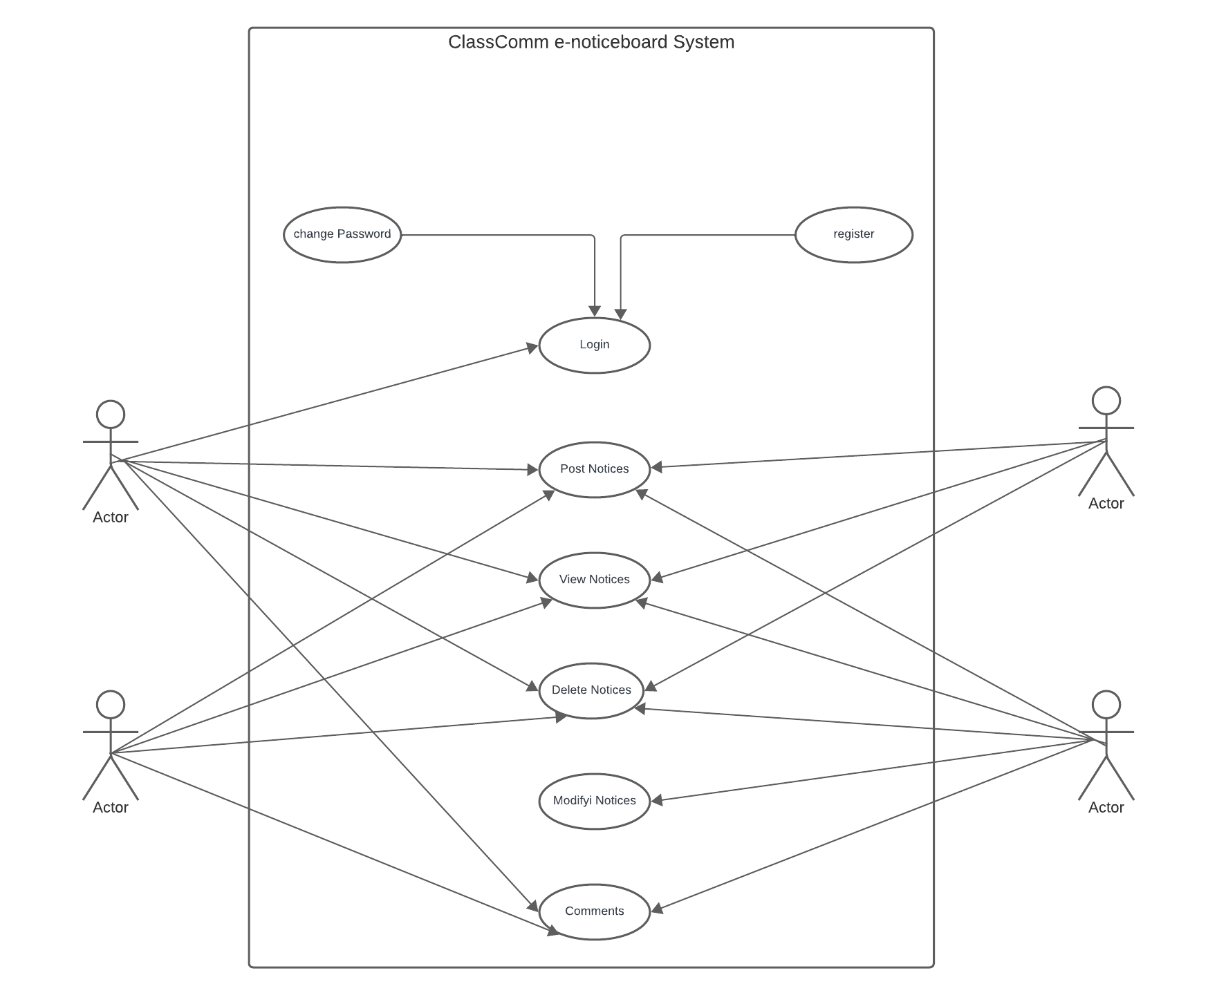 *Figure 1.3 shows use case diagram of online notice board*

### 3.5.2 Activity Diagram

Is described as a UML diagram that emphasizes behavior flow and execution rather than implementation. The term "object-oriented flowchart" is sometimes used.

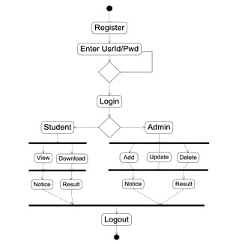

*Figure 1.6 shows activity diagram of online notice board*

### 3.5.3 Class Diagram

By displaying classes, their properties, actions, and their relationships among objects, it explains the structure of an online digital notification.

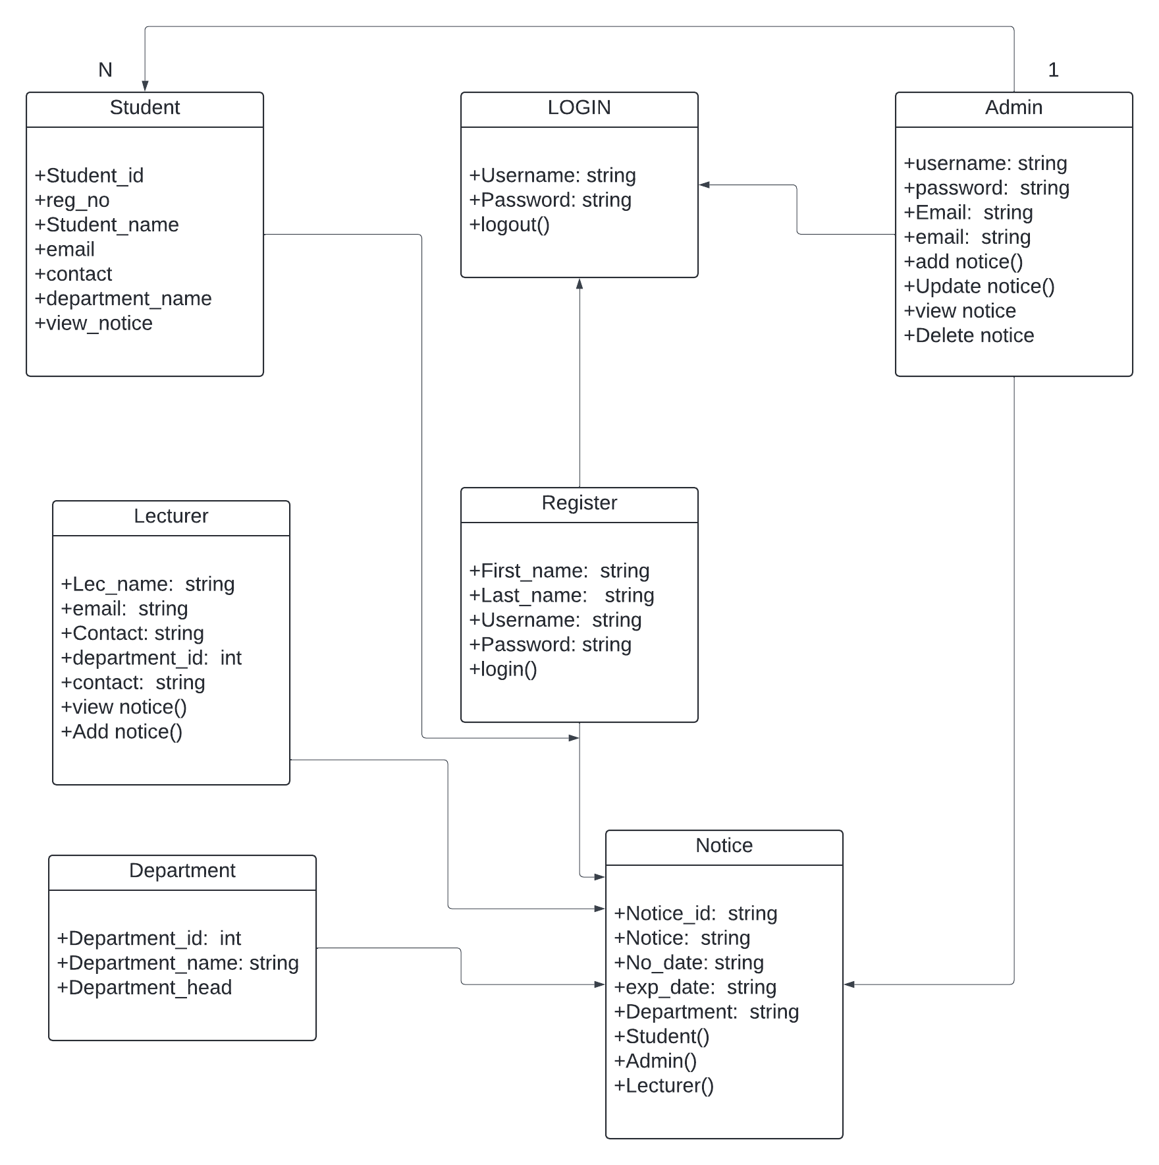

*Figure 1.4 shows class diagram of online notice board*

### 3.5.4 Sequence Diagram

It depicts interaction between objects in a sequential order i.e. the order in which these interactions take place. We can also use the terms event diagrams or event scenarios to refer to a sequence diagram. It describes how and in what order the objects in a system function.

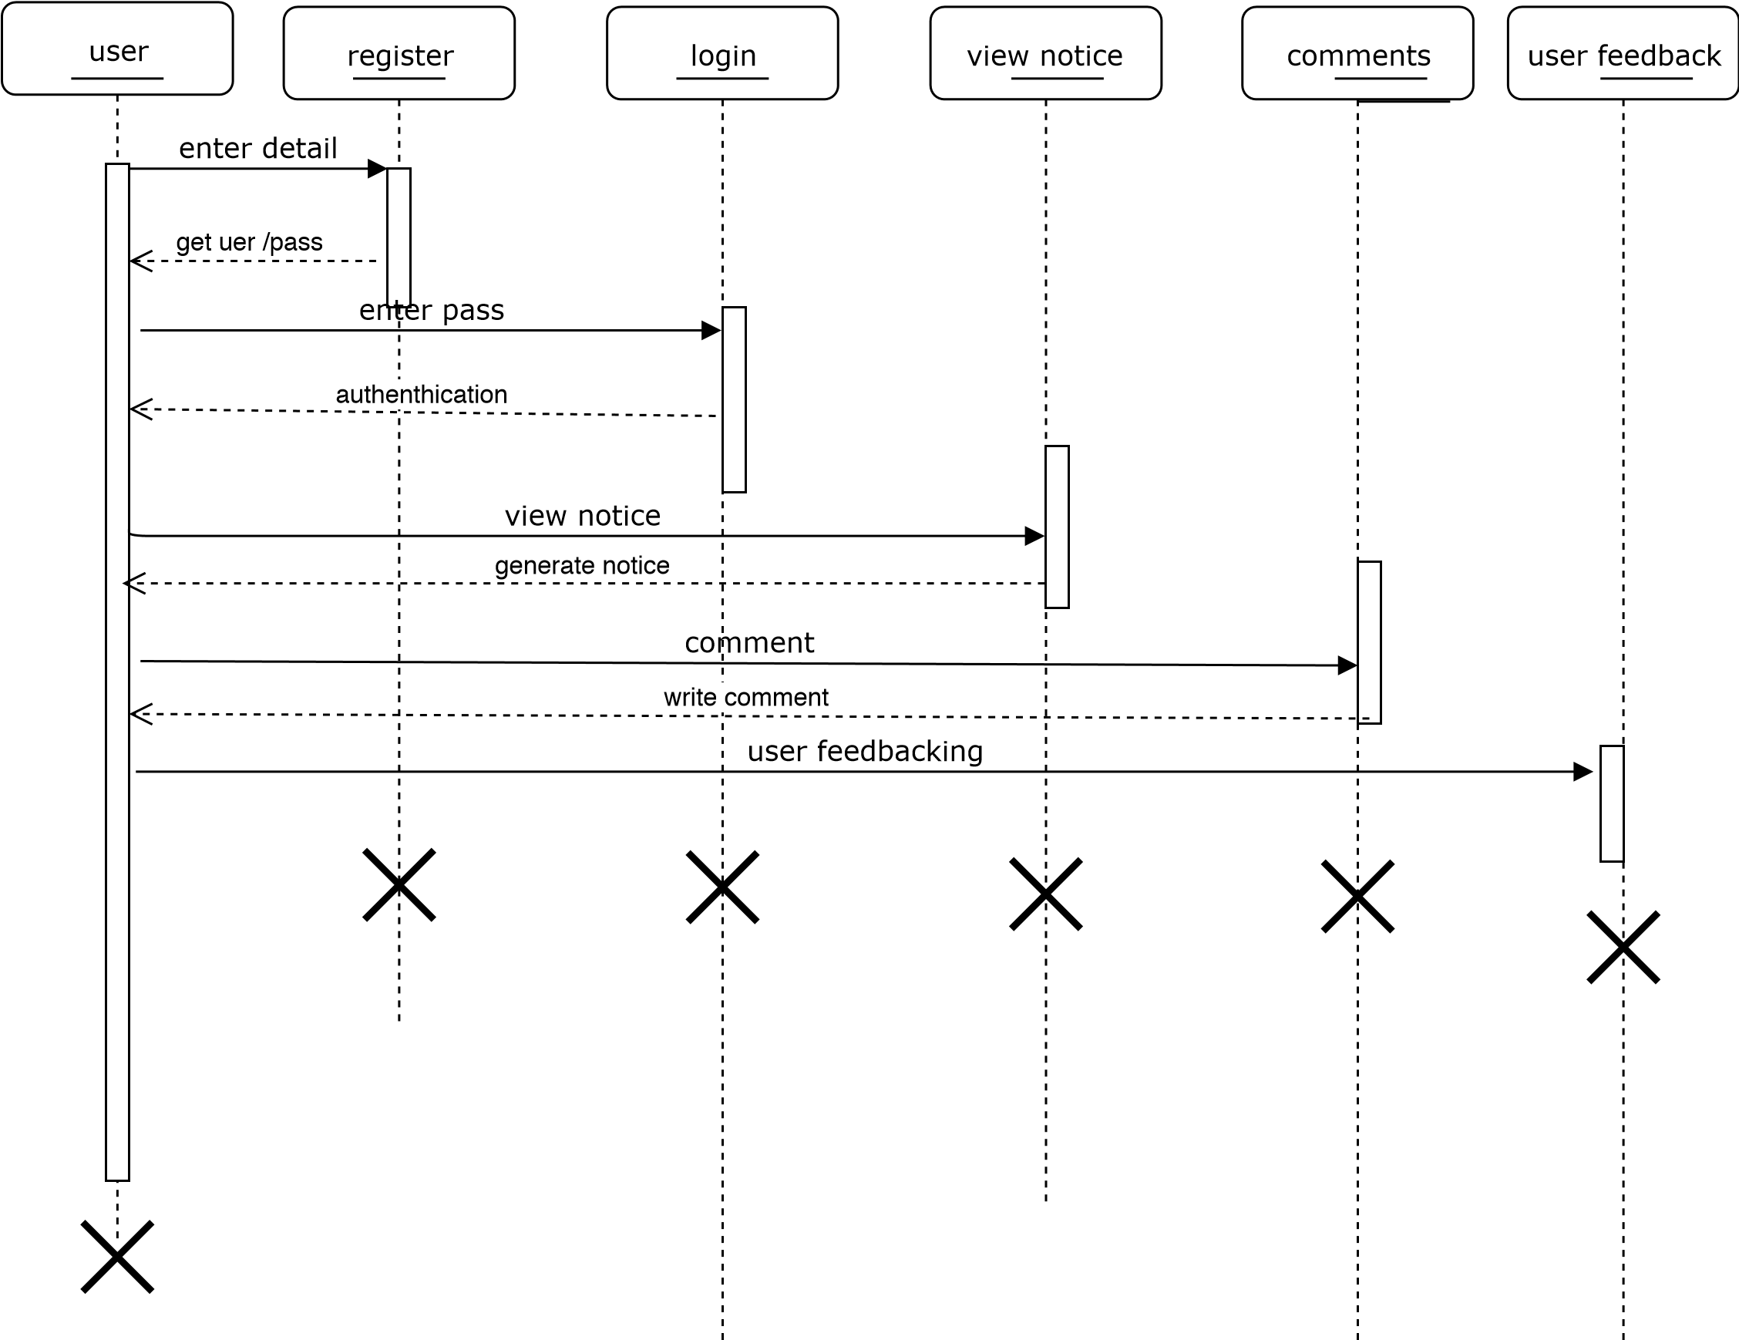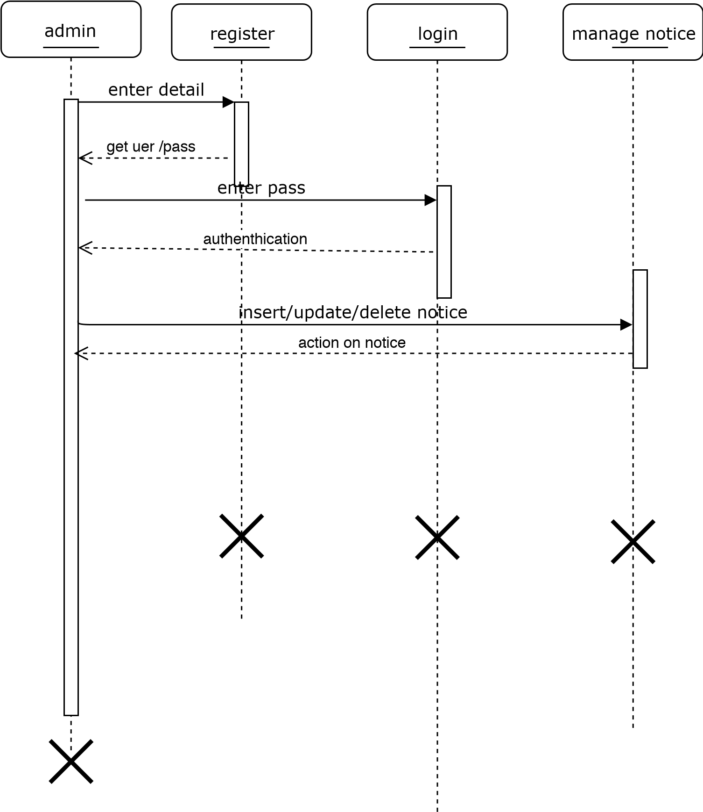

*Figure 1.5 shows sequential diagram of online notice board*

## 3.6 Database Design

### 3.6.1 Entity Relationship Diagrams

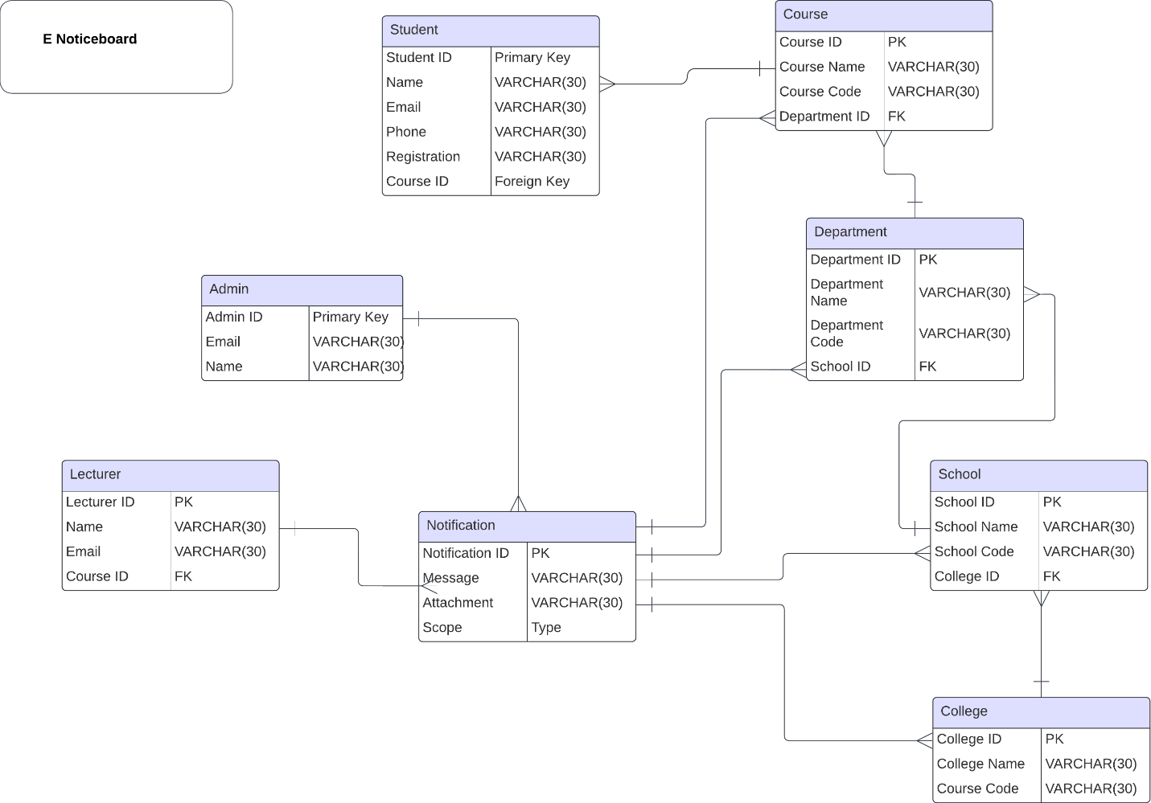

### 3.6.2 Tables

**Table 1: Student (3NF)**

|  |  |  |  |  |  |
| --- | --- | --- | --- | --- | --- |
| **Student ID** | **Name** | **Email** | **Phone** | **Registration** | **Course ID (FK)** |
| Primary Key | VARCHAR (30) | VARCHAR (30) | VARCHAR (30) | VARCHAR (30) | Foreign Key |

**Table 2: Course (3NF)**

|  |  |  |  |
| --- | --- | --- | --- |
| **Course ID (PK)** | **Course Name** | **Course Code** | **Department ID (FK)** |
| Primary Key | VARCHAR (30) | VARCHAR (30) | Foreign Key |

**Table 3: Department (3NF)**

|  |  |  |  |
| --- | --- | --- | --- |
| **Department ID (PK)** | **Department Name** | **Department Code** | **School ID (FK)** |
| Primary Key | VARCHAR (30) | VARCHAR (30) | Foreign Key |

**Table 4: School (3NF)**

|  |  |  |  |
| --- | --- | --- | --- |
| **School ID (PK)** | **School Name** | **School Code** | **College ID (FK)** |
| Primary Key | VARCHAR (30) | VARCHAR (30) | Foreign Key |

**Table 5: College (3NF)**

|  |  |  |
| --- | --- | --- |
| **College ID (PK)** | **College Name** | **Course Code** |
| Primary Key | VARCHAR (30) | VARCHAR (30) |

**Table 6: Notification (1NF)**

|  |  |  |  |
| --- | --- | --- | --- |
| **Notification ID (PK)** | **Message** | **Attachment** | **Scope** |
| Primary Key | VARCHAR (30) | VARCHAR (30) | Type |

**Table 7: Admin (1NF)**

|  |  |  |
| --- | --- | --- |
| **Admin ID (PK)** | **Email** | **Name** |
| Primary Key | VARCHAR (30) | VARCHAR (30) |

**Table 8: Lecturer (3NF)**

|  |  |  |  |
| --- | --- | --- | --- |
| **Lecturer ID (PK)** | **Name** | **Email** | **Course ID (FK)** |
| Primary Key | VARCHAR (30) | VARCHAR (30) | Foreign Key |

## 3.7 User Interface Design

The following are my user interface design mockups

*Inbox*

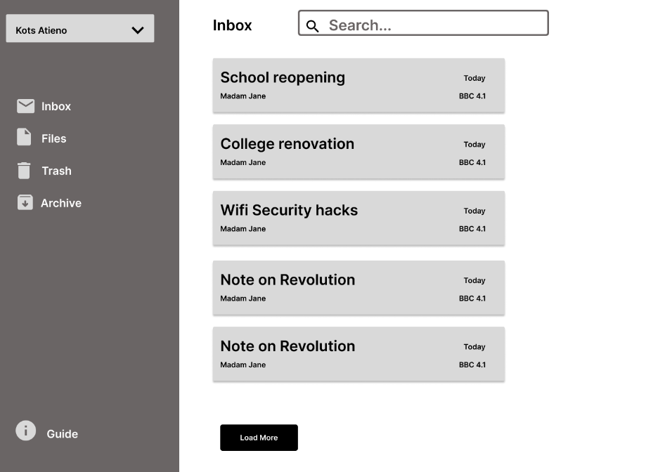

*archive*

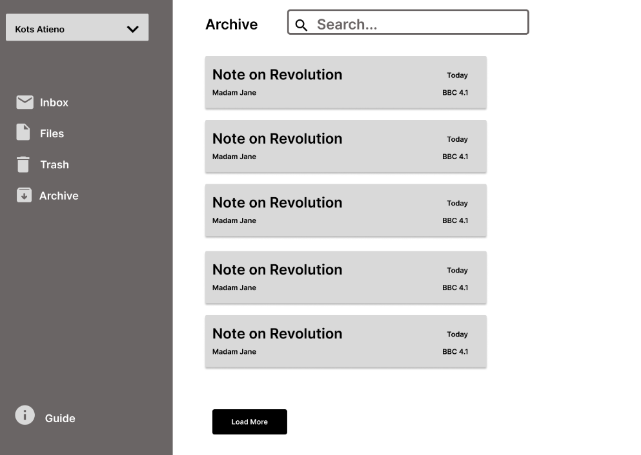

*files*

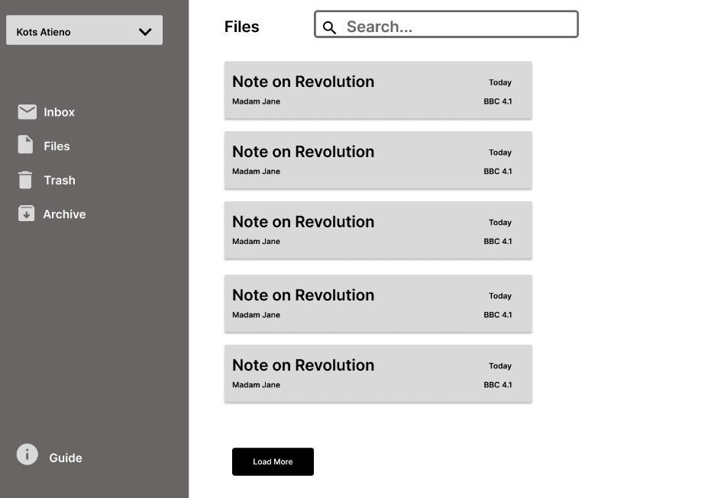

*trash*

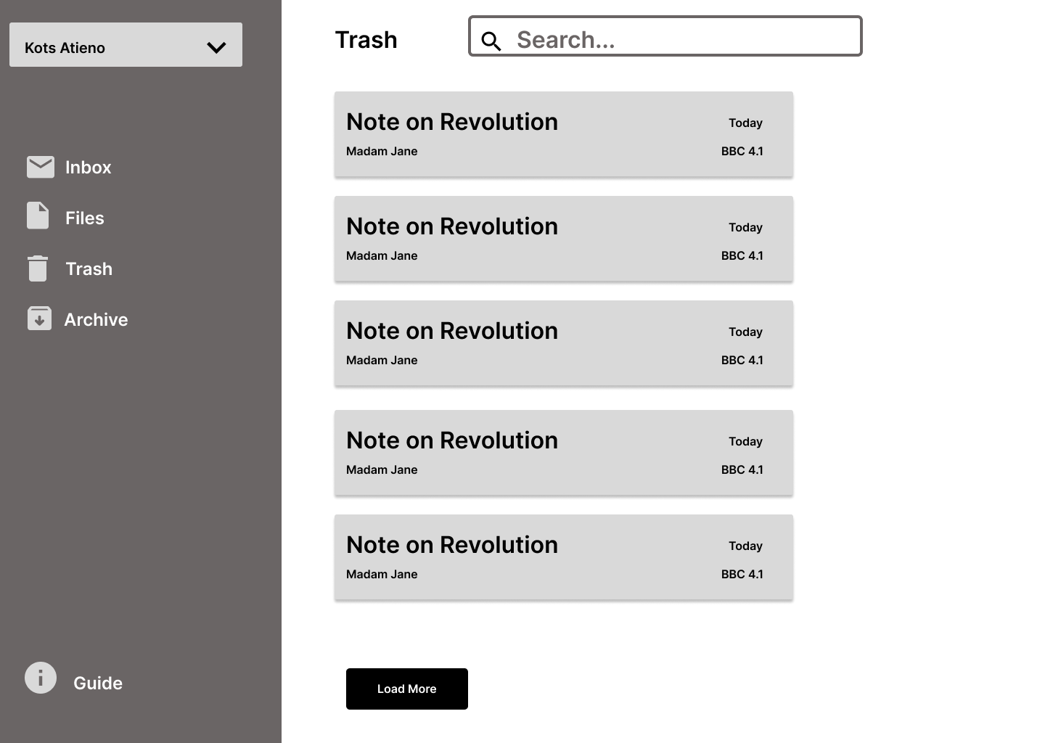

## 3.8 Platforms for Front End & Back End

The application will be divided into two parts the front end and the back end, the technologies that will be used in the front end will be HTML, SCSS, BOOTSTRAP5, REACTJS, and AXIOS. Yarn package management will be used to install the dependency packages. Will in the back end the technologies that will be used are Nodejs, Express, Mongoose, MongoDB, Axios, and Nodemone. Yarn package manager will be used to install all the dependencies.

## 3.9 System Testing

The questionnaire will be designed and distributed to target users for user testing.

### 3.9.1 Test Case

The Subsequent Will Be Examined;

The system will be tested in multiple browsers including Chrome, Firefox, and Safari with versions approved by the client. All mandatory fields will be tested to indicate with an asterisk (*), all error messages should be displayed in the same CSS style, for example using red color, and check the functionality of any buttons available on the page.

# REFRENCES

Myers, B. A., Rosson, M. B., Pausch, R., Selker, T., & Shneiderman, B. (1995). User Interface Software Tools. ACM Transactions on Computer-Human Interaction, 2(4), 221–275. https://doi.org/10.1145/212430.212435

Masibo, E. M. (2019). Evaluation of Digital Notice Board Systems: A Case of Universities in Kenya. International Journal of Information and Communication Technology Research, 9(2). http://esjournals.org/journaloftechnology/archive/vol9no2/vol9no2_2.pdf

Smith, J. (2020). "Effective Communication in Educational Institutions: A Review of Literature." Journal of Higher Education, 45(2), 123-145.

Johnson, A., & Brown, M. (2018). "Implementing E-Notice Board Systems in Universities: Case Studies and Best Practices." International Conference on Education Technology, 342-355.

Patel, R. & Srinivasan, L. (2019). "E-notice boards: Integrating Real-Time SMS Alerts for Effective University Communication." Journal of Digital Communication in Education, 24(3), 105-121.

Kim, J.H., & Lee, M.R. (2020). "Web-Based Interactive Communication Platforms in Higher Education: A Comparative Study." International Journal of E-Learning & Technology, 15(2), 33-47.

Sharma, P., & Gupta, N. (2018). "Enhancing Campus-Wide Communication: The Role of Digital Notice Boards." Journal of Higher Education Technology, 10(4), 68-80.

Williams, T., & Anderson, R. (2021). "The Evolution of E-Notice Boards: Challenges and Opportunities in Developing Nations." Journal of Digital Infrastructure, 12(1), 55-66.

Fernandez, L., & Gomes, C.R. (2019). "SMS Alerts in University Communication Platforms: An Analysis of Effectiveness and Response Time." Education and Technology Review, 18(2), 40-54.

Li, X., & Zhang, Y. (2020). "Real-time Digital Communication in Universities: Trends, Barriers, and Opportunities." Journal of Educational Informatics, 6(3), 22-37.

Chen, M., & Wu, L. (2021). "Interactive Features in E-Notice Boards: Improving Student Engagement and Communication in Universities." Journal of Interactive Learning Technologies, 17(4), 100-115.

Kumar, V., & Reddy, S. (2018). "Web Access and Digital Platforms in Higher Education Institutions: A Case Study." Asian Journal of Educational Technology, 4(2), 45-58.

Cockburn, A. (2006). Agile Software Development: The Cooperative Game. Addison-Wesley Professional. ISBN: 0321482751, 9780321482754

McWherter, J., & Gowell, S. (2012). Professional Mobile Application Development. John Wiley & Sons. ISBN: 1118240685, 9781118240687

Dionysiou, D., & Gregoriades, A. (2020). Information Systems for the University: A Pragmatic Approach. Springer Nature. ISBN: 303042032X, 9783030420326

## CITATIONS

Myers, B. A., Rosson, M. B., Pausch, R., Selker, T., & Shneiderman, B. (1995). User interface software tools. ACM Transactions on Computer-Human Interaction, 2(4), 221–275. https://doi.org/10.1145/212430.212435

Masibo, E. M. (2019). Evaluation of digital notice board systems: A case of universities in Kenya. International Journal of Information and Communication Technology Research, 9(2). Retrieved from http://esjournals.org/journaloftechnology/archive/vol9no2/vol9no2_2.pdf

According to Smith (2020), effective communication within educational institutions is crucial for fostering a sense of community.

The implementation of E-Notice Board systems has been studied extensively (Johnson & Brown, 2018).

Patel, R., & Srinivasan, L. (2019). E-notice boards: Integrating Real-Time SMS Alerts for Effective University Communication. Journal of Digital Communication in Education, 24(3), 105-121.

Kim, J.H., & Lee, M.R. (2020). Web-Based Interactive Communication Platforms in Higher Education: A Comparative Study. International Journal of E-Learning & Technology, 15(2), 33-47.

Sharma, P., & Gupta, N. (2018). Enhancing Campus-Wide Communication: The Role of Digital Notice Boards. Journal of Higher Education Technology, 10(4), 68-80.

Williams, T., & Anderson, R. (2021). The Evolution of E-Notice Boards: Challenges and Opportunities in Developing Nations. Journal of Digital Infrastructure, 12(1), 55-66.

Fernandez, L., & Gomes, C.R. (2019). SMS Alerts in University Communication Platforms: An Analysis of Effectiveness and Response Time. Education and Technology Review, 18(2), 40-54.

Li, X., & Zhang, Y. (2020). Real-time Digital Communication in Universities: Trends, Barriers, and Opportunities. Journal of Educational Informatics, 6(3), 22-37.

Chen, M., & Wu, L. (2021). Interactive Features in E-Notice Boards: Improving Student Engagement and Communication in Universities. Journal of Interactive Learning Technologies, 17(4), 100-115.

Kumar, V., & Reddy, S. (2018). Web Access and Digital Platforms in Higher Education Institutions: A Case Study. Asian Journal of Educational Technology, 4(2), 45-58.

Cockburn, A. (2006). Agile software development: The cooperative game (2nd ed.). Addison-Wesley Professional. ISBN: 0321482751, 9780321482754

McWherter, J., & Gowell, S. (2012). Professional mobile application development. John Wiley & Sons. ISBN: 1118240685, 9781118240687

Dionysiou, D., & Gregoriades, A. (2020). Information systems for the university: A pragmatic approach. Springer Nature. ISBN: 303042032X, 9783030420326