Supplementary appendix
  - Post-transplant cyclophosphamide as graft-versus-host disease prophylaxis after allogeneic haematopoietic stem-cell transplantation: a systematic review and Bayesian meta-analysis of infection risk
Marta Stanzani
Dimitrios P Kontoyiannis
Russell E Lewis
This appendix forms part of the article and has not been edited by the journal. It is referenced in the main text as “the appendix”.
All results reported in this appendix are from the cohort-deduplicated (Set B) analysis, in which one publication per cohort contributes to each outcome.

S1. Search strategy
Table 1: Search parameters.
Field | Content
Databases searched | PubMed/MEDLINE, EMBASE (Elsevier), SCOPUS
Search dates | Database inception to [FINAL SEARCH DATE — to be taken from the Covidence/RIS export log]
Records retrieved | PubMed 1061; EMBASE 2603; SCOPUS 481 (total 4145)
Date limits applied | [to be confirmed — sources conflict]
Language limit | English
Publication types excluded via filter | None. Conference abstracts, editorials, letters, and case reports were excluded at screening rather than by search filter, to minimise inappropriate exclusion
Other sources searched | Reference list screening of included studies and prior systematic reviews; forward citation tracking (Web of Science) for key index publications; PROSPERO search for related and ongoing reviews
Deduplication and management | RIS export from each database, imported into Covidence for deduplication and screening
Search piloted against | Eight known included publications (Holtan 2022, Moiseev 2016, Tang 2023, Papanicolaou 2023, Salas 2023, Massoud 2021, Meyer 2024, Shaffer 2024) to verify recall

The protocol specifies three concept blocks combined with AND, each block an OR of controlled vocabulary terms and free-text synonyms.

PubMed/MEDLINE
#1 Allogeneic HCT population
("Hematopoietic Stem Cell Transplantation"[Mesh] OR "Bone Marrow Transplantation"[Mesh]
OR "allogeneic stem cell transplant*"[tiab] OR "allo-HCT"[tiab] OR "allo-HSCT"[tiab]
OR "haploidentical"[tiab] OR "HLA-matched"[tiab] OR "matched unrelated donor"[tiab]
OR "mismatched unrelated donor"[tiab])
#2 PTCy intervention
("post-transplant cyclophosphamide"[tiab] OR "post-transplantation cyclophosphamide"[tiab]
OR "posttransplant cyclophosphamide"[tiab] OR "posttransplantation cyclophosphamide"[tiab]
OR "PTCy"[tiab] OR "PT-Cy"[tiab] OR "PTCY"[tiab]
OR ("Cyclophosphamide"[Mesh] AND "Graft vs Host Disease"[Mesh]))
#3 Infection outcomes
("Infections"[Mesh] OR "Bacterial Infections"[Mesh] OR "Virus Diseases"[Mesh]
OR "Mycoses"[Mesh] OR "Bacteremia"[Mesh] OR "Sepsis"[Mesh]
OR "Cytomegalovirus Infections"[Mesh] OR "Invasive Fungal Infections"[Mesh]
OR "bacterial infection*"[tiab] OR "viral infection*"[tiab] OR "fungal infection*"[tiab]
OR "BSI"[tiab] OR "sepsis"[tiab] OR "CMV"[tiab] OR "EBV"[tiab] OR "HHV-6"[tiab]
OR "BK virus"[tiab] OR "aspergillosis"[tiab] OR "candida"[tiab] OR "mucormycosis"[tiab]
OR "mold"[tiab] OR "yeast"[tiab] OR "mortality"[tiab])
#4 #1 AND #2 AND #3
Filters: Humans; English

EMBASE (Emtree)
#1 Allogeneic HCT population
('bone marrow transplantation'/exp OR 'stem cell transplantation'/exp
OR 'allogeneic stem cell transplant*':ti,ab OR 'allo-hct':ti,ab OR 'allo-hsct':ti,ab
OR haploidentical:ti,ab OR 'hla-matched':ti,ab OR 'matched unrelated donor':ti,ab
OR 'mismatched unrelated donor':ti,ab)
#2 PTCy intervention
('post-transplant cyclophosphamide':ti,ab OR 'post-transplantation cyclophosphamide':ti,ab
OR 'posttransplant cyclophosphamide':ti,ab OR 'posttransplantation cyclophosphamide':ti,ab
OR ptcy:ti,ab OR 'pt-cy':ti,ab
OR ('cyclophosphamide'/exp AND 'graft versus host reaction'/exp))
#3 Infection outcomes
('infection'/exp OR 'bacterial infection'/exp OR 'virus infection'/exp OR 'mycosis'/exp
OR 'bacteremia'/exp OR 'sepsis'/exp OR 'cytomegalovirus infection'/exp
OR 'invasive fungal infection'/exp
OR 'bacterial infection*':ti,ab OR 'viral infection*':ti,ab OR 'fungal infection*':ti,ab
OR bsi:ti,ab OR sepsis:ti,ab OR cmv:ti,ab OR ebv:ti,ab OR 'hhv-6':ti,ab
OR 'bk virus':ti,ab OR aspergillosis:ti,ab OR candida:ti,ab OR mucormycosis:ti,ab
OR mold:ti,ab OR yeast:ti,ab OR mortality:ti,ab)
#4 #1 AND #2 AND #3 AND [humans]/lim AND [english]/lim

SCOPUS
TITLE-ABS-KEY(
("allogeneic stem cell transplant*" OR "allo-HCT" OR "allo-HSCT"
OR "hematopoietic stem cell transplantation" OR "bone marrow transplantation"
OR haploidentical OR "HLA-matched" OR "matched unrelated donor"
OR "mismatched unrelated donor")
AND
("post-transplant cyclophosphamide" OR "post-transplantation cyclophosphamide"
OR "posttransplant cyclophosphamide" OR "posttransplantation cyclophosphamide"
OR PTCy OR "PT-Cy" OR (cyclophosphamide AND "graft versus host disease"))
AND
(infection* OR "bacterial infection*" OR "viral infection*" OR "fungal infection*"
OR BSI OR sepsis OR bacteremia OR CMV OR "cytomegalovirus infection*" OR EBV
OR "HHV-6" OR "BK virus" OR aspergillosis OR candida OR mucormycosis OR mold
OR yeast OR "invasive fungal infection*" OR mortality)
) AND LANGUAGE(english)

S2. Studies excluded at full-text screening (n=214)
Table 2: Reasons for exclusion at full-text screening.
Exclusion reason | n
Conference abstract | 116
Single-arm or no PTCy contrast | 41
Review, not primary study | 21
Duplicate publication | 13
Systematic review or meta-analysis | 11
Non-eligible population | 5
Protocol or survey only | 4
Other | 3
Total | 214

S3. Characteristics of included studies
Full study-level (table S4a, 251 rows) and arm-level (table S4b, 525 rows) characteristics are provided as supplementary data files (Table_S4a_study_characteristics.csv, Table_S4b_arm_characteristics.csv), and are reproduced from the extraction database in the accompanying notebook Study and arm characteristics.

S5. Risk of bias
Table 3: ROBINS-I domain-level risk of bias, counts by judgement (n = 211 comparative observational studies; single-arm descriptive studies excluded).
Domain | Low | Moderate | Serious
D1 Confounding | 0 | 83 | 128
D2 Selection of participants | 26 | 140 | 45
D3 Classification of interventions | 51 | 155 | 5
D4 Deviations from intended interventions | 193 | 18 | 0
D5 Missing data | 70 | 140 | 1
D6 Measurement of outcomes | 101 | 101 | 2
D7 Selection of the reported result | 161 | 42 | 1

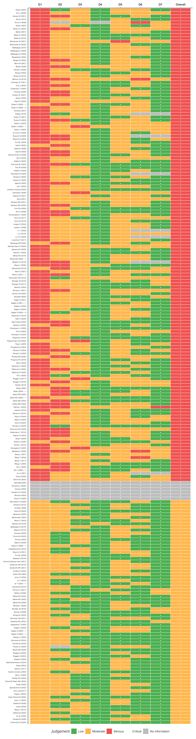
Figure 1: ROBINS-I traffic-light plot for all comparative observational studies.

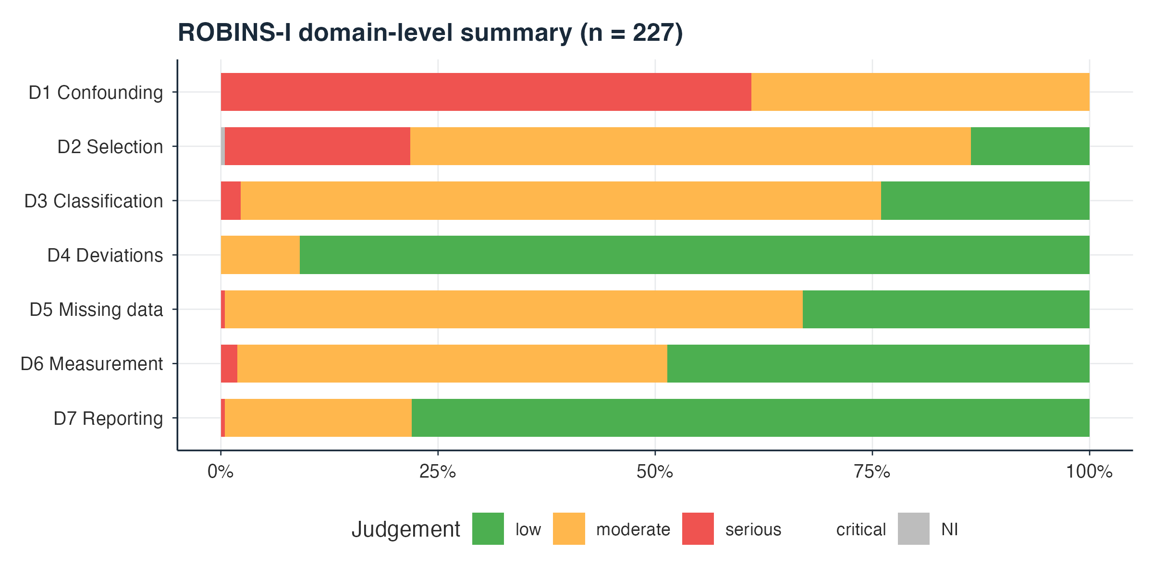
Figure 2: ROBINS-I domain-level summary.

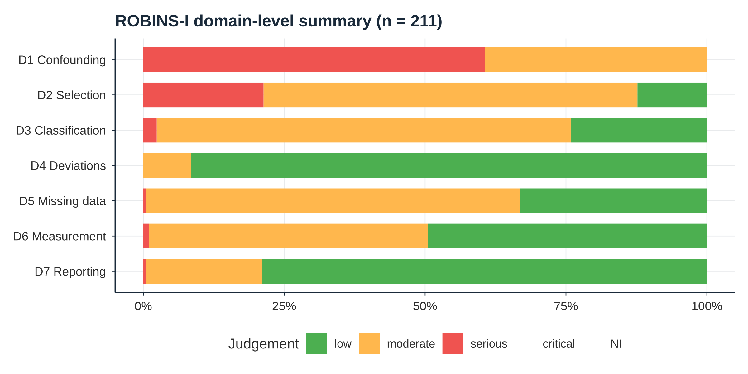
Figure 3: RoB 2 summary for the 14 randomised controlled trials.
Full justification narratives are available in rob.csv, submitted as a supplementary data file.

S6. Model specification and priors
Primary model (M1), for study $s$, arm $i$:
$${\text{events}}_{i}∣n_{i}∼\text{Binomial}​\left(n_{i}, {\text{logit}}^{−1}​\left(α+β_{\text{PTCy}}x_{i}+β_{\text{tp}}t_{i}+u_{s[i]}\right)\right), u_{s}∼N(0,τ^{2})$$
where $x_{i}$ indicates a PTCy arm and $t_{i}$ indicates a late (≥1 year) rather than early (day +100 or +180) timepoint.
Table 4: Prior specification for the primary model.
Parameter | Prior
Fixed effects (β) | N(0, 2·5)
Intercept (α) | N(0, 1·5)
Between-study SD (τ) | Student t(3, 0, 1), half

The steroid-mediation model (M2) adds arm-level systemic steroid exposure percentage, mean-centred, as an additional fixed effect.
MCMC: four chains × 4000 iterations (1000 warmup), adapt_delta = 0·95, giving 12 000 post-warmup draws per model.

S7. MCMC diagnostics
All Bayesian models were fitted with brms v2.23.0 and the rstan backend. R̂ (threshold < 1·01), bulk and tail effective sample size (ESS; threshold > 400), and the number of divergent transitions are reported for every fitted model. Values are the worst case (maximum R̂, minimum ESS) across all model parameters.
Table 5: MCMC convergence diagnostics, comparison 1 models.
Model | Max R̂ | Min bulk ESS | Min tail ESS | Divergences
OS M1 | 1·0037 | 1729 | 2962 | 0
OS M2 | 1·0022 | 2645 | 4217 | 0
NRM M1 | 1·0017 | 4176 | 5261 | 0
NRM M2 | 1·0017 | 3061 | 4066 | 0
aGVHD M1 | 1·0012 | 2178 | 3317 | 0
CMV M1 | 1·0011 | 2814 | 4158 | 0
CMV M2 | 1·0008 | 3323 | 4990 | 0
BSI M1 | 1·0011 | 3643 | 5034 | 0
IFI M1 | 1·0021 | 2795 | 4074 | 0
RRM M1 | 1·0011 | 3161 | 3767 | 0
BK M1 | 1·0013 | 3099 | 4143 | 0
IRM M1 | 1·0010 | 2965 | 4257 | 0

Table 6: MCMC convergence diagnostics, comparison 2 models.
Model | Max R̂ | Min bulk ESS | Min tail ESS | Divergences
OS M1 | 1·0030 | 3185 | 4841 | 0
OS M2 | 1·0011 | 3714 | 5136 | 0
NRM M1 | 1·0035 | 2876 | 2293 | 0
aGVHD M1 | 1·0010 | 3191 | 4855 | 0
CMV M1 | 1·0020 | 3436 | 5356 | 0
CMV M2 | 1·0007 | 3321 | 5570 | 0
RRM M1 | 1·0002 | 3225 | 4933 | 0
BK M1 | 1·0592 | 67 | 17 | 0

All models except C2 BK achieved R̂ < 1·01 with zero divergent transitions and bulk ESS above 1000. The C2 BK model (k = 3) did not converge to that standard (R̂ = 1·0592, bulk ESS 67, tail ESS 17) and its posterior should be read as indicative only.
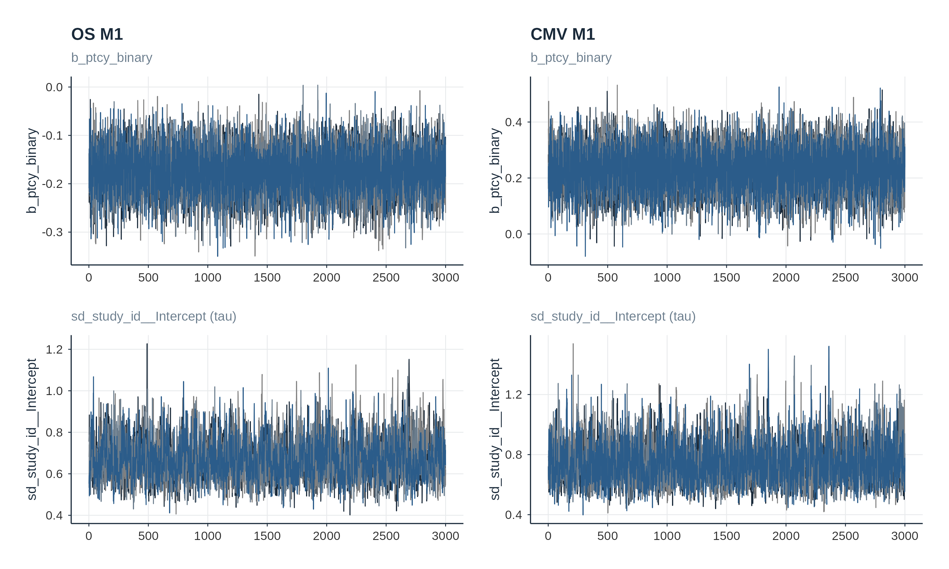
Figure 4: Trace plots for b_ptcy_binary (top) and sd_study_id__Intercept (τ, bottom) in OS M1 (left) and CMV M1 (right). All four chains mix well across the full post-warmup phase.

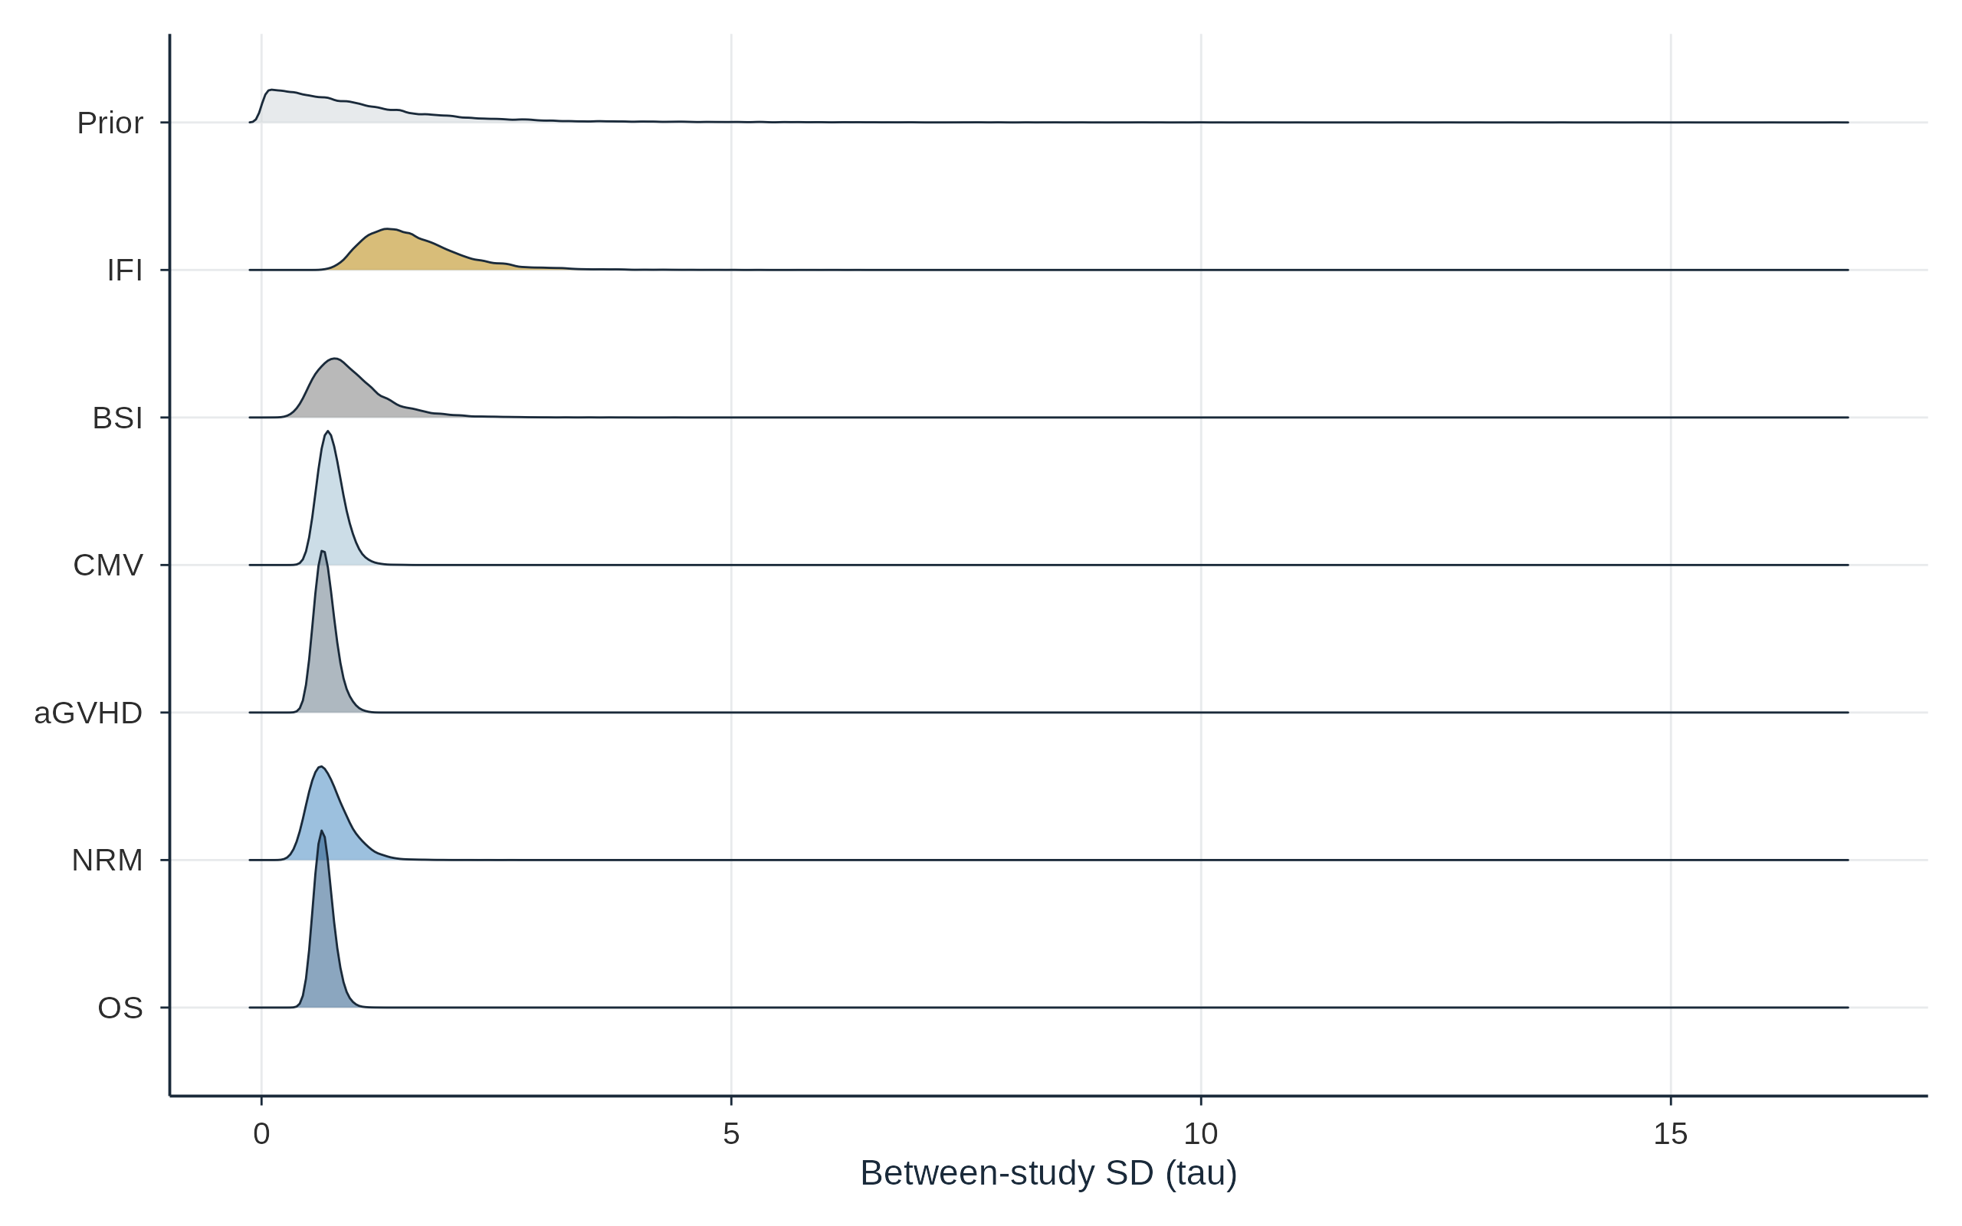
Figure 5: Posterior densities of τ (between-study SD) for comparison 1 M1 models. The half-Student t(3, 0, 1) prior common to all models is shown in grey. IFI shows the widest τ posterior, consistent with the structural heterogeneity identified in the leave-one-out analysis (S9).

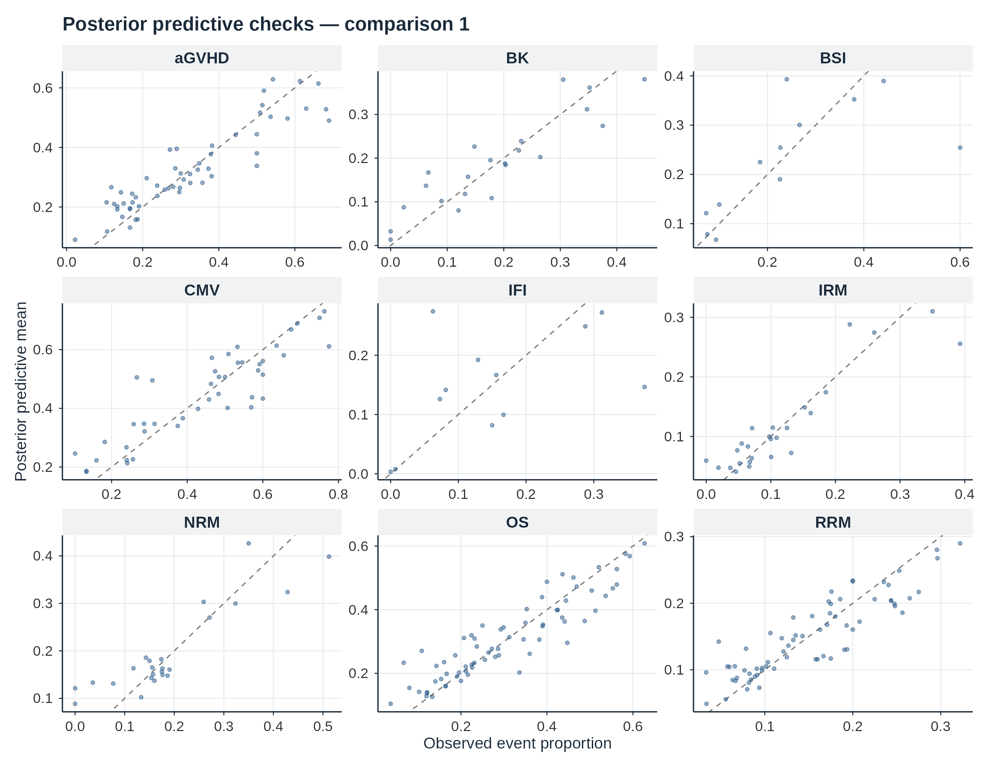
Figure 6: Posterior predictive checks, comparison 1. Each point is one study arm: the observed event proportion against its posterior predictive mean, over 500 posterior draws. The dashed line is the identity.

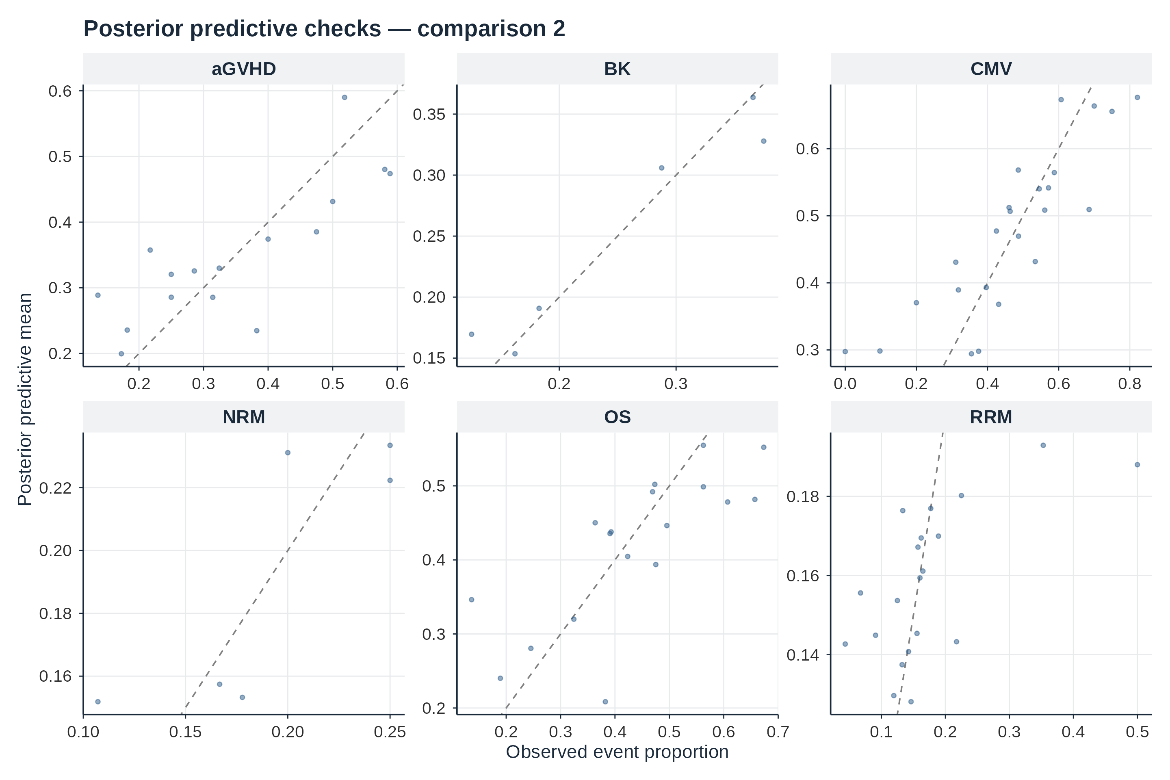
Figure 7: Posterior predictive checks, comparison 2. Layout and interpretation as in figure 6.
All models show adequate calibration, with points clustered near the identity line and symmetric scatter. The C1 IFI model (k = 6) shows the widest scatter, consistent with its large τ posterior (figure 5) and the heterogeneity identified in S9. No systematic over- or under-prediction is evident in any model.

S8. Forest plots
Individual study odds ratios with 95% CIs and the pooled frequentist random-effects estimate (metafor, REML), shown alongside the Bayesian estimates reported in the main text as concordance checks. All plots are from the cohort-deduplicated datasets.
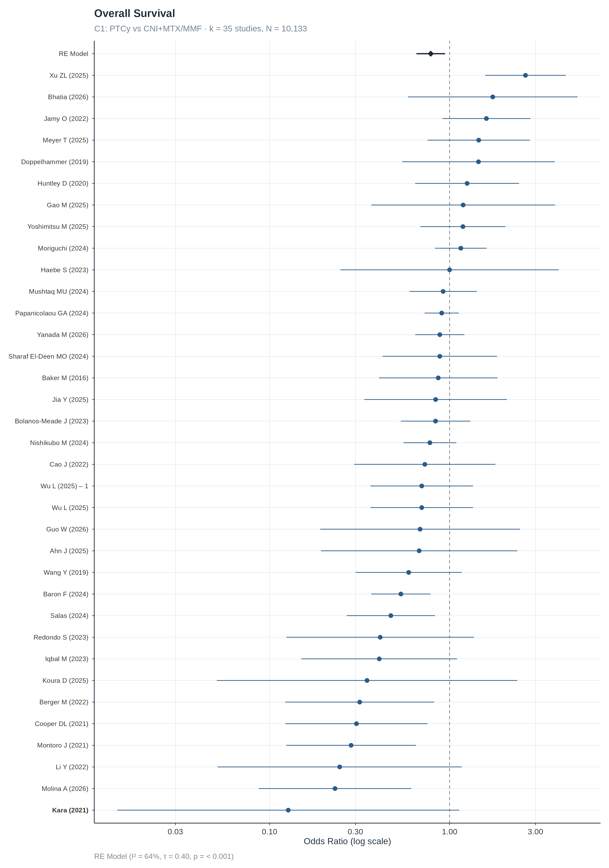
Figure 8: Overall survival, frequentist REML concordance check for figure 2 of the main text.

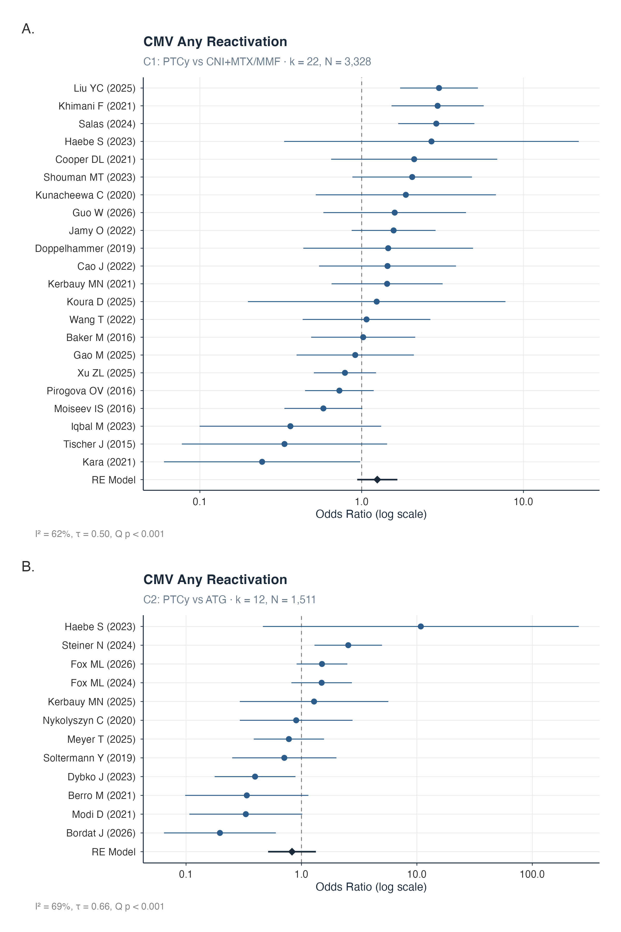
Figure 9: CMV any-reactivation, frequentist REML concordance check for figure 3 of the main text.

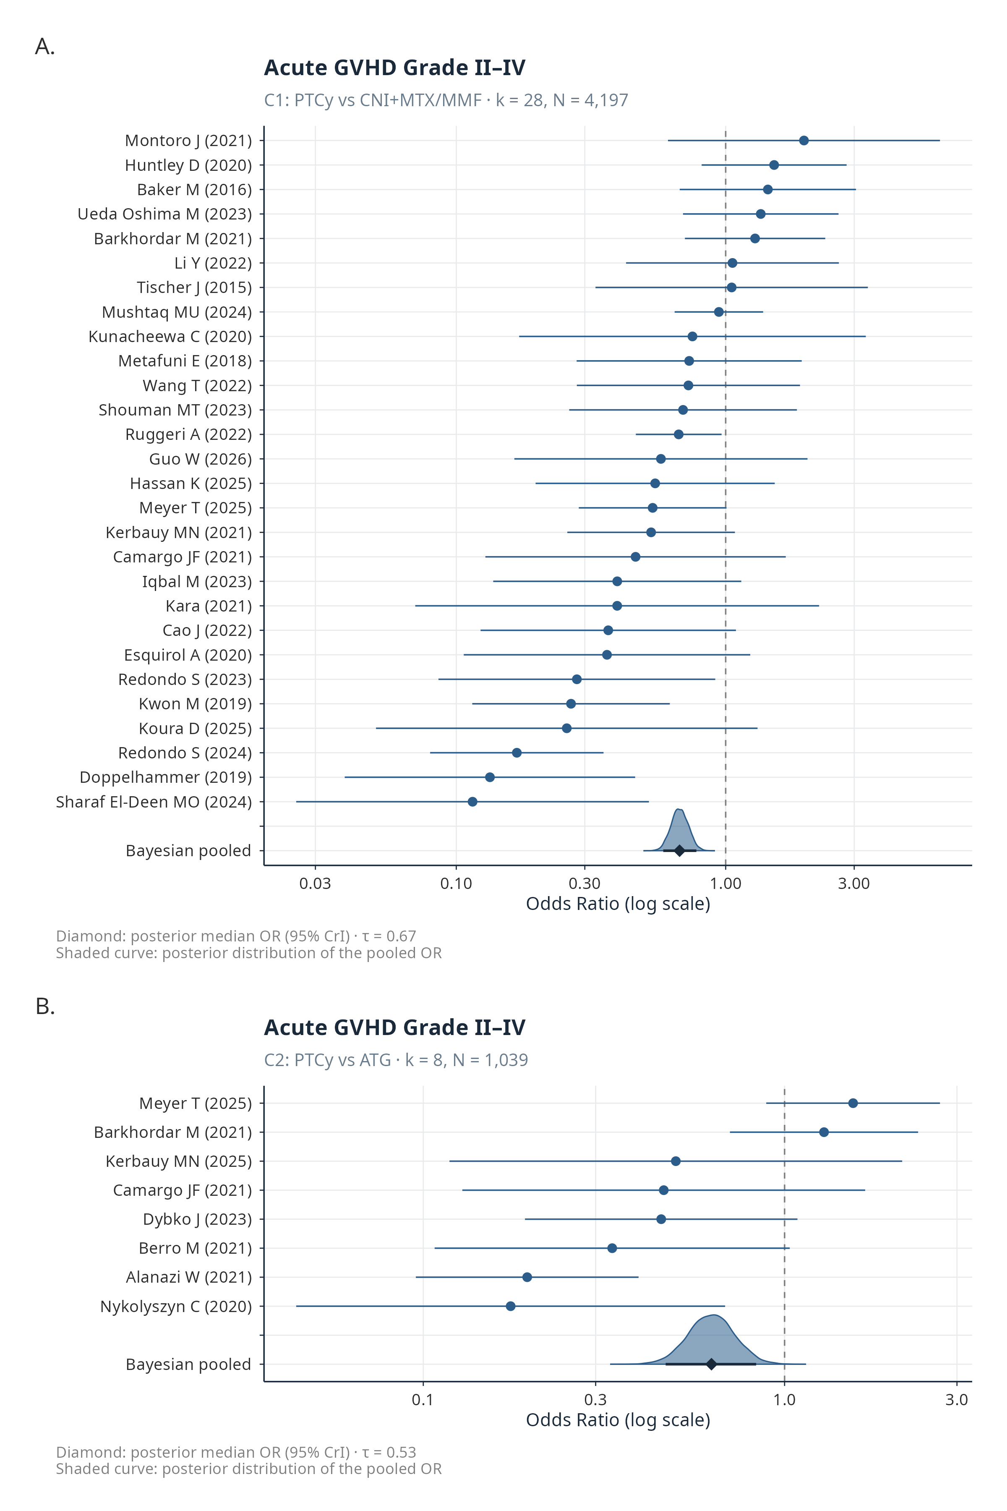
Figure 10: Acute GVHD grade II–IV.

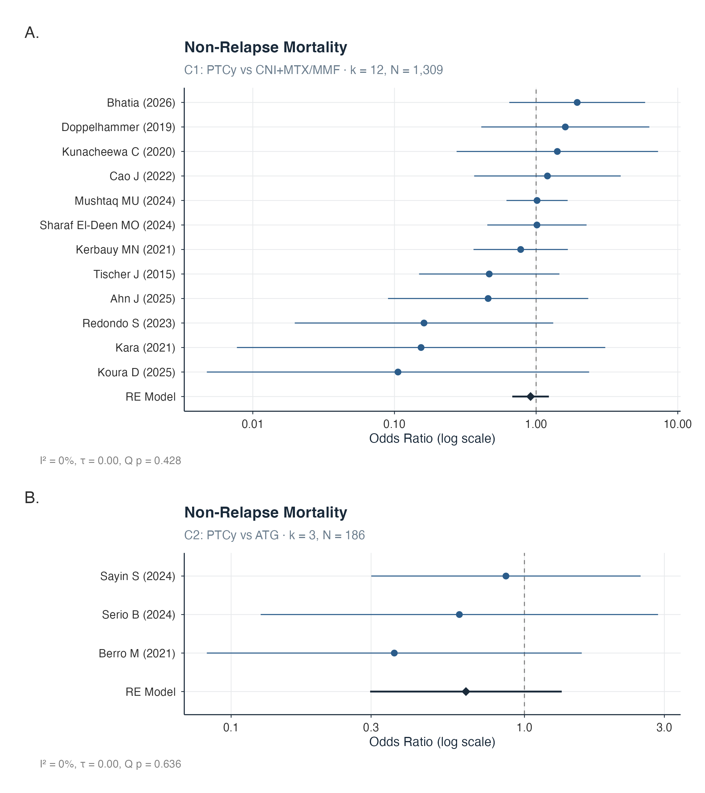
Figure 11: Non-relapse mortality.

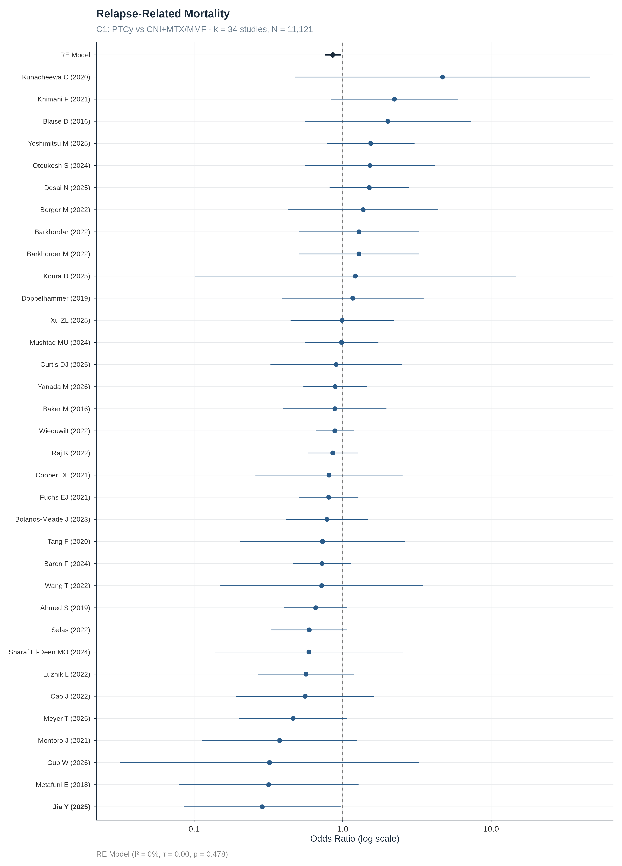
Figure 12: Relapse-related mortality.

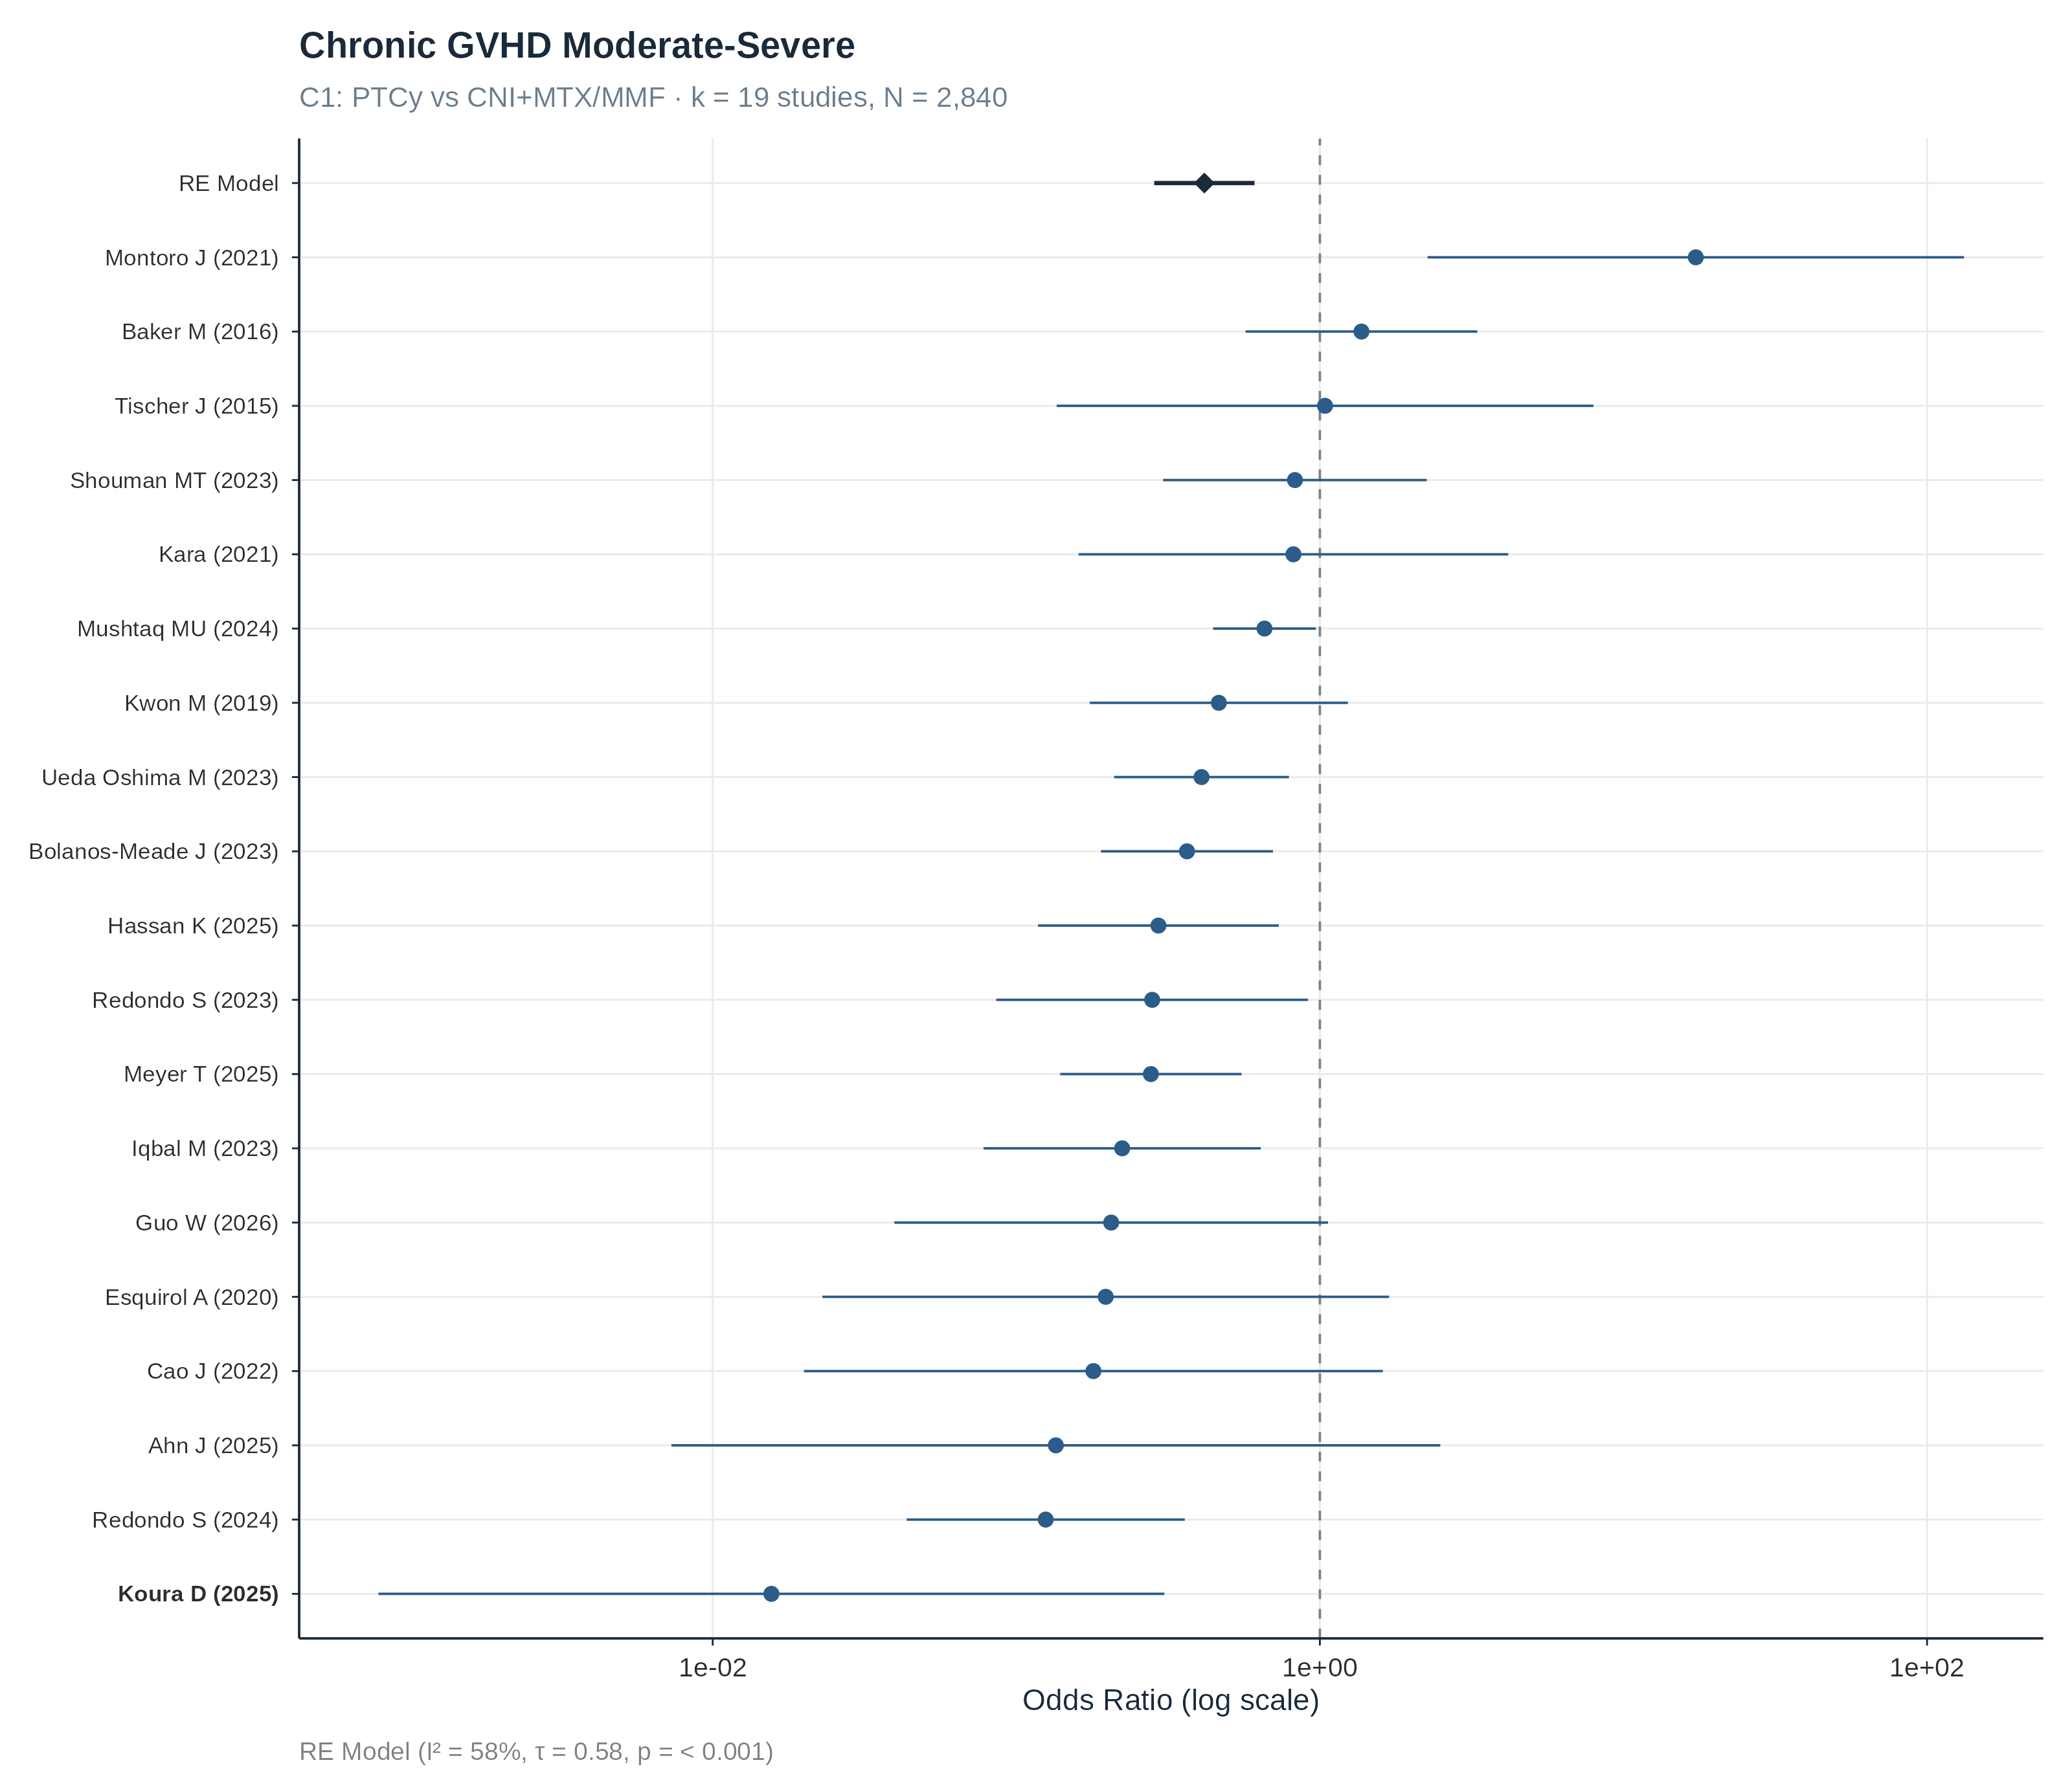
Figure 13: Chronic GVHD, moderate to severe.

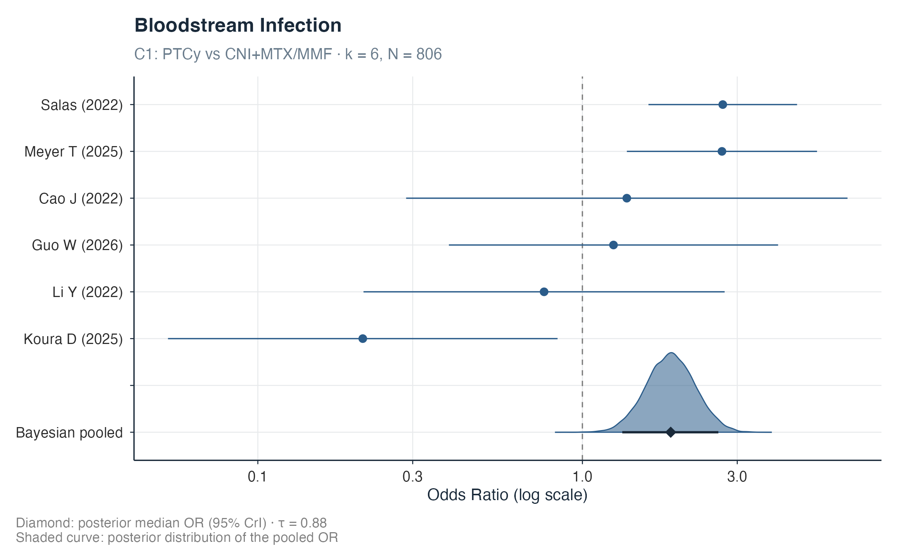
Figure 14: Bloodstream infection, any pathogen.

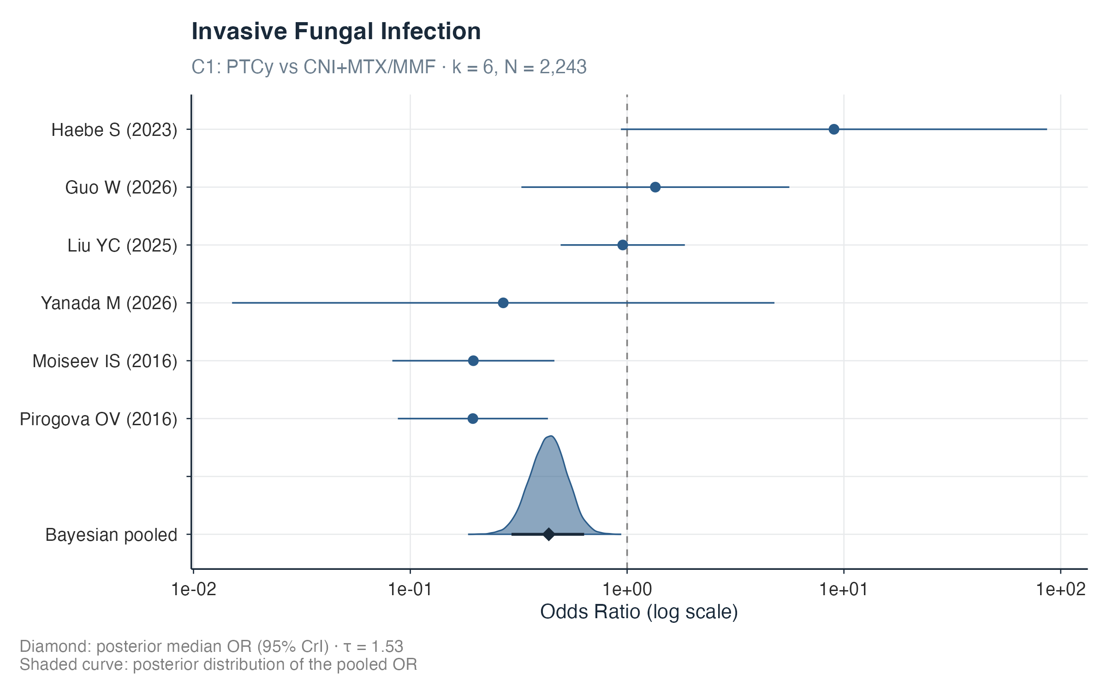
Figure 15: Invasive fungal infection, any.

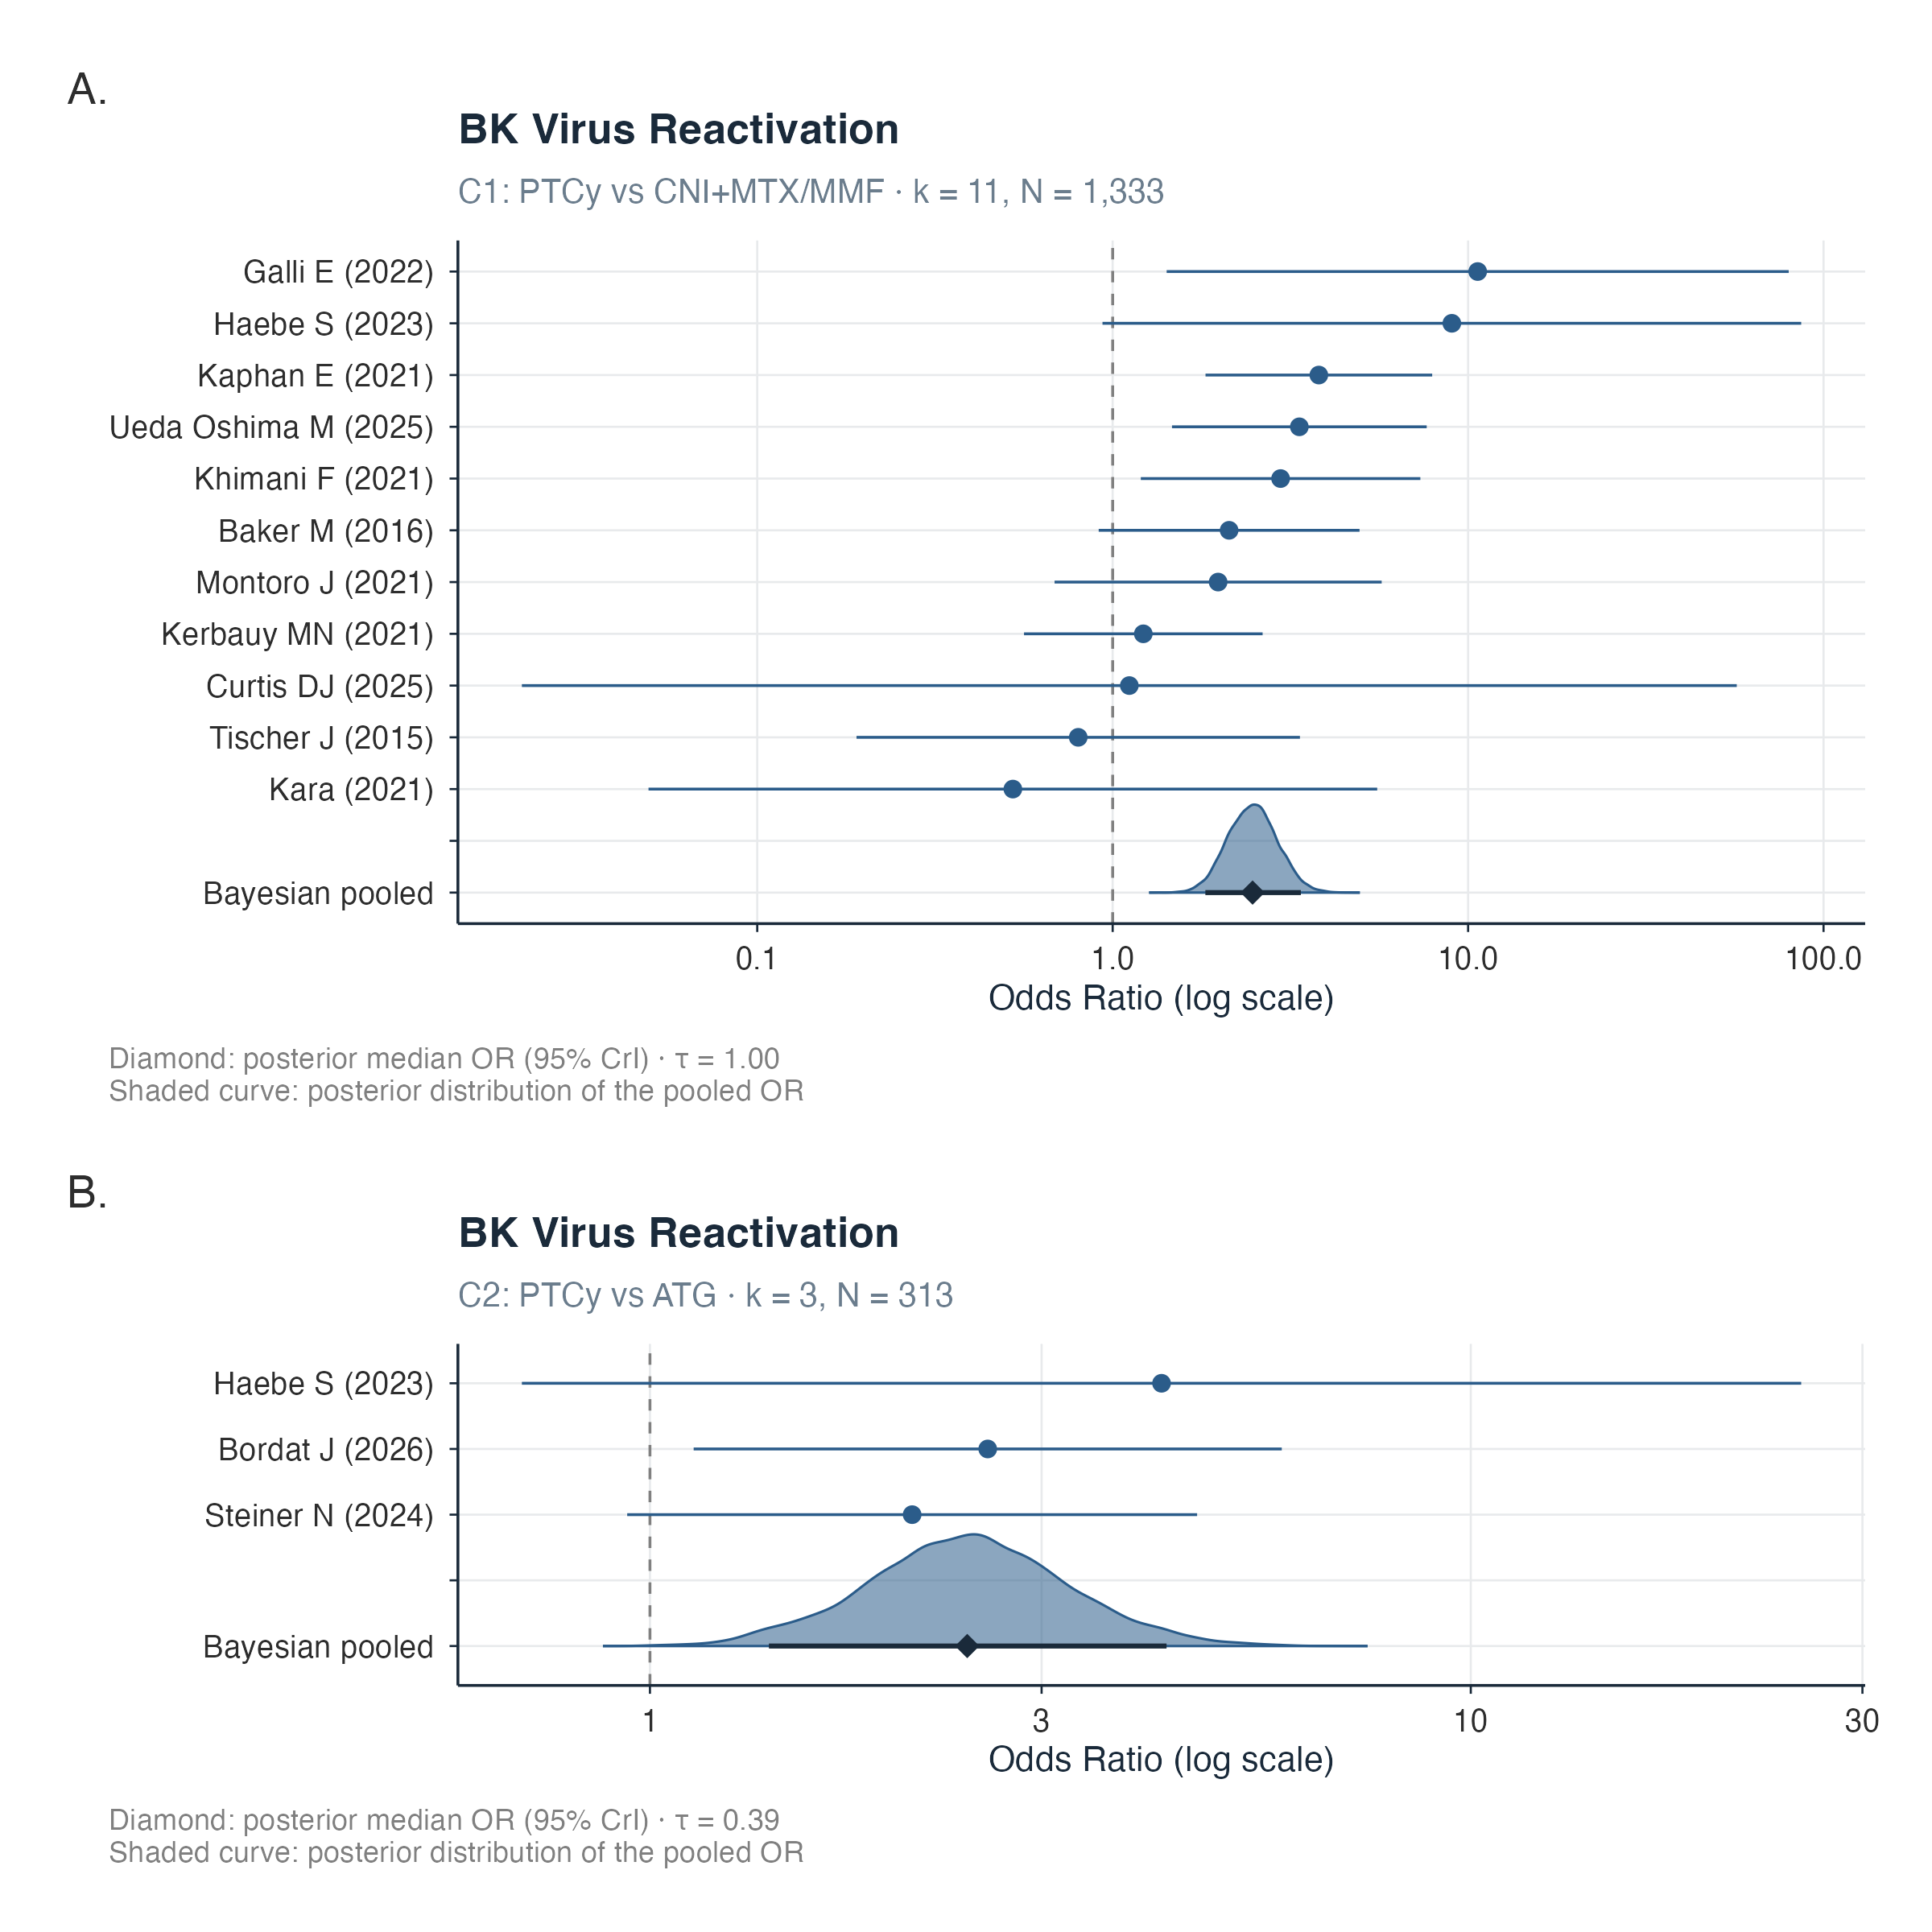
Figure 16: BK virus reactivation.

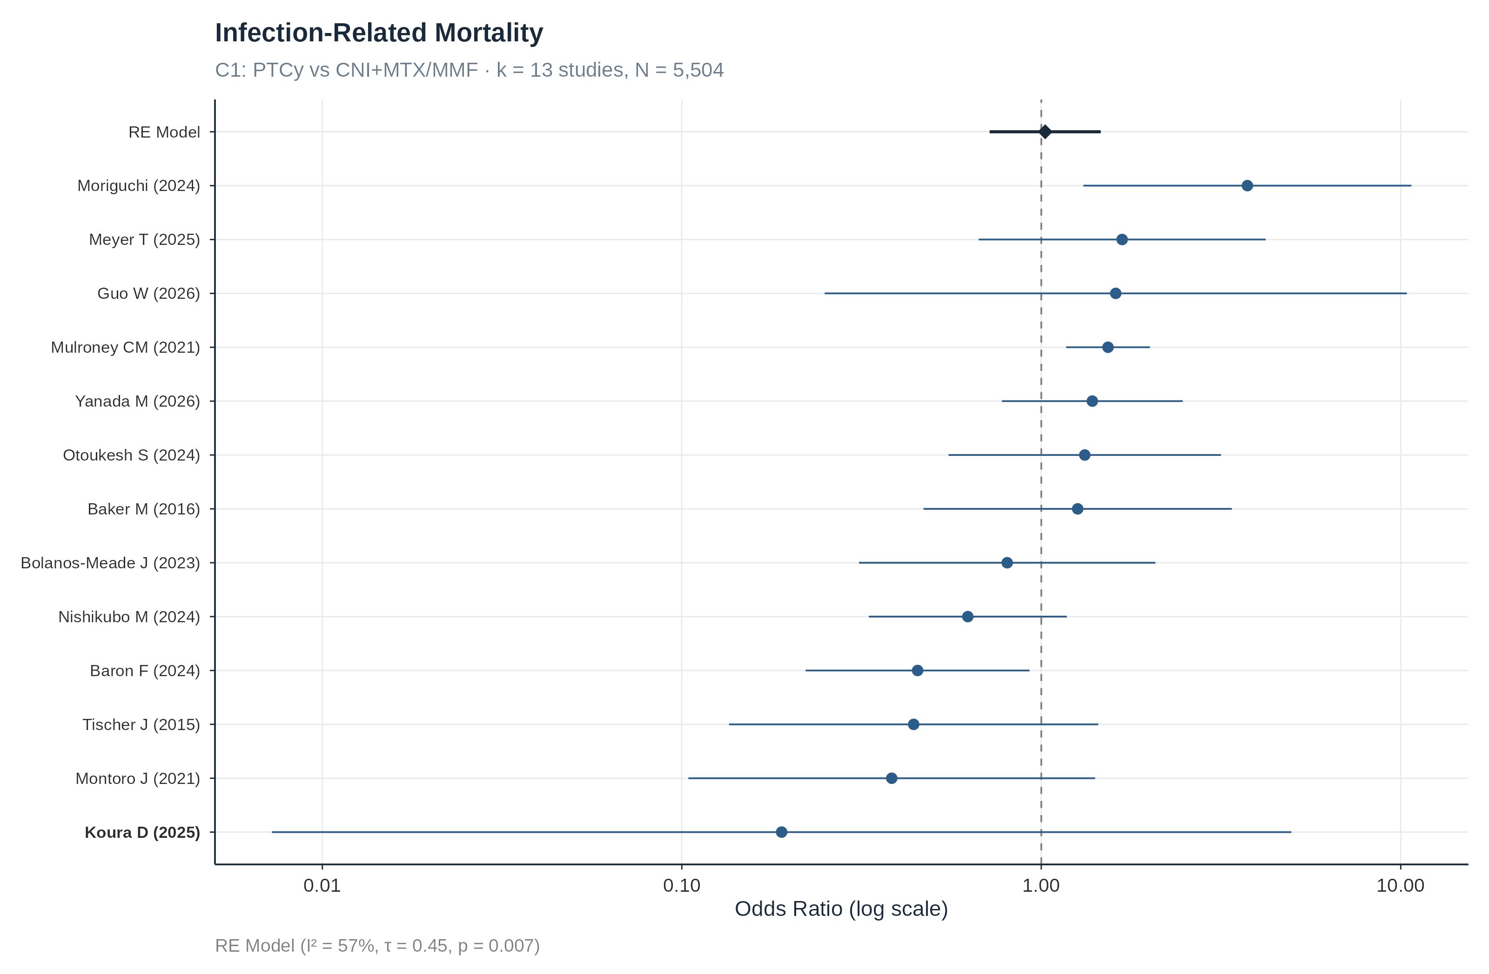
Figure 17: Infection-related mortality.

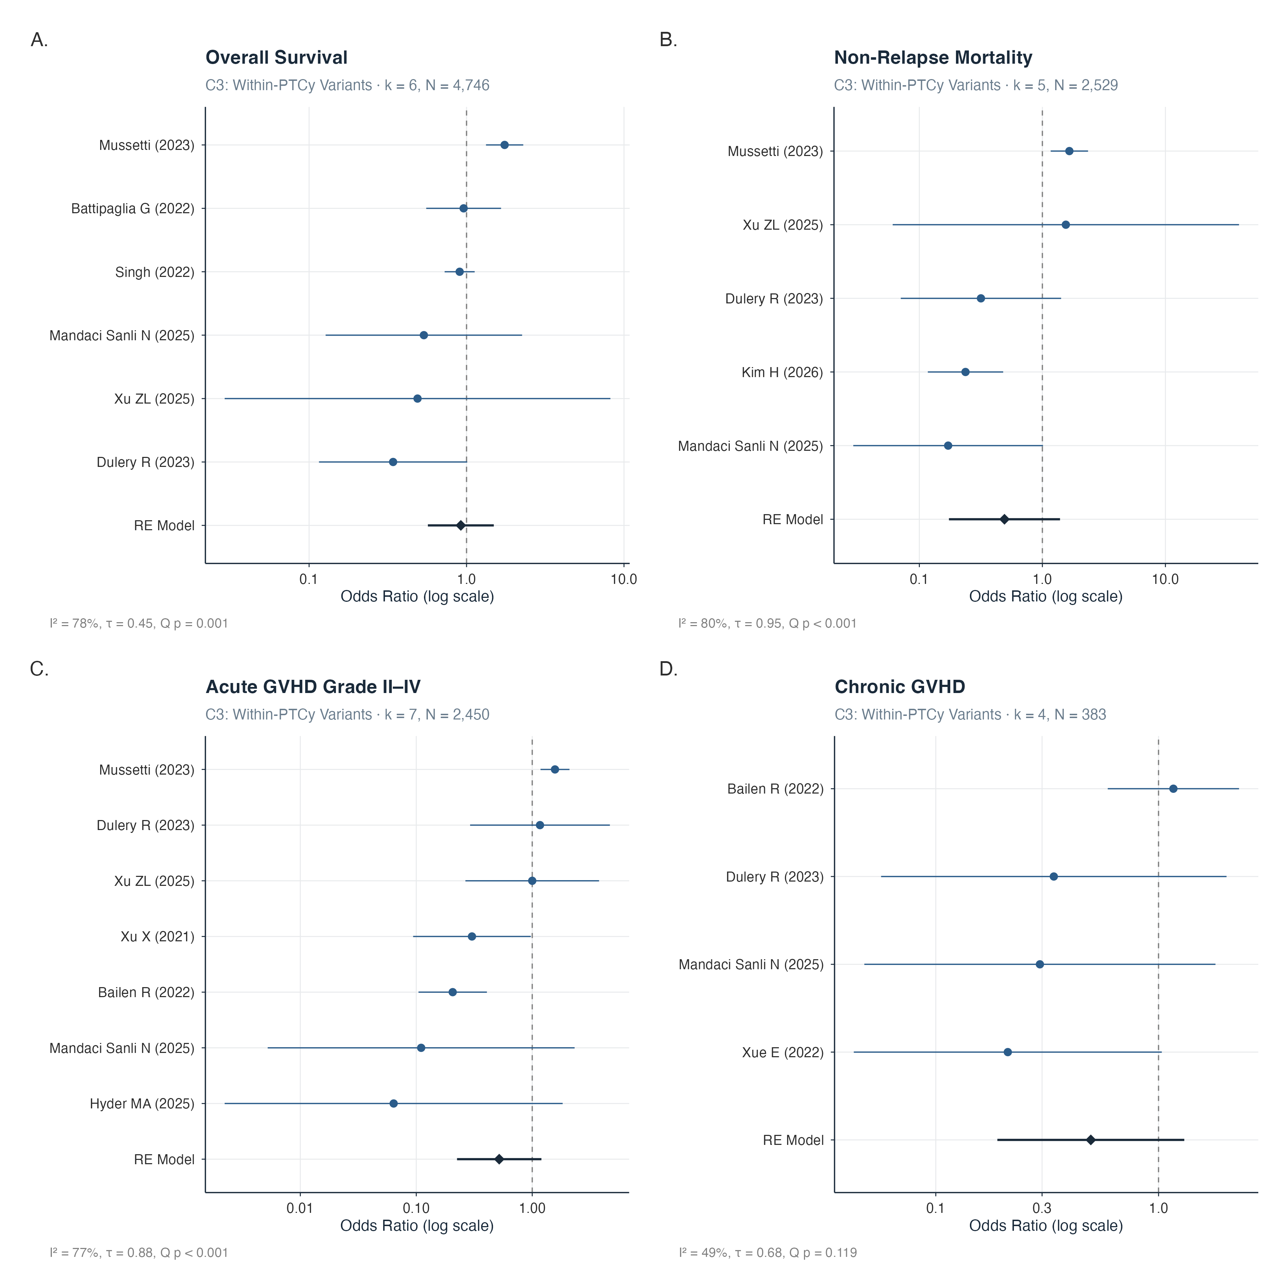
Figure 18: Comparison 3, within-PTCy regimen variants, all outcomes.

S9. Sensitivity analyses
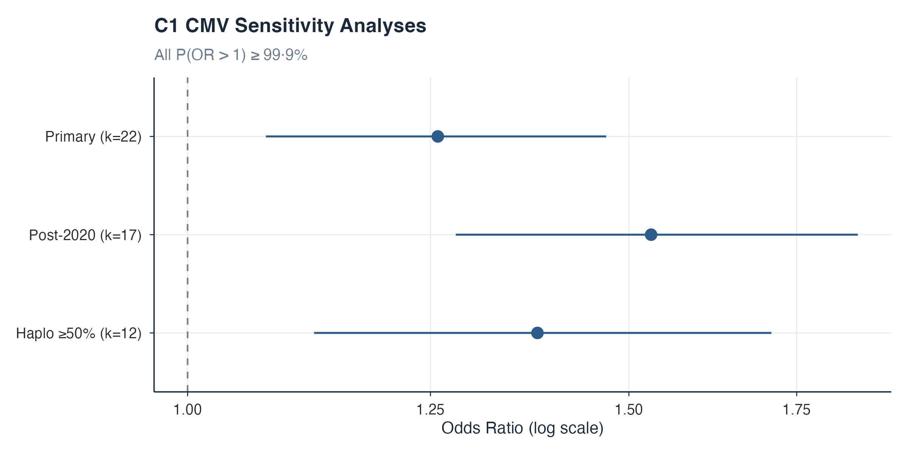
Figure 19: CMV sensitivity models, comparison 1: primary model, post-2020 restriction, and haploidentical-dominant restriction.

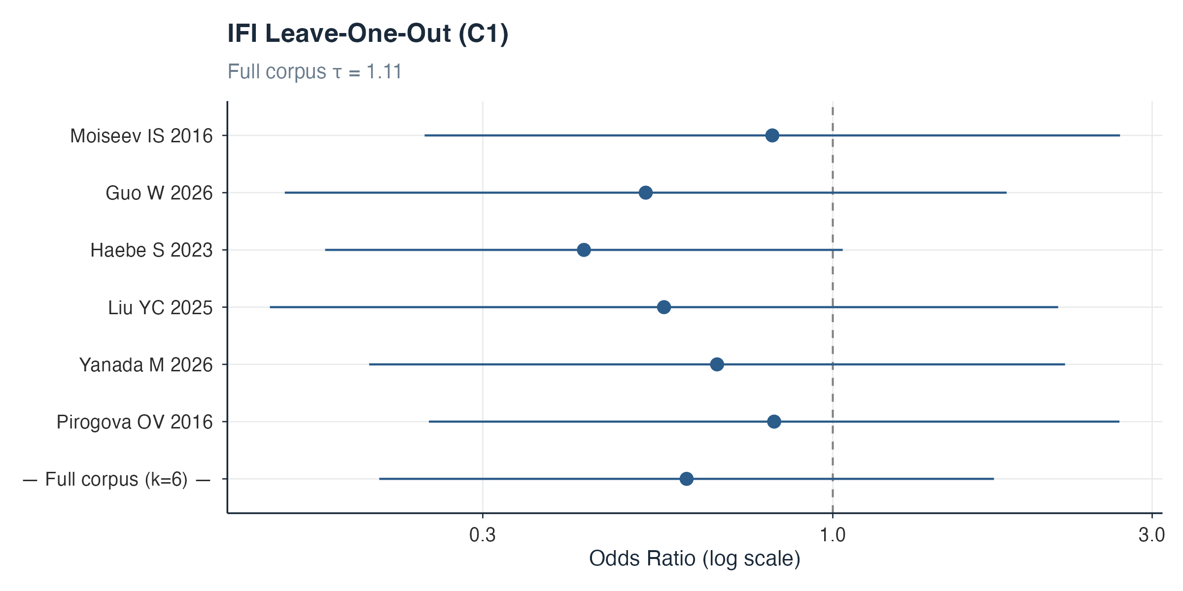
Figure 20: IFI leave-one-out analysis, comparison 1 (frequentist REML).
Full frequentist results for all models are provided in freq_results_setB.csv, a supplementary data file, which carries the deduplicated fits where deduplication applied and the original fits otherwise (see its source column). Direction was concordant between Bayesian and frequentist estimates for every outcome. Two framework-specific differences are worth noting: C1 BSI (Bayesian odds ratio 1·87 versus frequentist 1·29 [0·61–2·73]) and C1 IFI (0·43 versus 0·60 [0·21–1·74]), both reflecting the influence of informative priors at small k.

S10. Publication bias
Robust Bayesian model-averaging (RoBMA) models were fitted for all outcomes with k ≥ 6.

S11. GRADE certainty-of-evidence profiles
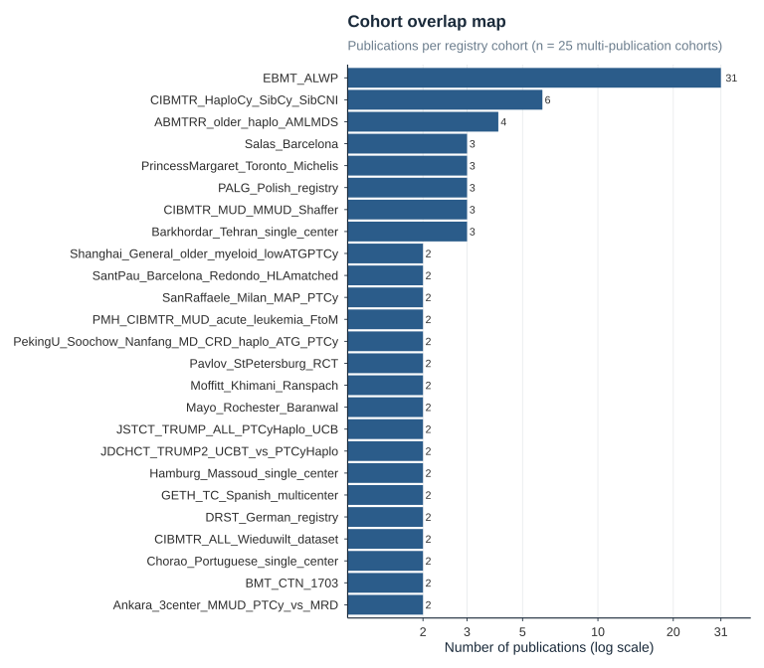
Figure 21: GRADE certainty-of-evidence profiles for the pre-specified primary and secondary outcomes.

S12. Cohort overlap
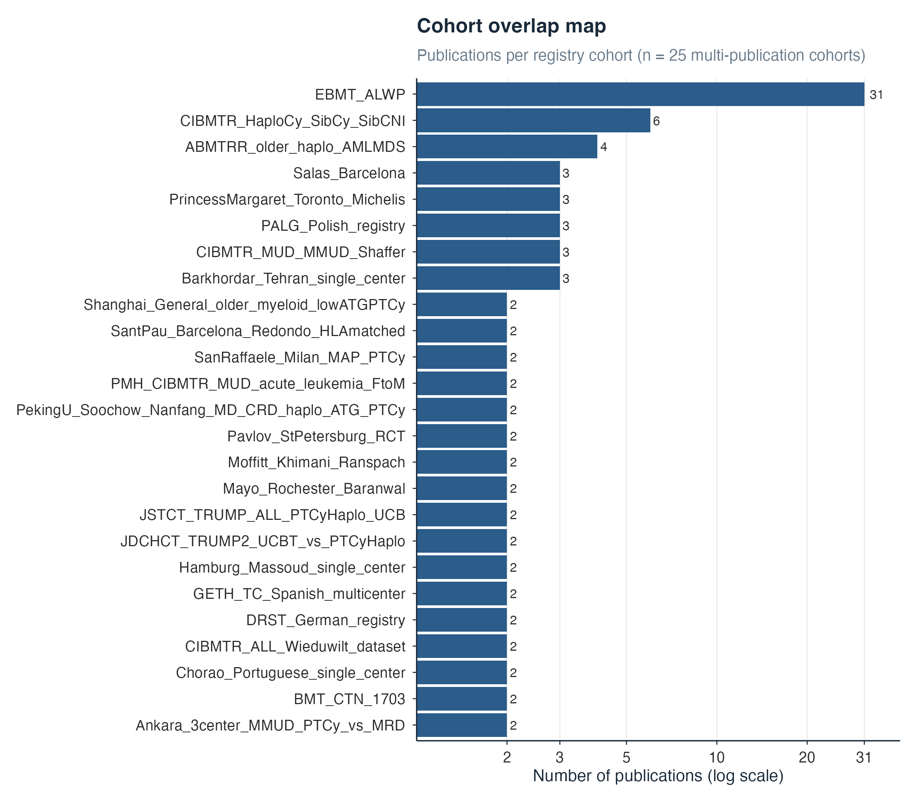
Figure 22: Cohort overlap map. Studies sharing patient cohorts were flagged and the most comprehensive publication designated as primary for each cohort–outcome combination (Set B, the adopted analysis).

S13. PROSPERO registration
The study protocol was registered with PROSPERO (CRD420261372156) before data extraction. Protocol amendments were: (1) a Bayesian rather than frequentist primary analysis framework; (2) addition of BK virus reactivation, infection-related mortality, and relapse-related mortality as secondary outcomes; and (3) addition of the steroid-mediation (M2) model.

S14. PRISMA 2020 checklist

