Post-transplant cyclophosphamide as graft-versus-host disease prophylaxis after allogeneic haematopoietic stem-cell transplantation: a systematic review and Bayesian meta-analysis of infection risk
Marta Stanzani
Dimitrios P Kontoyiannis
Russell E Lewis
2026-09-29

Summary
Background. Post-transplant cyclophosphamide (PTCy) is used for graft-versus-host disease (GVHD) prophylaxis after allogeneic haematopoietic stem-cell transplantation (allo-HSCT), but its infection effects versus longer-established prophylaxis have not been systematically quantified. We evaluated infection outcomes alongside survival, relapse and non-relapse mortality, and GVHD.
Methods. In this systematic review and Bayesian meta-analysis, we searched EMBASE, PubMed, and SCOPUS from inception to April 30, 2026 for studies comparing PTCy-based GVHD prophylaxis with alternative regimens in adult allo-HSCT recipients. Comparisons were pre-specified: PTCy versus calcineurin inhibitor (CNI) plus methotrexate or mycophenolate (C1); PTCy versus anti-thymocyte globulin (ATG; C2); and within-PTCy regimen variants (C3). The primary outcome was overall survival (OS); secondary outcomes were non-relapse mortality (NRM), acute GVHD grade II–IV, CMV reactivation, bloodstream infection (BSI), and invasive fungal infection (IFI). We fitted Bayesian random-effects binomial-logistic models. PROSPERO: CRD420261372156.
Findings. Of 4145 records, 251 studies (525 arms; 177 758 patients; 14 randomised trials) were included, 117 in the meta-analysis. In C1 (83 studies), PTCy was associated with improved OS (odds ratio 0·84 [95% credible interval 0·76–0·92]) and reduced acute GVHD (0·67 [0·59–0·78]), but increased CMV reactivation (1·26 [1·07–1·47]) and BSI (1·87 [1·33–2·62]). In C2 (42 studies), PTCy improved OS versus ATG (0·83 [0·75–0·92]) with no CMV excess (0·97 [0·77–1·23]). The CMV signal was steroid-independent and strengthened in post-2020 and haploidentical-dominant cohorts; the C1 survival benefit did not persist after steroid adjustment (1·04 [0·89–1·22]). GRADE certainty was low for survival and GVHD, very low for infections.
Interpretation. PTCy improves survival and reduces GVHD across comparators but increases CMV and bacterial infection risk versus less T-cell-depleting regimens. The CMV excess versus CNI-based but not ATG-based regimens suggests infection risk tracks T-cell-depletion depth, so that PTCy-associated infections are a class effect of T-cell depletion rather than a PTCy-specific limitation.
Funding. There was no funding source for this study.

Research in context

Evidence before this study
We searched PubMed for systematic reviews and meta-analyses of post-transplant cyclophosphamide in allogeneic haematopoietic stem-cell transplantation published from database inception to June 1, 2026, using the terms “post-transplant cyclophosphamide” AND (“meta-analysis” OR “systematic review”). We identified six comparative meta-analyses^{1–6} encompassing 6–20 studies each. All evaluated survival and GVHD outcomes; only two^{2,5} pooled infection outcomes, each with 2–4 studies per infection type. No prior meta-analysis simultaneously evaluated CMV, bacterial, and fungal infections alongside survival and GVHD. No prior study compared PTCy against both CNI-based and ATG-based comparators in a unified framework, and none has proposed a mechanistic explanation for the apparently contradictory infection findings across comparator contexts.

Added value of this stud
In this large systematic review and meta-analysis (251 studies, 177 758 patients), we were able to systematically pool CMV, bloodstream infection, and invasive fungal infection risk in the context of GVHD and survival within the same analytic framework. Its dual-comparator design reveals that the effect of PTCy on CMV reverses direction depending on the comparator’s own T-cell depletion depth. Greater infection risk was observed versus CNI-based (odds ratio 1·26) but not ATG-based (0·97) prophylaxis, suggesting T-cell depletion in general drives infection risk. Bayesian mediation analysis demonstrated that excess risk of CMV infection is is unchanged by adjustment for steroid exposure, whereas the survival benefit of PTCy versus CNI-based prophylaxis is reduced by steroid exposure.

Implications of all the available evidence
PTCy improves overall survival and reduces GVHD regardless of comparator prophylaxis. Its infection costs, elevated CMV reactivation and bacteraemia, are attributable to T-cell depletion depth and similar to ATG-based regimens. Clinical strategies to mitigate these risks should target T-cell reconstitution (adoptive T-cell therapy, optimised letermovir prophylaxis, earlier immunosuppression tapering) rather than PTCy avoidance. Within-PTCy regimen variants show no detectable differences, supporting flexibility in dose and backbone immunosuppression selection.

Introduction
Post-transplant cyclophosphamide (PTCy) has transformed the practice of allogeneic haematopoietic stem-cell transplantation (allo-HSCT) by enabling safe transplantation across HLA barriers and simplifying graft-versus-host disease (GVHD) prophylaxis.⁷ Originally developed for haploidentical transplantation⁸, PTCy is now widely used across all donor types⁹ and the BMT CTN 1703/1801 randomised controlled trial (RCT) established its superiority over conventional calcineurin inhibitor (CNI)-based prophylaxis for GVHD-free, relapse-free survival.¹⁰
Uncertainty persists regarding the magnaitude of PTCy on infection risk after transplant. CIBMTR registry studies have reported that PTCy-based regimens are associated with increased cytomegalovirus (CMV) reactivation¹¹ and a higher incidence of bacterial bloodstream infections with comparable or reduced rates of fungal infections.¹². This excess risk, however, has been difficult to quantify overall because prior meta-analyses have been restricted to single comparisons, limited to 6–20 studies, and have rarely included infection as a primary outcome. The absence of a unified analytic framework spanning multiple comparator contexts raises a fundamental question: are infection risks attributable to PTCy itself, or to the depth of T-cell depletion inherent to any intensive GVHD prophylaxis ? Answering this question requires simultaneous comparison of PTCy against both less depleting (CNI plus methotrexate) and more depleting (anti-thymocyte globulin [ATG]) regimens.
To address this question, we conducted a systematic review and Bayesian meta-analysis to simultaneously evaluate survival, GVHD, and infection outcomes of PTCy-based GVHD prophylaxis across three pre-specified comparisons, with a GVHD-mediation analysis to decompose the pathways through which PTCy influences clinical outcomes.

Methods

Search strategy and selection criteria
This systematic review and meta-analysis was conducted in accordance with PRISMA 2020 guidelines and registered with PROSPERO (CRD420261372156). We searched EMBASE, PubMed, and SCOPUS from database inception to April 30, 2026 for studies comparing PTCy-based GVHD prophylaxis with alternative regimens in adult (≥18 years) allo-HSCT recipients. The complete search strategy for PubMed is provided in the appendix (pp 2–4). Reference lists of included studies and relevant reviews were hand-searched. No language restrictions were applied at the search stage; studies not available in English were excluded at full-text review.
Studies were eligible if they reported at least one pre-specified outcome with extractable event counts (numerator and denominator) for at least two arms differing in GVHD prophylaxis strategy. Conference abstracts were excluded. We defined three pre-specified comparisons: C1, PTCy (with or without CNI or mycophenolate mofetil [MMF]) versus CNI plus methotrexate (MTX) or MMF without ATG or T-cell depletion; C2, PTCy versus ATG-based prophylaxis; and C3, within-PTCy regimen variants.
Two reviewers (MS and REL) screened titles and abstracts using the Covidence platform and conducted data extraction using a structured template (appendix p 5). AI-data tools (Claude Code, Anthropic, Inc.) was used to facilitate data extraction from PDF source documents to a data collection form, which were manually verified against source publications. Risk of bias was assessed using ROBINS-I for observational studies and RoB 2 for RCTs. Studies sharing patient cohorts were flagged and the most comprehensive publication was designated as primary publication for each cohort–outcome combination. All pooled estimates reported here were derived from the from this cohort-deduplicated dataset, so that no patient contributes more than once to any single outcome. The cohort overlap map is provided in the appendix (p 24).

Outcomes
The primary outcome was overall survival (OS). Secondary outcomes included non-relapse mortality (NRM), acute GVHD grade II–IV (at day +100), chronic GVHD (moderate to severe), CMV reactivation (any), bloodstream infection (BSI, any pathogen), invasive fungal infection (IFI, any), relapse-related mortality (RRM), BK virus reactivation, and infection-related mortality (IRM).

Statistical analysis
We fitted Bayesian random-effects binomial-logistic regression models using brms (version 2.23.0) with an rstan backend in R (version 4.6.0). The primary model (M1) estimated the PTCy treatment effect adjusted for timepoint (early [day +100 or +180] versus late [≥1 year]) with a random intercept for study. Weakly informative priors were specified: N(0, 2·5) on fixed effects, N(0, 1·5) on the intercept, and Student t(3, 0, 1) on the between-study standard deviation (τ). Four chains of 4000 iterations (1000 warmup) were run with adapt_delta = 0·95. Convergence was assessed by R̂ and effective sample size.
The GVHD-mediation model (M2) added arm-level systemic steroid exposure percentage as a covariate, providing an estimate of the PTCy effect independent of GVHD-mediated steroid burden. Attenuation of the treatment effect from M1 to M2 was interpreted as evidence of steroid-mediated confounding.
Pre-specified sensitivity analyses included restriction to post-2020 publications (beginning of letermovir prophylaxis), haploidentical-dominant cohorts (≥50% haploidentical donors), and leave-one-out analysis. Frequentist random-effects models (restricted maximum likelihood [REML], metafor version 5.0.1) were fitted as concordance checks. Publication bias was assessed using robust Bayesian model-averaging (RoBMA). Certainty of evidence was assessed using the GRADE framework adapted for observational evidence.

Role of the funding source
There was no funding source for this study.

Results

Search results and study characteristics
The database search identified 4145 records (EMBASE 2603, PubMed 1061, SCOPUS 481), of which 1220 were duplicates (Figure 1). After screening 2925 titles and abstracts, 517 articles were sought for full-text review; 52 could not be retrieved or were not in English. Of 465 full-text articles assessed, 214 were excluded (appendix pp 6–14), leaving 251 studies for the systematic review. Of these, 117 studies with extractable event counts contributed to the meta-analysis across three comparisons: C1 (83 studies), C2 (42 studies), and C3 (13 studies).
The 225 comparative studies encompassed 520 arms and 177 758 patients (Table 1). Most were retrospective cohorts (132 [59%]) or registry analyses (62 [28%]); 14 (6%) were RCTs. Median publication year was 2023 (IQR 2021–24), with median follow-up of 26 months (IQR 20–36). PTCy arms were predominantly haploidentical donor transplants (127 [47%]) whereas comparator arms were predominantly matched unrelated (94 [38%]) or matched sibling (54 [22%]) donor transplants.

Risk of bias
Of 227 observational studies assessed with ROBINS-I, 150 (66%) were at moderate risk of bias and 71 (31%) at serious risk, primarily due to confounding by donor type and conditioning intensity (appendix pp 15–17). Of 14 RCTs assessed with RoB 2, 11 had some concerns (predominantly unblinded outcome assessment), two were at high risk, and one was at low risk of bias.

Comparison 1: PTCy versus CNI plus MTX or MMF
PTCy was associated with improved OS (k = 35, odds ratio 0·84 [95% credible interval 0·76–0·92]; Figure 2). Adjusting for steroid exposure diminished the association (M2 1·04 [0·89–1·22], k = 28), suggesting that the survival advantage is mediated through GVHD suppression and the steroid burden that follows it rather than through an additional direct effect of PTCy. NRM showed a non-significant trend toward benefit (k = 12, 0·88 [0·66–1·18]). Relapse-related mortality was reduced (k = 34, 0·86 [0·77–0·97]), and this estimate was unchanged by steroid adjustment (M2 0·85 [0·73–0·99], k = 27).
Acute GVHD grade II–IV was substantially reduced (k = 28, 0·67 [0·59–0·78]), as was moderate-to-severe chronic GVHD (k = 19, 0·47 [0·38–0·57]).
CMV reactivation increased in the PTCy group (k = 22, 1·26 [1·07–1·47]; Figure 3). This effect was steroid-independent (M2 1·25 [1·01–1·54]) and strengthened in post-2020 studies (k = 17, 1·53 [1·28–1·85]) and haploidentical-dominant cohorts (k = 12, 1·38 [1·12–1·71]). BSI were also elevated with PTCy prophylaxis (k = 6, 1·87 [1·33–2·62]) . BK virus infection reactivation was associated with the largest infection effect (k = 11, 2·48 [1·82–3·38]; Figure 4). Conversely, IFI was reduced (k = 6, 0·43 [0·29–0·63]), though extreme heterogeneity was present (τ = 1·53). Infection-related mortality was elevated in patients receiving PTCy versus CNI with MTX or MMF, with a credible interval that reached the null (k = 13, 1·19 [1·00–1·43]).

Comparison 2: PTCy versus ATG
PTCy improved OS versus ATG (k = 9, odds ratio 0·83 [0·75–0·92]), with negligible steroid-mediated attenuation (M2 0·81 [0·70–0·93], k = 8). Acute GVHD was reduced (k = 8, 0·63 [0·47–0·83]). NRM could not be assessed (k = 2). CMV reactivation was not significantly different (k = 12, 0·97 [0·77–1·23]), contrasting with the excess seen in C1, and was likewise unaffected by steroid adjustment (M2 1·00 [0·79–1·26]). Infection-related mortality was not increased (k = 7, 0·90 [0·74–1·09]).

Comparison 3: within-PTCy variants
No significant differences were detected between PTCy-based regimen variants for any outcome (OS 1·11, NRM 0·96, acute GVHD 1·00, chronic GVHD 0·67, relapse-related mortality 0·80; all credible intervals crossed the null; k = 4–7 per outcome).

Certainty of evidence
GRADE certainty was low for C1 OS, C1 acute GVHD, C1 CMV, C2 OS, and C2 acute GVHD, and very low for C1 NRM, C1 BSI, C1 IFI, C2 CMV, and C2 BSI (Table 2). No outcome achieved moderate or high certainty. The C1 CMV robustness upgrade was supported by steroid independence and consistent direction across two sensitivity analyses.

Discussion
This systematic review and meta-analysis encompassing 251 studies, 525 arms, and over 177 000 patients is a comprehensive evaluation of infection risks with PTCy-based GVHD prophylaxis. Its dual-comparator design and simultaneous analysis of survival, GVHD, and infection outcomes within a unified Bayesian framework enables a mechanistic interpretation that has not been possible in prior single-comparison reviews.
The survival and GVHD findings are unequivocal in direction and consistent across comparators. PTCy reduces acute GVHD grade II–IV by approximately one-third versus CNI plus MTX or MMF (odds ratio 0·67) and by a similar margin versus ATG (0·63), with correspondingly large reductions in chronic GVHD. Overall survival is improved by approximately 16% in both comparisons (C1 0·84; C2 0·83). These findings align with and extend the BMT CTN 1703 RCT, which established the superiority of PTCy in the matched-donor setting.¹⁰ The present analysis confirms that this advantage generalises across donor types, conditioning regimens, and geographic settings.
The central conceptual contribution of this analysis is the resolution of apparently contradictory infection findings into a coherent mechanistic framework. PTCy administered on days +3 and +4 after transplant eliminates alloreactive T cells (the intended GVHD-preventive effect), but simultaneously depletes the nascent pathogen-specific T-cell repertoire (an unintended immunological cost). In C1, this T-cell depletion manifests as increased CMV reactivation (odds ratio 1·26) and BSI (1·87). Neither association is attenuated by adjusting for steroid exposure (CMV M2 1·25 [1·01–1·54]), confirming that these infection risks operate through a pathway orthogonal to the GVHD–steroid cascade.
The survival benefit behaves in the opposite way. Adjusting for steroid exposure removes it entirely (C1 OS M2 1·04 [0·89–1·22]), placing the survival advantage of PTCy on the GVHD–steroid pathway rather than alongside it. Taken together, the two results dissociate benefit from harm: what PTCy gains in survival it gains by suppressing GVHD and the steroid burden that follows, while what it costs in CMV and bacteraemia it costs through T-cell depletion, independently. That the reduction in relapse-related mortality (0·86) is likewise unmoved by steroid adjustment (0·85) suggests a third, separate contribution from the graft-versus-tumour effect. This mediation analysis rests on arm-level steroid exposure, is available for 28 of the 35 studies contributing to the survival model, and should be read as hypothesis-generating.
The C2 analysis provides a critical test of this framework. If CMV excess were an intrinsic property of cyclophosphamide, it should persist regardless of comparator. Instead, PTCy shows no CMV excess versus ATG (C2 odds ratio 0·97 [0·77–1·23]), consistent with the prediction that infection risk tracks the relative depth of T-cell depletion between arms. PTCy sits between the two comparators in depleting depth: infection risk is increased relative to less T-cell-depleting CNI-based regimens, but not relative to more-depleting ATG. This hierarchy (CNI-based < PTCy < ATG) reframes PTCy-associated infections as a class effect of T-cell-depleting prophylaxis rather than a drug-specific limitation.
Several limitations warrant discussion. First, the evidence base is predominantly observational, and no outcome exceeded low certainty under GRADE assessment. Selection bias, confounding by donor type, and centre-level practice variation are inherent limitations that cannot be fully addressed by meta-regression. Second, the steroid-mediation analysis uses arm-level rather than individual-patient data, limiting causal inference. Third, infection outcome definitions varied across studies (for example, any CMV reactivation versus clinically significant CMV infection; any positive blood culture versus BSI requiring intensive care), introducing measurement heterogeneity. Fourth, the IFI signal (odds ratio 0·43), while statistically significant, is driven by extreme heterogeneity (τ = 1·53) and probably reflects confounding by antifungal prophylaxis practices rather than a direct effect of PTCy. Fifth, cohort deduplication removes the largest registry publications from several outcomes where a smaller series reports the same patients in more detail, so the pooled totals for survival and chronic GVHD rest on fewer patients than the size of the review would suggest.
The within-PTCy comparison (C3) found no detectable differences between regimen variants for any outcome, supporting clinical flexibility in PTCy dosing and backbone immunosuppression selection. However, statistical power was limited (k = 4–7) and equivalence cannot be concluded.
These findings have direct clinical implications. For centres already using PTCy, the infection costs are quantitatively modest (CMV odds ratio 1·26) and are shared with ATG-based regimens, which carry at least comparable T-cell depletion liability. Clinical strategies to mitigate these costs should target T-cell reconstitution (adoptive T-cell therapies, letermovir prophylaxis, earlier immunosuppression tapering) rather than PTCy avoidance. The strengthening of the CMV signal in post-2020 studies (odds ratio 1·53), despite widespread letermovir adoption, suggests that pharmacological CMV prophylaxis alone does not fully offset the reconstitution delay. For NRM, optimising GVHD control remains a key strategy, as approaches towards reducing GVHD severity and attendant steroid exposure should translate into NRM benefit.
In conclusion, PTCy improves overall survival and reduces GVHD across comparator regimens. Its infection costs are attributable to the depth of T-cell depletion — a mechanistic property shared with ATG — and are best addressed through strategies targeting immune reconstitution. The present analysis provides a unified framework for interpreting the benefit–harm balance of PTCy and should inform guideline development, clinical counselling, and the design of future trials.

Contributors
REL, MS, and DPK developed the study protocol. REL and MS performed the searches, data extraction, risk of bias assessment, and statistical analysis, and wrote the first draft of the report. MS verified the extracted data. DPK revised the manuscript. All authors had full access to all the data in the study and had final responsibility for the decision to submit for publication. REL and MS directly accessed and verified the underlying data reported in the manuscript.

Declaration of interests

Data sharing
Individual study-level data extracted for this systematic review, including the complete extraction database and analytic datasets, are available on a public GitHub repository (https://github.com/Russlewisbo/ptcy_metaanalys). The manuscript source, including the notebooks that generate every table and figure, is available at https://github.com/lewis-id-lab/ptcy-infection, with a rendered version for review at https://lewis-id-lab.github.io/ptcy-infection/. The study protocol is registered with PROSPERO (CRD420261372156).

Use of artificial intelligence
AI-assisted extraction was performed to accelerate data extraction from PDF source documents; all AI-extracted values were manually verified against source publications.

References
1 Gagelmann N, Bacigalupo A, Rambaldi A, et al. Haploidentical stem cell transplantation with posttransplant cyclophosphamide therapy vs other donor transplantations in adults with hematologic cancers: A systematic review and meta-analysis. JAMA Oncology 2019; 5: 1739–48.
2 Jin X, Dong T, Ji J, et al. Comparison of the efficacy of pre-transplant and post-transplant antithymocyte globulin combined with post-transplant cyclophosphamide for graft-versus-host disease prophylaxis in myeloablative haploidentical peripheral blood stem cell transplantation. Cell Transplantation 2026; 35: 09636897261454024.
3 Arcuri LJ, Aguiar MTM, Ribeiro AAF, Pacheco AGF. Haploidentical transplantation with post-transplant cyclophosphamide versus unrelated donor hematopoietic stem cell transplantation: A systematic review and meta-analysis. Biology of Blood and Marrow Transplantation 2019; 25: 2422–30.
4 Arcuri LJ, Hamerschlak N, Rocha V, Bonfim C, Kerbauy MN. Outcomes after haploidentical hematopoietic cell transplantation with post-transplantation cyclophosphamide: A systematic review and meta-analysis comparing myeloablative with reduced-intensity conditioning regimens and bone marrow with peripheral blood stem cell grafts. Transplantation and Cellular Therapy 2021; 27: 782.e1–7.
5 Tang L, Liu Z, Li T, et al. Post-transplant cyclophosphamide versus anti-thymocyte globulin in allogeneic hematopoietic stem cell transplantation from unrelated donors: A systematic review and meta-analysis. Frontiers in Oncology 2023; 13: 1071268.
6 Luo C, Huang X, Wu G, et al. Combination of anti-thymocyte globulin with post-transplant cyclophosphamide for GVHD prophylaxis in patients undergoing haploidentical hematopoietic stem cell transplantation: Systematic review and meta-analysis. Transplantation and Cellular Therapy 2025; 31: 32.e1–15.
7 O’Donnell PV, Luznik L, Jones RJ, et al. Nonmyeloablative bone marrow transplantation from partially HLA-mismatched related donors using posttransplantation cyclophosphamide. Biology of Blood and Marrow Transplantation: Journal of the American Society for Blood and Marrow Transplantation 2002; 8: 377–86.
8 Luznik L, O’Donnell PV, Symons HJ, et al. HLA-haploidentical bone marrow transplantation for hematologic malignancies using nonmyeloablative conditioning and high-dose, posttransplantation cyclophosphamide. Biology of Blood and Marrow Transplantation: Journal of the American Society for Blood and Marrow Transplantation 2008; 14: 641–50.
9 Kanakry CG, Fuchs EJ, Luznik L. Modern approaches to HLA-haploidentical blood or marrow transplantation. Nature Reviews Clinical Oncology 2016; 13: 10–24.
10 Bolaños-Meade J, Hamadani M, Wu J, et al. Post-transplantation cyclophosphamide-based graft-versus-host disease prophylaxis. The New England Journal of Medicine 2023; 388: 2338–48.
11 Goldsmith SR, Abid MB, Auletta JJ, et al. Posttransplant cyclophosphamide is associated with increased cytomegalovirus infection: A CIBMTR analysis. Blood 2021; 137: 3291–305.
12 Papanicolaou GA, Chen M, He N, et al. Incidence and impact of fungal infections in post-transplantation cyclophosphamide-based graft-versus-host disease prophylaxis and haploidentical hematopoietic cell transplantation: A center for international blood and marrow transplant research analysis. Transplantation and Cellular Therapy 2024; 30: 114.e1–16.

Tables
Table 1: Characteristics of included studies. Data are n (%) or median (IQR) unless otherwise stated. *Median of arm-level values; IQR reflects between-arm variability. MUD = matched unrelated donor. MMUD = mismatched unrelated donor. MSD = matched sibling donor. PBSC = peripheral blood stem cells. BM = bone marrow. UCB = umbilical cord blood. MAC = myeloablative conditioning. RIC = reduced-intensity conditioning. NMA = non-myeloablative. NR = not reported.
Characteristic | PTCy arms (n=272) | Comparator arms (n=248)
Studies
Comparative (≥2 arms) | 225
Single-arm descriptive | 26
Arms | 272 | 248
Total patients | 177 758
RCTs | 14 (6%)
Study design
Retrospective cohort | 132 (59%)
Registry analysis | 62 (28%)
Prospective cohort | 17 (8%)
Publication year, median (IQR) | 2023 (2021–24)
Follow-up, months, median (IQR) | 26 (20–36)
ROBINS-I overall judgement (n=227)
Moderate | 150 (66%)
Serious | 71 (31%)
High | 6 (3%)
Arm-level characteristics
Patients per arm, median (IQR) | 99 (46–212) | 120 (51–375)
Age, years, median (IQR)* | 52·0 (44·9–58·0) | 53·0 (43·0–57·9)
Male, %* | 57·1 (54·0–61·5) | 57·4 (53·0–61·8)
Donor type (predominant)
Haploidentical | 127 (47%) | 36 (15%)
MUD (10/10) | 64 (24%) | 94 (38%)
MMUD (9/10 or lower) | 29 (11%) | 28 (11%)
MSD | 29 (11%) | 54 (22%)
Mixed / other / NR | 23 (8%) | 36 (15%)
Graft source (predominant)
PBSC | 204 (75%) | 181 (73%)
BM | 31 (11%) | 11 (4%)
UCB | — | 18 (7%)
Mixed / NR | 37 (14%) | 38 (15%)
Conditioning (predominant)
RIC | 110 (40%) | 85 (34%)
MAC | 106 (39%) | 119 (48%)
NMA | 7 (3%) | 3 (1%)
Mixed / NR | 49 (18%) | 41 (17%)
CMV R+, %* | 74·8 (65·8–80·1) | 69·4 (59·5–81·3)
Steroid exposure, %* | 26·6 (20·0–32·7) | 34·5 (28·5–43·5)

Table 2: Bayesian meta-analysis results: outcomes by comparison. Estimates are from the cohort-deduplicated dataset, in which one publication per cohort contributes to each outcome. M1 = primary model adjusted for timepoint. M2 = steroid-mediation model, fitted on the subset of studies reporting arm-level steroid exposure. k = number of paired studies. N = total patients across all arms. τ = between-study standard deviation (posterior median). CrI = credible interval. GRADE ratings are shown for pre-specified primary and secondary outcomes only. OR < 1 favours PTCy for survival and GVHD outcomes; OR > 1 indicates elevated risk with PTCy for infection outcomes. *The C2 BK virus model (k = 3) did not meet the convergence criteria applied to the other models (appendix p 18) and is reported as indicative only.
Outcome | Comparison | Model | k | N | OR (95% CrI) | τ | GRADE
Overall survival | C1 | M1 | 35 | 10 133 | 0·84 (0·76–0·92) | 0·66 | Low
 | C1 | M2 | 28 | 10 133 | 1·04 (0·89–1·22) | 0·60 | —
 | C2 | M1 | 9 | 12 791 | 0·83 (0·75–0·92) | 0·50 | Low
 | C2 | M2 | 8 | 12 791 | 0·81 (0·70–0·93) | 0·67 | —
 | C3 | M1 | 6 | 4746 | 1·11 (0·95–1·30) | 0·84 | —
Non-relapse mortality | C1 | M1 | 12 | 1309 | 0·88 (0·66–1·18) | 0·69 | Very low
 | C1 | M2 | 12 | 1309 | 0·90 (0·59–1·36) | 0·56 | —
 | C2 | M1 | — | — | k=2, not assessed | — | —
 | C3 | M1 | 5 | 2529 | 0·96 (0·74–1·24) | 1·11 | —
Relapse-related mortality | C1 | M1 | 34 | 11 121 | 0·86 (0·77–0·97) | 0·47 | —
 | C1 | M2 | 27 | 11 121 | 0·85 (0·73–0·99) | 0·55 | —
 | C2 | M1 | 10 | 17 182 | 0·79 (0·69–0·89) | 0·14 | —
 | C3 | M1 | 6 | 692 | 0·80 (0·50–1·27) | 0·31 | —
Acute GVHD II–IV | C1 | M1 | 28 | 4197 | 0·67 (0·59–0·78) | 0·67 | Low
 | C2 | M1 | 8 | 1039 | 0·63 (0·47–0·83) | 0·53 | Low
 | C3 | M1 | 7 | 2450 | 1·00 (0·80–1·25) | 0·75 | —
Chronic GVHD mod–severe | C1 | M1 | 19 | 2840 | 0·47 (0·38–0·57) | 0·77 | —
 | C2 | M1 | 6 | 905 | 0·79 (0·55–1·14) | 0·89 | —
Chronic GVHD any | C1 | M1 | 8 | 1732 | 0·23 (0·18–0·30) | 0·52 | —
 | C3 | M1 | 4 | 383 | 0·67 (0·39–1·14) | 0·31 | —
CMV reactivation | C1 | M1 | 22 | 3328 | 1·26 (1·07–1·47) | 0·73 | Low
 | C1 | M2 | 22 | 3328 | 1·25 (1·01–1·54) | 0·74 | —
 | C2 | M1 | 12 | 1511 | 0·97 (0·77–1·23) | 0·63 | Very low
 | C2 | M2 | 12 | 1511 | 1·00 (0·79–1·26) | 0·72 | —
Bloodstream infection | C1 | M1 | 6 | 806 | 1·87 (1·33–2·62) | 0·88 | Very low
Invasive fungal infection | C1 | M1 | 6 | 2243 | 0·43 (0·29–0·63) | 1·53 | Very low
BK virus | C1 | M1 | 11 | 1333 | 2·48 (1·82–3·38) | 1·00 | —
 | C2* | M1 | 3 | 313 | 2·44 (1·40–4·26) | 0·39 | —
Infection-related mortality | C1 | M1 | 13 | 5504 | 1·19 (1·00–1·43) | 0·82 | —
 | C2 | M1 | 7 | 13 346 | 0·90 (0·74–1·09) | 0·58 | —

Figures
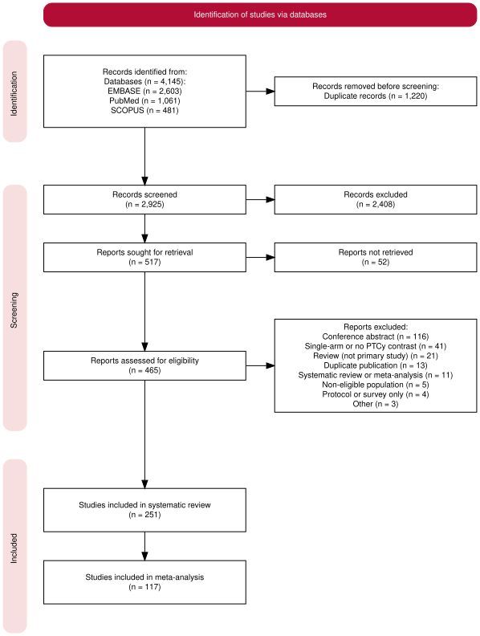
Figure 1: Study selection (PRISMA 2020 flow diagram). 4145 records were identified from databases (EMBASE 2603, PubMed 1061, SCOPUS 481) and 1220 duplicates removed. 2925 records were screened and 2408 excluded at title and abstract. 517 reports were sought for retrieval; 52 were not retrieved or not in English. 465 full-text reports were assessed and 214 excluded (appendix pp 6–14). 251 studies were included in the systematic review; 117 with extractable event counts were included in the meta-analysis (C1 83 studies; C2 42 studies; C3 13 studies).

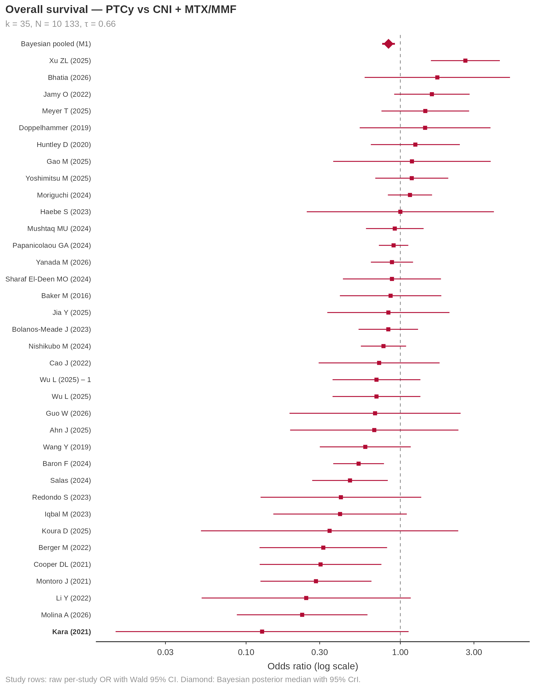
Figure 2: Forest plot — overall survival, comparison 1 (PTCy vs CNI + MTX/MMF). Study rows are raw per-study odds ratios with Wald 95% CIs, computed from the extracted event counts; the diamond is the pooled Bayesian random-effects posterior median with 95% credible interval (primary model M1). k = 35 after cohort deduplication.

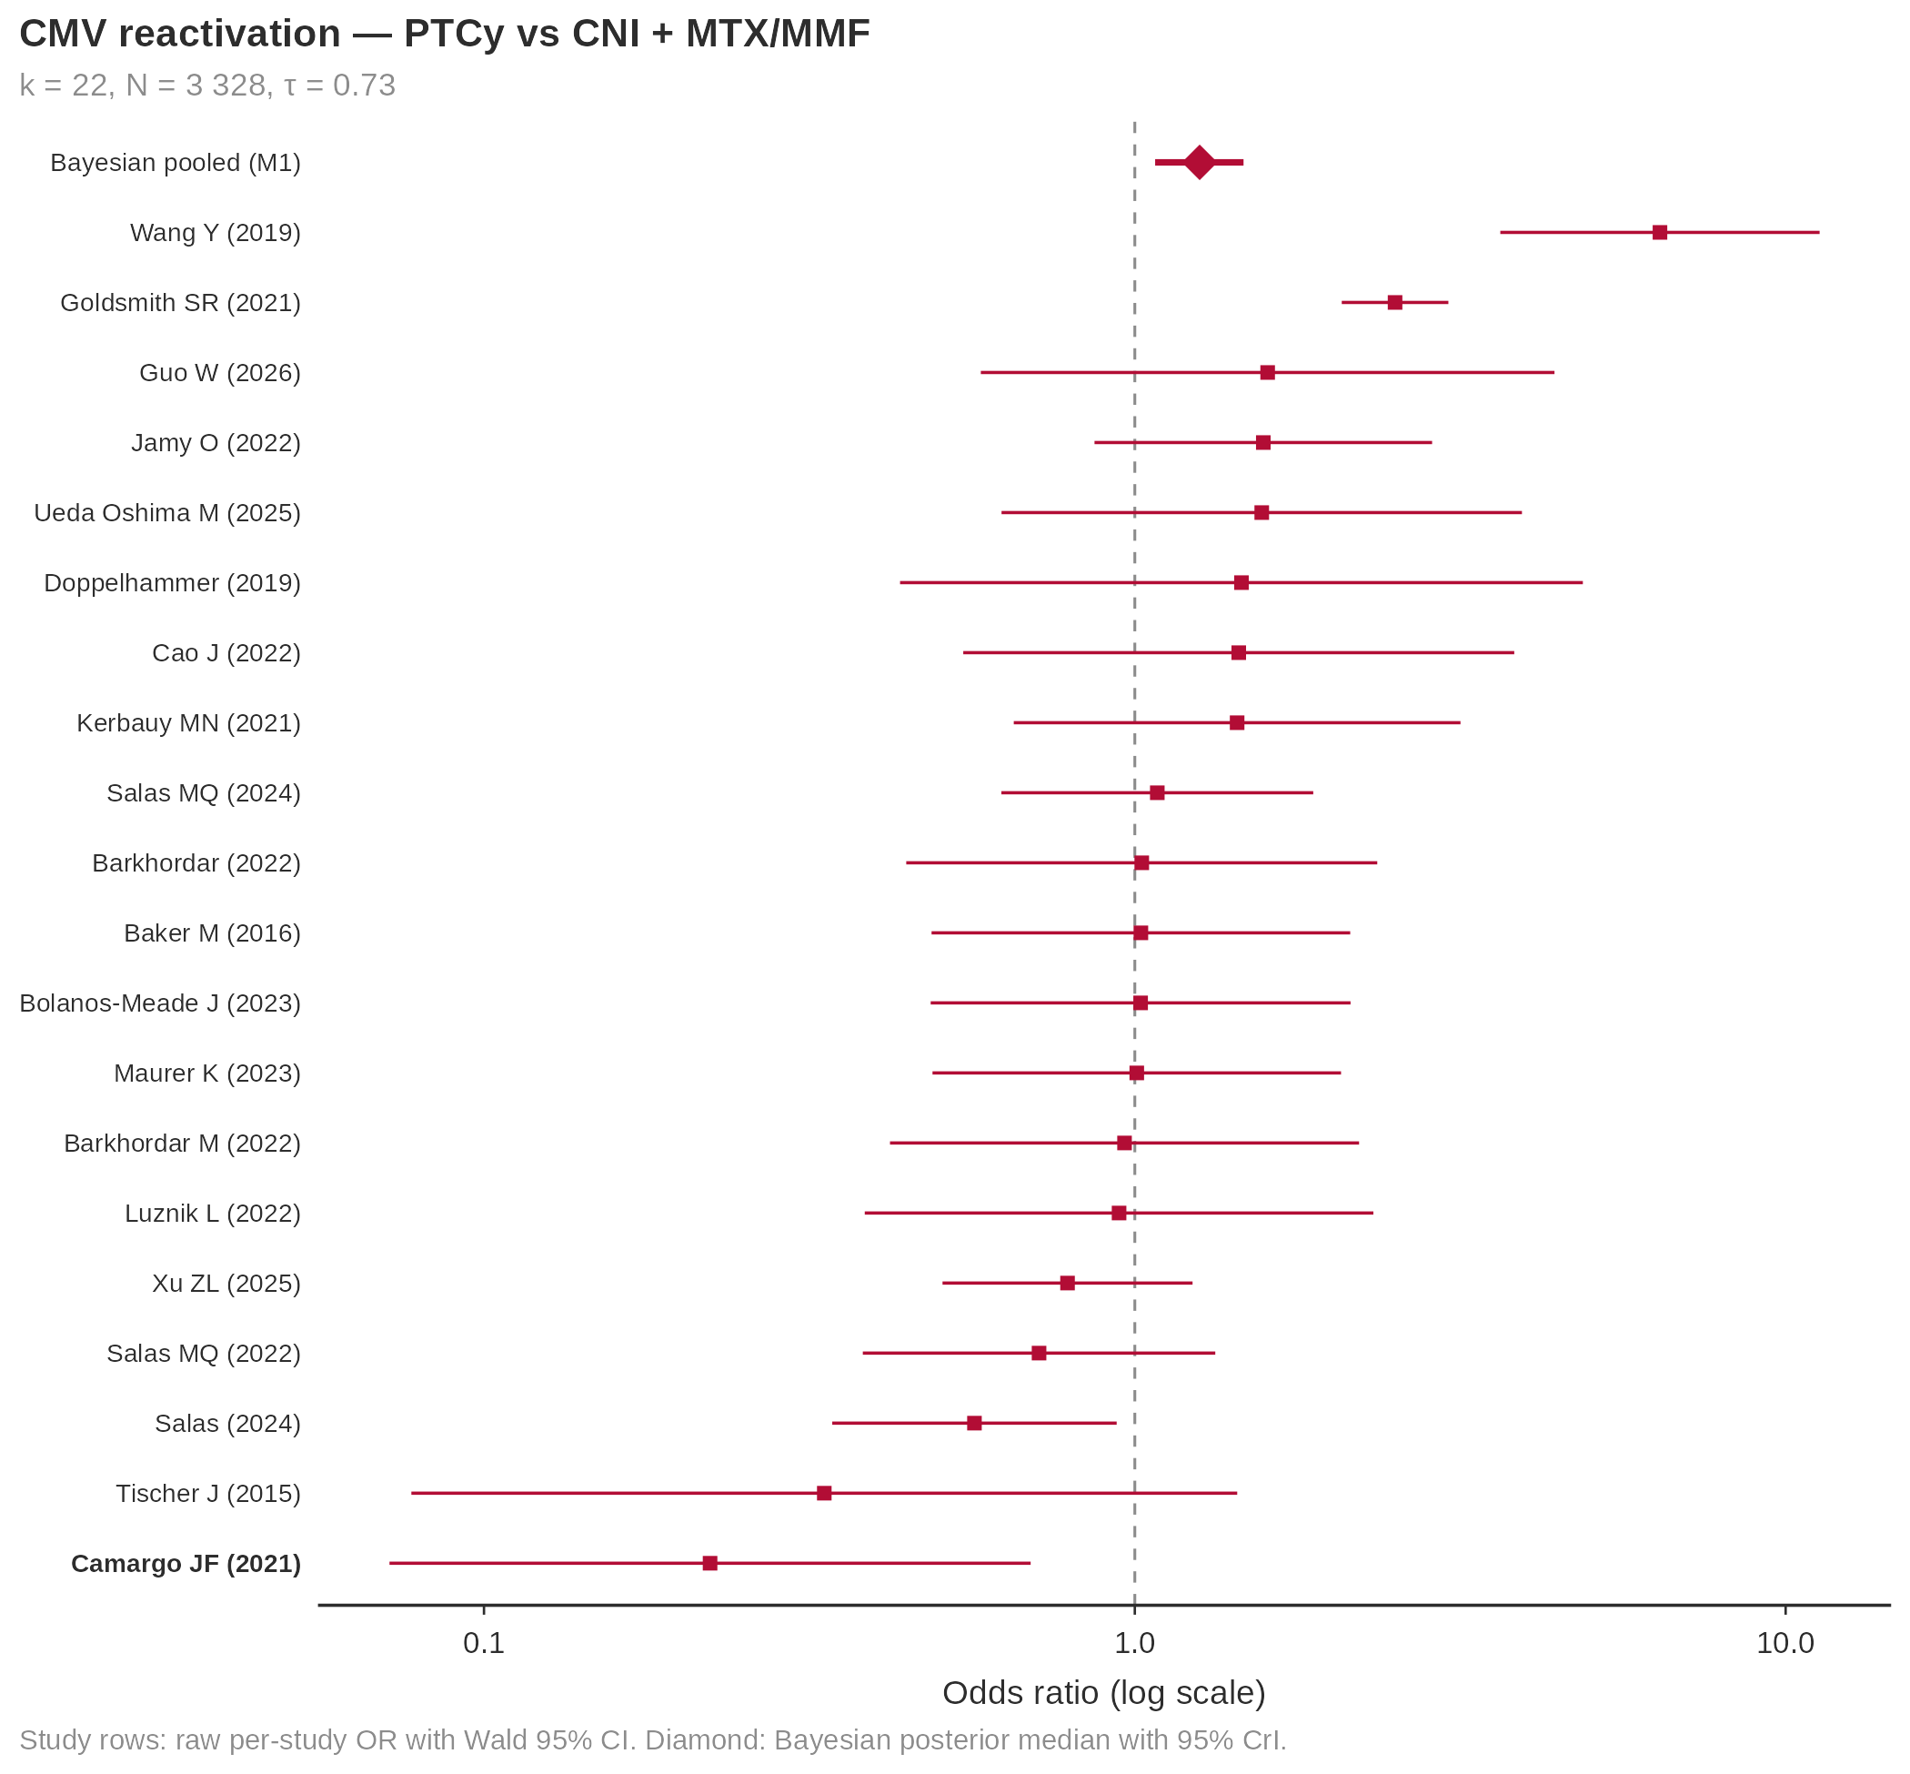
(a) Comparison 1: PTCy vs CNI + MTX/MMF (k = 22, odds ratio 1·26 [1·07–1·47])

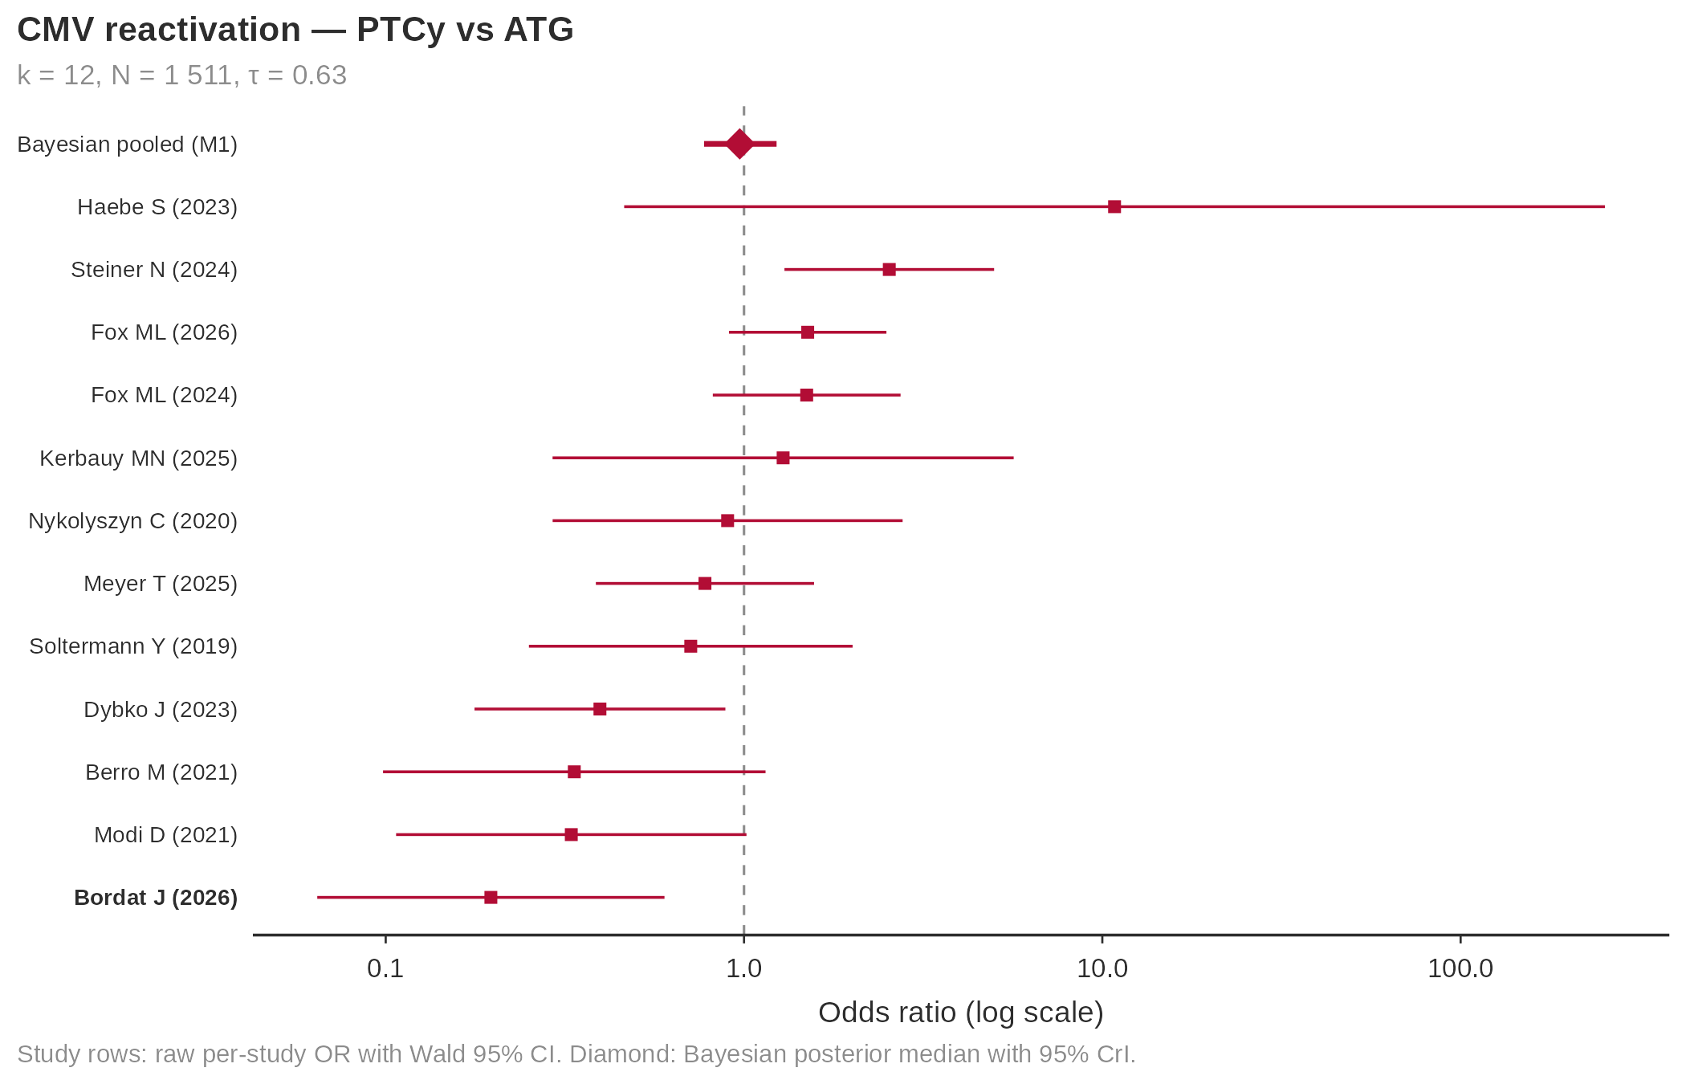
(b) Comparison 2: PTCy vs ATG (k = 12, 0·97 [0·77–1·23])

Figure 3: Forest plots — CMV reactivation. Individual study odds ratios for any CMV reactivation, with the pooled Bayesian posterior median and 95% credible interval. CMV excess is seen against CNI-based prophylaxis but not against ATG, consistent with a T-cell depletion depth hierarchy.

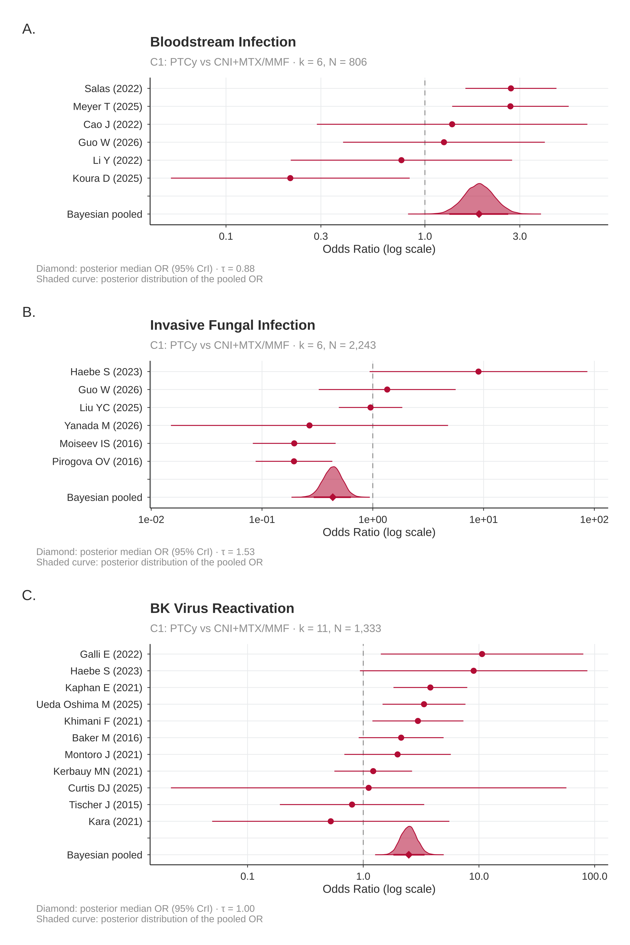
Figure 4: Forest plots — bacterial, fungal, and BK viral infection risk (comparison 1). Individual study odds ratios (raw per-study estimates) and pooled Bayesian random-effects posterior median with 95% credible interval (primary model M1), shown with the posterior density above each pooled row. Panel A: bloodstream infection, any pathogen (k = 6, odds ratio 1·87 [1·33–2·62]). Panel B: invasive fungal infection, any (k = 6, 0·43 [0·29–0·63]; τ = 1·53). Panel C: BK virus reactivation (k = 11, 2·48 [1·82–3·38]), the largest infection effect observed. All panels are comparison 1 (PTCy versus CNI plus MTX or MMF); insufficient studies were available to fit the corresponding comparison 2 models for BSI and IFI. None of these three outcomes was affected by cohort deduplication.

