Pathogen specific risks of post-transplant cyclophosphamide as graft-versus-host disease prophylaxis after allogeneic haematopoietic stem-cell transplantation: a systematic review and Bayesian meta-analysis of infection risk

Marta Stanzani,M.D., Ph.D. ¹ Dimitrios P Kontoyiannis M.D., Sc.D,²
Russell E Lewis, Pharm.D.^{3#}

¹ ULSS2 Marca Trevigiana Health System, Treviso, Italy
² Department of Infectious Diseases, Infection Control and Employee Health, The University of Texas M.D. Anderson Cancer Center, Houston, Texas, USA
³ Department of Molecular Medicine, University of Padua, Padua Italy

# Corresponding author:
Prof. Russell E. Lewis,
Department of Molecular Medicine,
Via Gabelli 63, 35121 Padua, Italy;
email: russelledward.lewis@unipd.it

Summary

Background: Post-transplant cyclophosphamide (PTCy) is increasingly used to prevent graft-versus-host disease (GVHD) after allogeneic haematopoietic stem-cell transplantation (allo-HSCT) but may increase infection risk. We examined its effect on survival, GVHD, and infection outcomes.

Methods: We searched EMBASE, PubMed, and SCOPUS to April 30, 2026, for studies comparing PTCy-based prophylaxis with alternatives in adults undergoing allo-HSCT. Comparisons were PTCy versus calcineurin inhibitor (CNI) plus methotrexate or mycophenolate, versus anti-thymocyte globulin (ATG), and between PTCy-based regimens. Outcomes included overall survival (primary), non-relapse mortality, acute GVHD, CMV reactivation, bloodstream infection (BSI), invasive fungal infection, and BK virus reactivation, pooled by Bayesian random-effects meta-analysis (PROSPERO CRD420261372156).

Findings: Of 4145 records, 250 studies (523 arms; 177 849 patients) were included, 105 in the meta-analysis. Versus CNI-based prophylaxis, PTCy was associated with lower odds of death (OR 0·73, 95% credible interval 0·58–0·89) and grade II–IV acute GVHD (0·58, 0·44–0·76). CMV reactivation was numerically more frequent with PTCy (RR 1·20, 0·87–1·65; posterior probability of RR>1, 0·87), more so in studies published from 2020 (1·43, 0·97–2·06; probability 0·96). BSI risk was also numerically higher but rested on four studies (2·17, 0·86–4·39). Invasive fungal infection did not clearly differ (0·63, 0·19–2·44; 6 studies; τ=1·28). Versus ATG, survival numerically favoured PTCy (0·75, 0·43–1·28) and CMV reactivation did not differ (0·86, 0·51–1·42). BK virus reactivation was increased with PTCy against both CNI-based prophylaxis (2·39, 1·41–3·73) and ATG (2·49, 1·08–6·24; three studies). Certainty of evidence was very low for all outcomes.

Interpretation.: PTCy was associated with less GVHD and possibly better survival than CNI-based prophylaxis, with numerical increases in CMV and bacterial infection. The CMV pattern fits an effect of depth of T-cell depletion, whereas a similar BK virus increase against both comparators suggests a cyclophosphamide-specific effect. These findings support close viral monitoring rather than avoidance of PTCy.

Funding. None
Research in context

Evidence before this study
We searched PubMed, EMBASE, and SCOPUS from database inception to April 30, 2026, for systematic reviews and meta-analyses of post-transplant cyclophosphamide (PTCy) in allogeneic haematopoietic stem-cell transplantation, using the terms “post-transplant cyclophosphamide” AND (“meta-analysis” OR “systematic review”). We found ten comparative meta-analyses, each including 6–30 studies. All examined survival and graft-versus-host disease (GVHD), but only three pooled infection outcomes, with few studies per infection and comparator. None compared PTCy with both calcineurin inhibitor (CNI)-based and anti-thymocyte globulin (ATG)-based prophylaxis, so it remained unclear whether infections seen with PTCy reflect the drug itself or T-cell depletion in general.

Added value of this study
This systematic review and Bayesian meta-analysis (250 studies; 177 849 patients) jointly evaluated survival, GVHD, CMV and BK virus reactivation, bloodstream infection, and invasive fungal disease, comparing PTCy with a less T-cell-depleting regimen (calcineurin inhibitor plus methotrexate or mycophenolate) and a more depleting one (ATG). The odds of CMV reactivation were higher with PTCy than with CNI-based prophylaxis (odds ratio 1·20, 95% credible interval 0·87–1·65; posterior probability of OR > 1, 0·88), whereas the estimate relative to ATG favoured PTCy (OR 0·86, 95% CrI 0·51–1·42; posterior probability of OR < 1, 0·74). This gradient is consistent with the comparators’ differing depth of T-cell depletion, although the credible interval for the difference between comparisons was wide and included the null (ratio of ORs 0·71, 95% CrI 0·41–1·20). By contrast, BK virus reactivation was increased to a similar extent with PTCy relative to both comparators (OR 2·39, 95% CrI 1·41–3·73) vs CNI-based prophylaxis; OR 2·49, 95% CrI 1·08–6·24 vs ATG). Estimates for bloodstream bacterial infection and invasive fungal disease were imprecise and did not indicate a clear difference against either comparator (OR 2·17, 95% CrI 0·86–4·39 and OR 0·63, 95% CrI 0·19–2·44), with sparse and heterogeneous evidence for these outcomes.
This systematic review (250 studies; 177 849 patients) is the first to concurrently evaluate survival, GVHD, CMV, bloodstream infection, and invasive fungal infection, comparing PTCy with both a less T-cell-depleting regimen (CNI plus methotrexate or mycophenolate) and a more depleting one (ATG). CMV reactivation was more frequent with PTCy than with CNI-based prophylaxis (odds ratio 1·20, 95% credible interval 0·87–1·65) but not compared with ATG (0·86, 0·51–1·42), a pattern compatible with the comparators’ depth of T-cell depletion, although a formal test did not confirm the difference (ratio of odds ratios 0·71, 0·41–1·20). BK virus reactivation, by contrast, was increased to a similar extent in all PTCy-containing regimens. There was no statistically significant increase bacterial bloodstream infection or fungal infections against both comparators, although evidence was sparce and heterogeneous.

Implications of all the available evidence
PTCy is associated with less GVHD and better overall survival than CNI-based prophylaxis, although certainty of evidence is very low and adjustment for publication bias weakened these benefits. Infection risks differ by pathogen: CMV risk may follow the depth of T-cell depletion, whereas BK virus risk may be specific to cyclophosphamide induced bladder mucosal injury. For clinicians, this argues for close CMV and BK virus monitoring and for strategies that support immune recovery (optimised letermovir prophylaxis, earlier tapering of immunosuppression, adoptive T-cell therapy) rather than avoiding PTCy. Different PTCy-based regimens showed no detectable differences, but with three to six studies per outcome this is absence of evidence, not evidence of equivalence.

Introduction
Allogeneic haematopoietic stem-cell transplantation (allo-HSCT) is potentially curative for many haematological malignancies, but graft-versus-host disease (GVHD) remains a major cause of morbidity and mortality after transplantation.¹ GVHD prophylaxis must therefore strike a difficult balance: sufficient control of donor T cells to prevent GVHD, without unduly delaying immune reconstitution, weakening the graft-versus-leukaemia effect, or increasing susceptibility to infection.
The introduction of post-transplant cyclophosphamide (PTCy) has substantially changed this balance. Initially developed for haploidentical transplantation, it enables transplantation across HLA barriers and has made haploidentical donors a widely available alternative when no matched donor exists.^{2,3} Its use has since extended to matched related and unrelated donors,⁴ and in the BMT CTN 1703/1801 randomised controlled trial (RCT), PTCy was superior to conventional calcineurin inhibitor (CNI)-based prophylaxis for GVHD-free, relapse-free survival.⁵
The benefits of PTCy must be weighed against effects on immune recovery. Cyclophosphamide given on days +3 and +4 preferentially eliminates the proliferating alloreactive T cells responsible for GVHD,^{6,7} but may also slow recovery of pathogen-memory T cells,⁸ which is important because infections remain a major cause of non-relapse mortality after allo-HSCT.⁹
Whether PTCy itself increases infection risk is uncertain. Compared with CNI-based prophylaxis, CIBMTR registry studies have reported more cytomegalovirus (CMV) reactivation¹⁰ and bacterial bloodstream infection (BSI) with PTCy, with similar or fewer invasive fungal infections (IFI).¹¹ These signals are biologically plausible, but infection risk after transplantation is dynamic and dependent on donor type, conditioning intensity, graft source, GVHD and its corticosteroid treatment, and antimicrobial prophylaxis. Therefore, infection risk associated with PTCy might not reflect a direct effect of cyclophosphamide.
The key clinical question is therefore whether the infection profile of PTCy is specific to the drug or a “marker” of intensive T-cell depletion in general. If the latter, similar infections would be expected with other strongly T-cell-depleting regimens. If particular infections are more frequent with PTCy irrespective of the depth of T cell depletion, a cyclophosphamide-specific effect becomes more likely. Comparing PTCy against both a less depleting comparator (CNI plus methotrexate or mycophenolate) and a more depleting one (anti-thymocyte globulin [ATG]) offers a way to separate these explanations. No previous meta-analysis compared PTCy with both; each included 6–30 studies and focused mainly on GVHD and survival rather than infection.
We therefore performed a systematic review and Bayesian meta-analysis of PTCy-based GVHD prophylaxis in adults undergoing allo-HSCT, evaluating survival, non-relapse mortality, GVHD, and infection outcomes across three prespecified comparisons: PTCy versus CNI plus methotrexate or mycophenolate, PTCy versus ATG, and different PTCy-based regimens.

Methods

Search strategy and selection criteria
This systematic review and meta-analysis was conducted in accordance with PRISMA 2020 guidelines and registered with PROSPERO (CRD420261372156). We searched EMBASE, PubMed, and SCOPUS from database inception to April 30, 2026 for studies comparing PTCy-based GVHD prophylaxis with alternative regimens in adult (≥18 years) allo-HSCT recipients published in English. The complete search strategy is provided in the supplementary appendix (pp 2–4). Reference lists of included studies and relevant reviews were hand-searched. No language restrictions were applied at the search stage; studies not available in English were excluded at full-text review.
Studies were eligible if they reported at least one pre-specified outcome with extractable event counts (numerator and denominator) for at least two arms differing in GVHD prophylaxis strategy. Conference abstracts were excluded. We defined three pre-specified comparisons: C1, PTCy (with or without CNI or mycophenolate mofetil [MMF]) versus CNI plus methotrexate (MTX) or MMF without ATG or T-cell depletion; C2, PTCy versus ATG-based prophylaxis; and C3, within-PTCy regimen variants.
Two reviewers (MS and REL) screened titles and abstracts and full-text publications using the Coevidence platform (www.coevidence.org). Data from PDF source files were extracted into a structured template (appendix p 5) using Claude Opus 4.8 (Anthropic, Inc.) using a purpose-built extraction script (available at https://github.com/lewis-id-lab/ptcy-infection). All extracted values were manually verified by both investigators against source publications. Risk of bias was assessed using ROBINS-I for observational studies and RoB 2 for RCTs. Studies sharing patient cohorts were flagged and the most comprehensive publication was designated as primary publication for each cohort–outcome combination. All pooled estimates reported here were derived from this cohort-deduplicated dataset, so that no patient contributed more than once to any single outcome. The cohort overlap map is provided in the appendix (p 24).

Outcomes
The primary outcome was overall survival (OS), analysed as all-cause mortality (death as the event) at the reported timepoint. Secondary outcomes included non-relapse mortality (NRM), acute GVHD grade II–IV (at day +100), chronic GVHD (moderate to severe), CMV reactivation (any), bloodstream infection (BSI, any pathogen), invasive fungal infection (IFI, any), relapse-related mortality (RRM), BK virus reactivation, and infection-related mortality (IRM).

Statistical analysis
We fitted Bayesian random-effects binomial-logistic regression models using brms (version 2.23.0) with a rstan backend in R (version 4.6.0). The primary model (M1) estimated the PTCy treatment effect with a random intercept and a random PTCy-effect slope for study, so that pooled effects average over between-study heterogeneity in the treatment effect. Each study contributed a single row per outcome with a preferred timepoint where reported (day +100 or +180 for early outcomes, one year for late outcomes), otherwise the nearest reported (fallback) timepoint was used so no within-study correlation across timepoints arises. An indicator variable distinguished fallback from preferred timepoints. Weakly informative priors were specified: N(0, 2·5) on fixed effects, N(0, 1·5) on the intercept, and Student t(3, 0, 1) on the between-study standard deviations (τ). Four chains of 4000 iterations (1000 warmup) were run with adapt_delta = 0·95 (increased to 0·99 where divergent transitions occurred). Convergence was assessed by R̂ and effective sample size. Single-arm descriptive studies (n = 26) were retained for the PRISMA flow diagram and descriptive tabulation only; without contributing outcome data to any comparative model, all of which are restricted to studies reporting event counts for both a PTCy and a non-PTCy arm. Arms receiving PTCy together with anti-thymocyte globulin were classified as PTCy arms in all three comparisons; a sensitivity analysis excluding the C2 studies containing such arms is reported in appendix S9.
An exploratory steroid-adjustment model (M2), a post-hoc amendment to the registered protocol (appendix S13), added arm-level systemic corticosteroid exposure as a covariate. Because the covariate is post-treatment and arm-level, and in most arms approximated from acute GVHD incidence rather than directly reported, M2 estimates no indirect effect and is reported only in the appendix (S9), together with its definition, provenance, results, and a matched-set comparison against M1.
Pre-specified sensitivity analyses included restriction to publications from 2020 onward (a publication-year, not enrolment-era, subset, spanning the letermovir-introduction period), to haploidentical-dominant cohorts (≥50% haploidentical donors), and leave-one-out analysis. Hazard ratios were not pooled in the primary analysis because most studies reported only event counts or Kaplan–Meier estimates at fixed timepoints; in a post-hoc sensitivity analysis, the reported overall-survival hazard ratios (multivariable-adjusted where available, one per study, direction harmonised to PTCy versus comparator with death as the event) were pooled two-stage under a random-effects model (appendix S9). Frequentist random-effects models (restricted maximum likelihood [REML], metafor version 5.0.1) were fitted as concordance checks. Publication bias was assessed using robust Bayesian model-averaging (RoBMA). Certainty of evidence was assessed using the GRADE framework adapted for observational evidence.

Role of the funding source
There was no funding source for this study.

Results

Search results and study characteristics
The search identified 4145 records (EMBASE 2603, PubMed 1061, SCOPUS 481), of which 1220 were duplicates (Figure 1). After screening 2925 titles and abstracts, 517 articles were sought for full-text review; 52 could not be retrieved or were not in English. Of 465 full-text articles assessed, 215 were excluded (appendix pp 6–14), leaving 250 studies for the systematic review. Of these, 105 had sufficient details to contribute outcome data to the meta-analysis: 72 compared PTCy with CNI plus methotrexate (MTX) or mycophenolate mofetil (MMF) (C1), 27 compared PTCy with ATG (C2), and 13 compared different PTCy-based regimens (C3); seven studies contributed to more than one comparison (per-outcome attrition in appendix S12).
The 224 comparative studies included 518 treatment arms and 177 461 patients (Table 1). Most were retrospective cohorts (131 [58%]) or registry studies (62 [28%]); only 14 (6%) were RCTs. Median publication year was 2023 (IQR 2021–24) and median follow-up 26 months (22–36).
PTCy was used mostly in haploidentical transplantation (126 [46%] of PTCy arms), whereas comparator arms were mostly matched unrelated (94 [38%]) or matched sibling (54 [22%]) donor transplants. Because donor type itself influences GVHD, infection, and survival, this imbalance was addressed in sensitivity analyses.

Risk of bias
Of 210 comparative observational studies assessed with ROBINS-I, 142 (68%) were at serious and 68 (32%) at moderate risk of bias, mainly because of confounding by donor type and conditioning intensity; none was at low or critical risk (appendix pp 15–17). Of the 14 RCTs (assessed with RoB 2), 11 had some concerns, two were at high risk, and one was at low risk. Measurement concerns (three trials) affected clinician-judged outcomes such as GVHD grading and infection ascertainment, not objective outcomes such as mortality or laboratory-confirmed BSI.

PTCy versus CNI plus MTX or MMF

Survival and GVHD
Compared with CNI plus MTX or MMF, PTCy was associated with better overall survival (k = 29; odds ratio [OR] 0·73, 95% credible interval [CrI] 0·58–0·89; Figure 2). Non-relapse mortality (NRM) showed a trend towards benefit, but the estimate was uncertain (k = 11; 0·84, 0·48–1·28), and relapse-related mortality was modestly lower (k = 34; 0·87, 0·76–0·99). The effect on GVHD was more consistent: PTCy was associated with less grade II–IV acute GVHD (k = 28; 0·58, 0·44–0·76) and less moderate-to-severe chronic GVHD (k = 18; 0·41, 0·23–0·72).

Infections
CMV reactivation was more frequent with PTCy on average, but the credible interval included no difference (k = 21; 1·20, 0·87–1·65; Figure 3). The estimate was larger in studies published from 2020 onward (k = 16; 1·43, 0·97–2·06) and in haploidentical-dominant cohorts (k = 12; 1·34, 0·89–1·96). In the primary BSI analysis, restricted to culture-confirmed bacterial infection by day +100, the odds were about twice as high with PTCy (k = 4; 2·17, 0·86–4·39), but with only four studies this estimate is uncertain; no BSI model was possible for comparison 2. BK virus reactivation showed the clearest signal, and was the only infection outcome whose credible interval excluded no difference (k = 11; 2·39, 1·41–3·73; Figure 4). Invasive fungal infection did not clearly differ (k = 6; 0·63, 0·19–2·44); the estimate rests on few studies with extreme between-study variation (τ = 1·28). Infection-related mortality was not increased with PTCy (k = 13; 1·02, 0·67–1·50).

PTCy versus ATG
Fewer studies compared PTCy with ATG, so these estimates were associated with less certainty. Overall survival favoured PTCy, but not conclusively (k = 6; 0·75, 0·43–1·28), as did acute GVHD (k = 7; 0·53, 0·23–1·17) and relapse-related mortality (k = 10; 0·79, 0·55–1·03). NRM could not be assessed because only two studies provided usable data. The infection pattern differed from comparison 1: CMV reactivation did not differ between PTCy and ATG (k = 12; 0·86, 0·51–1·42), nor did infection-related mortality (k = 7; 0·98, 0·62–1·77). BK virus reactivation was again higher with PTCy (k = 3; 2·49, 1·08–6·24), although this estimate rests on only three studies.

Different PTCy-based regimens
We found no clear differences between PTCy-based regimen variants for overall survival (OR 1·05), NRM (0·55), acute GVHD (0·31), chronic GVHD (0·60), or relapse-related mortality (0·78); all credible intervals included no difference. With only three to six studies per outcome, this reflects insufficient evidence to detect a difference, not evidence that the regimens are equivalent.

Sensitivity analyses
The main findings were broadly unchanged in sensitivity analyses (appendix S9). Within individual studies, the proportion of haploidentical donors differed little between arms (median difference 0), adjusting for this difference did not change any comparison 1 estimate, and restricting to studies with closely matched donor types (difference ≤15 percentage points) strengthened rather than weakened the survival association (k = 21; 0·58, 0·41–0·78). Trial-only analyses were not possible, because no more than two trials per outcome reported observed event counts; analyses restricted to observational studies gave results similar to the main analysis (overall survival 0·79, 0·63–0·96, k = 26; acute GVHD 0·59, 0·44–0·78, k = 27; chronic GVHD 0·48, 0·27–0·86, k = 14; NRM 0·91, 0·57–1·36, k = 10; CMV 1·01, 0·64–1·64, k = 7). Pooled overall-survival hazard ratios (mostly multivariable-adjusted) showed a consistent but attenuated effect (hazard ratio 0·88, 0·66–1·14, k = 14; count-based OR in the same studies 0·75, 0·57–0·93).
The survival association appeared stronger against CNI plus MTX (0·56, 0·34–0·84; k = 12) than against CNI plus MMF (1·10, 0·44–3·01; k = 5), but a formal test did not confirm that the comparator backbone explains this difference (ratio of ORs 1·82, 0·76–4·53). For CMV, restricting to clinically significant infection rather than any reactivation gave an estimate compatible with both a decrease and an increase (0·94, 0·49–1·71; k = 8), which does not establish that clinically significant CMV infection is unaffected by PTCy. Adjusting for a letermovir enrollment-era proxy did not change the CMV estimate (1·20, 0·86–1·67). No arm in the 2020-onward subset had recorded letermovir use, and most of these cohorts enrolled before or across the letermovir era, so the larger recent estimate cannot be attributed to letermovir.

Certainty of evidence
Certainty of evidence (GRADE) was very low for all prespecified outcomes (Table 2; appendix S10–S11), mainly because of the predominance of observational studies, risk of confounding, between-study inconsistency, and imprecision. Imprecision was judged against clinically meaningful thresholds (OR 0·80 for benefit, 1·25 for harm). Every prespecified outcome was downgraded for imprecision except C1 acute GVHD, whose interval lay entirely below 0·80; this outcome was nevertheless rated very low because of inconsistency and publication bias. Among secondary outcomes added by protocol amendment, certainty was low for BK virus reactivation versus CNI-based prophylaxis and very low for the remainder (appendix S11).
Publication-bias analyses (robust Bayesian model-averaging) found strong evidence of bias for both overall survival and acute GVHD in comparison 1 (Bayes factors for bias 10·4 and 10·9). After adjustment, both estimates were close to no effect (overall survival 0·97, 0·71–1·16; acute GVHD 0·96, 0·57–1·38; appendix S10), so the size of the unadjusted benefits should be interpreted cautiously.

Discussion
This systematic review and meta-analysis of 250 studies (over 177 000 patients) evaluated the benefits and infection risks of PTCy-based GVHD prophylaxis within a single analytic framework. Its central finding is that the infection profile of PTCy may depend on both the comparator and the pathogen.

Survival and GVHD
The reduction in GVHD is consistent with how PTCy mechanism of action. Given shortly after transplantation, it targets the rapidly dividing donor T cells responsible for alloreactivity.^{16,17} In comparison 1, PTCy was associated with about 108 fewer cases of grade II–IV acute GVHD per 1000 patients (from a median comparator-arm incidence of 33%) and about 68 fewer deaths per 1000 patients by one year (from a median comparator-arm mortality of 35%). Better GVHD control may reduce the need for prolonged immunosuppression and corticosteroids, which contribute to both infection and non-relapse mortality, as GVHD and its treatment are leading drivers of non-relapse mortality.¹¹An exploratory steroid-adjustment analysis (appendix S9) was compatible with this pathway. These findings extend the matched-donor result of BMT CTN 1703¹⁵ across donor types, conditioning regimens, and geographic settings, although the ATG comparison was underpowered relative to comparison 1.

CMV
The odds of CMV reactivation were about 20% higher with PTCy than with CNI-based prophylaxis, with substantial uncertainty, but were not increased compared with ATG. One explanation is that CMV risk follows the depth of T-cell depletion rather than cyclophosphamide itself. CNI-based prophylaxis, PTCy, and ATG deplete T cells to increasing degrees, and impaired CMV-specific cellular immunity is a key determinant of reactivation.¹⁸ However, our analysis cannot prove this. A formal comparison of the two pooled CMV estimates did not resolve the difference (ratio of ORs 1·41, 0·76–2·54), nor did a meta-regression on comparator class pooling both datasets (k = 33; 0·71, 0·41–1·20; appendix S9). Moreover, the two comparisons enrolled different populations (mainly haploidentical transplants in comparison 1, matched donors in comparison 2), so differences between them may reflect the patient profile rather than the type of GVHD prophylaxis. The depletion-depth ordering (CNI-based < PTCy < ATG) is therefore a hypothesis compatible with the data, not a proven hierarchy. One external comparison supports it: in a meta-analysis of haploidentical transplantation, CMV reactivation was more frequent with combined ATG–PTCy than with PTCy alone (risk ratio 1·42, 1·03–1·95) but similar to ATG alone (1·04, 0·74–1·45).⁸

BK virus
BK virus showed a different pattern with an increase was almost identical against CNI-based prophylaxis and ATG (OR 2·39 vs 2·49; ratio 0·96, 0·33–2·50). This is compatible with a cyclophosphamide-specific effect rather than a general effect of T-cell depletion. Cyclophosphamide is a recognised cause of haemorrhagic cystitis, of which BK virus reactivation is a major driver after allo-HSCT.^{22–24} With only three prior-influenced studies versus ATG, this interpretation is preliminary.

Bacterial and fungal infections
The data suggest a possible increase in bacterial BSI with PTCy, but with four studies the size of this risk cannot be established. There was no convincing evidence that PTCy affects IFI. The few available studies were highly heterogeneous, probably reflecting differences in antifungal prophylaxis, heterogeneity in fungal diagnostic strategies and the estimate is compatible with anything from a large reduction to a large increase. Importantly, infection-related mortality was not increased.

Balancing benefits and risks
For clinicians, PTCy should not be regarded simply as “higher-risk” or “lower-risk” for infection. The data instead suggest a trade-off: better GVHD control and possibly better survival, alongside greater susceptibility to selected infections, particularly CMV and BK virus. Absolute effects are more informative than ORs. At the median comparator-arm rates, the CMV OR of 1·20 corresponds to about 46 additional reactivations per 1000 patients by day +100 (a relative risk of about 1·09 at a 48% baseline) and refers to reactivation rather than clinically significant disease. The BK OR of 2·39 corresponds to about 134 additional cases per 1000 patients from a 13% baseline, although BK definitions and screening varied between studies. These findings support careful CMV and BK virus monitoring in patients receiving PTCy, appropriate antiviral prophylaxis such as letermovir,²⁵ and pre-emptive treatment of clinically significant infection. They do not justify avoiding PTCy because of infection concerns. Mitigation is more likely to come from strategies that improve immune recovery, such as effective CMV prophylaxis, earlier tapering of unnecessary immunosuppression, and adoptive transfer of pathogen-specific T cells. The larger CMV estimate in recent publications remains unexplained.
Reporting of infectious complications in alloSCT GvHD prophylaxis studies
Only 105 out of 250 eligible studies (60%) had sufficient information regarding infectious complications for analysis. In addition, inconsistencies in infection reporting and definitions made data pooling more difficult. Clearly there is a need for a minimum standard for core reporting dataset consisting of category, site, severity, organism, and endpoints was developed as for reporting of infection events in immunocompromised patients across all study types in oncology. The standardised reporting of infectious events and attributable complications in immunocompromised patients will improve, in addition to diagnostic, treatment, and prevention approaches, future meta-analyses of pooled databases.
Future studies should measure immune reconstitution alongside infection outcomes..

Limitations
This study has several limitations. First, most evidence was observational; although sensitivity analyses were generally consistent, residual confounding by donor type, conditioning intensity, transplant platform, antimicrobial prophylaxis, diagnostic approaches and centre specific variances in supportive care practices cannot be excluded. Second, infection definitions varied (for example, any CMV reactivation versus clinically significant infection; any positive blood culture versus BSI requiring intensive care). Third, due to inconsistency of reporting, there was no information about the severity of infection at presentation. nor a follow up of their evolution Fourth, several comparisons rest on only a handful of studies: our for bloodstream infection, six for invasive fungal infection, and three for BK virus versus ATG. With so few studies, the data say very little about how much the true effect varies from one study to the next, so that part of the model is driven largely by the prior we chose rather than by the evidence. The practical consequence is that the credible intervals for these sparse outcomes (six studies or fewer) are probably narrower than they should be and are best read as a lower bound on the real uncertainty.. Fifth, IFI showed extreme heterogeneity, probably reflecting antifungal prophylaxis and local epidemiology and diagnostic approaches. Sixth, cohort deduplication removed the largest registry publications from seven outcomes where a smaller series reports the same patients in more detail, so the survival and chronic GVHD analyses rest on fewer patients than the size of the review suggests (appendix S12). Finally, publication bias is a concern: the survival and acute GVHD benefits were substantially attenuated after adjustment, so the magnitude of benefit in the primary analysis should not be assumed to be the true treatment effect. Similarly, the absence of differences between PTCy-based regimens, with three to six studies per outcome, does not support flexibility in dosing or backbone selection.
In conclusion, PTCy-based prophylaxis was associated with less acute and chronic GVHD and better overall survival than CNI plus MTX or MMF, although this evidence was predominantly observational and weakened by publication-bias adjustment. The infection findings were pathogen-specific: possible increases in CMV reactivation and bacterial BSI versus CNI-based prophylaxis, the most consistent increase in BK virus reactivation, and no clear CMV increase versus ATG. Whether CMV risk follows T-cell depletion depth and BK risk follows cyclophosphamide itself remains a hypothesis. The evidence supports a benefit–risk trade-off. PTCy provides effective GVHD control, and clinicians should remain attentive to CMV, BK virus reactivations, and potentially excess of bloodsteam bacterial infections. Given the very low certainty of evidence, these findings should inform, not replace, adequately powered randomised trials.

Contributors
REL, MS, and DPK developed the study protocol. REL and MS performed the searches, data extraction, risk of bias assessment, and statistical analysis, and MS wrote the first draft of the report. MS and REL verified the extracted data. DPK revised the manuscript. All authors had full access to all the data in the study and had final responsibility for the decision to submit for publication.

Declaration of interests
MS and REL declare no competing interests. DPK: honoraria and research support (Gilead, Astellas), consulting fees (Astellas, Merck, Knight), and data-review committee roles (Cidara, AbbVie, Scynexis, Mycoses Study Group)

Data sharing
Individual study-level data extracted for this systematic review, including the complete extraction database and analytic datasets, are available on a public GitHub repository https://github.com/lewis-id-lab/ptcy-infection.git. The manuscript source, including the notebooks that generate every table and figure, is available with a rendered version for review at https://lewis-id-lab.github.io/ptcy-infection/. The study protocol is registered with PROSPERO (CRD420261372156).

Use of artificial intelligence
AI tools (Claude Code, Anthropic, Inc.) were used to aid data extraction from original PDF source documents into a data collection form. AI-extracted values were manually by investigators verified against source publications. Posit Assistant (Posit, Inc.) was used for R statistical code debugging within the Positron integrated development environment (IDE) during analysis. The authors take full responsibility for the analysis and manuscript contents.

References

1 Zeiser R, Blazar BR. Acute graft-versus-host disease — biologic process, prevention, and therapy. The New England Journal of Medicine 2017; 377: 2167–79.
2 O’Donnell PV, Luznik L, Jones RJ, et al. Nonmyeloablative bone marrow transplantation from partially HLA-mismatched related donors using posttransplantation cyclophosphamide. Biology of Blood and Marrow Transplantation: Journal of the American Society for Blood and Marrow Transplantation 2002; 8: 377–86.
3 Luznik L, O’Donnell PV, Symons HJ, et al. HLA-haploidentical bone marrow transplantation for hematologic malignancies using nonmyeloablative conditioning and high-dose, posttransplantation cyclophosphamide. Biology of Blood and Marrow Transplantation: Journal of the American Society for Blood and Marrow Transplantation 2008; 14: 641–50.
4 Kanakry CG, Fuchs EJ, Luznik L. Modern approaches to HLA-haploidentical blood or marrow transplantation. Nature Reviews Clinical Oncology 2016; 13: 10–24.
5 Bolaños-Meade J, Hamadani M, Wu J, et al. Post-transplantation cyclophosphamide-based graft-versus-host disease prophylaxis. The New England Journal of Medicine 2023; 388: 2338–48.
6 Kanakry CG, Ganguly S, Zahurak M, et al. Aldehyde dehydrogenase expression drives human regulatory t cell resistance to posttransplantation cyclophosphamide. Science Translational Medicine 2013; 5: 211ra157.
7 Wachsmuth LP, Patterson MT, Eckhaus MA, Venzon DJ, Gress RE, Kanakry CG. Post-transplantation cyclophosphamide prevents graft-versus-host disease by inducing alloreactive t cell dysfunction and suppression. The Journal of Clinical Investigation 2019; 129: 2357–73.
8 Zhao C, Bartock M, Jia B, et al. Post-transplant cyclophosphamide alters immune signatures and leads to impaired t cell reconstitution in allogeneic hematopoietic stem cell transplant. Journal of Hematology & Oncology 2022; 15: 64.
9 Styczyński J, Tridello G, Koster L, et al. Death after hematopoietic stem cell transplantation: Changes over calendar year time, infections and associated factors. Bone Marrow Transplantation 2020; 55: 126–36.
10 Goldsmith SR, Abid MB, Auletta JJ, et al. Posttransplant cyclophosphamide is associated with increased cytomegalovirus infection: A CIBMTR analysis. Blood 2021; 137: 3291–305.
11 Papanicolaou GA, Chen M, He N, et al. Incidence and impact of fungal infections in post-transplantation cyclophosphamide-based graft-versus-host disease prophylaxis and haploidentical hematopoietic cell transplantation: A center for international blood and marrow transplant research analysis. Transplantation and Cellular Therapy 2024; 30: 114.e1–16.
12 Kaphan E, Germi R, Bailly S, et al. Risk factors of BK viral hemorrhagic cystitis in allogenic hematopoietic stem cell transplantation. Transplant Infectious Disease 2021; 23: e13601.
13 Ruggeri A, Roth-Guepin G, Battipaglia G, et al. Incidence and risk factors for hemorrhagic cystitis in unmanipulated haploidentical transplant recipients. Transplant Infectious Disease 2015; 17: 822–30.
14 Chorão P, Villalba M, Balaguer-Roselló A, Montoro J, Granados P, Gilabert C. Incidence, risk factors, and outcomes of BK hemorrhagic cystitis in hematopoietic stem cell transplantation from HLA-matched and haploidentical donors with post-transplant cyclophosphamide. Transplantation and Cellular Therapy 2025; 31: 182.e1–11.
15 Marty FM, Ljungman P, Chemaly RF, et al. Letermovir prophylaxis for cytomegalovirus in hematopoietic-cell transplantation. New England Journal of Medicine 2017; 377: 2433–44.

Tables
Table 1: Characteristics of included studies. Data are n (%) or median (IQR) unless otherwise stated. *Median of arm-level values; IQR reflects between-arm variability. Steroid exposure is the percentage of arm patients receiving systemic corticosteroids for graft-versus-host disease (appendix S9). MUD = matched unrelated donor. MMUD = mismatched unrelated donor. MSD = matched sibling donor. PBSC = peripheral blood stem cells. BM = bone marrow. UCB = umbilical cord blood. MAC = myeloablative conditioning. RIC = reduced-intensity conditioning. NMA = non-myeloablative. NR = not reported.
Characteristic | PTCy arms (n=271) | Comparator arms (n=247)
Studies
Comparative (≥2 arms) | 224
Single-arm descriptive | 26
Arms | 271 | 247
Total patients | 177 849
Unique patients after cohort deduplication | 111 214
RCTs | 14 (6%)
Study design
Retrospective cohort | 131 (58%)
Registry analysis | 62 (28%)
Prospective cohort | 17 (8%)
Publication year, median (IQR) | 2023 (2021–24)
Follow-up, months, median (IQR) | 26 (22–36)
ROBINS-I overall judgement (n=210)
Serious | 142 (68%)
Moderate | 68 (32%)
Low / Critical | 0
Arm-level characteristics
Patients per arm, median (IQR) | 99 (46–212) | 119 (50–375)
Age, years, median (IQR)* | 52·0 (45·0–58·0) | 53·0 (43·0–57·9)
Male, %* | 57·3 (54·0–61·6) | 57·4 (53·0–61·8)
Donor type (predominant)
Haploidentical | 126 (46%) | 35 (14%)
MUD (10/10) | 64 (24%) | 94 (38%)
MMUD (9/10 or lower) | 29 (11%) | 28 (11%)
MSD | 29 (11%) | 54 (22%)
Mixed / other / NR | 23 (8%) | 36 (15%)
Graft source (predominant)
PBSC | 204 (75%) | 181 (73%)
BM | 31 (11%) | 11 (4%)
UCB | — | 18 (7%)
Mixed / NR | 36 (13%) | 37 (15%)
Conditioning (predominant)
RIC | 110 (41%) | 85 (34%)
MAC | 106 (39%) | 119 (48%)
NMA | 7 (3%) | 3 (1%)
Mixed / NR | 48 (18%) | 40 (16%)
CMV R+, %* | 74·8 (65·8–80·1) | 69·4 (59·5–81·3)
Steroid exposure, %* | 26·6 (20·0–32·9) | 34·8 (28·4–43·7)

Table 2: Bayesian meta-analysis results: outcomes by comparison. Estimates are from the cohort-deduplicated dataset, in which one publication per cohort contributes to each outcome. M1 = primary model with a random study intercept and a random PTCy-effect slope, adjusted for timepoint; τ is the between-study standard deviation of the PTCy effect (posterior median). k = number of paired studies. N = total patients across all arms. CrI = credible interval. PI = prediction interval for the PTCy effect in a new study, from the posterior of the random PTCy-effect slope. GRADE ratings are shown for C1 and C2 comparisons of the pre-specified outcomes and the secondary outcomes added by protocol amendment (appendix S11); C3 outcomes were not rated. OR < 1 favours PTCy for survival and GVHD outcomes; OR > 1 indicates elevated risk with PTCy for infection outcomes.
Outcome | Comparison | Model | k | N | OR (95% CrI) | τ | 95% PI | GRADE
Overall survival | C1 | M1 | 29 | 9 295 | 0·73 (0·58–0·89) | 0·42 | 0·29–1·82 | Very low
 | C2 | M1 | 6 | 12 325 | 0·75 (0·43–1·28) | 0·51 | 0·19–2·92 | Very low
 | C3 | M1 | 5 | 4 688 | 1·05 (0·49–1·88) | 0·49 | 0·20–4·47 | —
Non-relapse mortality | C1 | M1 | 11 | 1 231 | 0·84 (0·48–1·28) | 0·39 | 0·20–2·72 | Very low
 | C2 | M1 | — | — | k=2, not assessed | — | — | —
 | C3 | M1 | 3 | 2 405 | 0·55 (0·11–2·44) | 1·09 | 0·02–13·25 | —
Relapse-related mortality | C1 | M1 | 34 | 11 121 | 0·87 (0·76–0·99) | 0·08 | 0·64–1·18 | Very low
 | C2 | M1 | 10 | 17 182 | 0·79 (0·55–1·03) | 0·19 | 0·35–1·70 | Very low
 | C3 | M1 | 6 | 692 | 0·78 (0·35–1·67) | 0·43 | 0·15–3·96 | —
Acute GVHD II–IV | C1 | M1 | 28 | 4 197 | 0·58 (0·44–0·76) | 0·55 | 0·18–1·88 | Very low
 | C2 | M1 | 7 | 983 | 0·53 (0·23–1·17) | 0·86 | 0·06–4·32 | Very low
 | C3 | M1 | 5 | 2 326 | 0·31 (0·06–1·46) | 1·43 | 0·01–17·79 | —
Chronic GVHD mod–severe | C1 | M1 | 18 | 2 762 | 0·41 (0·23–0·72) | 0·97 | 0·05–3·46 | —
 | C2 | M1 | 6 | 905 | 0·70 (0·26–1·59) | 0·75 | 0·07–5·75 | —
Chronic GVHD any | C1 | M1 | 8 | 1 732 | 0·24 (0·14–0·42) | 0·56 | 0·06–0·99 | —
 | C3 | M1 | 3 | 325 | 0·60 (0·15–2·30) | 0·80 | 0·04–10·61 | —
CMV reactivation | C1 | M1 | 21 | 3 131 | 1·20 (0·87–1·65) | 0·56 | 0·35–4·14 | Very low
 | C2 | M1 | 12 | 1 511 | 0·86 (0·51–1·42) | 0·68 | 0·16–4·29 | Very low
Bloodstream infection | C1 | M1 | 4 | 636 | 2·17 (0·86–4·39) | 0·43 | 0·35–9·99 | Very low
Invasive fungal infection | C1 | M1 | 6 | 2 243 | 0·63 (0·19–2·44) | 1·28 | 0·02–20·02 | Very low
BK virus | C1 | M1 | 11 | 1 333 | 2·39 (1·41–3·73) | 0·36 | 0·71–7·33 | Low
 | C2 | M1 | 3 | 313 | 2·49 (1·08–6·24) | 0·33 | 0·55–12·13 | Very low
Infection-related mortality | C1 | M1 | 13 | 5 504 | 1·02 (0·67–1·50) | 0·48 | 0·29–3·10 | Very low
 | C2 | M1 | 7 | 13 346 | 0·98 (0·62–1·77) | 0·41 | 0·31–3·53 | Very low

Figures
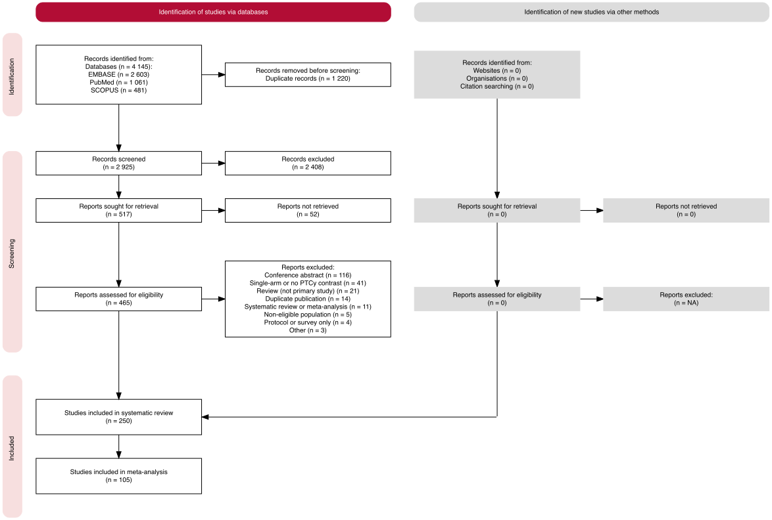
Figure 1: Study selection (PRISMA 2020 flow diagram). 4145 records were identified from databases (EMBASE 2603, PubMed 1061, SCOPUS 481) and 1220 duplicates removed. 2925 records were screened and 2408 excluded at title and abstract. 517 reports were sought for retrieval; 52 were not retrieved or not in English (not recorded as separate counts). 465 full-text reports were assessed and 215 excluded (appendix pp 6–14). 250 studies were included in the systematic review; one publication entered twice during extraction was removed during revision (appendix S12). 105 unique studies contributed outcome data to the meta-analysis (C1 72 studies; C2 27 studies; C3 13 studies; 7 studies contribute to more than one comparison). Reference lists, citation tracking, and PROSPERO registrations were also searched but yielded no separately recorded reports, so the identification-via-other-methods branch of the diagram shows zero.

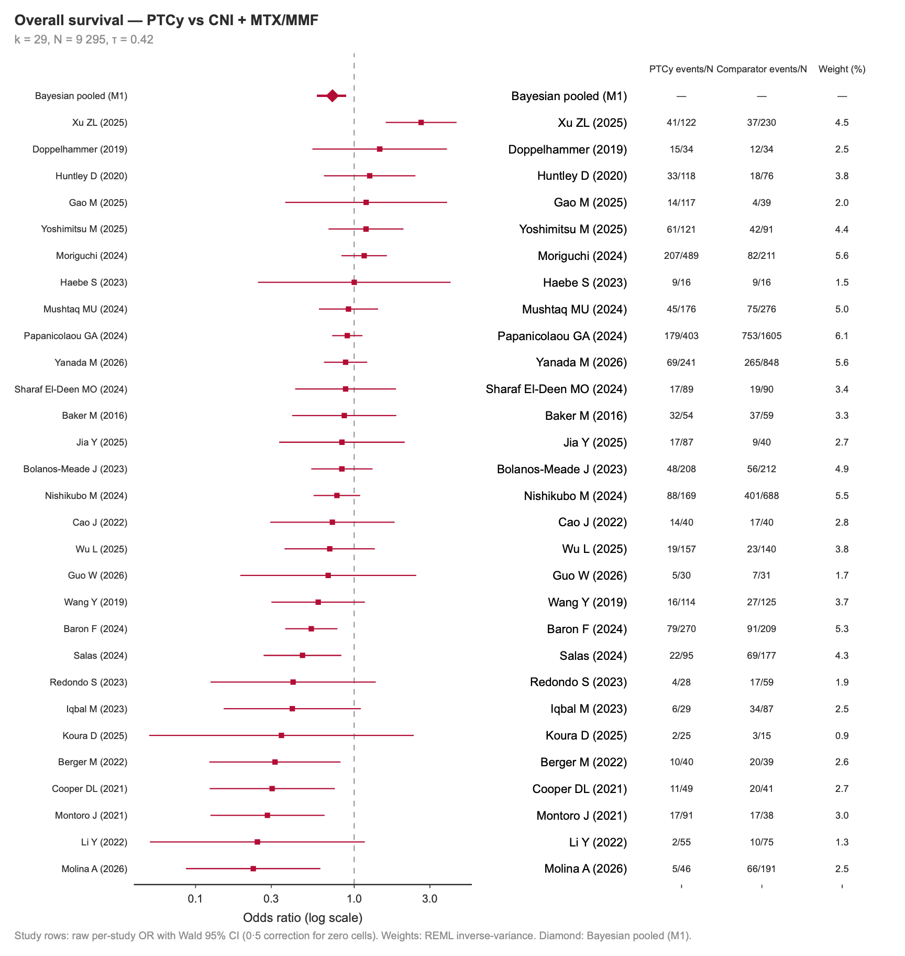
Figure 2: Forest plot — overall survival, comparison 1 (PTCy vs CNI + MTX/MMF). Study rows are raw per-study odds ratios with Wald 95% CIs, computed from the extracted event counts; the diamond is the pooled Bayesian random-effects posterior median with 95% credible interval (primary model M1). Events and totals of each arm and REML inverse-variance weights are shown beside each study row; a 0·5 continuity correction was applied to zero cells when computing the Wald intervals. k = 29 after cohort deduplication, removal of one duplicate publication, and exclusion of cumulative-incidence-derived event counts (appendix).

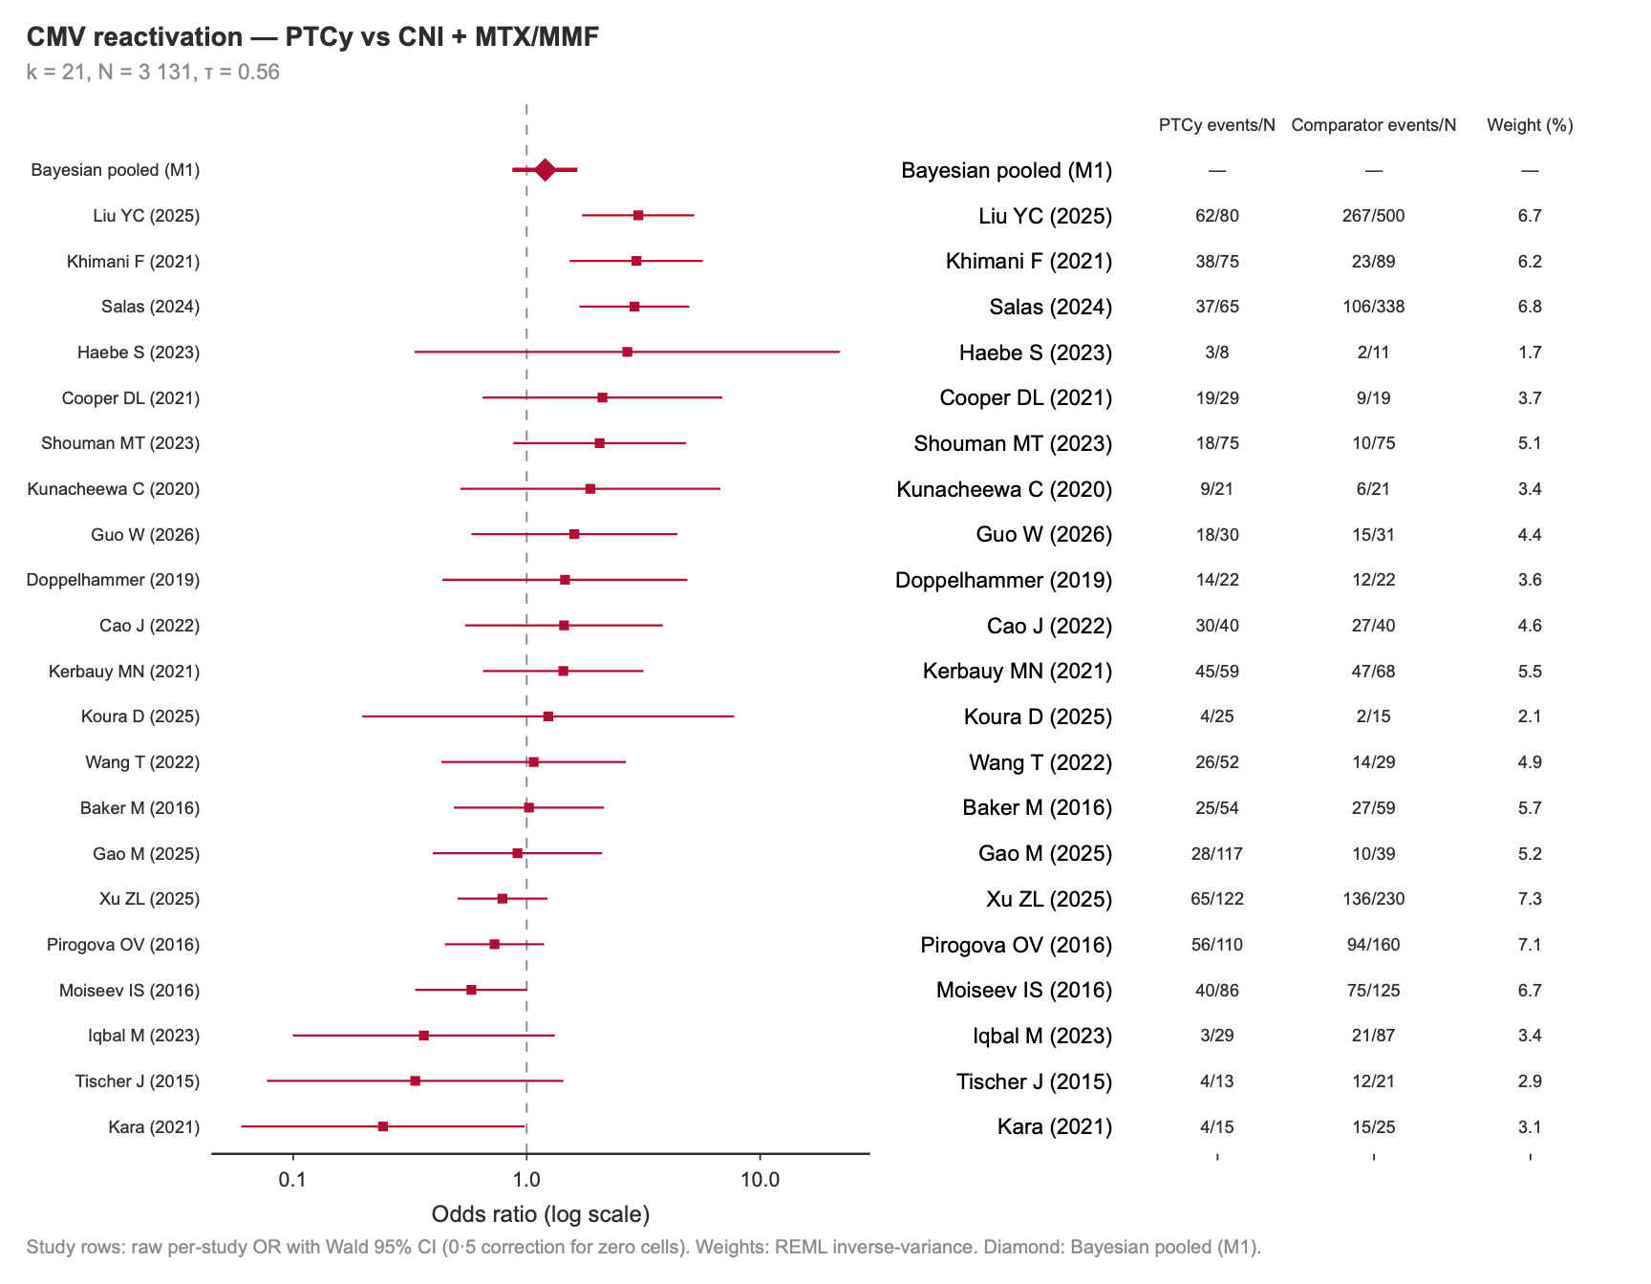
(a) Comparison 1: PTCy vs CNI + MTX/MMF (k = 21, odds ratio 1·20 [0·87–1·65])

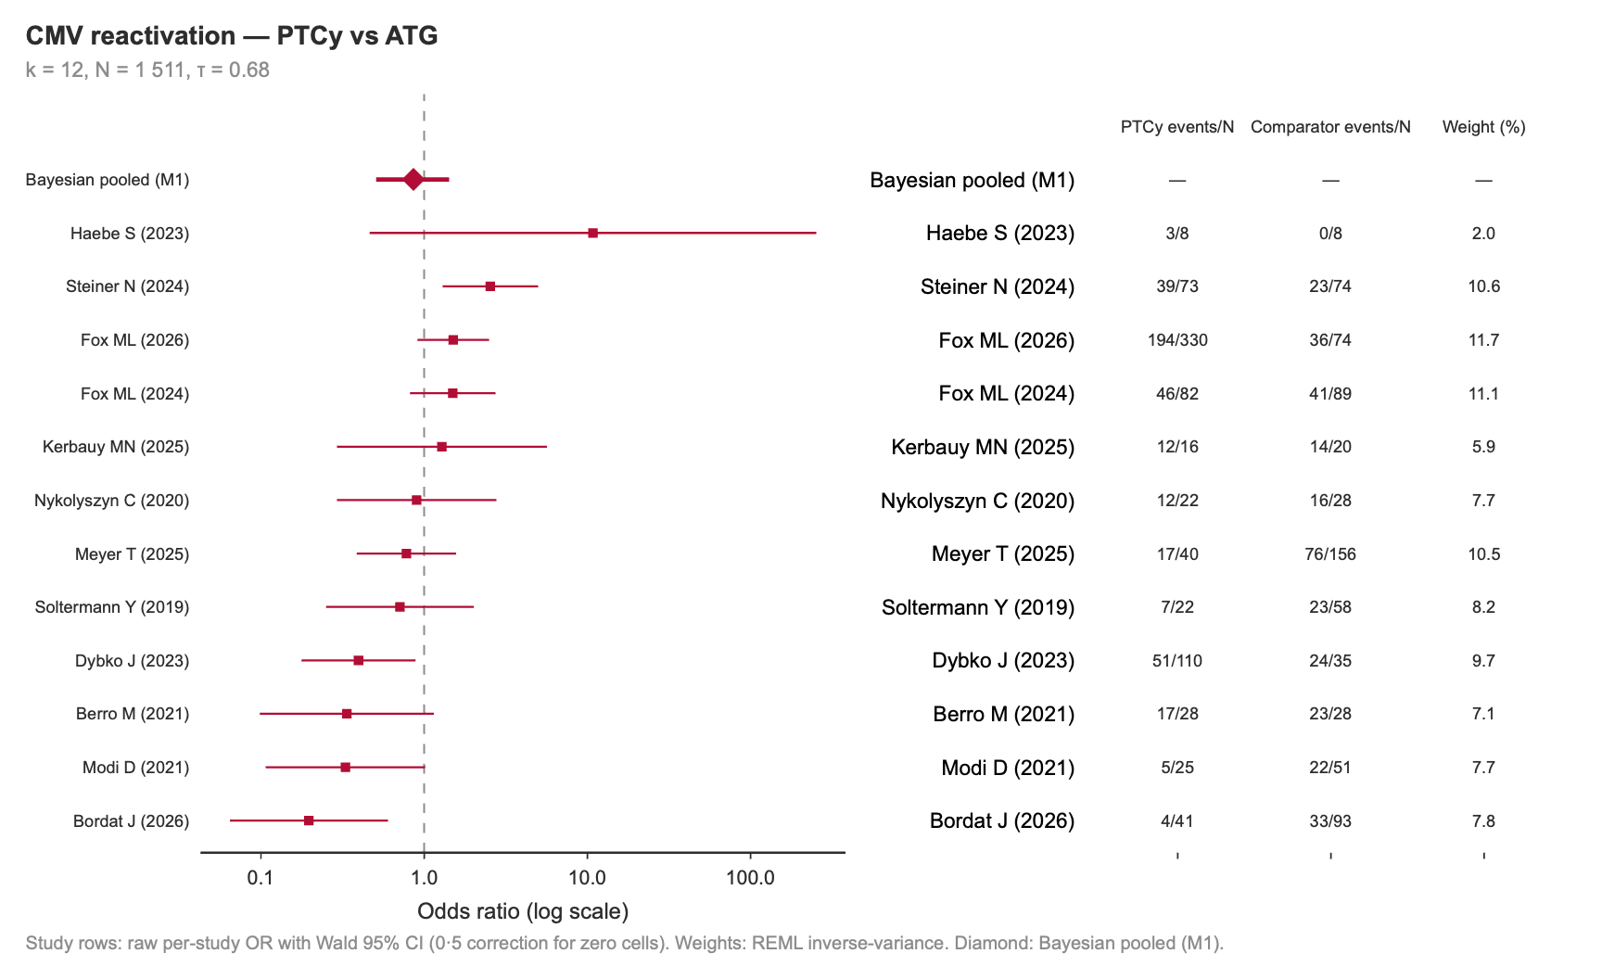

(b) Comparison 2: PTCy vs ATG (k = 12, 0·86 [0·50–1·42])

Figure 3: Forest plots — CMV reactivation. Individual study odds ratios for any CMV reactivation, with the pooled Bayesian posterior median and 95% credible interval. The pooled odds ratio was 1·20 (95% credible interval 0·87–1·65) against CNI-based prophylaxis and 0·86 (0·50–1·42) against ATG; both intervals include the null, and the formal comparator-class comparison is unresolved (appendix S9). Events, totals, and REML inverse-variance weights are shown beside each study row.

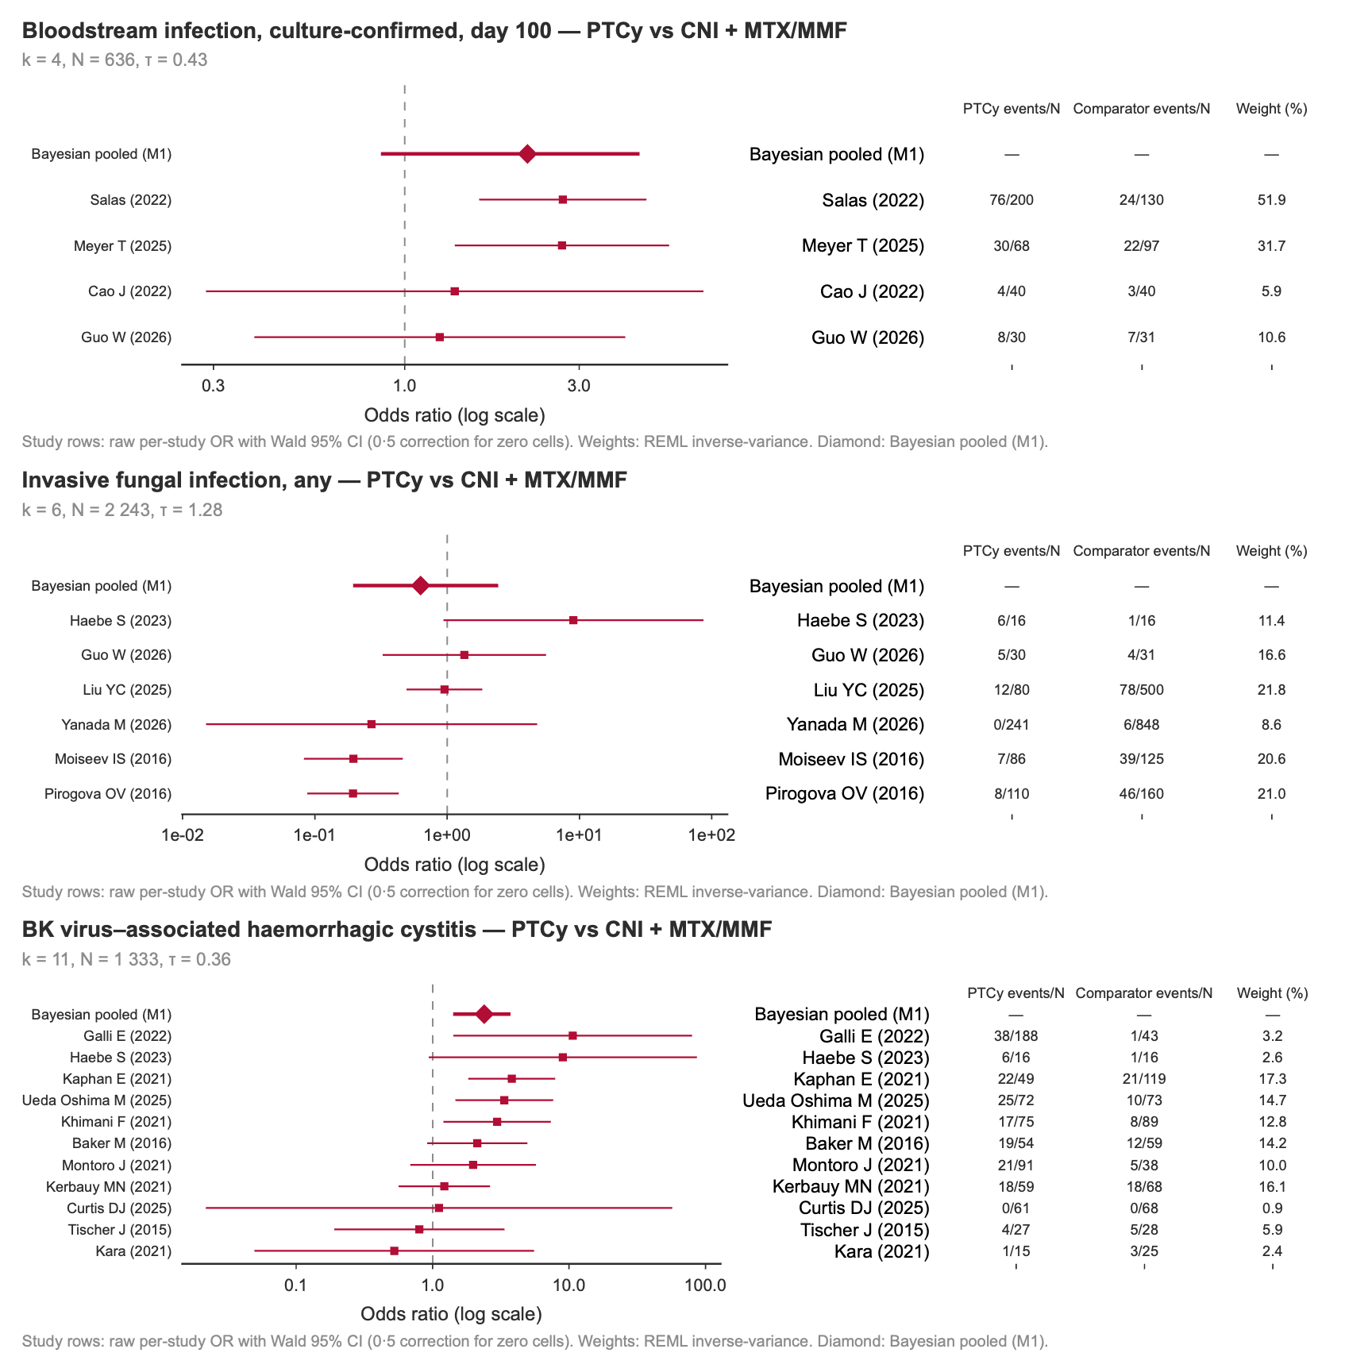
Figure 4: Forest plots — bacterial, fungal, and BK viral infection risk (comparison 1). Individual study odds ratios (raw per-study estimates) and pooled Bayesian random-effects posterior median with 95% credible interval (primary model M1). Events, totals, and REML inverse-variance weights are shown beside each study row; a 0·5 continuity correction was applied to zero cells when computing the Wald intervals. Panel A: bloodstream infection, culture-confirmed day-100 (k = 4, odds ratio 2·17 [0·86–4·39]). Panel B: invasive fungal infection, any (k = 6, 0·63 [0·19–2·44]; τ = 1·28). Panel C: BK virus–associated haemorrhagic cystitis (k = 11, 2·39 [1·41–3·73]), the largest infection effect observed and the only one whose interval excluded the null. All panels are comparison 1 (PTCy versus CNI plus MTX or MMF); insufficient studies were available to fit the corresponding comparison 2 models for BSI and IFI. None of these three outcomes was affected by cohort deduplication.

