Supplementary appendix
  - Post-transplant cyclophosphamide as graft-versus-host disease prophylaxis after allogeneic haematopoietic stem-cell transplantation: a systematic review and Bayesian meta-analysis of infection risk

Table of Contents
S1. Search strategy 2
Search parameters 2
PubMed/MEDLINE 2
EMBASE (Emtree) 3
SCOPUS 3
S2. Studies excluded at full-text screening (n=215) 4
S3. Characteristics of included studies 4
S4. Risk of bias 4
S5. Model specification and priors 6
S6. MCMC diagnostics 7
S7. Frequentist forest plots 11
S9. Sensitivity analyses 20
τ-prior sensitivity for the sparse outcomes (k = 4–6) 22
Fixed (stratified) study intercepts 22
Hazard-ratio sensitivity for overall survival 23
Exploratory steroid-adjustment analysis (M2) 23
Donor-type confounding 24
Randomised-trials-only analyses 25
CMV serostatus and letermovir 26
Comparator backbone and PTCy+ATG arms 26
CMV outcome definitions 27
BK virus outcome scope 27
Indirect comparison of the C1 and C2 pooled effects 28
Formal comparator-class meta-regression (CMV) 28
S10. Publication bias 29
S11. GRADE certainty-of-evidence profiles 30
Summary-of-findings absolute effects 32
S12. Cohort overlap 34
Per-outcome attrition from extraction to pooling 34
Estimates before and after cohort deduplication 35
S13. PROSPERO registration 36
S14. PRISMA 2020 checklist 36
S15. Software and statistical packages used 40
References 41

S1. Search strategy

Search parameters
Field | Content
Databases searched | PubMed/MEDLINE, EMBASE (Elsevier), SCOPUS
Search dates | Database inception to January 1999-April 2026
Records retrieved | PubMed 1061; EMBASE 2603; SCOPUS 481 (total 4145)
Date limits applied | January 1999-April 2026
Language limit | English
Publication types excluded via filter | None. Conference abstracts, editorials, letters, and case reports were excluded at screening rather than by search filter, to minimise inappropriate exclusion
Other sources searched | Reference list screening of included studies and prior systematic reviews; forward citation tracking (Web of Science) for key index publications; PROSPERO search for related and ongoing reviews
Deduplication and management | RIS export from each database, imported into Covidence for deduplication and screening
Search piloted against | Eight known included publications (Holtan 2022, Moiseev 2016, Tang 2023, Papanicolaou 2023, Salas 2023, Massoud 2021, Meyer 2024, Shaffer 2024) to verify recall
The protocol specifies three concept blocks combined with AND, each block an OR of controlled vocabulary terms and free-text synonyms.

PubMed/MEDLINE
#1 Allogeneic HCT population
("Hematopoietic Stem Cell Transplantation"[Mesh] OR "Bone Marrow Transplantation"[Mesh]
OR "allogeneic stem cell transplant*"[tiab] OR "allo-HCT"[tiab] OR "allo-HSCT"[tiab]
OR "haploidentical"[tiab] OR "HLA-matched"[tiab] OR "matched unrelated donor"[tiab]
OR "mismatched unrelated donor"[tiab])
#2 PTCy intervention
("post-transplant cyclophosphamide"[tiab] OR "post-transplantation cyclophosphamide"[tiab]
OR "posttransplant cyclophosphamide"[tiab] OR "posttransplantation cyclophosphamide"[tiab]
OR "PTCy"[tiab] OR "PT-Cy"[tiab] OR "PTCY"[tiab]
OR ("Cyclophosphamide"[Mesh] AND "Graft vs Host Disease"[Mesh]))
#3 Infection outcomes
("Infections"[Mesh] OR "Bacterial Infections"[Mesh] OR "Virus Diseases"[Mesh]
OR "Mycoses"[Mesh] OR "Bacteremia"[Mesh] OR "Sepsis"[Mesh]
OR "Cytomegalovirus Infections"[Mesh] OR "Invasive Fungal Infections"[Mesh]
OR "bacterial infection*"[tiab] OR "viral infection*"[tiab] OR "fungal infection*"[tiab]
OR "BSI"[tiab] OR "sepsis"[tiab] OR "CMV"[tiab] OR "EBV"[tiab] OR "HHV-6"[tiab]
OR "BK virus"[tiab] OR "aspergillosis"[tiab] OR "candida"[tiab] OR "mucormycosis"[tiab]
OR "mold"[tiab] OR "yeast"[tiab] OR "mortality"[tiab])
#4 #1 AND #2 AND #3
Filters: Humans; English

EMBASE (Emtree)
#1 Allogeneic HCT population
('bone marrow transplantation'/exp OR 'stem cell transplantation'/exp
OR 'allogeneic stem cell transplant*':ti,ab OR 'allo-hct':ti,ab OR 'allo-hsct':ti,ab
OR haploidentical:ti,ab OR 'hla-matched':ti,ab OR 'matched unrelated donor':ti,ab
OR 'mismatched unrelated donor':ti,ab)
#2 PTCy intervention
('post-transplant cyclophosphamide':ti,ab OR 'post-transplantation cyclophosphamide':ti,ab
OR 'posttransplant cyclophosphamide':ti,ab OR 'posttransplantation cyclophosphamide':ti,ab
OR ptcy:ti,ab OR 'pt-cy':ti,ab
OR ('cyclophosphamide'/exp AND 'graft versus host reaction'/exp))
#3 Infection outcomes
('infection'/exp OR 'bacterial infection'/exp OR 'virus infection'/exp OR 'mycosis'/exp
OR 'bacteremia'/exp OR 'sepsis'/exp OR 'cytomegalovirus infection'/exp
OR 'invasive fungal infection'/exp
OR 'bacterial infection*':ti,ab OR 'viral infection*':ti,ab OR 'fungal infection*':ti,ab
OR bsi:ti,ab OR sepsis:ti,ab OR cmv:ti,ab OR ebv:ti,ab OR 'hhv-6':ti,ab
OR 'bk virus':ti,ab OR aspergillosis:ti,ab OR candida:ti,ab OR mucormycosis:ti,ab
OR mold:ti,ab OR yeast:ti,ab OR mortality:ti,ab)
#4 #1 AND #2 AND #3 AND [humans]/lim AND [english]/lim

SCOPUS
TITLE-ABS-KEY(
("allogeneic stem cell transplant*" OR "allo-HCT" OR "allo-HSCT"
OR "hematopoietic stem cell transplantation" OR "bone marrow transplantation"
OR haploidentical OR "HLA-matched" OR "matched unrelated donor"
OR "mismatched unrelated donor")
AND
("post-transplant cyclophosphamide" OR "post-transplantation cyclophosphamide"
OR "posttransplant cyclophosphamide" OR "posttransplantation cyclophosphamide"
OR PTCy OR "PT-Cy" OR (cyclophosphamide AND "graft versus host disease"))
AND
(infection* OR "bacterial infection*" OR "viral infection*" OR "fungal infection*"
OR BSI OR sepsis OR bacteremia OR CMV OR "cytomegalovirus infection*" OR EBV
OR "HHV-6" OR "BK virus" OR aspergillosis OR candida OR mucormycosis OR mold
OR yeast OR "invasive fungal infection*" OR mortality)
) AND LANGUAGE(english)

S2. Studies excluded at full-text screening (n=215)
Table 1. Reasons for exclusion at full-text screening
Exclusion reason | n
Conference abstract | 116
Single-arm or no PTCy contrast | 41
Review, not primary study | 21
Duplicate publication | 14
Systematic review or meta-analysis | 11
Non-eligible population | 5
Protocol or survey only | 4
Other | 3
Total | 215

S3. Characteristics of included studies
Full study-level (table S4a, 250 rows) and arm-level (table S4b, 523 rows) characteristics are provided as supplementary data files (Table_S4a_study_characteristics.csv, Table_S4b_arm_characteristics.csv), and are reproduced from the extraction database in the accompanying notebook Study and arm characteristics.

S4. Risk of bias
Table 2. ROBINS-I domain-level risk of bias, counts by judgement (n = 210 comparative observational studies). Single-arm descriptive studies are excluded from these counts; 16 of the 26 were also rated. D6 and D7 were not recorded for the same 7 studies, so those rows sum to 203. The overall judgements (serious 142, moderate 68) are recorded for all 210 studies.
Domain | Low | Moderate | Serious
D1 Confounding | 0 | 83 | 127
D2 Selection of participants | 26 | 140 | 44
D3 Classification of interventions | 51 | 154 | 5
D4 Deviations from intended interventions | 192 | 18 | 0
D5 Missing data | 69 | 140 | 1
D6 Measurement of outcomes | 101 | 100 | 2
D7 Selection of the reported result | 160 | 42 | 1

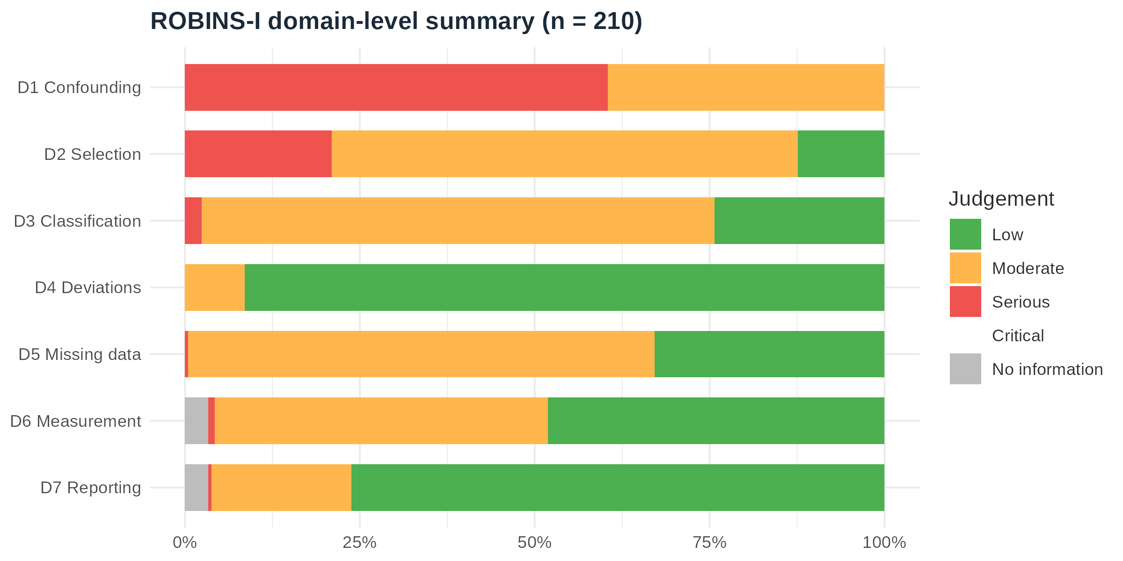
Figure 1: ROBINS-I domain-level summary.

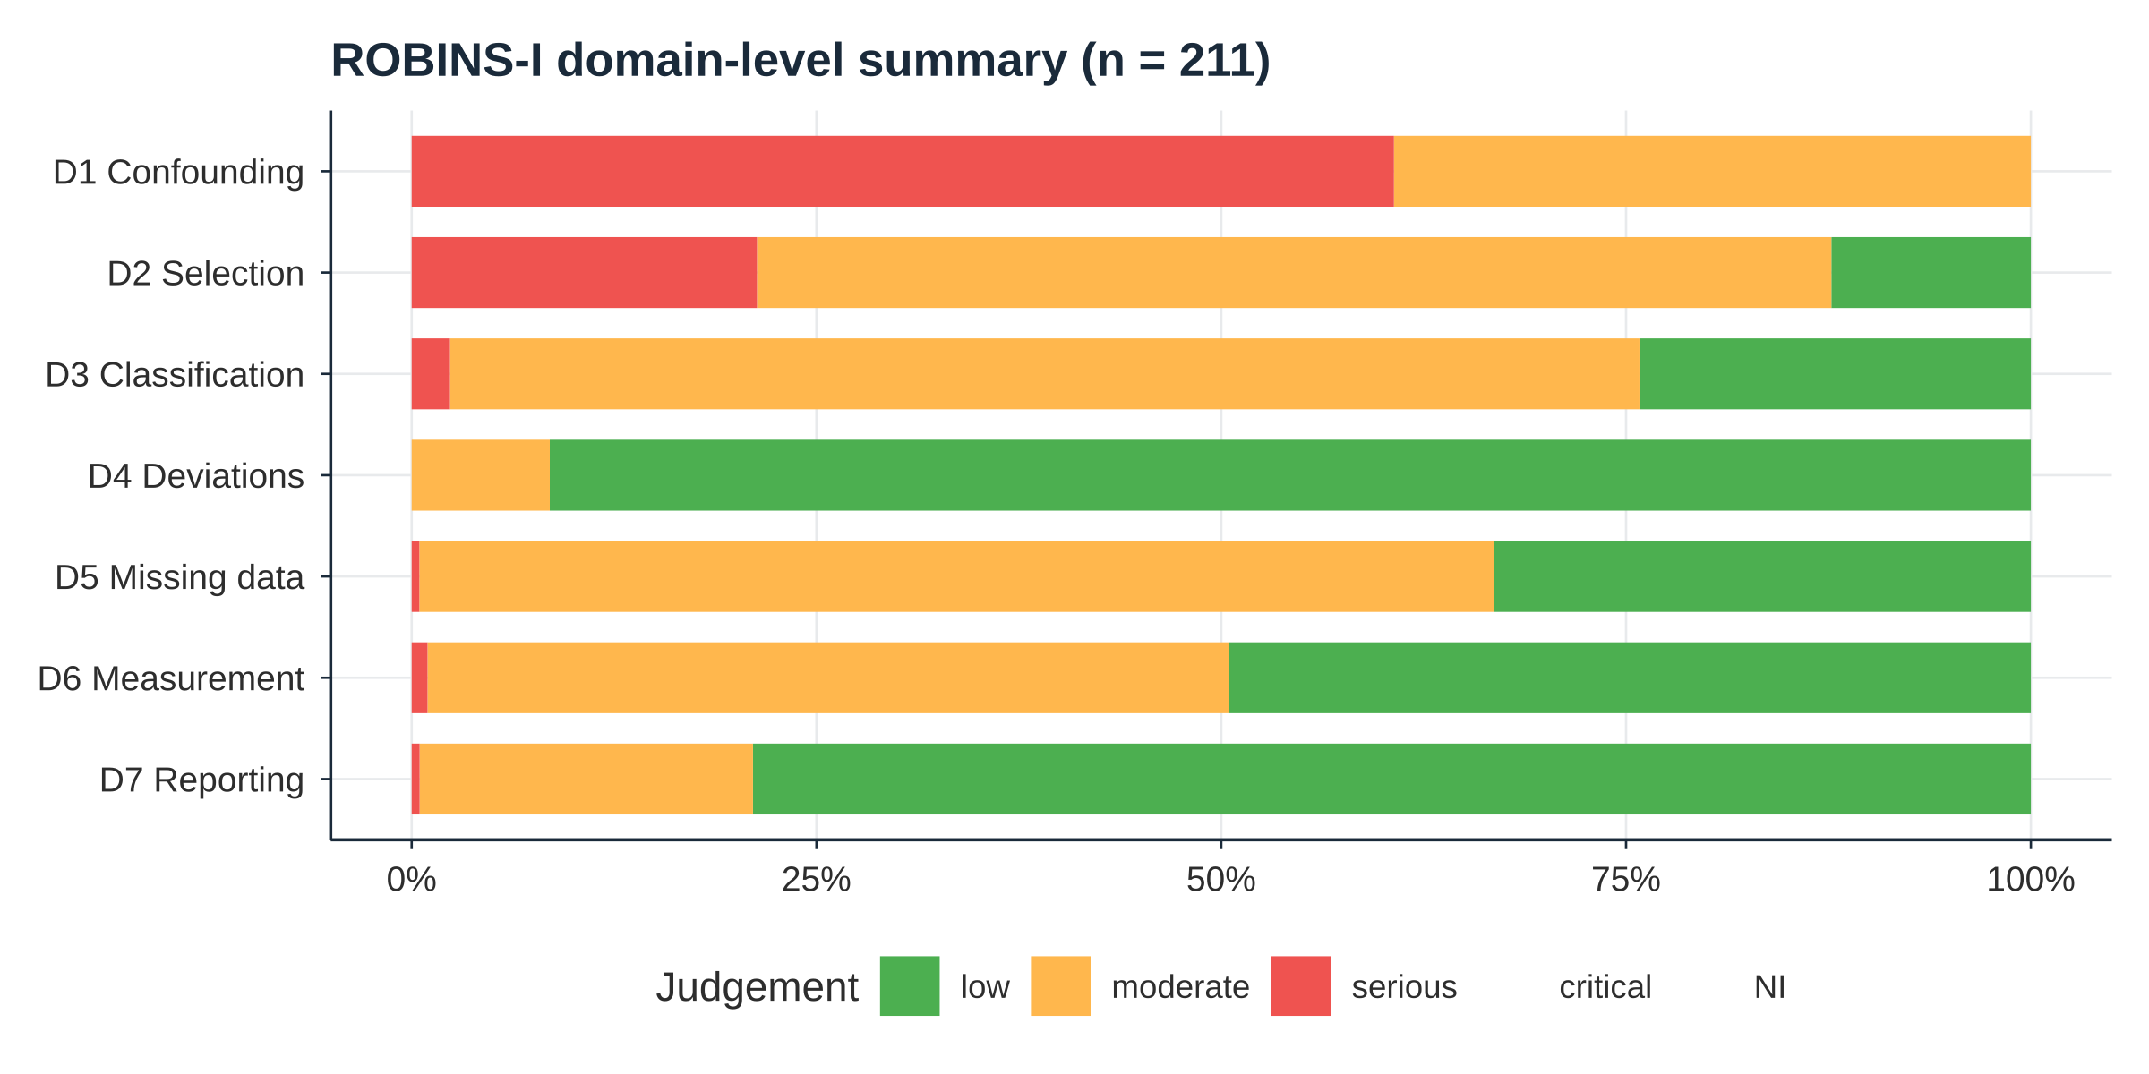
Figure 2: RoB 2 summary for the 14 randomised controlled trials.
Because the RoB 2 measurement-of-outcome domain (D4) is most consequential for subjective endpoints, the 14 trial assessments were reviewed by outcome objectivity. For objective outcomes — overall survival, non-relapse and relapse-related mortality, and laboratory-confirmed bloodstream infection — measurement-domain risk was low in all 14 trials. For subjective, clinician-assessed outcomes — acute and chronic GVHD grading and adjudication of infection episodes — 3 of 14 trials had some concerns in the measurement domain because outcome assessors were unblinded to allocation (studies 2, 105 and 465). Two trials were at high overall risk: one for deviations from the assigned randomised regimen (study 432, D2) and one for baseline imbalances suggestive of randomisation problems (study 72, D1). These judgements support treating the trials’ mortality and virological endpoints as more dependable than their GVHD endpoints.
Full justification narratives are available in rob.csv, submitted as a supplementary data file.

S5. Model specification and priors
Primary model (M1), for study $s$, arm $i$:
$${\text{events}}_{i}∣n_{i}∼\text{Binomial}​\left(n_{i}, {\text{logit}}^{-1}​\left(α+(β_{\text{PTCy}}+v_{s[i]}) x_{i}+β_{\text{tp}} t_{i}+u_{s[i]}\right)\right), (u_{s},v_{s})∼N_{2}(0,Σ)$$
where $x_{i}$ indicates a PTCy arm and $t_{i}$ indicates that the study contributed a fallback timepoint rather than the outcome’s preferred timepoint (day +100 or +180 for early outcomes, one year for late outcomes). Each study contributes exactly one row per outcome — the preferred timepoint when reported, otherwise the nearest reported timepoint — so no within-study correlation across timepoints arises. Each study contributes a random intercept $u_{s}$ (baseline-risk variation) and a random PTCy-effect slope $v_{s}$, so the pooled coefficient $β_{\text{PTCy}}$ estimates the average study-level treatment effect and the between-study SD of $v_{s}$ (reported as τ) quantifies heterogeneity in the PTCy effect. With two arms per study the model is just-identified at study level, so for sparse outcomes (k ≤ 6) the prior on the SD parameters is correspondingly influential.
Table 3. Prior specification for the primary model
Parameter | Prior
Fixed effects (β) | N(0, 2·5)
Intercept (α) | N(0, 1·5)
Between-study SDs (τ) | Student t(3, 0, 1), half
Intercept–slope correlation | LKJ(1)
The exploratory steroid-adjustment model (M2; a post-hoc protocol amendment, S13) adds arm-level systemic corticosteroid exposure, mean-centred, as an additional fixed effect, and is fitted on the complete-case subset of studies with exposure data (C1 OS 27/34, C1 RRM 27/34, C1 NRM 9/12, C1 CMV 18/22, C2 OS 8/9, C2 CMV 12/12). M2 is reported only in this supplement: its definition, provenance, results, and limitations are given in S9.
MCMC: four chains × 4000 iterations (1000 warmup), adapt_delta = 0·95 (increased to 0·99 where divergent transitions occurred), giving 12 000 post-warmup draws per model.

S6. MCMC diagnostics
All Bayesian models were fitted with brms v2.23.0 and the rstan backend. R̂ (threshold < 1·01), bulk and tail effective sample size (ESS; threshold > 400), and the number of divergent transitions are reported for every fitted model. Values are the worst case (maximum R̂, minimum ESS) across all model parameters.
Table 4. MCMC convergence diagnostics, comparison 1 models
Model | Max R̂ | Min bulk ESS | Min tail ESS | Divergences
OS M1 | 1·0013 | 3607 | 5273 | 0
OS M2 | 1·0010 | 3307 | 4822 | 0
NRM M1 | 1·0012 | 2757 | 3478 | 0
NRM M2 | 1·0019 | 3368 | 3145 | 0
aGVHD M1 | 1·0010 | 2513 | 4276 | 0
CMV M1 | 1·0026 | 3515 | 5340 | 0
CMV M2 | 1·0010 | 3162 | 3174 | 0
BSI M1 | 1·0006 | 3836 | 3961 | 0
IFI M1 | 1·0020 | 3419 | 4593 | 0
RRM M1 | 1·0005 | 3486 | 5143 | 0
BK M1 | 1·0009 | 4015 | 4638 | 0
IRM M1 | 1·0024 | 3703 | 4281 | 0

Table 5. MCMC convergence diagnostics, comparison 2 models
Model | Max R̂ | Min bulk ESS | Min tail ESS | Divergences
OS M1 | 1·0014 | 4373 | 5330 | 0
OS M2 | 1·0013 | 4091 | 5634 | 0
NRM M1 | 1·0015 | 4072 | 3913 | 0
aGVHD M1 | 1·0015 | 5200 | 6650 | 0
CMV M1 | 1·0006 | 4465 | 6041 | 0
CMV M2 | 1·0011 | 3605 | 4939 | 0
RRM M1 | 1·0013 | 1744 | 3186 | 0
BK M1 | 1·0010 | 3789 | 3323 | 0
All models achieved R̂ < 1·01 with zero divergent transitions and bulk ESS above 1700. The C2 BK model (k = 3) meets the same convergence standard under the random-slope specification, but with three studies its posterior remains heavily prior-influenced and should be read as indicative only.
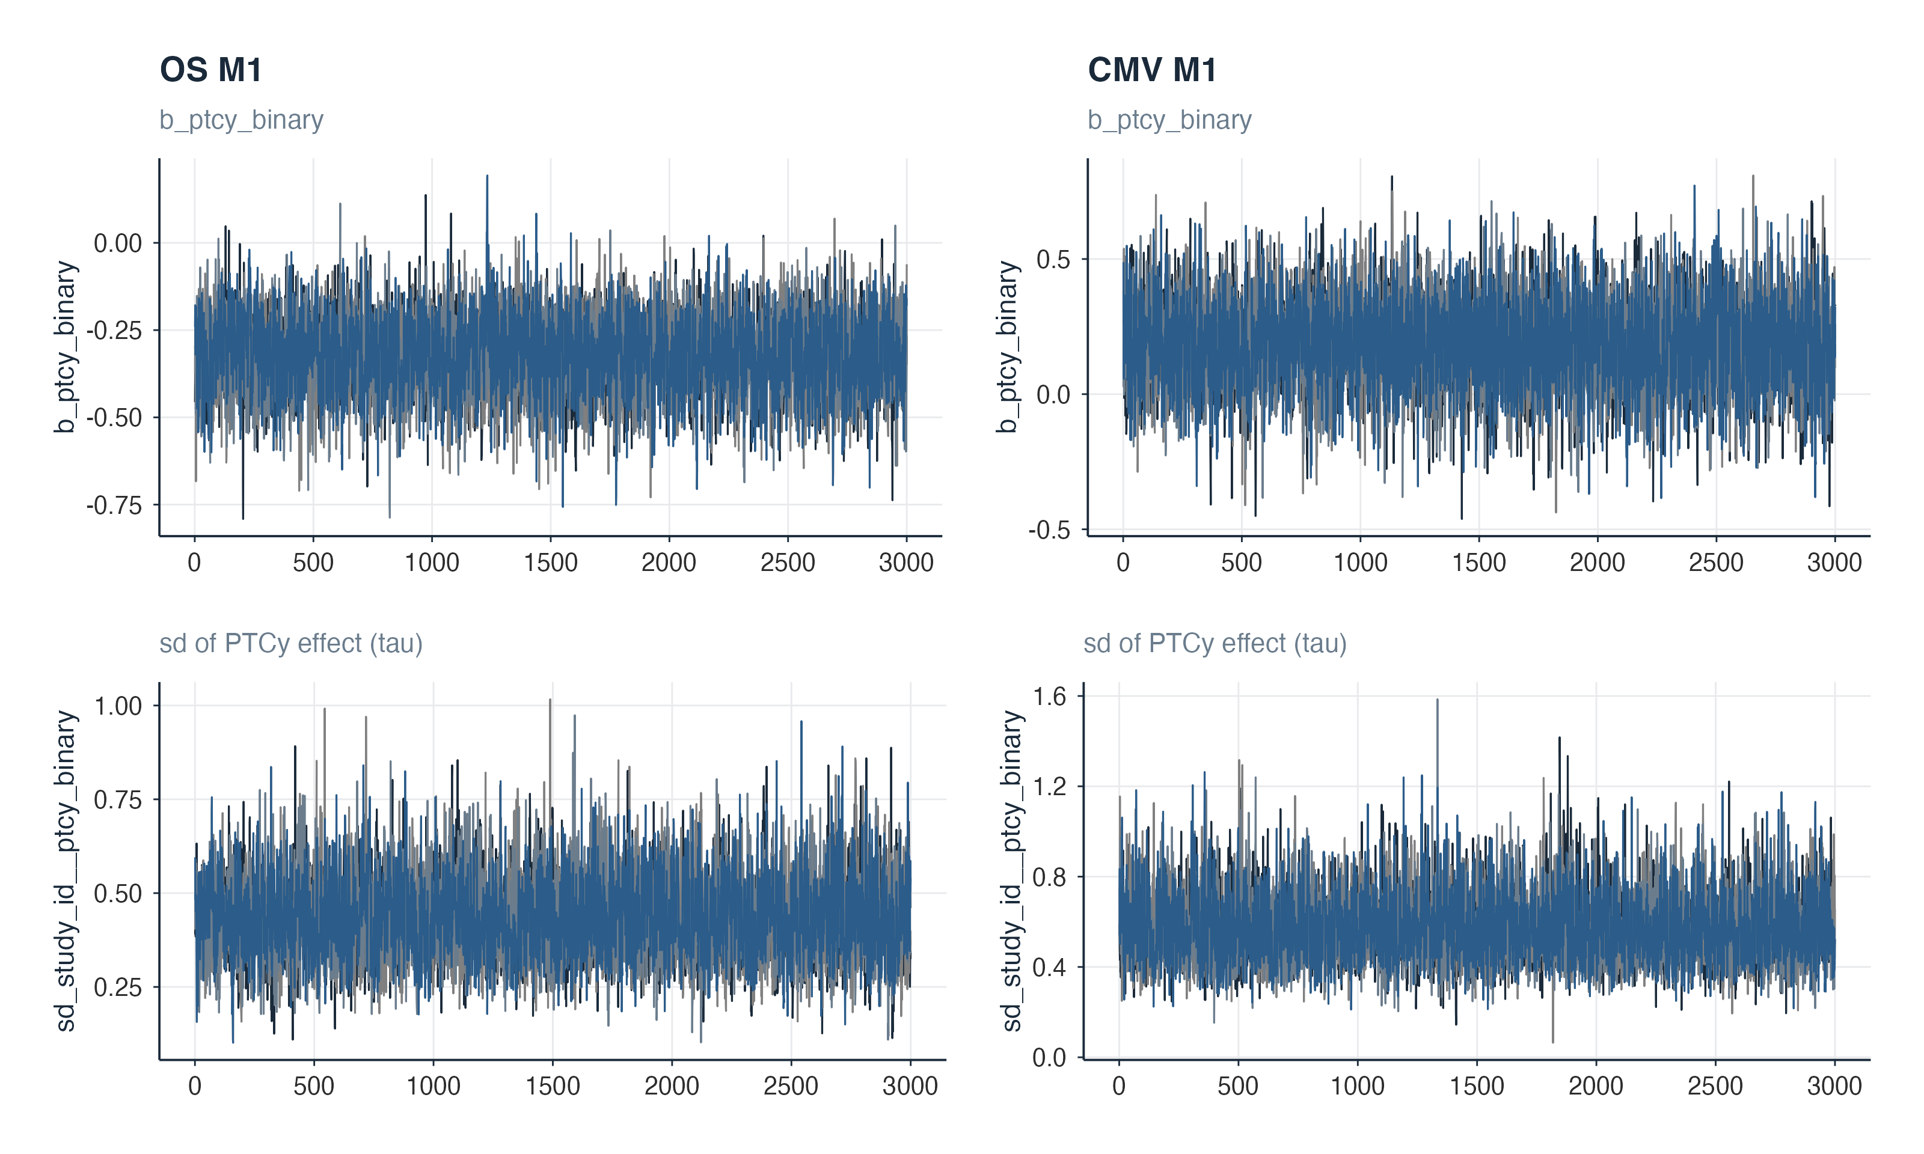
Figure 4: Trace plots for b_ptcy_binary (top) and the between-study SD of the PTCy effect (τ, bottom) in OS M1 (left) and CMV M1 (right). All four chains mix well across the full post-warmup phase.

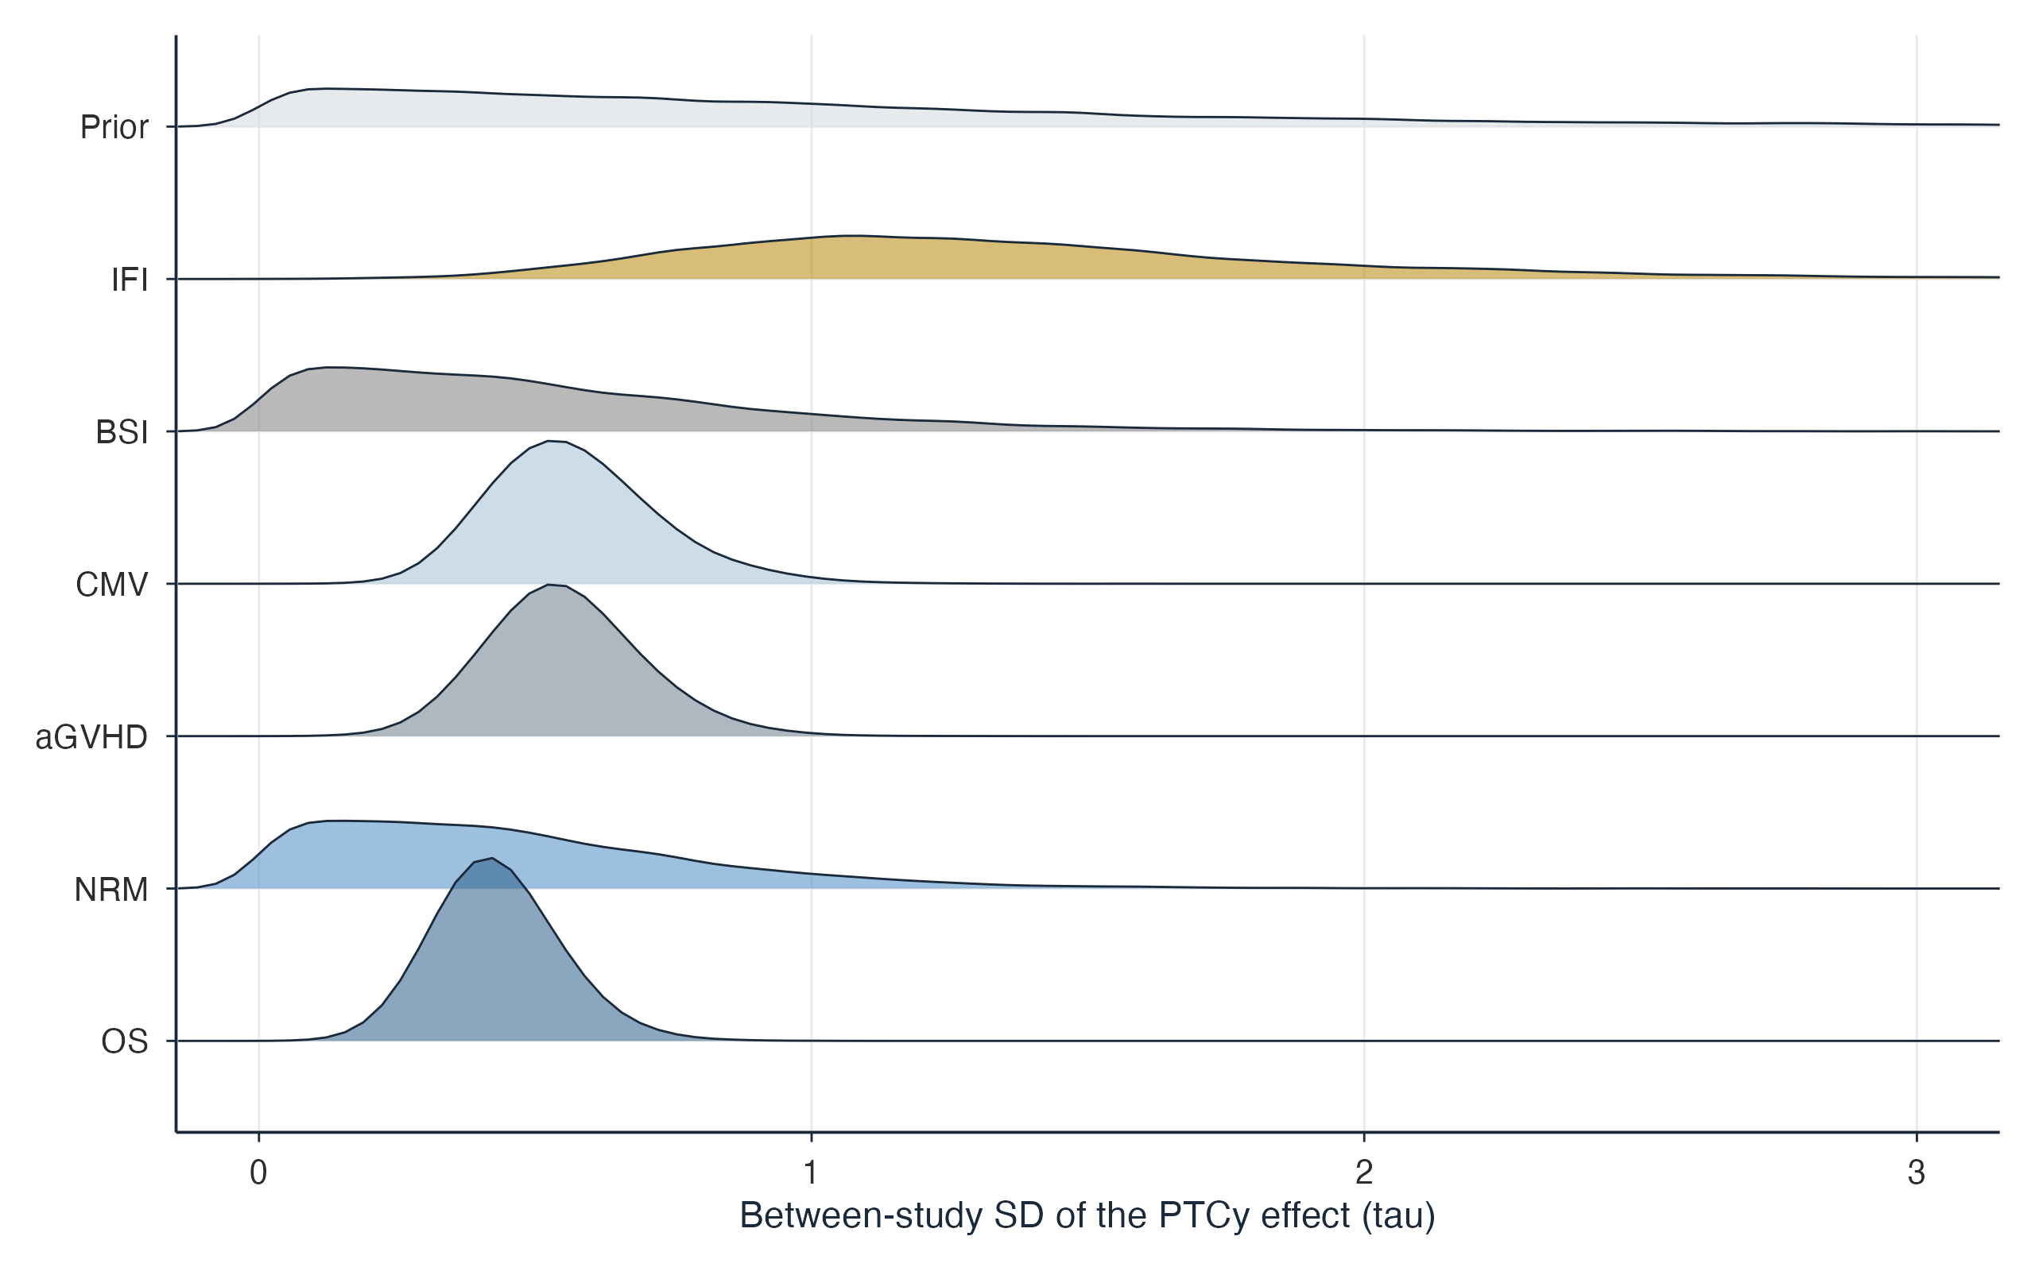
Figure 5: Posterior densities of the between-study SD of the PTCy effect (τ) for comparison 1 M1 models. The half-Student t(3, 0, 1) prior common to all models is shown in grey. IFI shows the widest τ posterior, consistent with the structural heterogeneity identified in the leave-one-out analysis (S9).

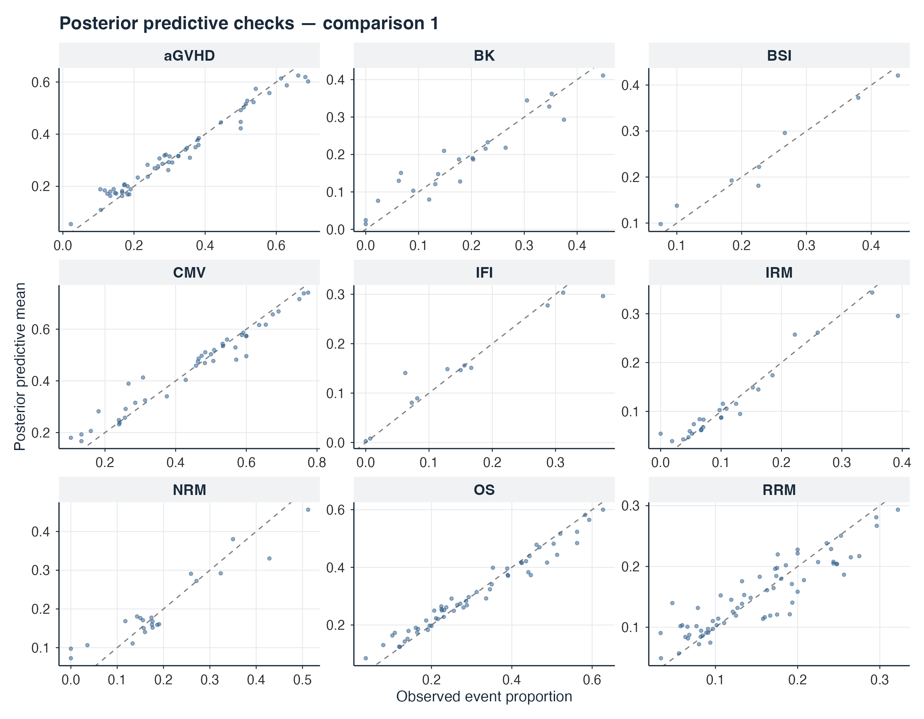
Figure 6: Posterior predictive checks, comparison 1. Each point is one study arm: the observed event proportion against its posterior predictive mean, over 500 posterior draws. The dashed line is the identity.

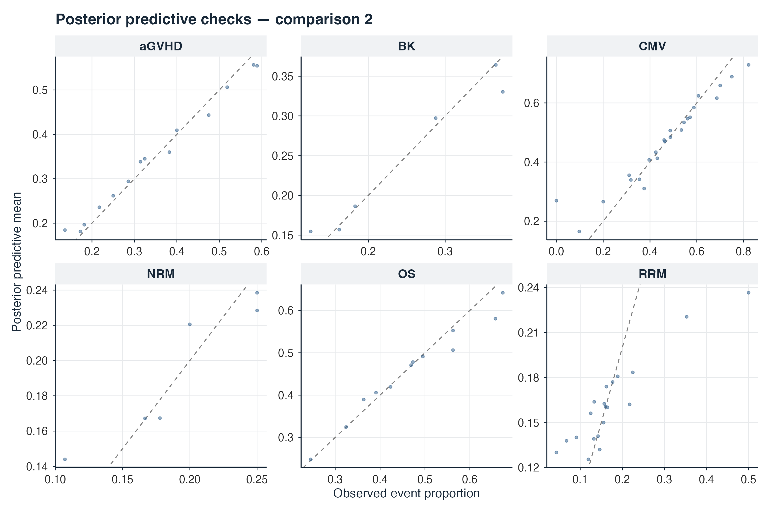
Figure 7: Posterior predictive checks, comparison 2. Layout and interpretation as in figure S7d(i).
All models show adequate calibration, with points clustered near the identity line and symmetric scatter. The C1 IFI model (k = 6) shows the widest scatter, consistent with its large τ posterior (figure S7c) and the heterogeneity identified in S9. No systematic over- or under-prediction is evident in any model.

S7. Frequentist forest plots
Every plot shows raw per-study odds ratios with Wald 95% confidence intervals (0·5 continuity correction where a cell count is zero), with the events and totals of each arm and the REML inverse-variance weight of each study beside each study row. Panels S8a and S8j pool with the frequentist REML model (metafor) as concordance checks; the remaining panels pool with the Bayesian M1 model of table 2. All plots use the cohort-deduplicated datasets.
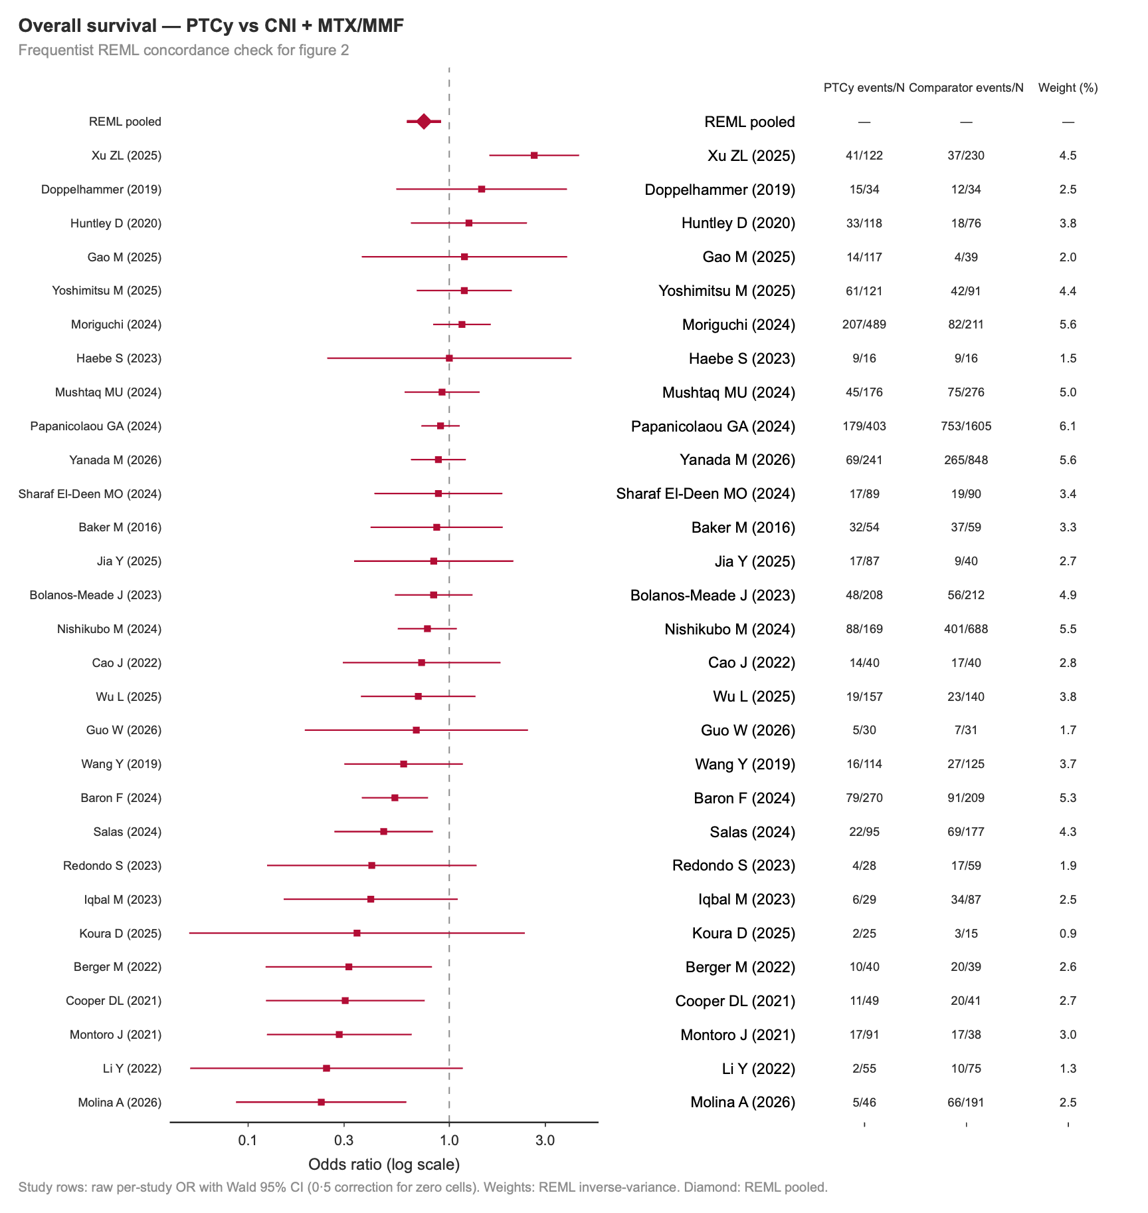
Figure 8: Overall survival, frequentist REML concordance check for figure 2 of the main text.

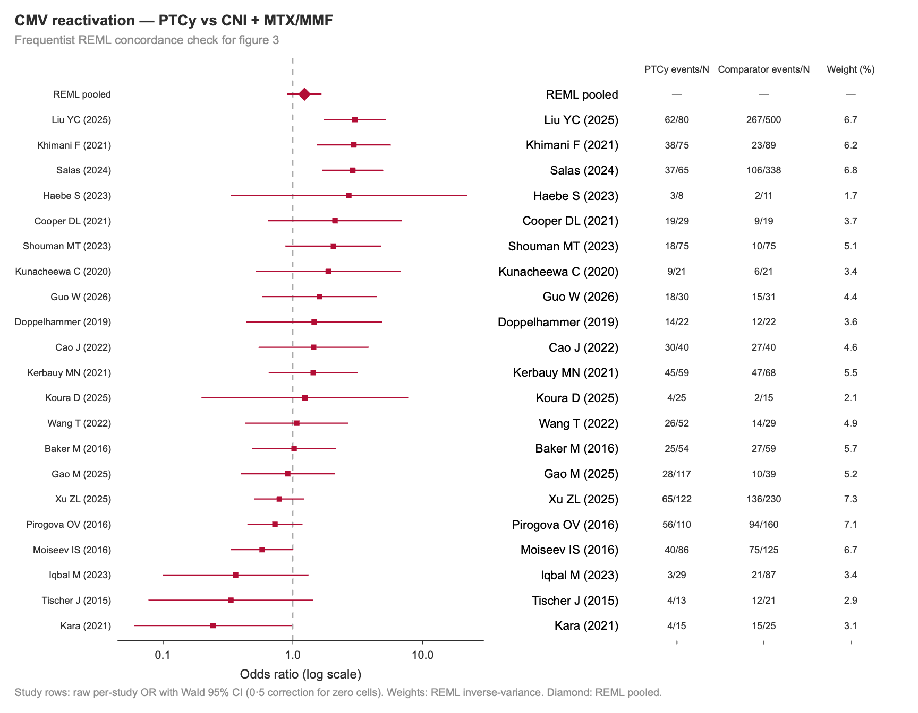
Figure 9: CMV any-reactivation, frequentist REML concordance check for figure 3 of the main text.

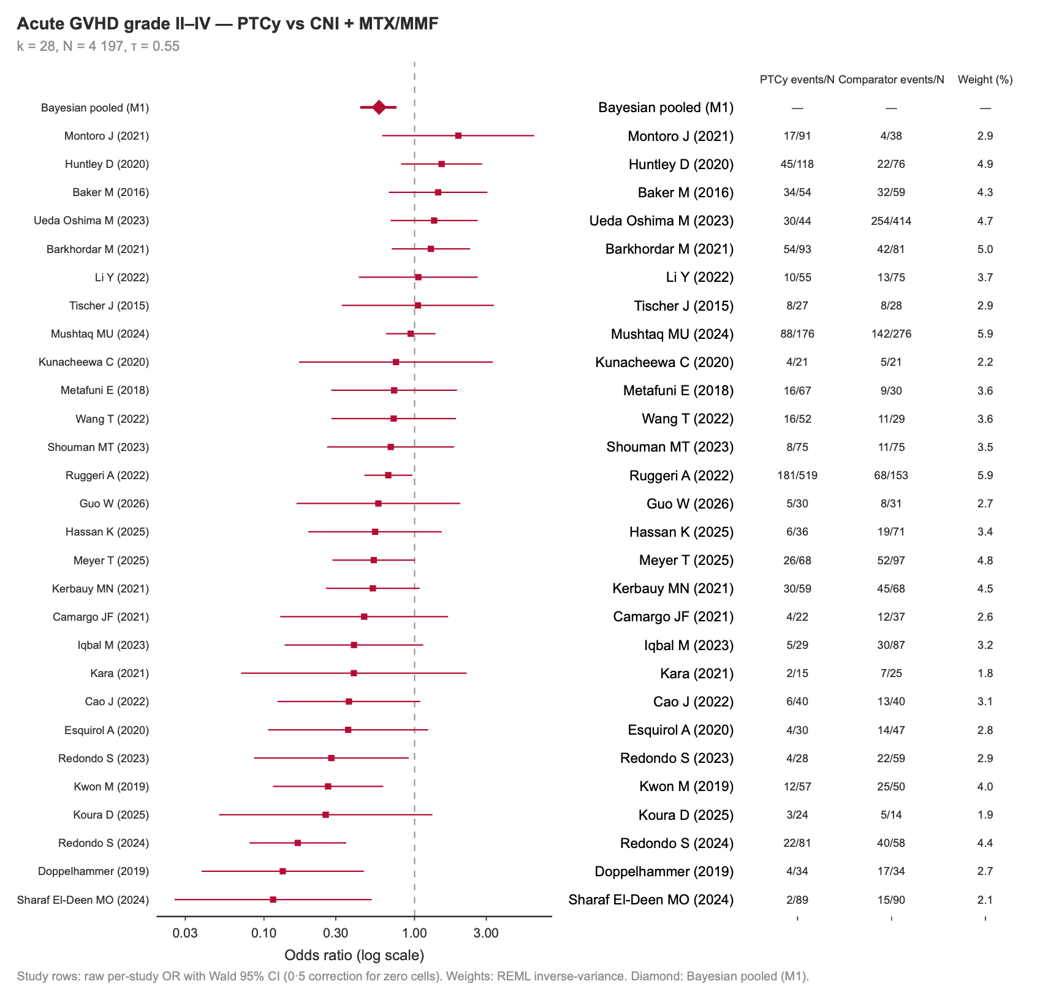
Figure 10: Acute GVHD grade II–IV.
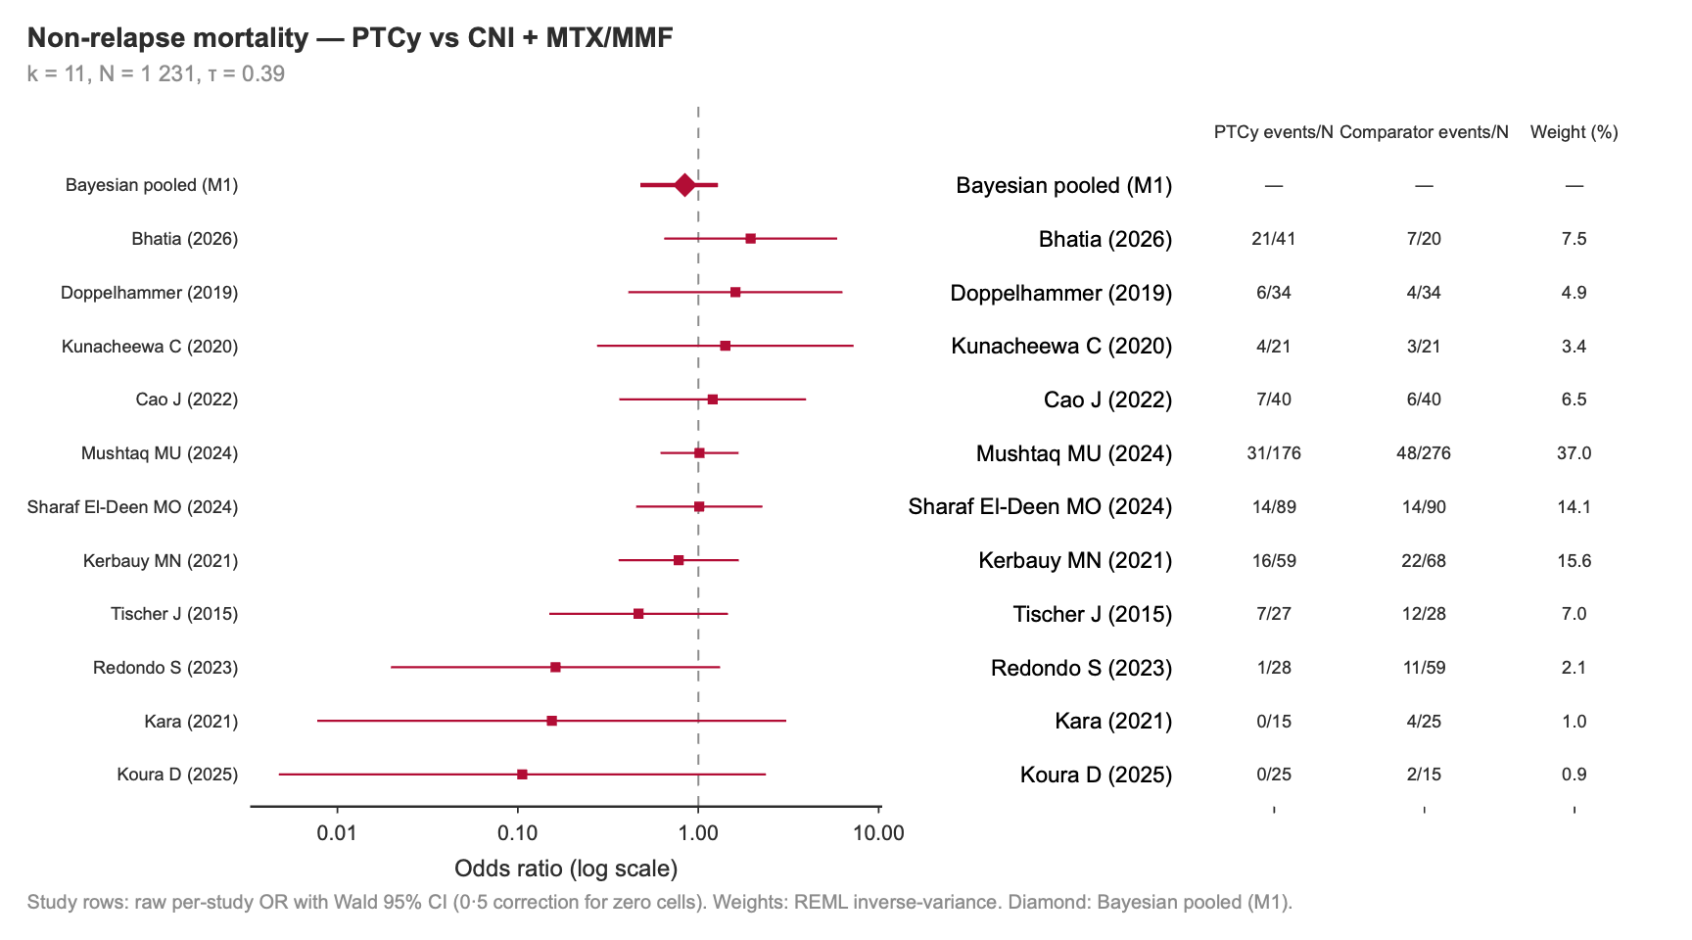
Figure 11: Non-relapse mortality.

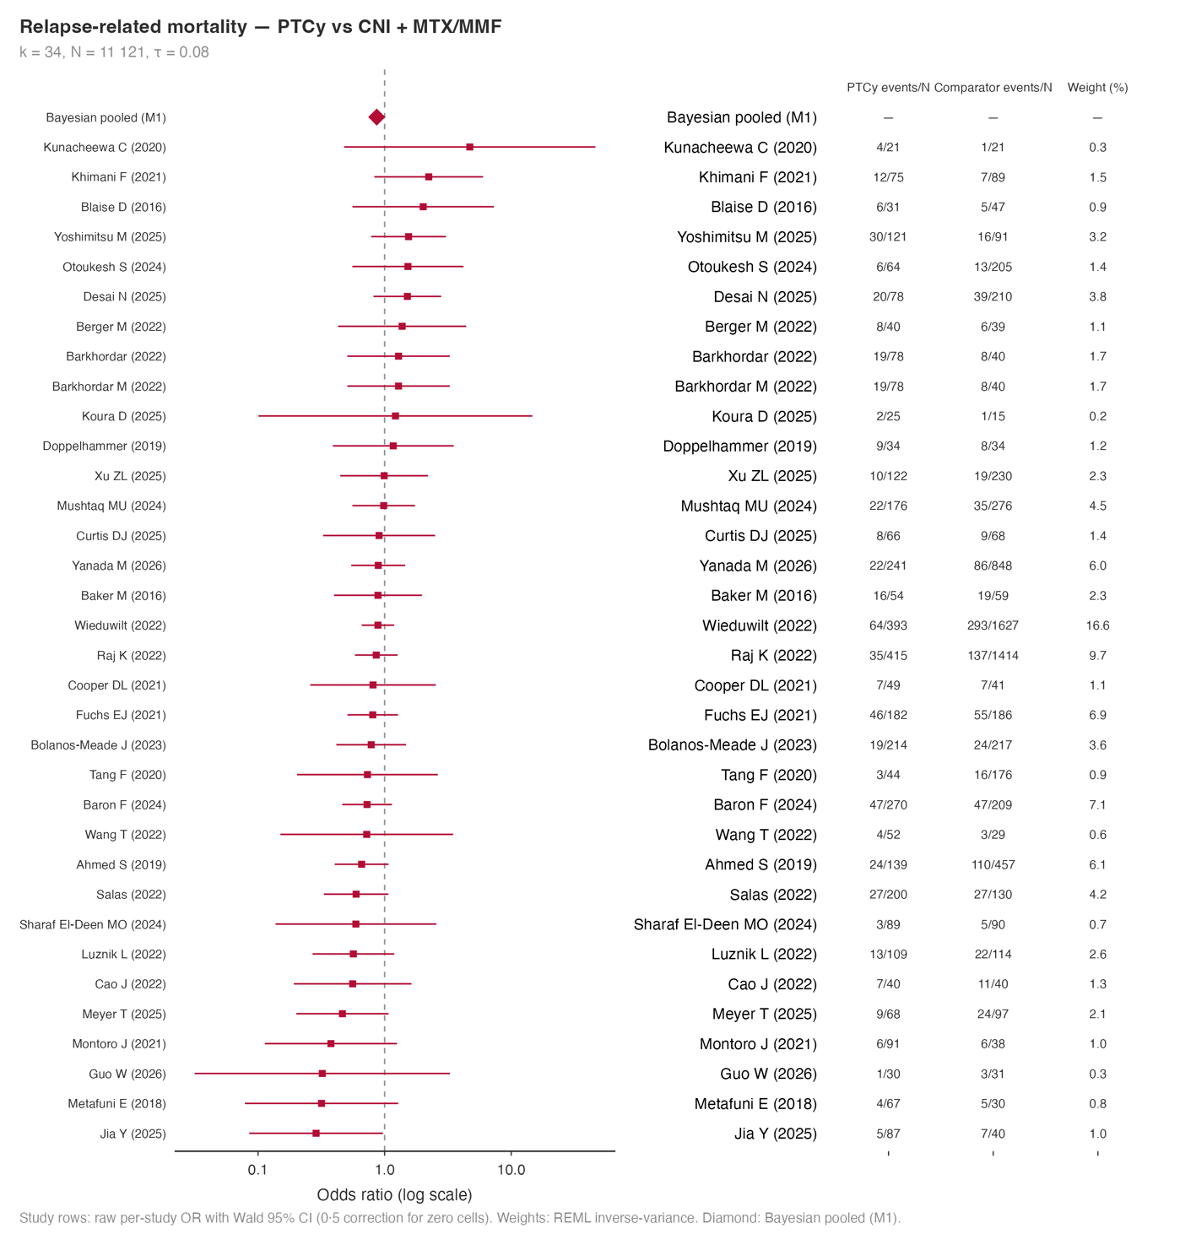
Figure 12: Relapse-related mortality.

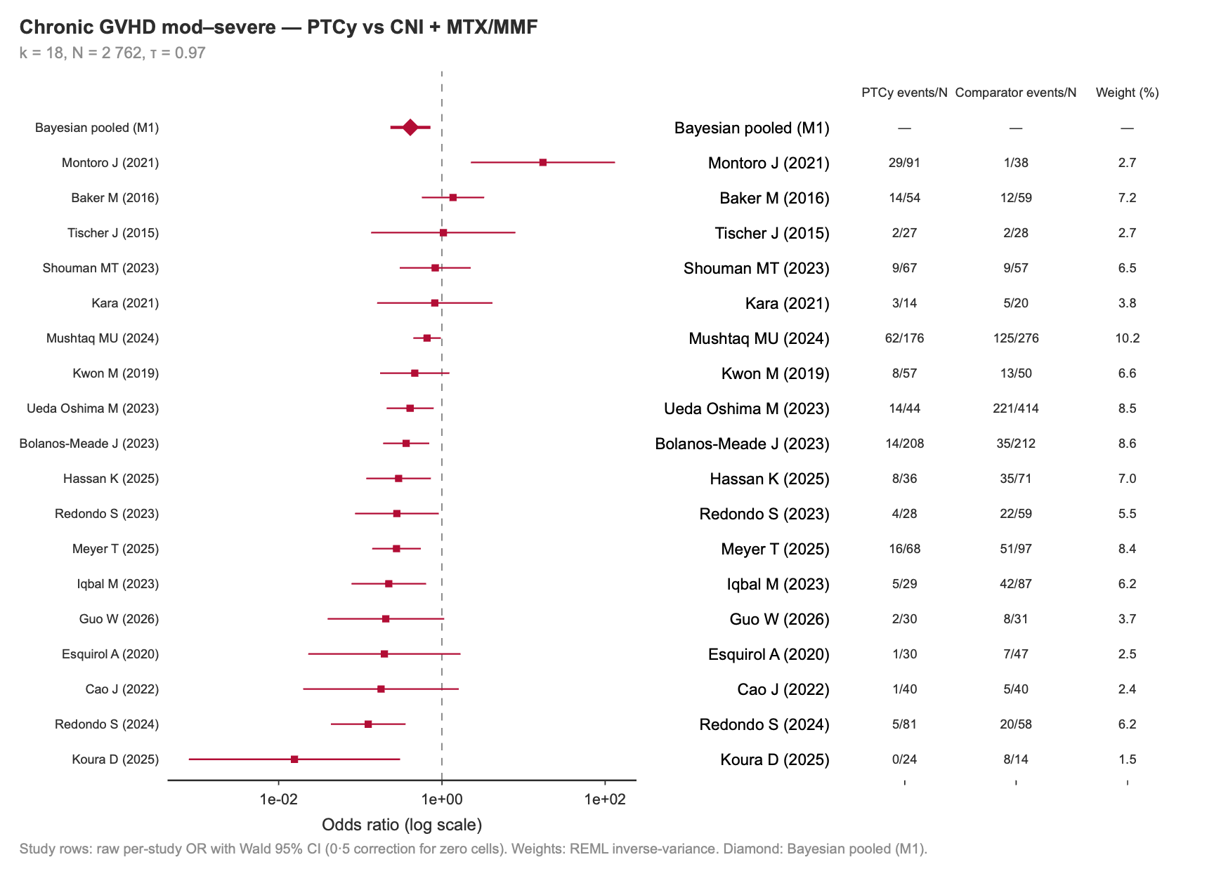
Figure 13: Chronic GVHD, moderate to severe.

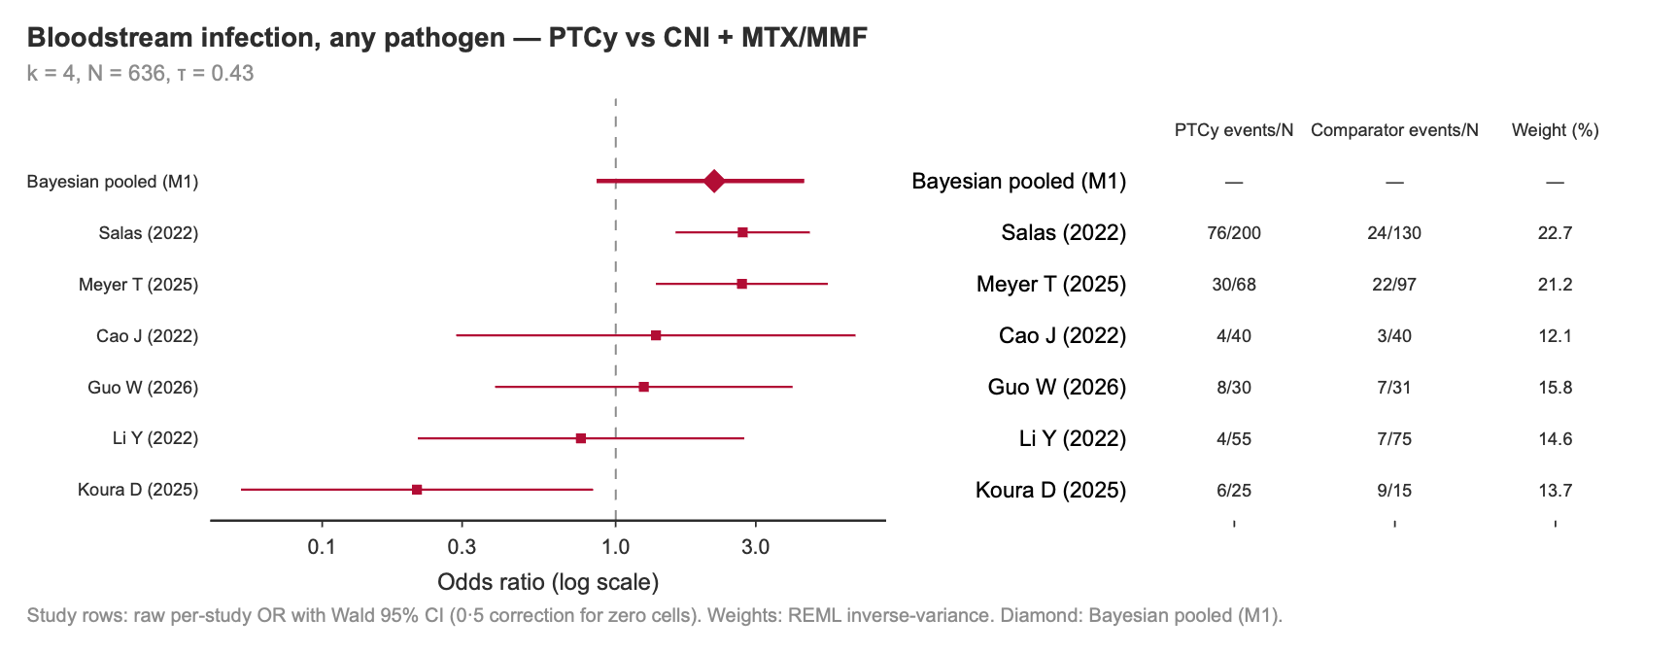
Figure 14: Bloodstream infection, any pathogen.

Figure 15: Invasive fungal infection, any.

Figure 16: BK virus reactivation.

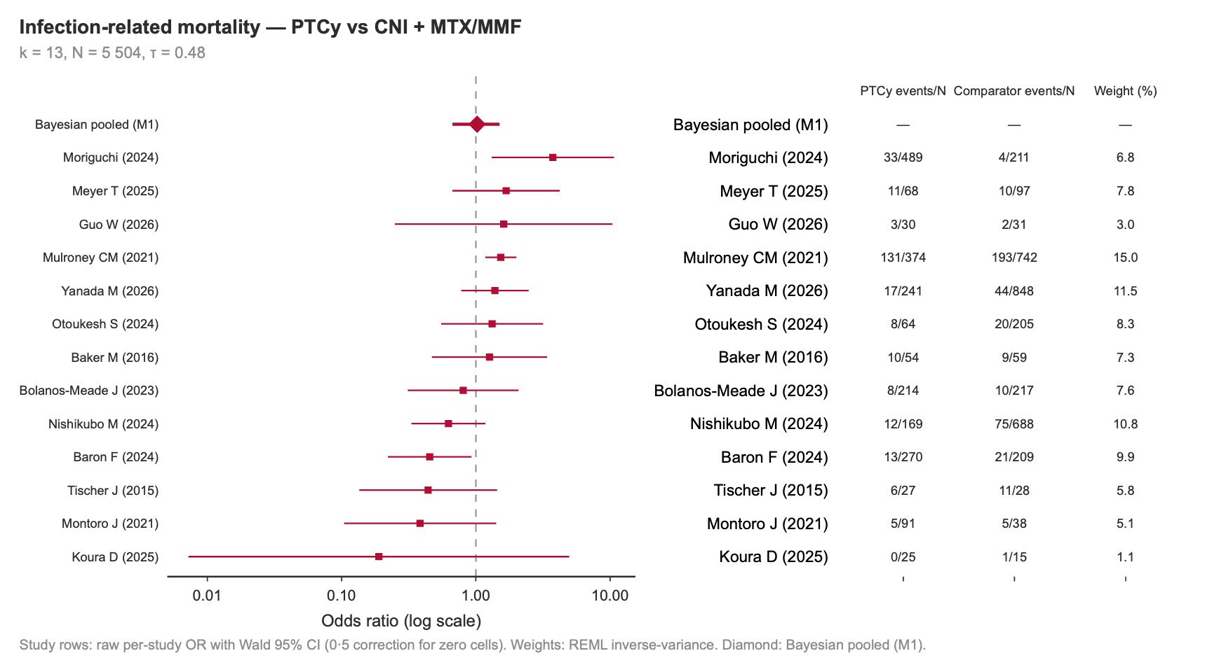
Figure 17: Infection-related mortality.

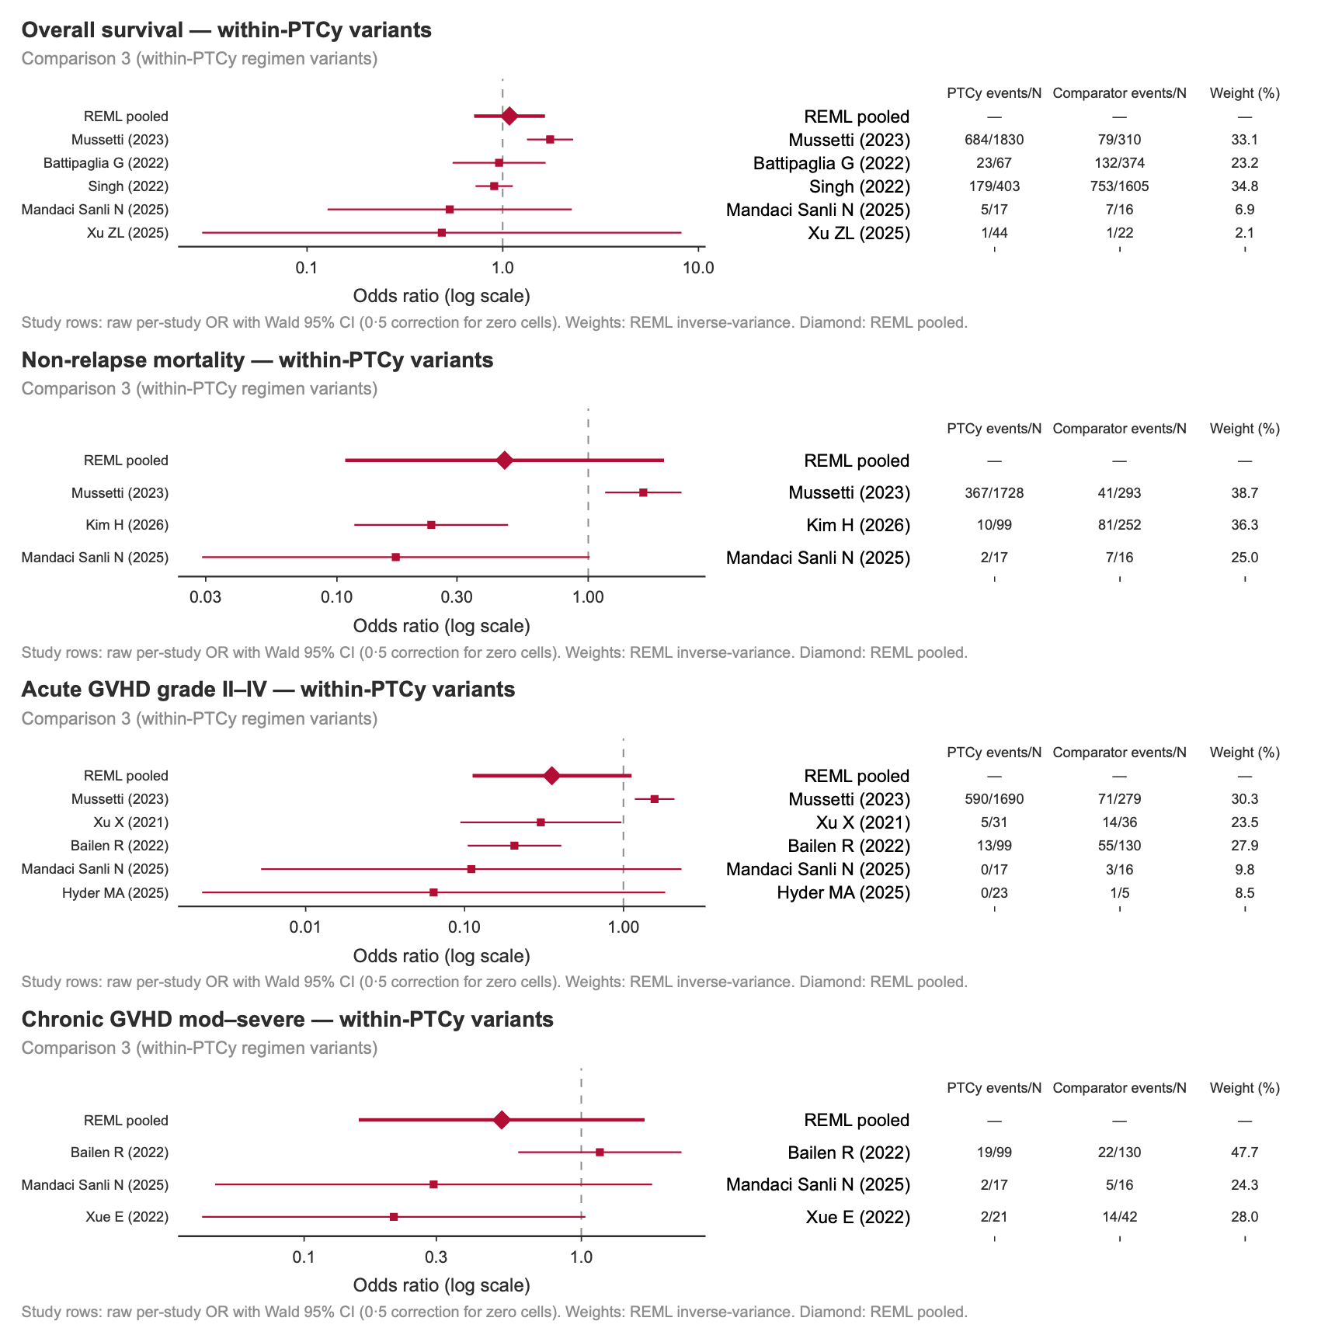
Figure 18: Comparison 3, within-PTCy regimen variants, all outcomes.

S9. Sensitivity analyses
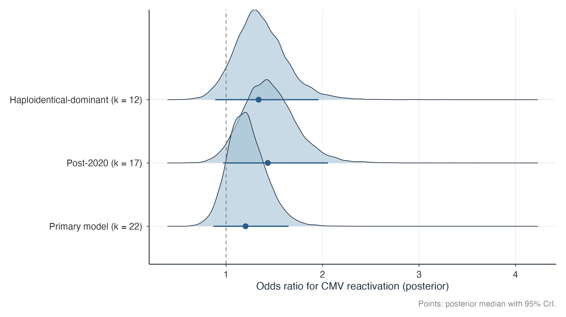
Figure 19: CMV sensitivity models, comparison 1: primary model, post-2020 restriction, and haploidentical-dominant restriction.

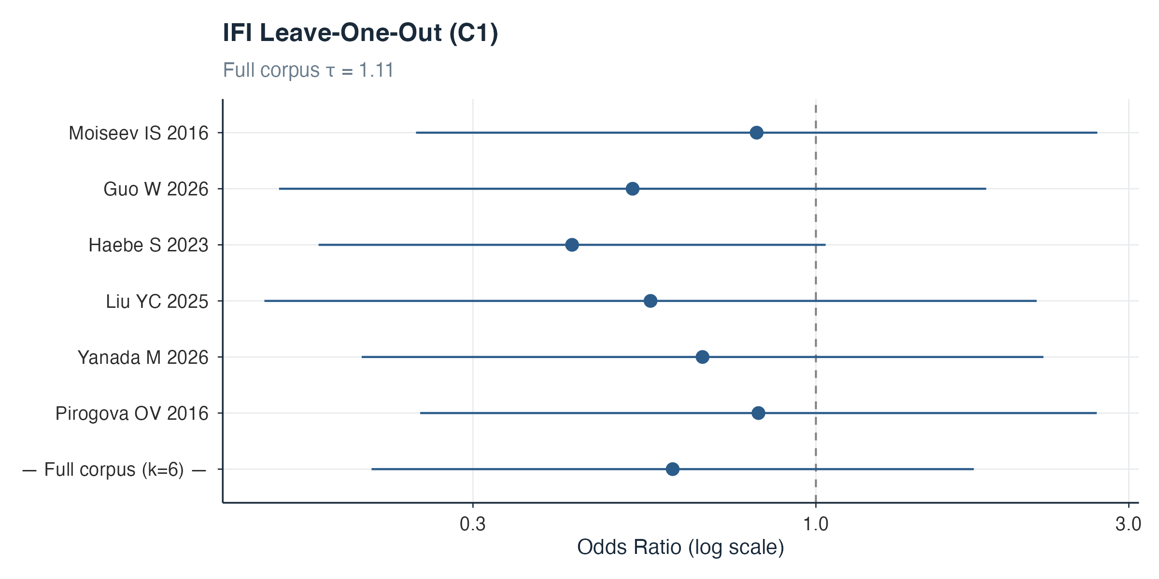
Figure 20: IFI leave-one-out analysis, comparison 1 (frequentist REML).

Table 6. Bayesian posterior median odds ratios beside frequentist REML estimates for every primary (M1) model. The REML models pool within-study log odds ratios with a 0·5 continuity correction where needed and carry the deduplicated fits where deduplication applied (see the source column of freq_results_setB.csv, a supplementary data file, which also reports τ, Cochran’s Q and its p value).
Outcome | Comparison | k | Bayesian OR (95% CrI) | Frequentist REML OR (95% CI) | I²
Overall survival | C1 | 29 | 0·73 (0·58–0·89) | 0·75 (0·61–0·91) | 66%
 | C2 | 6 | 0·75 (0·43–1·28) | 0·74 (0·48–1·13) | 90%
 | C3 | 5 | 1·05 (0·49–1·88) | 1·08 (0·71–1·65) | 71%
Non-relapse mortality | C1 | 11 | 0·84 (0·48–1·28) | 0·94 (0·69–1·27) | 0%
 | C3 | 3 | 0·55 (0·11–2·44) | 0·46 (0·11–2·00) | 91%
Relapse-related mortality | C1 | 34 | 0·87 (0·76–0·99) | 0·86 (0·76–0·97) | 0%
 | C2 | 10 | 0·79 (0·55–1·03) | 0·78 (0·57–1·05) | 57%
 | C3 | 6 | 0·78 (0·35–1·67) | 0·75 (0·44–1·29) | 7%
Acute GVHD II–IV | C1 | 28 | 0·58 (0·44–0·76) | 0·61 (0·47–0·79) | 62%
 | C2 | 7 | 0·53 (0·23–1·17) | 0·54 (0·27–1·06) | 77%
 | C3 | 5 | 0·31 (0·06–1·46) | 0·36 (0·11–1·12) | 85%
Chronic GVHD mod–severe | C1 | 18 | 0·41 (0·23–0·72) | 0·42 (0·29–0·62) | 59%
 | C2 | 6 | 0·70 (0·26–1·59) | 0·77 (0·40–1·45) | 60%
Chronic GVHD any | C1 | 8 | 0·24 (0·14–0·42) | 0·24 (0·15–0·40) | 63%
 | C3 | 3 | 0·60 (0·15–2·30) | 0·52 (0·16–1·69) | 59%
CMV reactivation | C1 | 21 | 1·20 (0·87–1·65) | 1·23 (0·91–1·66) | 63%
 | C2 | 12 | 0·86 (0·51–1·42) | 0·83 (0·51–1·33) | 69%
Bloodstream infection | C1 | 4 | 2·17 (0·86–4·39) | 2·39 (1·64–3·50) | 0%
Invasive fungal infection | C1 | 6 | 0·63 (0·19–2·44) | 0·60 (0·21–1·74) | 80%
BK virus | C1 | 11 | 2·39 (1·41–3·73) | 2·36 (1·63–3·42) | 17%
 | C2 | 3 | 2·49 (1·08–6·24) | 2·44 (1·41–4·22) | 0%
Infection-related mortality | C1 | 13 | 1·02 (0·67–1·50) | 1·03 (0·72–1·46) | 57%
 | C2 | 7 | 0·98 (0·62–1·77) | 0·93 (0·66–1·31) | 39%
The pre-specified CMV sensitivity analyses estimated a larger effect in studies published from 2020 onward (k = 16, 1·43 [0·97–2·06]; a publication-year restriction, not an enrolment-era one) and an elevated but imprecise estimate in haploidentical-dominant cohorts (k = 12, 1·34 [0·89–1·96]).

τ-prior sensitivity for the sparse outcomes (k = 4–6)
For C1 BSI (k = 4, culture-confirmed day-100 primary analysis) and C1 IFI (k = 6), where the Student t(3, 0, 1) prior on the between-study SDs is most influential, the random-slope M1 models were refitted with a narrower (t(3, 0, 0·5)) and a wider (t(3, 0, 2)) SD prior, all other settings unchanged. The pooled odds ratios and their intervals shift little across a fourfold change in prior scale, and no conclusion changes, so these estimates are driven by the likelihood rather than the τ prior.
Table 7. τ-prior sensitivity for the two outcomes with k = 6. Fits and full posterior summaries are exported in prior_sensitivity_tau.csv, a supplementary data file
Outcome | SD prior | OR (95% CrI) | τ (slope SD, posterior median)
C1 BSI | t(3, 0, 0·5) | 2·19 (1·00–3·81) | 0·33
C1 BSI | t(3, 0, 1) — base | 2·17 (0·87–4·27) | 0·42
C1 BSI | t(3, 0, 2) | 2·16 (0·78–5·04) | 0·51
C1 IFI | t(3, 0, 0·5) | 0·60 (0·22–2·03) | 1·03
C1 IFI | t(3, 0, 1) — base | 0·63 (0·20–2·54) | 1·28
C1 IFI | t(3, 0, 2) | 0·66 (0·18–3·70) | 1·58

Fixed (stratified) study intercepts
The primary models use a random study intercept, under which the pooled treatment effect is estimated partly from between-study contrasts and within-study randomisation is not preserved¹. As a sensitivity analysis, every model in Table 2 was refitted with fixed (stratified) study-specific intercepts and a random PTCy-effect slope, so that the treatment effect is identified solely from within-study contrasts, as in two-stage meta-analysis of odds ratios; priors and sampler settings were otherwise unchanged. Posterior median odds ratios were concordant: the median absolute shift on the log-odds-ratio scale across the 29 models was 0·03, no estimate changed direction, and 25 of 29 shifts were below 0·1. The largest shifts occurred in sparse or steroid-adjusted models — C1 NRM (M2): 0·80 [0·27–1·55] to 0·61 [0·14–1·40]; C1 OS (M2): 0·95 [0·70–1·29] to 0·83 [0·59–1·16]; C3 RRM: 0·78 [0·35–1·67] to 0·68 [0·28–1·40]; C1 IFI: 0·63 [0·19–2·44] to 0·54 [0·16–1·84]. Only one interval conclusion changed: C2 BK virus (k = 3), whose lower credible bound moved from 1·08 to 0·95 and so no longer excludes 1, an outcome already rated low certainty. Full per-model results are provided in fe_sensitivity_setB.csv, a supplementary data file.
Restricting the primary outcome to randomised trials is only weakly informative after cohort deduplication, which leaves two trials (odds ratio 0·73 [0·17–3·42]). An earlier estimate across seven randomised trials in the pre-deduplication C1 overall-survival dataset (0·79 [0·59–1·08]) was computed before cumulative-incidence-derived event counts were removed from pooling (2026-10-02; see the randomised-trials-only section below) and is superseded: with observed event counts only, at most two trials remain per outcome, so trial-only analyses are no longer estimable.

Hazard-ratio sensitivity for overall survival
Overall survival was analysed as the odds ratio of death at fixed timepoints because most studies reported only event counts or Kaplan–Meier estimates at those timepoints; hazard ratios were available for a minority of studies, with heterogeneous covariate adjustment. In a post-hoc sensitivity analysis, one overall-survival hazard ratio per study was taken from the extraction database (multivariable-adjusted estimates preferred; the timepoint matching the analytic dataset preferred; direction harmonised to PTCy versus comparator with death as the event, inverting comparator-first estimates) and pooled two-stage in a Bayesian normal-normal random-effects model on log hazard ratios with known standard errors (same weakly-informative prior family as the primary models), with a frequentist REML concordance check.
For C1 (k = 14 of 29 studies, 13 adjusted) the pooled hazard ratio was 0·88 [0·66–1·14] (REML 0·88 [0·69–1·12]), versus the primary odds ratio of 0·73 [0·58–0·89]. For C2 (k = 4 of 6 studies, all adjusted) it was 0·60 [0·27–1·10], versus 0·75 [0·43–1·28]. To separate subset composition from estimand and adjustment, the count-based model was also refitted restricted to the same hazard-ratio-reporting studies: the C1 count estimate on that subset is 0·75 [0·57–0·93] (k = 13 of the 14 hazard-ratio studies with valid counts), so the attenuation of the hazard ratio towards 1 persists within the same study subset. The C2 count estimate on the same subset is 0·60 [0·21–1·61] (k = 2 of 4), identical in point estimate to the hazard ratio. The direction of effect is therefore consistent across estimands, and the C1 attenuation is attributable to the multivariable adjustment carried by nearly all hazard-ratio-reporting studies — which removes confounding that the raw-count odds ratio absorbs — and to the different estimand (a whole-follow-up hazard ratio versus fixed-timepoint mortality odds), rather than to which studies report hazard ratios. The C2 estimate is imprecise at k = 4. The per-study hazard ratios used are provided in hr_sensitivity_os.csv, and the same-subset comparison in hr_same_subset.csv, both supplementary data files.

Exploratory steroid-adjustment analysis (M2)
M2 was a post-hoc amendment to the registered protocol (S13) and is exploratory; it is reported only in this appendix. It adds arm-level systemic corticosteroid exposure, mean-centred, to the M1 specification. Steroid exposure was defined as the percentage of patients in each arm receiving systemic corticosteroids for graft-versus-host disease, as reported by the study at the study’s own timepoint; where a study did not report exposure directly it was approximated from the arm’s acute GVHD grade II–IV cumulative incidence under a pre-specified extraction rule. The database does not distinguish the two sources, but comparing exposure values against arm-level acute GVHD grade II–IV incidences shows that 175 of the 202 steroid-complete arms across the six M2 outcome datasets (87%) carry values numerically identical to the arm’s GVHD incidence (≤0·5 percentage points), so most M2 covariate values are the approximation rather than a direct report. Exposure could not be obtained for 127 of 523 arms (24%), so M2 is fitted on a complete-case subset for each outcome (studies with exposure data / all studies: C1 OS 27/34, C1 RRM 27/34, C1 NRM 9/12, C1 CMV 18/22, C2 OS 8/9, C2 CMV 12/12); no values were imputed by the model.
M2 is not a mediation analysis: it estimates no indirect effect, and because it adjusts for a post-treatment variable measured at arm level it is open to ecological bias and to collider bias — steroid use follows GVHD, which PTCy itself prevents, and may also mark other causes of death. Attenuation from M1 to M2 is therefore hypothesis-generating rather than evidence of mediation or confounding.
The reported M1 uses all studies with outcome data, whereas M2 drops studies without exposure data, so an M1–M2 contrast mixes covariate adjustment with a changed study set. M1 was therefore refitted — specification and priors unchanged — on each outcome’s M2 complete-case subset. For C1 overall survival the attenuation is attributable to the covariate rather than the subset: on the same 24 studies M1 gives 0·75 (0·57–0·95) and M2 gives 0·95 (0·70–1·29), against a full-set M1 of 0·73 (0·58–0·89). For C2 overall survival the attenuation is likewise attributable to the covariate (matched-set M1 0·66 [0·35–1·25] versus M2 0·70 [0·29–2·10]). Conversely, the C1 relapse-related-mortality interval crossing the null after steroid adjustment is attributable to the subset rather than the covariate (matched-set M1 0·87 [0·74–1·02]; M2 0·85 [0·71–1·02]). Fits and per-model summaries are exported in m1_m2_matched.csv, a supplementary data file.
Table 8. Matched-set comparison of M1 and M2. M1 full set = reported primary model; M1 matched set = M1 refitted on the M2 complete-case studies; M2 = reported steroid-adjustment model. N = total patients across both arms; matched-set M1 and M2 always share the same studies and N. All fits use the random-slope specification with unchanged priors.
Outcome | Model | k | N | OR (95% CrI) | τ
C1 Overall survival | M1 full set | 29 | 9 295 | 0·73 (0·58–0·89) | 0·42
C1 Overall survival | M1 matched set | 24 | 6 326 | 0·75 (0·57–0·95) | 0·47
C1 Overall survival | M2 | 24 | 6 326 | 0·95 (0·70–1·29) | 0·46
C1 Relapse-related mortality | M1 full set | 34 | 11 121 | 0·87 (0·76–0·99) | 0·08
C1 Relapse-related mortality | M1 matched set | 27 | 7 773 | 0·87 (0·74–1·02) | 0·11
C1 Relapse-related mortality | M2 | 27 | 7 773 | 0·85 (0·71–1·02) | 0·10
C1 Non-relapse mortality | M1 full set | 11 | 1 231 | 0·84 (0·48–1·28) | 0·39
C1 Non-relapse mortality | M1 matched set | 9 | 991 | 0·74 (0·36–1·17) | 0·37
C1 Non-relapse mortality | M2 | 9 | 991 | 0·80 (0·27–1·55) | 0·39
C1 CMV reactivation | M1 full set | 21 | 3 131 | 1·20 (0·87–1·65) | 0·56
C1 CMV reactivation | M1 matched set | 17 | 2 128 | 1·09 (0·78–1·49) | 0·43
C1 CMV reactivation | M2 | 17 | 2 128 | 1·20 (0·82–1·73) | 0·42
C2 Overall survival | M1 full set | 6 | 12 325 | 0·75 (0·43–1·28) | 0·51
C2 Overall survival | M1 matched set | 5 | 9 963 | 0·66 (0·35–1·25) | 0·50
C2 Overall survival | M2 | 5 | 9 963 | 0·70 (0·29–2·10) | 0·56
C2 CMV reactivation | M1 full set | 12 | 1 511 | 0·86 (0·51–1·42) | 0·68
C2 CMV reactivation | M1 matched set | 12 | 1 511 | 0·86 (0·51–1·43) | 0·69
C2 CMV reactivation | M2 | 12 | 1 511 | 0·87 (0·46–1·51) | 0·71

Donor-type confounding
PTCy arms are enriched for haploidentical recipients (47% versus 15% of comparator arms overall). Two analyses address the resulting confounding concern for the five main C1 outcomes, refitted 2026-10-02 on the post-adjudication datasets. Arm-level haploidentical-donor percentage was available for 95% of extraction-database arms (498 of 523) and for every arm in the pooled outcome datasets (zero exclusions); missing values were never treated as zero — both analyses are complete-case. First, within-study imbalance is small: the between-arm difference in haploidentical-donor percentage has median 0 in every outcome dataset, so most of the marginal imbalance is between studies — the component absorbed by the study intercepts (and removed entirely in the fixed-intercept sensitivity above). Second, a meta-regression on the between-arm difference and a donor-matched restriction (absolute difference ≤ 15 percentage points) were fitted for each outcome. The meta-regression coefficient is near zero throughout, and the donor-matched overall-survival estimate is stronger, not weaker, than the full-set estimate (0·58 [0·41–0·78] versus 0·73 [0·58–0·89]), so the C1 survival and GVHD benefits are not driven by studies in which PTCy arms carried more haploidentical recipients. Fits and summaries are exported in donor_confounding.csv, a supplementary data file.
Table 9. Donor-type confounding analyses for C1 outcomes (post-adjudication refits, 2026-10-02). Δ-haplo = PTCy-arm minus comparator-arm haploidentical-donor percentage (study-level); the meta-regression coefficient is on the log-OR scale per percentage point.
Outcome | Analysis | k | OR (95% CrI) | Δ-haplo coefficient (95% CrI)
Overall survival | M1 reported | 29 | 0·73 (0·58–0·89) | —
Overall survival | M1 + Δ-haplo meta-regression | 29 | 0·74 (0·59–0·90) | 0·005 (−0·001–0·010)
Overall survival | M1 donor-matched (≤15 pp) | 21 | 0·58 (0·41–0·78) | —
Relapse-related mortality | M1 reported | 34 | 0·87 (0·76–0·99) | —
Relapse-related mortality | M1 + Δ-haplo meta-regression | 34 | 0·87 (0·76–0·99) | 0·001 (−0·003–0·005)
Relapse-related mortality | M1 donor-matched (≤15 pp) | 18 | 0·87 (0·67–1·10) | —
Acute GVHD II–IV | M1 reported | 28 | 0·58 (0·44–0·76) | —
Acute GVHD II–IV | M1 + Δ-haplo meta-regression | 28 | 0·59 (0·44–0·77) | 0·006 (0·000–0·012)
Acute GVHD II–IV | M1 donor-matched (≤15 pp) | 17 | 0·50 (0·34–0·74) | —
CMV reactivation | M1 reported | 21 | 1·20 (0·87–1·65) | —
CMV reactivation | M1 + Δ-haplo meta-regression | 21 | 1·21 (0·87–1·65) | 0·001 (−0·008–0·009)
CMV reactivation | M1 donor-matched (≤15 pp) | 15 | 1·01 (0·68–1·50) | —
Non-relapse mortality | M1 reported | 11 | 0·84 (0·48–1·28) | —
Non-relapse mortality | M1 + Δ-haplo meta-regression | 11 | 0·85 (0·48–1·27) | 0·002 (−0·009–0·014)
Non-relapse mortality | M1 donor-matched (≤15 pp) | 8 | 0·58 (0·21–1·28) | —
Arm-level baseline confounders vary widely in availability across the 523 extracted arms: donor-type composition 95%, conditioning intensity (MAC percentage) 89%, graft source (PBSC percentage) 85%, systemic-steroid exposure 76%, disease risk (high-risk percentage) 59%, CMV recipient serostatus 47%, donor-positive/recipient-negative serostatus 31%, and enrolment era 100% (study-level). Of these, donor type, CMV serostatus, letermovir era, and steroid exposure are addressed by dedicated analyses (this section, the CMV serostatus/letermovir section, and the exploratory M2 model); conditioning intensity, graft source, and disease risk are not adjusted for in any model, because between-study adjustment for arm-level percentages cannot remove within-study confounding and within-study imbalances were not systematically reported. This is a residual-confounding limitation of the pooled estimates.

Randomised-trials-only analyses
The 14 randomised trials contribute to the comparisons unevenly after cohort deduplication, so these analyses use the full analytic datasets (one publication per trial cohort). The trial-only estimates previously reported here are superseded because they included cumulative-incidence-derived event counts. After those derived counts were removed from pooling (2026-10-02), trial-only analyses are no longer estimable for any C1 outcome: the randomised trials report Kaplan–Meier and cumulative-incidence estimates almost exclusively, and restricting to observed event counts leaves at most two trials per outcome (overall survival k = 2; acute GVHD k = 1; chronic GVHD k = 2; non-relapse mortality k = 1; CMV k = 0). The observational-only estimates below (non-trial studies only) are the post-adjudication complement and should be read alongside the explicit statement that trial evidence with observed counts is insufficient to carry the survival and GVHD conclusions independently.
Table 10. Observational-only M1 models (post-adjudication datasets, 2026-10-02), C1 outcomes. Trial-only models are not estimable after the exclusion of cumulative-incidence-derived event counts (see text). Fits and summaries are exported in rct_only_results.csv, a supplementary data file.
Outcome | Design | k | OR (95% CrI)
Overall survival | Observational only | 26 | 0·79 (0·63–0·96)
Acute GVHD II–IV | Observational only | 27 | 0·60 (0·44–0·78)
Chronic GVHD mod–severe | Observational only | 14 | 0·48 (0·27–0·86)
Non-relapse mortality | Observational only | 10 | 0·91 (0·57–1·36)
CMV reactivation | Observational only | 7 | 1·01 (0·64–1·64)

CMV serostatus and letermovir
Arm-level CMV recipient serostatus was available for only half of the CMV model arms. Letermovir status is recorded in the extraction database as confirmed use, confirmed non-use, or not reported, and the three are kept distinct throughout: of the 44 C1 CMV model arms, 28 are confirmed non-use and 16 are not reported; no model arm has recorded letermovir use. (Database-wide, recorded use exists — 37 arms with universal or selective use — but none of those arms contribute to the C1 CMV model.) An enrollment-era proxy (post-2018 versus earlier or era-spanning) is available for all arms and is preferable to publication year, which lags adoption. Adjusting for the era proxy leaves the CMV estimate unchanged (1·20 [0·86–1·67], k = 21; era coefficient −0·79 [−1·74–0·15] on the log-OR scale), as does adjustment for the between-arm difference in recipient seropositivity on the subset with serostatus data (1·16 [0·64–1·97], k = 10; coefficient 0·05 [−0·04–0·14] per percentage point). A meta-regression on directly reported use is not identifiable: every arm with a reported status is a confirmed non-user, so there is no exposure variation to adjust for (13 studies, 26 arms). Reconciling this with the publication-2020-onward sensitivity cohort (17 publications, 34 arms, of which 16 studies contribute after adjudication): enrolment in that cohort spans 2000–2024, largely before or across the letermovir era, and no arm has recorded use (16 confirmed non-use, 18 not reported). The larger CMV estimate in recent publications therefore cannot be attributed to — or claimed to persist despite — letermovir adoption; it is a publication-year association, not evidence about letermovir. The sensitivity subsets themselves are labelled by publication year accordingly (models and fits refitted 2026-10-02 on the post-adjudication dataset: publication-2020-onward k = 16, 1·43 [0·97–2·06]; haploidentical-dominant k = 12, 1·34 [0·89–1·96]). Fits and summaries are exported in cmv_letermovir.csv and cmv_sensitivity_subsets_adj.csv, supplementary data files.
Table 11. Letermovir and serostatus adjustments for C1 CMV reactivation
Analysis | k | CMV OR (95% CrI) | Covariate coefficient (95% CrI)
M1 reported (any reactivation) | 21 | 1·20 (0·87–1·65) | —
M1 + letermovir era (post-2018 enrolment) | 21 | 1·20 (0·86–1·67) | −0·79 (−1·74–0·15)
M1 + arm-level letermovir use (reported subset; all confirmed non-use) | 13 | not identifiable (no use variation) | —
M1 + between-arm CMV R+% difference | 10 | 1·16 (0·64–1·97) | 0·05 (−0·04–0·14)

Comparator backbone and PTCy+ATG arms
C1 comparators mix CNI+MTX, CNI+MMF and CNI+MTX+MMF backbones. Subgroup estimates suggest the overall-survival benefit may be concentrated against CNI+MTX comparators (0·56 [0·34–0·84], k = 12), with no benefit against CNI+MMF (1·10 [0·45–3·01], k = 5) and an intermediate estimate against CNI+MTX+MMF (0·85 [0·57–1·26], k = 11); the acute GVHD reduction is consistent against CNI+MTX and CNI+MMF (0·53 [0·36–0·75] and 0·51 [0·12–2·22]) but attenuated against the combined backbone (0·85 [0·45–1·57]). However, a formal backbone × PTCy interaction model does not resolve these differences: for overall survival the ratio of odds ratios is 1·82 [0·76–4·53] (CNI+MMF versus CNI+MTX) and 1·46 [0·87–2·54] (CNI+MTX+MMF versus CNI+MTX); for acute GVHD, 1·08 [0·48–2·46] and 1·58 [0·76–3·29]; and for CMV, 0·77 [0·28–2·52] and 0·70 [0·38–1·51]. Backbone differences in the PTCy effect are therefore compatible with, but not demonstrated by, the data, and the fact that one subgroup interval excludes 1 while another does not is not itself evidence of a differential effect. Comparator mix may nonetheless contribute to the pooled C1 estimates. Arms receiving PTCy together with ATG are classified as PTCy arms in all three comparisons (53 arms database-wide; 26 C1-eligible, 8 C2-eligible, 17 C3-eligible; the remaining 2 are eligible for no comparison); three C2 studies include such arms, and excluding them leaves the C2 estimates essentially unchanged (table). Fits and summaries are exported in comparator_backbone.csv, a supplementary data file.
Table 12. Comparator-backbone subgroups (C1) and PTCy+ATG-arm exclusion (C2)
Analysis | k | OR (95% CrI)
C1 OS, comparator CNI+MTX | 12 | 0·53 (0·33–0·79)
C1 OS, comparator CNI+MMF | 5 | 1·30 (0·76–2·29)
C1 OS, comparator CNI+MTX+MMF | 11 | 0·85 (0·56–1·28)
C1 acute GVHD II–IV, comparator CNI+MTX | 15 | 0·52 (0·35–0·74)
C1 acute GVHD II–IV, comparator CNI+MMF | 3 | 0·52 (0·12–2·10)
C1 acute GVHD II–IV, comparator CNI+MTX+MMF | 5 | 0·85 (0·44–1·57)
C1 CMV, comparator CNI+MTX | 10 | 1·31 (0·65–2·36)
C1 CMV, comparator CNI+MMF | 2 | not estimable (k < 3)
C1 CMV, comparator CNI+MTX+MMF | 7 | 0·94 (0·65–1·44)
C2 acute GVHD II–IV, excluding PTCy+ATG-arm studies | 6 | 0·54 (0·24–1·12)
C2 CMV, excluding PTCy+ATG-arm studies | 11 | 0·79 (0·45–1·40)
C2 OS, excluding PTCy+ATG-arm studies | 9 | 0·75 (0·42–1·26)

CMV outcome definitions
The reported CMV outcome is any reactivation, which rises under modern surveillance regardless of prophylaxis, whereas clinically significant CMV infection (csCMV) is the outcome letermovir-type prophylaxis is expected to change. A paired-arm csCMV dataset was built from the extraction database (8 studies, day +100 preferred, counts back-calculated from percentages where necessary, following the main pipeline’s conventions). The csCMV estimate (0·94 [0·49–1·71]) is compatible with anything from a halving to a 71% increase in odds; with eight small, self-selected studies it is uncertain, and should not be read as evidence that the elevation seen for any reactivation (1·20 [0·87–1·65]) is absent for clinically significant infection. The two definitions answer different clinical questions and are reported separately rather than pooled. Fits and summaries are exported in cmv_definitions.csv, a supplementary data file.
Tabel 13. CMV estimates by outcome definition, C1
Definition | k | OR (95% CrI)
Clinically significant CMV infection (csCMV) | 8 | 0·94 (0·49–1·71)
Any CMV reactivation (reported M1) | 21 | 1·20 (0·87–1·65)

BK virus outcome scope
The BK virus outcome in this review is BK virus–associated haemorrhagic cystitis (BK-HC) only. Viruria and viraemia were not extracted as outcomes, so no BK replication measures contribute to any synthesis; where a study reported both replication and cystitis, only the cystitis endpoint was taken. The label “BK virus reactivation” used for brevity in tables and figures should be read accordingly. Because BK-HC requires clinical disease (haematuria with compatible symptoms, with BK attribution per each study’s criteria), it is downstream of viral replication and its incidence depends on local monitoring and diagnostic practice; definitions across the pooled studies are clinical (Bedi or ECIL grading) rather than laboratory-standardised. This scope limitation should be borne in mind when comparing the pooled BK effect with studies of BK viruria or viraemia.

Indirect comparison of the C1 and C2 pooled effects
The depletion-depth interpretation in the main text contrasts the C1 and C2 pooled estimates. A formal indirect comparison — the posterior of the ratio of the two pooled odds ratios — is reported below. The two study sets are disjoint except for one three-arm study (Haebe 2023, study 167), whose shared contribution makes the test mildly conservative. The comparisons enrol different populations (predominantly haploidentical in C1, matched-donor in C2), so the contrast is confounded by population as well as comparator.
Table 14. Posterior indirect contrast of the pooled PTCy effects between comparisons. P(C1 > C2) is the posterior probability that the C1 pooled effect exceeds the C2 pooled effect.
Outcome | C1 OR (95% CrI) | C2 OR (95% CrI) | Ratio (95% CrI) | P(C1 > C2)
CMV reactivation | 1·20 (0·87–1·65) | 0·86 (0·51–1·42) | 1·41 (0·76–2·54) | 0·87
BK virus reactivation | 2·39 (1·41–3·73) | 2·49 (1·08–6·24) | 0·96 (0·33–2·50) | 0·46
The CMV contrast is not resolved: the depletion-depth hierarchy is compatible with the data but not demonstrated by it. The BK contrast is compatible with no difference between comparators, consistent with a comparator-invariant — cyclophosphamide-specific — elevation.

Formal comparator-class meta-regression (CMV)
As a formal test of the C1–C2 CMV difference, the C1 and C2 CMV datasets were pooled (k = 33) and refitted with a comparator-class main effect and a PTCy-by-comparator-class interaction added to the M1 specification. The interaction estimates the difference in the PTCy effect between comparator classes directly: a ratio of odds ratios of 0·71 (95% CrI 0·41–1·20) for C2 versus C1, with 90% posterior probability that the C1 effect is the larger. The difference is not resolved — the C2 estimate (0·86 [0·55–1·32]) is compatible with parity as well as with an intermediate position — so the depletion-depth ordering CNI-based < PTCy < ATG remains a hypothesis compatible with the data rather than a demonstrated hierarchy. The populations also differ (predominantly haploidentical in C1, matched-donor in C2), so comparator and population effects cannot be separated. Results are exported in cmv_comparator_class.csv, a supplementary data file.

S10. Publication bias
Funnel-plot asymmetry was assessed on the post-adjudication datasets (2026-10-02; Egger’s regression, Peters’ sample-size test, Begg’s rank test, and Duval–Tweedie trim-and-fill; full results in pub_bias_results.csv, supplementary data file). C1 overall survival showed asymmetry by Egger (p = 0·025) but not by the sample-size-based Peters test (p = 0·13) or Begg (p = 0·075); trim-and-fill imputed six studies, shifting the frequentist estimate from 0·75 to 0·86 [0·70–1·07]. C1 acute GVHD showed asymmetry across tests (Egger p = 0·023; Begg p = 0·018; Peters p = 0·072), with trim-and-fill shifting the estimate from 0·61 to 0·83 [0·61–1·13]. No other outcome showed significant asymmetry (all p > 0·07). These null results should not be interpreted as evidence that bias is absent: with k = 6–13 studies the funnel-based tests have low power, and the corresponding RoBMA inclusion Bayes factors below 1 indicate at most weak evidence against publication bias for those outcomes.
Robust Bayesian model-averaging (RoBMA v4.0.0; ensemble of selection-function, PET, and PEESE publication-bias models) was fitted to every outcome with k ≥ 6 on the cohort-deduplicated datasets. Model-averaged estimates and inclusion Bayes factors for the presence of an effect (BF_{eff}) and of publication bias (BF_{bias}) are shown below. All ensembles converged (R̂ ≤ 1·01; ESS > 1000).
Table 15. RoBMA model-averaged estimates, refitted 2026-10-02 on the post-adjudication datasets (cumulative-incidence- and Kaplan–Meier-derived event counts excluded; scripts/refit-robma-adjudicated.R). BFeff and BFbias are inclusion Bayes factors for the presence of an effect and of publication bias, respectively; values > 3 are conventionally taken as moderate, > 10 as strong evidence. Bloodstream infection is not shown: following the change of the primary BSI analysis to the culture-confirmed day-100 subset (k = 4; S9), a model-averaged publication-bias assessment is not interpretable at k = 4. The funnel-plot tests above were computed on the pre-adjudication Set B datasets and are retained for reference.
Outcome | Comparison | k | Model-averaged OR (95% CrI) | BF_{eff} | BF_{bias}
Overall survival | C1 | 29 | 0·97 (0·71–1·16) | 0·29 | 10·4
Non-relapse mortality | C1 | 11 | 0·99 (0·77–1·08) | 0·19 | 0·27
Relapse-related mortality | C1 | 34 | 0·95 (0·79–1·00) | 0·55 | 0·87
Acute GVHD II–IV | C1 | 28 | 0·96 (0·57–1·38) | 0·40 | 10·9
Chronic GVHD mod–severe | C1 | 18 | 0·58 (0·34–1·00) | 5·4 | 2·8
Chronic GVHD any | C1 | 8 | 0·44 (0·19–1·03) | 4·5 | 5·3
CMV reactivation | C1 | 21 | 1·04 (0·95–1·47) | 0·31 | 0·49
Invasive fungal infection | C1 | 6 | 0·80 (0·34–1·30) | 0·93 | 0·61
BK virus reactivation | C1 | 11 | 1·97 (1·00–3·13) | 9·5 | 0·89
Infection-related mortality | C1 | 13 | 1·00 (0·84–1·22) | 0·20 | 0·44
Overall survival | C2 | 6 | 0·94 (0·57–1·13) | 0·41 | 1·2
Acute GVHD II–IV | C2 | 7 | 0·87 (0·39–1·53) | 0·72 | 2·1
Chronic GVHD mod–severe | C2 | 6 | 0·98 (0·62–1·33) | 0·32 | 0·95
CMV reactivation | C2 | 12 | 0·99 (0·70–1·34) | 0·27 | 1·2
Relapse-related mortality | C2 | 10 | 0·92 (0·67–1·11) | 0·71 | 1·8
Infection-related mortality | C2 | 7 | 0·98 (0·78–1·07) | 0·24 | 0·51
Three findings stand out. First, publication bias is supported only for the two headline C1 benefit outcomes — overall survival (BF_{bias} 10·4) and acute GVHD (BF_{bias} 10·9) — and for both, the bias-adjusted model-averaged estimate is essentially null (OS 0·97 [0·71–1·16]; aGVHD 0·96 [0·57–1·38]), consistent with the trim-and-fill results above. Second, BK virus reactivation is the only outcome with strong evidence of a non-null effect after model-averaging (BF_{eff} 9·5; adjusted estimate 1·97 [1·00–3·13]), with no evidence of bias; moderate effect evidence supports chronic GVHD (BF_{eff} 5·4 moderate–severe, 4·5 any), with weak-to-moderate bias evidence for the any-definition subset (BF_{bias} 5·3). Third, no other outcome yielded more than weak evidence for either an effect or publication bias. The RoBMA results should temper confidence in the unadjusted C1 survival and acute GVHD estimates reported in table 2.

S11. GRADE certainty-of-evidence profiles
Certainty was assessed per the GRADE Handbook, adapted for observational evidence (starting certainty LOW). The profiles below were reassessed (2026-10-02) against the post-adjudication, random-slope estimates of table 2 and the refitted publication-bias analyses of S10, and supersede all earlier profiles. Risk of bias. Two-thirds (68%) of contributing observational studies are at serious risk of bias by ROBINS-I (S5); the evidence therefore starts at LOW for observational designs, and no further risk-of-bias downgrade is applied beyond the starting level except for C1 NRM (steroid-mediation confounding). The randomised trials are too few to shift any pooled estimate materially (S9), so their generally lower risk of bias does not raise the rating for any outcome. Indirectness. No outcome is downgraded for indirectness; qualifications are noted per row (any-CMV-reactivation as a surrogate for clinically significant infection; BK measured as haemorrhagic cystitis rather than viral replication; predominantly haploidentical C1 versus matched-donor C2 populations). Imprecision is assessed against pre-specified clinically meaningful thresholds (odds ratio 0·80 for benefit, 1·25 for harm): a downgrade is applied when the 95% credible interval spans the relevant threshold or the null.
Table 16. GRADE domain profiles for the pre-specified primary and secondary outcomes, reassessed against the post-adjudication random-effects estimates (2026-10-02). Starting certainty LOW (observational evidence; 68% of contributing studies at serious ROBINS-I risk). Imprecision is assessed against clinically meaningful thresholds (OR 0·80 benefit, 1·25 harm). On this reassessment C1 relapse-related mortality moves from LOW to VERY LOW (its interval spans the 0·80 threshold); C1 BK virus remains LOW (interval entirely above 1·25). C2 BSI and C2 IFI were not modelled (insufficient studies) and are not rated. The final six rows cover the secondary outcomes added by protocol amendment (BK virus reactivation, infection-related mortality, relapse-related mortality; S13), rated under the same framework; C3 outcomes were not rated.
Outcome | Comparison | k | OR (95% CrI) | Risk of bias | Indirectness | Inconsistency | Imprecision (vs OR 0·80/1·25) | Publication bias | Certainty
Overall survival | C1 | 29 | 0·73 (0·58–0·89) | 0 (start LOW, observational) | 0 | −1 (τ = 0·42) | −1 (spans 0·80 benefit threshold) | −1 (RoBMA BF_{bias} = 10·4; bias-adjusted 0·97 [0·71–1·16]) | ⊕⊖⊖⊖ VERY LOW
Overall survival | C2 | 6 | 0·75 (0·43–1·28) | 0 (start LOW) | 0 | −1 (τ = 0·51) | −1 (spans null and both thresholds) | not assessable (k = 6) | ⊕⊖⊖⊖ VERY LOW
Non-relapse mortality | C1 | 11 | 0·84 (0·48–1·28) | −1 (steroid-mediation confounding) | 0 | 0 | −1 (spans 0·80 and 1·25) | 0 | ⊕⊖⊖⊖ VERY LOW
Acute GVHD II–IV | C1 | 28 | 0·58 (0·44–0·76) | 0 (start LOW) | 0 | −1 (τ = 0·55) | 0 (entirely below 0·80) | −1 (RoBMA BF_{bias} = 10·9; bias-adjusted 0·96 [0·57–1·38]) | ⊕⊖⊖⊖ VERY LOW
Acute GVHD II–IV | C2 | 7 | 0·53 (0·23–1·17) | 0 (start LOW) | 0 | −1 (τ = 0·86) | −1 (spans 0·80) | not assessable (k = 7) | ⊕⊖⊖⊖ VERY LOW
CMV reactivation | C1 | 21 | 1·20 (0·87–1·65) | 0 (start LOW) | 0 (any reactivation surrogates for clinical disease) | −1 (τ = 0·56) | −1 (spans 1·25 harm threshold) | 0 | ⊕⊖⊖⊖ VERY LOW
CMV reactivation | C2 | 12 | 0·86 (0·51–1·42) | 0 (start LOW) | 0 | −1 (τ = 0·68) | −1 (spans null and 1·25) | 0 | ⊕⊖⊖⊖ VERY LOW
Bloodstream infection | C1 | 4 | 2·17 (0·86–4·39) | 0 (start LOW) | 0 (culture-confirmed subset) | 0 (τ = 0·43) | −1 (spans null and 1·25) | not assessable (k = 4) | ⊕⊖⊖⊖ VERY LOW
Invasive fungal infection | C1 | 6 | 0·63 (0·19–2·44) | 0 (start LOW) | 0 | −1 (τ = 1·28; extreme) | −1 (spans null and both thresholds) | not assessable (k = 6) | ⊕⊖⊖⊖ VERY LOW
Relapse-related mortality | C1 | 34 | 0·87 (0·76–0·99) | 0 (start LOW) | 0 | 0 (τ = 0·08) | −1 (spans 0·80 benefit threshold) | 0 | ⊕⊖⊖⊖ VERY LOW
Relapse-related mortality | C2 | 10 | 0·79 (0·55–1·03) | 0 (start LOW) | 0 | 0 (τ = 0·19) | −1 (spans 0·80) | not assessable (k = 10) | ⊕⊖⊖⊖ VERY LOW
BK virus | C1 | 11 | 2·39 (1·41–3·73) | 0 (start LOW) | 0 (haemorrhagic cystitis, not replication) | 0 (τ = 0·36) | 0 (entirely above 1·25) | 0 | ⊕⊕⊖⊖ LOW
BK virus | C2 | 3 | 2·49 (1·08–6·24) | 0 (start LOW) | 0 | 0 (τ = 0·33) | −1 (lower bound below 1·25; k = 3) | not assessable (k = 3) | ⊕⊖⊖⊖ VERY LOW
Infection-related mortality | C1 | 13 | 1·02 (0·67–1·50) | 0 (start LOW) | 0 | −1 (τ = 0·48) | −1 (spans 0·80 and 1·25) | 0 | ⊕⊖⊖⊖ VERY LOW
Infection-related mortality | C2 | 7 | 0·98 (0·62–1·77) | 0 (start LOW) | 0 | −1 (τ = 0·41) | −1 (spans 0·80 and 1·25) | not assessable (k = 7) | ⊕⊖⊖⊖ VERY LOW

Summary-of-findings absolute effects
Odds ratios are not relative risks, and relative measures alone can mislead at the event rates seen here. The table below translates each pooled odds ratio into an absolute difference per 1000 patients at the stated baseline risk (the median comparator-arm event proportion across included studies). These are illustrative translations of the odds ratios, not model-based risk estimates, and inherit the very low certainty of the underlying evidence.
Tabel 17. Summary-of-findings absolute effects with uncertainty intervals and explicit time horizons (the preferred timepoint of each outcome’s analysis, with fallback timepoints in parentheses). Baseline risk is the median comparator-arm event proportion at that horizon; the intervention risk is derived from the pooled odds ratio as OR·p₀/(1−p₀+OR·p₀). Negative values are fewer events with PTCy. Source data: absolute_effects.csv, a supplementary data file.
Outcome | Comparison | Time horizon | Assumed baseline risk | OR (95% CrI) | Absolute difference per 1000 (95% CrI)
Overall survival (mortality) | C1 | 1 year (2-yr/last follow-up fallbacks) | 35% | 0·73 (0·58–0·89) | −68 (−111 to −26)
Overall survival (mortality) | C2 | 1 year (2-yr fallback) | 52% | 0·75 (0·43–1·28) | −71 (−204 to +61)
Non-relapse mortality | C1 | 1 year (day +100/last follow-up fallbacks) | 16% | 0·84 (0·48–1·28) | −22 (−77 to +37)
Acute GVHD II–IV | C1 | day +100 (day +180 fallback) | 33% | 0·58 (0·44–0·76) | −108 (−155 to −58)
Acute GVHD II–IV | C2 | day +100 (day +180 fallback) | 40% | 0·53 (0·23–1·17) | −138 (−266 to +38)
CMV reactivation | C1 | day +100 (day +180/last follow-up fallbacks) | 48% | 1·20 (0·87–1·65) | +46 (−35 to +123)
CMV reactivation | C2 | day +100 (day +180 fallback) | 47% | 0·86 (0·51–1·42) | −38 (−160 to +88)
Bloodstream infection | C1 | day +100 (culture-confirmed primary) | 21% | 2·17 (0·86–4·39) | +154 (−24 to +326)
Invasive fungal infection | C1 | end of follow-up | 14% | 0·63 (0·19–2·44) | −48 (−111 to +146)

S12. Cohort overlap
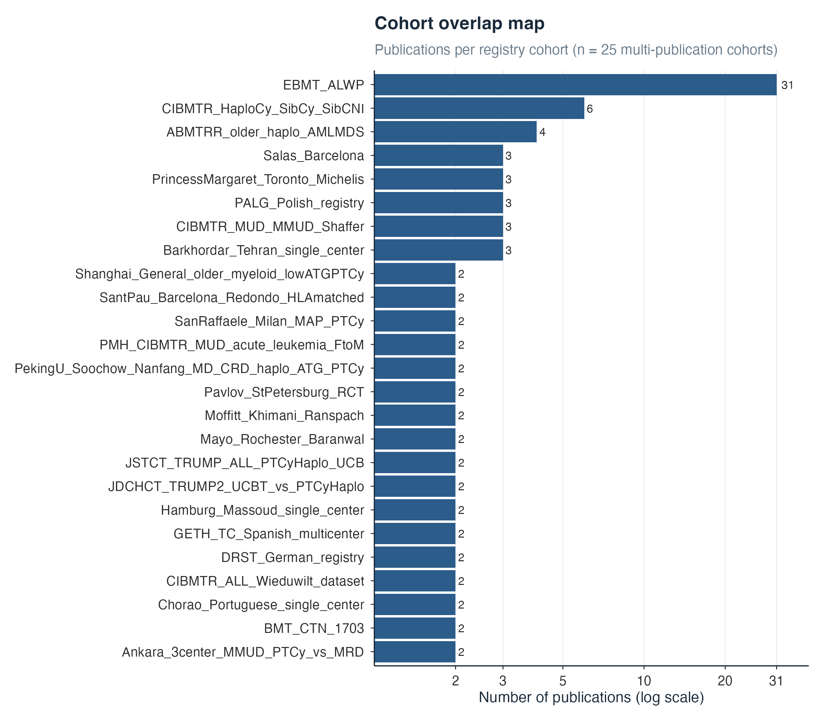
Figure 21: Cohort overlap map. Studies sharing patient cohorts were flagged and the most comprehensive publication designated as primary for each cohort–outcome combination (Set B, the adopted analysis).
During revision, one publication (Wu 2025, British Journal of Haematology; doi 10.1111/bjh.70133) was found to have been entered twice in the extraction database (study identifiers 395 and 401, assigned separate cohort identifiers 1154 and 1158). The duplicate entry was removed. All counts, analyses, tables, and figures in this revision use the corrected database (250 studies, 523 arms; C1 overall survival k = 29).

Per-outcome attrition from extraction to pooling
The pooled study count is smaller than the comparison size for every outcome because the models require a harmonised timepoint with actual event counts per arm, and because cohort deduplication (Set B) retains one publication per cohort. The table below gives, for each outcome, the number of studies with paired-arm outcome records in the extraction database and the number pooled in the reported model.
Table 18. Per-outcome attrition. “Studies with paired-arm records” counts studies with extractable event data (counts or percentages) for both a PTCy and an eligible comparator arm in outcomes.csv; “studies pooled” is the model-input k from table 2. The difference reflects outcome-specific eligibility (harmonised timepoint, actual event counts rather than derived estimates), complete-case rules, and — for the seven deduplication-affected outcomes below — removal of duplicate cohort publications. A small number of pooled studies enter via rebuilt estimates (for example from reported hazard ratios) and so do not appear in the extracted-count column. Source data: outcome_flow.csv, a supplementary data file.
Comparison | Outcome | Studies with paired-arm records | Studies pooled
C1 | Overall survival | 116 | 29
C1 | Non-relapse mortality | 109 | 11
C1 | Relapse-related mortality | 41 | 34
C1 | Acute GVHD II–IV | 104 | 28
C1 | Chronic GVHD mod–severe | 61 | 18
C1 | Chronic GVHD any | 28 | 8
C1 | CMV reactivation | 46 | 21
C1 | Bloodstream infection | 13 | 4
C1 | Invasive fungal infection | 7 | 6
C1 | BK virus | 27 | 11
C1 | Infection-related mortality | 18 | 13
C2 | Overall survival | 47 | 6
C2 | Non-relapse mortality | 43 | 3
C2 | Relapse-related mortality | 12 | 10
C2 | Acute GVHD II–IV | 43 | 7
C2 | Chronic GVHD mod–severe | 26 | 6
C2 | CMV reactivation | 18 | 12
C2 | BK virus | 10 | 3
C2 | Infection-related mortality | 9 | 7
C3 | Overall survival | 18 | 5
C3 | Non-relapse mortality | 18 | 3
C3 | Relapse-related mortality | 6 | 6
C3 | Acute GVHD II–IV | 18 | 5
C3 | Chronic GVHD mod–severe | 14 | 3

Estimates before and after cohort deduplication
Cohort deduplication (Set B) changed seven outcomes; all other outcomes were unaffected. Set A values are the pre-deduplication estimates under the originally submitted common-effect model; Set B values are the reported estimates under the random-slope model (the specification change is documented in S6 and S9). Note that the Set A C1 overall-survival M2 result (0·86 [0·77–0·96]) was originally read as a residual direct survival benefit; under Set B the steroid-adjusted estimate is 0·96 [0·72–1·28], and M2 is now reported as an appendix-only exploratory analysis (S9).
Table 19. Estimates before (Set A) and after (Set B) cohort deduplication for the seven affected outcomes. Set A estimates are from the originally submitted common-effect models; Set B estimates are the reported random-slope models (post-adjudication, 2026-10-02), so intervals are not directly comparable in width.
Outcome | k, Set A | OR, Set A (common-effect) | k, Set B | OR, Set B (reported)
C1 Overall survival (M1) | 40 | 0·79 (0·73–0·85) | 29 | 0·73 (0·58–0·89)
C1 Overall survival (M2, appendix-only) | 40 | 0·86 (0·77–0·96) | 24 | 0·95 (0·70–1·29)
C1 Relapse-related mortality | 38 | 0·84 (0·76–0·93) | 34 | 0·87 (0·76–0·99)
C1 Chronic GVHD mod–severe | 21 | 0·33 (0·29–0·36) | 18 | 0·41 (0·23–0·72)
C1 Infection-related mortality | 16 | 1·35 (1·16–1·57) | 13 | 1·02 (0·67–1·50)
C2 Overall survival | 10 | 0·81 (0·74–0·90) | 6 | 0·75 (0·43–1·28)
C2 Acute GVHD II–IV | 9 | 0·58 (0·44–0·77) | 7 | 0·53 (0·23–1·17)
C2 CMV reactivation | 13 | 0·92 (0·73–1·15) | 12 | 0·86 (0·51–1·42)

S13. PROSPERO registration
The study protocol was registered with PROSPERO (CRD420261372156) before data extraction. Protocol amendments were: (1) a Bayesian rather than frequentist primary analysis framework; (2) addition of BK virus reactivation, infection-related mortality, and relapse-related mortality as secondary outcomes; and (3) addition of the steroid-adjustment (M2) model as an exploratory analysis.

S14. PRISMA 2020 checklist
Page and line references are to the typeset submission build: the article PDF (31 pages, continuous line numbering) and this appendix (72 pages, separately paginated). Locations cite the page and, for main-text sections, the line at which the relevant content begins.
Table 20. PRISMA 2020 checklist for the review, with page and line references to the typeset submission build
Section and topic | Item | Checklist item | Location (page, line)
Title | 1 | Identify the report as a systematic review | p. 1, line 5 (title page)
Abstract | 2 | Structured summary (PRISMA 2020 for Abstracts) | p. 1, line 8 – p. 2, line 37 (Summary)
Rationale | 3 | Rationale for the review in the context of existing knowledge | p. 4, line 71 (Introduction); p. 2, line 38 (Research in context)
Objectives | 4 | Explicit statement of objectives and questions | p. 5, lines 90–94 (“To address this question…”); appendix p. 57 (S13, PROSPERO CRD420261372156)
Eligibility criteria | 5 | Inclusion and exclusion criteria and grouping rationale | p. 5, line 95 (Methods — Search strategy and selection criteria); appendix p. 6 (S2)
Information sources | 6 | Databases, registers, websites, organisations, citation searching, with dates | p. 5, line 95; appendix p. 1 (S1: EMBASE, PubMed/MEDLINE, SCOPUS, inception–April 2026); p. 28 (figure 1)
Search strategy | 7 | Full search strategies for all sources | appendix p. 1 (S1, complete search strings per database)
Selection process | 8 | Methods used to decide inclusion (screeners, independence, automation) | p. 5, line 95 (Methods: two reviewers in Covidence); p. 28 (figure 1)
Data collection process | 9 | Methods used to collect data (reviewers, forms, verification) | p. 5, line 95 (Methods: structured extraction template, AI-assisted extraction with manual verification)
Data items | 10 | All variables and outcomes sought; methods for handling multiple measures | p. 6, line 120 (Methods — Outcomes); p. 22 (Table 1); appendix p. 6 (S3–S4); extraction database (supplementary data)
Study risk of bias assessment | 11 | Tools and process for assessing risk of bias in included studies | p. 5, line 95 (Methods: ROBINS-I, RoB 2, two reviewers); appendix p. 7 (S5)
Effect measures | 12 | Effect measures used for each outcome | p. 6, line 127 (Methods — Statistical analysis, odds ratios at fixed timepoints); appendix p. 20 (S9, hazard-ratio sensitivity)
Synthesis methods | 13a | Processes for deciding which studies were eligible for each synthesis | p. 5, line 95; appendix p. 53 (S12, per-outcome attrition)
 | 13b | Data preparation methods | p. 6, line 127; appendix p. 10 (S6); analytic code (Data sharing, p. 17, line 364)
 | 13c | Tabulation or visualisation of individual results and syntheses | p. 24 (Table 2); pp. 29–31 (Figures 2–4); appendix p. 16 (S8)
 | 13d | Methods used to synthesise results and rationale for their choice | p. 6, line 127 (Bayesian random-effects binomial-logistic models); appendix p. 10 (S6, specification, priors, MCMC)
 | 13e | Assessment of heterogeneity in effect estimates | p. 24 (Table 2, τ and 95% prediction intervals); appendix p. 12 (S7); appendix p. 20 (S9)
 | 13f | Assessment of robustness (sensitivity analyses) | appendix p. 20 (S9: fixed study intercepts, matched M1/M2 sets, donor-type, RCT-only, serostatus/letermovir, comparator backbone, outcome definitions, τ-prior)
Reporting bias assessment | 14 | Methods for assessing risk of bias due to missing results (reporting biases) | appendix p. 45 (S10, RoBMA)
Certainty assessment | 15 | Methods for assessing certainty (confidence) in the body of evidence | p. 6, line 127 (Methods: GRADE); appendix p. 48 (S11)
Study selection | 16a | Results of the search and selection process, ideally with a flow diagram | p. 8, line 167 (Results — Study selection); p. 28 (figure 1)
 | 16b | Studies excluded with reasons | appendix p. 6 (S2, full-text exclusions with reasons)
Study characteristics | 17 | Characteristics of included studies | p. 22 (Table 1); appendix p. 6 (S3–S4)
Risk of bias in studies | 18 | Risk-of-bias assessments for each study and domain | p. 9, line 183 (Results — Risk of bias); appendix pp. 7–9 (S5; figures S5a–S5c)
Results of individual studies | 19 | Summary statistics and effect estimates for each study | pp. 29–31 (Figures 2–4); appendix p. 16 (S8: per-study odds ratios, events/totals, weights); supplementary data files
Results of syntheses | 20a | Results of each synthesis, including summary statistics and certainty | p. 24 (Table 2); p. 9, line 190 (Comparison 1); p. 10, line 206 (Comparison 2); p. 10, line 216 (Comparison 3)
 | 20b | Results of investigations of causes of heterogeneity | p. 10, line 220 (Confounding and robustness analyses); appendix p. 20 (S9)
 | 20c | Results of sensitivity analyses | appendix p. 20 (S9)
 | 20d | Results of reporting-bias assessment | appendix p. 45 (S10)
Reporting biases | 21 | Assessment of risk of bias due to missing results | appendix p. 45 (S10)
Certainty of evidence | 22 | Assessment of certainty of evidence for each outcome | p. 11, line 235 (Certainty of evidence); p. 24 (Table 2, GRADE column); appendix p. 48 (S11; all five GRADE domains per outcome, with imprecision assessed against pre-specified clinically meaningful thresholds of OR 0·80 for benefit and 1·25 for harm)
Discussion | 23a | General interpretation in the context of other evidence | p. 11, line 244 (Discussion)
 | 23b | Limitations of the evidence | p. 14, line 307 (Limitations)
 | 23c | Limitations of the review processes | p. 14, line 307; appendix p. 53 (S12, cohort deduplication and duplicate-entry removal)
 | 23d | Implications for practice, policy, and future research | p. 16, line 346 (Conclusions)
Registration and protocol | 24a | Registration information and protocol access | p. 5, line 95 (Methods); appendix p. 57 (S13, PROSPERO CRD420261372156)
 | 24b | Protocol amendments | appendix p. 57 (S13, all amendments listed)
 | 24c | Protocol access | PROSPERO CRD420261372156; p. 17, line 364 (Data sharing)
Support | 25 | Sources of financial or non-financial support, and role of funders | p. 2 (Summary — Funding); p. 8, line 164 (Role of the funding source: none)
Competing interests | 26 | Competing interests of review authors | p. 16, line 362 (Declaration of interests)
Availability of data, code, and materials | 27 | Public access to data, analytic code, and other materials | p. 17, line 364 (Data sharing: extraction database and analytic datasets on GitHub; manuscript source and notebooks on GitHub Pages); appendix p. 68 (S15, software)

S15. Software and statistical packages used
All analyses were performed in R (versions 4·6·0 and 4·6·1; R: A Language and Environment for Statistical Computing, R Foundation for Statistical Computing, Vienna, Austria)². Bayesian models were fitted with Stan via brms^{3–5}; frequentist concordance models used metafor⁶; publication-bias assessment used RoBMA⁷; data manipulation used the tidyverse packages⁸. Documents were rendered with Quarto (version 1.10.18).
Table 21. R packages used in the analysis and manuscript preparation, with versions from the analysis environment.
Package | Version | Role
brms | 2.23.0 | Bayesian binomial-logistic meta-analysis models (M1, M2, and all sensitivity models)
rstan | 2.32.7 | MCMC sampling backend; convergence diagnostics (R̂, effective sample sizes, divergences)
StanHeaders | 2.39.1 | Stan model compilation
posterior | 1.7.0 | Posterior draw handling and summaries
metafor | 5.2.1 | Frequentist REML concordance models, leave-one-out analysis, log-odds-ratio calculations
RoBMA | 4.0.0 | Robust Bayesian model-averaging assessment of publication bias
bayesplot | 1.16.0 | MCMC diagnostic figures (trace plots, posterior densities)
ggplot2 | 4.0.3 | All figures
ggridges | 0.5.7 | τ posterior density figure
patchwork | 1.3.2 | Multi-panel figure composition and forest-plot side tables
scales | 1.4.0 | Axis and percentage formatting
PRISMA2020 | 1.1.5 | PRISMA 2020 flow diagram (figure 1)
knitr | 1.52 | Tables in source notebooks
dplyr | 1.2.1 | Data manipulation
tidyr | 1.3.2 | Data reshaping
readr | 2.2.0 | Data import
purrr | 1.2.2 | Iteration
stringr | 1.6.0 | String formatting
tibble | 3.3.1 | Data frames
forcats | 1.0.1 | Factor handling

References
1 Senn S. Hans van houwelingen and the art of summing up. Biometrical Journal 2010; 52: 85–94.
2 R Core Team. R: A language and environment for statistical computing. Vienna, Austria: R Foundation for Statistical Computing, 2026 DOI:10.32614/R.manuals.
3 Bürkner P-C. brms: An R package for Bayesian multilevel models using Stan. Journal of Statistical Software 2017; 80: 1–28.
4 Bürkner P-C. Advanced Bayesian multilevel modeling with the R package brms. The R Journal 2018; 10: 395–411.
5 Carpenter B, Gelman A, Hoffman MD, et al. Stan: A probabilistic programming language. Journal of Statistical Software 2017; 76: 1–32.
6 Viechtbauer W. Conducting meta-analyses in R with the metafor package. Journal of Statistical Software 2010; 36: 1–48.
7 Bartoš F, Maier M. RoBMA: An R package for robust Bayesian meta-analyses. 2020. https://CRAN.R-project.org/package=RoBMA.
8 Wickham H, Averick M, Bryan J, et al. Welcome to the tidyverse. Journal of Open Source Software 2019; 4: 1686.

