Creating a CentOS Virtual Machine in Amazon AWS
These instructions will explain how to create a new (CentOS) Virtual Machine in Amazon AWS. You should register for a free Amazon AWS account at https://aws.amazon.com/. You can use an Amazon AWS EC2 server free for one year – providing you stay within the free services.

- To get started with Amazon EC2 go to https://aws.amazon.com/ec2/?ft=n.
- You need to sign in with your AWS account.
- Once logged in select Launch a Virtual Machine (with EC2).

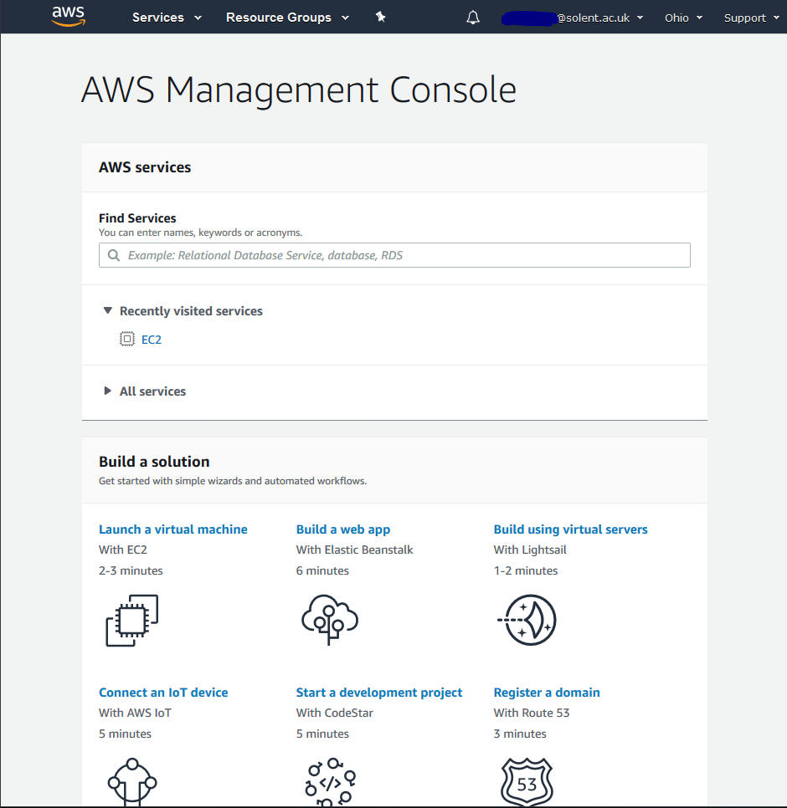
Click Launch a Virtual Machine
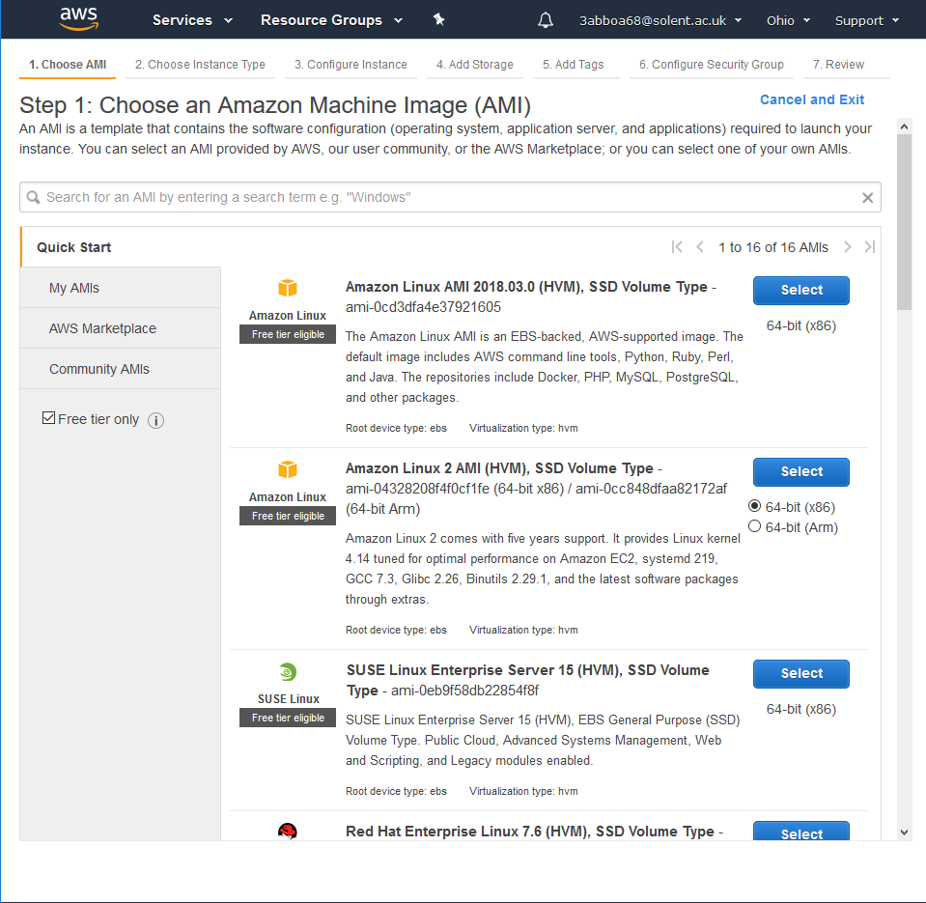
- Make sure you select “Free tier only”. Then pick the relevant OS for the work. To start, pick either CentOS.
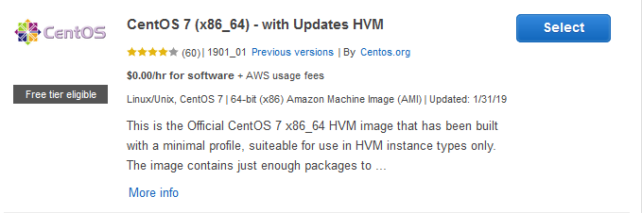
Check that the OS is labelled free tier eligible.
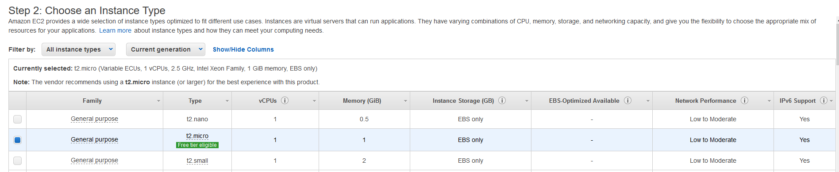
- Select a t2.micro instance for this lab. This will allow you to run the VM continually for 750 hours per month, for twelve months without incurring cost.
- Hit launch on the instance.
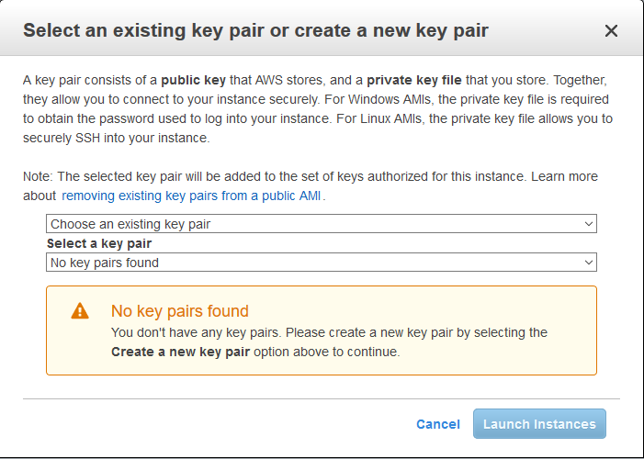
- A prompt for a key pair will appear. Create a new key pair. Keep this safe, as it is needed to allow you to connect in.
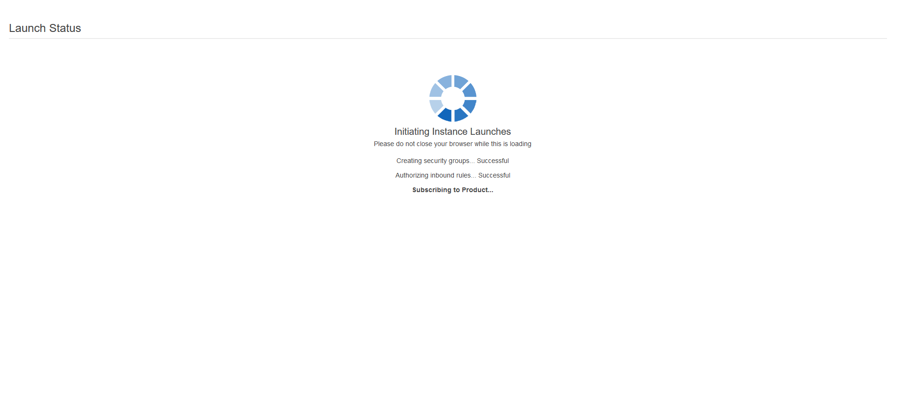
Once you save your Key, the instance will be launched.
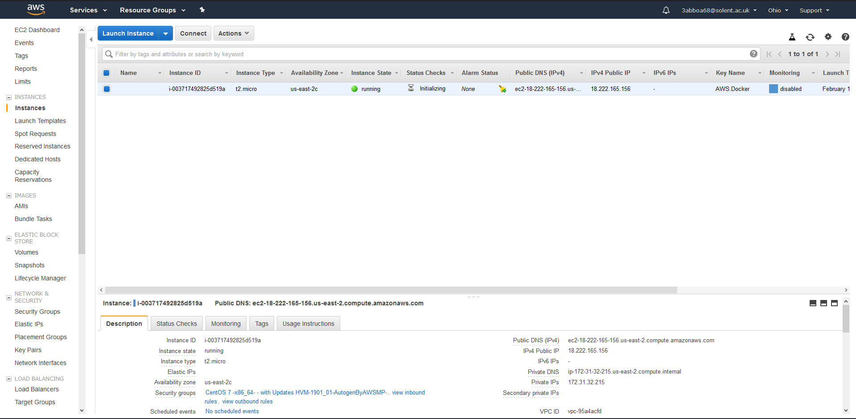
- Hit view instance. Once the VM has finished initializing, a public DNS address will be shown.

- From here, follow this amazon guide to connect: https://docs.aws.amazon.com/AWSEC2/latest/UserGuide/putty.html?icmpid=docs_ec2_console

