Creating a CentOS Virtual Machine in Miscrosoft Azure
These instructions will explain how to create a new (CentOS) Virtual Machine in Microsoft Azure. You should already have registered with Azure and have a username and password for your Azure account to hand. You will need to do this on the Azure Portal on the Interment and also to have the Putty console program available to connect to the new VM once created. You only need a basic VM (1-2Gb RAM and standard) – this will avoid any charges.

- Create an Azure account and login to it.
- Go the Azure Portal.
- Select the Virtual Machines from the menu on the left
- The Create a Virtual Machine page appears – see figure 1 below.
- Add a new VM
- Ensure that the subscription is Free Trial
- Give the VM a name of your choosing
- Select the region as UK South
- Select CentOS-based 7.7 as the Image type (not Linux or anything else)
- Select Size and then from the list select “B1s” – you only need 1-2Gb of RAM and one processor (to avoid charges)
- For “Authentication type” it is easiest to select “Password”
Enter a username for your administrator account on the VM, eg. admin01 and a secure password that you can remember
(the VM will be accessible over the Internet so a good password is essential)

Note: if you want to configure SSH with a public key instead of password – please see instruction at the end of this document)
- Select Inbound Port Rules and then make sure that SSH port 22 and RDP port 3386 are checked to allow remote access.
- Leave everything else as per defaults.
- Then click the Next: Disks button at the bottom of the page
- On the Disks page (see figure 2 below) select the OS disk type as Standard HDD

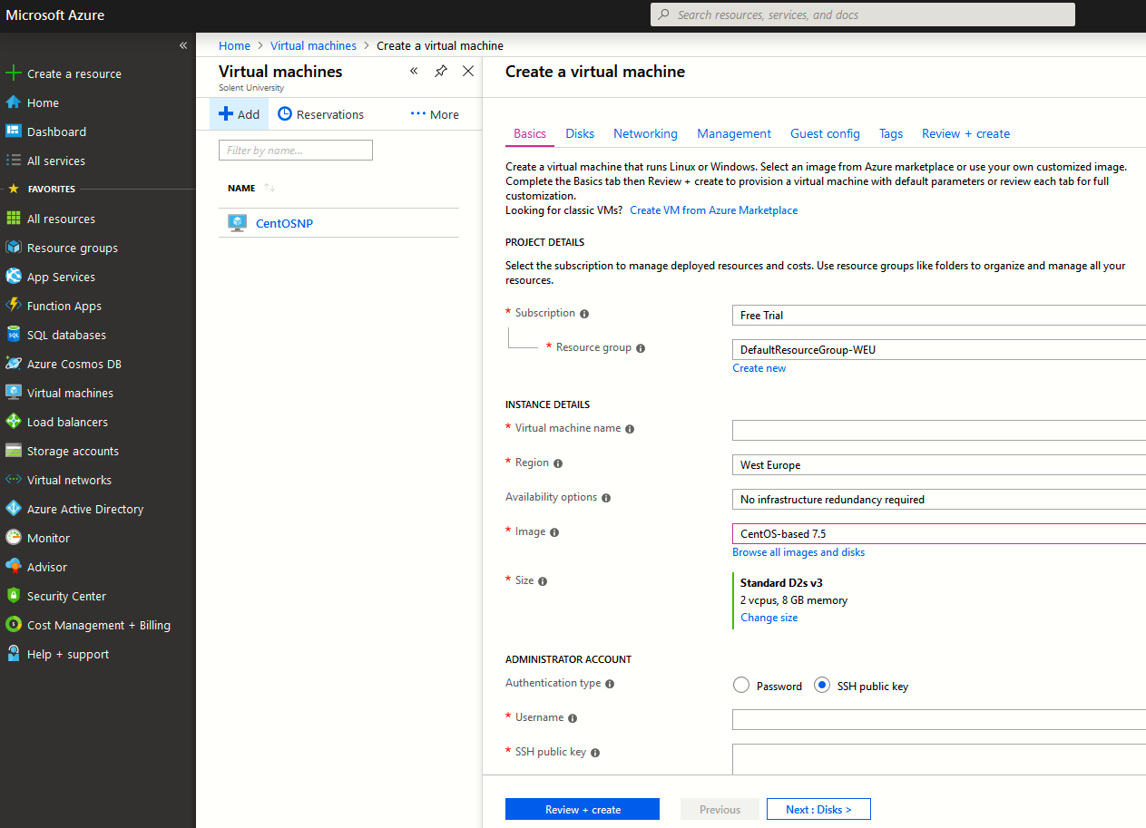
Figure 1. Creating a new virtual machine in Azure. Note: select B1s for Size (not D2 as shown)
- Then select Next: Networking at the bottom of the page

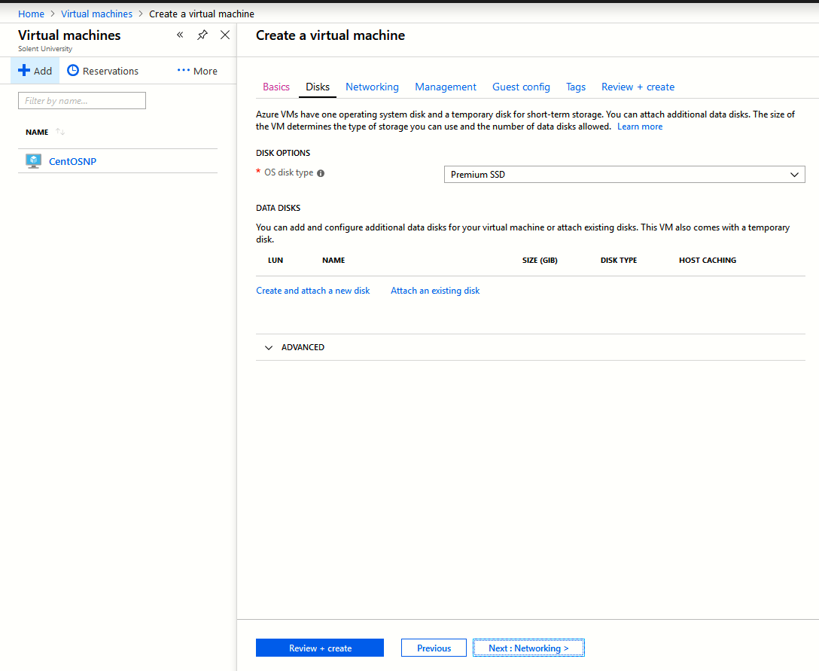
Figure 2. Disks page.

- On the Networking page see figure 3 – leave the defaults for all, but make sure that under “Public Inbound Ports” that “allow Selected Ports” is selected (so that you can connect to your virtual machine remotely.
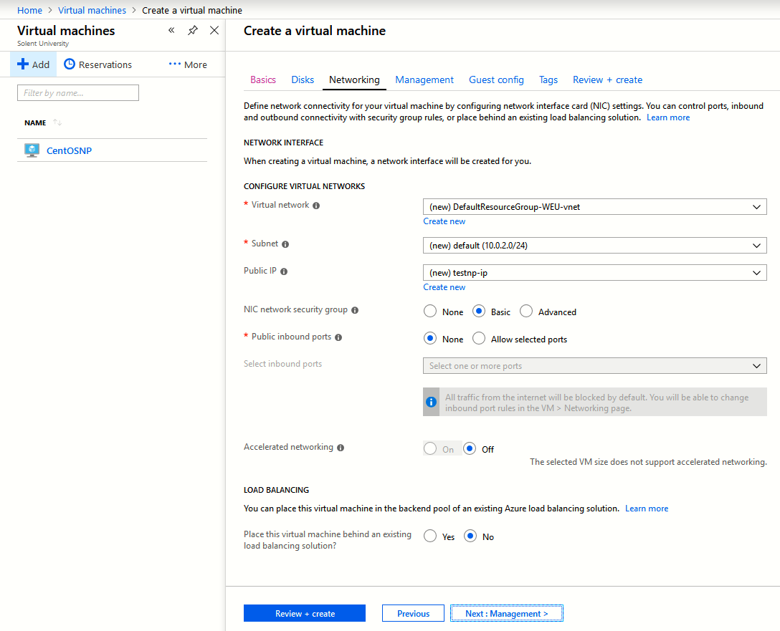
Figure 3 Networking Page – note select the

- Select Next: Management at the bottom of the page.
- At the Management screen just leave it as is and select Next: Guest config at the bottom of the page
- At the Guest Config screen just select Next: Tags at the bottom of the page
- At the Tags screen just select Next: Review and Create at the bottom of the page.
- At the Review and Create screen check the settings and go back to make changes if something is wrong or missing.
- Then select Next at the bottom of the page and proceed with the creation of your new CentOS VM

To see your new VM – select Virtual Machines from the left hand menu – here you will also see your public IP address.

IMPORTANT NOTE: - make sure that you STOP your virtual machine from the “Virtual Machines” tab in the Azure Portal each time you finish a session to avoid charges during your free trial.

Accessing your new VM Over the Internet
- To access your VM start Putty to open a new putty session (see figure 5 below).
- Ensure that SSH is selected (port 22) and the public IP address of your VM.
- Then select Open.
- You should be prompted for the username and password that you created above.
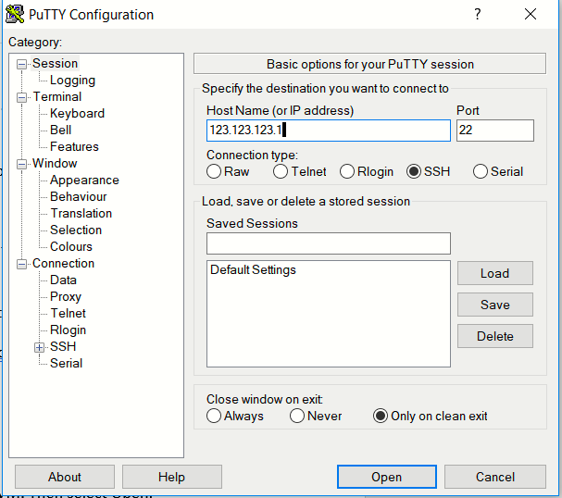
Figure 5. Accessing your VM using SSH in Putty.

Using and SSH Public Key to Connect to you VM rather than username and Password
If you selected Password for “Authentication Type” you will need to supply a username and password each time you connect using Putty. A more secure method is to use an SSH key.
- On the first page in creating a virtual machine you could either select Password or SSH Public Key. If you selected SSH public key you should run PuttyGen (see figure 6 below)
- You should select Generate and then move your mouse around in the blank area as instructed.
- Then select all the text in the “Public key for passing into OpenSSH ……” and paste this into the “SSH Public Key” box on the first page when creating your new VM in Azure.
- Then above this box in Azure enter a username that you will use for the administrator on the new VM.

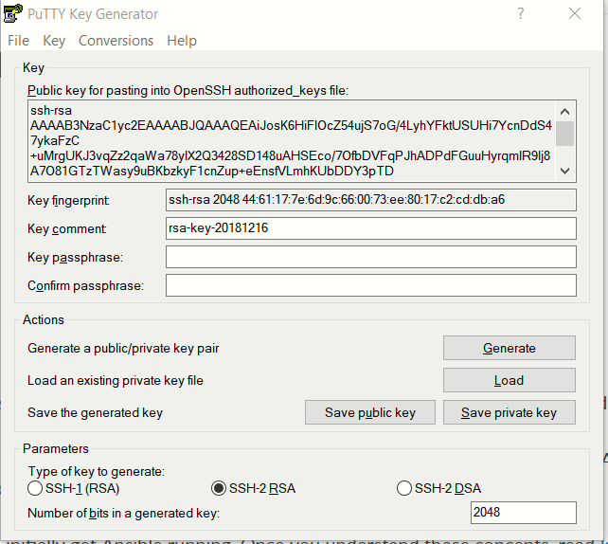
Figure 6. Generating a Public Key with PuttyGen.

