Solent University

Faculty of Business, Law and Digital Technologies

Software Engineering
2023

E-Learning for Stargazers: Improving Amateur Astronomy through Artificial Intelligence and Gamification

Tutor:
Date of submission: May 2023

Acknowledgements

Abstract
Astronomy is ever-growing field with many recent publications and findings, and with recent events such as the COVID-19 pandemic, there has been a notable increase in individuals learning astronomy and attempting to partake in amateur astronomy. To aid new learners, there are a wide range of courses to give individuals the knowledge needed to begin the hobby, as well as virtual planetarium tools to identify objects through a simulated night sky. But, despite the number of courses and tools, beginners typically feel stressed and isolated, leading to high dropout rates. To potentially resolve these issues, an e-learning tool was created to assist amateur astronomers in finding objects to observe through content-based and collaborative algorithms. Furthermore, techniques to navigate across the night sky were visualised in a virtual planetarium, possibly making this one of the first tools for interactively learning star-hopping. When tested by amateur astronomers, the tool was found to positively impact their learning experience by increasing the number of successfully found objects whilst also decreasing the time it took to star-hop. However, many of these individuals appeared to already be skilled, making it difficult to determine if the features would also assist new learners. Because of this, more time should be invested into testing these features on new learners, giving them an increased amount of time to learn from the tool.

Contents
Acknowledgements 1
Abstract 2
Contents 3
List of Figures 5
1. Introduction 11
1.1. The growth of Astronomy 11
1.2. Present tools to support learning & partaking in Amateur Astronomy 12
1.3. Issues with current tools 13
1.4. The goal 14
2. Literature Review 15
2.1. The present learning environment for amateur astronomers 15
2.2. Issues with current learning methods 17
2.3. Methods of enhancing amateur astronomy 19
2.3.1. Automated object finding 19
2.3.2. Star traversal assistance 22
2.3.3. Incorporating gamification 25
2.4. Applying the methods 26
3. Methodology 27
3.1. Methodology Overview 27
3.2. Experiment Procedure 27
3.3. Experiment Outcome 29
4. Project Management 30
4.1. Management Overview 30
The GitHub repository for the project, of which also contains the project board, can be found here: 32
4.2. Design & Implementation 32
4.2.1. Problem Identification 32
4.2.2. Requirements Gathering 32
4.2.3. Feasibility Study 37
4.2.3.1. Prototype 1 – Location Retrieval 38
4.2.3.2. Prototype 2 – Planetarium Visualisations 39
4.2.3.3. Prototype 3 – Object Recommendations 41
4.2.4. Application Development & Testing 43
4.2.4.1. Sprint 1 – Data Gathering and UI Design 43
4.2.4.2. Sprint 2 – UI Implementation and Data Integration 53
4.2.4.3. Sprint 3 – E-Learning and Gamification 60
4.2.4.4. Sprint 4 – Object-finding Automation 74
4.2.4.5. Sprint 5 – Advanced Functionality 85
4.3. Professional, Legal and Ethical issues 90
5. Results 93
5.1. Interest survey 93
5.2. Pre-tool phase 94
5.3. Post-tool phase 95
6. Discussion 96
6.1. Pre-tool results 96
6.2. Post-tool results 97
6.3. Overall results 98
6.3.1. Skill difference 98
6.3.2. Time difference 98
6.3.3. Free-period difference 98
7. Conclusions 100
8. Recommendations 102
8.1. Experiment Improvements 102
8.2. Tool Improvements 102
9. Reference list 105

List of Figures
Figure 1: Central black hole of the M87 galaxy
ESO, 2019. First image of a black hole [viewed 15 Februrary 2023]. Avaliable from: https://www.eso.org/public/images/eso1907a/

Figure 2: Pillars of creation taken by the James Webb Telescope
NASA, 2022. NASA’s Webb Takes Star-Filled Portrait of Pillars of Creation [viewed 15 Februrary 2023]. Available from: https://www.nasa.gov/feature/goddard/2022/nasa-s-webb-takes-star-filled-portrait-of-pillars-of-creation
Figure 3: User interface of Stellarium Web.
CHEREAU, G. and F. CHEREAU, 2022. Stellarium Web Online Star Map [viewed 15 Februrary 2023]. Available from: https://stellarium-web.org/

Figure 4: Night skies before and during the 2003 Northeast blackout, showing the impact of city lights.

Figure 5: The process of content-based recommenders, which recommend similar objects to a given object.

Figure 6: The process of collaborative recommenders, which recommend objects that similar amateur astronomers tend to observe.

Figure 7: The process of hybrid recommenders, which recommend objects that are both similar to previously observed objects & relevant among similar astronomers.

Figure 8: Constellations consist of bright stars, making them easier to follow compared to faint starts.

Figure 9: Finding the shortest-path without object positions, resulting in unrealistic distances which may be preferred (due to low magnitude costs) as well as going below the horizon.

Figure 10: Finding the shortest-path with object positions, resulting in hops that do not exceed a certain amount of distance.

Figure 11: Knowledge against time with key observational achievements.

Figure 12: The phases of the experiment.

Figure 13: The overarching stages of the project.

Figure 14: Project timeline.

Figure 15: GitHub project board.

Figure 16: Development process for each feature.

Figure 17: Sprint milestones.

Figure 18: Requirements overview and justifications.

Figure 19: Risk matrix of identified requirements, plotted by issue number.

Figure 20: Passing latitude and longitude to the Google Maps tile server.

Figure 21: NGC 224, also known as the Andromeda Galaxy, taken by NASA.

Figure 22: The Andromeda Galaxy visualised through d3-celestial.

Figure 23: The Andromeda Galaxy visualised through VirtualSky.

Figure 24: Prototype database design, noting that this omits associative entities (meaning a yellow field such as userId may not be needed in a non-relational database).

Figure 25: Recommendation query through SQL.

Figure 26: Prototype recommendations. After clicking on multiple galaxies and star clusters, it begins to recommend more of those categories.

Figure 27: The various names and catalogue identifiers for Sirius.

Figure 28: NGC/IC field information and decisions.

Figure 29: Removing duplicate objects.

Figure 30: Removing invalid objects.

Figure 31: HYG field information and decisions.

Figure 32: Merging DataFrames.

Figure 33: Greek and constellation names.

Figure 34: Bortle calculation.

Figure 35: Initial object search design.

Figure 36: Initial object popup design.

Figure 37: Initial object observation design.

Figure 38: Database design.

Figure 39: Database tables.

Figure 40: Database connection.

Figure 41: Converting objects to Object models.

Figure 42: Search page UI (desktop).

Figure 43: Search page UI (mobile).

Figure 44: Obtaining location through IP.

Figure 45: Sign-in error.

Figure 46: Sign-up testing through Pytest.

Figure 47: GitHub Action for Pytest.

Figure 48: Deployed application.

Figure 49: Gunicorn configuration.

Figure 50: Expected search arguments.

Figure 51: Switching queries depending on search arguments.

Figure 52: Passing date and time to an Observer.

Figure 53: Getting object positions.

Figure 54: Initialising infinite scroll.

Figure 55: Utilising hips2fits.

Figure 56: Dynamic zoom for hips2fits.

Figure 57: Searching for NGC 448.

Figure 58: Popup for NGC 448.

Figure 59: Choosing hips2fits dimensions.

Figure 60: Object position calculations.

Figure 61: Viewing Bortle information of objects.

Figure 62: Searching Wikipedia for relevant pages.

Figure 63: Observing an object.

Figure 64: Finding a nearby object.

Figure 65: Loading star-hopping marker.

Figure 66: Ensuring star-hopping objects are visible.

Figure 67: Preparing stars for star-hopping.

Figure 68: Creating a star-hopping graph.

Figure 69: Visualisation of star-hopping graph.

Figure 70: Calculating node weights.

Figure 71: Visualising the issue of linking nodes.

Figure 72: Looping through nodes that do not have appropriate edges.

Figure 73: Finding the star-hopping path through A*.

Figure 74: Visualising the star-hopping path.

Figure 75: Extended VirtualSky code for drawing lines.

Figure 76: Profile page.

Figure 77: Unlocking the Humble Beginnings achievement.

Figure 78: Achievement notification.

Figure 79: Unlocking the Constellation Wizard achievement.

Figure 80: Nearby categories and range settings.

Figure 81: Storing and popping nearby range.

Figure 82: Filters for nearby objects.

Figure 83: Querying for nearby objects.

Figure 84: Displaying nearby objects.

Figure 85: Querying through Pandas.

Figure 86: Calculating object similarity.

Figure 87: Displaying similar objects.

Figure 88: Interest scores table.

Figure 89: Converting objects to LibRecommender’s format.

Figure 90: Determining content-based attributes.

Figure 91: Fitting the recommender model.

Figure 92: Running the recommender model.

Figure 93: Displaying recommended objects, after clicking on a multitude of stars.

Figure 94: Displaying recommended objects, after clicking on a multitude of star clusters.

Figure 95: Saving the recommender model.

Figure 96: Loading the recommender model.

Figure 97: Latitude and longitude settings.

Figure 98: Date and time settings.

Figure 99: Handling latitude, longitude, dates and times.

Figure 100: The location of IC 1 near Moscow, Russia.

Figure 101: Red-mode display.

Figure 102: Injecting styles into the head element.

Figure 103: Tutorial process.

Figure 104: Stargazers Lounge post.

Figure 105: Consent questions.

Figure 106: Follow up message from the initial survey.

Figure 107: Deleting data.

Figure 108: Removing from the database.

Figure 109: Interest survey results.

Figure 110: Pre-tool results.

Figure 111: Post-tool results.

Figure 112: Pre-tool averages.

Figure 113: Post-tool averages.

Figure 114: Comparing skill difference.

Figure 115: Comparing time difference.

Figure 116: Comparing free-period difference.

Figure 117: Current VirtualSky planetarium.

Figure 118: Experimental VirtualSky planetarium.
CHEREAU, G. and F. CHEREAU, 2022. Stellarium Web Online Star Map [viewed 15 Februrary 2023]. Available from: https://stellarium-web.org/

1. Introduction

1.1. The growth of Astronomy
Astronomy is the area of study that gives more insight into the universe and how all came to be. There have been more opportunities to research, learn and develop upon this field due to advances in technology, such as the ‘Event Horizon Telescope’ capturing the first photograph of a black hole in 2019 (Azulay et al. 2019). Furthermore, the long-awaited James Webb Telescope launch in 2021 has improved upon Hubble’s resolution and allowed for deeper insights into the universe (Gardner et al. 2006). There is a clear scientific growth that is present in astronomy with more advancements to come as technology improves.
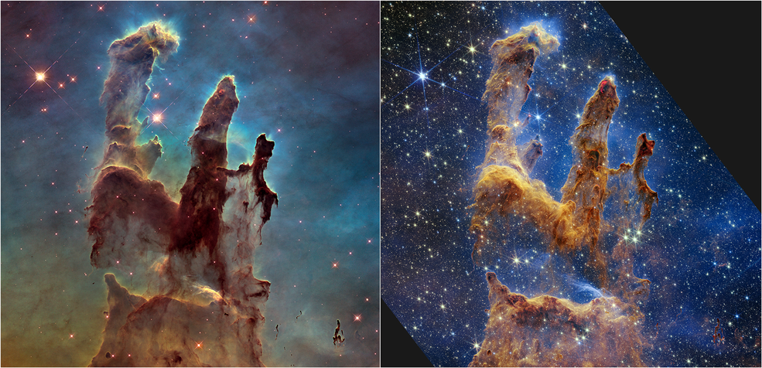
Figures 1 & 2 – Central black hole of the M87 galaxy, along with the Pillars of Creation captured by the James Webb Telescope.
With said scientific advancements, along with the COVID-19 pandemic, there has been a recent increase in those with an interest in astronomy. This was particularly seen through a notable enrolment surge in astronomy-related courses, with one such course spiking to 16740 students compared to its typical average of 1100, which is an increase of 1422% (Impey, Chris and Formanek 2021). Alongside this, there has also been an increase in telescope sales and star-party attendees (Buxner, Fitzgerald and Freed 2021), suggesting many of these students are using the opportunity that the COVID-19 lockdown provided to enter amateur astronomy.

1.2. Present tools to support learning & partaking in Amateur Astronomy
Whilst many of these courses provide theory regarding astronomy, they do not allow an amateur astronomer to put the theory to practice through observational astronomy. To give these individuals a method of finding and identifying astronomical objects, a multitude of applications exist to simulate the night sky. Examples include:
- Starry Night Pro, a desktop application
- SkySafari, a mobile application
- Stellarium, a desktop & mobile application
These applications provide planetariums of the night sky by calculating object positions from their right ascension and declination (acting as global coordinates), which are converted into altitude and azimuth (acting as local coordinates) based on a given location and time (De Lorenzis and Orofino 2018). By being simulations, they are sufficient for experienced individuals who want to quickly identify where particular objects are located, enhancing their experience and reducing the need for star charts.
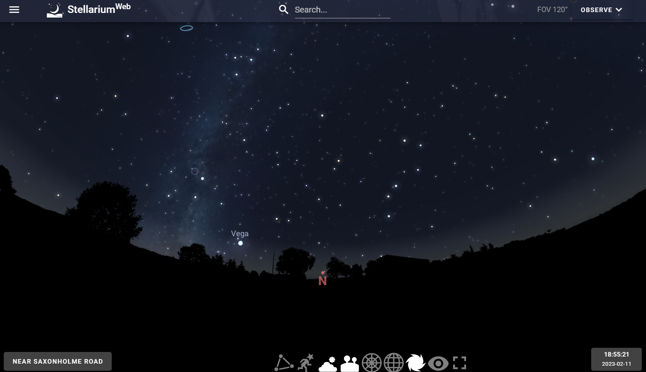
Figure 3 – User interface of Stellarium Web, showcasing the virtual planetarium.

1.3. Issues with current tools
Whilst the focus on providing accurate simulations of the night sky may be beneficial for professional astronomers, it may also act as a barrier due to the lack of educational information they provide. In addition, they do not expand on a key reason why many enter the hobby, which is to learn more about astronomy and to find objects in the night sky through their telescopes (Jones et al. 2017). This could lead to less-skilled individual experiencing issues such as:
- Struggling to find objects due to a lack of known techniques, such as “star-hopping” to find a target (Azevedo 2019). For a beginner or intermediate to navigate to a high-magnitude (low brightness) object, they will need to know the techniques for doing so.
- Not knowing where to go next during their observations, possibly due to the large number of objects in catalogues such as the New General Catalogue (Dreyer 1988). Once all well-known objects (such as the moon and planets) have been observed, there is a lack of guidance on where to go next.
- Trying to find objects that may be hidden due to factors such as light pollution (Walker 1977). If an individual does not know that the environment is blocking Deep Sky Objects (DSO’s) from being observed, they may continuously fail to observe specific types of objects due to their lowered contrast.

1.4. The goal
This project aims to improve upon the observational experience of amateur astronomers and tackle the issues of finding objects by providing an e-learning tool, which will build upon the foundation that astronomy courses and planetarium tools have laid. By incorporating features such as object recommendations and star-hopping suggestions, barriers that may hinder an amateur astronomer’s experience could be lowered, ultimately reducing stress and increasing knowledge.

2. Literature Review

2.1. The present learning environment for amateur astronomers
A large number of individuals, many of which do not have degrees in associated studies, are presently taught astronomy through small courses (commonly referred to as Astro 101 courses). These introduce the basic concepts of astronomy, from the ways light allows us to “see into the past” to understanding the phases of the moon (Prather, Rudolph and Brissenden 2009). In addition, many of these courses can be found online in MOOC (Massively Open Online Course) formats, which has allowed for a greater number of individuals to learn astronomy (Impey, Chris D., Wenger and Austin 2015). This has allowed for a surge of new learners, which in turn has increased the number of individuals starting amateur astronomy.

Whilst courses teach the backbone of astronomy, many of these learners do not have prior experience in the field. Furthermore, many wish to enter amateur astronomy as a hobby, meaning their expectations may differ from experienced individuals with greater theoretical knowledge (Formanek et al. 2018). This creates a challenge, as those with experience may prefer or adapt better to the theory, whilst non-experienced people will want to start using their telescopes and applying what they have learnt.

Because of this, many courses try to appeal to a wide demographic by taking a mixed approach, combining theoretical material with tutorial sessions. This helps to keep the material less intimidating and more directed to new learners, whilst also providing hands-on practice to ease the learning experience.

By taking a practical approach, the potential of stress could be greatly reduced for those starting the hobby, increasing the ability to grasp new things. LoPresto and Slater provide an example of this, where a set of astronomy exams had a grade increase of 35% on average when incorporating tutorials (2016). Furthermore, teaching theory through practical lessons has made complex tasks easier to follow and more understandable for new learners (Shen and Confrey 2007). Because of these positive results, learners taking practically taught courses could experience higher learning growth compared to theoretical courses, further supporting why practical elements may be impactful for new learners.

Techniques of teaching astronomy in practical ways include activities such as observational astronomy, typically at rural locations far from city lights. These are commonly known as star-parties, which involve experienced astronomers teaching beginners the various ways of identifying objects and navigating to them through techniques such as star-hopping (Azevedo 2019). For individuals with a lack of experience, these meetups can act as crucial lessons on how to navigate the night-sky, giving beginners the confidence to navigate to, identify, and understand objects on their own.

To further aid in this and increase beginner independence, planetarium tools are typically utilised to identify objects and learn more about them. One such tool is Stellarium, which describes itself as an “observational aid for amateur astronomers” (Zotti and Wolf 2022). Such tools have also been combined with Augmented Reality (AR) technology to simulate the sky in front of the user, which further improved the learning experience (Fleck and Simon 2013). By utilising tools such as Stellarium, it can allow beginners to perform observations and identify objects without the presence of a professional, as well as reduce the need for celestial maps (such as star charts).

2.2. Issues with current learning methods
Whilst there are a multitude of courses that are taught in both theoretical and practical ways, there still appear to be issues for learners looking to get into amateur astronomy. For example, an astronomy course that utilised the mixed approach (alongside planetarium tools) for observational astronomy had a dropout rate of 77% (Maravelias et al. 2018). A notable reason for this was that students struggled to put the theoretical concepts to practice, suggesting that taught theory may not be entirely relevant for individuals who want to partake at an amateur level. Furthermore, this also suggests that current planetarium tools may be missing features that ease the learning experience for beginners, which may be due to their focus on providing simulations instead of learning experiences.

Issues such as light pollution may also contribute to the dropout rate and create further problems for new learners. This is due to one of its numerous effects, which is to reduce the contrast of objects against the backdrop of space. Because of this, there has been a decrease in amateur astronomy activity as cities are developed and expanded, lowering the number of visible objects in formally prominent dark-zones (Faid et al. 2016). At a star-party event, experienced astronomers could inform beginners regarding the visibility of light polluted objects, but not all individuals may have a local astronomy group to join. This acts as an entry barrier for beginners, as new learners may not know this is a problem, leading to a lack of successful observations and possibly contributing to the feelings of isolation when starting the hobby (Gada, Stern and Williams 2000).

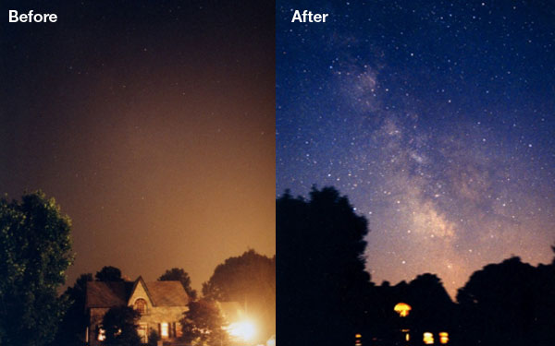
Figure 4 – Night skies before and during the 2003 Northeast blackout, showing the impact of city lights.
If beginners are not able to find objects of interest due to the effects of light pollution, they may also feel that they are “not ready” for this hobby and give up. This is because many individuals take part in amateur astronomy to learn and to put their knowledge to practice (Curtis 2013), with the end result being a successful observation of an object they are interested in. Not being able to accomplish this could further contribute to the high levels of beginner stress, which may influence the high dropout rates seen in courses.

Whilst the theory taught from courses will teach learners the backbone of astronomy, it is apparent that there is a present gap between moving from the theory of astronomy to observational astronomy. For this reason, additional tools that enhance the learning experience and further aid learners may help to smooth the transition between learning astronomy and becoming an amateur astronomer.

2.3. Methods of enhancing amateur astronomy

2.3.1. Automated object finding
One method of potentially enhancing the learning experience, which is currently used by some individuals, is Smart/GOTO telescopes. These telescopes, one such example being the Unistellar eVscope, can connect to planetarium tools and automatically point at objects desired by the observer (Marchis et al. 2020). By using such telescopes, the use of the star-hopping technique is no longer required, which may help to lower the difficulty of finding faint or light polluted objects. However, electronic telescopes are expensive and do not allow an individual to utilise their learnt skills to find objects, creating new issues that may go against their reasons for entering the hobby (Curtis 2013).

To provide an experience which does not interfere with the learning process, the act of finding new objects to observe could be automated instead of the automated movements of smart telescopes. This could be achieved by integrating recommendation engines into astronomy tools, which have been found to reduce the time it takes to find new items of interest (Joy and Pillai 2022). Utilising this technology, objects that are relevant and desirable to observe by the user could be easily identified, reducing the time needed to plan observations. Furthermore, by purposely not automating the process of finding objects, it may help beginners grow their skills and increase stargazing satisfaction.

One form of recommendation engine that may achieve this is a “more-like-this” or content-based algorithm. These algorithms work by recommending items similar to a given item’s attributes (such as category or subcategory), which has been implemented with positive outcomes in areas such as book-finding (Mooney and Roy 2000). By being content-based, theses algorithms do not need user interactions to function, bypassing the “cold-start” problem of other recommender algorithms. This may massively help astronomers with specific interests (such as high-magnitude double stars) find more objects of interest, potentially increasing the number of interesting objects that could be found.

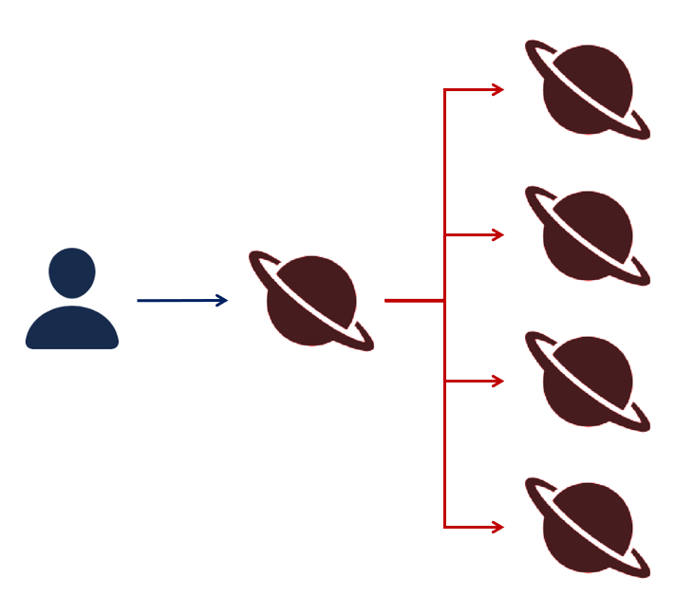
Figure 5 – The process of content-based recommenders, which recommend similar objects to a given object.

However, content-based algorithms do not consider the popularity of items, meaning the algorithm could recommend items to a beginner that only professionals may be able to find. For this reason, a collaborative algorithm could instead be used, which recommends items that similar individuals have consumed. Such algorithms have seen success in e-learning tools, with one focusing on finding computer science resources seeing an increase of 16% in user satisfaction and 10% increase in progression (Tavakoli et al. 2022). By incorporating this, objects observed by people of specific skill levels would be recommended to similarly skilled individuals, which may help to steady the progression of new learners.

Figure 6 – The process of collaborative recommenders, which recommend objects that similar amateur astronomers tend to observe.

But, by using a collaborative approach, the “cold-start” problem as well as item relevancy issues become apparent. This is because it is hard to tell what an individual with little to no observations may like, and even when there are observations, collaborative algorithms will not take into account an objects attributes. This has the potential to create issues, one being that beginners who do not have previous observations will not be able to utilise this algorithm. Furthermore, by not considering object attributes, the recommender could occasionally recommend high-magnitude objects that exceeds a beginners skill level.

Despite the issues of collaborative and content-based approaches, there is nothing stopping the algorithms from being combined. These are typically known as hybrid algorithms, which mix the features of these algorithms to ensure that preferable items consumed by similar users are recommended. This allows the recommender to fill its own gaps, which has been utilised in areas such as e-commerce to increase the number of desirable products and increase product relevancy (Baier and Stüber 2010). By applying such an algorithm to astronomy, it would mean that recommended objects can initially be similar to the low number of objects they have observed (utilising a more content-based approach), before utilising the observations of similar users to similar items once an adequate number of observations is known (utilising a mixed content-based and collaborative approach).

Figure 7 – The process of hybrid recommenders, which recommend objects that are both similar to previously observed objects & relevant among similar astronomers.
This may help to provide an alternative form of automation compared to Smart/GOTO telescopes, giving astronomers a method of quickly finding new objects to observe without impeding their learnt skill. However, this algorithm would not help an astronomer navigate to the object with their telescope, nor would it teach navigational techniques such as star-hopping.

2.3.2. Star traversal assistance
Teaching techniques such as star-hopping could be achievable through graph theory, which is used to convert elements of a problem into nodes and linking edges. This has been used to solve similar problems where physical space (in this case, the night sky and objects within it) must be considered to calculate a “shortest path”, which has been used to guide the GPS systems of cars (Zhang et al. 2016) and arial vehicles (Lin et al. 2021). This is due to its ability to be calculated from any node, massively reducing the time it would take to create star-hopping paths between countless stars in the night sky.
Whilst the shortest path is typically defined as the fastest, or lowest cost, distance between nodes, this needs to be defined differently for star-hopping. This is because the shortest path between stars could take an observer across high-magnitude stars, which may be harder to follow compared to paths of bright stars. For this reason, the distance between stars could also consider the joint magnitude of objects, meaning shortest path algorithms will naturally follow bright objects and make paths easier to follow through telescopes.
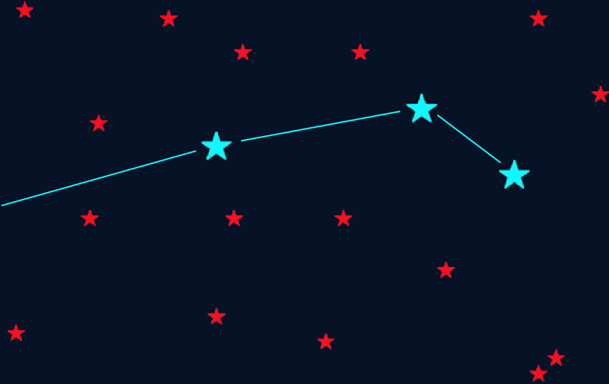
Figure 8 – Constellations consist of bright stars, making them easier to follow compared to faint starts.
However, a problem with graph theory is that node positions are not directly stored, meaning that star-hopping paths could suggest unrealistic directions. For instance, a low-magnitude star at azimuth 0° could be linked to another low-magnitude star at azimuth 180°, which are on opposite ends of the sky and may make the path frustrating and difficult to follow. In addition, stars below the horizon could remain linked with stars above the horizon, possibly making the path impossible to follow.
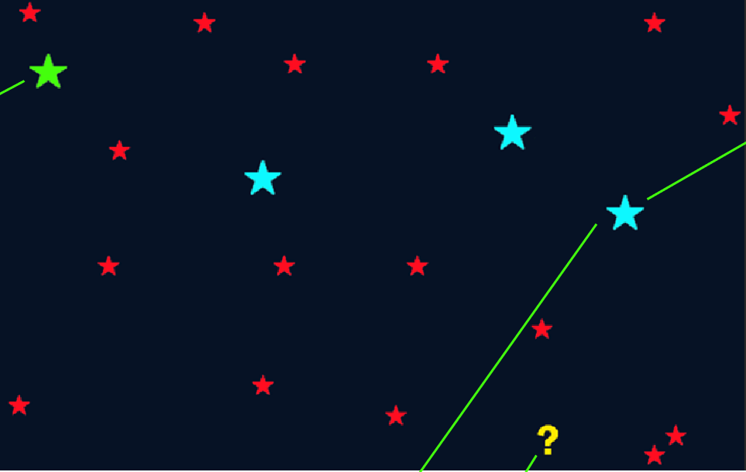
Figure 9 – Finding the shortest-path without object positions, resulting in unrealistic distances which may be preferred (due to low magnitude costs) as well as going below the horizon.
To resolve this, geometric graphs could be used to provide shortest paths whilst also considering the positions of nodes. Geometric graphs have been used in other problems involving positions, such as finding optimal paths through the ground that avoid rocks (Salina Borello et al. 2022) or steering away from hazardous paths in caves (Gelenbe and Wu 2012). Using geometric graphs, the altitude and azimuth of objects could be used to determine connectivity distance, ensuring that only stars within a set distance (e.g. 30°) can be linked. This keeps the paths realistic and helpful, enhancing the experience of finding objects and possibly teaching the ways of star-hopping to less skilled individuals.
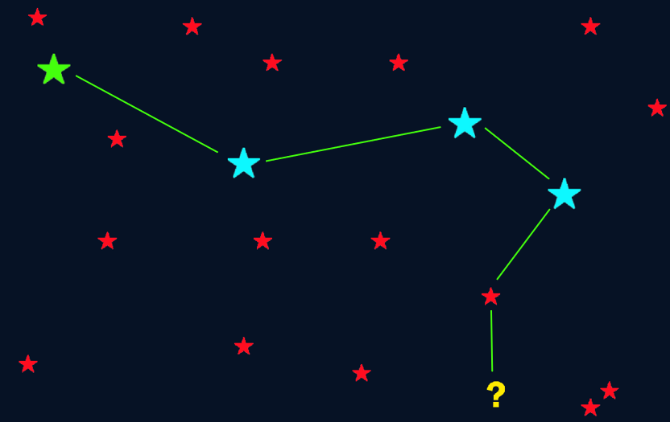
Figure 10 – Finding the shortest-path with object positions, resulting in hops that do not exceed a certain amount of distance.
With the ability to recommend and provide paths to objects, the complexity of learning amateur astronomy could be greatly reduced. However, if beginners do not use these algorithms in the long-term, the low number of repeated interactions may not allow for knowledge to be gained. One common solution to this issue is gamification, which is used to incorporate game-like features into applications and has been previously used in astronomy to increase enjoyment and knowledge (Cardinot and Fairfield 2022). Therefore, gamification is a suitable technique for possibly improving the e-learning experience of those using the tool.

2.3.3. Incorporating gamification
To ease the feeling of being thrown into amateur astronomy, one feature of gamification that may support learners is tutorials (also known as onboarding). Tutorials act as a step-by-step introduction to a system or topic, which are effective at supporting new or struggling learners (Fu and Clarke 2016) and have been used in astronomy tools to improve learning (Gede and Hargitai 2017); (Barringer et al. 2018). Using tutorials that are optional to take, individuals may obtain a greater understanding on how to find and navigate to objects, helping to reduce the time it takes to adapt to the tool.

Whilst tutorials are an effective way to introduce the tool to new learners, they are typically not a repeatable experience that individuals can continue to learn from. For this reason, including additional gamification elements such as achievements may increase the motivation to learn. Achievements are unlocked depending on certain criteria being met, which have been effectively used in e-learning tools to act as goals for learners (Cavalcanti, Filatro and Presada 2018) whilst also acting as a motivational reward (Goehle 2013). Achievements could be granted based on completed observations, rewarding learners for successfully finding objects of specific categories and potentially increasing their motivation to learn.

By incorporating achievements in a linear and challenging direction, where easy achievements are designed to lead onto harder achievements, the flow of learning could be kept progressive. This has been utilised in other e-learning systems, with one seeing an average increase of 34.75% in student performance (Legaki et al. 2020) due to its progressively scaling achievements. This, along with object recommendations based on similar individuals, may help to guide new learners and ensure that they do not attempt to observe difficult objects too quickly. Furthermore, this may increase the motivation learners experience, as they are likely to obtain achievements whilst learning from the tool instead of towards the end of their experience.
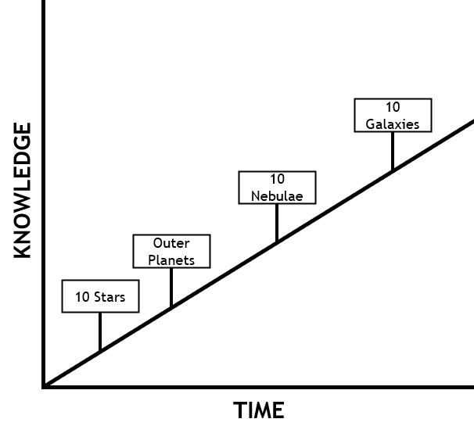
Figure 11 – Knowledge against time with key observational achievements.

2.4. Applying the methods
Based on the identified problems of amateur astronomy, and to take advantage of the identified algorithmic solutions, a web-based e-learning tool was proposed. This would allow for the incorporation of recommendations, star-hopping paths, and gamification in a singular environment, which may enhance the learning experience and increase gained knowledge.

3. Methodology

3.1. Methodology Overview
Through the literature review, it is evident that both theoretical knowledge and practical skills are key to amateur astronomy. However, practical skills (i.e., observational astronomy) are favoured more heavily for non-professionals, which is the expected audience of the e-learning tool. Therefore, the means of measuring an individual’s ability to find objects after using the tool was required, allowing for an analysis of whether it successfully enhanced the learning experience.

To achieve this, an experiment involving amateur astronomers as participants was devised. This would be performed directly after the tool is developed, allowing for the target audience of the project to directly test the tool whilst also preventing bias. Ultimately, this collected data on:
- The baseline skill of participants before utilising the tool, providing access to the tool immediately upon completion.
- The skill of participants directly after utilising the tool for a set period, helping to ensure that the baseline does not change between phases.
- The change of skill before and after utilising the tool.

3.2. Experiment Procedure
To assess the skill of participants, as well as measure the tool’s impact on amateur astronomy, the experiment was split into 5 phases:

Phase | Name | Objective | Data Collected
1 | Participant Selection | Identifying and getting consent from amateur astronomers who wished to take part in the experiment. Participants were limited to the northern hemisphere, ensuring that object visibility was consistent across all participants.  Access was given by the administrators of Stargazers Lounge, a forum for amateur astronomers, to post a survey for doing this (Tasker 2023). | Consent to take part in the experiment, as well as their Stargazers Lounge username (and optionally email address) for further updates.  Furthermore, continental information was gathered to aid in choosing which objects should be included in the experiment, ensuring people did not need to stay up late.
2 | Pre-tool phase | Asking difficulty-scaling questions regarding amateur astronomy, allowing for a baseline of skill to be identified. Difficulty levels scale in the following order, where each question should take no more than five minutes:  - Beginner – finding bright stars and planets which should require zero star-hopping.  - Intermediate – finding higher magnitude objects which should require easy to moderate levels of star-hopping. Furthermore, a “free period” is given to find objects of their own interest.  - Professional – finding high magnitude, possibly light-polluted objects that should require moderate to hard levels of star-hopping.  Objects of all skill levels are ensured to be visible between 22:00 and 02:00, preventing them from being below the horizon and impossible to observe. | The number of objects found at each difficulty level, as well as the time to find successfully observed objects. If an object is not successfully observed, it is assumed that the participant took the maximum amount of time (300 seconds).
3 | Learning phase | Giving participants a week to use the tool, extended until they have a clear sky for observations. This ensured that participants had an adequate amount of time to understand its features and possibly learn more about amateur astronomy. | None.
4 | Post-tool phase | Participants were once again asked to observe difficulty-scaling objects. However, all objects are changed to similarly difficult objects, preventing the memorisation of object positions. | Data in the same format as phase 2, but with different objects.
5 | Evaluation | The results of phases 2 and 4 were directly compared, allowing for a comparison of skill.  To calculate the comparison, pre-tool and post-tool questions were divided into expected skill categories:  - Questions 1-5 were for beginners, being used to calculate the beginner skill level.  - Questions 6-11 were for intermediates, being used to calculate the intermediate skill level.  - Questions 12-16 were for professionals, being used to calculate the professional skill level.  This made it possible to calculate the average skill percentage across each category, which in turn was used to calculate the average overall skill percentage. | Change percentage from phase 2 to phase 4.
Figure 12 – The phases of the experiment.

3.3. Experiment Outcome
The results of phase 5, specifically the overall skill difference in finding objects, were used to determine the effectiveness of the tool. Particularly, this value determined one of two possible outcomes:
- Aim Achieved – A skill increase of 15% or more was encountered, suggesting the tool may have successfully enhanced the learning experienced. There may have been a decrease in the time to find objects, as well as an increase in the objects found in the free period.

- Aim Not Achieved – A skill increase (or decrease) below 15% was encountered, suggesting the tool has gaps or increased the complexity of learning. There may have been an increase in the time to find objects, along with a decrease in the objects found in the free period.

4. Project Management

4.1. Management Overview
The overarching stages of the project were intended to come one after another, where full completion is required before moving onto the next stage. For example, the experiment cannot begin without the tool, but the tool cannot be complete without requirements gathering. Because of this, the waterfall methodology was used to keep the project progress linear, which has been found to benefit similarly structured projects (Andrei et al. 2019).

In total, five stages were created, each of which was given a set amount of time to complete:
Stage | Name | Overview | Hours to complete
1 | Problem Identification | Investigating the current state of learning amateur astronomy, identifying present gaps and potential solutions. | 50
2 | Requirements Gathering | Creating requirements based on the present gaps and potential solutions, as well as the priority and importance of each requirement. | 25
3 | Feasibility Study | Creating prototypes for high priority & high importance requirements, proving their feasibility, and ensuring they can be completed in the timeframe. | 50
4 | Application Development & Testing | Designing, developing, deploying, and testing the e-learning tool with an agile-like process which utilises sprints. | 175
5 | Project Evaluation | Conducting the experiment and collecting the results, which will be used to determine project success. | 100
Figure 13 – The overarching stages of the project.

1 unit = 1 hour
 |  | Hours
 |  | 25 | 50 | 75 | 100 | 125 | 150 | 175 | 200 | 225 | 250 | 275 | 300 | 325 | 350 | 375 | 400
Stage | 1
 | 2
 | 3
 | 4
 | 5
Figure 14 – Project timeline.
To centrally store the project at each phase of development during stage 4, a form of file storage and version-control was also required. This was achieved by utilising Git, which is a popular tool amongst developers due to its branching and commit capabilities (Zöller, Morgan and Schröder 2020). By using a Git repository, which was stored online through GitHub, it was possible to:
- Safeguard the project from local issues, such as storage failure.
- Document changes that were made at each stage.
- Separate development cycles into individual branches.

Furthermore, utilising Git through GitHub also provided additional features that were used in the project. One such example was through its project management features, allowing for the creation of a project board to visualise issue categories and simplify planning:
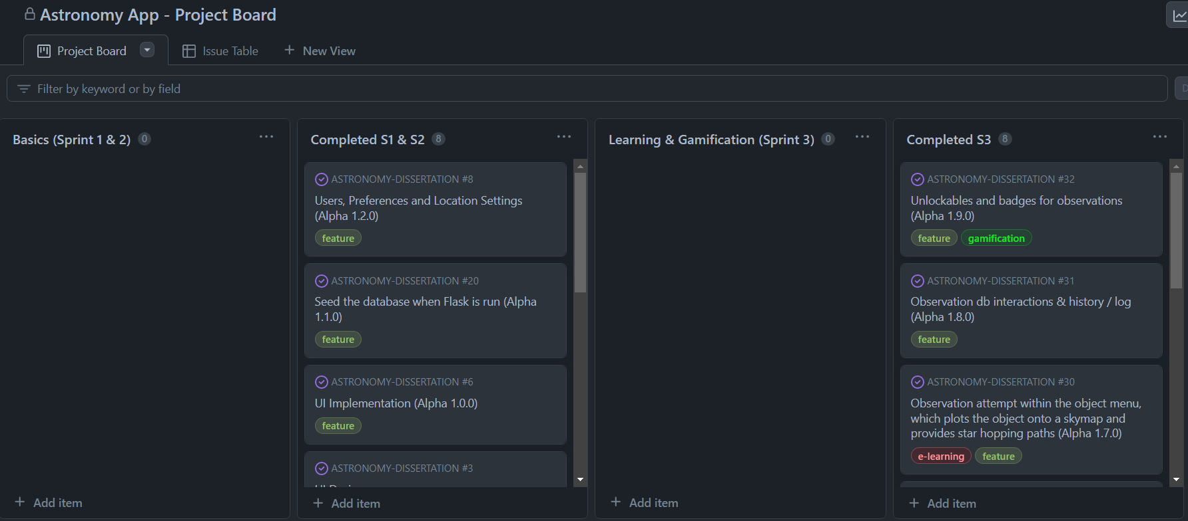
Figure 15 – GitHub project board.

Through GitHub, it was also possible to automate testing and deployment tasks using GitHub actions. Utilising this, it was possible to create and follow a developmental process, ensuring subsequent actions were successfully completed before the project could continue:
Action Number | Action Process | Justification
1 | Creating a new “dev” branch for the feature. | Ensures the feature is not developed concurrently with other features.
2 | Manually testing the feature. | Ensures the new feature is working as intended.
3 | Creating tests for the feature and running tests locally. | Ensures the new feature has test coverage and is compatible with existing features.
4 | Committing & pushing code on substantial changes. | Allows progress to be reverted due to tool-breaking bugs, whilst also acting as development documentation.
5 | Automatically running tests through GitHub Actions. | Ensures that new features are working in different environments.
6 | Merging into the main branch on feature completion. | Ensures the feature is only added to the latest “stable” version once fully complete and passing tests.
7 | Automatically deploying code. | Allows the latest tool to be used online instead of locally, lowering the time it takes to use the tool.
Figure 16 – Development process for each feature.

The GitHub repository for the project, of which also contains the project board, can be found here: https://github.com/WT000/ASTRONOMY-DISSERTATION

4.2. Design & Implementation

4.2.1. Problem Identification
Describing the current state of learning astronomy, along with the present issues and potential solutions, was completed through the literature review (section 2).

4.2.2. Requirements Gathering
Whilst the waterfall methodology was useful for keeping the projects overall direction linear, it does not allow development to reverse for enhancing old features and resolving bugs. Because of this, the development phase instead used an adapted version of Agile for sole developers, allowing for the requirements to be split into weeklong sprints.

In total, five sprints were created based on the problem identification phase:

Sprint | Name | Outline | Key Milestones | Tests
1 | Data Gathering and UI Design | Creating UI designs along with preparing the data for use in the tool. | - Created UI designs for the pages of the tool, such as where individuals will browse objects and how the star-hopping planetarium interface should behave.  - Data cleaned and pre-processed, actions such as removing duplicate objects and deciding what variables should be removed. | No tests needed at this stage.
2 | UI Development and Data Integration | Turning the UI design into non-functioning pages and integrating the data into a database. | - Built a web server which will be used to display pages and handle API routes.  - Translated the UI designs into basic code using CSS libraries such as Bootstrap or Tailwind.  - Handled user setup (signing up, logging in, logging out) along with obtaining their location.  - Seeded a database with the previously cleaned objects | Database-related integration tests, ensuring that the seeder works and routes do not return unexpected results.
3 | E-Learning and Gamification | Building the back-end and making most of the pages work as intended. | - Displayed the objects in the UI, which can be clicked on for more information.  - Showed rise and set times on objects, as well as if they are currently visible.  - Allowed for observations to be made, which will aid the user through star-hopping paths.  - Provided unlockable and badges to enhance the experience. | Additional integration tests for the new functionality that this sprint brings.  For instance, a query for “Andromeda Galaxy” should expect a single object to be returned.
4 | Object-finding Automation | Incorporating recommendation algorithms into the tool. | - Provided content-based recommendations based on a clicked or observed object.  - Provided collaborative filtering recommendations, allowing for leaners to see objects that similar leaners also liked. | Additional integration tests for the new functionality that this sprint brings, where possible.  It may not be possible to test collaborative / hybrid recommendations as their results may change on each train.
5 | Advanced Functionality | Adding advanced features that may further enhance the learning experience. | - Allowed the time to be adjusted, making it easier to plan observations.  - Added more light-pollution considerations, such as displaying the Bortle value (a method of measuring light pollution) of objects based.  - Additional changes added that may help to enhance the experience, such as a red-mode for night vision. | Additional integration tests for the new functionality that this sprint brings, where possible.
Figure 17 – Sprint milestones.

By utilising these sprints and their key milestones, requirements were possible to list and extract from the problem identification phase. In total, 20 requirements were possible to identify, each of which was mapped to an associated sprint:

Sprint Number | Issue Number | Description | Justification
1 | 1.1 | Obtain and clean astronomy catalogue data. | The tool should use observable objects, not doing so would provide no real objects to learn about.
 | 1.2 | Create a UI design for the tool. | The tool will require a front-end interface for general use and the experiment, which will be combined with astronomy-related modules such as Astropy.
2 | 2.1 | Implement the UI design.
 | 2.2 | Handle time, location, and preferences. | Object azimuth and altitude changes depending on time and location.
 | 2.3 | Incorporate the objects into a database. | The tool needs an efficient way of fetching objects.
3 | 3.1 | Displaying and searching for objects. | Objects need to be shown on the tool, as well as allow for individuals to find objects of interest.
 | 3.2 | Object details and real images. | Object details (such as category, position, and magnitude) may give individuals more to learn about astronomy.
 | 3.3 | Descriptive information via external sources. | A method of finding descriptions for specific objects, otherwise giving a description based on the category, may further benefit the learning experience.
 | 3.4 | Providing rise & set times for objects. | Knowing when an object will rise and set may help individuals plan their observation sessions, as well as add further insights.
 | 3.5 | Star-hopping observations and guides. | Teaching star-hopping by suggesting movement paths may positively impact the experience of individuals. This is a current gap that should be addressed by the tool.
 | 3.6 | Observation log. | Ensures individuals can go back to previously observed objects, allowing for revision and repeated observations.
 | 3.7 | Unlockable badges for observations. | Gamified elements such as badges may entice individuals to learn more.
4 | 4.1 | Recommendations based on object contents. | By automating the process of finding new objects to observe, individuals may feel more guided in their observations and not need to browse through thousands of objects.
 | 4.2 | Recommendations based on user profiles.
5 | 5.1 | Adjustable observation time. | May enhance the functionality of 3.4 and further aid individuals in planning observations and learning about object movements.
 | 5.2 | Starter tutorial or guide. | Supports beginners in starting the hobby, potentially making them feel less isolated.
 | 5.3 | Light pollution (Bortle scale) object details. | Supports both beginners and intermediates learn how light pollution affects object visibility.
 | 5.4 | Mobile-friendly UI adaptations. | Improves accessibility by not needing a computer, laptop or tablet with the telescope.
 | 5.5 | Toggleable red mode. | Preserves night vision during observations.
 | 5.6 | Adjusting the starting point of star-hopping. | Helps individuals star hop to targets if the automated starting point is covered by something, for instance a building or tree.
Figure 18 – Requirements overview and justifications.

Whilst each of these requirements may help to improve the learning experience, some features inherently have higher developmental demands than others. Therefore, to ensure each requirement was possible to develop in the given timeframe, a risk matrix was used to determine their risk based on consequence and likelihood (ISO 2019).

 |  | Severity
 |  | Minor | Moderate | Significant | Severe
Issue Likelihood | High | 5.4 | 1.1 | 2.2 | 3.2
 | Likely | 5.6 | 5.3 | 2.1 | 4.2
 | Possible | 5.1 | 3.7 | 4.1 | 3.1
 | Unlikely | 3.6 | 3.3 | 2.3 | 3.5
 | Low | 5.5 | 5.2 | 3.4 | 1.2
Figure 19 – Risk matrix of identified requirements, plotted by issue number.
Utilising a risk matrix, it was possible to visualise how likely developmental issues would occur amongst the identified requirements. Furthermore, it resulted in two prominent “corners” of the risk matrix becoming apparent, these being:
- The top-right “red-zone”, which are requirements of high importance and integral to the tool.
- The bottom-left “green-zone”, which are requirements of low importance and are safe to not include in the tool.

4.2.3. Feasibility Study
Due to a number of requirements being within and near the red-zone of the risk matrix, three prototypes were developed to ensure their feasibility for completion in the given development time frame (175 hours). These prototypes focused on investigating and demonstrating the crucial algorithms behind the requirements, these being:
- A location-retrieving web-application, showing that the latitude and longitude of a user can be obtained.
- A planetarium web-application, showing that the local sky and object positions can be visualised.
- A recommender web-application, showing that objects have enough attributes for recommender algorithms to function.

4.2.3.1. Prototype 1 – Location Retrieval
If an objects right ascension and declination (global coordinates) are to be converted to azimuth and altitude (local coordinates), the latitude and longitude of the user must be known. Because of this, the aim of this prototype was to experiment with the methods of obtaining a user’s location.

To incorporate such functionality into a web-application, JavaScript can be used to incorporate logic into HTML pages. Specifically, JavaScript’s geolocation API was used to automatically retrieve the latitude and longitude. Then, to check if these values were correct, their values were converted to X & Y coordinates and passed to the Google Maps tile server. By doing this, the location could be physically shown, proving that the API works as intended.
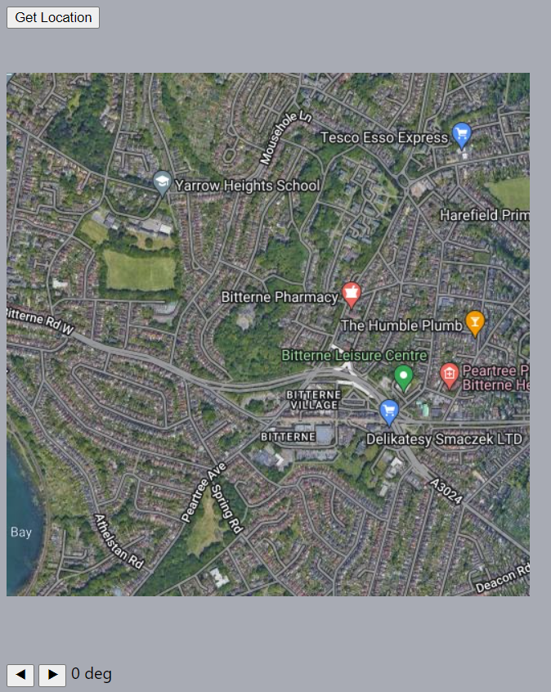
Figure 20 – Passing latitude and longitude to the Google Maps tile server.
By creating this prototype, location information could now be obtained by the tool, but it more importantly made an issue apparent. If a user does not allow geolocation services, or their device is not compatible, then alternative methods of obtaining latitude and longitude would be needed in the final tool.

4.2.3.2. Prototype 2 – Planetarium Visualisations
Incorporating the features of the previous prototype, it was now possible to obtain the location of a user. Using this, the local night sky of a user could now be determined, making the focus of this prototype to visualise the positions of objects in a virtual planetarium.

Before this could be developed, the right ascension and declination of objects needed to be known, otherwise there would be no objects to visualise. Therefore, object positions were firstly sourced from OpenNGC, a comma-separated (CSV) version of the New General Catalogue and Index Catalogue (Verga 2017). These catalogues contain data on well-known DSO’s (Dreyer 1988), meaning the global positions of objects such as NGC 224 (Andromeda Galaxy) were now known.

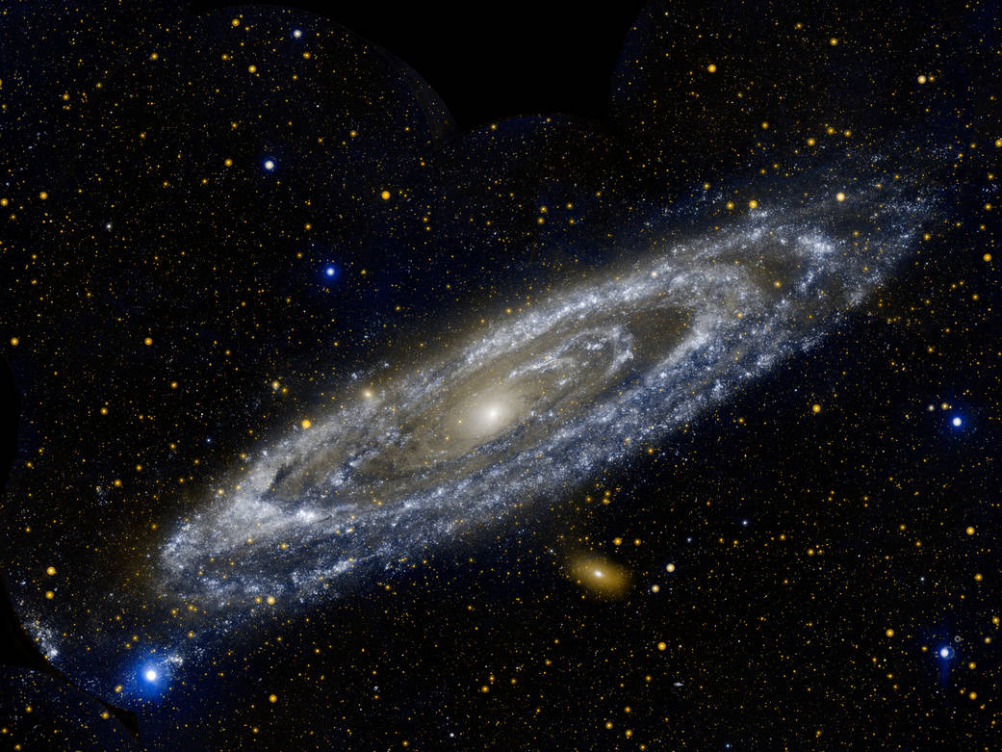
Figure 21 – NGC 224, also known as the Andromeda Galaxy, taken by NASA.
Next, a visualisation library was needed to show the objects on. Initially, this was chosen to be d3-celestial, which used the location of the user to display the night sky. When combined with the global coordinates of the Andromeda Galaxy, the planetarium was able to plot and smoothly move to the object’s local position.

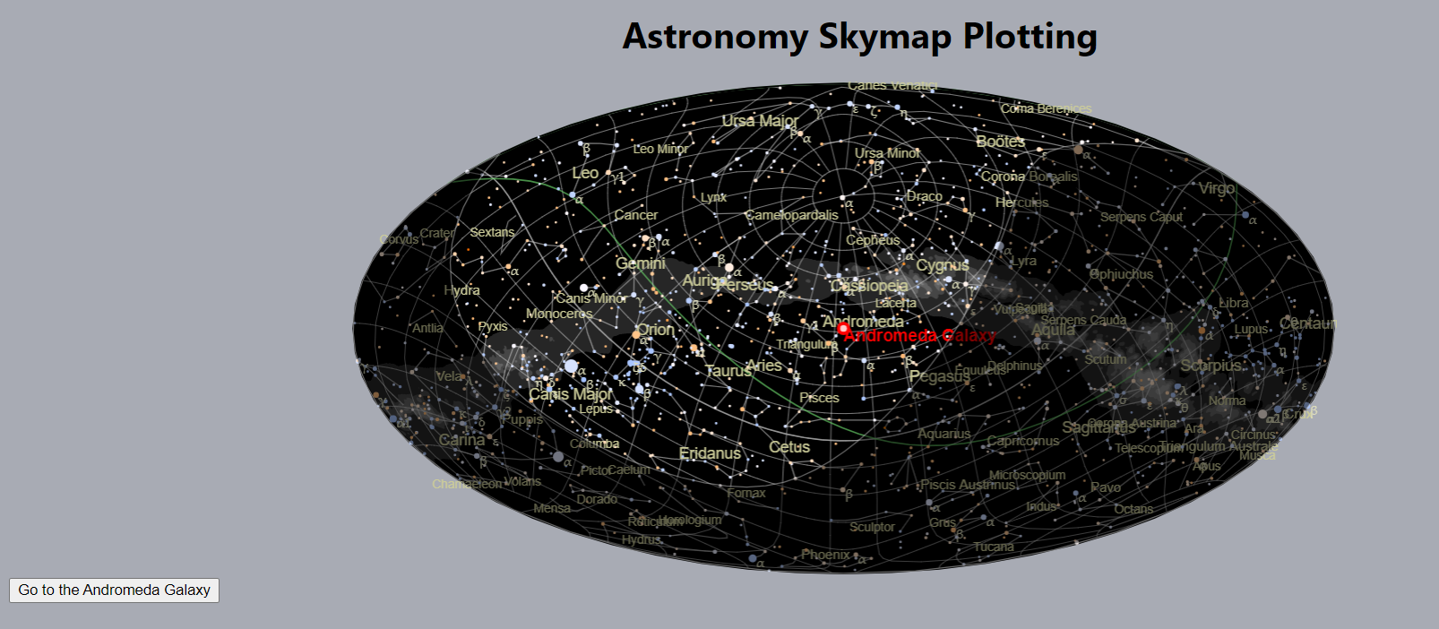
Figure 22 – The Andromeda Galaxy visualised through d3-celestial.
However, numerous issues were encountered when utilising d3-celestial such as:
- Needing to convert data formats to GeoJSON, increasing complexity and workload.
- Cardinal directions being hidden, due to the visualisation acting like a star-map.
- Plotting objects requires multiple callbacks, further increasing complexity.

Because of these issues, a sub-prototype was developed to test additional planetarium libraries. One such library was VirtualSky, which at the cost of needing to extend the library for automatic movements, allowed for a less complex and visually enhanced experience.

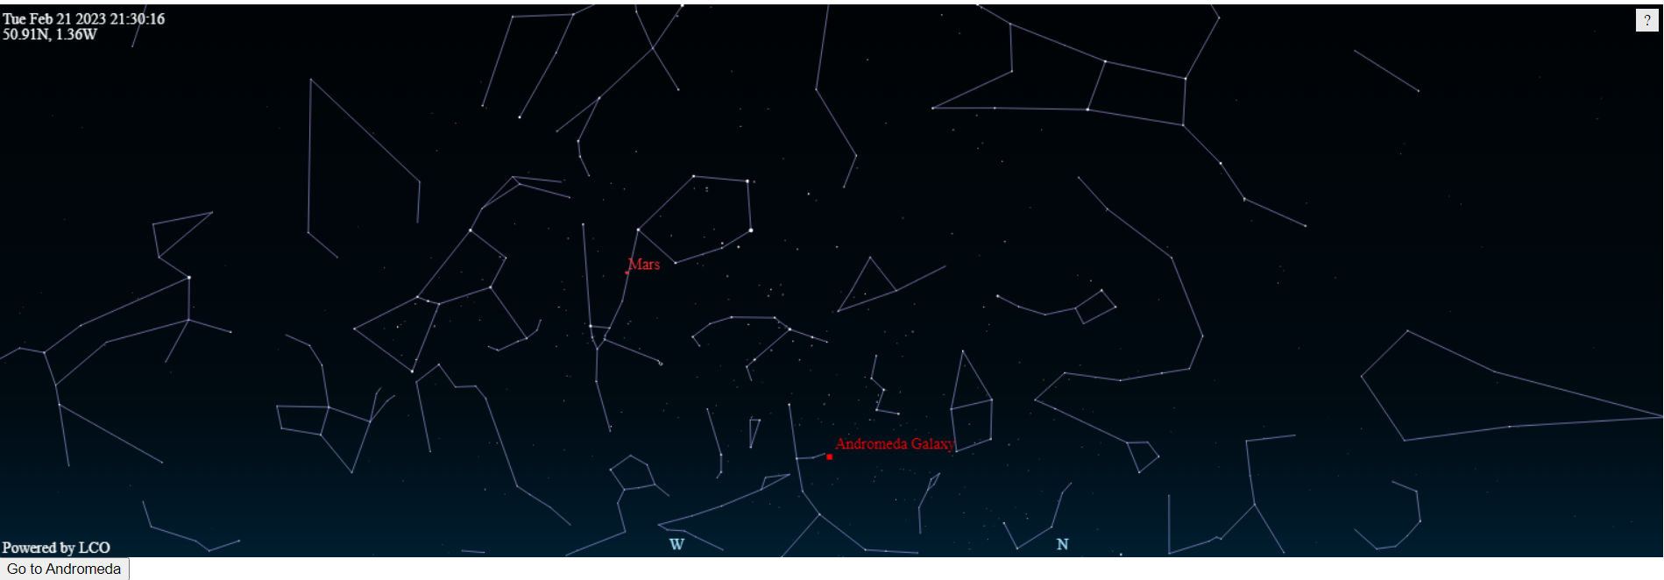
Figure 23 – The Andromeda Galaxy visualised through VirtualSky.
Like the previous prototype, an issue was made apparent regarding object position calculations. Specifically, doing them in JavaScript did not account for details such as atmospheric disturbance, which may make calculations slightly off. This is not an issue in libraries such as Astropy for Python, which suggested that a Python API or web framework may be needed.

4.2.3.3. Prototype 3 – Object Recommendations
By now having data on objects through the New General Catalogue, object attributes such as category, magnitude, and surface brightness were now known. Utilising these, the aim of the final prototype was to experiment with recommendation algorithms and how they could interact with the known data of objects.

To incorporate this, an SQL database was firstly needed to store objects, categories, users, and observations (to act as a rating-like system). MySQL was specifically chosen due to the prominent relationships across data fields, as well as my existing knowledge with MySQL queries.

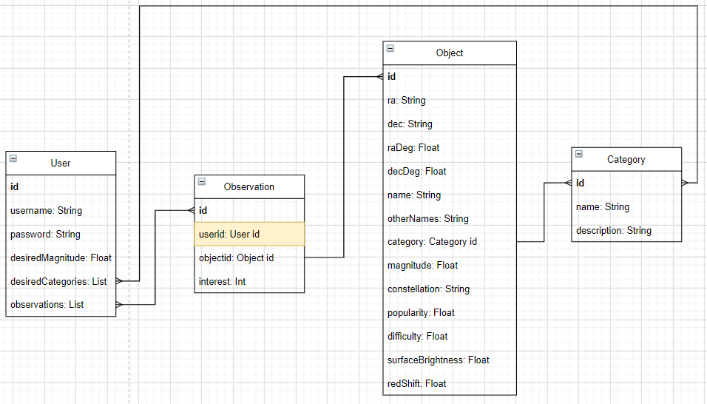
Figure 24 – Prototype database design, noting that this omits associative entities (meaning a yellow field such as userId may not be needed in a non-relational database).
An SQL query was then designed to mimic the function of recommender algorithms, which fetches objects that are relevant to the user based on an entered user ID. This is achieved by giving each object a recommend score, which is defined as the total number of objects the user has observed in that category. Once calculated, the value is combined with the popularity and magnitude (renamed to difficulty) of an object, providing recommendations that are similar to collaborative-filtering algorithms (Adomavicius and Tuzhilin 2005).

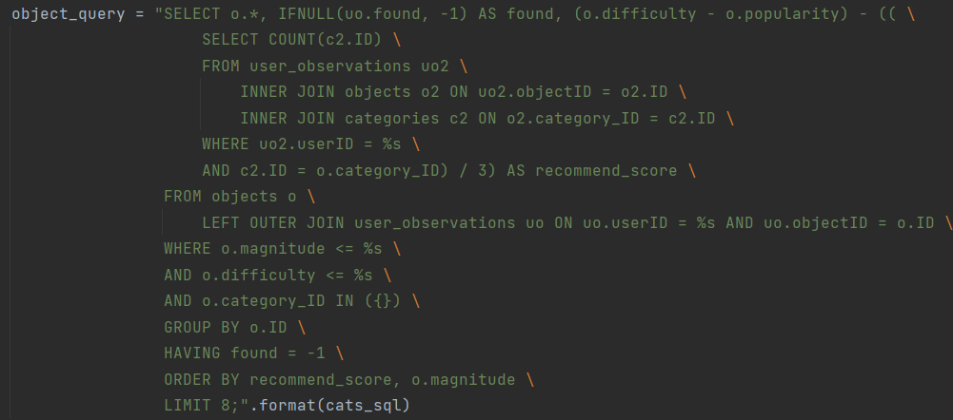
Figure 25 – Recommendation query through SQL.
This query is performed from a Flask API in Python, which itself is used from a Node server, demonstrating how multiple services could be used in the final tool. When a user makes an observation of an object by clicking on either of the Observe buttons, the query is capable of finding new objects of interest for the user.
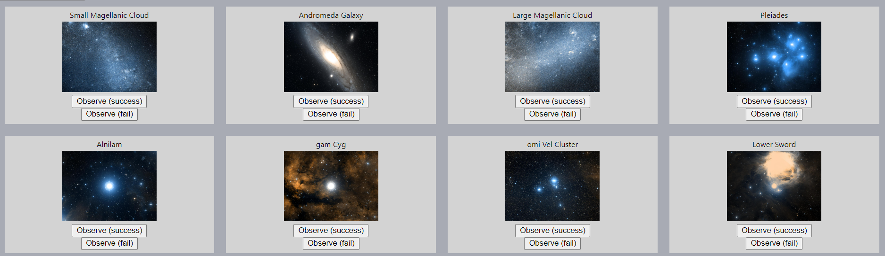
Figure 26 – Prototype recommendations. After clicking on multiple galaxies and star clusters, it begins to recommend more of those categories.
To further enhance the results, and to demonstrate how object images could be obtained, object coordinates are sent to the hips2fits API. This API is able to return images of the night sky from any set of coordinates (Fernique et al. 2017), meaning object images (aside from solar system bodies) do not need to be stored locally. In the prototype, the 2MASS/colour survey was chosen due to it having 100% sky coverage alongside being in true colour.

4.2.4. Application Development & Testing
With high importance requirements now demonstrated, development of the tool could now safely begin. This followed the designed sprints in the agile-like process, starting with Data Gathering and UI Design.

4.2.4.1. Sprint 1 – Data Gathering and UI Design
Whilst the New General Catalogue and Index Catalogue contain well-known DSO’s, they do not include well-known stars such as Sirius and Betelgeuse. Furthermore, planets are not included in these catalogues, meaning many clearly visible objects were missing from the prototypes. Due to these issues, numerous star catalogues were identified for potential inclusion in the tool, such as:
- Henry Draper (HD)
- Hipparcos (HIP)
- Harvard Revised (HR)
- Gliese
- Gaia
- Yale Bright Star

This was not a simple choice to make, as some catalogues contain too many stars (such as Gaia, which has over 1 billion) and could hinder the tool’s performance, whilst others contained too little (such as Yale Bright Star, which has around 9000) and hinder the available stars for star-hopping. Furthermore, objects can exist across catalogues, meaning the name of an object in one catalogue may be more recognisable than another.

To resolve this issue, a data source that contained high-magnitude stars to a limited degree along with their well-known catalogue names was required. After a period of research, the HYG Database was found to fill this niche, combining the Hipparcos, Yale Bright Star, and Gliese catalogues into a singular entity (Nash 2023). In addition, the HYG Database includes additional catalogue names as well as common names, greatly increasing the number of ways to search for objects.

Figure 27 – The various names and catalogue identifiers for Sirius.

For this data to be integrated into the tool, as well as combined with the existing New General Catalogue / Index Catalogue data, exploratory data analysis (EDA) and data pre-processing were required. Without this, field names across both the data sources may be inconsistent, some of which may not even be relevant for the tool.

To accomplish this, the data files (downloaded in CSV format) were examined with Pandas through Jupyter Notebook, starting with a look of the New General Catalogue / Index Catalogue data fields. Through looking at documentation related to the catalogues, it was possible to determine what fields are relevant.

Field Name | Field Info | Required | Justification
Name | Default name | Yes | Acts as a starting name for an object.
Type | Object category (e.g. * for star, ** for double star) | Yes | Acts as a category for an object.
RA | Right Ascension | Yes | Used as global coordinates.
Dec | Declination | Yes
Const | Object constellation | Yes | May help individuals find objects if they know the constellation well.
MajAx | Major axis | No | Not necessary for observing objects.
MinAx | Minor axis | No
PosAng | Major axis position angle | No
B-Mag | Magnitude in B filter | Yes | A fallback magnitude if visual magnitude is not known.
V-Mag | Magnitude in V filter | Yes | If known, it will allow for algorithms such as light pollution calculations to work.
J-Mag | Magnitude in J filter | No | Not close enough to the V & B filter.
H-Mag | Magnitude in H filter | No
K-Mag | Magnitude in K filter | No
SurfBr | Surface brightness | Yes | If known, will enhance the light pollution calculations to be more realistic for galaxies.
Hubble | Galaxy type | Yes | Helps learners identify galaxy types.
Pax | Parallax | No | Space is vast; slight object movements will have little impact on observations for thousands of years.
Pm-RA | Proper motion (RA) | No
Pm-Dec | Proper motion (Dec) | No
RadVel | Radial velocity | No
Redshift | Redshift value | Yes | May be of use when doing astrophotography.
Cstar U-Mag | Central star magnitude in U filter | No | Magnitude is already known.
Cstar B-Mag | Central star magnitude in B filter | No
Cstar V-Mag | Central star magnitude in V filter | No
M | Messier number | Yes | Additional identifiers that are useful to keep track of, making searches easier.
NGC | Duplicate New General Catalogue number | Yes
IC | Index Catalogue number | Yes
Cstar Names | Central star names | Yes
Identifiers | Other known identifiers | Yes
Common names | Well-known names | Yes
NED notes | Object notes and documentation | No | This information will not be useful for learning.
OpenNGC notes
Sources
Sources,,,
Figure 28 – NGC/IC field information and decisions.

Unrequired fields were dropped from the DataFrame, leading into an investigation into potentially invalid objects. By it being a duplicate column, it meant that some NGC objects were duplicates of others, as such they needed to be removed by dropping objects of the Dup category (signifying that they are a duplicate).
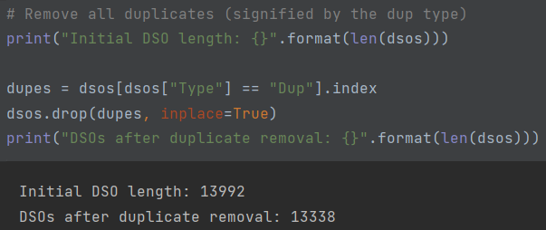
Figure 29 – Removing duplicate objects.

Additional invalid objects were removed, such as removing objects with crucial missing information (such as position details) and non-existent objects.
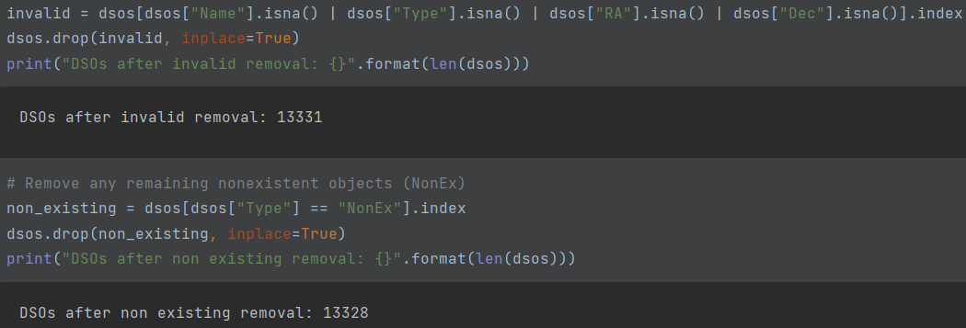
Figure 30 – Removing invalid objects.

The above process was then utilised for the star data, but due to it having different field names, the process of determining and isolating relevant fields was once again needed.
Field Name | Field Info | Required | Justification
Hip | Hipparcos ID | Yes | Various star identifiers that can be used if a proper name does not exist.
Hd | Henry Draper ID | Yes
Hr | Harvard Revised ID | Yes
Gl | Gliese ID | Yes
Bf | Bayer / Flamsteed ID | Yes
Ra | Right Ascension | Yes | Used as global coordinates.
Dec | Declination | Yes
Proper | Proper name for the star | Yes | Used as the stars name if known due to its recognisability.
Dist | Distance to the star | No | Not relevant for observations.
Pmra, pmdec | Proper motion | No
Rv | Radial velocity | No
Mag | Magnitude in V-filter | Yes | If known, it will allow for algorithms such as light pollution calculations to work.
Absmag | Absolute magnitude | No | Absolute magnitude is not useful from Earth, as it is used for comparing star magnitudes without considering distance.
Spect | Star spectrum | Yes | May provide learning insights into the colours of stars and why they appear a specific way.
Ci | Star colour index | Yes
X,y,z | Cartesian coordinates | No | Not relevant for observations.
Vx,vy,vz | Cartesian velocity | No
Rarad, decrad, pmrarad, pmdecrad | Above positions but in radians | No
Bayer | Bayer (Greek) designation | Yes | Additional names for stars that may be more recognisable than catalogue ID’s.
Flam | Flamsteed (number) designation | Yes
Con | Constellation | Yes | May help individuals find objects if they know the constellation well.
Comp, comp_primary, base | ID’s of stars, if in a multiple star system | No | Not needed, as these could be found by comparing object positions.
Lum | Luminosity | Yes | Attributes associated to star brightness & variance may help to pinpoint why a star sometimes looks different.
Var | Variance designation | Yes
Var_min, var_max | Magnitude range for variable stars | Yes
Figure 31 – HYG field information and decisions.

With the irrelevant columns now dropped, the New General Catalogue / Index Catalogue objects was merged with the HYG Database stars by making their column names consistent. By doing this, future calculations would now be performed on a singular Pandas DataFrame instead of multiple, reducing system load and increasing efficiency.
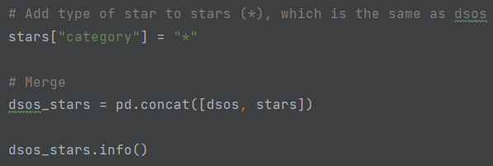
Figure 32 – Merging DataFrames.

Now that the data was prepared, numerous operations were performed to improve the readability and information of objects. Firstly, objects were assigned a singular name based on their known other names (which were added into a single comma-separated value to decrease DataFrame size), using the following priority order:
- Proper / Common name – A well-known name for an object (such as Sirius or Betelgeuse), making these names very recognisable.
- Bayer / Flamsteed – A known name for bright objects (such as Alpha Monocerotis or 26 Monocerotis), making these names recognisable.
- Gliese – A small catalogue of nearby stars and bodies (such as Gliese 581), making these names relatively recognisable.
- Messier – A small catalogue of well-known objects (such as M31), making these names relatively recognisable.
- NGC – A large catalogue of well-known objects (such as NGC 2264), making these names recognisable for niche objects.
- Variance – Sometimes used alongside the genitive constellation (such as VY Canis Majoris), making these names recognisable for niche stars.
- Other (HR, HIP, HD, etc) – Large catalogues of many high magnitude objects, making these names unrecognisable.

Achieving this was simple through chained if statements to check if certain names existed. If a preferable name was found, it would replace the current name and add the old name to additional names, ensuring that other designations were not wiped. However, many of the Greek letters and constellation names were abbreviated, possibly making Bayer / Flamsteed and Variance names difficult to search for.

To resolve this, a dictionary was created which mapped each abbreviated Greek letter and constellation to its full name, allowing for full names to be used in the tool.
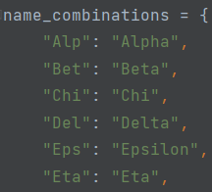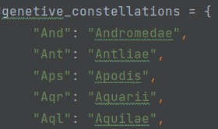
Figure 33 – Greek and constellation names.

With object names now improved, magnitude was next improved to use visual magnitude if known, otherwise switching to B-filter magnitude. If neither were known, the object could be an object without a magnitude (such as an open cluster, which has no central body), making it safe to keep the magnitude null.

Furthermore, for objects with a known magnitude, it was also possible to add Bortle scale data. The Bortle scale is commonly used to measure light-pollution, where 9 is the maximum amount of light pollution (e.g. a city sky) and 1 is the lowest amount of light pollution (true darkness) (Caruana et al. 2020) (Hung et al. 2021). Using this, it was possible to assign objects to their associated naked-eye Bortle classification, which may prevent learners in unideal lighting conditions from observing light-polluted objects.

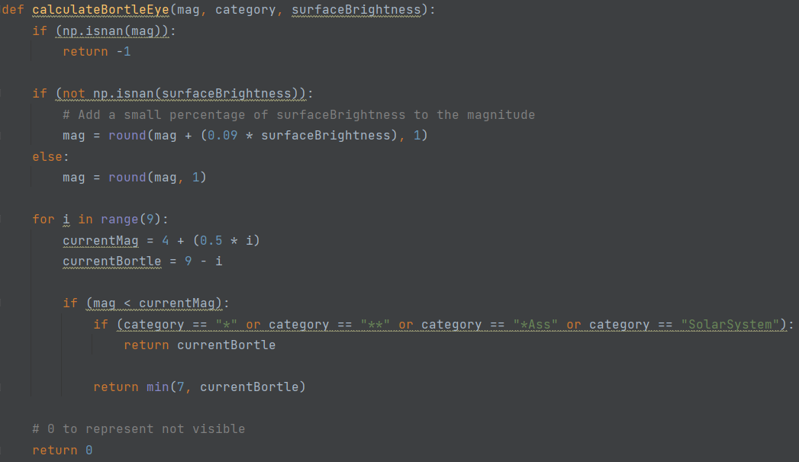
Figure 34 – Bortle calculation.

Many more changes were made to these objects before finally outputting the DataFrame into a CSV file, for use in the tool. For instance:
- Adding a Right Ascension and Declination field in degrees, allowing for a numerical representation of the typical (hh/deg):mm:ss format.
- Adding Solar System planets with their average magnitude (Mallama and Hilton 2018), due to them being bright and prominent in the night sky.
- Extending Bortle values by also providing estimated views for a 10” telescope, as the previous Bortle value was for naked-eye views.

By finalising the data, it was now possible to create basic UI designs for the application. In the designs, a heavily AJAX-based approach was assumed, as this would reduce the number of page-loads a user experiences. By doing this, it could coincide well with the continuous exploration of objects (Azevedo 2019), especially if learners can endlessly browse through available objects to observe.

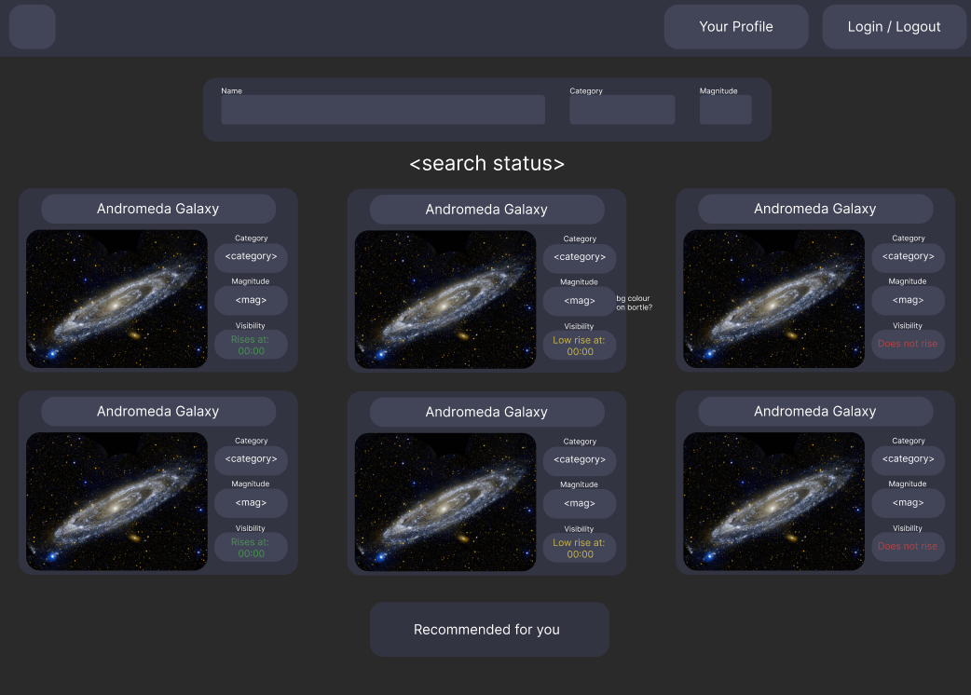
Figure 35 – Initial object search design.

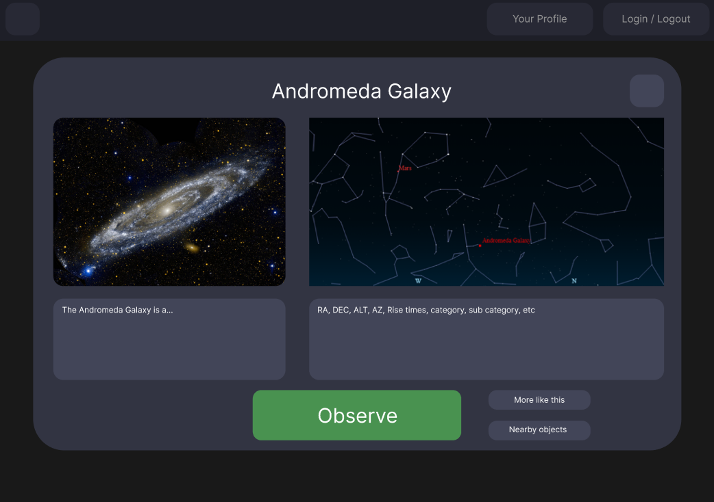
Figure 36 – Initial object popup design.

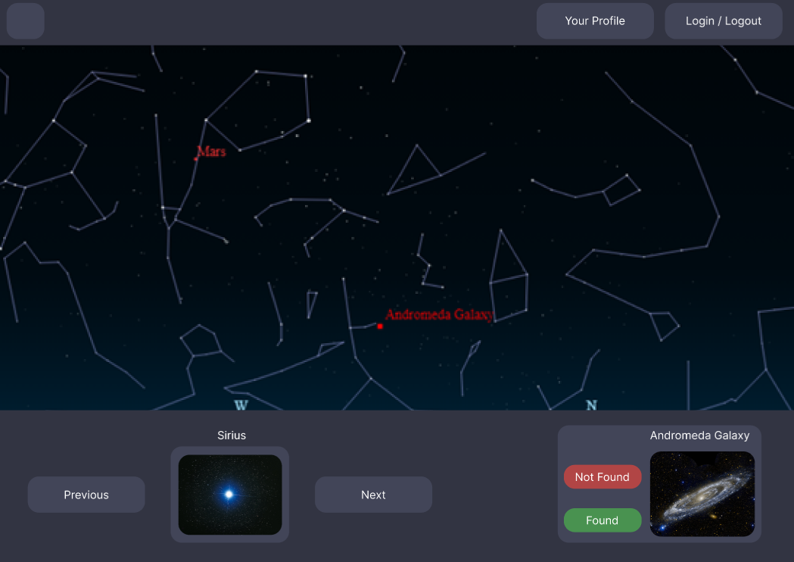
Figure 37 – Initial object observation design.

4.2.4.2. Sprint 2 – UI Implementation and Data Integration
Having prepared the data and user interface design, it was now possible to begin the development of the tool. Whilst this could have followed a similar approach to the feasibility prototypes (consisting of a Node server with a Flask API), a purely Flask-based approach was selected for a multitude of reasons:
- Simplifying development by not requiring multiple servers.
- Providing templating alternatives to EJS such as Jinja2.
- Simplifying the process of running the application.
- Making online deployments easier to manage.

However, by now purely using Flask, the previous method of interacting with the database (mysql2, a package for Express) was no longer possible. Furthermore, the database used in the feasibility study did not account for the newly cleaned data, also meaning the design now needed to be extended. For these reasons, SQLAlchemy (an Object Relational Mapper compatible with Flask) was used to create a new design, conforming to the following format:
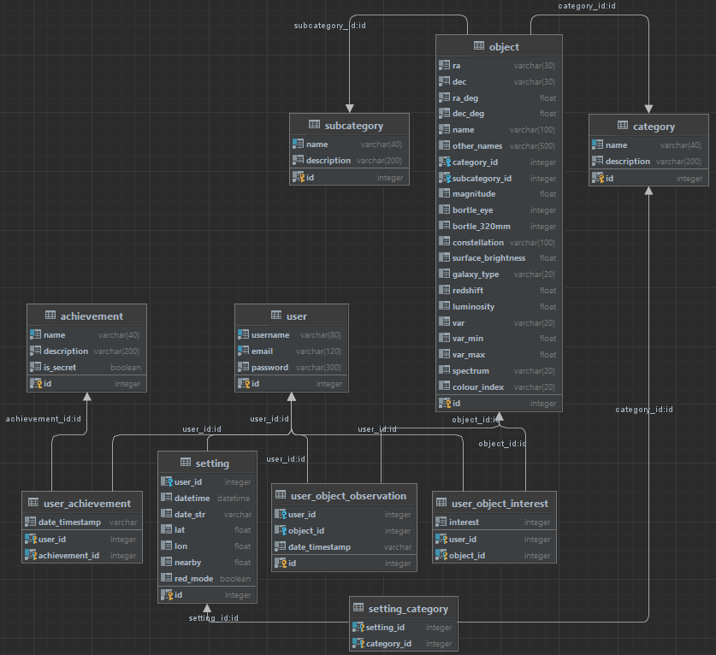
Figure 38 – Database design.

Using SQLAlchemy allowed for tables to be created through classes, simplifying the process of expanding the previous database design to support new features. These tables were:
Table Name | Table Description | Table Justification
Object | Stores the various astronomical objects and their attributes. | Required as a central location to store objects.
Category | Categorical information for objects. | Allows for objects to be filtered more effectively.
Subcategory | Sub-categorical information for objects.
User | Users and their associated details. | Users are required for features such as recommendations to work.
Setting | Stored session settings for users who are signed in. | Allows user settings to be saved to the account, persisting them across devices.
Setting_Category | Preferred categories for nearby object searching. | Gives users the ability to filter nearby objects by a type, if they want to identify a particular nearby object.
User_Object_Observations | Holds observations made by users. | Stores successful object observations, making it easy to track observations.
User_Object_Interest | Holds unique interest levels for objects. | Unlike User_Object_Observations, this is used as a “rating” system for objects, meaning duplicates are not allowed.
Achievement | Stores achievements and their associated descriptions. | Ensures there are achievements to grant.
User_Achievement | Stores achievements unlocked by users. | Ensures unlocked achievements can be viewed.
Figure 39 – Database tables.

Whilst MySQL was previously used in the feasibility prototypes, it required XAMPP to be running in the background for it to function. This increased the complexity of running the database, which may not be possible on all deployment tools. To resolve this, SQLite through SQLAlchemy was instead used, allowing Flask to directly connect (and create, if needed) to a local database file. Although storing the database locally may not a suitable solution for production applications, it eased the development process and was deemed suitable for obtaining project results.

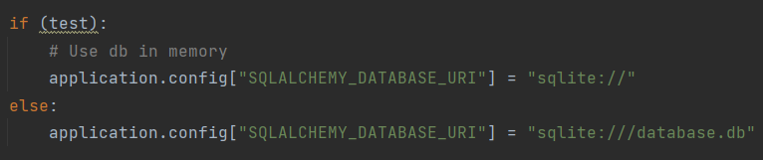
Figure 40 – Database connection.

Utilising the connection, it was now possible to populate the database with the cleaned data. To accomplish this, a method was created to convert objects into associated Object models, committing them to the database once all models were created. Furthermore, this only runs when no records are detected in the database, ensuring that user data was not needlessly overwritten.

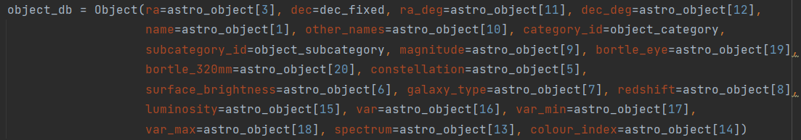
Figure 41 – Converting objects to Object models.

By now having prepared the database, it was possible to begin development of the front-end. This started with non-functioning pages based on the UI designs, reducing the front-end work that would be needed in subsequent sprints. However, changes were made to improve upon the designs, with noteworthy changes consisting of:
- Making the pages mobile-friendly to cater for a wider range of leaners, made feasible to complete within the timeframe by utilising Tailwind for pre-created CSS classes (TailwindCSS 2023).
- Including loading icons where possible, helping to prevent leaners from thinking the tool is frozen or not working as expected.
- Adding SVG-based icons for buttons, which may improve the tool’s readability.
- Improving consistency by utilising a “base” template, which was combined with element views created through JQuery to also cut down on code reuse.
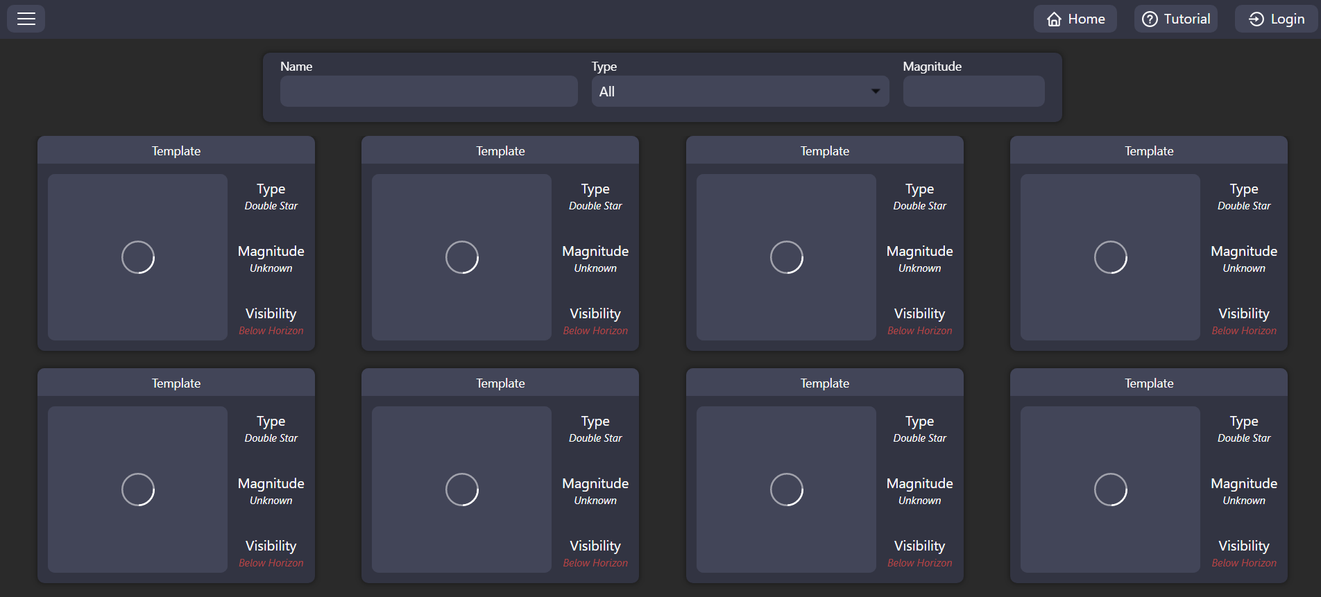
Figure 42 – Search page UI (desktop).

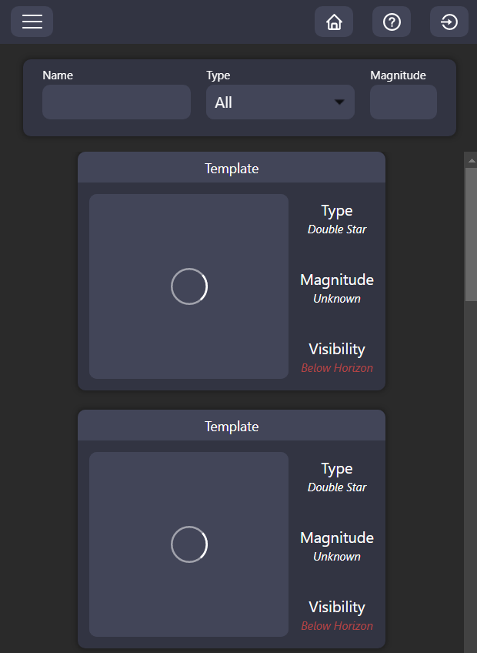
Figure 43 – Search page UI (mobile).

At this stage, there were still missing features that were integral for other features to function, as well as development pipelines that were previously not possible to create. Because of this, incorporating these features was the final aim of this sprint.

Firstly, the latitude and longitude of users was required for multiple astronomy calculations, which was seen in the feasibility prototype for object visualisations (section 4.2.3.2.). To obtain this information automatically and without relying on location services, it was possible to forward a user’s IP address to BigDataCloud’s geolocation API. This API can be used to determine the basic location of leaners without explicit user interactions (BigDataCloud 2023), which was then cached to reduce API queries and stay within rate limits.
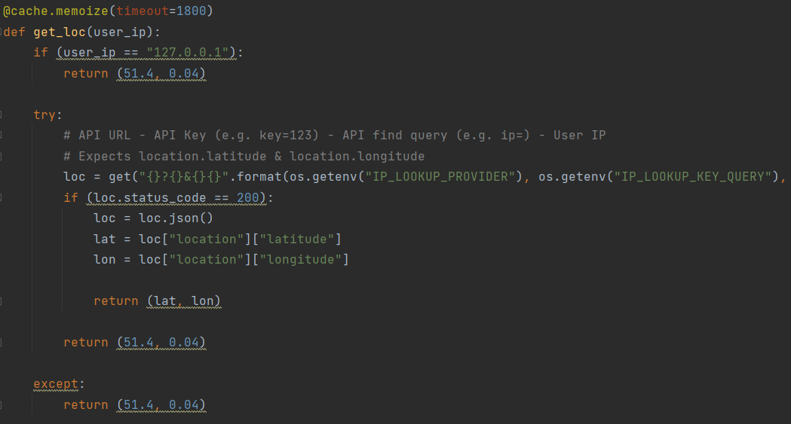
Figure 44 – Obtaining location through IP.

Secondly, user accounts and their associated interests and observations were required for recommendations, which was seen in the feasibility prototype for recommendation algorithms (section 4.2.3.3.). This was achieved by extending the previous “ID input” approach with a local sign-up and sign-in method, eliminating the need to remember ID’s whilst also increasing security. To further increase the security, various algorithms such as password length checks (to prevent easily hackable accounts) and password hashing through bcrypt (to prevent passwords leaking in a data breach) were implemented.

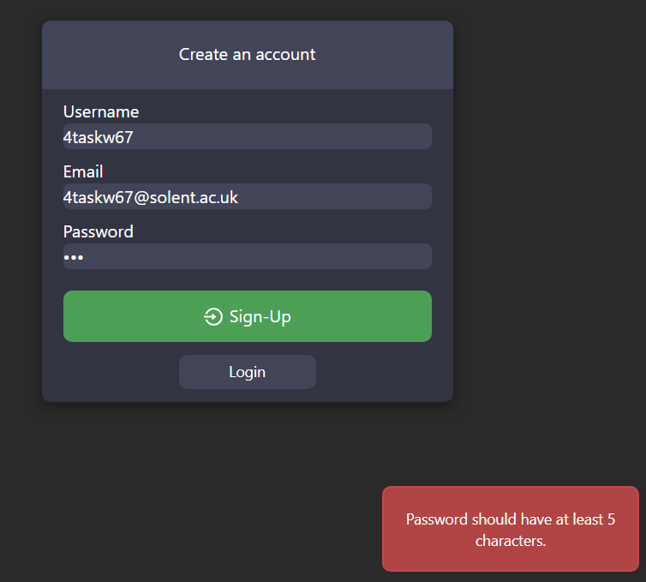
Figure 45 – Sign-in error.
Thirdly, it was necessary to begin incorporating the development pipeline, which was discussed in section 4.1. Due to the AJAX-based approach of the tool, these tests predominantly focused on API routes and were possible to achieve through Flask’s test client. This allowed Pytest to interact directly with the tool’s routes (Pallets 2022), ensuring the correct JSON was still being returned after the implementation of new features.
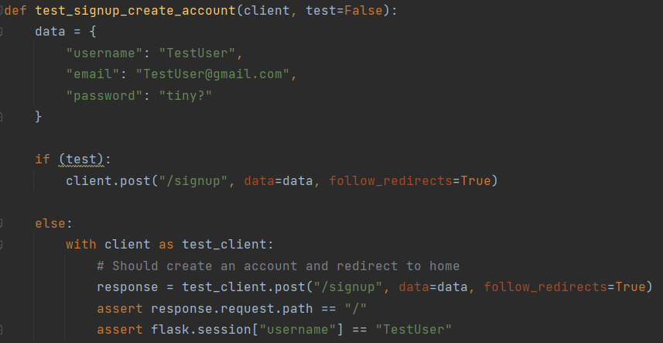
Figure 46 – Sign-up testing through Pytest.

These tests were then incorporated into a GitHub Actions pipeline, allowing for the tool to be tested outside of the development environment. Doing this increased the reliability of tests, as well as the likelihood of finding potential issues.
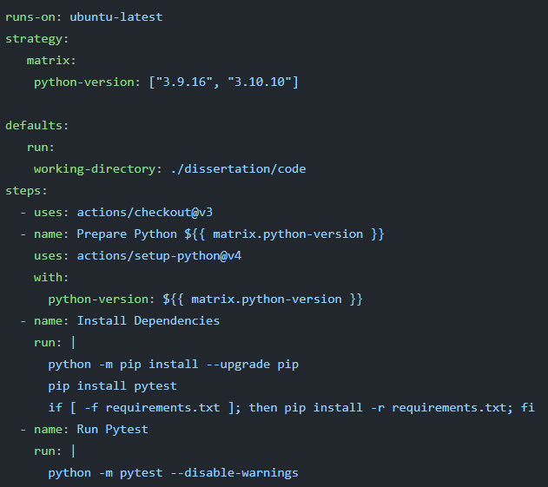
Figure 47 – GitHub Action for Pytest.

If tests successfully passed internally (through locally running Pytest) and externally (through the previous GitHub Action), it was safe to assume that the tool was ready for deployment. For this to be done automatically, an additional GitHub Action was utilised to automatically deploy the main branch of the tool online, made possible through DigitalOcean’s app deployment platform (DigitalOcean 2023). This reduced the time needed to manually deploy the tool, ensuring that more time could be spent on developing features.
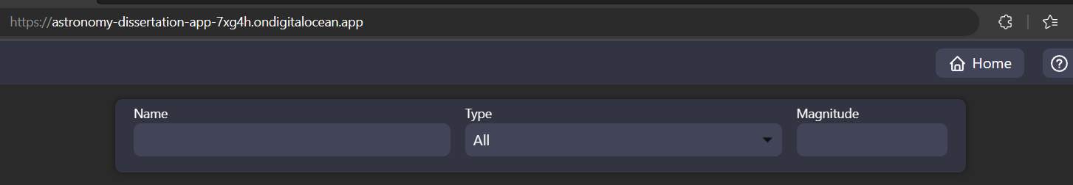
Figure 48 – Deployed application.

Despite the success of deploying the tool, issues arose when attempting to use it with multiple simultaneous connections. By default, Flask was operating synchronously and only able to handle one request at a time, creating a queue of requests that slowed the experience of leaners. For this reason, the deployment was changed to operate through Gunicorn’s AsyncIO workers, allowing routes to be handled asynchronously (Chesneau 2021) and without a singular queue-like structure.

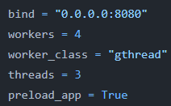
Figure 49 – Gunicorn configuration.

4.2.4.3. Sprint 3 – E-Learning and Gamification
The integral technologies and pipelines were now complete, meaning the remaining non-functional pages could now be developed to work as intended. This started by firstly developing object search functionalities, as to provide object information to learners, they would firstly need a method of navigating to them.

To do this, an API route for searching was developed. This allowed the following request arguments:
Name | Type | Usage | Null Behaviour
search_term | String | Acts as the object name to search for. | Displays all objects.
subcat | String | Allows objects to be filtered, expected as a String to allow for comma-separated numbers. | Displays objects under all subcategories.
mag | Float | Further filters objects by acting as a limiting magnitude, if high-magnitude objects do not want to be seen. | Does not apply a limiting magnitude.
page | Int | For pagination, ensuring that all objects were not loaded at once due to high object counts (132948). | Defaults to the first page.
Figure 50 – Expected search arguments.

Based on the provided search arguments, the route queried the Object table for relevant objects. Furthermore, the query was designed to be case-insensitive and performed as a LIKE search, meaning that a search for “jupi” would still allow an object such as “Jupiter” to be displayed. This, combined with the ability to search based on an object’s other names, may have provided a greater searching experience for learners.

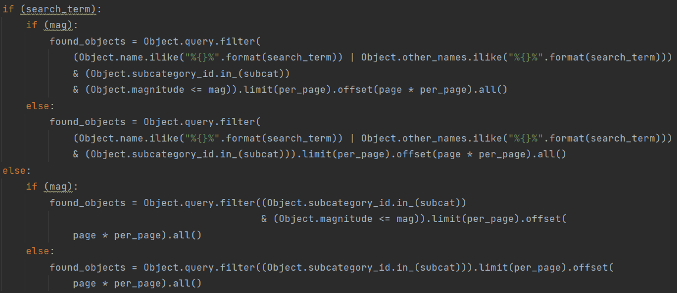
Figure 51 – Switching queries depending on search arguments.

Once relevant objects were found, their visibility status was also required to be displayed. To achieve this, the latitude and longitude of the user (of which was already obtained through the geolocation API), as well as the current UTC time (where tz is UTC), were firstly passed into an Astropy Observer object.
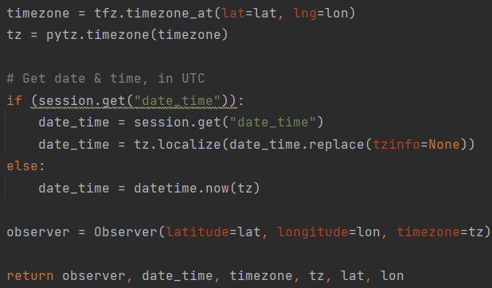
Figure 52 – Passing date and time to an Observer.

Astropy is commonly used in Python applications to perform astronomical calculations (Robitaille et al. 2013), making it an efficient library for calculating object visibility. To do this, the get_object_times method was created to utilise Astropy’s various methods, returning the visibility of an object as a Boolean in one of two ways:
- If the given object is in the Solar System, its right ascension and declination is calculated through Astropy’s get_body method (due to its position always changing as it orbits the Sun). With this, it is then possible to pass the calculated coordinates into Astropy’s target_is_up method.
- If the given object is not in the Solar System, its right ascension and declination from the database is directly used in Astropy’s target_is_up method (due to orbits not needing to be considered).
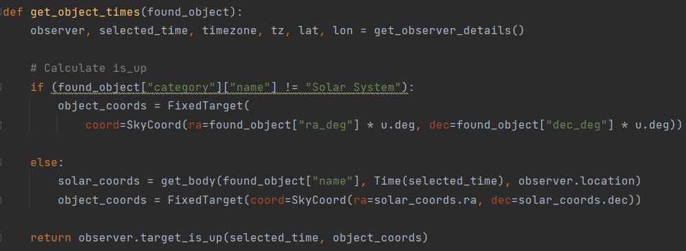
Figure 53 – Getting object positions.

This method was then used for each found object, before finally returning the object details through JSON. This allowed the front-end of the tool to utilise this route through JavaScript, which specifically utilised the infinite-scroll library to dynamically load objects as learners scroll (by querying the API route with an increasing page number).

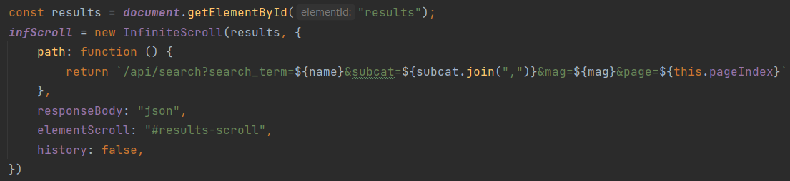
Figure 54 – Initialising infinite scroll.

To further improve these results, the hips2fits API from the feasibility prototypes was implemented in a route, providing low-quality object previews for learners utilising the tool. This ensured object thumbnails were quick to load, the speed of which was further improved by caching the route.
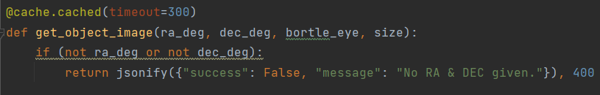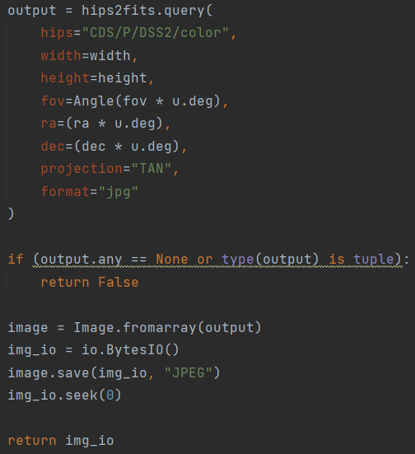
Figure 55 – Utilising hips2fits.
However, an issue in the previous prototype was that hips2fits used a fixed field of view (FOV), making particularly small and dim objects (such as distant galaxies) difficult to see. To resolve this, the route was designed to multiply the FOV by the objects Bortle value, resulting in low Bortle (dim and easily light-polluted) objects having high zoom amounts.

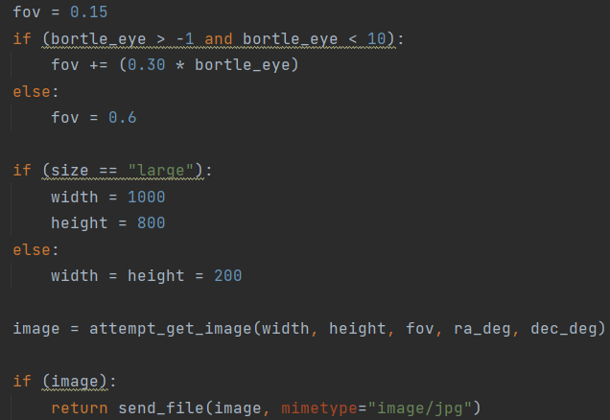
Figure 56 – Dynamic zoom for hips2fits.

By combining this with infinite scrolling, it may have helped to recreate the feeling of exploration that amateur astronomers typically feel (Azevedo 2019), possibly enhancing their experience and assisting in finding appealing objects.
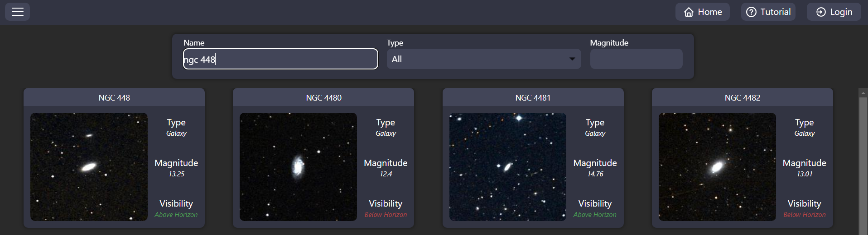
Figure 57 – Searching for NGC 448.

To learn more about these objects, as well as act as a form of navigation across the tool, click events were added to search results. These click events opened an informative popup, providing additional object details for learners.

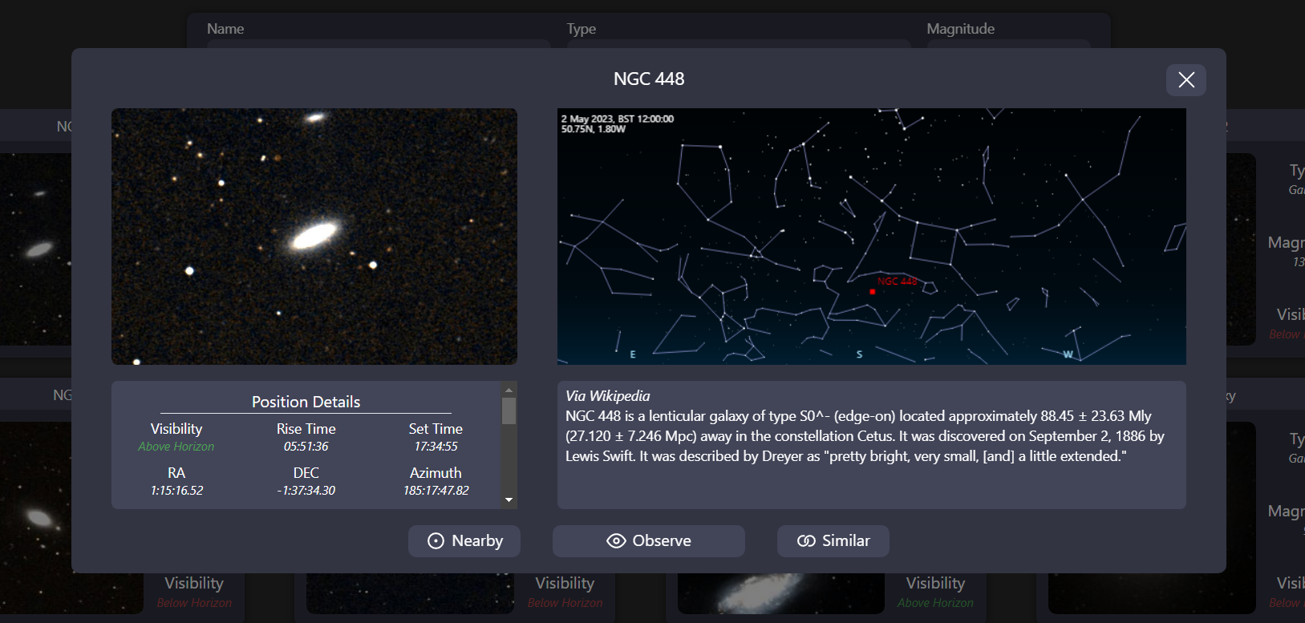
Figure 58 – Popup for NGC 448.

The upper-left section provides a higher quality version of the hips2fits image, providing details that may have been previously unseen. This was achieved by extending the hips2fits route with a size parameter, which altered the width and height accordingly. Using high resolution images here ensured that images with longer loading times (due to higher file sizes, making hips2fits run slower) were only loaded when necessary, increasing the tool’s response time and improving user experience.

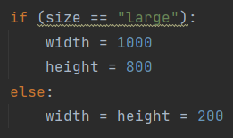
Figure 59 – Choosing hips2fits dimensions.

The upper-right section displays the objects current position in the sky based on the latitude and longitude of the learner. This was achieved through VirtualSky, the planetarium visualisation library previously used in the feasibility study (section 4.2.3.2.). By including this here, learners could identify if an object is in a good position for observations, preventing them from attempting to observe objects that are too close to the horizon.

The bottom-left section listed known information regarding the object, which were directly fetched from the database. To provide additional information, these results were also extended by calculating details such as an objects current altitude and azimuth (local coordinates, which are also used in the VirtualSky planetarium to automatically point at objects). These details were obtained by implementing an additional API route, which once again utilises Astropy’s methods (such as altaz for calculating local coordinates and target_rise_time for calculating the rise time).

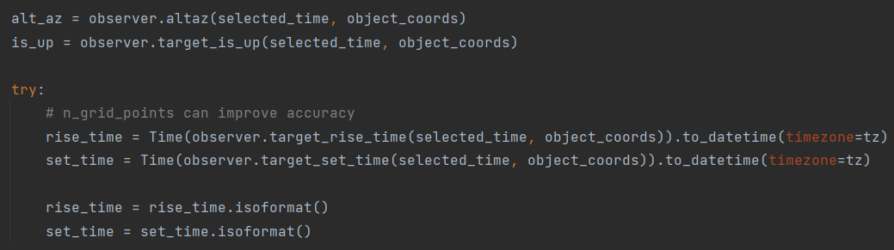
Figure 60 – Object position calculations.

By doing this, learners could more easily plan their observations by knowing the approximate rise and set times of desired objects, improving the observational experience. Furthermore, colour coded Bortle values were also added to this section, making it easier to determine the location light-polluted objects should be observed from.
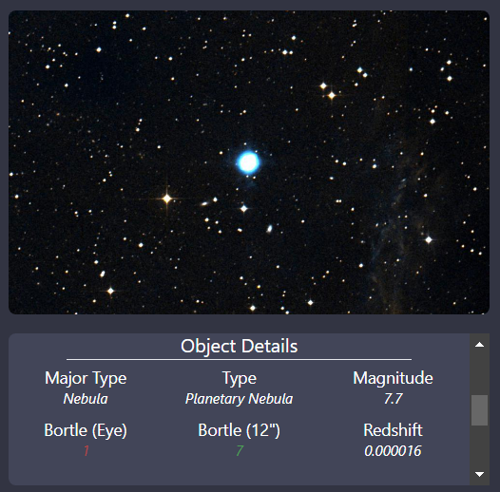
Figure 61 – Viewing Bortle information of objects.

Finally, the bottom-right section showed educational information regarding the object, which was fetched by Wikipedia if an associated page was found (otherwise using a generic category description). This was achieved by utilising the Wikipedia package, which allowed for the object’s name and other names to be searched for.

With hundreds of thousands of objects present in the database, fetching a description automatically was a suitable approach given the limited time for development. Furthermore, to ensure the results were astronomy-related, the Wikipedia search would also perform numerous verification checks:
- Ensuring that the page categories contain “astronomical” or “objects”.
- Ensuring the name of the object is present in the page contents.
- Ensuring that the category of the object is in the page contents.
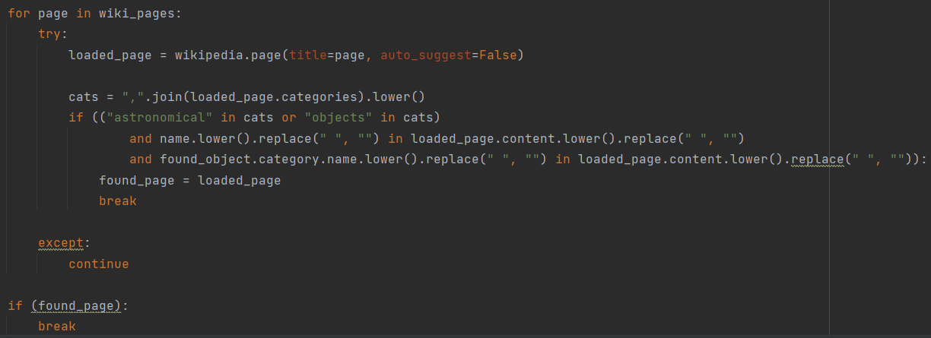
Figure 62 – Searching Wikipedia for relevant pages.

By clicking on an object of interest, the learner may also be interested in attempting to observe it. Because of this, a button that links learners to an observation page was incorporated into popups, providing a larger view of the planetarium to make the object position (as well as the positions of bright stars) more apparent.

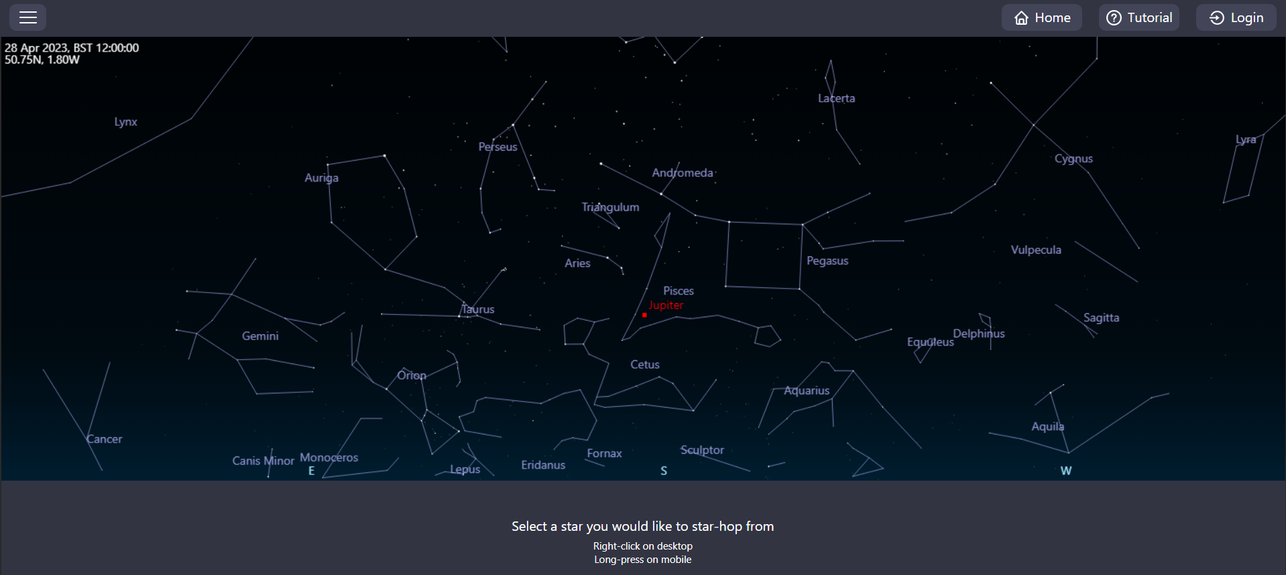
Figure 63 – Observing an object.

This page was intended to provide star-hopping assistance, meaning a method of selecting a star to star-hop from was required. To achieve this, the VirtualSky library was firstly extended with a context menu callback, which would trigger on right-click (desktop) or long press (mobile). This callback would take the XY coordinates of the click/press and translate them into right ascension and declination coordinates, which could then be passed into a “nearby” route for finding the closest object (favouring brighter objects).

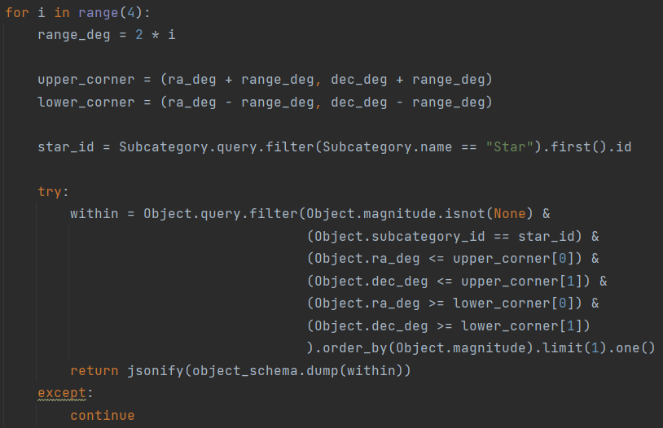
Figure 64 – Finding a nearby object.

The found object would then be returned through JSON, allowing the planetarium to set a second marker. This visually showed the starting point that would be used for star-hopping, as well as informed the user that the star-hopping path is being loaded.

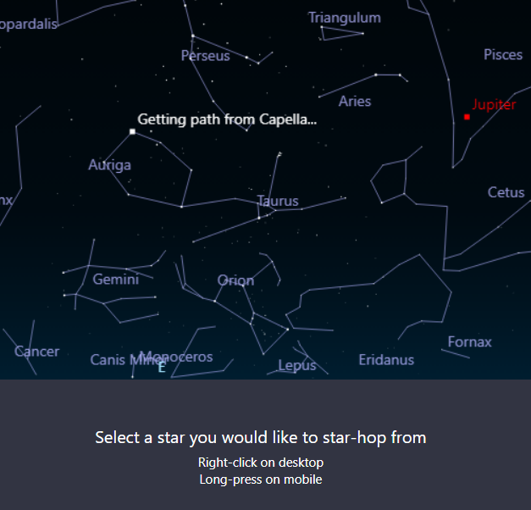
Figure 65 – Loading star-hopping marker.

With the process of beginning star-hopping now set, as well as a method to get the closest object to the learners click/press, the development of a star-hopping algorithm could now begin. To start, a route was created that expects from and to object ID’s, allowing previously utilised visibility calculations to be performed.

Figure 66 – Ensuring star-hopping objects are visible.

This ensured that both objects were currently visible, as a star-hopping path should not fall below the horizon. Next, bright stars of magnitudes lower than 6 were queried from the database (to prevent long loading times as there are over 100,000 stars in the database), which were merged into a node list with the start and end objects. It should be noted that the method to achieve this (format_hopping_objects) also extended the objects by attaching their local coordinates (altitude and azimuth) under the “pos” attribute, ensuring that stars with an altitude lower than the horizon line (0) were removed.
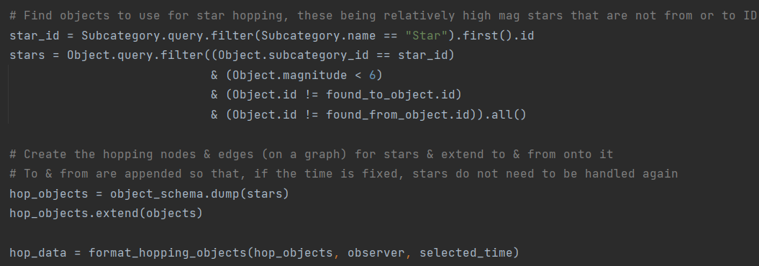
Figure 67 – Preparing stars for star-hopping.

With the objects now prepared, a geometric graph (as discussed in section 2.3.2.) would now be required to incorporate a graph of stars. To achieve this, the NetworkX library was utilised due to its ability to automatically generate geometric graphs (Hagberg, Swart and S Chult 2008), making it possible to create edges across objects within a radius of 20° to each other.

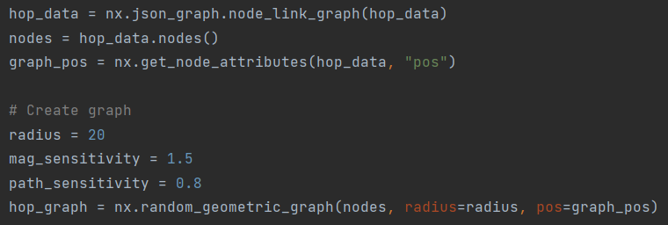
Figure 68 – Creating a star-hopping graph.

By using a radius of 20°, edges were maintained across all nodes whilst also not stretching too far. This can be seen through the visualisation below:
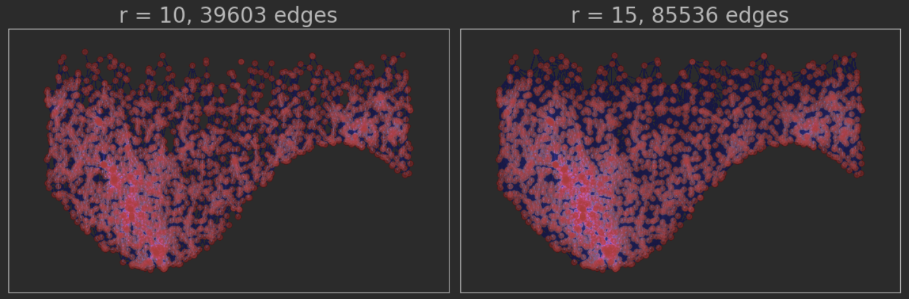
Figure 69 – Visualisation of star-hopping graph.

However, the generated edges did not have yet have weights, meaning star-hopping paths generated through the graph would not consider their shared distance (calculated through the heuristic method, which utilises Euclidian Distance) or magnitude. Because of this, edges were next iterated through and given a weight that combines their distance between each other and magnitude. By doing this, edges connecting to bright stars naturally had lower costs than faint stars (due to these objects having higher magnitudes).
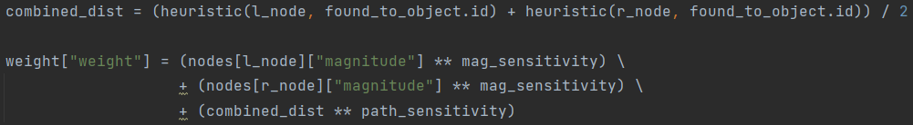
Figure 70 – Calculating node weights.

This was not the only encountered issue, as another was encountered when linking nodes. Azimuth goes from 0° to 360°, where exceeding 360° would loop around to 0° and vice versa. However, the geometric graph did not know this, causing an issue where technically close stars were not being linked.

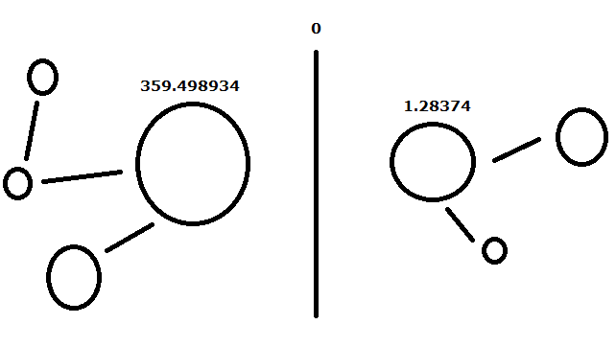
Figure 71 – Visualising the issue of linking nodes.
Because of this, a second loop was required to loop through nodes that were close to this boundary, checking their altitudes to see if they are close enough to link. This ensured star-hopping paths could pass this boundary, preventing the paths from becoming unnecessarily long.

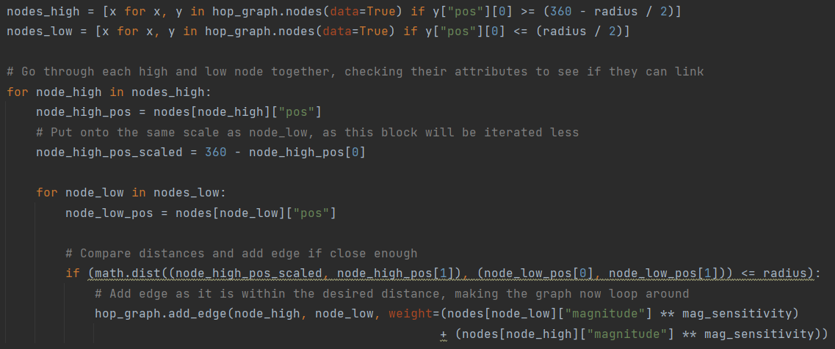
Figure 72 – Looping through nodes that do not have appropriate edges.

With the graph created, it was now possible to find the shortest path (i.e., the brightest path of stars to the target object, as defined by the edge weight criteria) between objects in the graph. To achieve this, the A* algorithm was used due to its efficiency improvements over Dijkstra (Foead et al. 2021), allowing the heuristic method (for calculating straight-line distances) to guide the algorithm towards the target object.

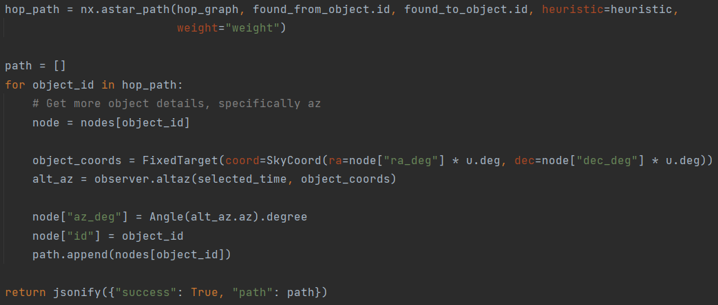
Figure 73 – Finding the star-hopping path through A*.

Finally, the found path is returned as JSON, which was then possible to utilise from the observation page. This functioned by drawing the star-hopping path onto the planetarium, allowing learners to identify what objects need to be traversed across to reach a target. Furthermore, movement buttons and previews of objects were also added below the planetarium, which may have further assisted learners in reaching a target.

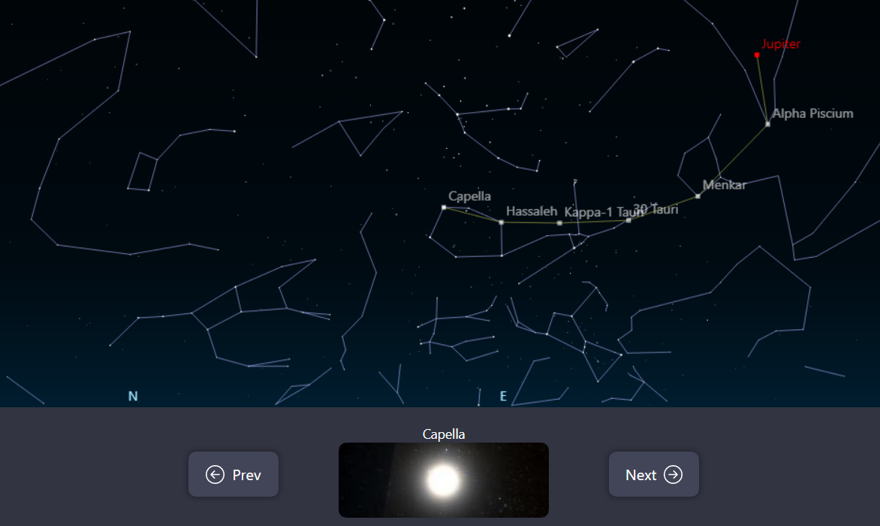
Figure 74 – Visualising the star-hopping path.

It should be noted that this functionality is not part of the base VirtualSky library, which was heavily modified to support the features of this tool. Drawing lines between objects involved extending the library to support being inputted an object list, as well as developing a new method (based on how it renders constellation lines) to draw straight lines between objects.
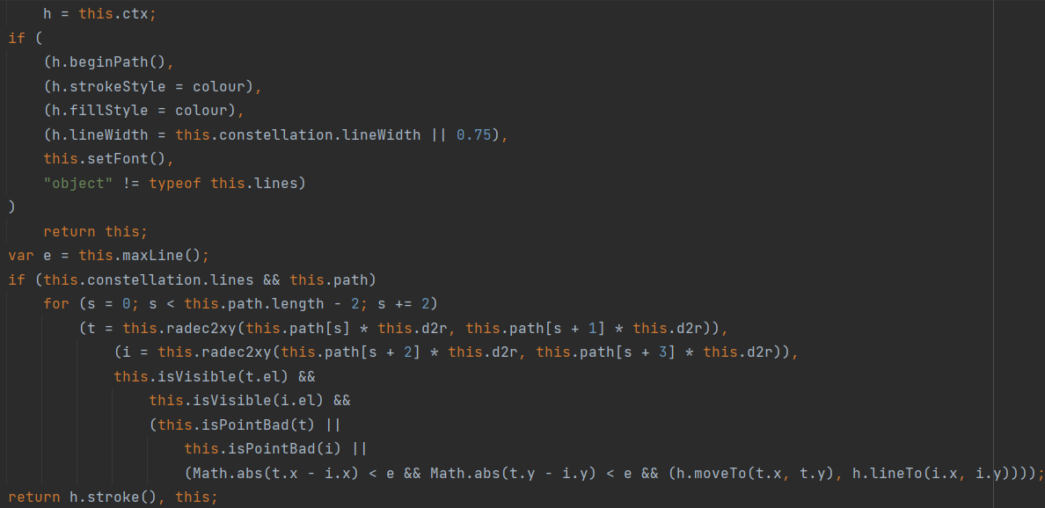
Figure 75 – Extended VirtualSky code for drawing lines.

With the ability to visualise star-hopping paths now complete, signed-in learners were given additional features to both improve their experience and ensure future methods could work. One of these was allowing objects to be marked as “found” or “not found” at the end of an observation, which would add the object to an observation log on a profile page.

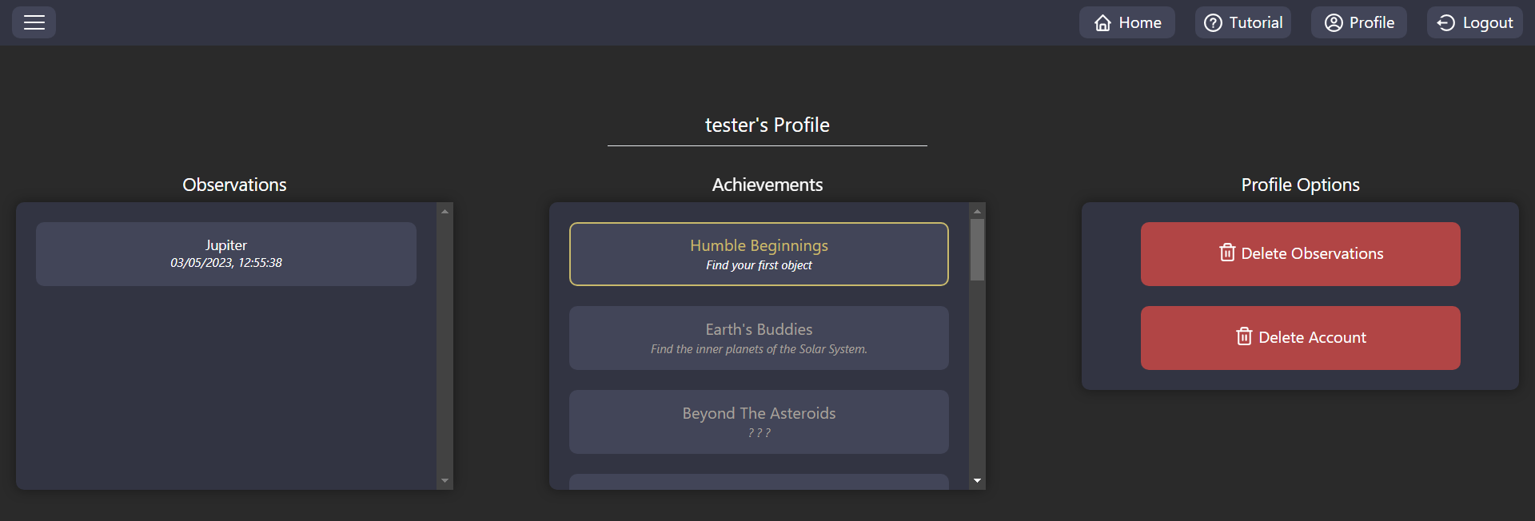
Figure 76 – Profile page.

Furthermore, successfully observing an object would also check if the learner has unlocked any difficulty-scaling achievements. For instance, the Humble Beginnings achievement is the first achievement expected to be unlocked, which counts the learner’s current observations and grants this achievement if that value is now going to be one. Furthermore, the achievement(s) are attached onto the observation response, allowing the front-end to display an achievement popup.
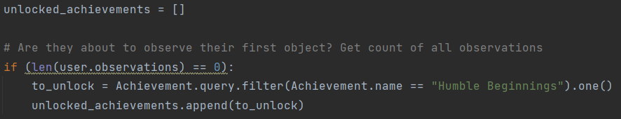
Figure 77 – Unlocking the Humble Beginnings achievement.

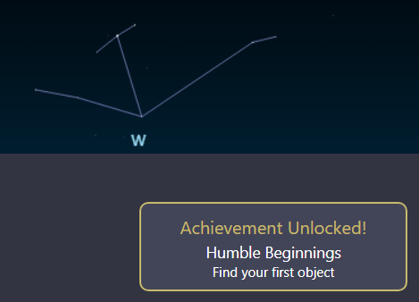
Figure 78 – Achievement notification.

When a learner continues using the tool and learning how to observe to objects, harder achievements such as observing objects in all constellations are expected to be unlocked. This allowed for a guided and gamified experience, which may have improved the enjoyability of amateur astronomy for learners.

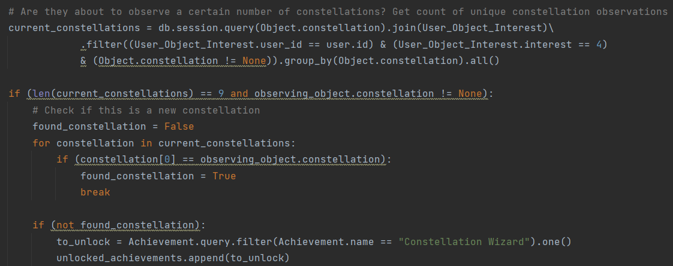
Figure 79 – Unlocking the Constellation Wizard achievement.

4.2.4.4. Sprint 4 – Object-finding Automation
Features to assist learners in observing objects were now added, of which were further enhanced through gamification techniques. However, the only present method of finding objects was through the search bear, which assumes that the learner knows what they are looking for. Because of this, the next sprint focused on easing the search experience of the tool.

The first method of doing this was built to extend upon successful observations, this being automatically finding nearby objects. This improved the process of identifying objects that the learner may currently be seeing through their telescope, whilst also acting as guidance on where they could go next.

Firstly, options within the hamburger menu were created, which allowed learners to adjust how the nearby objects algorithm behaved. These include:
- Nearby Categories, making it easier to find particular object types that are near a target. By default, all objects are selected.
- Nearby Range, allowing the range to be adjusted. By default, this is set to 2°.
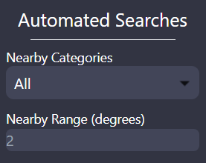
Figure 80 – Nearby categories and range settings.

When a learner closes the hamburger menu, a POST request was made to a settings route to automatically store these values in the user session. Furthermore, if a user is signed in, these settings were also stored to their profile to make settings persistent across devices.
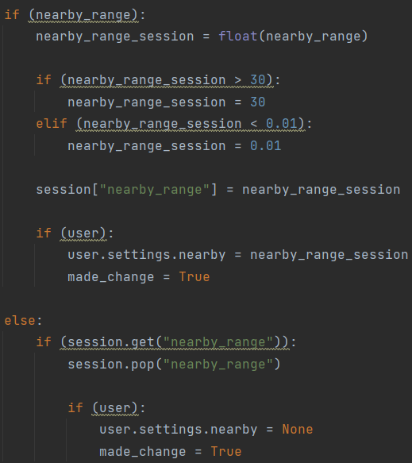
Figure 81 – Storing and popping nearby range.

Utilising these values, it was possible to enhance the nearby objects algorithm utilised from the observation page (detailed in section 4.2.4.3.) into a new nearby route. One method of enhancement came from allowing the upper and lower corners to loop between right ascension 0° and 360° (as it loops similarly to azimuth). This functions by checking if the nearby range would exceed the right ascension boundaries, looping the selection corners around the boundary if needed.

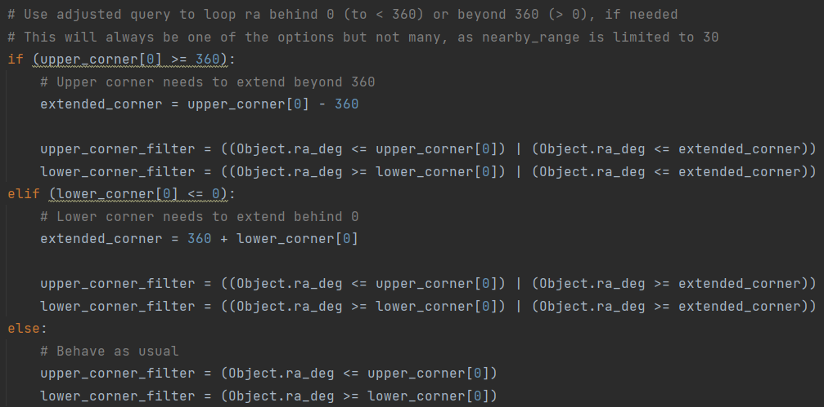
Figure 82 – Filters for nearby objects.
Unlike the previous nearby objects query which returns a singular object, this version needs to return multiple. Because of this, along with the number of objects that could be nearby (in a structure such as a star cluster), the pagination-based approach seen in object searches was once again used.

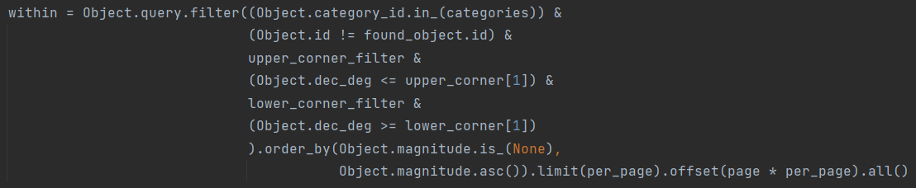
Figure 83 – Querying for nearby objects.

Finally, these objects were returned through JSON, which are fetched when the Nearby button on the observation page / object popup is clicked. These results are then shown in an infinite scroll container, which may have enhanced the object finding experience of learners. However, it should be noted that planets are not included in these results, which is due to their right ascensions and declinations needing continuous updates.

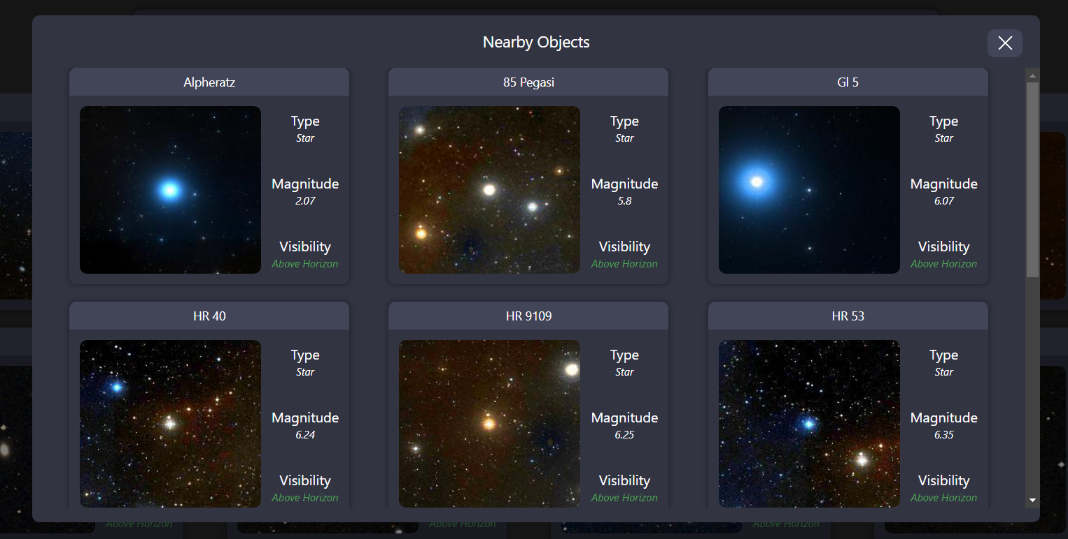
Figure 84 – Displaying nearby objects.

Finding nearby objects was useful for identification purposes, but the results were not similar to the selected object. Because of this, the second method of automating object-finding was implemented through a content-based algorithm. This allowed learners to quickly find objects similar to a given object, meaning individuals with specific object tastes (such as high magnitude galaxies) were able to rapidly find more.

To incorporate this, a route was created to firstly insert all objects (aside from the selected object and objects not of the same category) into a Pandas DataFrame. This ensured that calculations for each object could be performed without utilising loops, increasing the efficiency and responsiveness of the tool.
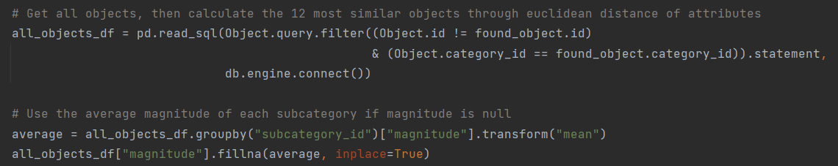
Figure 85 – Querying through Pandas.

By now having the objects in a DataFrame, their attributes were now possible to compare with the selected object, where lower “distances” between values suggests greater object similarity. This made the previously utilised Euclidian Distance algorithm capable of solving this problem, utilising the following object attributes to determine similarity:
- Subcategory, ensuring the object is of a same or very similar type (such as star or double star).
- Bortle (eye) and Bortle 10” telescope), ensuring the object is visible in similar environments.
- Magnitude, ensuring the object is similarly bright.

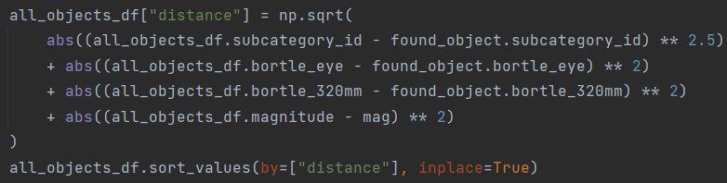
Figure 86 – Calculating object similarity.

Like before, these results were then utilised from a popup, allowing leaners to effectively find similar objects. However, to ensure that the objects were always relevant, the results within the popup were limited to twelve objects. This is because, if the user had the ability to infinitely scroll through the results, they may reach the point of seeing dissimilar objects. Therefore, by limiting the results, only the most relevant objects would be shown.

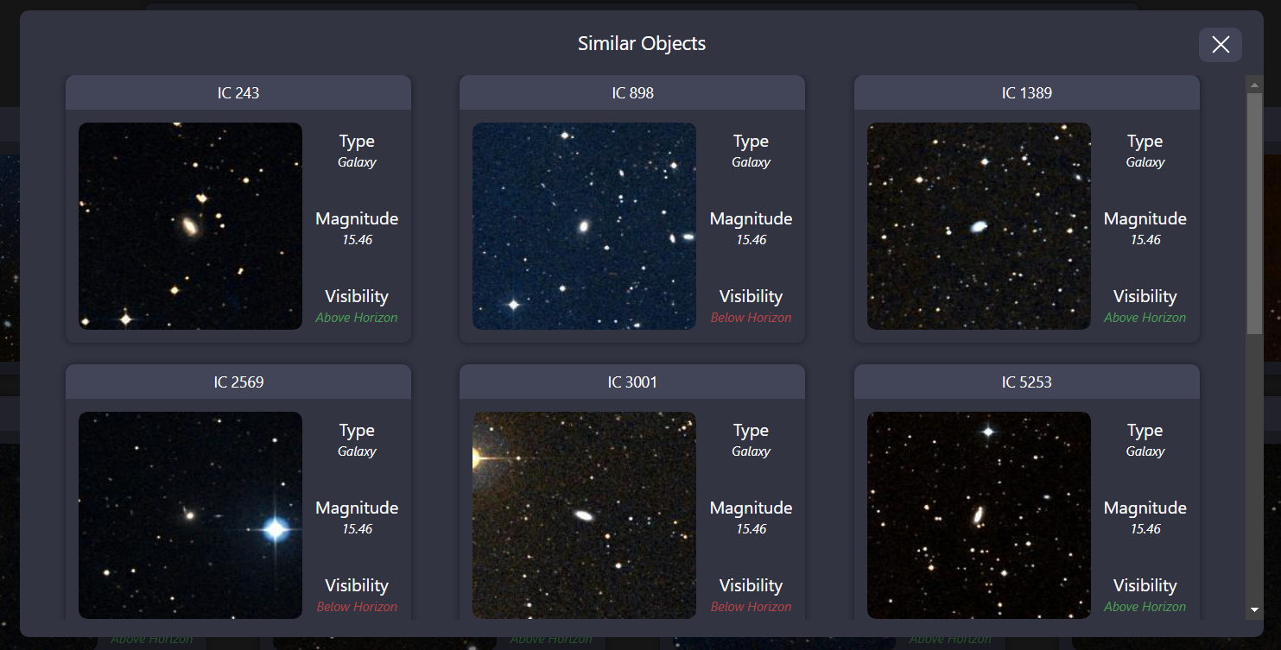
Figure 87 – Displaying similar objects.

However, as mentioned in the literature review (section 2.3), content-based algorithms do not always provide appropriate results. This is because they do not consider previous user interactions, which in the case of the tool, means it is not acknowledging object interest. Because of this, the final approached mixed the content-based approach with a collaborative approach, providing a hybrid object recommender based on signed-up learner activity.

For this to function without explicitly asking leaners to rate observations (which could slow or impede the user experience), a method of implicitly collecting the interests of signed-in learners was required. To incorporate implicit this, specific user interactions were chosen to be stored in the database, consisting of:
Interaction | Reasoning | Interest
Clicking on an object | Clicking on an object means the learner wanted to find out more about the object, showing minor interest. | 1
Observing an object | Looking at an objects position may mean the learner plans on observing the object, showing slight interest. | 2
Failing to observe an object | Attempting to find an object shows the learner has an interest in this type of object, showing interest. | 3
Successfully observing an object | Successfully finding an object shows the learner can observe this object and has as an interest for this type, showing high interest. | 4
Figure 88 – Interest scores table.

To now incorporate a hybrid recommender, it was necessary for a recommender modelling library to now be utilised. For this, the LibRecommender library was chosen due to its compatibility with Pandas, which was previously used to incorporate similar object functionalities. Furthermore, this library contains numerous hybrid recommendation algorithms such as:
- YouTube Ranking (Covington, Adams and Sargin 2016)
- DeepFM (Guo et al. 2017)
- Wide & Deep (Cheng et al. 2016)

Of these recommenders, the YouTube Ranking algorithm was chosen due to its prominent usage (on sites such as YouTube) as well as cold-start mitigation techniques. To begin implementing this algorithm, a Recommender class was created, which firstly queried for all user interests and renames fields to the appropriate LibRecommender format.
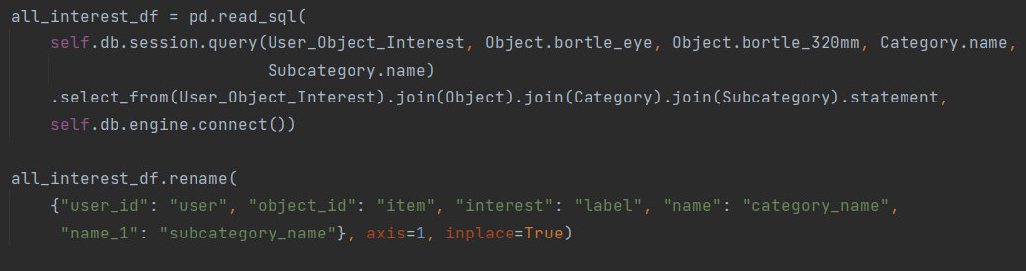
Figure 89 – Converting objects to LibRecommender’s format.

Bortle information as well as categorical information was then fed into the sparse and item columns of LibRecommender, which are used to define content-based attributes that the YouTube ranking algorithm will use. From these, a trainset is created through LibRecommender’s build_trainset method, converting the data to the expected format. However, the library appeared to throw an exception when only one distinct user existed in the train set. Because of this, a check for distinct users was implemented before it was used, avoiding the exception.
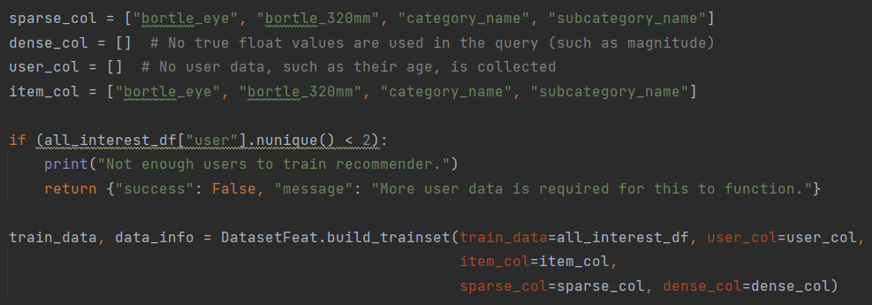
Figure 90 – Determining content-based attributes.

By now having the data prepared, it was now possible to create and train the recommendation algorithm. Firstly, the YouTubeRanking model was called, of which was assigned the unconsumed sampler to ensure recommended objects have not already been interacted with. Then, the model was fitted to the train data, which was negatively sampled due to unknown Bortle values being represented with a negative number.
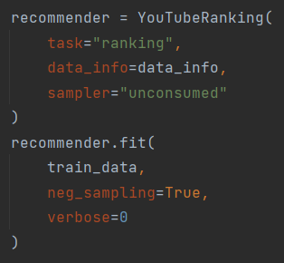
Figure 91 – Fitting the recommender model.

With the recommender now trained on object interactions, it was now possible to provide object recommendations based on a given user ID. This was done through utilising the recommend_user method of the recommender, passing in the currently signed in user’s ID as well as the number of recommendations to make (typically twelve, but is lowered if not enough interactions exist).

Furthermore, utilising this method also allowed for the cold start problem to be bypassed. This is because it incorporates modes of handling unknown users, such as recommending popular (highly rated) or average (typically rated) objects. In the case of this tool, the average strategy was used determined to be ideal, ensuring that the common interests of learners are reflected in initial recommendations.
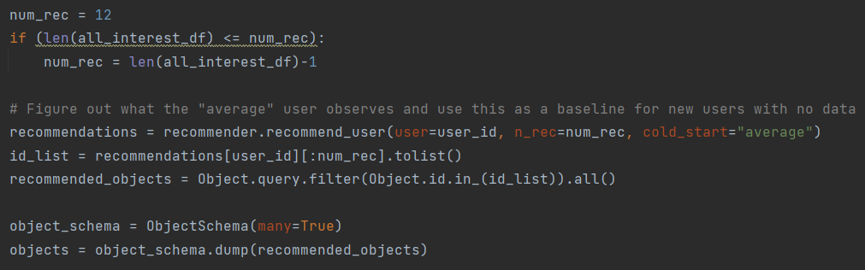
Figure 92 – Running the recommender model.

Like the process for similar objects, recommended objects were limited to twelve and returned as JSON, ensuring recommendations do not become weak if users continuously scrolled. Now, when a learner showed an interest in specific types of objects (such as stars), the recommender was capable of providing similar objects that similar users observed.

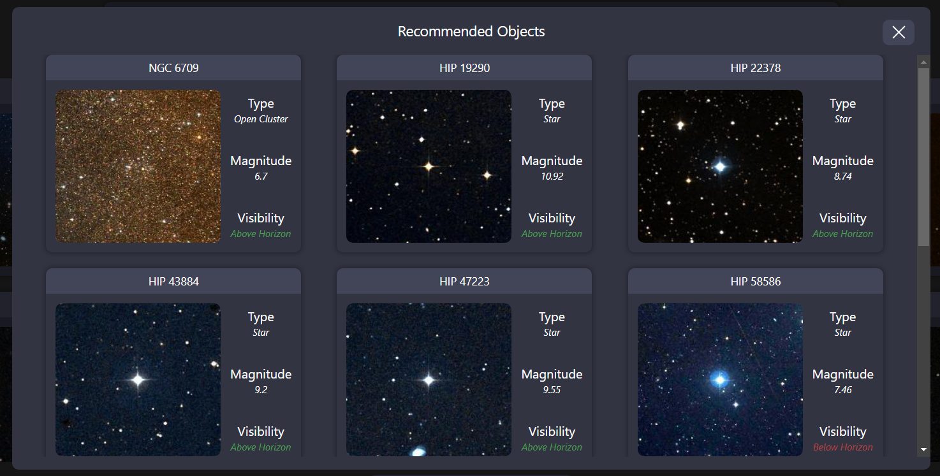
Figure 93 – Displaying recommended objects, after clicking on a multitude of stars.

By then interacting predominantly with another type of object category, such as star clusters, the recommender would retrain itself and begin to recommend objects like those categories. This improved the personalisation of recommendations, whilst also acting as a method of ensuring the model works as intended (due to recommendation engines not typically being utilised for astronomy, meaning there is no test data to evaluate the model on).
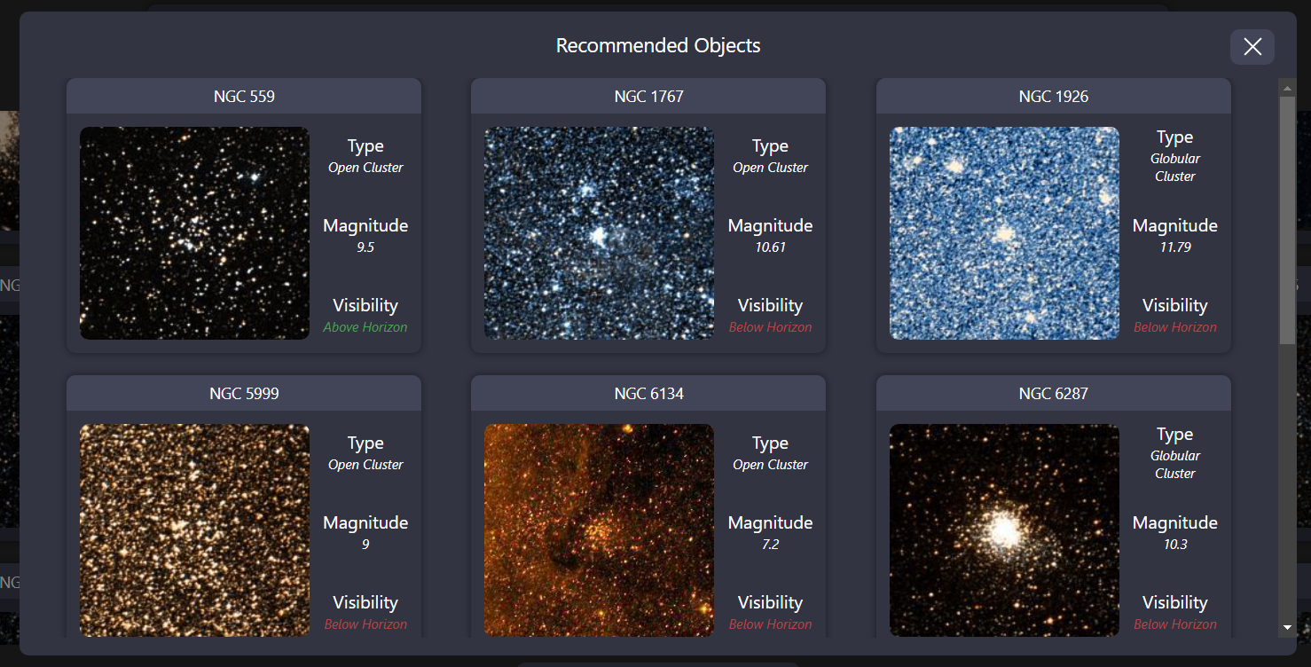
Figure 94 – Displaying recommended objects, after clicking on a multitude of star clusters.

Whilst retraining the model ensured the recommender would always reflect a learners up-to-date interests, it massively slowed down the performance of the tool. This meant that learners were required to wait upwards of 30 seconds to access recommendations, decreasing the tool’s response time and possibly resulting in lowered recommendation usage. To mitigate this issue, the recommender was extended by firstly locally writing the model and its most recent training data, if the current locally written training data is a different length (preventing unchanged data from being resaved).

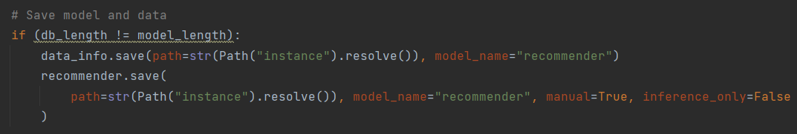
Figure 95 – Saving the recommender model.

Then, before the model was trained, the lengths of the most recent interest levels were then compared with the previously utilised interest levels. If these numbers were identical, the locally saved model was directly used (as training data has not changed), otherwise the model would train itself like before. Doing this improved the response times of recommendations, which may have influenced more learners into utilising this feature.
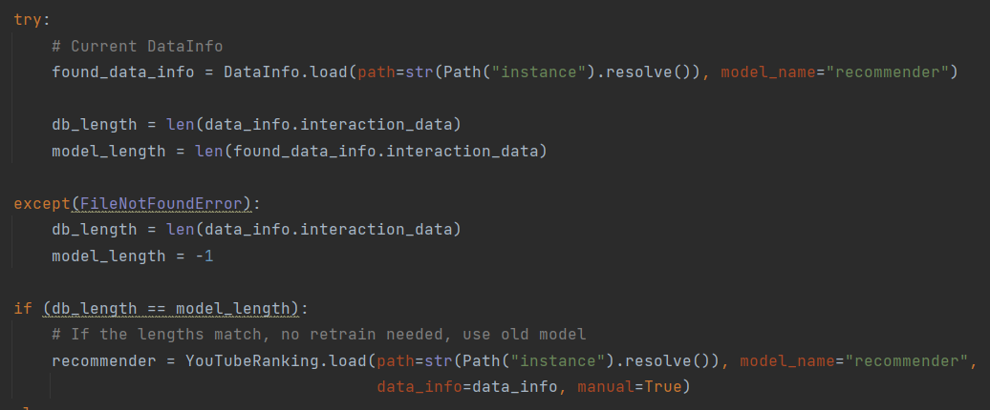
Figure 96 – Loading the recommender model.

With the recommendation engine complete, the development pipeline process outlined in section 4.1 could be followed. However, a major issue was encountered during the deployment of the application, as the libraries utilised by LibRecommender (such as TensorFlow and Torch) were not capable of being installed in the remote environment. This was despite the tests being successful, suggesting that DigitialOcean’s app deployment platform may limit the installable packages.

Due to these issues, the deployment provider was switched to PythonAnywhere. PythonAnywhere has libraries such as TensorFlow and Torch preinstalled, whilst also giving the ability to install packages without limitations (PythonAnywhere 2023). Because of this, the recommender could now be successfully used by learners online, but this came at a cost. PythonAnywhere does not have GitHub Actions process to automatically deploy the code, requiring zip files to be uploaded and increasing the time needed to host the tool online. However, due to this being the second to last sprint, the slower deployment times were deemed acceptable.

4.2.4.5. Sprint 5 – Advanced Functionality
The core functionalities to test with the tool, these being automated object finding, star-hopping assistance, and gamification were implemented. But, these were completed sooner than expected, leaving additional time to enhance the present methods and improve the tools functionality. Because of this, the final sprint focused on incorporating additional features and enhancements that may improve the learning experience.

One method of doing this related back to the visibility calculations of objects, which currently fetched the learner’s latitude and longitude through their IP address. This process had numerous issues, such as not allowing learners to change their latitude and longitude to plan future observations, whilst also not being as accurate as the previously utilised geolocation API (section 4.2.3.1.). Therefore, the settings within the hamburger menu were extended to also provide location control, which also allowed the geolocation API to be utilised with the Auto (geo) button.

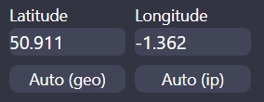
Figure 97 – Latitude and longitude settings.

To further improve upon the observation planning process, the ability to change the time was also added. Development started by firstly incorporating a time picker into the hamburger menu, which utilised the flatpickr library to simplify the experience of inputting dates.

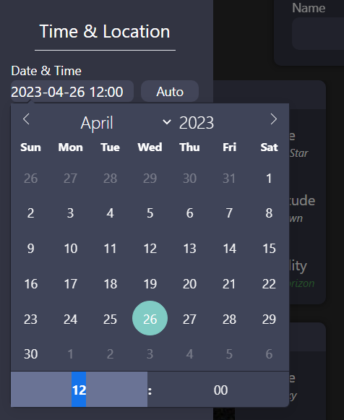
Figure 98 – Date and time settings.

By being able to input dates into settings menu (which are stored into the session as other settings are), the time used for visibility calculations could now be overwritten. This was developed assuming that the learner wishes to see objects at the given time of the desired location (such as switching to Russia’s time zone if the latitude and longitude of Moscow are entered), preventing confusion by using the server’s local time or continuing to use UTC.

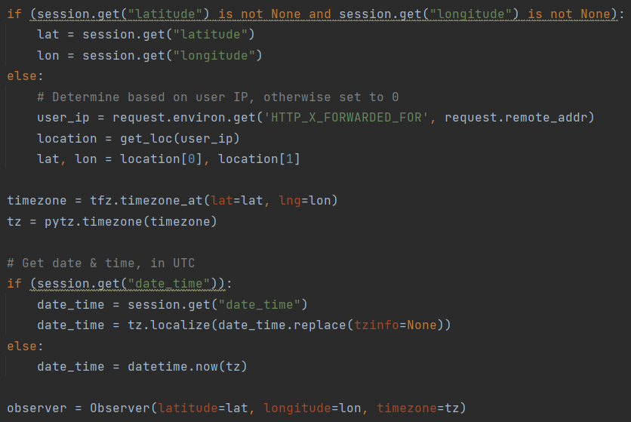
Figure 99 – Handling latitude, longitude, dates and times.

This functioned by firstly overriding the IP geolocation if custom latitude and longitude values have been added, ensuring the API is not unnecessarily called. Then, given the location, the tfz and pytz libraries were used to determine the time zone of the location, which was attached onto the datetime object. Finally, the VirtualSky library was further extended to provide time zone information, making it more apparent to learners that the time adapts to the location.

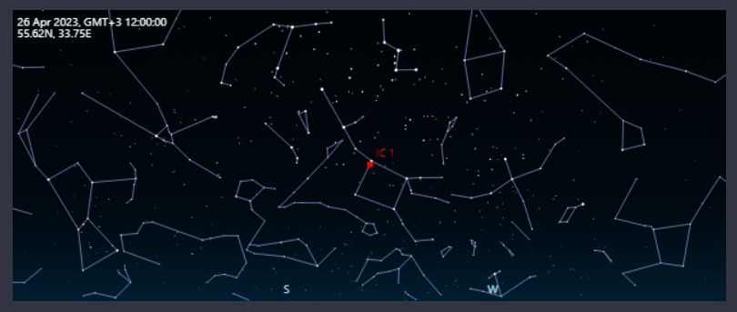
Figure 100 – The location of IC 1 near Moscow, Russia.

In addition to creating the location and time settings, another added setting was the ability to toggle “red-mode”. Selecting this option would overlay a red div with the multiply mix-mode across the screen, helping to preserve night vision when utilising the tool.
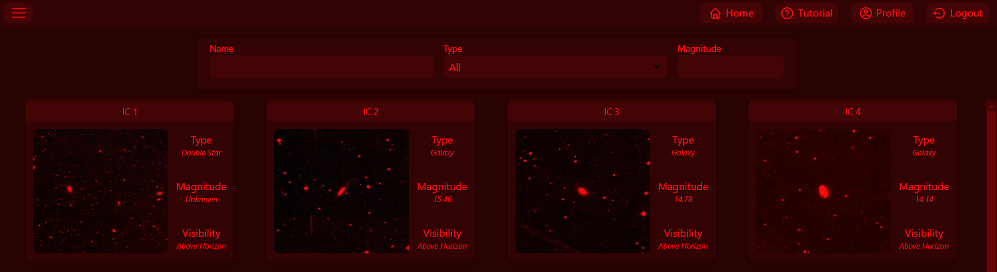
Figure 101 – Red-mode display.

However, utilising the red-mode could make text colours such as green difficult to read, which is due to the overlay effect of the multiply mix-mode. Because of this, a stylesheet is injected into the head element to change the colour of green text to red, ensuring that text remains readable. This ensured that learners do not feel there are trade-offs to consider when using red-mode, allowing them to use it without visual consequences and possibly prolonging their learning time with the tool.

Figure 102 – Injecting styles into the head element.

With the large number of features that were currently present in the tool, it was important to include a method of introducing them to new learners. Without this, it would be difficult for less-experienced amateur astronomers to get started with the tool, which would not ease the stress of beginners (Gada, Stern and Williams 2000). To achieve this, an interactive tutorial mode (which was found to be helpful for new learners in section 2.3.3.) was incorporated into the tool, providing step-by-step instructions on how to use and learn from the tool.

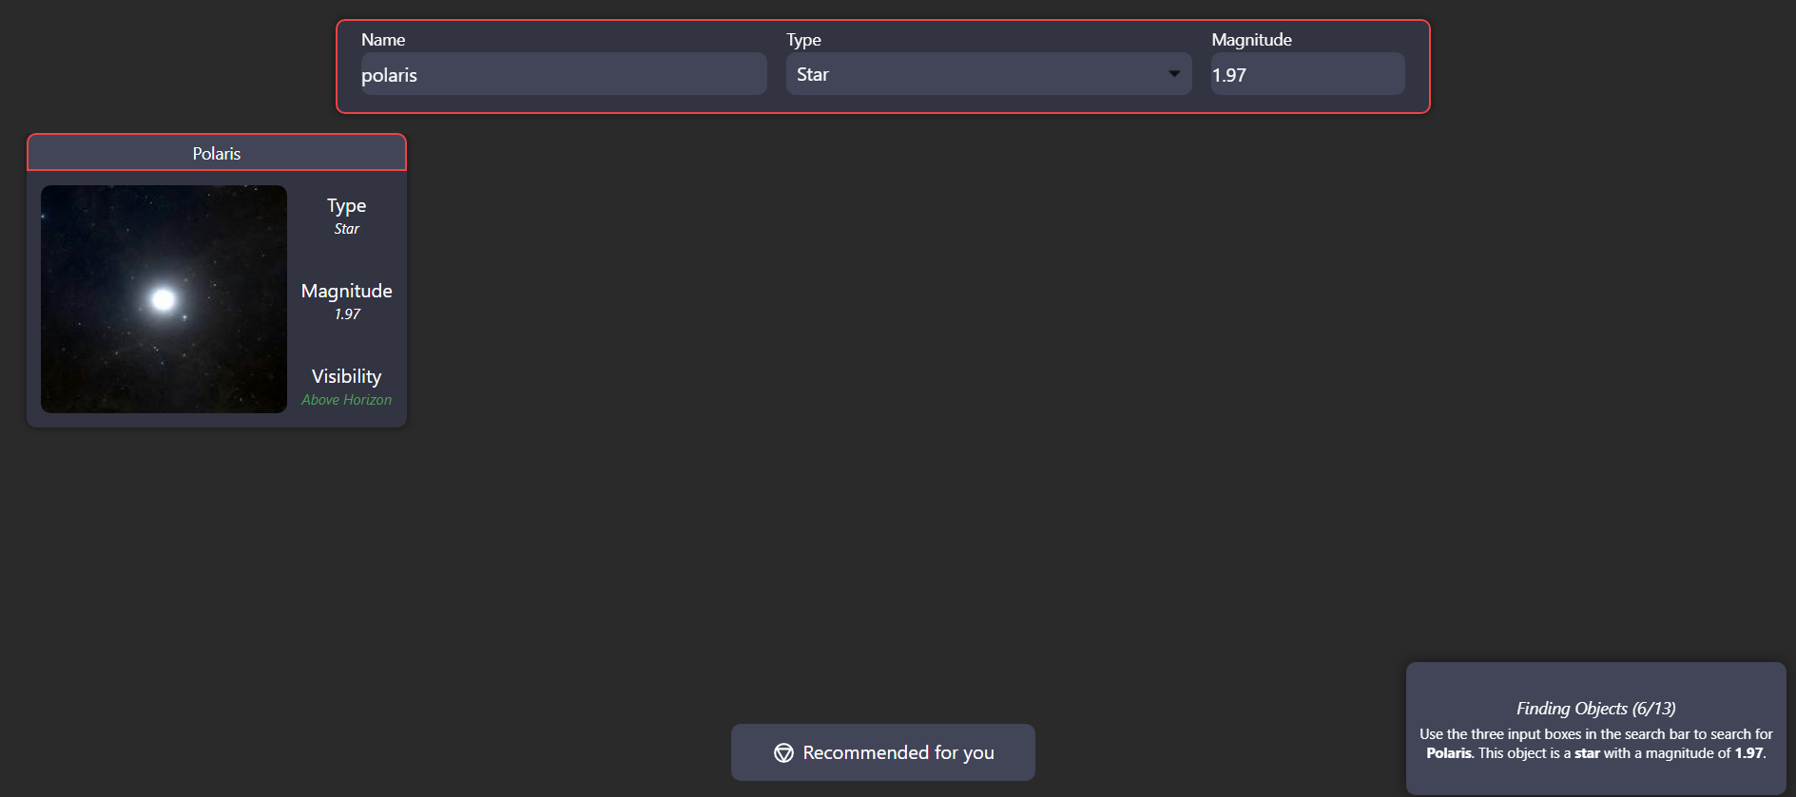
Figure 103 – Tutorial process.

This functions by providing tutorial information on the bottom right, whilst also highlighting and adding event listeners to sections expected to be clicked. When the highlighted object is then clicked, the tutorial moves onto the next section, helping to slowly introduce new learners to the tool which may have lowered the stress of beginners.

Finally, a multitude of smaller changes were made to further improve the tool. Examples include:
- Increasing textbox sizes on smaller screens, making the tool easier to operate from phones.
- Allowing the star-hopping starting point to be changed at any time, reducing the difficulty of following a set path.
- Converting to Flask Blueprint’s, which modularised the tool and makes it easier to extend and enhance in the future.

With these last additions and changes, the tool had now fulfilled all requirements outlined in section 4.2.2. Some requirements were fulfilled sooner than expected (such as requirement 5.3, as including Bortle information became important for other requirements to be fulfilled) but were otherwise achieved and stable due to the continuously written tests at the end of each sprint. Because of this, the experiment could now begin.

4.3. Professional, Legal and Ethical issues
Due to the experiment involving participants, care was taken to ensure that individuals knew the purpose of the project. One way of achieving this was through providing transparent information regarding the project and experiment, which can be seen in the Stargazers Lounge post (Tasker 2023) below:
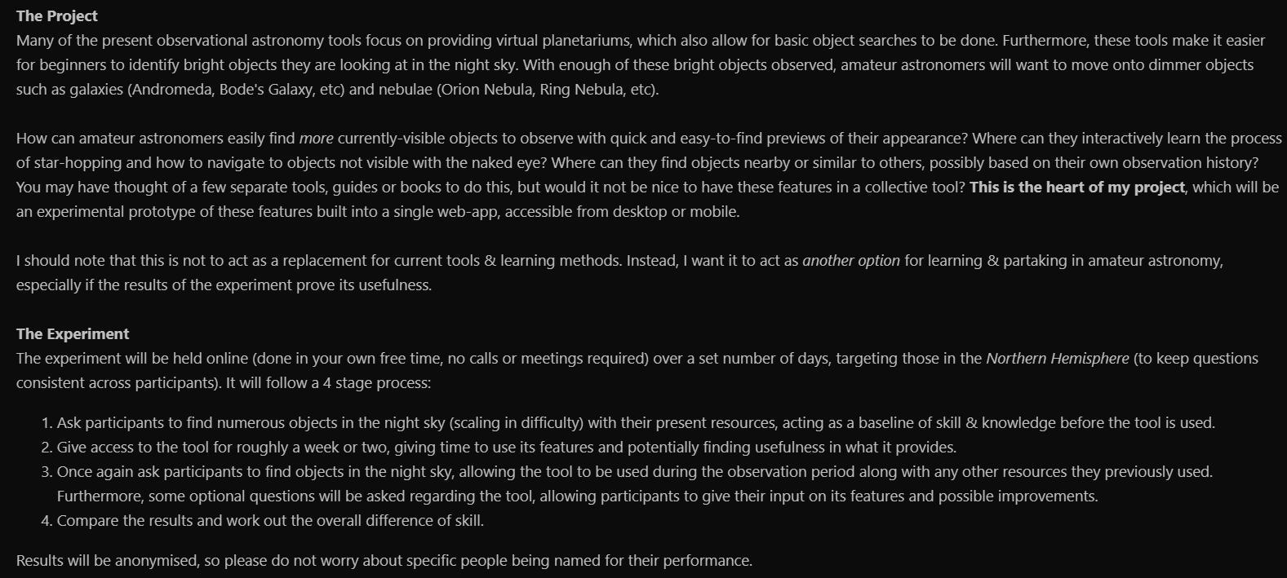
Figure 104 – Stargazers Lounge post.

This ensured individuals knew the purpose of the project, preventing misunderstandings and providing project context. However, this would not prevent an individual from skipping over the text and directly filling out the attached interest survey. Because of this, the interest survey also required individuals to explicitly declare that they understand the purpose of the project and experiment, as well as declare that they are comfortable taking part.

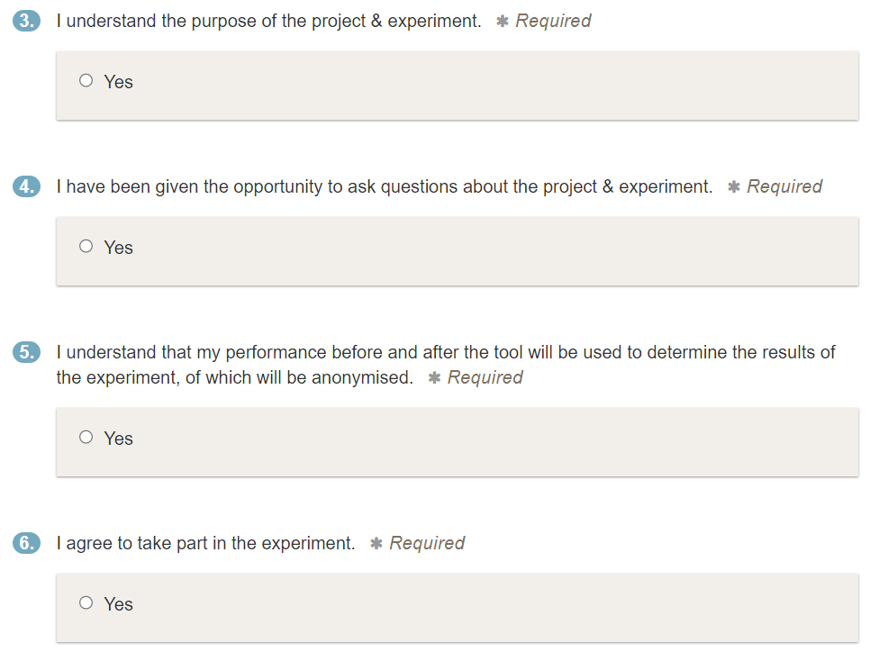
Figure 105 – Consent questions.

By only allowing the interest survey to be completed if consent was given, it was ensured that collected responses were only from consensual individuals with an assumed understanding of the project. This was further ensured when moving onto the pre-tool and post-tool phases of the experience, by only providing the questions (as well as access to the tool) to those who responded to the initial survey.

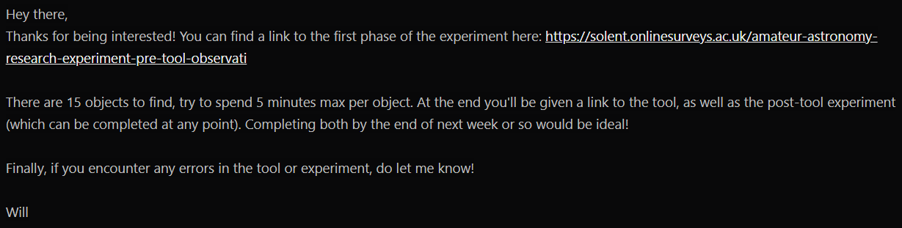
Figure 106 – Follow up message from the initial survey.

To protect the privacy of participants who responded to the initial survey, their usernames and emails were omitted from the results. Furthermore, no identifiable information was collected during the experiment. This ensured that participants were kept anonymous, preventing individuals from being specifically identified.

Privacy considerations were also made for the tool, as features such as object recommendations collect the data of learners. Because of this, it was important to ensure that users of the tool could opt out of this process and remove their data at any time. To incorporate this, a deletion button for observations was incorporated into the profile page, which removed their observations, interests, and achievements. If the learner wished to opt out entirely, an account deletion button was also added, allowing them to continue using the tool anonymously as a guest.

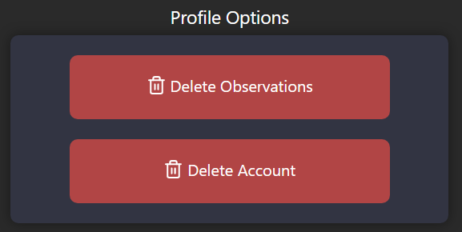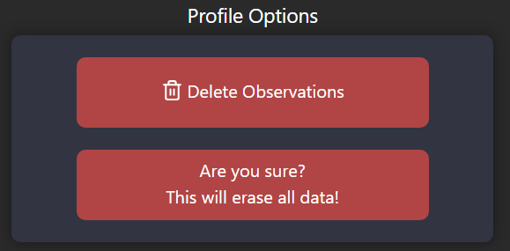
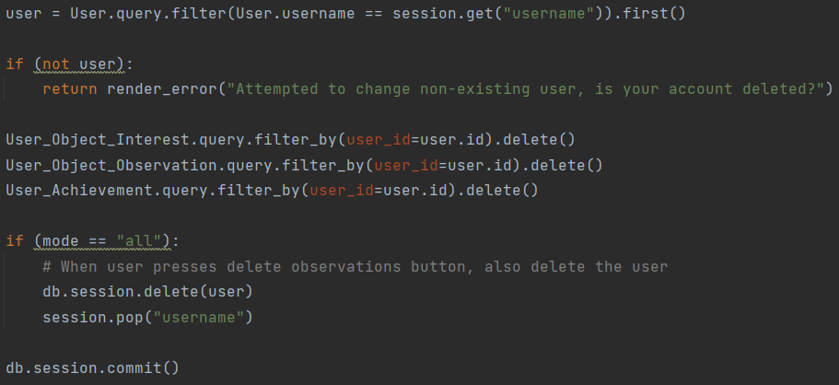
Figures 107 & 108 – Deleting data and removing from the database.

5. Results

5.1. Interest survey
Response Number | Northern Hemisphere | Continental Location | Understands Project & Consents
1 | Yes | Europe | Yes
2 | Yes | Europe | Yes
3 | Yes | Europe | Yes
4 | Yes | Europe | Yes
5 | Yes | North America | Yes
6 | Yes | Europe | Yes
7 | Yes | Europe | Yes
8 | Yes | Europe | Yes
9 | Yes | Europe | Yes
10 | Yes | Europe | Yes
11 | Yes | Europe | Yes
Figure 109 – Interest survey results.

5.2. Pre-tool phase
 |  | Response Number
 |  | 1 | 2 | 3 | 4 | 5 | 6 | 7 | 8
 |  | Beginner
Objects | Capella (sec) | 1 | 2 | 4 | 2 | 3 | 14 | 3 | 2
 | Mars  (sec) | 2 | 3 | 6 | 3 | 5 | 18 | 2 | 4
 | Polaris (sec) | 2 | 1 | 7 | 1 | 4 | 6 | 4 | 3
 | Arcturus (sec) | 2 | 2 | 4 | 3 | 11 | 14 | 5 | 2
 | Regulus (sec) | 1 | 2 | 5 | 4 | 4 | 13 | 5 | 3
 | Skill Percent | 100% | 100% | 100% | 100% | 100% | 100% | 100% | 100%
 |  | Intermediate
 | NGC 129 (sec) | 20 | 20 | 13 | 23 | 43 | 300 | 15 | 36
 | M44  (sec) | 10 | 7 | 38 | 34 | 146 | 168 | 35 | 42
 | NGC 869 (sec) | 10 | 10 | 26 | 27 | 78 | 300 | 20 | 103
 | Bode’s (sec) | 40 | 30 | 300 | 64 | 300 | 300 | 60 | 300
 | M3  (sec) | 300 | 300 | 218 | 56 | 300 | 236 | 300 | 300
 | Skill Percent | 80% | 80% | 80% | 100% | 60% | 40% | 80% | 60%
 | Free-Time Objects | 20 | 30 | 9 | 23 | 12 | 6 | 13 | 17
 |  | Professional
 | M97  (sec) | 300 | 120 | 80 | 65 | 97 | 246 | 113 | 172
 | M63  (sec) | 300 | 300 | 300 | 61 | 300 | 300 | 178 | 300
 | M101 (sec) | 300 | 300 | 300 | 43 | 300 | 300 | 300 | 300
 | NGC 3718 (sec) | 300 | 300 | 300 | 300 | 300 | 300 | 300 | 300
 | 3C 273 (sec) | 300 | 300 | 300 | 300 | 300 | 300 | 300 | 300
 | Skill Percent | 0% | 20% | 20% | 60% | 20% | 20% | 40% | 20%
Figure 110 – Pre-tool results.

5.3. Post-tool phase
 |  | Response Number
 |  | 1 | 2 | 3 | 4 | 5 | 6 | 7 | 8
 |  | Beginner
Objects | Procyon (secs) | 2 | 1 | 2 | 4 | 3 | 3 | 2 | 4
 | Alioth (secs) | 5 | 6 | 4 | 14 | 4 | 9 | 5 | 12
 | Kochab (secs) | 3 | 10 | 3 | 9 | 5 | 5 | 4 | 10
 | Vega (secs) | 2 | 1 | 1 | 3 | 2 | 3 | 2 | 3
 | Pollux (secs) | 2 | 3 | 2 | 5 | 2 | 4 | 3 | 4
 | Skill Percent | 100% | 100% | 100% | 100% | 100% | 100% | 100% | 100%
 |  | Intermediate
 | M35  (secs) | 16 | 13 | 15 | 32 | 20 | 43 | 14 | 48
 | Double Cls (secs) | 23 | 32 | 300 | 45 | 36 | 300 | 27 | 42
 | NGC 2264 (secs) | 32 | 43 | 300 | 78 | 54 | 73 | 46 | 165
 | M51  (secs) | 93 | 74 | 60 | 300 | 67 | 112 | 81 | 300
 | M13  (secs) | 300 | 132 | 110 | 300 | 96 | 127 | 126 | 300
 | Skill Percent | 80% | 100% | 60% | 60% | 100% | 80% | 100% | 60%
 | Free-Time Objects | 19 | 24 | 13 | 16 | 25 | 16 | 22 | 18
 |  | Professional
 | M82  (secs) | 165 | 176 | 150 | 300 | 142 | 300 | 154 | 300
 | M60  (secs) | 143 | 300 | 130 | 213 | 164 | 245 | 138 | 300
 | M98  (secs) | 179 | 300 | 100 | 188 | 112 | 197 | 122 | 156
 | NGC 4236  (secs) | 300 | 87 | 300 | 96 | 126 | 300 | 300 | 300
 | IC 3589  (secs) | 300 | 300 | 300 | 300 | 300 | 300 | 300 | 300
 | Skill Percent | 60% | 40% | 60% | 60% | 80% | 40% | 60% | 20%
Figure 111 – Post-tool results.

6. Discussion

6.1. Pre-tool results
Of the eleven participants who gave consent, only eight completed this phase of the experiment. This could have been due to a multitude of reasons, such as not being given access to the tool immediately or forgetting about the project. However, because there was no form of contact made by these individuals regarding why they no longer wished to take part, it is difficult to determine an exact reason.

Because of this, the average skill across each difficulty scale could only be calculated for eight participants. Furthermore, to gain additional insights into the data, the average time to find objects as well as total objects found in the free-period were also calculated.

 | Average Skill | Average Time | Average Found
Beginner | 100% | 4.55 | 17
Intermediate | 72.5% | 123.2
Professional | 23.33% | 254.38
Overall | 65.28% | 127.38 | 17
Figure 112 – Pre-tool averages.

From these eight participants, all successfully found the beginner objects. Furthermore, these individuals could find the beginner objects in roughly four and a half seconds, which is incredibly fast considering the number of objects in the night sky. Because of this, numerous assumptions could be made regarding the beginner objects, such as:
- Beginner objects being too easy, due to all of them being low magnitude.
- Individuals not attempting to find the objects through their telescopes, instead finding them with the naked eye and assuming they are looking at the correct position.
- Assuming that the observed object is correct, as there is no method of verifying the participants observations.

A likely explanation is that, because participants came from an astronomy forum (due to there being not enough time to specifically find beginners), they may have already been knowledgeable in amateur astronomy. This is made particularly apparent when looking at the results for intermediate objects, where the average skill was found to be 72.5%. Because of this, the experiment may have targeted the wrong audience, as skilled participants will have no need to develop beginner skills.

Despite this, a pattern of difficulty was noticed when rising through the difficulty scales. For instance, there was a difference of 76.67% in beginner and professional skills, suggesting that the participants still have areas to improve upon. This was also seen when comparing the time to find objects, being 254.38 seconds for professional objects and 4.55 seconds for beginner objects, a difference of 249.83 seconds.

6.2. Post-tool results
All eight of the participants successfully completed the post-tool phase of the experiment, allowing for the average skill, time and objects found to once again be calculated.

 | Average Skill | Average Time | Average Found
Beginner | 100% | 4.28 | 19
Intermediate | 80% | 109.38
Professional | 52.5% | 222.08
Overall | 77.5% | 111.91 | 19
Figure 113 – Post-tool averages.

Like before, the pattern of objects becoming more difficult was still present, but the jumps between averages were now slightly lower. For instance, the previous skill difference between beginner and professional objects was 76.67%, whilst the difference when utilising the tool was 47.5%. This suggests that the tool could have improved the search experience of participants, as well as improving the ways of learning how to navigate to challenging objects.

With the results of the pre-tool and post-tool phases now obtained, the percentage differences between values could be compared.

6.3. Overall results

6.3.1. Skill difference
 | Average Skill (pre) | Average Skill (post) | Percent Change
Beginner | 100% | 100% | 0%
Intermediate | 72.5% | 80% | 10.34%
Professional | 23.33% | 52.5% | 125%
Overall | 65.28% | 77.5% | 18.72%
Figure 114 – Comparing skill difference.

6.3.2. Time difference
 | Average Time (pre) | Average Time (post) | Percent Change
Beginner | 4.55 | 4.28 | -6.04%
Intermediate | 123.2 | 109.38 | -11.22%
Professional | 254.38 | 222.08 | -12.70%
Overall | 127.38 | 111.91 | -12.14%
Figure 115 – Comparing time difference.

6.3.3. Free-period difference
 | Average Found (pre) | Average Found (post) | Percent Change
Overall | 17 | 19 | 11.7%
Figure 116 – Comparing free-period difference.

Overall, an increase of 18.72% was encountered for the overall skill difference, meeting the success criteria laid in section 3.3 and suggesting a positive impact on the learning experience. Furthermore, there was a decrease of 12.14% in the time taken to navigate to objects, as well as a slight increase in the objects found in the free-period, showing additional positive outcomes that may have resulted in lower difficulty and increased knowledge.

Despite the positive results, participants were only given a short amount of time to learn from the tool. This makes testing the knowledge gained from the tool difficult, as there was a low amount of time for participants to learn from its features. Because of this, there may have been additional factors influencing the skill of participants, such as:
- Objects being easier to find at higher elevations, making it simpler to progress through the questions.
- Better weather conditions, as lower cloud coverage results in a greater number of visible objects.
- Observing from a less light-polluted location, increasing the contrast of objects in the sky.
- A slightly different moon phase, as the brightness of the full moon can drown out dim objects.

These issues, combined with the existing skill of participants and their observations not being verifiable and consistent, makes it difficult to determine if long-term skills were truly gained by utilising the tool. However, given the limited amount of time to conduct the experiment (due to the tool needing to be finalised before it could begin), avoiding issues within the timeframe of this project would have been difficult. Because of this, more research should be invested into how these methods could reliably improve the learning experience, focusing more on beginners rather than intermediates.

7. Conclusions
By successfully incorporating all of the experimental features into an e-learning environment for amateur astronomers, the learning experience of the hobby has the potential to be greatly improved. This was seen through an 18.72% increase in observational astronomy skills after learning from & utilising the tool, reducing the time it takes to navigate to objects by 12.14%. Because of this, features such as suggesting star-hopping paths may have taught and reinforced the process of navigating to objects.

Furthermore, the number of objects observed rose by 11.7%, suggesting that the tool improved the ways of finding new objects to observe. This may have been due to the various algorithms that exist in the tool, such as the content-based and hybrid engines. Combined with the ability to infinitely scroll through objects, the process may have been ultimately simplified for learners, possibly making the tool good to pair with present online planetarium applications.

Despite this, there are still areas of uncertainty. Many of the participants were already skilled in amateur astronomy, resulting in all beginner objects being successfully observed. Because of this, along with the limited amount of time to learn from the tool, it is difficult to determine how helpful the tool will be for beginners. Consequently, the impact of gamification on the hobby is also difficult to determine, as the tool’s full number of achievements were designed to require long learning periods to unlock. Furthermore, the tutorials are designed to be taken by beginners who were not present in the experiment, further adding to the uncertainty.

Additional time is therefore required to determine the appropriateness of the tool and its impact on amateur astronomy, allowing more comprehensive experiments to be performed. This would allow beginners, who have the most to learn from the tool, to utilise the features across a longer period and possibly enhance their learning experience. Furthermore, this would also allow potentially impactful features such as the star-hopping paths to be further enhanced, providing additional features such as planetarium zooming to improve the clarity of recommended paths and ultimately increase gained knowledge.

8. Recommendations

8.1. Experiment Improvements
The experiment of the project obtained participants from an astronomy forum, asking them to complete observations in their own time. However, many of these individuals were already skilled in amateur astronomy, resulting in participants easily completing beginner and intermediate questions. Therefore, if more time was allocated for the experiment, then a more suitable approach for finding beginners could be achieved.

This could function by finding individuals with an interest in amateur astronomy, who have not yet started the hobby (such as individuals who have just completed an astronomy course, as mentioned in section 2.1). Then, these individuals could be given the same pre-tool and post-tool questions, being given a greater amount of time to utilise the tool. Because of this, the experiment would be targeted more towards beginners, whilst also ensuring that there is an appropriate amount of time for knowledge to be gained.

Additionally, if this experiment were held in-person, it would ensure that participants make observations from a consistent observation site. Furthermore, this would also ensure that their observations can be validated and timed externally, improving the consistency and accuracy of results.

8.2. Tool Improvements
Many of the present features in the tool are not completely finalised, meaning there are areas that could be improved on to further enhance the learning experience. One improvement could be through utilising a more robust and feature-rich planetarium, as the present version only allows the camera to be moved horizontally.
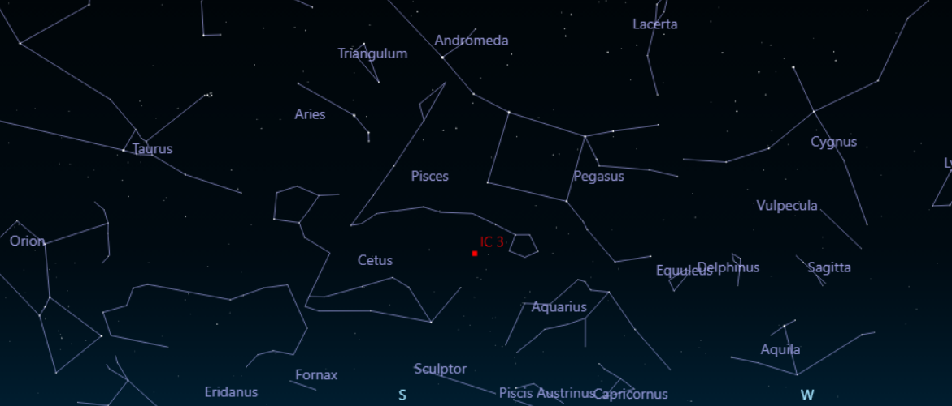
Figure 117 – Current VirtualSky planetarium.

However, by extending the VirtualSky library and allowing learners to move the camera vertically with zoom functionality (which has already been partially achieved in a separate branch), it may make close-proximity star-hopping paths easier to follow. This feature could then be tested in a follow-up experiment, allowing for its impact on learners to be measured.
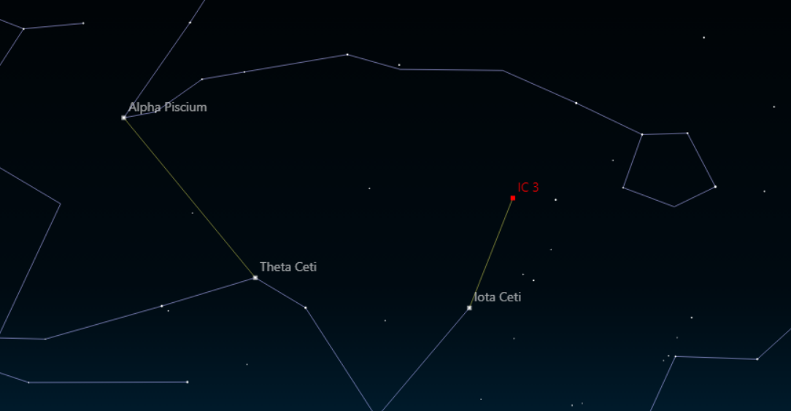
Figure 118 – Experimental VirtualSky planetarium.

By utilising a zoom approach, an object identifier could also be incorporated that acts similarly to present online planetariums. This would allow learners to visually identify objects, where they could click on an object to view more information about it (through an information popup, similar to the one currently utilised in the tool). If this were to be implemented, the tool could act as an alternative or replacement for online planetariums, which may further simplify the process of learning amateur astronomy by not requiring additional applications.
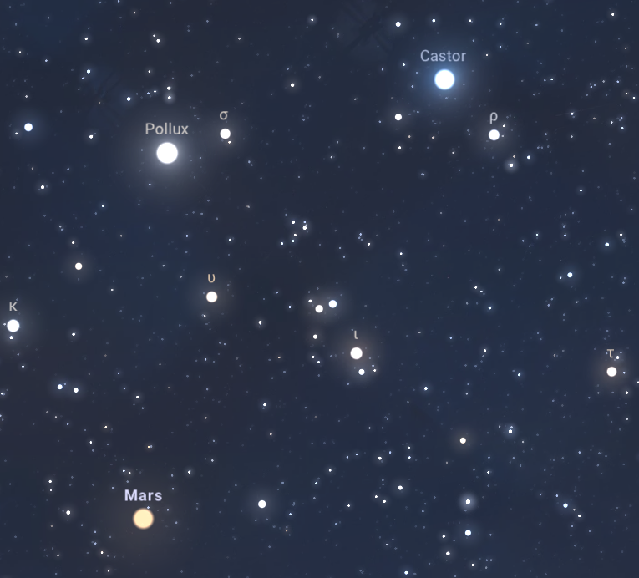
Figure 119 – Object identification via Stellarium.

Becoming an alternative or replacement for present astronomy tools could be further supported by including additional object catalogues. This would allow for a greater number of objects to be learnt about whilst also increasing the number of star-hopping routes, acting as another method of enhancing the tool. Furthermore, catalogues for stellar remnants such as pulsars and black holes could also be included, providing objects that may be more desirable to observe and study by professionals.

9. Reference list
ADOMAVICIUS, G. and A. TUZHILIN, 2005. Toward the next generation of recommender systems: a survey of the state-of-the-art and possible extensions. IEEE transactions on knowledge and data engineering, 17(6), 734-749
ANDREI, B. et al., 2019. A study on using waterfall and agile methods in software project management. Journal of Information Systems & Operations Management, , 125-135
AZEVEDO, F.S., 2019. A pedagogy for interest development: The case of amateur astronomy practice. Learning, Culture and Social Interaction, 23, 100261
AZULAY, R. et al., 2019. First M87 Event Horizon Telescope Results. I. The Shadow of the Supermassive Black Hole. Astrophys.J.Lett, 875(1), 1-17
BAIER, D. and E. STÜBER, 2010. Acceptance of recommendations to buy in online retailing. Journal of Retailing and Consumer Services, 17(3), 173-180
BARRINGER, D.F. et al., 2018. Gamified approach to teaching introductory astronomy online. Physical Review Physics Education Research, 14(1), 010140
BIGDATACLOUD, 2023. IP Address Geolocation and IP Intelligence API package [viewed 27 April 2023]. Available from: https://www.bigdatacloud.com/packages/ip-geolocation
BUXNER, S.R., M.T. FITZGERALD and R.M. FREED, 2021. Chapter 8 - Amateur Astronomy: Engaging the Public in Astronomy Through Exploration, Outreach, and Research. In: A. P. KAMINSKI, ed. Space Science and Public Engagement. Elsevier, pp.143-168
CARDINOT, A. and J.A. FAIRFIELD, 2022. Game-based learning to engage students with physics and astronomy using a board game. Research Anthology on Developments in Gamification and Game-Based Learning. IGI Global, pp.785-801
CARUANA, J. et al., 2020. A photometric mapping of the night sky brightness of the Maltese islands. Journal of environmental management, 261, 110196
CAVALCANTI, C.C., A. FILATRO and W.A. PRESADA, 2018. Gamification design for tutor education in an online course. ETD Educação Temática Digital, 20(4), 887-904
CHENG, H. et al., 2016. Wide & deep learning for recommender systems. Proceedings of the 1st workshop on deep learning for recommender systems. pp.7-10
CHESNEAU, B., 2021. Design - Gunicorn 20.1.0 [viewed 27 April 2023]. Available from: https://docs.gunicorn.org/en/stable/design.html
COVINGTON, P., J. ADAMS and E. SARGIN, 2016. Deep neural networks for youtube recommendations. Proceedings of the 10th ACM conference on recommender systems. pp.191-198
CURTIS, V., 2013. Evaluating the Motivations and Expectations of those Attending a Public Astronomy Event. Communicating Astronomy with the Public Journal, 13, 14
DE LORENZIS, A. and V. OROFINO, 2018. Comparison of astronomical software programs for archaeoastronomical applications. Astronomy and Computing, 25, 118-132
DIGITALOCEAN, 2023. DigitalOcean App Platform [viewed 27 April 2023]. Available from: https://www.digitalocean.com/products/app-platform
DREYER, J.L.E., 1988. NGC 2000.0 : the complete new general catalogue and index catalogues of nebulae and star clusters. New York: Cambridge University Press
FAID, M.S. et al., 2016. Monitoring the Level of Light Pollution and Its Impact on Astronomical Bodies Naked-Eye Visibility Range in Selected Areas in Malaysia Using Sky Quality Meter. Journal of Industrial Engineering and Management Science, 2016(1), 1-18
FERNIQUE, P., ALLEN, M., BOCH, T., DONALDSON, T., DURAND, D., EBISAWA, K., LAURENT, M., SALGADO, J. and STOEHR, F., 2017. IVOA Recommendation: HiPS - Hierarchical Progressive Survey. Ithaca: Cornell University Library, arXiv.org. Available from: https://search.proquest.com/docview/2075750904
FLECK, S. and G. SIMON, 2013. An augmented reality environment for astronomy learning in elementary grades: An exploratory study. Proceedings of the 25th Conference on l'Interaction Homme-Machine. pp.14-22
FOEAD, D. et al., 2021. A Systematic Literature Review of A* Pathfinding. Procedia Computer Science, 179, 507-514
FORMANEK, M. et al., 2018. Motivational differences between MOOC and undergraduate astronomy students. American Astronomical Society Meeting Abstracts# 231. pp.139.02
FU, Y. and P.J. CLARKE, 2016. Gamification-based cyber-enabled learning environment of software testing. 2016 ASEE Annual Conference & Exposition.
GADA, A., A.H. STERN and T.R. WILLIAMS, 2000. What Motivates Amateur Astronomers? Amateur Professional Partnerships in Astronomy Astronomical Society of the Pacific Conference Series, 220, 14-21
GARDNER, J.P. et al., 2006. The James Webb Space Telescope. Space Science Reviews, 123(4), 485-606
GEDE, M. and H. HARGITAI, 2017. An online planetary exploration tool: “Country Movers”. Acta Astronautica, 137, 334-344
GELENBE, E. and F. WU, 2012. Large scale simulation for human evacuation and rescue. Computers & Mathematics with Applications, 64(12), 3869-3880
GOEHLE, G., 2013. Gamification and web-based homework. Primus, 23(3), 234-246
GUO, H. et al., 2017. DeepFM: a factorization-machine based neural network for CTR prediction. arXiv preprint arXiv:1703.04247,
HAGBERG, A., P. SWART and D. S CHULT, 2008. Exploring network structure, dynamics, and function using NetworkX. SCIPY 08. Pasadena: Los Alamos National Lab, pp.1-5
HUNG, L. et al., 2021. Changes in night sky brightness after a countywide LED retrofit. Journal of environmental management, 292, 112776
IMPEY, C.D., M.C. WENGER and C.L. AUSTIN, 2015. Astronomy for astronomical numbers: A worldwide massive open online class. International Review of Research in Open and Distributed Learning, 16(1), 57-79
IMPEY, C. and M. FORMANEK, 2021. MOOCS and 100 Days of COVID: Enrollment surges in massive open online astronomy classes during the coronavirus pandemic. Social Sciences & Humanities Open, 4(1), 100177
ISO, 2019. IEC 31010:2019: Risk management. Risk assessment techniques. Available from: https://www.iso.org/standard/72140.html
JONES, M.G. et al., 2017. Factors contributing to lifelong science learning: Amateur astronomers and birders. Journal of research in science teaching, 54(3), 412-433
JOY, J. and R.V.G. PILLAI, 2022. Review and classification of content recommenders in E-learning environment. Journal of King Saud University - Computer and Information Sciences, 34(9), 7670-7685
LEGAKI, N. et al., 2020. The effect of challenge-based gamification on learning: An experiment in the context of statistics education. International Journal of Human-Computer Studies, 144, 102496
LIN, X. et al., 2021. Trajectory planning for unmanned aerial vehicles in complicated urban environments: A control network approach. Transportation Research Part C: Emerging Technologies, 128, 103120
LOPRESTO, M.C. and T.F. SLATER, 2016. A new comparison of active learning strategies to traditional lectures for teaching college astronomy. Journal of Astronomy & Earth Sciences Education (JAESE), 3(1), 59-76
MALLAMA, A. and J.L. HILTON, 2018. Computing apparent planetary magnitudes for The Astronomical Almanac. Astronomy and Computing, 25, 10-24
MARAVELIAS, G., VOURLIOTIS, E., MAROUDA, K., BELIAS, I., KARDASIS, E., PAPADEAS, P., STRIKIS, I., VAKALOPOULOS, E. and VOUTYRAS, O., 2018. A paradigm to develop new contributors to Astronomy. Ithaca: Cornell University Library, arXiv.org. Available from: https://search.proquest.com/docview/2118103339
MARCHIS, F. et al., 2020. Unistellar eVscopes: Smart, portable, and easy-to-use telescopes for exploration, interactive learning, and citizen astronomy. Acta Astronautica, 166, 23-28
MOONEY, R.J. and L. ROY, 2000. Content-based book recommending using learning for text categorization. Proceedings of the fifth ACM conference on Digital libraries. pp.195-204
NASH, D., 2023. HYG-Database [viewed 23 April 2023]. Available from: https://github.com/astronexus/HYG-Database
PALLETS, 2022. Testing Flask Applications [viewed 27 April 2023]. Available from: https://flask.palletsprojects.com/en/2.2.x/testing/
PRATHER, E.E., A.L. RUDOLPH and G. BRISSENDEN, 2009. Teaching and learning astronomy in the 21st century. Physics Today, 62(10), 41-47
PYTHONANYWHERE, 2023. Batteries included: PythonAnywhere [viewed 29 April 2023].
ROBITAILLE, T.P. et al., 2013. Astropy: A community Python package for astronomy. Astronomy & Astrophysics, 558, A33
SALINA BORELLO, E. et al., 2022. Application of A∗ algorithm for microstructure and transport properties characterization from 3D rock images. Energy, 239, 122151
SHEN, J. and J. CONFREY, 2007. From conceptual change to transformative modeling: A case study of an elementary teacher in learning astronomy. Science Education, 91(6), 948-966
TAILWINDCSS, 2023. Tailwind - Rapidly build modern websites without ever leaving your HTML [viewed 27 April 2023]. Available from: https://tailwindcss.com/
TASKER, W., 2023. Amateur Astronomy Research Experiment [viewed 29 April 2023]. Available from: https://stargazerslounge.com/topic/407972-amateur-astronomy-research-experiment/
TAVAKOLI, M. et al., 2022. An AI-based open recommender system for personalized labor market driven education. Advanced Engineering Informatics, 52, 101508
VERGA, M., 2017. OpenNGC. GAVO Data Center Team. Available from: https://dc.zah.uni-heidelberg.de/voidoi/q/lp/custom/10.21938/y.1ejWUD_MQ6b_eDFoVbbw/
WALKER, M.F., 1977. THE EFFECTS OF URBAN LIGHTING ON THE BRIGHTNESS OF THE NIGHT SKY. Publications of the Astronomical Society of the Pacific, 89(529), 405-409
ZHANG, J. et al., 2016. Efficient vehicles path planning algorithm based on taxi GPS big data. Optik, 127(5), 2579-2585
ZÖLLER, N., J.H. MORGAN and T. SCHRÖDER, 2020. A topology of groups: What GitHub can tell us about online collaboration. Technological Forecasting and Social Change, 161, 120291
ZOTTI, G. and A. WOLF, 2022. Stellarium 1.2 User Guide. Available from: https://www.researchgate.net/publication/366588797_Stellarium_12_User_Guide

