Solent University
Faculty of Business, Law and Digital Technologies

BSc (Hons) Computing
2023

“Automated Restaurant Booking System”

Supervisor :
Date of submission : May 2023

Acknowledgements

Abstract

Numerous restaurants are using automated systems to manage their reservations as online booking platforms become more prevalent. This study examines explores customers' perspectives on using such a system and how those perspectives can inform the development and implementation of an effective automated restaurant booking system. We conducted preliminary surveys, built requested features, and assessed the system through interviews with possible users using the 5-steps design thinking method. The adoption of a loyalty program, floor plan selection, waitlist management, reservation reminders, group booking management, and the availability to view the restaurant menu are just a few of the recommendations we provide for future enhancements based on the findings. According to the findings, a system like this might be a useful tool for restaurants, enabling them to enhance customer satisfaction, handle bookings more effectively, and potentially increase income.

Table of Contents
Acknowledgements ii
Abstract iii
1. Introduction 4
1.1 Background and Context of the project 4
1.2 Problem Statement 4
1.3 Research question 5
2. Literature Review 7
3. Methodology 13
3.1 Qualitative method 14
3.2 Quantitative method 15
3.3 Professional, Legal and Ethical issues 17
3.3 Project Management 17
4. Design & implementation 18
4.1 Prototype 18
4.1.1 Prototype Features 20
4.2 Implementation 25
4.2.1 Chosen technology 25
4.3 Problems encountered. 33
5. Results 35
5.1 Initial Survey 35
5.2 Interviews 41
6. Conclusions 44
7. Recommendations 46
8. Reference list 48
9. Bibliography 52
10. Appendices A
Appendix A: Gantt Chart A
Appendix B: Usability interviews questions B
Appendix C: Links to full interviews transcript C

List of Figures
Figure 1: 5 Steps of the design thinking process
CareerFoundry. (2023). The Design Thinking Process: 5 Steps Complete Guide. [online] Available at: https://careerfoundry.com/en/blog/ux-design/design-thinking-process/ [Accessed 25 Apr. 2023].
Figure 2: Best Practices to conduct quantitative research
Questionpro.com. (2023). Available at: https://www.questionpro.com/blog/wp-content/uploads/2023/02/best-practices-to-conduct-quantitative-research.jpg.webp [Accessed 13 Feb. 2023].
Figure 3: Waterfall approach
Aroral, H. (2021). Waterfall Process Operations in the Fast-paced World: Project Management Exploratory Analysis. International Journal of Applied Business and Management Studies, [online] 6(1). Available at: http://www.ijabms.com/wp-content/uploads/2021/05/05_ARORAL_PB.pdf.
Figure 4: Firestore database tables
Figure 5: Firestore configuration file
Figure 6: Code for table manipulation
Figure 7: Code implementing Google Maps as a component
Figure 8: Chatbot integration as a component
Figure 9: Code logic for real-time availability of tables
Figure 10: User Flow Diagram
Figure 11: Information Architecture
Figure 12: Network tab from the inspection panel of the browser
Figure 13: Console logging of the status of the table
Figure 14: Question 1 Initial Survey
Figure 15: Question 2 Initial survey
Figure 16: Question 3 Initial survey
Figure 17: Question 4 Initial survey
Figure 18: Question 5 Initial survey
Figure 19: Question 6 Initial survey
Figure 20: Question 7 Initial survey
Figure 21: Question 8 Initial survey
Figure 22: Question 10 Initial survey
Figure 23: UX User Personas
Figure 24: UX Empathy maps
Figure 25: User needs

1. Introduction

1.1 Background and Context of the project

The restaurant industry has been rapidly evolving in recent years, with technology playing an increasingly important role in the way that customers interact with restaurants. A more digital approach is needed in the restaurant sector in order to meet the needs of all customers. Although some of the big restaurants offer online booking, they deliver less automation and convenience than what the customer would want to see. According to (Zhang et al., 2018), compared to smaller businesses, who typically use third-party platform websites as their booking agents, the majority of the top restaurants, hotels and etc., use their own online booking websites. However, most of them do not offer the best experience for the customer because he needs to wait for approval from the manager once he books a table through the online booking system. On the other hand, it is impossible for the customer to check the availability in a restaurant in real-time or he needs to call the hostess and check if there is an available table for the desired time, but, in most cases during the busiest hours, it is impossible to book a table. Accordingly, all of the issues can lead to loss of customers, as well as, loss of restaurant revenue. One such technology is the automated restaurant booking system, which allows customers to make reservations quickly and easily through an online platform. This can help to streamline the reservation process for both customers and restaurant staff, reducing the likelihood of double bookings and miscommunication.

1.2 Problem Statement

In order to solve this problem, a project was launched for developing an automated restaurant reservation system with a map that will enhance diners' dining experiences and simplify restaurant reservation procedures. Despite the significant growth in the restaurant industry and the increasing demand for restaurant services, there is a lack of efficient and user-friendly automated restaurant booking systems. The objective of the project is to deliver a high-quality system that will satisfy customer expectations and enhance restaurant management by lowering human mistake rates, shortening customer wait times, and giving them real-time availability information. Customers will have the ability to simply access all restaurants using the application and using the search panel, they can quickly find a certain restaurant on a map and reserve a table there. Customers will also be able to get assistance from an integrated chatbot if they face any problems. The best choice is to make a direct reservation because there is little margin for error (Dutta, 2021). Therefore, there is a need for an automated restaurant booking system that can provide customers with a seamless and hassle-free experience while also improving the restaurant's management and operations. With the provided application the customers will be able to look for restaurants in particular locations and choose a certain number of seats at any time.

1.3 Research question

The project research question is, “What are customers’ perspectives on using an automated restaurant booking system, and how can those perspectives inform the development and implementation of such a system?” This study aims to understand the possible advantages and disadvantages of an automated reservation system and to assess how it will affect both customers and restaurants.
The project's goal is to provide an efficient high-quality automated system for making restaurant reservations that will address both consumers' and establishments' demands in real time. We are confident that this system will have a positive impact on the restaurant industry and will provide a more convenient and enjoyable dining experience for customers.

2. Literature Review

People's business practices have changed significantly as a result of the development of technology and the Internet. One of the sectors that have greatly benefited from this development is the restaurant industry. In recent years, automated restaurant reservation systems have grown more and more widely utilised in the restaurant business. In today's technologically advanced world, automated restaurant reservation systems allow customers to reserve tables online, making the reservation process easier and more convenient. The purpose of this literature review is to explore the benefits and limitations of automated restaurant booking systems and examine the existing research in this area.
One of its main benefits is how simple automated restaurant reservation systems are. Customers can make a reservation whenever they want, from any location, without having to call or visit the restaurant. The development of an intelligent restaurant application for dine-in services was the aim of the study carried out by Bagaskara et al. (2021). The writers pointed out the need for technology to raise restaurant operations' efficiency, particularly in light of the COVID-19 outbreak. Customers who use the smart restaurant application created by the writers may order, pay, and reserve tables among other things using their phones. Customers may use the system to leave evaluations and feedback that the restaurant can use to improve its services. According to the authors, using the smart restaurant application resulted in speedier service, fewer waits, and improved levels of customer satisfaction. The study also identified a number of barriers to the adoption of the smart restaurant application, including the need for a stable internet connection, a shortage of appropriate equipment, and the need for staff training. Despite these challenges, the authors came to the conclusion that using technology in the restaurant industry might increase efficiency and improve client happiness. Similarly to this, a method enabling restaurants to book tables and menu items online was suggested in the study by Kale et al. (2021). The technology was designed to give consumers a quick and easy method to see menus and book tables online, enhancing the customer experience and cutting down on wait times. Restaurant managers were interviewed as part of the study's qualitative research methodology to assess the viability and efficacy of the suggested strategy. The study evaluated the system's potential effects on order processing, table turnover, and staff productivity in restaurants. The study concluded that the online approach for reserving tables and ordering food was practical and efficient for increasing the dining experience and streamlining restaurant operations. Customers could use the system to reserve tables and check menus online, which decreased wait times and increased table turnover. The method might decrease order processing mistakes and boost employee productivity, according to the research.
On the other side, automated restaurant reservation systems are advantageous to restaurant owners as well. Automated booking systems that use electronic customer relationship management (e-CRM) can assist restaurants in gathering information on client preferences and eating routines. This information may be utilised to create personalised marketing strategies and enhance the consumer experience (Marsyahariani et al., n.d.). Automated solutions can also make it easier for restaurants to handle their reservations. The paper by Miao, Li, and Wang (2018) suggests a restaurant management system with a technique for combining tables to maximise table utilisation and decrease customer wait times. The study's restaurant reservation management system was created using a mathematical modeling strategy. Based on client bookings and table availability, the system distributed tables using an algorithm. To test the efficiency of the system and measure its effects on restaurant operations and customer pleasure, the research also carried out a simulation experiment. The technology prioritises table assignment optimisation to increase restaurant capacity utilisation. According to the study, the restaurant reservation management system that takes into account table combinations works well to maximise table utilisation and improve restaurant operations efficiency. The simulation experiment has shown that the technology may be able to shorten wait times and raise client satisfaction. The technique may help restaurants make more money by decreasing the number of idle tables, according to the research. Restaurants can manage their seating arrangements and maximise capacity utilisation by using an automated reservation system that takes table combinations into account, claim Miao, Li, and Wang (2018). The technology makes it possible to make more precise reservations and lowers the chance of overbooking, which can result in a long wait and poor consumer satisfaction. Despite this, by enabling restaurants to accept more customers at busy times, automated reservation systems that take table combinations into account also have the potential to boost revenues for the establishments. Miao, Li, and Wang (2018) point out that the method they suggested was created especially for the restaurant where it was put into use and that a comparable system would not work for other establishments with various set-ups and client preferences. Therefore, before deploying an automated reservation system, restaurant owners and managers must thoroughly assess their demands and the available solutions.
On the other side, as smartphone usage rises, mobile-based restaurant reservation systems are becoming increasingly common. According to Tharun et al. (2021), a mobile-based online restaurant reservation system aims to give clients a quick and easy method to reserve a seat at a restaurant, browse menus, and place orders using their mobile devices. Users may use the system to find restaurants in their area, check for available tables, and make bookings. The authors highlight the value of convenience in the dining experience and claim that a mobile-based reservation system can help to reduce the time and effort required for making a reservation, leading to higher customer satisfaction as well as reducing errors and improving the accuracy of bookings. Tharun et al. (2021) performed a usability test to assess the system's performance and user-friendliness as part of the evaluation process. The Tharun et al. (2021) method offers restaurants a chance to access a bigger client base, boost efficiency, and improve customer experience, similar to Miao et al. (2018) and Botti et al. (2017) presented another comparable system. He performed an investigation to examine how smart service technologies are used in restaurant management and their effects on customer satisfaction and service quality. A smartphone application, a digital menu, and a method for gathering consumer feedback were the authors' three key picks for smart service systems. Botti et al. (2017) came to the same conclusion as Tharun et al. (2021) that clients can explore the menu, place orders, and make bookings via the application on their mobile devices. By minimising wait times, boosting convenience, and enhancing interaction between customers and employees, this feature can improve the customer experience. Botti et al. (2017) claim that this may result in a rise in consumer satisfaction and loyalty. Overall, the study by Botti et al. (2017) shows how smart service systems have the potential to raise customer satisfaction and service quality in the restaurant sector. According to the authors, incorporating technology into restaurant management may boost productivity, earnings, and client happiness. However, the writers highlight the need for technology to be user-friendly, and accessible, and to avoid undermining the human element of the customer experience.
Automated restaurant reservation systems provide advantages, but there are also drawbacks to take into account. For instance, the usage of automated systems may decrease one-on-one communication between clients and restaurant staff members, which may have a negative impact on customer satisfaction. In addition, certain clients might like making a reservation in person or over the phone. The study by Marsyahariani et al. (n.d.) emphasises the significance of taking consumer preferences into account while putting in place an automated booking system. Alt (2021) also looked at recent changes and the effects of the digital revolution on the restaurant business. The author covered a number of technical developments in the sector, such as computerised restaurant reservation systems. The author emphasised the advantages of these solutions, including improved productivity, table utilisation, and client happiness. The author also noted the need for more study to address the systems' possible drawbacks and shortcomings, such as accuracy and scalability.
In conclusion, implementing an automated restaurant reservation system might provide a number of advantages. Improved efficiency is one of the key advantages of automated restaurant reservation systems. Restaurants can cut time and costs by automating the reservation process rather than manually managing bookings. guests' wait times may also be shortened as a result of the system's improved ability to estimate how long it will take to seat guests and efficiently manage table turnover. Customer satisfaction is raised, which is another advantage of automated booking systems. Customers no longer have to deal with the discomfort of being put on hold or navigating a convoluted phone system when they can quickly make bookings online or using a mobile application. Additionally, these systems may offer users additional details about the eatery, such as menus and reviews, which can assist them in making more well-informed dining choices. However, it's crucial to strike a balance between the advantages of automation and the necessity of human interactions during the eating experience. The amount of human connection in the restaurant may decline as a result of automated technologies, despite the fact that they can be effective and handy. For instance, if an automated booking system takes the position of the host or hostess, clients could be less likely to interact with them. Data security and privacy may be another issue with automated restaurant reservation systems. Customers may be asked to enter personal data such as their name, email address, and phone number when making bookings online or using a mobile application. It is crucial that restaurants have adequate security measures in place to preserve sensitive data and make sure it is not disclosed to unauthorised parties. Additionally, customers must be notified about the purposes for which their data will be used and have the choice not to receive any marketing or promotional materials. Finally, even though automated restaurant booking systems may assist both businesses and consumers in a variety of ways, it is crucial to take into account any potential drawbacks and make sure that the integration is done carefully. In addition to taking measures to safeguard the security and privacy of their guests' data, restaurants should work to strike a balance between the advantages of automation and the requirement for human contact throughout the eating experience. The adoption of such technologies is anticipated to increase further in the future as the restaurant sector continues its trend toward digitalisation and automation.

3. Methodology

The main objectives of automating a restaurant reservation system are to increase productivity, decrease mistakes, and improve the client experience. These goals may be met by streamlining the reservation process, reducing client wait times, offering real-time information on table availability, and making sure reservations are managed accurately. The system's automation can also help restaurant hostesses manage reservations more efficiently, reduce the possibility of errors or multiple bookings in manual reservation systems, and provide useful information and insights for company analysis and planning.

The five-stage design thinking model, a user-centered approach to problem-solving that focuses on comprehending the needs of the user and developing solutions that fit those needs, is the main methodology we will utilise in this project. Qualitative and quantitative methods are included in the core methodology. The design thinking model's five stages are (See Figure 1):
- Empathise
- Define
- Ideate
- Prototype
- Test
The design thinking process is a non-linear process with an iterative approach in order to achieve the best solution for a given problem. It is based on evidence, to find a solution to a problem by putting the requirements of the customer above everything else. Due to the project's magnitude and the limited time frame, only one iteration will be conducted.

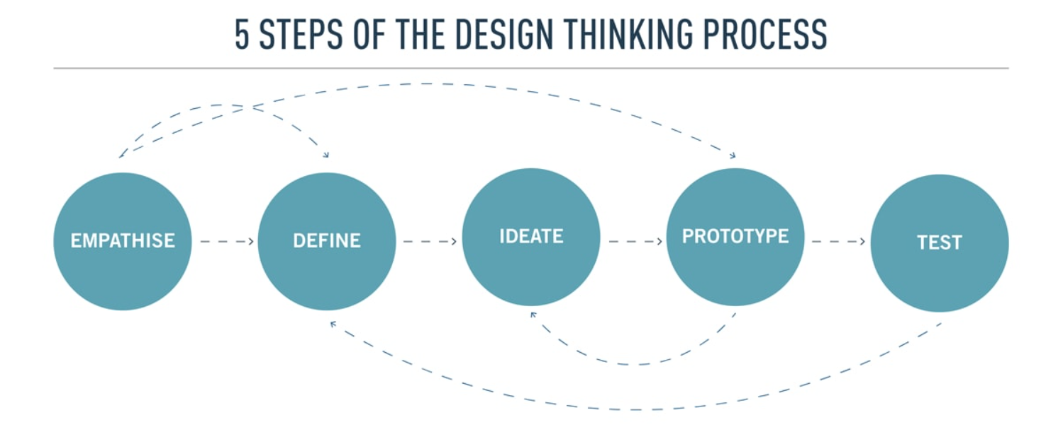
Figure 1 5 Steps of the design thinking process

The main goals of the project will be addressed and assessed by combining qualitative and quantitative approaches. The success of the project will be evaluated using usability interviews, questionnaires, and questions. This mix of techniques will make it possible to gather both quantitative data and user feedback to assess how well the project is addressing the stated issue. In order to help with the process of evaluation, specific reactions and opinions from users will also be gathered.

3.1 Qualitative method

This method section describes the process for utilising the talk-out-loud method to assess the usability and user experience of an automated restaurant reservation system. The usability interviews are part of the last phase of Design thinking process. In order to get insight into their decision-making process and spot any usability difficulties, users can verbalise their ideas and actions as they engage with the system using the talk-out-loud technique. Targeted social media advertising was used to find participants for this study. Participants had to be at least 18 years old and have previous online reservation experience in order to meet the inclusion requirements. In total 4 interviews are conducted. While conducting a survey, the talk-out-loud technique was used when the participant completed a series of activities utilising the automated restaurant booking system. They were instructed to use the system to reserve a table for a particular time and day while organising a meal for two at a particular restaurant. A table had to be chosen, a day and time had to be selected, personal information had to be entered, and the reservation procedure had to be finished. To document the participants' verbalisations and interactions with the system, every session was videotaped. A video recording of each session was taken in order to document the participants' verbalisations and interactions with the system. Identifying patterns or themes in the participants' feedback was done by transcribing in the results section and analysing the video recordings. Using this approach the usability of the system will be tested and evaluated.

3.2 Quantitative method

During the Empathise stage of the Design thinking process, the use of quantitative methodologies attempts to collect numerical data using surveys and questionnaires. The best practices for doing quantitative research will be followed in order to create efficient and dependable surveys and questionnaires (See Figure 2). In order to properly characterise the issue that the automated restaurant booking system seeks to address, an initial survey will be undertaken. Customers' opinions regarding the difficulties and restrictions they now experience with the restaurant reservation systems will be gathered through this poll. The automated system will be developed using the information provided to guarantee that the concerns noted are addressed. After the automated restaurant booking system has been created and put into use, UX testing interviews, mentioned above, will be used to conduct a final evaluation. The survey will be completely anonymous in order to promote candid and accurate input, and the numerical data gathered will be examined to offer a thorough assessment of the system.
The first step of design thinking, empathise, is where this quantitative study fits in. In order to collect information from possible users of an automated restaurant reservation system, this project will conduct a survey. User personas and user journey maps will be made using the survey data that was gathered, as well as identifying the user needs. The participants of the study were recruited through social media platforms. All of the participants had to be at least 18 years old, have online reservation experience, and be interested in using an automated restaurant booking system. The aim of the survey is to have 20 responses. An online survey was distributed to participants, asking them to respond to questions on their past experiences with automated booking systems, their current restaurant reservation practices, and their preferred features for a future automated booking system. In order to fulfil the needs and preferences of potential users, the user personas and user journey maps that were developed based on the survey results will be utilised to guide the design of the new automated restaurant booking system.
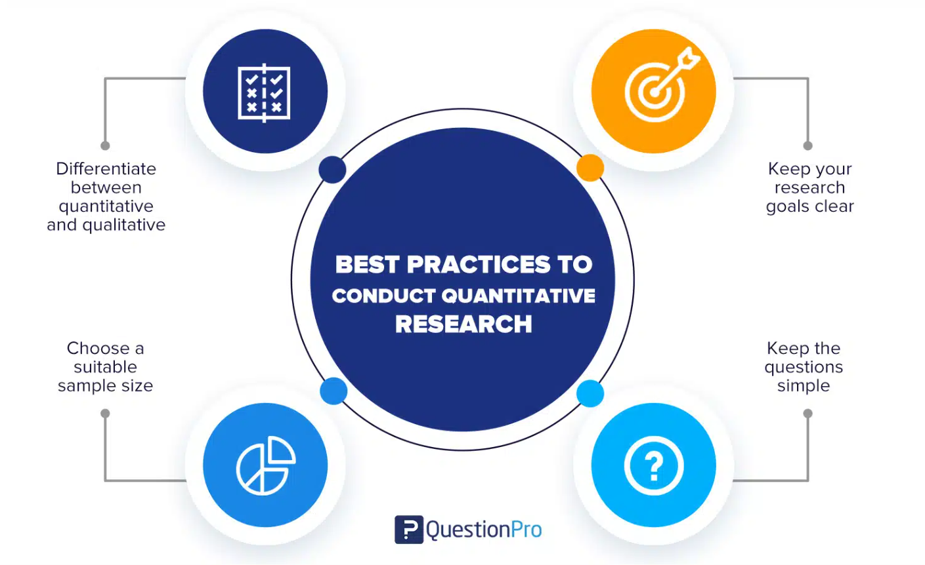
Figure 2 Best Practices to conduct quantitative research

3.3 Professional, Legal and Ethical issues

All data gathering and research will be done responsibly and ethically, in accordance with the university's regulations. The General Data Protection Regulation (GDPR) has been complied with by taking the required measures to protect survey participants' privacy. A project ethics application form will also be delivered to Solent University. Sensitive personal information will not be obtained because of the careful design of the survey questions. Participants will be made aware of the usage and purpose of their personal data. Only the project will utilise the survey data, which will be safely preserved. Each participant has the right to access their data and ask for its deletion while maintaining their anonymity. The Solent University Consent form must be filled out by each survey and interview participant. To make sure that all ethical issues are taken into account, the research and development process will be periodically evaluated and supervised.

3.3 Project Management

The Waterfall technique will be used to manage the project (See Figure 3). A classic project management style known as "Waterfall" places a strong emphasis on the linear and sequential flow of project operations. The steps of requirements gathering, design, implementation, testing, and maintenance are often included. Each step of a project is finished before the next one starts using the linear and sequential project management method known as the waterfall (Aroral, 2021). Accordingly, the project will proceed to the design phase when the requirements collecting phase is finished, and so on, until the project is finished. However, the last stage's "maintenance" won't be done due to the project's scope and short timeline.
The Waterfall technique has the benefit of offering a clear framework and a step-by-step procedure for finishing the project. When working on complicated projects that demand a lot of planning and coordination, this may be quite helpful. The Waterfall methodology's limitation is that it could not be as adaptable as alternative project management techniques like Agile, which allow for slower and iterative development.
A Gantt chart (See Appendix A) will be used to measure progress and make sure the project continues on track. A Gantt chart is a diagram that displays a project's timeframe as well as the activities that must be undertaken. On the chart, every task is shown as a bar with a length that corresponds to how long it took to complete. The chart also includes deadlines and milestones, which will help the development of the project stay on track. The supplied template is used in "Microsoft Excel" to build the Gantt chart.
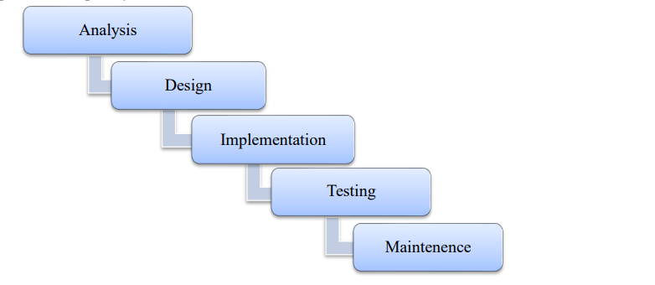
Figure 3 Waterfall approach

4. Design & implementation
GitHub Link: https://github.com/Radoslav22/COM616
Clickable prototype Link: https://www.figma.com/proto/sxrOowLPPOrzY43Jl9iErN/COM616?page-id=0%3A1&node-id=4-195&viewport=437%2C166%2C0.24&scaling=min-zoom&starting-point-node-id=4%3A196
Application Link: https://com616-40d65.firebaseapp.com/

4.1 Prototype

In this section which is part of the ideate phase of the design thinking process the prototype was created. All of the low and high-fidelity prototypes are constructed using the UX tool “Figma”. The use of Figma was decided because of the free plan and the huge amount of tools and plugins it provides. In order to meet all of the users' needs gained from the initial survey, firstly the user interface needs to be created. Using low-fidelity sketches easily can be seen the places of buttons, text fields, and navigation bar, it is a simple rough draft that is quickly created without much detail, in order to spot the places of each component in the prototype. As part of the ideate phase of the design thinking process, using the low-fidelity sketches and the user needs gained from the initial survey, it is easier to generate a wide range of ideas and explore multiple solutions. The next step is the high-fidelity prototype, the high-fidelity prototype refers to the level of features and functionality incorporated inside, it represents the final product in terms of functionality and features. According to (Pernice , 2016), high-fidelity prototypes are considered as a “live” software. In this way, test subjects are more likely to perform naturally as if they were interacting with a genuine system. In order to meet the user's needs for easy for use and user-friendly automated restaurant booking system with real-time availability, confirmation of the booking, google Maps with restaurants near them, and customer support for any query, the high-fidelity prototype is created using the minimalistic approach. According to Hazel (2021), in terms of digital products, websites, and apps that prioritise user experience and usability are particularly well-suited for minimalism. The minimalist design may make it easier for users to obtain the necessary information and accomplish jobs more quickly by removing clutter and pointless elements. The main features which are implemented in order to meet the user's needs are a chatbot, a map of the location of the restaurants, real-time check of the available table in certain restaurants, and the booking details. The high-fidelity prototypes are created using the “Material Design Icons” plugin, and pictures from Unsplash, because of the free license for use. Overall, the prototype acts as a working model that directs the construction of the automated restaurant reservation system, guaranteeing that the end result satisfies the user's requirements. The prototype was modified and improved during the ideation stage of the design thinking process to provide a user-friendly and simple-to-use system that suited the requirements of the intended audience. The clickable prototype's web address is provided above.

4.1.1 Prototype Features

4.1.1.1 User sign up/ sign in

Users will be able to conveniently fill out the booking data and locate their bookings by using the functionality, which will enable them to authenticate themselves. A user must first create an account before they may make a book for their table. They will have the option to log in or register using “Facebook” or “Google”.
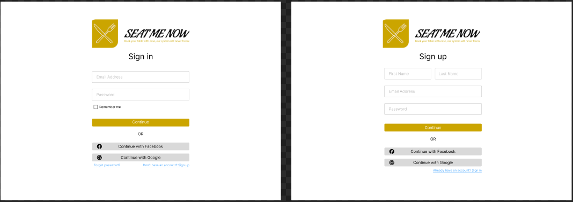

4.1.1.2 Google map
Google map is a popular application and widely used, which is why this feature is chosen. It will help the users to find the restaurant near them or to look where the restaurant's location exactly is. 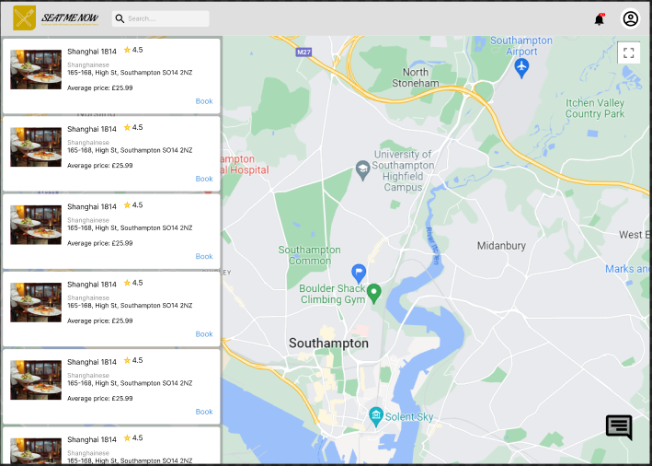

4.1.1.3 Search bar
The search bar feature in the prototype is a powerful and helpful tool that enables users to search through all of the restaurants in the database with ease. The purpose of this feature is to make the user interface simple and easy to use, allowing the users to quickly find the restaurant they are looking for or to discover new restaurants around them.

4.1.1.4 Notifications
A crucial aspect of the automated restaurant reservation system that keeps the user informed is notifications. The alerts are designed to make sure that application users are aware of whether or not the booking was successful.
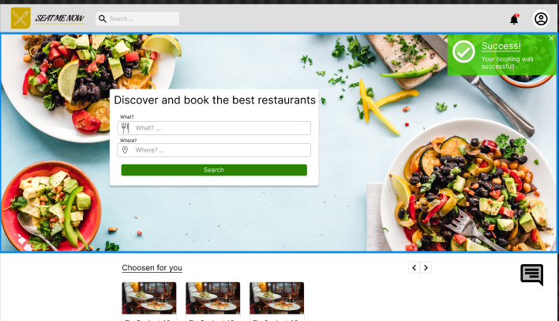

4.1.1.5 Chatbot

Chatbot feature is implemented in order to enhance the user experience by assisting the users with support during the whole booking process. If needed, the chatbots can provide support during the booking process and answer any questions the user has.
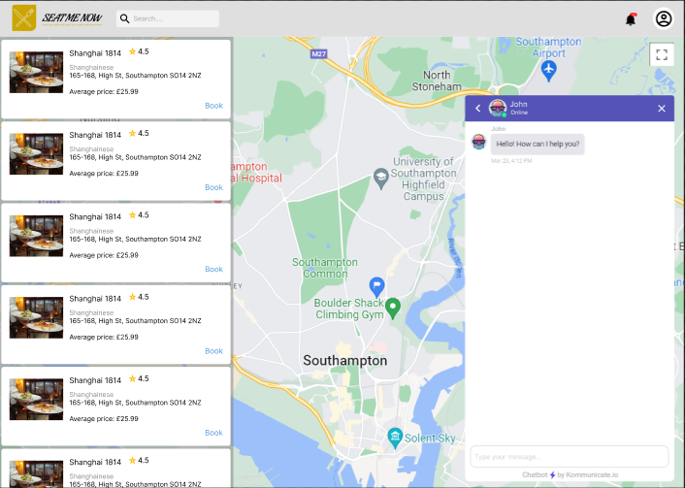

4.1.1.6 Real-time check of the available table

Real-time availability is a crucial feature of the automated restaurant booking system that provides users with immediate and up to date information on table availability. In this manner, it will be easier for the users to check for available tables instead of calling the restaurant or the need to wait for the hostess to approve their booking.
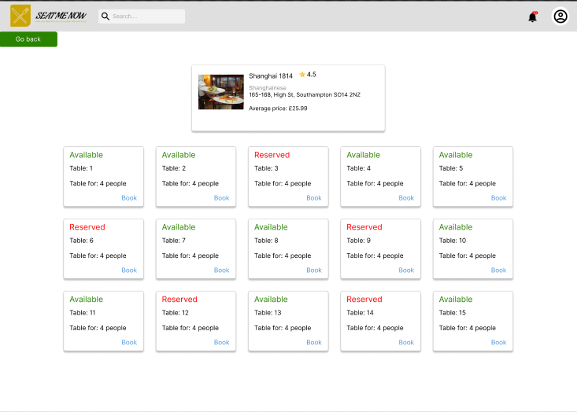

4.1.1.7 Booking details

A booking information function has been developed to ensure that users won't forget about their reservations. By simply clicking on the profile image and choosing the option for booking details, users can quickly search for their reservations.
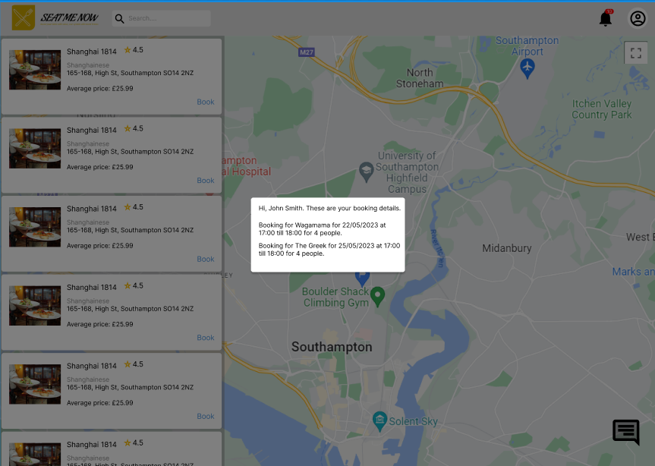

4.2 Implementation

The implementation section gives an outline of how the automated restaurant booking system was put into action, it is an essential part of the prototype phase of the design thinking process. According to (Simplilearn, 2021), the early release of the system in order to test its feasibility and effectiveness is called a prototype. Also, the technology that was selected, the features that were developed, and the issues that occurred during the implementation process, all of that will be covered in this part of the report.

4.2.1 Chosen technology

The automated restaurant booking system was successfully implemented in large part because of the technology that was selected. This section will explain why the particular technology was chosen and how it was applied to produce the intended results. We will also go through how the selected technology helped create a user-friendly and effective system.

4.2.1.1 (NPM) Node Package Manager

For the creation of an automated restaurant reservation system based on React, Node Package Manager (NPM) is the perfect technology. A widely used free and open-source JavaScript library for creating user interfaces is called React. It offers a declarative vocabulary for building reusable components, making it simpler to create intricate user interfaces. The automated restaurant booking system developed on React is selected to utilise NPM as its package management since it gives developers access to a large library of pre-made packages and modules that are simple to include into the project. These packages reduce the requirement for writing custom code and let developers create apps more quickly by offering pre-built functionality. The time and effort that have been saved may be used to create new features and enhance the application's overall usefulness. It is simple to manage dependencies, test the application, and deploy it to a production environment with NPM's command-line interface (CLI). This enables developers to automate several activities, lowering the possibility of human mistakes and assuring the consistency and dependability of the system. Managing and bundling dependencies is another benefit of using NPM with React. NPM is used to manage the packages that the application needs and its dependencies, resulting in a smooth and effective operation of the application. With this package manager, all of the technology choices for the project were installed by using the command “npm install”.

4.2.1.2 Firebase

Building a sophisticated application like an automated restaurant booking system is perfect given Firebase's robust and adaptable capabilities. Firebase is a great option for this project in particular because of its Firestore database, authentication features, and hosting possibilities, which are used for the development process of the application. Firestore is a scalable, adaptable NoSQL database that offers quick and dependable data storage for online and mobile applications. It makes it possible for programmers to quickly save and retrieve data in real-time, making it perfect for applications that need frequent and rapid updates, like an automated restaurant reservation system. According to (Idowu Omisola, 2021), the Firebase idea is basic. For instance, Firebase may quickly transform client-side software created using JavaScript or any of its frameworks into a serverless app. Additionally, since it manages databases for you, there is no longer a need for you to do so. The ability to authenticate users is another important feature of Firebase. Secure authentication is necessary for the automated restaurant booking system to make sure that only authorised users may access the system. In addition to email and password authentication, Firebase provides third-party authentication services like Google and Facebook. This provides robust security safeguards to protect against unauthorised access while also making it simple for users to create an account and log in to the system. The automated restaurant booking system can be quickly deployed and scaled because of Firebase's hosting capabilities. The quick and dependable hosting service Firebase Hosting enables to launch of the automated restaurant booking application with just a few commands.

4.2.1.3 Google map react package.

Because of its simplicity of integration with Google Maps, the Google Map React package was selected as the solution for one of the user needs for the automated restaurant booking system. With the help of this package, Google Maps was made, which includes markers for the restaurants that accept reservations. Users may quickly find the closest open restaurant and make reservations thereby seeing the locations on a map. Additionally, The Google Map React package offers a straightforward and user-friendly method of showing users nearby restaurants. The package enables the building of a responsive and interactive map with a customisable interface to meet the unique requirements of the application. The package furthermore offers a number of features that make it simple to include Google Maps into a React application (Ovie Okeh, 2021). An essential component of the automated restaurant booking system is the capability to quickly show the restaurants on the map. This enables customers to easily identify the closest restaurant and make a reservation. Users may more easily make well-informed selections regarding their reservation, including their location and type of restaurant.

4.2.1.4 Dialogflow with Kommunicate.io

Due to its numerous benefits, Google Dialogflow was selected as the technology for the chatbot function in the automated restaurant booking system. Dialogflow, which was employed in this system, first and foremost makes it simple to integrate with other chatbot systems like Kommunicate.io. The user experience is made more comfortable and straightforward thanks to this connection, which enables the chatbot to smoothly communicate with users using natural language processing. The simplicity of utilising Dialogflow is another benefit. The platform provides a straightforward and user-friendly interface that makes building chatbots simple. Additionally, the platform offers pre-built templates for typical chatbot use cases, making implementation simple and quick. This combination of technology is chosen in order to enable the system to be more user-friendly and efficient when the users of the application have any queries.

4.2.1.5 (MUI) Material User Interface

The automated restaurant reservation system was designed with MUI (Material-UI) technology to take advantage of its many benefits. The main thing that MUI offers is a broad selection of UI elements that are already designed and may be customised in accordance. The construction of a dependable and visually appealing user interface was made simpler as a result because of the lack of styling for every single component.

4.2.2 Artefact implementation.

The artefact implementation section highlights the important steps taken during the prototype phase of the design thinking process. In order to satisfy the customer demands specified during the ideation phase, the automated restaurant booking system was implemented using the selected technologies. The “npm create-react-app” command, which offered a quick and easy approach to setting up the React application, was used to establish the project framework. The user interface was designed using the (MUI) Material UI package in a minimalistic manner to satisfy the user's need for usability. The system has a more appealing visual because of the integration of Material Design Icons and photos from Unsplash. The MUI package was installed using the node package manager. The system's backend utilised Firebase, particularly the Firestore database for data administration and storage. Firebase's email and password authentication as well as third-party authentication using Google and Facebook were used to enable authentication. The web application was deployed and hosted using Firebase hosting as well. The Firestore database is created using 4 tables (See Figure 4): “bookings, pubs, tables, users”. The user id, restaurant id, and table id were the key connectors to establish links between them. Then the connection to the system was established using the firebase configuration file (See Figure 5). Each of the tables has its own service to get the records from the database (See Figure 6).
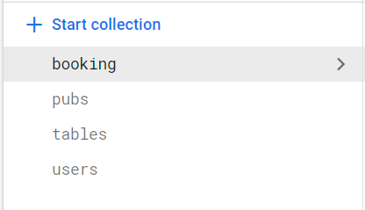
Figure 4 Firestore database tables
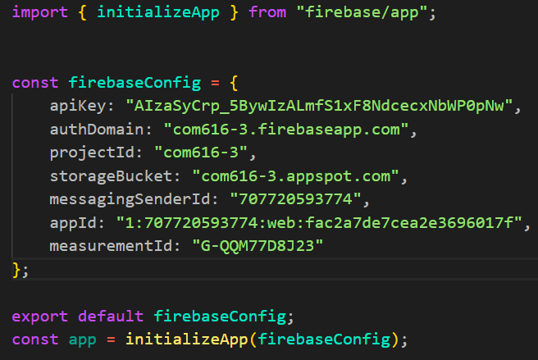
Figure 5 Firestore configuration file
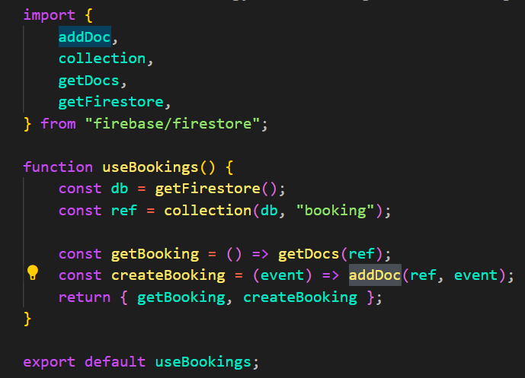
Figure 6 Code for table manipulation
A map with markers for local restaurants, which are created using React map function to loop through the records for restaurants in the database, is provided by the system because of the integration of the Google Maps React package as a component (See Figure 7). However, because of the scope of the project API key for activation was not created. The purpose of implementing this feature was to satisfy customer demand for a simple method to locate restaurants nearby.
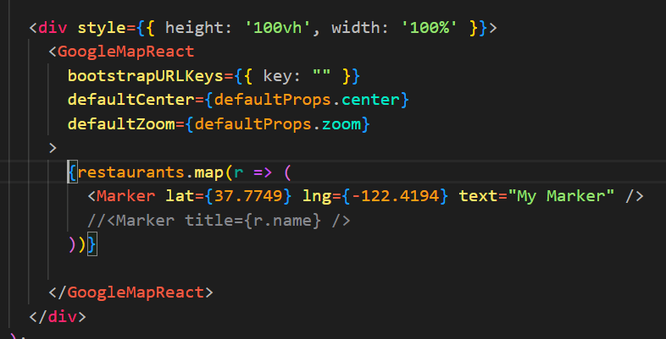
Figure 7 Code implementing Google Maps as a component
After displaying all of the restaurants from the database the next step was to integrate the chatbot into the application. Similarly, to the implementation of Google Maps, the chatbot is created using the Kommunicate.io integration code inside a component in order to be reusable (See Figure 8). Google Dialogflow was integrated into the Kommunicate to provide a chatbot for users queries when they face any difficulties during the reservations process. This feature was implemented to meet the user's needs for a convenient and quick way to make reservations.
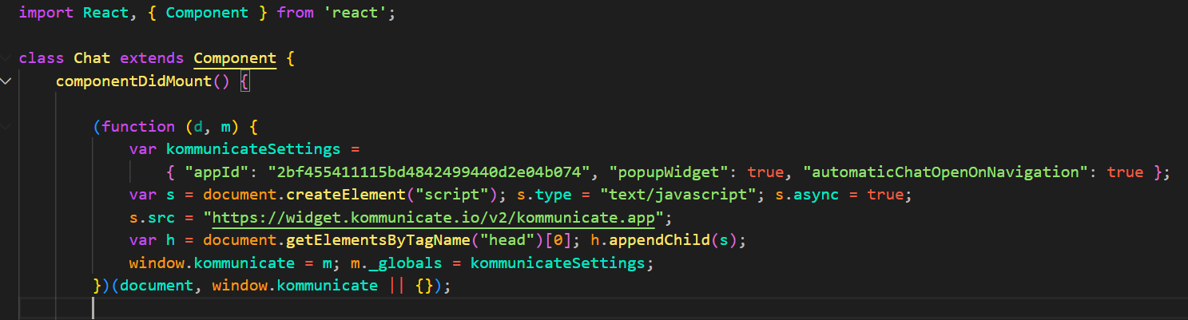
Figure 8 Chatbot integration as a component
After the implementation of the login and sign-up pages, the next step was to create the booking page. The booking page was created to display in real-time the available tables in certain restaurants. To check if the table is available or not two important decisions were made. The first one was to get the date and time of the moment of checking the available tables, the next more important want was the logic implemented in order to check through the bookings to display the tables for the chosen restaurant only and to check if a reservation exists for a certain table. If it exists then change the status into the tables record to false (See Figure 9). The last step is to create the booking by sending the desired date, start and end time using a form where the restaurant id, table id, the number of people for the table and the user id are sent using hidden inputs.
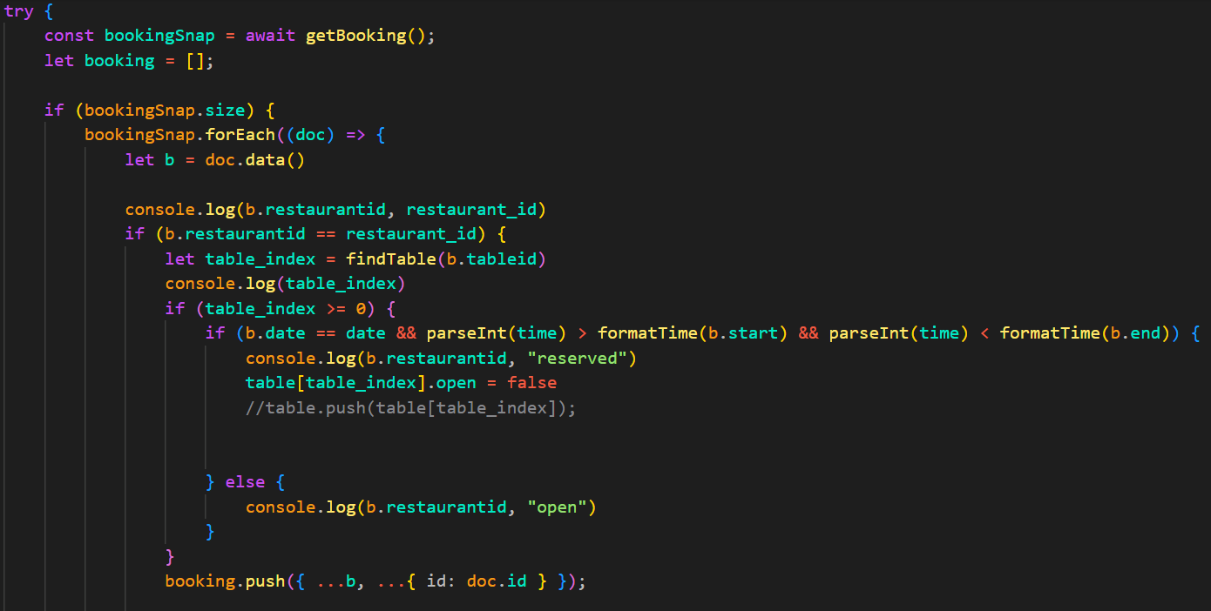
Figure 9 Code logic for real-time availability of tables

The user flow (See Figure 10) of the automated restaurant booking system is designed to provide a seamless experience for users, making it easy for them to find and book a table at their desired restaurant. The user flow starts with the home page when the user wants to search for restaurants the user is prompted to log in or sign up. Once logged in, the user is redirected to the restaurants' page, which displays the restaurants and the map. The user has the option to search for a specific restaurant using the search bar in the navigation bar of the system. Once the user has selected a restaurant and clicked the book button, it is taken to the booking page, where they can see the available table in real-time. After selecting a table the user needs to fill in the details for the desired date and time. Once the book button is clicked the reservation notification will pop up and the user will be taken to the home page. 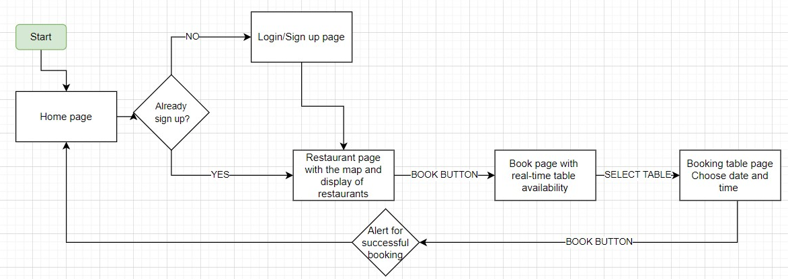
Figure 10 User Flow Diagram
Accordingly, information architecture diagram is created (See Figure 11).
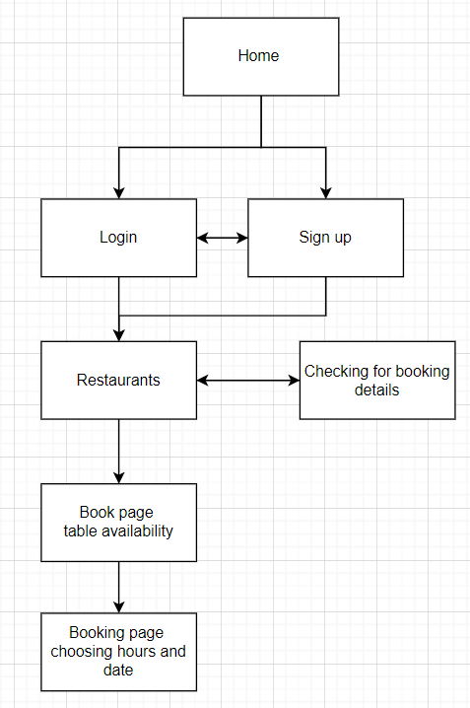
Figure 11 Information Architecture

4.3 Problems encountered.

There were various issues that occurred throughout the automated restaurant reservation system's implementation process for which a solution was not found. One of the most significant problems came from the Firestore database's high read activity, which suddenly stop because of the quota exceeded prevented it from operating as it should. The website continues to send requests for the database, which is where the issue first arises, as can be seen on the network tab from the inspection panel of the browser (See Figure 12). Unfortunately, a solution to this issue could not be found, Despite numerous attempts to refactor the useEffects in the code.
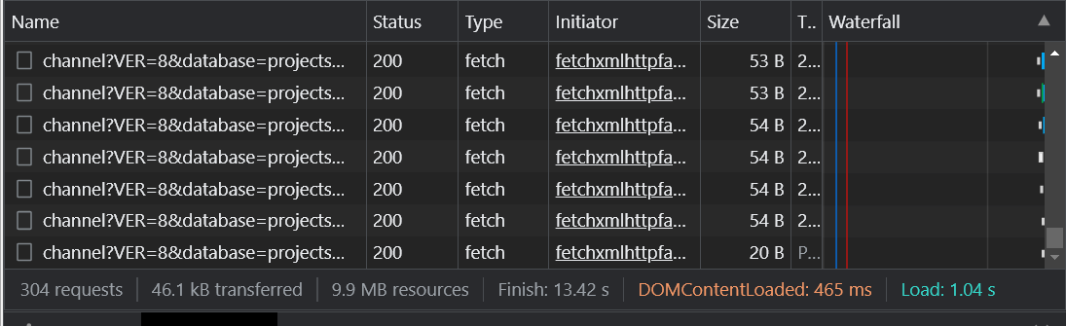
Figure 12 Network tab from the inspection panel of the browser
Another issue was related to the displaying of markers on the Google map. Despite making use of the Google Maps React package, the markers weren't appearing as they should have. After reviewing the documentation and the code possible issue might be that the react version is 18.
Another major issue that persisted throughout the implementation was related to the rendering of the table list and its availability. Because of the multiple used useEffects the page is rendered twice which causes the tables from the database to be updated. However, on the first render, it can be seen from the debugging that the logic created is doing its work, unfortunately, on the second render everything is updated and the status of the tables is no longer available (See Figure 13). Despite the attempts to find a solution, no workable solution was found, however, various suggestions were discovered. Utilising the useCallback hook was one solution that was suggested, but it did not resolve the issue. Another idea was to include the function straight in the useEffect, however, this solution was similarly ineffective. Last but not least, an effort was made to implement all the functions using a single useEffect, but unfortunately, this strategy also failed. The problem remained unsolved within the scope of the project despite intensive investigation and attempts to find a solution.
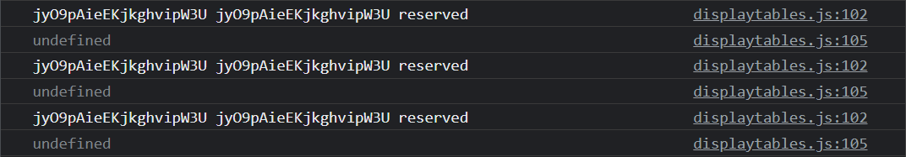
Figure 13 Console logging of the status of the table

5. Results

5.1 Initial Survey

This section of the report aimed to evaluate the user needs for an automated restaurant booking system. An initial survey was conducted with the goal of obtaining feedback from at least 20 participants. The initial survey was from the empathise phase of the design thinking process. After analysing the questions user personas and user empathy maps were created. The user personas were created in order to provide insights into user needs, challenges, and motivations; however, the user personas are semi-fictional representations of various client types (Userpilot Content Team, 2022). On the other hand, empathy maps are a tool used to gain a deep understanding of the people for whom you are designing. They provide a comprehensive perspective of the customer's pain points, concerns, and other important user data. This information can be utilised to enhance the customer experience at every stage of the user journey (Userpilot Content Team, 2022).
The first question from the survey was about if any of the participants faced any difficulty booking a table in a restaurant due to it being fully booked (See Figure 14). Where most of the participants answered with “yes”.
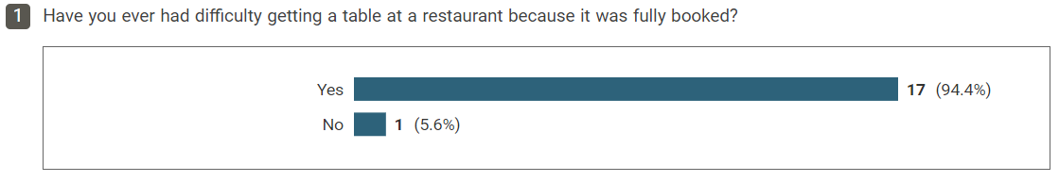
Figure 14 Question 1 Initial Survey
The next question was about “How often do you dine out at restaurant?” (See Figure 15). Based on the responses, the majority of participants (6 out of 18) dine out a few times a month. As users who dine out frequently may benefit from a more effective and streamlined booking process, this suggests that there is a sizable market for the automated restaurant booking system. In addition, the fact that two participants go out to eat a few times a week raises the possibility that some users may be interested in using the system more regularly.
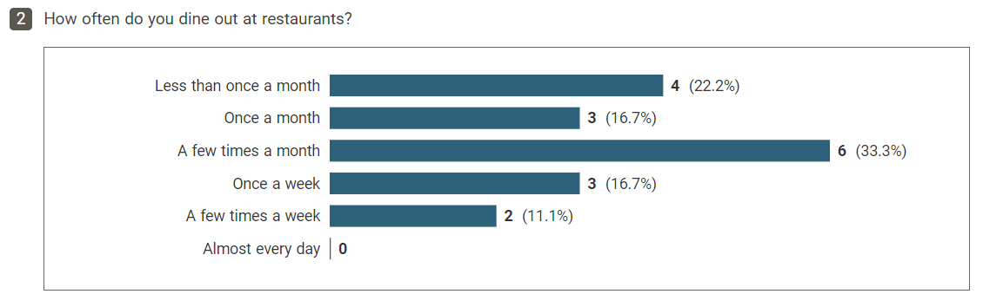
Figure 15 Question 2 Initial survey
Based on the responses to the next question (See Figure 16), nearly half of the replies prefer casual dining restaurants to other types of restaurants. Similarly, 4 of the participants answered that they prefer local/independent restaurants.
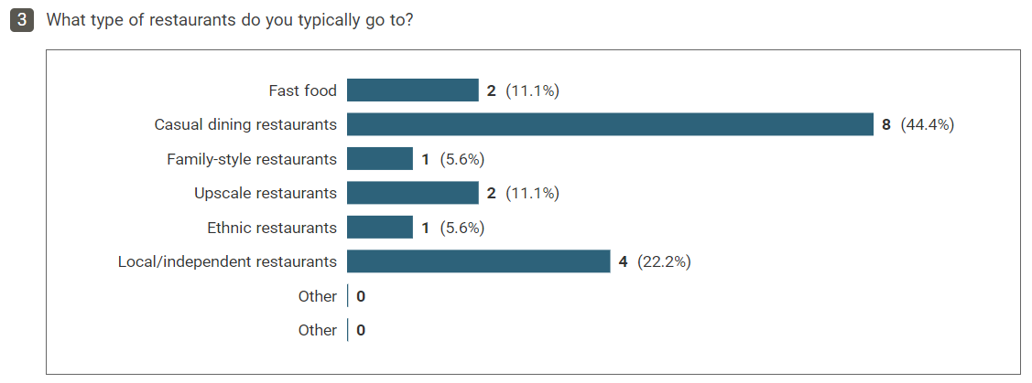
Figure 16 Question 3 Initial survey
According to the responses to the question “How do you currently book a table at a restaurant?” (See Figure 17), nearly 50 percent prefer to call the restaurant directly. Accordingly, 30 percent prefer to use the restaurant booking system, and the other 20 percent just prefer to walk in and request a table.
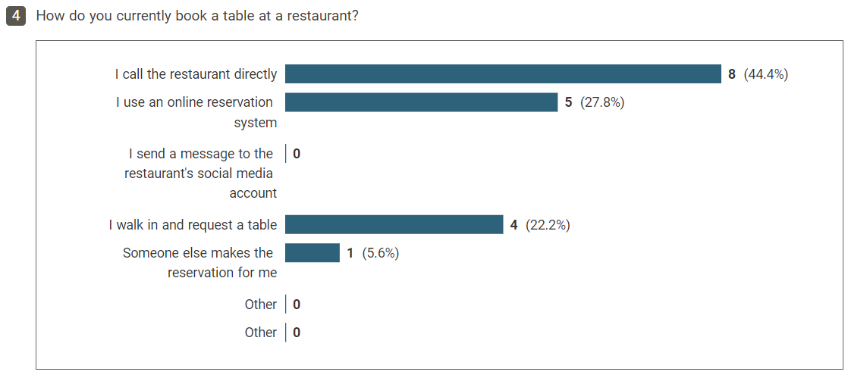
Figure 17 Question 4 Initial survey
With 11 out of 18 respondents responding “no”, it can be concluded from the initial survey question (See Figure 18) that most participants had never utilised an automated restaurant booking system. The fact that 7 individuals had used an automated booking system before, however, suggests that they are at least somewhat familiar with the idea. However, the insights from this question suggest that there is a potential for the implementation of an automated restaurant booking system to meet the demands of individuals who have not yet adopted this technology. It also suggests the other people might need additional support in order to use a similar system.
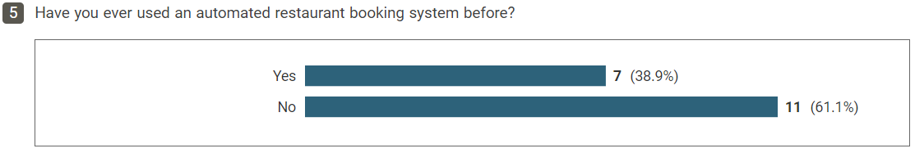
Figure 18 Question 5 Initial survey
According to the replies to the next question (See Figure 19), it appears that 16 out of 18 participants are willing to make a reservation using an automated restaurant booking system. This suggests that clients may be interested in and have a need for such a solution. It's important to take note of the fact that 2 respondents chose "maybe," which may indicate that some people are unsure or feel uncomfortable about using an automated system.
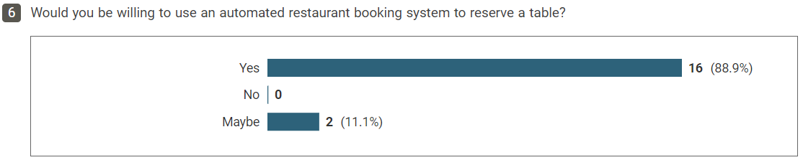
Figure 19 Question 6 Initial survey
The next question is open-ended (See Figure 20), in order to gain insights into what the potential future users want to see as a feature in the application. Based on the responses the users want to see an application that is user-friendly, which is simple to use, and with clear instructions. Also, they want to see Google Maps with all of the restaurants in their area. Another common feature is the real-time availability of the tables. Additionally, the users want to have automated assistance or a chatbot to help them if they have any queries about their bookings.
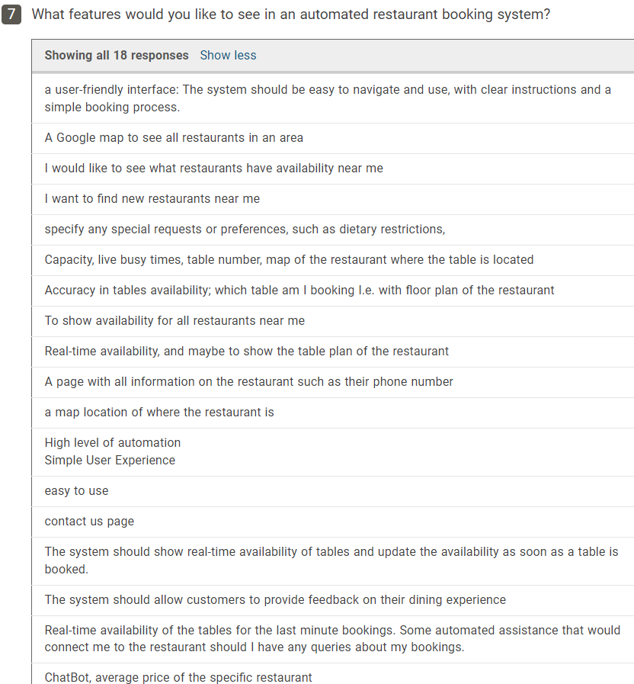
Figure 20 Question 7 Initial survey

The insights from the next question (See Figure 21) indicate that 16 out of 18 participants said they would be more likely to utilise an automated booking system if it offered loyalty points or real-time table availability. This suggests that these features are important for users when considering using an automated booking system. The other 2 participants answered with “maybe”.
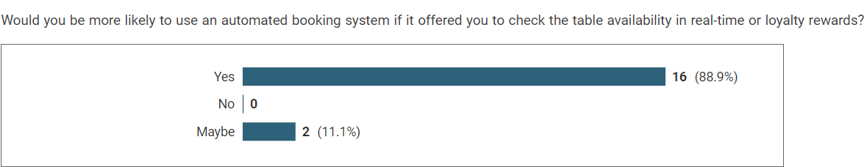
Figure 21 Question 8 Initial survey

Based on the last question of the survey (See Figure 22) the majority of the participants prefer to plan ahead and have a set reservation time, additionally, 4 participants like to have a reservation, but they are flexible, and just one participant answered that he prefers to walk in and see if there is availability in the restaurant.
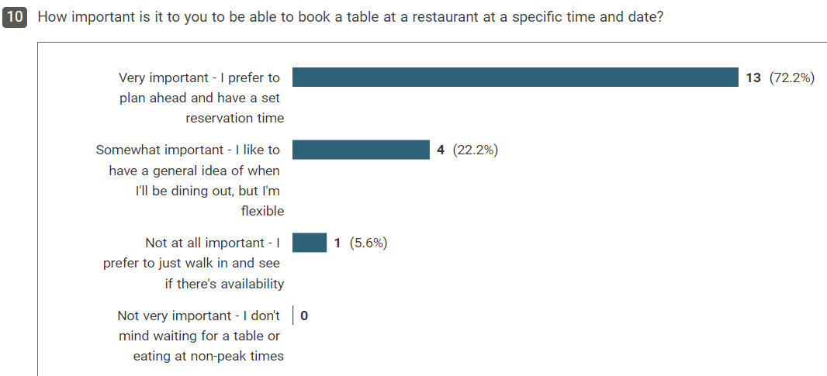
Figure 22 Question 10 Initial survey

Based on the feedback two user personas (See Figure 23) and two user empathy maps (See Figure 24) are created using templates from the Figma to identify the user needs (See Figure 25).
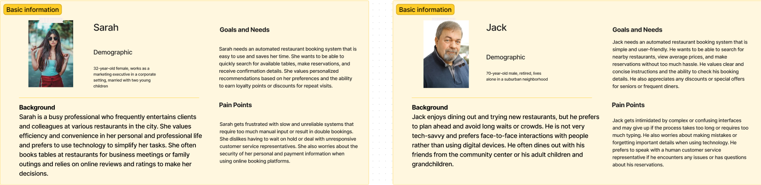
Figure 23 UX User Personas

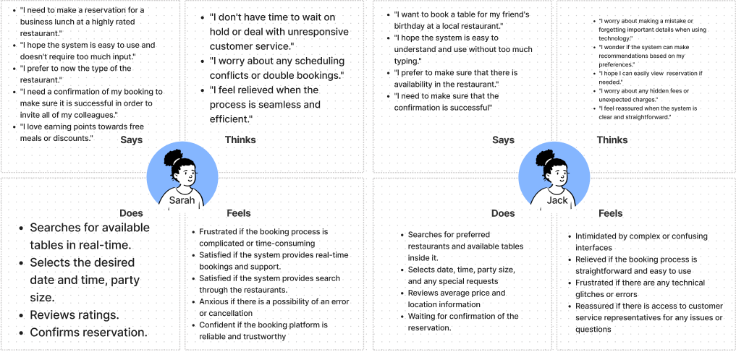
Figure 24 UX Empathy maps
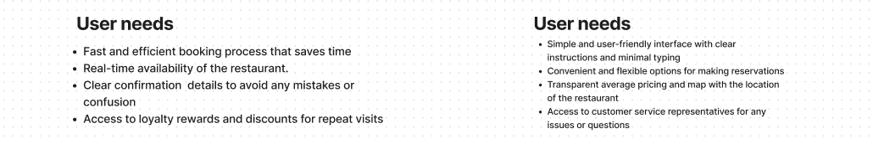
Figure 25 User needs

5.2 Interviews

The final phase of the design thinking process is testing. In order to test the implementation 4 people were recruited to participate in usability interviews to test the functionality, design, and effectiveness, and understand their perspectives using the system. The interviews were following the talk-out loud method. All of the participants were informed for the purpose of the interviews and will stay anonymous following the (GDPR) General Data Protection Regulation. Each of the participants answered to 10 questions prepared by the researcher (See Appendix B).
The main task which all of the participants needed to accomplish was to book a table in a restaurant (See Appendix C ), where all of the participants did not find any issues during the process. All of them mentioned that the process is “straightforward” and easy to use. One of the sub-tasks was to find their booking details, and all of them again did not have any troubles:
“Participant 1: Well, I would probably go to my account. If you mean the booking the you do you mean the booking details? Yeah. So my booking details are. They are pretty easy to find because I would go first to search for my account and look for my bookings details. So, I will go through that. So and I found it there, so it's pretty easy and straightforward.”

“Participant 2: Sure. OK, so usually my bookings will be under my profile so. That is as well and expected plates booking details. And it shows me that it shows me my booking details and.”

“Participant 3: So it's my booking details, I would probably go to my account. So and that's correct, because I can see my booking details. So once I click on the booking details button, I can see all of my booking information of all the restaurants that I booked and I'm planning to go. So this is very clear and it's very handy when I let's say forget what time I booked the table.”

“Participant 4: Yeah. So I would expect to see it and under my profile settings probably. So I'm clicking on the icon on the right top corner and it gives me options of booking details and the log out click on booking details. And yeah, my booking is right there. So booking for. For people and the data I've selected.”

All of the participants liked the features implemented and found them useful, additionally, mentioned that the user experience of the system is good. On the other hand, participant 2 mentioned that if the opportunity was given, it will be better to change the display of the icon for the chatbot. Finally, all of them suggest a feature for future development like “Highlight the restaurants around me not only on the map”, “offers to see if they have like any discounts or loyalty points”, and “save my search criteria”. Overall, the feedback from the participant was good and all of them confirmed that they will use the system in the future.

6. Conclusions

In conclusion, the outcomes of this study showed that customers' perspectives on implementing an automated restaurant reservation system vary, with some customers being more open to using it than others which indicates that some of the potential future users may need the training to use the system. Nevertheless, the feedback was generally beneficial, suggesting that there exists a market for such a system. The project was initialised using the 5-step design thinking process. During the Ideate phase of the design thinking process was able to gather important insights into consumer wants and preferences, which were implemented into the finished product. According to the initial survey, the users' needs were identified using user personas and empathy maps. They suggest features like reserving a table for a specified time and day, having real-time table bookings, advanced support during the booking process, easy for use user interface, and a map with the location of the restaurants nearby. These discoveries were then utilised to develop a high-fidelity prototype that included these crucial characteristics as well as additional aspects that potential users would find practical. Some problems that were discovered during the prototype were not resolved in the allotted time. However, the evaluation interviews offered insightful feedback that could be applied going forward to enhance the system. Only one iteration of the design thinking process was carried out due to the project's scope.
As a result, this research offers insightful information on the viewpoints of customers evaluating the automated restaurant booking system, which also emphasises the necessity for a user-friendly, simple system that includes the key features mentioned above. These insights were discovered, and a prototype that satisfies client demands was created, due to the use of the design thinking methodology. By examining the possible effects of new features or other system implementations, future research might build on this work. Implementation of the project was on schedule and the project's objectives were met.

7. Recommendations

During the study, several recommendations were found for future improvements to the system. Offering loyalty points to loyal consumers was proposed to encourage additional users of the system. Therefore, future developments should consider implementing a loyalty program. Providing the user with a floor map of the tables so they may select their ideal table in the restaurant was another interesting addition that was mentioned. To improve the automated restaurant booking system, further functions could be included in addition to those mentioned above. The administration of waitlists is one such aspect. Without a reservation, diners could show up to the restaurant and need to be put on waiting. Customers may be notified when a table becomes available and the waitlist can be managed by the booking system. This will enhance the overall experience of clients who show up without reservation by ensuring that they may acquire a table as quickly as feasible. Reminders for reservations might be introduced as another feature. Customers who have upcoming bookings can receive notifications by email and SMS from the system, which lowers the possibility of no-shows and cancellations. With the aid of this tool, restaurants will be able to better manage their reservations and guarantee that they can accommodate all of their customers. Another significant feature that may be used is group booking management. The reservation system may support group reservations for sizable celebrations or meetings and offer possibilities for customisation and pre-ordering. This will help restaurants better manage their resources while also making it simpler for consumers to plan and organise their events. Finally, it would be advantageous for the booking system to enable users to view the restaurant's menu. Before making a reservation, customers could better understand what is offered because of this feature, which would also make it easier for them to decide what they want to order. By implementing all of those features in future developments, the automated restaurant reservation system will become more efficient and user-friendly overall by adding these capabilities, improving the diners' overall experience.

8. Reference list

Alt, R. (2021). (PDF) Digital Transformation in the Restaurant Industry: Current Developments and Implications. ResearchGate. [online] doi:https://doi.org/10.52255//smarttourism.2021.1.1.9.
Aroral, H. (2021). Waterfall Process Operations in the Fast-paced World: Project Management Exploratory Analysis. International Journal of Applied Business and Management Studies, [online] 6(1). Available at: http://www.ijabms.com/wp-content/uploads/2021/05/05_ARORAL_PB.pdf.
Bagaskara, A., Naufal, A.R., Dhojopatmo, I.E., Abdurrab, A. and Budiharto, W. (2021). Development of Smart Restaurant Application for Dine-In. 2021 1st International Conference on Computer Science and Artificial Intelligence (ICCSAI). [online] doi:https://doi.org/10.1109/iccsai53272.2021.9609723.
Botti, A., Grimaldi, M., Monda, A. and Vesci, M. (2017). (PDF) Smart service systems in restaurant management: a case study analysis. [online] ResearchGate. Available at: https://www.researchgate.net/publication/324439645_Smart_service_systems_in_restaurant_management_a_case_study_analysis [Accessed 22 Apr. 2023].
Hazel, I. (2021). Minimalism in Web Design: Essentials and Advantages. [online] Medium. Available at: https://bootcamp.uxdesign.cc/minimalism-in-web-design-essentials-and-advantages-9fd3f5e6c8a4 [Accessed 2 May 2023].
Idowu Omisola (2021). What Is Google Firebase and Why Should You Use It? [online] MUO. Available at: https://www.makeuseof.com/what-is-google-firebase-why-use-it/?newsletter_popup=1 [Accessed 3 May 2023].
Kale, S., Goti, P. and Roychaudhary, R. (2021). (PDF) Online Table and Menu Booking System for Restaurants. [online] ResearchGate. Available at: https://www.researchgate.net/publication/353753942_Online_Table_and_Menu_Booking_System_for_Restaurants [Accessed 20 Feb. 2023].
Kumar Sharma, A., Pandey, R., Tarafdar, S. and Dubey, S. (2021). Towards Smart Mobility in Cities - Bus Tracking and Booking System. 2021 9th International Conference on Reliability, Infocom Technologies and Optimization (Trends and Future Directions) (ICRITO). [online] doi:https://doi.org/10.1109/icrito51393.2021.9596492.
Marsyahariani, N., Daud, N., Amin, M. and Aziz, A. (n.d.). RESTAURANT RESERVATION SYSTEM USING ELECTRONIC CUSTOMER RELATIONSHIP MANAGEMENT. [online] Available at: https://e-ajuitmct.uitm.edu.my/v2/images/vol8specialissuegrace2018/G46---RESTAURANT-RESERVATION-SYSTEM-USING-ELECTRONIC.pdf.
Miao, Q., Li, Y. and Wang, X. (2018). (PDF) Restaurant reservation management considering table combination. ResearchGate. [online] Available at: https://www.researchgate.net/publication/324525715_Restaurant_reservation_management_considering_table_combination [Accessed 20 Feb. 2023].
Ovie Okeh (2021). Integrating Google Maps with React - LogRocket Blog. [online] LogRocket Blog. Available at: https://blog.logrocket.com/integrating-google-maps-react/ [Accessed 15 Feb. 2023].
Patton, M. (1988). How to Use Qualitative Methods in Evaluation. [online] Google Books. Available at: https://books.google.co.uk/books?hl=en&lr=&id=0co1ESOVJHkC&oi=fnd&pg=PA5&dq=qualitative+methods+for+evaluation&ots=wIy4ABh8ya&sig=WQCGoWR7aNOO-2XdvekqocqZp6s#v=onepage&q=qualitative%20methods%20for%20evaluation&f=false [Accessed 10 Feb. 2023].
Pernice , K. (2016). UX Prototypes: Low Fidelity vs. High Fidelity. [online] Nielsen Norman Group. Available at: https://www.nngroup.com/articles/ux-prototype-hi-lo-fidelity/ [Accessed 2 May 2023].
Questionpro.com. (2023). Available at: https://www.questionpro.com/blog/wp-content/uploads/2023/02/best-practices-to-conduct-quantitative-research.jpg.webp [Accessed 13 Feb. 2023].
Saundariya, K., Abirami, M., Senthil, K.R., Prabakaran, D., Srimathi, B. and Nagarajan, G. (2021). Webapp Service for Booking Handyman Using Mongodb, Express JS, React JS, Node JS. 2021 3rd International Conference on Signal Processing and Communication (ICPSC). [online] doi:https://doi.org/10.1109/icspc51351.2021.9451783.
Simplilearn (2021). Prototyping In Design Thinking: Definition, Types & Benefits. [online] Simplilearn.com. Available at: https://www.simplilearn.com/prototyping-in-design-thinking-article [Accessed 3 May 2023].
Tharun, K.C., Kumar, P.S.T., Hameed, S. and Preethi, G. (2021). MOBILE BASED ONLINE RESTAURANT RESERVATION SYSTEM. [online] Available at: https://www.irjet.net/archives/V8/i4/IRJET-V8I4328.pdf [Accessed 20 Feb. 2023].
Thorne, S. (2000). Data analysis in qualitative research. Evidence-Based Nursing, [online] 3(3), pp.68–70. doi:https://doi.org/10.1136/ebn.3.3.68.
Userpilot Content Team (2022a). Empathy Map vs Persona: What’s the Difference and Why You Need Both. [online] Thoughts about Product Adoption, User Onboarding and Good UX | Userpilot Blog. Available at: https://userpilot.com/blog/empathy-map-vs-persona/#:~:text=The%20main%20difference%20between%20an,customers'%20attitudes%20and%20behaviors%20are. [Accessed 4 May 2023].
Userpilot Content Team (2022b). Empathy Map vs Persona: What’s the Difference and Why You Need Both. [online] Thoughts about Product Adoption, User Onboarding and Good UX | Userpilot Blog. Available at: https://userpilot.com/blog/empathy-map-vs-persona/#:~:text=The%20main%20difference%20between%20an,customers'%20attitudes%20and%20behaviors%20are. [Accessed 4 May 2023].
Zhang, Z., Li, H., Meng, F. and Qiao, S. (2018). Journal of Electronic Commerce Research, VOL 19, NO 3. [online] Available at: http://www.jecr.org/sites/default/files/2018vol19no3_paper4.pdf [Accessed 24 Feb. 2023].

9. Bibliography

Bhandari, P. (2022). What Is Qualitative Research? | Methods & Examples. [online] Scribbr. Available at: https://www.scribbr.co.uk/research-methods/introduction-to-qualitative-research/ [Accessed 10 Feb. 2023].
Bhatt, S. (2021). How React Native Helped In Building a Restaurant App (Case Study). [online] BoTree Technologies. Available at: https://www.botreetechnologies.com/blog/case-study-of-restaurant-app-built-with-react-native/ [Accessed 16 Feb. 2023].
Cleave, P. (2022). Improving Survey Response Rates - SmartSurvey. [online] SmartSurvey. Available at: https://www.smartsurvey.co.uk/blog/top-tips-to-improve-your-online-survey-response-rates [Accessed 14 Feb. 2023].
Dutta, S. (2021). Top 6 Reasons You Need an Online Restaurant Reservation System. [online] Quandoo.com. Available at: https://restaurants.quandoo.com/en-sg/blog/online-restaurant-reservation-system-reasons [Accessed 9 Feb. 2023].
Falkenstern, M. (2022). Digitalisation of restaurants – Gearing up for the future» resmio. [online] resmio. Available at: https://www.resmio.com/en/spoon-bytes/digitalisation-restaurant-industry/ [Accessed 19 Apr. 2023].
Fleetwood, D. (2018). Quantitative Research: What it is, Tips & Examples | QuestionPro. [online] QuestionPro. Available at: https://www.questionpro.com/blog/quantitative-research/ [Accessed 13 Feb. 2023].
Ibragimova, E. (2016). High-fidelity prototyping: What, When, Why and How? [online] Medium. Available at: https://blog.prototypr.io/high-fidelity-prototyping-what-when-why-and-how-f5bbde6a7fd4 [Accessed 2 May 2023].
Ideas. (2021). What is design thinking and why is it important? [online] Available at: https://www.wework.com/ideas/professional-development/creativity-culture/what-is-design-thinking [Accessed 28 Apr. 2023].
Informed Consent Form Project Title: I confirm that (please tick as appropriate and add your initials alongside). (n.d.). Available at: https://www.solent.ac.uk/research-innovation-enterprise/documents/informed-consent-form.pdf.
Jennie (2021). Restaurant Reservation System: Traditional Restaurant And Technology Difference In Pandemic. [online] CmsMart. Available at: https://cmsmart.net/community/restaurant-reservation-system [Accessed 3 May 2023].
Konch.ai. (2022). 5 Steps to GDPR Compliant Research Interviews. [online] Available at: https://www.konch.ai/post/5-steps-to-gdpr-compliant-research-interviews-in-education [Accessed 16 Feb. 2023].
Maiorca, D. (2023a). What Is Figma and What Is It Used For? [online] MUO. Available at: https://www.makeuseof.com/what-is-figma-used-for/ [Accessed 2 May 2023].
Maiorca, D. (2023b). What Is Figma and What Is It Used For? [online] MUO. Available at: https://www.makeuseof.com/what-is-figma-used-for/ [Accessed 2 May 2023].
Naveen Thangam (2020). How To Improve Your Restaurant’s Reservation System. [online] Restaurantware.com. Available at: https://www.restaurantware.com/blog/post/how-to-improve-your-restaurants-reservation-system/ [Accessed 7 Feb. 2023].
npm. (2022). google-map-react. [online] Available at: https://www.npmjs.com/package/google-map-react [Accessed 15 Feb. 2023].
Ovie Okeh (2020). The complete guide to publishing a React package to npm - LogRocket Blog. [online] LogRocket Blog. Available at: https://blog.logrocket.com/the-complete-guide-to-publishing-a-react-package-to-npm/ [Accessed 3 May 2023].
Roberthalf.com. (2022a). 4 Types of Job Interview Questions to Help You Dig Deeper. [online] Available at: https://www.roberthalf.com/blog/how-to-interview-candidates/job-interview-questions-4-types-to-consider [Accessed 10 Feb. 2023].
Roberthalf.com. (2022b). 4 Types of Job Interview Questions to Help You Dig Deeper. [online] Available at: https://www.roberthalf.com/blog/how-to-interview-candidates/job-interview-questions-4-types-to-consider [Accessed 10 Feb. 2023].
Ruralhealthinfo.org. (2019). Evaluation of Quantitative and Qualitative Data – RHIhub Aging in Place Toolkit. [online] Available at: https://www.ruralhealthinfo.org/toolkits/aging/5/evaluation-of-data-sources#:~:text=Quantitative%20data%20includes%20specific%20measurements,and%20supportive%20agencies%20and%20individuals. [Accessed 9 Feb. 2023].
SevenRooms. (2021). Online Restaurant Reservation Software. [online] Available at: https://sevenrooms.com/en/platform/acquire/reservations/?cq_cmp=16376872515&cq_term=booking%20solution&cq_plac=&cq_net=g&cq_pos=&cq_plt=gp&Detail-MR=adwords&Detail=adwords&campaign=Google_Search_Beta_NB_UK&channel=google&utm_source=google&utm_medium=search&utm_campaign=Google_Search_Beta_NB_UK&utm_term=booking%20solution&utm_content=textlink&adcreative=Google_Search_Beta_NB_UK&gclid=CjwKCAiA0JKfBhBIEiwAPhZXD_ghDscG2f5hydtdbTvGgPIiNHKnN7dZCUavtYMaRQrASIOEx6O5cBoC1QsQAvD_BwE [Accessed 9 Feb. 2023].
Shrivastava, P. (2018). Integrate Dialogflow (Api.ai) Bot into Website - Kommunicate - Medium. [online] Medium. Available at: https://medium.com/kommunicate/how-to-integrate-bot-using-dialogflow-in-kommunicate-1ac32911a7d0 [Accessed 4 May 2023].
Small Business - Chron.com. (2013). Restaurant Customer Expectations Survey Questions. [online] Available at: https://smallbusiness.chron.com/restaurant-customer-expectations-survey-questions-77176.html [Accessed 13 Feb. 2023].
Stevens, E. (2023). The Design Thinking Process: 5 Steps Complete Guide. [online] CareerFoundry. Available at: https://careerfoundry.com/en/blog/ux-design/design-thinking-process/ [Accessed 25 Apr. 2023].
What is usability testing? | Experience UX (2015). What is usability testing? | Experience UX. [online] Experience UX. Available at: https://www.experienceux.co.uk/faqs/what-is-usability-testing/#:~:text=Usability%20testing%20is%20a%20way,encounter%20problems%20and%20experience%20confusion. [Accessed 28 Apr. 2023].

10. Appendices

Appendix A: Gantt Chart

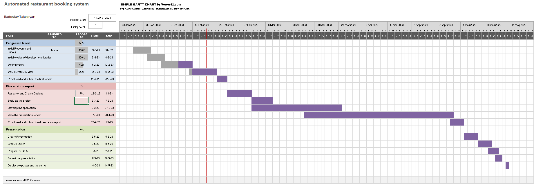

Appendix B: Usability interviews questions

1. Can you walk me through the steps you took to make a restaurant reservation?
2. Was the process of making a reservation easy or difficult for you?
3. Did you have any trouble understanding the instructions or finding the information you needed?
4. Did you encounter any errors or issues while using the system? If so, can you describe what happened?
5. Can you walk me through the chatbot feature?
6. How would you rate the overall user experience of the system?
7. Can you walk me through the booking details
8. Were there any features or functions that you found particularly helpful or frustrating?
9. Did the system provide you with all the information you needed to make an informed decision about your reservation?
10. Do you have any additional feedback or suggestions on how the system could be improved?

Appendix C: Links to full interviews transcript

