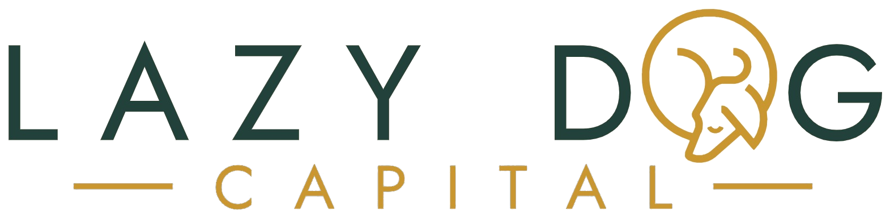
SECURED REAL ESTATE LENDING · DALLAS–FORT WORTH
[ Date ]
Re: Proof of funds — [ Borrower name ] · [ Property address ]
To whom it may concern:
This letter confirms that [ Borrower name ] is an approved borrower of Lazy Dog Capital, a private real estate lender serving the Dallas–Fort Worth market, and that Lazy Dog Capital has funds available to finance the borrower's purchase of the property at [ Property address ] in an amount of up to [ $ Amount ].
Our loans are secured by a first-lien deed of trust, close at a title company, and can typically fund within days of clear title — allowing the borrower to perform on the timeline of a cash purchaser.
This letter is issued in support of the borrower's offer on the property identified above and is valid through [ Date — 30 days out ]. It is a statement of available funds, not a loan commitment; final funding is subject to Lazy Dog Capital's underwriting, property evaluation, and the execution of definitive loan documents.
To verify this letter or discuss timing, contact me directly at [ phone ] or [ email ].
Sincerely,
Lewis McKnight
[ Title ] · Lazy Dog Capital
Lazy Dog Capital lends on non-owner-occupied investment property for business purposes only. This letter is provided at the borrower's request for use with offers on the property identified above and may not be relied upon by any other party or for any other transaction.

