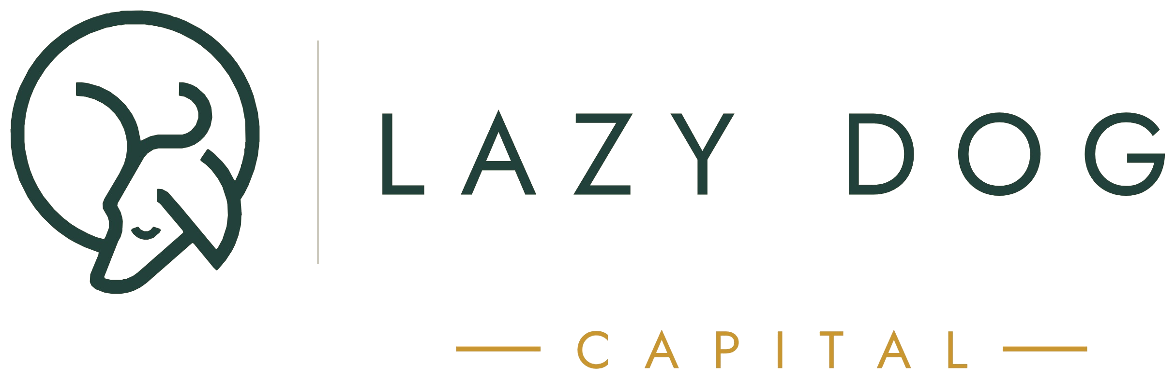

Capital Partner Opportunity
Secured private lending for residential real estate · Dallas–Fort Worth
THE OPPORTUNITY
Dallas–Fort Worth is one of the most active fix & flip markets in the country. Experienced flippers need fast, reliable capital — and banks can't move at the speed these deals require.
Private lending fills that gap, and lenders get paid for it. Lazy Dog Capital connects private capital with vetted flippers on short-term loans secured by real property.
Paid first | A recorded first-priority claim, ahead of our own money
80% max | Every loan capped at 80% of after-repair value
7–9 months | Expected time frame — principal back at payoff
5.5–7.0% | Annualized rate, paid monthly
HOW IT WORKS
1. We identify and underwrite a deal with an experienced flipper.
2. Lazy Dog makes one first-lien loan to the borrower — 80% of after-repair value — secured by a recorded first-lien deed of trust.
3. You fund your share: 45–60% of that loan.
4. You hold a recorded assignment of the first lien — a first-priority claim for your investment amount, ahead of our own money.
5. The borrower puts in 10% of the purchase price and pays monthly interest; at payoff, your principal comes back first.
Every loan is capped at 80% of after-repair value — our hard limit on how much sits against a property.
A SAMPLE DEAL
Appraisal (ARV) | $320,000
Loan (recorded first lien) | $256,000
Purchase price | $200,000
Rehab budget | $50,000
Estimated time | 7 – 9 months
The borrower's $256,000 first-lien note is assigned to you. At the 55% tier you are paid in full: your $140,800 plus $6,864 interest — $147,664 total. Payable anytime, no penalty.
THE CAPITAL STACK
POSITION | AMOUNT | PAID
Capital Partner | $140,800 | First
Lazy Dog Capital | $115,200 | Next
Borrower down payment (equity) | $20,000 | Last
You and Lazy Dog fund the $256,000 loan; the borrower's $20,000 down payment is equity beneath it — the first money to absorb any loss. Repayment order in any payoff or foreclosure: costs first, then you by recorded collateral assignment, then Lazy Dog, then the borrower.
YOUR RETURN
YOUR SHARE | YOU FUND | YOUR RATE | MONTHLY | OVER 9 MONTHS | TOTAL RETURNED
45% | $115,200 | 5.5% | $528 | $4,752 | $119,952
50% | $128,000 | 6.0% | $640 | $5,760 | $133,760
55% · this deal | $140,800 | 6.5% | $763 | $6,864 | $147,664
60% | $153,600 | 7.0% | $896 | $8,064 | $161,664
No fees touch your return. Lazy Dog is paid by the borrower — origination points, a flat admin fee, and the interest spread. Every dollar of your rate is yours.
HOW YOU'RE PROTECTED
Your first-priority claim is $140,800 against a $320,000 finished home — 44% of value. At closing, $59,200 of other people's cash sits beneath you. At finish, about $179,200 of cash and equity — 56% of the finished home's value.
First-priority from day one. By a recorded collateral assignment you hold first call on the borrower's first-lien note for the entire $140,800 the day the loan closes. Our $76,000 holdback only enters the property as verified work adds value — so the loan never gets ahead of the home's worth, and your cushion grows every week.
THE DOWNSIDE, STRESS-TESTED
IF THE PROPERTY SOLD AT… | VS. ARV | YOUR $140,800
$320,000 (plan) | ARV | Fully repaid
$256,000 (a 20% miss) | –20% | Fully repaid
$200,000 (un-renovated purchase price) | –37.5% | Fully repaid
$158,000 (approximate breakeven) | –51% | Fully repaid
The home would have to sell for roughly half its finished value before your position is impaired. The borrower's $20,000 and our own $115,200 absorb every dollar of loss first.
IF THE DEAL GOES SIDEWAYS
Notice and cure. The borrower gets written notice and a 10-day period to cure the default.
Fast foreclosure. If uncured, we accelerate and foreclose. Texas non-judicial foreclosure is among the fastest in the nation — roughly 45–60 days.
You're paid in order. Sale proceeds follow the waterfall: foreclosure costs, then you by recorded collateral assignment, then Lazy Dog, then the borrower.
We finish it ourselves. Our own repair company completes the rehab; we then sell it or move it into our property management company. A default doesn't strand the project — it just changes who finishes it.
WHO WE ARE
Lewis McKnight 23 years in real estate
800+ transactions — private loans, flips, single-family construction, rehabs, and remodels. Owns a repair company and a property management company, with in-house crews to finish any stalled project.
Stephen Maner 13+ years as a real estate investor
U.S. Marine Corps veteran; corporate professional turned entrepreneur. Owns investment property and co-owns the repair and property management companies with Lewis.
We put our own money into every deal — in the position behind yours. To date, Lazy Dog has never had a borrower default (past performance does not guarantee future results).
NEXT STEPS
1. Review the Capital Partner Agreement and sample loan documents.
2. Choose your share of the loan — your rate follows the tier.
3. Fund your contribution; your first-priority collateral assignment is recorded.
4. Receive monthly payments and statements; principal back at payoff — then do it again.
IMPORTANT DISCLOSURES
This document is an illustrative example based on representative deal terms and is provided for discussion purposes only. It is not an offer to sell or a solicitation of an offer to buy any security. Capital partner returns are secured by a recorded first-priority collateral assignment of a first-lien note and deed of trust on a specific Texas property; they are secured, not guaranteed. Real estate values can decline, borrowers can default, and foreclosure recoveries can be less than anticipated. Past performance does not guarantee future results. Figures are shown before taxes; interest income is generally taxed as ordinary income. Prospective capital partners should review all loan documents and consult their own legal, tax, and financial advisors before investing.

