Weak AI Prompts:
- Explain regression
- Help me understand SQL
- Create a dataset

Revised AI Prompts:

- Explain regression as a data analysis beginner and include small examples.
- As a beginner, help me understand what SQL does and how it works.
- Create 1 data set that includes 6 rows showing store name, sales and the average rating for each. The format should be a Table.

- 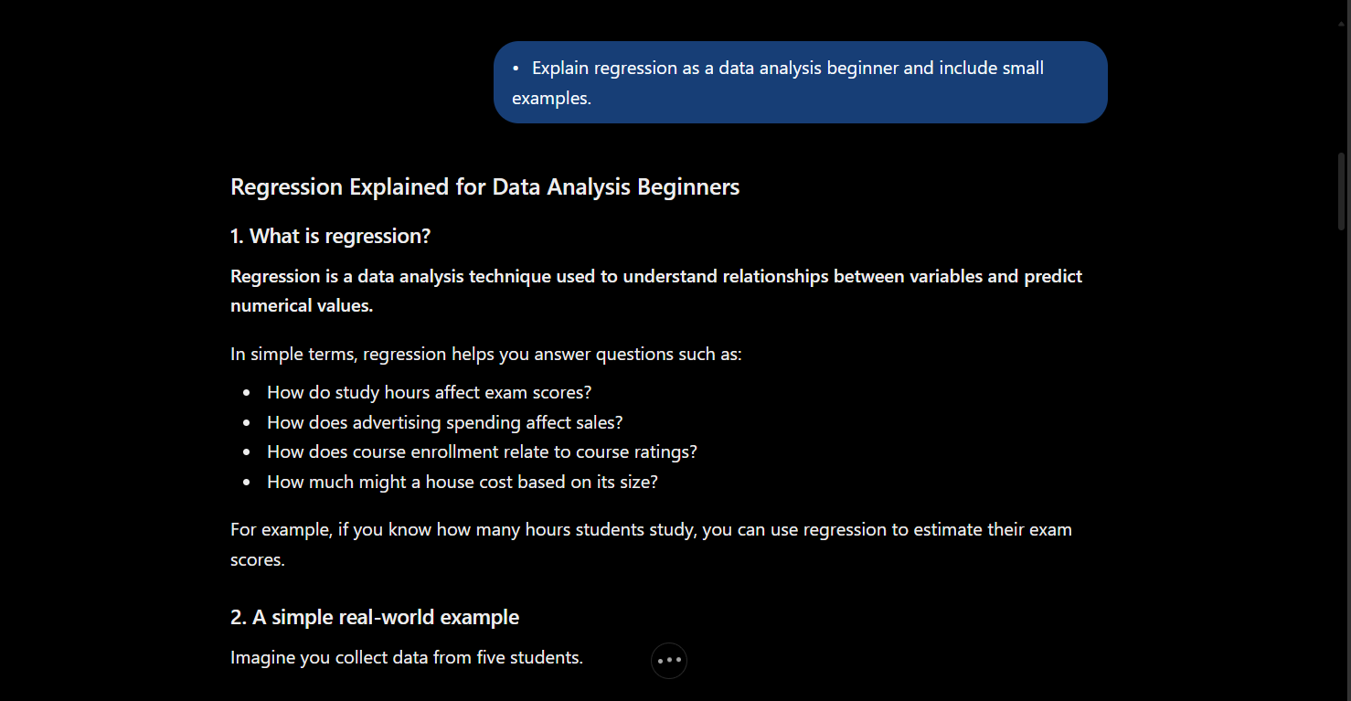

- 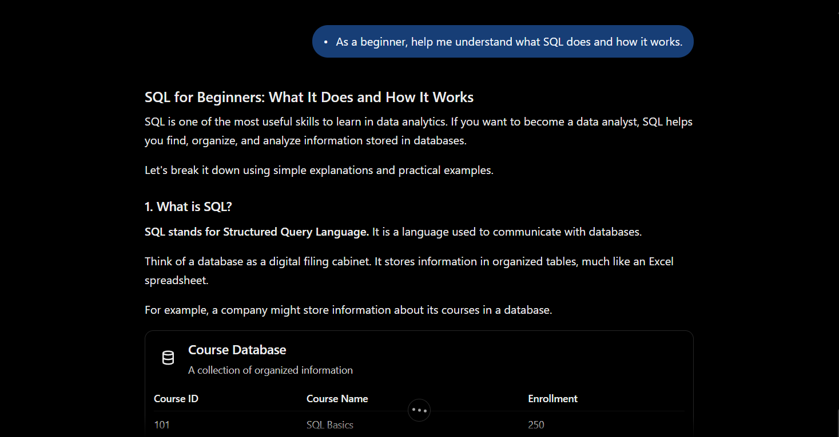

- 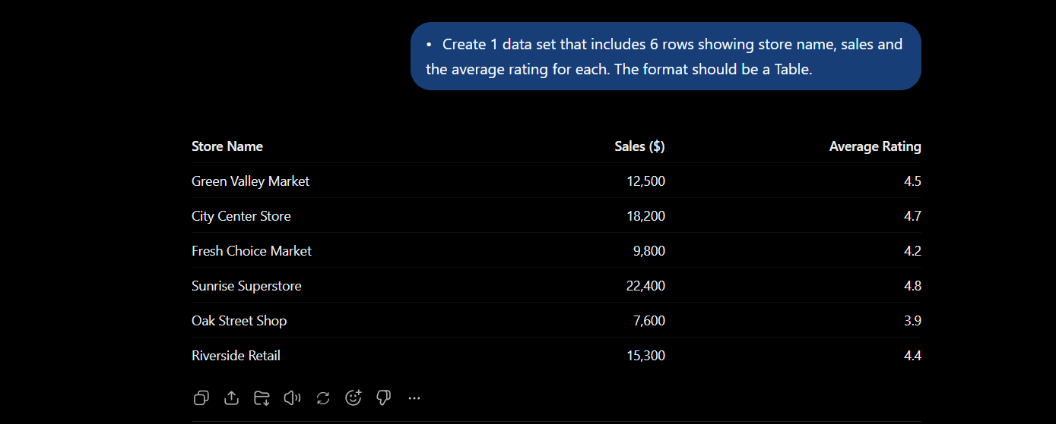

My revised prompt is stronger because, not only does it provide more context but it’s also more in depth, rather than it being vague for only 3 words long without any additional context.

