<https://alicehgsun.github.io/dialogflow-unity-v2/>

**Get the Service Account Key As JSON**

1) On DialogFlow Console. Open project. Click Settings Cog Icon.

2) Click Service Account Email Address. Check the email @gserviceaccount.com.

3) Click Create Service Account.

4) Enter PT-Bot for Service Account Name. Enter something for Service Account Description.

5) Click Create.

6) Select DialogFlow API Admin for Role. Click Continue.

7) Click Create Key. Select JSON.

This saves the private key.

**2) Install Latest Cloud SDK & Set the Environment Variable to JSON File Path, then Get Access Token**

1) Download Google Cloud SDK, and unzip into newagent folder.

2) Run this command in CMD:

*gcloud init*

3) Run this command:

*set GOOGLE_APPLICATION_CREDENTIALS=*JSON-FILE-PATH-HERE\**

3) Get the access token using this command:

*gcloud auth application-default print-access-token*

<https://cloud.google.com/sdk/docs/quickstart-windows>

<https://cloud.google.com/docs/authentication/production>

<https://cloud.google.com/sdk/gcloud/reference/auth/application-default/print-access-token>

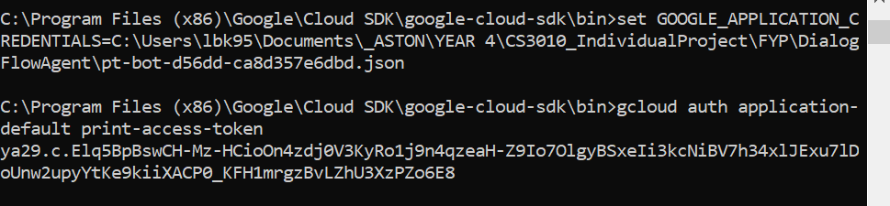

ya29.c.Elq5BpBswCH-Mz-HCioOn4zdj0V3KyRo1j9n4qzeaH-Z9Io7OlgyBSxeIi3kcNiBV7h34xlJExu7lDoUnw2upyYtKe9kiiXACP0_KFH1mrgzBvLZhU3XzPZo6E8

**Create JsonData Script Inside Plugins Folder of Unity**

1) Get code from file Assets 🡪 Plugins 🡪 JsonData.cs

2) In Unity, in the Assets Folder create a new folder called Plugins

3) In the Plugins folder create a new script called JsonData.cs

4) Replace the code with the code from the first file.

**Create DialogFlow API Script Inside Unity Assets**

1) Get code from file Assets 🡪 DialogflowAPIScript.cs

2) In Unity, click Main Camera in hierarchy.

3) Go to Inspector, Add a component 🡪 New Script

4) Replace the code with the code from the first file.

5) Update the code to reflect the class name.

6) Update the code to replace “YOUR_PROJECT_ID” with ID from DialogFlow.

7) Update “YOUR_ACCESS_TOKEN” with value from Step 3.