**Play Video In Unity**

**Just for testing**

[**https://codeholo.com/2018/01/14/playing-videos-on-the-hololens-apps/**](https://codeholo.com/2018/01/14/playing-videos-on-the-hololens-apps/)

**If video is stored in the Assets Folder**

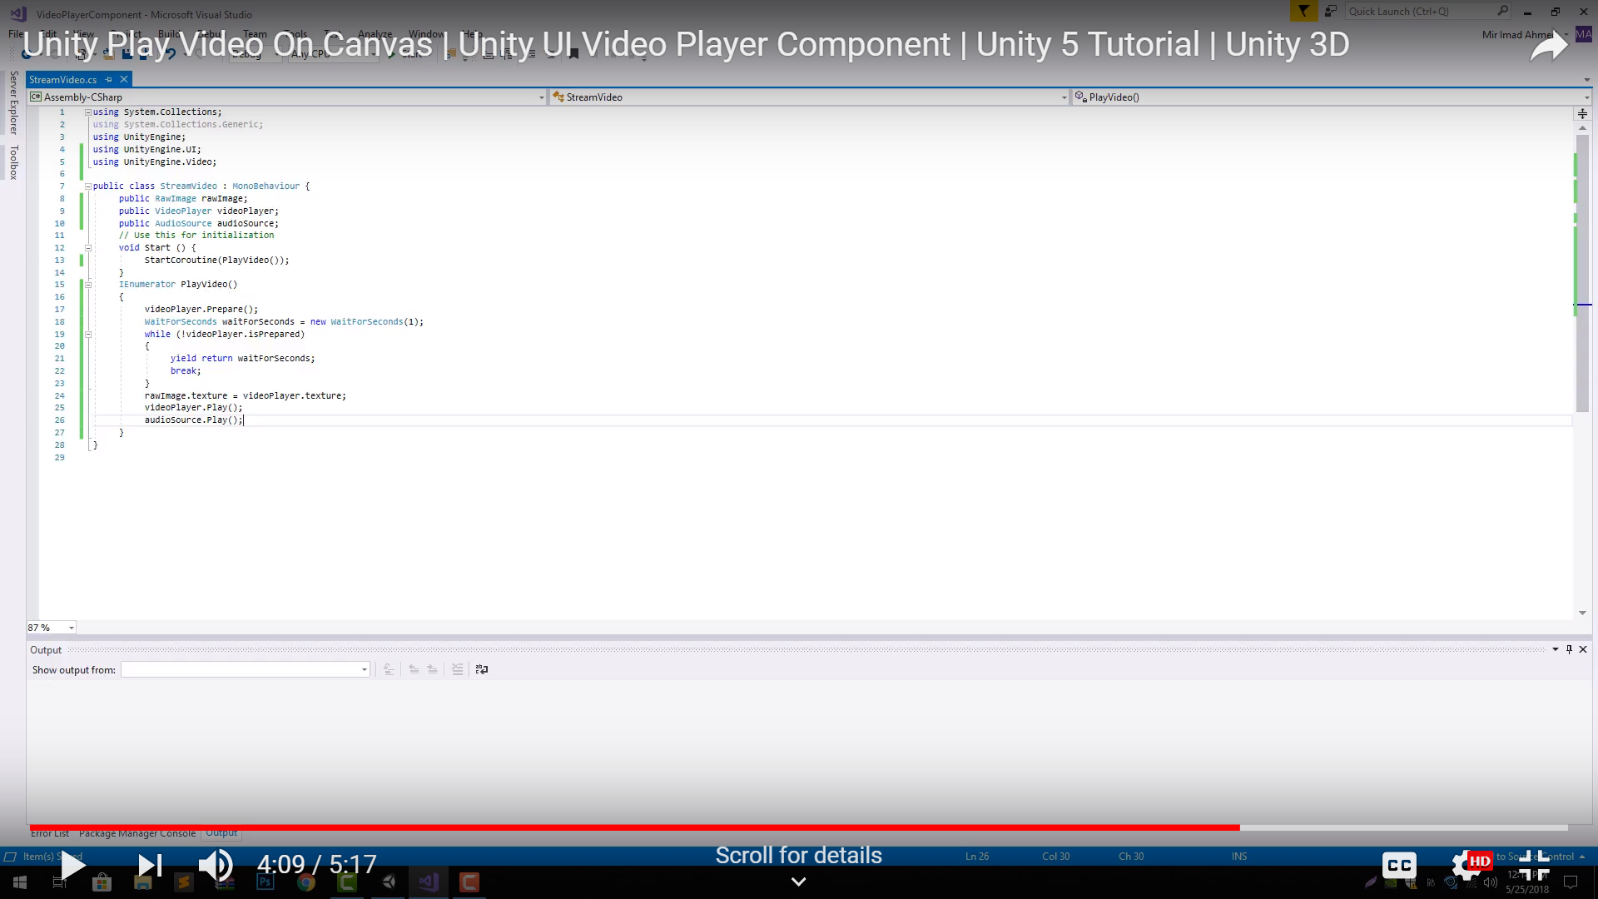**Create this class Use these settings in Inspector**

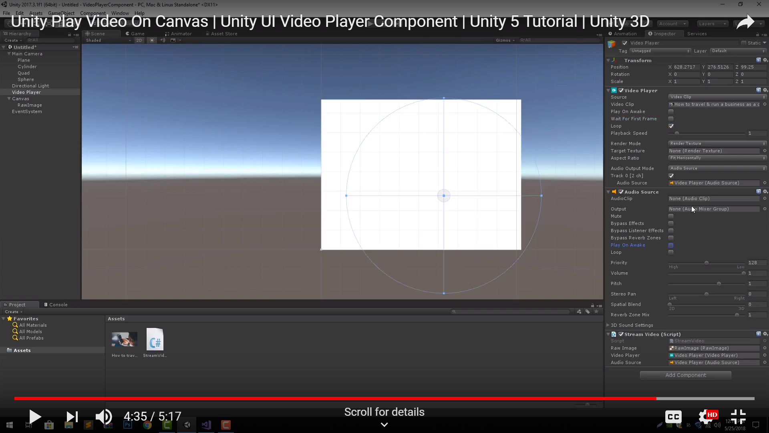

**IF VIDEO IS STORED IN ASSETS FOLDER**

//Raw Image to Show Video Images [Assign from the Editor]

public RawImage image;

//Video To Play [Assign from the Editor]

public VideoClip videoToPlay;

private VideoPlayer videoPlayer;

private VideoSource videoSource;

//Audio

private AudioSource audioSource;

// Use this for initialization

void Start()

{

Application.runInBackground = true;

StartCoroutine(playVideo());

}

IEnumerator playVideo()

{

//Add VideoPlayer to the GameObject

videoPlayer = gameObject.AddComponent<VideoPlayer>();

//Add AudioSource

audioSource = gameObject.AddComponent<AudioSource>();

//Disable Play on Awake for both Video and Audio

videoPlayer.playOnAwake = false;

audioSource.playOnAwake = false;

//We want to play from video clip not from url

videoPlayer.source = VideoSource.VideoClip;

//Set Audio Output to AudioSource

videoPlayer.audioOutputMode = VideoAudioOutputMode.AudioSource;

//Assign the Audio from Video to AudioSource to be played

videoPlayer.EnableAudioTrack(0, true);

videoPlayer.SetTargetAudioSource(0, audioSource);

//Set video To Play then prepare Audio to prevent Buffering

videoPlayer.clip = videoToPlay;

videoPlayer.Prepare();

//Wait until video is prepared

while (!videoPlayer.isPrepared)

{

Debug.Log("Preparing Video");

yield return null;

}

Debug.Log("Done Preparing Video");

//Assign the Texture from Video to RawImage to be displayed

image.texture = videoPlayer.texture;

//Play Video

videoPlayer.Play();

//Play Sound

audioSource.Play();

Debug.Log("Playing Video");

while (videoPlayer.isPlaying)

{

Debug.LogWarning("Video Time: " + Mathf.FloorToInt((float)videoPlayer.time));

yield return null;

}

Debug.Log("Done Playing Video");

}

**IF VIDEO IS ONLINE**

//Raw Image to Show Video Images [Assign from the Editor]

public RawImage image;

private VideoPlayer videoPlayer;

private VideoSource videoSource;

//Audio

private AudioSource audioSource;

// Use this for initialization

void Start()

{

Application.runInBackground = true;

StartCoroutine(playVideo());

}

IEnumerator playVideo()

{

//Add VideoPlayer to the GameObject

videoPlayer = gameObject.AddComponent<VideoPlayer>();

//Add AudioSource

audioSource = gameObject.AddComponent<AudioSource>();

//Disable Play on Awake for both Video and Audio

videoPlayer.playOnAwake = false;

audioSource.playOnAwake = false;

//We want to play from url

videoPlayer.source = VideoSource.Url;

videoPlayer.url = "http://www.quirksmode.org/html5/videos/big_buck_bunny.mp4";

//Set Audio Output to AudioSource

videoPlayer.audioOutputMode = VideoAudioOutputMode.AudioSource;

//Assign the Audio from Video to AudioSource to be played

videoPlayer.EnableAudioTrack(0, true);

videoPlayer.SetTargetAudioSource(0, audioSource);

//Set video To Play then prepare Audio to prevent Buffering

videoPlayer.Prepare();

//Wait until video is prepared

while (!videoPlayer.isPrepared)

{

Debug.Log("Preparing Video");

yield return null;

}

Debug.Log("Done Preparing Video");

//Assign the Texture from Video to RawImage to be displayed

image.texture = videoPlayer.texture;

//Play Video

videoPlayer.Play();

//Play Sound

audioSource.Play();

Debug.Log("Playing Video");

while (videoPlayer.isPlaying)

{

Debug.LogWarning("Video Time: " + Mathf.FloorToInt((float)videoPlayer.time));

yield return null;

}

Debug.Log("Done Playing Video");

}

[**https://stackoverflow.com/questions/41144054/using-new-unity-videoplayer-and-videoclip-api-to-play-video**](https://stackoverflow.com/questions/41144054/using-new-unity-videoplayer-and-videoclip-api-to-play-video)