Authorization

Type: Bearer Token

Token: From <https://developers.google.com/oauthplayground/?code=4/_ABhYA3uNVPDrx32jQ0APujUpumDrgiuPWt8ox4fhMUfdr3bKKr4aEFRWI0dxcsqgHVLAqWXOeoG2YA7B9mUQ7c&scope=https://www.googleapis.com/auth/dialogflow>

Headers

Content-type – Application/JSON

Body:

{

"queryInput":

{

"text":

{

"text": "let's do calves",

"languageCode": "en"

}

}

}

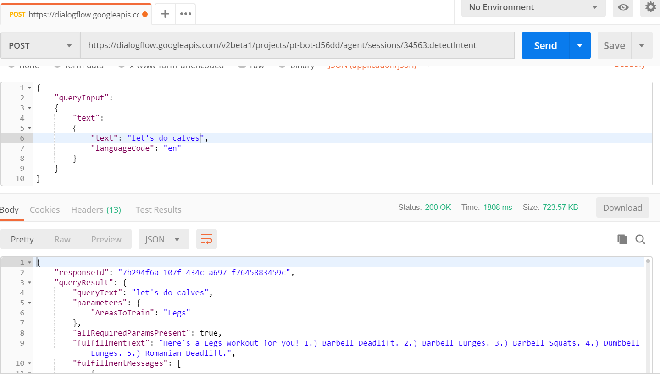

I found it wasn’t recognising entities properly, e.g. when saying “Let’s do abs” it would return a legs workout for some reason. So, I created separate entities for arms/back/chest/core/legs instead of a single entity and now it works.

