**Part 1 - Creating Animation**

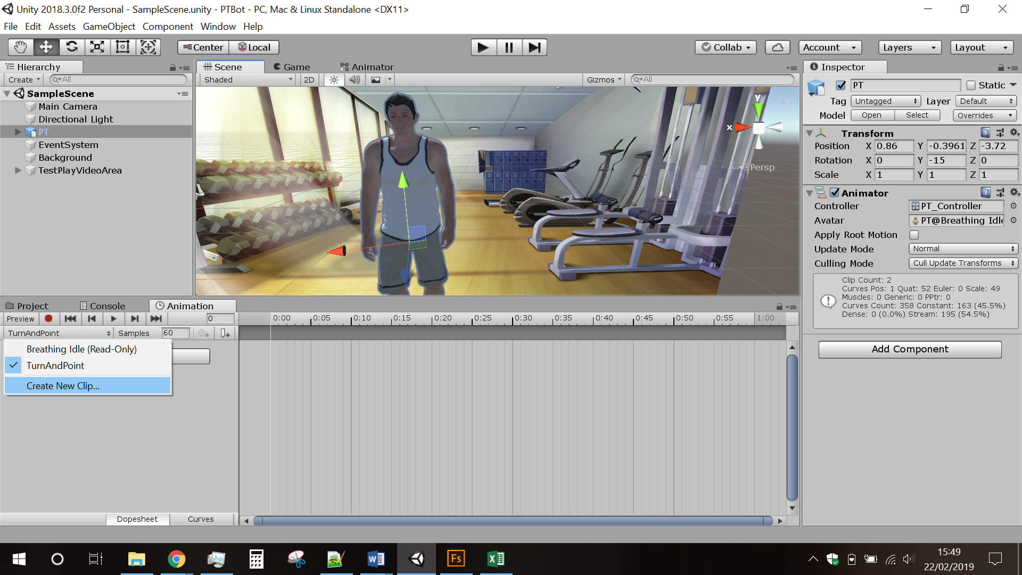1) Select PT object

2) Open Animation Window

3) Create a new clip and save in a folder

4) Click Red “Record” button.

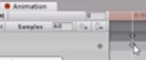5) Rotate the object slightly.

6) Reset the Rotation / Position values and ensure the

points under the cursor in the image are at the frame 0.00.

7) Click a position further along the timeline.

8) Rotate the object to desired position in the Scene.

9) Go to the Animator tab.

10) Click on the newly created Animation State and untick the Loop Time box.

11) Add a Bool parameter

12) Right Click and create a Transition to the new Animation State from the Idle state.

13) Add a condition in the Inspector on the transition and set it to true.

14) Copy & Paste the new Animation State and rename the copy.

15) Set the speed to -1 to reverse the animation in the Inspector.

16) Right click the newly created Animation State and create a transition to the cop state.

17) Click the transition and add a condition and set the parameter to false on the Inspector.

18) Untick the Has Exit Time option for the Transition in the Inspector.

19) Right click the copy state and create a Transition to the Idle State.

<https://www.youtube.com/watch?v=dEpH6-vwxYY>

**Part 2 - Edit PlayVideoScript.cs**

1) At the top with the other declared variables, add

private static Animator animator;

private GameObject pt;

2) In the Test() method add

pt = GameObject.Find("PT");

animator = pt.GetComponent<Animator>();

3) In the PlayTheVideo method add

animator.SetBool("IsVideoPreparing", true);

underneath

Debug.Log("Done Preparing Video");

4) In the PlayTheVideo method add

animator.SetBool("IsVideoPreparing", false);

underneath

Debug.Log("Done Playing Video");