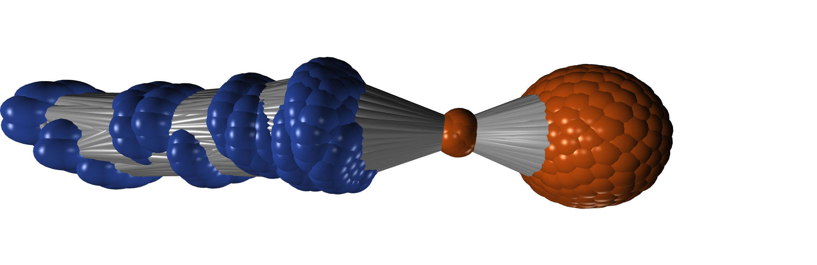This is a representation of the clustering of observations from the Trauma dataset. Each node is an observation, each edge (the grey tubes) is the connection between the nodes. Every node has an actual relationship to every other, but here only the strong connections are left in, then the graph is drawn using the list of nodes and edges. The Pearson correlation is used because it’s surprisingly robust.

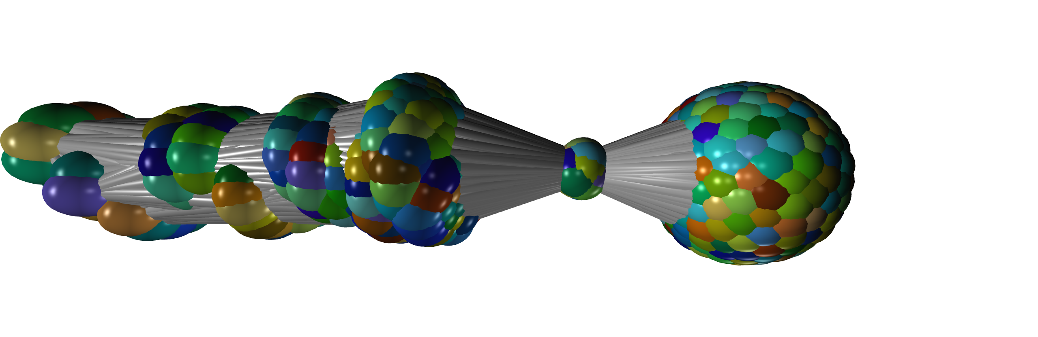Here the nodes are coloured by arrival time to ED. No correlation.