MODULE TITLE: Implementing Secure Systems

MODULE CODE: WM242-24 (cw2)

STUDENT ID NUMBER: U1834961

GPG FINGERPRINT:

F157202342CC4C1BAD90C09463167BBAE805C8CC

01D30C70CBEB3B45273ED0E3C280BCD3EB9771C1

PHASE 1:

Implementation | Reasoning | Evidence
Implemented an x509 structure across the organisations network. This included one root CA and one intermediate CA. | The organisation has a requirement that an x509 certificate authority hierarchy be implemented.  Creating an Intermediate CA that generates a certificate signing request to the root CA is an example of the x509 hierarchy; the intermediate CA can go on to be used to sign users requesting remote access to the organisations network. | Build_x509.sh  Network Model Diagram
Generated keys and certificates for the root CA, Intermediate CA, all mobusrs, gw-u1834961-u1824952.cyber.test and www. u1834961-u1824952.cyber.test | The root CA generates a key and a self-signed certificate. The I_CA then generates its own key and generates a certificate signing request to the root CA to initiate a chain of trust. | From build_x509.sh;  key-gen cmd for root CA:  ipsec pki --gen --type rsa --size 4096 --outform pem > CA.key.pem  Intermediate CA certificate signing request cmd:  ipsec pki --issue --ca --in ica.csr.pem --lifetime 365 --cacert CA.crt.pem --cakey CA.key.pem --dn "C=UK, O=University of Warwick - Cyber Security Centre, OU=ISS CW2, CN=i_ca.cyber.test" --san 192.168.65.5 --san @192.168.65.5 --flag serverAuth --flag ikeIntermediate --outform pem > ica.crt.pem
Ipsec VPN implemented using StrongSwan for one remote user wishing to access the network.  Included creating a user that sits on the 192.168.65.0/24 network (Warwick internal) having some communication with an external user (mobusr1); configured such that communication between the two will be encrypted through the authentication of trusted certificates. | Setting up a secure VPN connection for authenticated users requesting remote access to the organisations network. | Within internet.startup is the tcpdump cmd:  tcpdump -i any -w /hostlab/internetCapture.pcap  which will collect traffic destined for the organisations network.  Using a netcat listening on host ‘a’ with the command:  nc -lvnp 8000  creates a listener on port 8000  on mobusr 1which has the ip address 20.10.0.5 connects to hist ‘a’ using the cmd:  nc 192.168.65.20 8000  and generated some traffic for proof that the packets being sent across the internet are encrypted.

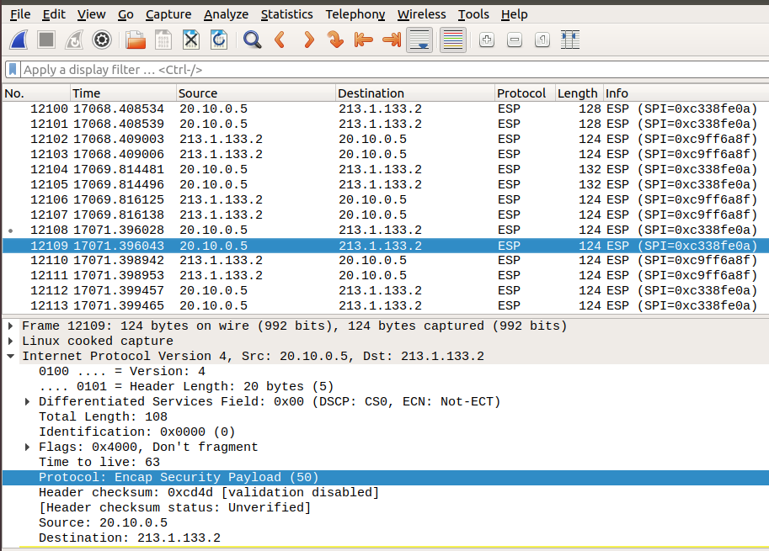

Figure 1: An Encapsulated Security Payload from mobusr1 that uses the internet to access the internal network.

PHASE 2:

Implementation | Reasoning | Evidence
Implement IPsec VPN for two or more users.  Achieved by creating two more external users that each perform achieve communication with a host sat on the Warwick internal network (192.168.65.0/24). Again, the authentication used is the x509 certificates. | Setting up further secure VPN connections for 2 more users both requesting remote access to Warwick’s internal network. | Using the same test as before, setting up a netcat listener on host ‘a’:  nc -lvnp 8000  and connection to it one mobusr 2 and mobusr 3.  Figure 2: Is mobusr2 sending encrypted packets across the internet from the IP address 182.10.10.50  Figure 3: Is mobus3 sending the encrypted packets across the internet from the IP address 54.100.211.91
Correctly allocate the IP addresses and domain names on the network. | Ensuring that the IP addresses for the internal network are correct, in the 192.168.65.0/24 rand. Changes to the name of the VPN gateway (gw.u 1834961-u1824952.cyber.test) and the Apache webserver (www.u1834961-u1824952.cyber.test) | gw.u 1834961-u1824952.cyber.test.startup includes:  #for the internal network  ifconfig eth0 192.168.65.1/24 up  #designated public ip for the organisation  ifconfig eth1 213.1.133.2/27 up  # 1:1 routing for the Apache web server.  ifconfig eth1:1 213.1.133.3/27 up  www.u1834961-u1824952.cyber.test.startup  ifconfig eth0 192.168.65.10  a.startup  ifconfig eth0 192.168.65.20

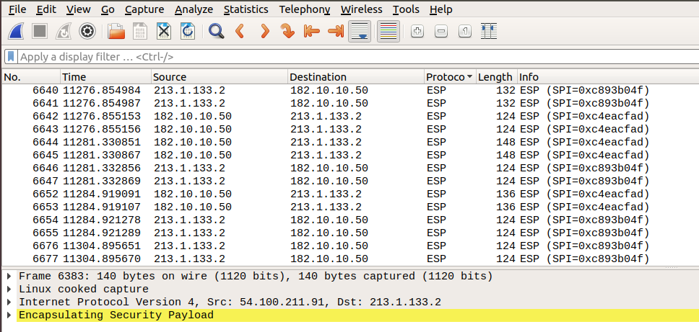
Figure 2: Shows an Encapsulated Security Payload that uses the internet to access the internal network for mobusr2.

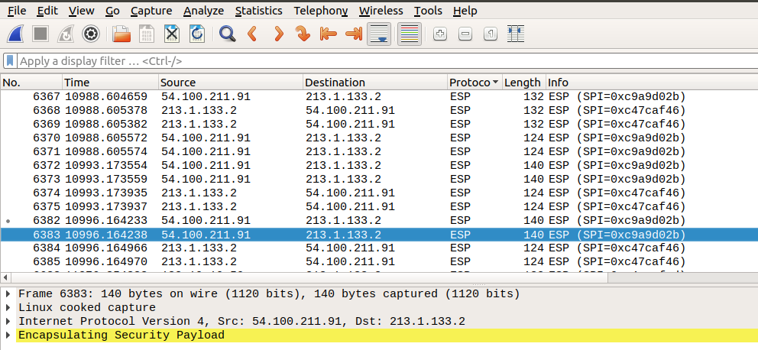
Figure 3: Shows an Encapsulated Security Payload that uses the internet to access the internal network for mobusr3

Implementation | Reasoning | Evidence
Creating keys of specific size and validity period, depending on the machines functionality. | All of the keys generated are 4096 bits in length. The root CA has a certificate that is valid for 10 years where as all others have a validity period of 1 year. | build_x509.sh:  # generate root CA key  ipsec pki --gen --type rsa --size 4096 --outform pem > CA.key.pem  # generate root certificate  ipsec pki --self --ca --lifetime 3650 --in CA.key.pem --type rsa --dn "C=UK, O=University of Warwick - Cyber Security Centre, OU=ISS CW2, CN=CA" --outform pem > CA.crt.pem  # gw certificate creation  # generate key  ipsec pki --gen --type rsa --size 4096 --outform pem > gw.key.pem  # generate csr  ipsec pki --pub --in gw.key.pem --type rsa --outform pem > gw.csr.pem  # sign certificate with root key  ipsec pki --issue --in gw.csr.pem --lifetime 365 --cacert CA.crt.pem --cakey CA.key.pem --dn "C=UK, O=University of Warwick - Cyber Security Centre, OU=ISS CW2, CN=gw.u1834961-u1824952.cyber.test" --san 213.1.133.2 --san @213.1.133.2 --san 192.168.65.1 --san @192.168.65.1 --flag serverAuth --flag ikeIntermediate --outform pem > gw.crt.pem
Creating a certificate revocation list (CRL) for users that are no longer permitted access to the internal network externally. For the purpose of demonstration, a rogue user has been added that has had their certificate adding to the CRL. | Within organisations such privileges are remotely accessing networks may need to be revoked (eg. change in occupation). A revocation list ensures the networks integrity by restricting access to those who were once granted entry.  The list is added to the I_CA which will perform a check against to determine entry. | Within the build_x509.sh:  ipsec pki --signcrl --carcert ica.crt.pem --cakey ica.key.pem --reason superseeded --cert rogueOne.crt.pem > ica.crl.pem
Creating a robust Apache web server. | Creating an Apache web server that has thought out features to ensure the organisations security. | www.u1834961-u1824952.cyber.test.startup  a2enmod headers initiated to set some rules. In this case the ssl-params.conf file includes:  Header always set Strict-Transport-Security "max-age=63072000; includeSubdomains"  which enables strict transport security so that browsers always use this site via https.  Another thing added within the ssl-params.conf file is the decision to use only specific cypher suites.  SSLCipherSuite EECDH+AESGCM:EDH+AESGCM:AES256+EECDH:AES256+EDH  Cypher suites chosen use a combination of Diffie Hellman key exchange and/or elliptical curve encryption.  Also within ssl-params.conf is a configuration of what version of TLS and SSL to include  only allow TLSv1.1 and TLSv1.2 (and TLSv1.3 on apache 2.4 e.g. not the netkit version)  SSLProtocol All -SSLv2 -SSLv3 -TLSv1
Adding 1:1 NAT for the internal Apache server. | Mapping the internal address of the Apache webserver 192.168.65.10 to one of the organisations public IP addresses (213.1.133.3) | gw.u1834961-u1824952.cyber.test.startup  iptables -t nat -A PREROUTING -i eth1 -d 213.1.133.3 -j DNAT --to-destination 192.168.65.10  iptables -t nat -A POSTROUTING -s 192.168.65.10 -j SNAT --to-source 213.1.133.3  iptables -t nat -A POSTROUTING -o eth1 -j SNAT --to-source 213.1.133.2
Adding the root CA to etc/ssl/certs | Added our root CA to the etc/ssl/certs folder.

