**Steps taken for creating seccomp webserver**

1 – Edit the **Dockerfile** -> add **strace and audit audit-libs**

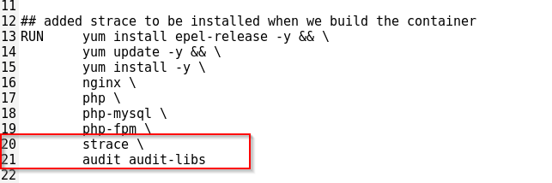

2 – Run the webserver container without a seccomp file, but add strace capability

docker run -d --net iss-cw3_net --ip 192.0.2.10--hostname webserver database:192.0.2.3 -p 80:80 --cap-add=SYS_PTACE --name nginx-server_c <docker image>

3 – Get inside the container

docker exec -it nginx-server_c /bin/bash

4 – Use strace for viewing the syscalls

The command used as well as the output is found in **strace_from_inside_docker.txt**

5 – Create a seccomp file with all the syscalls found from step 4

**custom.json**

6 – Stop the container and run it with the new seccomp file

Even if all the syscalls found by strace were added to the seccomp file, the container was still not working

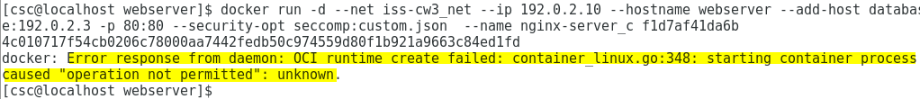

The above error was coming up as well as something called “readdirent operation not permitted”

7 - used this link for adding the missing syscalls

<https://github.com/moby/moby/issues/22252>

Update the seccomp file with the syscalls found in there

8 – disable syscalls that nginx doesn’t use

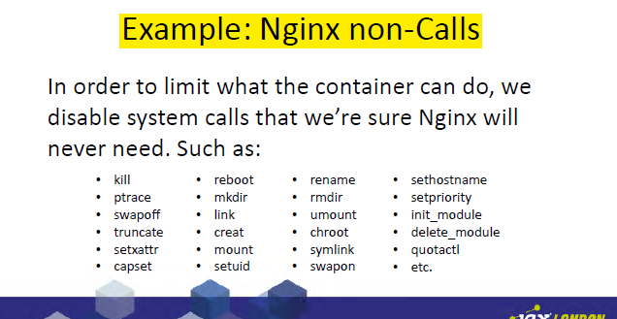

9 – add some more missing syscalls required by docker

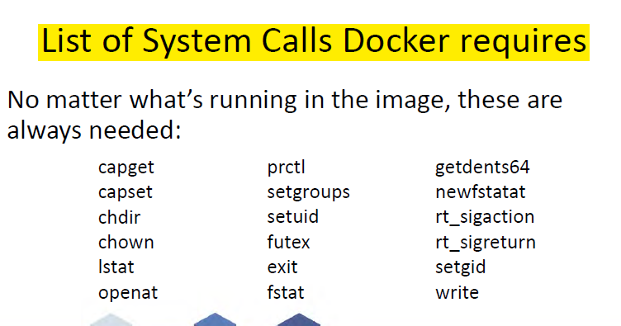

10 – now no error is given when running the container with the new seccomp file, but container exits immediately.

docker run -d --net iss-cw3_net --ip 192.0.2.10 --hostname webserver database:192.0.2.3 -p 80:80 --security-opt seccomp:custom.json --name nginx-server_c <docker image>

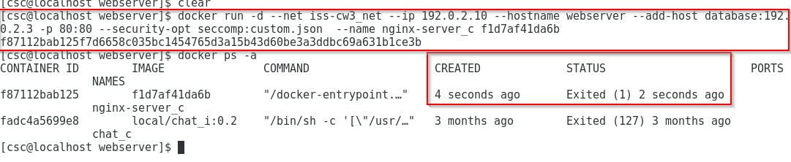

11 – When I tried to access the logs from docker I was getting this error



Next I added the **getpgrp** syscall tot the seccomp and no errors were coming up

**Seccomp doesn’t crash the container anymore, but when I am trying to access the local webpage, it doesn’t work**

**Steps taken for creating seccomp mysql**

1 – Edit the **Dockerfile** -> add **strace and audit audit-libs**

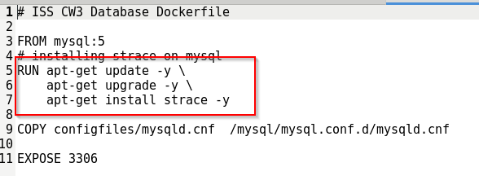

2 – Run the webserver container without a seccomp file, but add strace capability

docker run -d --net iss-cw3_net --ip 192.0.2.3 --hostname database MYSQL_ROOT_PASSWORD=”test” -e MYSQL_DATABASE=”data” –security-opt seccomp:custom.json --name mysql-server_c <docker image>

3 – Get inside the container

docker exec -it mysql-server_c /bin/bash

4 – Use strace for viewing the syscalls

The command used as well as the output is found in **strace_from_inside_mysql.txt**

5 – Create a seccomp file with all the syscalls found from step 4

**custom.json**

6 – Stop the container and run it with the new seccomp file

The seccomp doesn’t crash the container, but when I am trying to execute the second

docker exec -i mysql-server_c mysql -uroot -ptest data < sqlconfig/data.sql

This error comes up

