Qualitative Risk Assessment
Two complementary techniques: Scenario Analytics (Fleisher & Bensoussan, 2015, Ch. 22) and Industry Fusion Analytics (Ch. 17) are adopted to qualitatively evaluate twenty risks. Scenario Analytics are used to forecast the evolution of risks in different acquisition scenarios. For example, Seagen’s scientific talent is most exposed to competitor recruitment within the 18 – 24 month post-close window. Also, the multi-year IRA negotiation timeline determines when ADCETRIS becomes eligible for price negotiation. Industry Fusion Analytics can triangulate each risk against the broader oncology competitive and regulatory environment. For example, instead of assessing Pfizer in isolation, the Industry Fusion Analytics found that AbbVie, Merck, Bristol Myers Squibb, and Gilead had committed over $15 billion in total to ADC platforms in the same time window as when Pfizer is integrating with Seagen. As a result, the competitive risk has a high likelihood score.
The Likelihood and Impact of each risk is rated on an ordinal scale from 1 to 10 instead of a basic low, medium, or high ranking. In this way, risks can be prioritized in a fine-grained way to support the later quantitative analysis. In risk scoring, each team member focused on the risk that matched their area of knowledge. For example, the member who was familiar with the deal’s capital structure evaluated and scored financial risks. The member who was familiar with HR and integration research focused on operational and people-related risks. The member who tracked IRA and FTC issues would evaluate legal and regulatory risks. Finally, the member with knowledge in pharmaceutical IT will assess technology risks. When there is a disagreement on scores, the evidence behind each risk was discussed, and a resolution was reached through the discussion.

Severity Distribution and the Case for Further Quantitative Analysis
Among the twenty risks, one risk is rated Critical (R-006), five risks are rated High (R-001, R-002, R-003, R-010, and R-017), twelve risks are rated Medium, and the remaining two risks are rated Low (R-014 and R-020). The register is dominated by Medium-level operational and financial risks that are common in large pharmaceutical acquisitions. Also, High and Critical level risks are all closely tied to competition in the ADC market. Some of these competition risks are related to competitors’ actions (R-001, R-003, R-010) while others are related to Pfizer’s loss of key scientific talent to rival companies (R-006).
Based on these findings, Pfizer should prioritize three risks for deeper quantitative analysis. They are ADC market-share erosion, critical ADC talent attrition, and the ADC combination therapy opportunity. Other risks are not competitive and time-sensitive in nature. For example, IT harmonization delay (R-009) or antitrust compliance (R-014) are better handled by monitoring associated KRI continuously. These risks are largely driven by internal risks or risks related to procedures. The value of these risks is not worth the effort used in building the probabilistic model.
This is aligned with the core logic of risk analysis. Not all identified risks require the risk analysis of the same depth. Quantitative modeling is useful only in three cases. First, if a risk has large financial impact and big uncertainty, a single number may not capture all possible outcomes related to this risk. As a result, quantitative modeling is useful. Second, the quantitative modeling can also be used if the risk has a lot of leading indicators that can be used to estimate the probability of each scenario. Third, if managers need information on the risk’s whole distribution rather than a single risk estimate to make decisions, quantitative modeling of risks is needed as well. Among twenty risks, R-001 (interest coverage) and R-002 (revenue target) are both rated High. But the financial assumptions behind them are already addressed in the DCF stress testing. Thus, Monte Carlo simulation is not applied. Instead, they are monitored through KRIs and scenario stress bands.

Corrected Risk Heatmap
Earlier, a stricter rule is adopted to construct the heatmap and color the grid. The rule will rate a risk as “High” if its Likelihood is 8 or above and its Impact is 5 or above. Also, the rule was only applied to two risks, R-003 and R-006. The heatmap contracted with the Priority column in the register. With the instructor’s feedback, the heatmap has been revised so that its classification is aligned with the register (Table 1 of the consolidated report). The corrected heatmap is displayed in Figure 1. The old version classifier was kept separately as an exercise for predictive-validation in the Quantitative Risk Assessment.
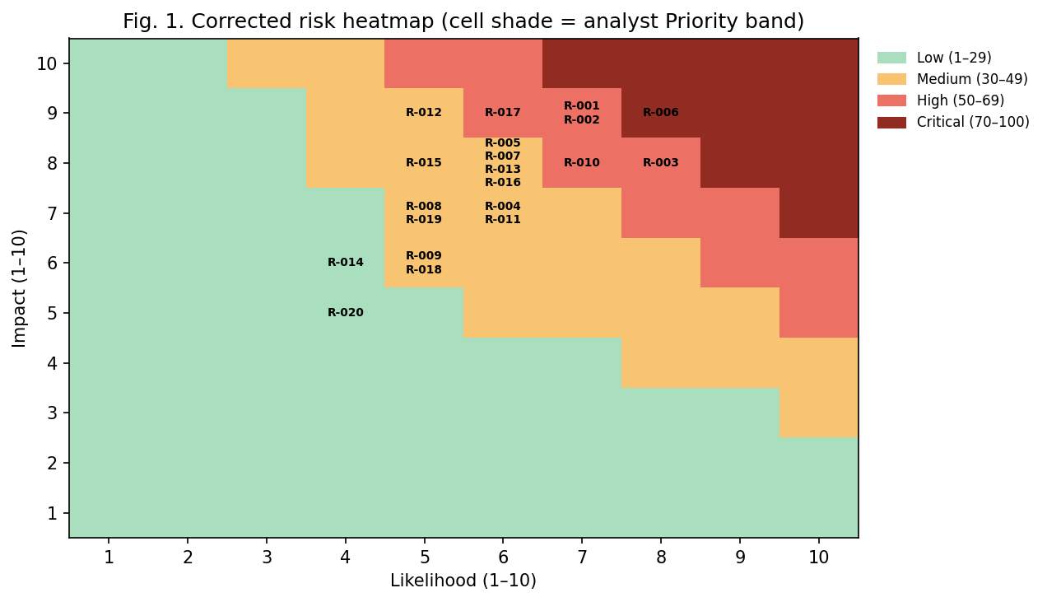
Figure 1. Corrected risk heatmap. Cell shade reflects Priority band assigned by the analyst from the register. The cell shade is consistent across the heatmap and the written register.
The revised heatmap shows that most serious risks with high Likelihood and Impact cluster in the upper-right quadrant. The risk exposure is unevenly distributed with a small number of financial and competitive risks with High and Critical Exposure. They are R-001, R-002, R-003, R-006, R-010 and R-017. By contrast, risks rated as Medium are operational and legal risks. The result supports that the Monte Carlo simulation analysis should only focus on R-006, R-MSE, and R-010. R-MSE is the risk related to market share erosion. It is associated with the logic of competition in R-001.

References
Committee of Sponsoring Organizations of the Treadway Commission. (2017). Enterprise risk management: Integrating with strategy and performance. AICPA.
Fleisher, C. S., & Bensoussan, B. E. (2015). Business and competitive analysis: Effective application of new and classic methods (2nd ed.). Pearson Education.

